1. MTCNN , FaceNet and SVC

Training Accuracy: 0.9792

Test Accuracy: 0.9583

Classification Report:

precision recall f1-score support

Arshdeep_Singh 0.75 1.00 0.86 3

Axar_Patel 1.00 0.67 0.80 3

Jasprit_Bumrah 1.00 1.00 1.00 5

Kuldeep_Yadav 1.00 1.00 1.00 6

Ravindra_Jadeja 1.00 1.00 1.00 3

Virat_Kohli 1.00 1.00 1.00 4

accuracy 0.96 24

macro avg 0.96 0.94 0.94 24

weighted avg 0.97 0.96 0.96 24

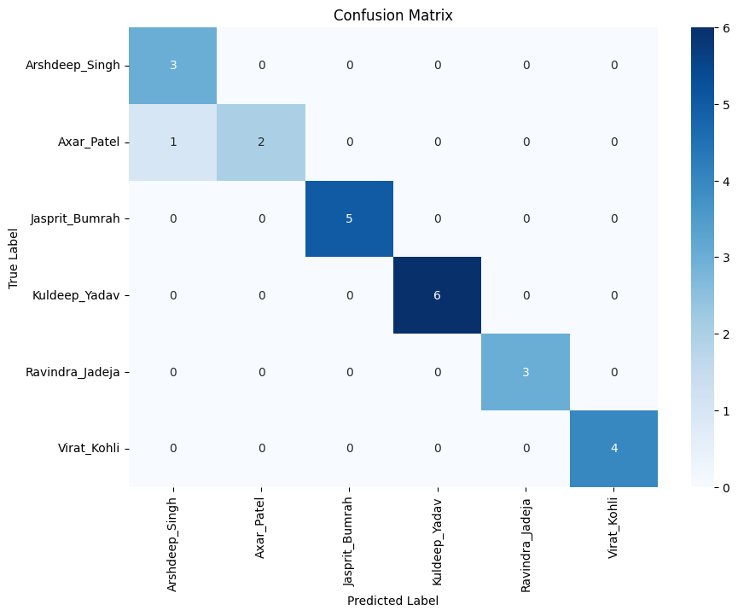

1. MTCNN, ViT, SVC

Training Accuracy: 1.0000

Test Accuracy: 0.8000

Classification Report:

precision recall f1-score support

Arshdeep_Singh 0.83 1.00 0.91 5

Axar_Patel 0.75 0.75 0.75 4

Jasprit_Bumrah 0.80 0.67 0.73 6

Kuldeep_Yadav 1.00 1.00 1.00 6

Ravindra_Jadeja 0.50 0.40 0.44 5

Virat_Kohli 0.80 1.00 0.89 4

accuracy 0.80 30

macro avg 0.78 0.80 0.79 30

weighted avg 0.79 0.80 0.79 30

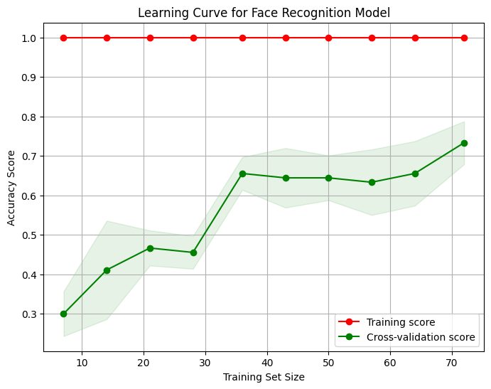

1. YOLO, FaceNet, SVC

Training Accuracy: 0.7586

Test Accuracy: 0.7000

Classification Report:

precision recall f1-score support

Arshdeep_Singh 0.36 0.80 0.50 5

Axar_Patel 0.75 0.50 0.60 6

Jasprit_Bumrah 1.00 0.83 0.91 6

Kuldeep_Yadav 0.75 0.60 0.67 5

Ravindra_Jadeja 1.00 0.50 0.67 4

Virat_Kohli 1.00 1.00 1.00 4

accuracy 0.70 30

macro avg 0.81 0.71 0.72 30

weighted avg 0.80 0.70 0.72 30

findings:

yolo is not suitable for this type of tasks

1. YOLO, ViT, SVC

Training Accuracy: 1.0000

Test Accuracy: 0.6667

Classification Report:

precision recall f1-score support

Arshdeep_Singh 1.00 1.00 1.00 5

Axar_Patel 0.56 0.83 0.67 6

Jasprit_Bumrah 0.75 0.50 0.60 6

Kuldeep_Yadav 0.60 0.60 0.60 5

Ravindra_Jadeja 0.40 0.50 0.44 4

Virat_Kohli 1.00 0.50 0.67 4

accuracy 0.67 30

macro avg 0.72 0.66 0.66 30

weighted avg 0.71 0.67 0.67 30

**MTCNN , FaceNet and Stacked ensemble with SVC and KNN with tuned parameters**

Training Accuracy: 0.9792

Test Accuracy: 0.9583

Classification Report:

precision recall f1-score support

Arshdeep_Singh 1.00 1.00 1.00 3

Axar_Patel 1.00 0.67 0.80 3

Jasprit_Bumrah 1.00 1.00 1.00 5

Kuldeep_Yadav 1.00 1.00 1.00 6

Ravindra_Jadeja 1.00 1.00 1.00 3

Virat_Kohli 0.80 1.00 0.89 4

accuracy 0.96 24

macro avg 0.97 0.94 0.95 24

weighted avg 0.97 0.96 0.96 24

