**SPATIAL MODEL**

1. **ViT with YOLO,4 players (model 1)** 8 hours and 30 min

epochs=5

optimizer = AdamWeightDecay(learning_rate=3e-5, weight_decay_rate=0.01)

batch_size=16

Classification Report:

precision recall f1-score support Predicted

Axar_Patel 0.50 0.74 0.60 993 NO

Kuldeep_Yadav 0.45 0.40 0.42 474 NO

Ravindra_Jadeja 0.57 0.24 0.34 571 NO

Virat_Kohli 0.57 0.48 0.52 629 YES

accuracy 0.51 2667

macro avg 0.52 0.47 0.47 2667

weighted avg 0.52 0.51 0.49 2667

F1 Score (macro-average): 0.47000779288034167

Accuracy: 0.5114360704911886

Mean Average Precision (mAP): 0.4309001207919875

1. **ViT with YOLO,4 players (model 2)** 17 hours

epochs=10

optimizer = AdamWeightDecay(learning_rate=1e-5, weight_decay_rate=0.01

batch_size=32

Classification Report:

precision recall f1-score support Predicted

Axar_Patel 0.40 0.95 0.57 993 YES

Kuldeep_Yadav 0.58 0.34 0.43 474 YES

Ravindra_Jadeja 0.27 0.01 0.01 571 NO

Virat_Kohli 0.50 0.03 0.05 629 NO

accuracy 0.42 2667

macro avg 0.44 0.33 0.26 2667

weighted avg 0.43 0.42 0.30 2667

F1 Score (macro-average): 0.2642639045353383

Accuracy: 0.4225721784776903

Mean Average Precision (mAP): 0.39568228096691377

1. **ViT with YOLO,9 players,25 images per player (model 3)** 15hours

epochs=10

optimizer = AdamWeightDecay(learning_rate=3e-5, weight_decay_rate=0.01

batch_size=32

Classification Report:

precision recall f1-score support

Arshdeep_Singh 0.00 0.00 0.00 35

Axar_Patel 0.00 0.00 0.00 117

Hardik_Pandya 0.06 0.17 0.09 24

Jasprit_Bumrah 0.25 0.37 0.30 142

Kuldeep_Yadav 0.00 0.00 0.00 33

Ravindra_Jadeja 0.00 0.00 0.00 118

Rohit_Sharma 0.00 0.00 0.00 58

Suryakumar_Yadav 0.10 0.49 0.17 77

Virat_Kohli 0.00 0.00 0.00 43

accuracy 0.15 647

macro avg 0.05 0.11 0.06 647

weighted avg 0.07 0.15 0.09 647

F1 Score (macro-average): 0.06168571007340383

Accuracy: 0.14528593508500773

Mean Average Precision (mAP): 0.12839186696721797

1. **ViT with YOLO+Normalized+CLAHE, 9 players,25 images per player (model 4)** 19 hours

epochs=15

optimizer = AdamWeightDecay(learning_rate=3e-5, weight_decay_rate=0.01

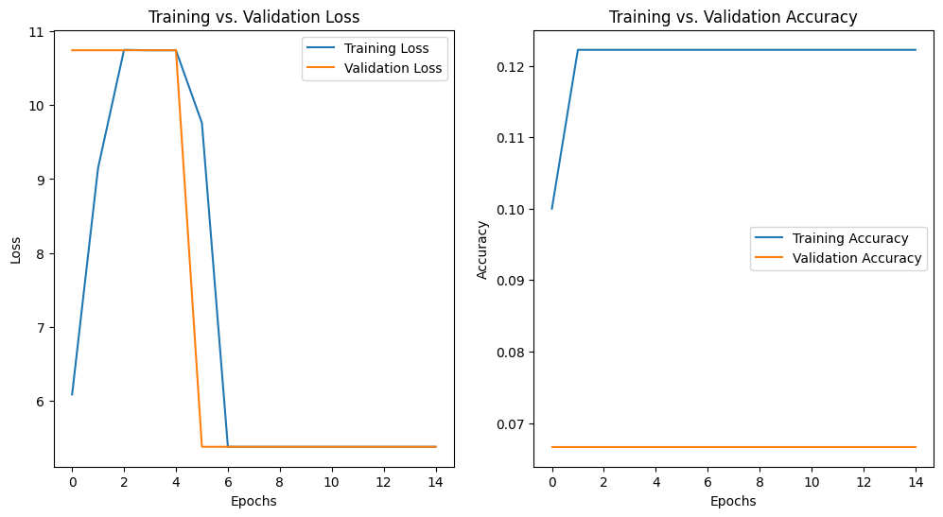batch_size=32

Classification Report:

precision recall f1-score support

Arshdeep_Singh 0.00 0.00 0.00 4

Axar_Patel 0.00 0.00 0.00 7

Hardik_Pandya 0.00 0.00 0.00 5

Jasprit_Bumrah 0.00 0.00 0.00 7

Kuldeep_Yadav 0.00 0.00 0.00 5

Ravindra_Jadeja 0.00 0.00 0.00 6

Rohit_Sharma 0.00 0.00 0.00 6

Suryakumar_Yadav 0.07 1.00 0.12 3

Virat_Kohli 0.00 0.00 0.00 2

accuracy 0.07 45

macro avg 0.01 0.11 0.01 45

weighted avg 0.00 0.07 0.01 45

F1 Score (macro-average): 0.013888888888888888

Accuracy: 0.06666666666666667

Mean Average Precision (mAP): 0.17052455944177378

1. **ViT with YOLO+CLAHE, 6 players, all images (model 5)** 16 hours

epochs=10

optimizer = AdamWeightDecay(learning_rate=3e-5, weight_decay_rate=0.01

batch_size=32

Classification Report:

precision recall f1-score support Predicted

Arshdeep_Singh 0.00 0.00 0.00 320 NO

Axar_Patel 0.00 0.00 0.00 537 YES

Jasprit_Bumrah 0.00 0.00 0.00 560 NO

Kuldeep_Yadav 0.06 0.25 0.10 168 NO

Ravindra_Jadeja 0.00 0.00 0.00 492 NO

Virat_Kohli 0.19 0.77 0.30 453 NO

accuracy 0.15 2530

macro avg 0.04 0.17 0.07 2530

weighted avg 0.04 0.15 0.06 2530

F1 Score (macro-average): 0.06710638335220341

Accuracy: 0.15454545454545454

Mean Average Precision (mAP): 0.17949712994277509

1. **EfficientNetB0 with YOLO+Normalized+CLAHE, 6 players, all images**

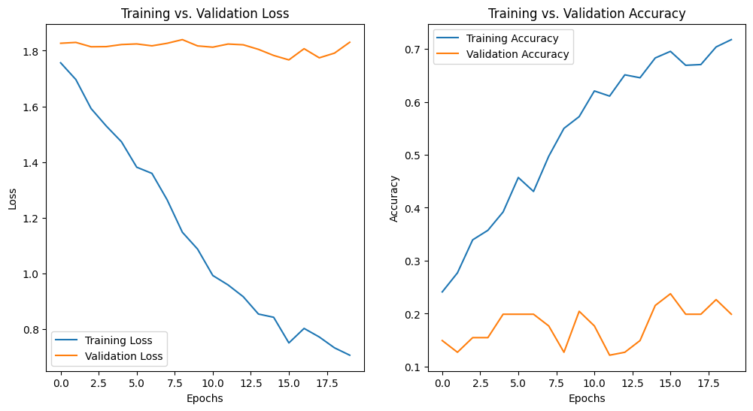

Classification Report:

precision recall f1-score support Predicted

Arshdeep_Singh 0.00 0.00 0.00 34 NO

Axar_Patel 0.00 0.00 0.00 23 NO

Jasprit_Bumrah 0.00 0.00 0.00 28 YES

Kuldeep_Yadav 0.00 0.00 0.00 27 NO

Ravindra_Jadeja 0.00 0.00 0.00 33 NO

Virat_Kohli 0.20 1.00 0.33 36 NO

accuracy 0.20 181

macro avg 0.03 0.17 0.06 181

weighted avg 0.04 0.20 0.07 181

F1 Score (macro-average): 0.05555555555555556

Accuracy: 0.19889502762430938

Mean Average Precision (mAP): 0.2689384839762784

1. **EfficientNetB0 with YOLO+CLAHE, 6 players, all images**

Classification Report:

precision recall f1-score support Predicted

Arshdeep_Singh 0.91 0.88 0.90 34 NO

Axar_Patel 0.82 0.78 0.80 23 YES

Jasprit_Bumrah 1.00 1.00 1.00 28 NO

Kuldeep_Yadav 0.96 0.96 0.96 27 NO

Ravindra_Jadeja 0.94 0.94 0.94 33 NO

Virat_Kohli 0.92 0.97 0.95 36 NO

accuracy 0.93 181

macro avg 0.93 0.92 0.92 181

weighted avg 0.93 0.93 0.93 181

F1 Score (macro-average): 0.9239708727270916

Accuracy: 0.9281767955801105

Mean Average Precision (mAP): 0.9821984095466108

1. **ResNet with YOLO+CLAHE, 6 players, all images-20 epochs**

Classification Report:

precision recall f1-score support Predicted

Arshdeep_Singh 0.93 0.82 0.87 34 NO

Axar_Patel 0.77 0.74 0.76 23 YES

Jasprit_Bumrah 0.90 0.96 0.93 28 NO

Kuldeep_Yadav 0.92 0.89 0.91 27 YES

Ravindra_Jadeja 0.82 0.94 0.87 33 YES

Virat_Kohli 0.94 0.92 0.93 36 NO

accuracy 0.88 181

macro avg 0.88 0.88 0.88 181

weighted avg 0.89 0.88 0.88 181

F1 Score (macro-average): 0.8783445528468529

Train Accuracy: 0.9986149584487535

Test Accuracy: 0.8839779005524862

Mean Average Precision (mAP): 0.9431579158478929

1. **ResNet with YOLO+CLAHE, 6 players, all images-30 epochs**

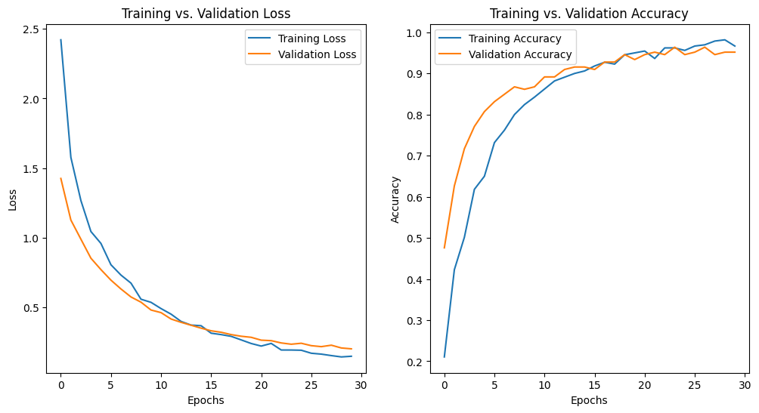

Classification Report:

precision recall f1-score support Predicted

Arshdeep_Singh 0.88 0.97 0.92 30 YES

Axar_Patel 0.96 0.89 0.93 28 YES

Jasprit_Bumrah 1.00 0.97 0.98 30 NO

Kuldeep_Yadav 0.94 1.00 0.97 3 YES

Ravindra_Jadeja 0.95 0.88 0.91 24 YES

Virat_Kohli 1.00 1.00 1.00 23 NO

accuracy 0.95 166

macro avg 0.96 0.95 0.95 166

weighted avg 0.95 0.95 0.95 166

F1 Score (macro-average): 0.9519008620465571

Train Accuracy: 1.0

Test Accuracy: 0.9518072289156626

Mean Average Precision (mAP): 0.9929924762723799

1. **ResNet with YOLO+Normalized+CLAHE, 6 players, all images**

Classification Report:

precision recall f1-score support Predicted

Arshdeep_Singh 0.53 0.74 0.62 34 NO

Axar_Patel 0.67 0.35 0.46 23 NO

Jasprit_Bumrah 0.62 0.64 0.63 28 NO

Kuldeep_Yadav 0.52 0.63 0.57 27 YES

Ravindra_Jadeja 0.47 0.52 0.49 33 NO

Virat_Kohli 0.71 0.47 0.57 36 NO

accuracy 0.56 181

macro avg 0.59 0.56 0.56 181

weighted avg 0.58 0.56 0.56 181

F1 Score (macro-average): 0.5553487852750503

Train Accuracy: 0.7714681440443213

Test Accuracy: 0.56353591160221

Mean Average Precision (mAP): 0.6781088403586856

1. **MobileNetV2 with YOLO+CLAHE, 6 players, all images**

Classification Report:

precision recall f1-score support Predicted

Arshdeep_Singh 0.66 0.74 0.69 34 YES

Axar_Patel 0.71 0.43 0.54 23 NO

Jasprit_Bumrah 0.86 0.86 0.86 28 NO

Kuldeep_Yadav 0.87 0.74 0.80 27 NO

Ravindra_Jadeja 0.56 0.82 0.67 33 NO

Virat_Kohli 0.80 0.67 0.73 36 YES

accuracy 0.72 181

macro avg 0.74 0.71 0.71 181

weighted avg 0.74 0.72 0.72 181

F1 Score (macro-average): 0.7143445393445393

Train Accuracy: 0.9958448753462604

Test Accuracy: 0.7182320441988951

Mean Average Precision (mAP): 0.8081841479772186

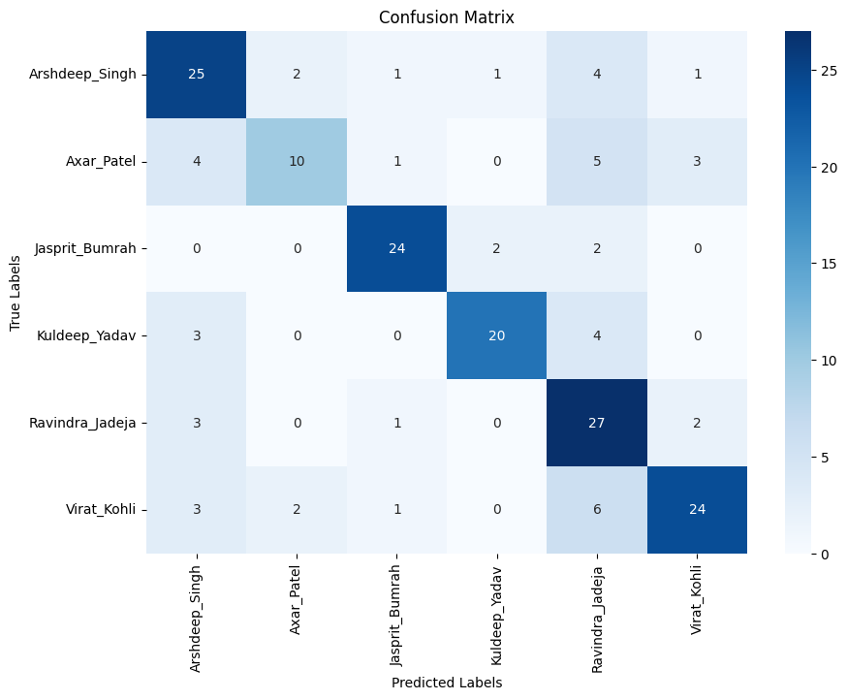

1. **InceptionV3 with YOLO+CLAHE, 6 players, all images**

Classification Report:

precision recall f1-score support Predicted

Arshdeep_Singh 0.36 0.41 0.38 34 NO

Axar_Patel 0.45 0.43 0.44 23 NO

Jasprit_Bumrah 0.57 0.46 0.51 28 NO

Kuldeep_Yadav 0.28 0.26 0.27 27 NO

Ravindra_Jadeja 0.39 0.48 0.43 33 NO

Virat_Kohli 0.68 0.58 0.63 36 NO

accuracy 0.45 181

macro avg 0.45 0.44 0.44 181

weighted avg 0.46 0.45 0.45 181

F1 Score (macro-average): 0.4443898138589468

Train Accuracy: 0.6620498614958449

Test Accuracy: 0.44751381215469616

Mean Average Precision (mAP): 0.49936544603165217

1. **DenseNet with YOLO+CLAHE, 6 players, all images**

Classification Report:

precision recall f1-score support Predicted

Arshdeep_Singh 0.66 0.62 0.64 34 YES

Axar_Patel 0.63 0.52 0.57 23 NO

Jasprit_Bumrah 0.82 0.64 0.72 28 NO

Kuldeep_Yadav 0.64 0.67 0.65 27 NO

Ravindra_Jadeja 0.62 0.79 0.69 33 NO

Virat_Kohli 0.82 0.86 0.84 36 YES

accuracy 0.70 181

macro avg 0.70 0.68 0.69 181

weighted avg 0.70 0.70 0.69 181

F1 Score (macro-average): 0.6855848055848056

Train Accuracy: 0.8878116343490304

Test Accuracy: 0.6961325966850829

Mean Average Precision (mAP): 0.7465469869226823

1. **VGG16 with YOLO+CLAHE, 6 players, all images**

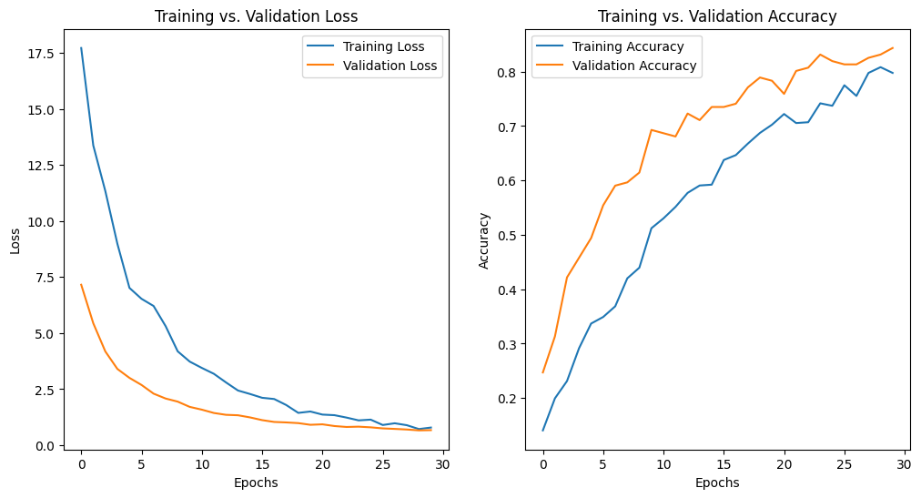

Classification Report:

precision recall f1-score support Predicted

Arshdeep_Singh 0.84 0.90 0.87 30 YES

Axar_Patel 0.81 0.88 0.84 24 NO

Jasprit_Bumrah 0.84 0.93 0.89 29 NO

Kuldeep_Yadav 0.78 0.86 0.82 29 NO

Ravindra_Jadeja 0.90 0.63 0.75 30 NO

Virat_Kohli 0.91 0.88 0.89 24 NO

accuracy 0.84 166

macro avg 0.85 0.85 0.84 166

weighted avg 0.85 0.84 0.84 166

F1 Score (macro-average): 0.8424334725357753

Train Accuracy: 0.972809667673716

Test Accuracy: 0.8433734939759037

Mean Average Precision (mAP): 0.8990265556710101

1. **NASNet with YOLO+CLAHE, 6 players, all images**

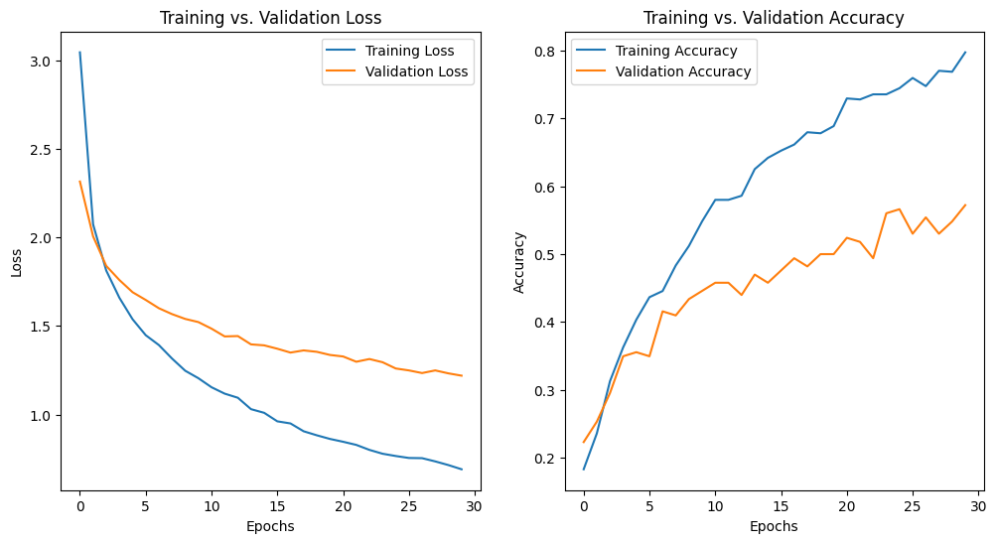

Classification Report:

precision recall f1-score support Predicted

Arshdeep_Singh 0.39 0.50 0.44 30 NO

Axar_Patel 0.61 0.58 0.60 24 NO

Jasprit_Bumrah 0.79 0.52 0.62 29 NO

Kuldeep_Yadav 0.55 0.59 0.57 29 NO

Ravindra_Jadeja 0.57 0.57 0.57 30 NO

Virat_Kohli 0.68 0.71 0.69 24 NO

accuracy 0.57 166

macro avg 0.60 0.58 0.58 166

weighted avg 0.59 0.57 0.58 166

F1 Score (macro-average): 0.5815220059655068

Train Accuracy: 0.8172205438066465

Test Accuracy: 0.572289156626506

Mean Average Precision (mAP): 0.6190944697638547

1. **Inception-ResNet-V2 with YOLO+CLAHE, 6 players, all images**

Classification Report:

precision recall f1-score support Predicted

Arshdeep_Singh 0.00 0.00 0.00 30 NO

Axar_Patel 0.00 0.00 0.00 24 NO

Jasprit_Bumrah 0.00 0.00 0.00 29 NO

Kuldeep_Yadav 0.00 0.00 0.00 29 NO

Ravindra_Jadeja 0.00 0.00 0.00 30 NO

Virat_Kohli 0.14 1.00 0.25 24 NO

accuracy 0.14 166

macro avg 0.02 0.17 0.04 166

weighted avg 0.02 0.14 0.04 166

F1 Score (macro-average): 0.042105263157894736

Train Accuracy: 0.18277945619335348

Test Accuracy: 0.14457831325301204

Mean Average Precision (mAP): 0.1750410697024074

1. **Xception with YOLO+CLAHE, 6 players, all images**

Classification Report:

precision recall f1-score support Predicted

Arshdeep_Singh 0.71 0.73 0.72 30 YES

Axar_Patel 0.58 0.46 0.51 24 YES

Jasprit_Bumrah 0.38 0.41 0.39 29 NO

Kuldeep_Yadav 0.61 0.66 0.63 29 NO

Ravindra_Jadeja 0.72 0.60 0.65 30 NO

Virat_Kohli 0.71 0.83 0.77 24 NO

accuracy 0.61 166

macro avg 0.62 0.62 0.61 166

weighted avg 0.62 0.61 0.61 166

F1 Score (macro-average): 0.6139152604078262

Train Accuracy: 0.9924471299093656

Test Accuracy: 0.6144578313253012

Mean Average Precision (mAP): 0.6867499680486353

**ResNet50**

1. With 5 fold Cross Validation

Classification Report:

precision recall f1-score support

Arshdeep_Singh 0.94 1.00 0.97 30

Axar_Patel 0.93 0.89 0.91 28

Jasprit_Bumrah 0.97 1.00 0.98 30

Kuldeep_Yadav 1.00 1.00 1.00 31

Ravindra_Jadeja 1.00 0.96 0.98 24

Virat_Kohli 1.00 0.96 0.98 23

accuracy 0.97 166

macro avg 0.97 0.97 0.97 166

weighted avg 0.97 0.97 0.97 166

F1 Score (macro-average): 0.9694900973308211

Train Accuracy: 1.0

Test Accuracy: 0.9698795180722891

Mean Average Precision (mAP): 0.9906417649610968

1. ResNet as a feature extractor and SVM as a classifier

Classification Report:

precision recall f1-score support

Arshdeep_Singh 0.91 1.00 0.95 30

Axar_Patel 1.00 0.93 0.96 28

Jasprit_Bumrah 1.00 0.93 0.97 30

Kuldeep_Yadav 0.94 1.00 0.97 31

Ravindra_Jadeja 0.95 0.88 0.91 24

Virat_Kohli 0.96 1.00 0.98 23

accuracy 0.96 166

macro avg 0.96 0.96 0.96 166

weighted avg 0.96 0.96 0.96 166

Training Accuracy: 0.9696969696969697

Testing Accuracy: 0.9578313253012049

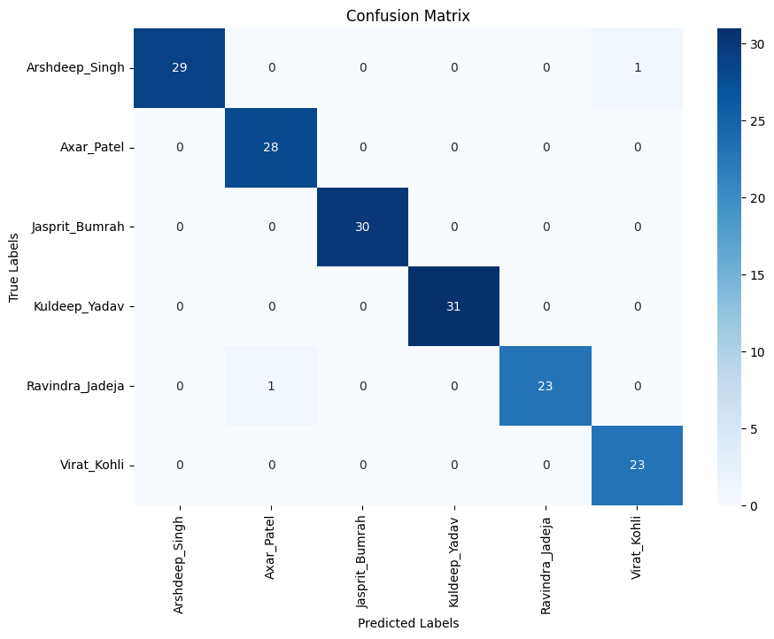

1. ResNet as a feature extractor and Random Forest as a classifier

Classification Report:

precision recall f1-score support

Arshdeep_Singh 0.94 0.97 0.95 30

Axar_Patel 1.00 0.96 0.98 28

Jasprit_Bumrah 1.00 0.90 0.95 30

Kuldeep_Yadav 0.97 1.00 0.98 31

Ravindra_Jadeja 0.92 0.92 0.92 24

Virat_Kohli 0.92 1.00 0.96 23

accuracy 0.96 166

macro avg 0.96 0.96 0.96 166

weighted avg 0.96 0.96 0.96 166

Training Accuracy: 1.0

Testing Accuracy: 0.9578313253012049

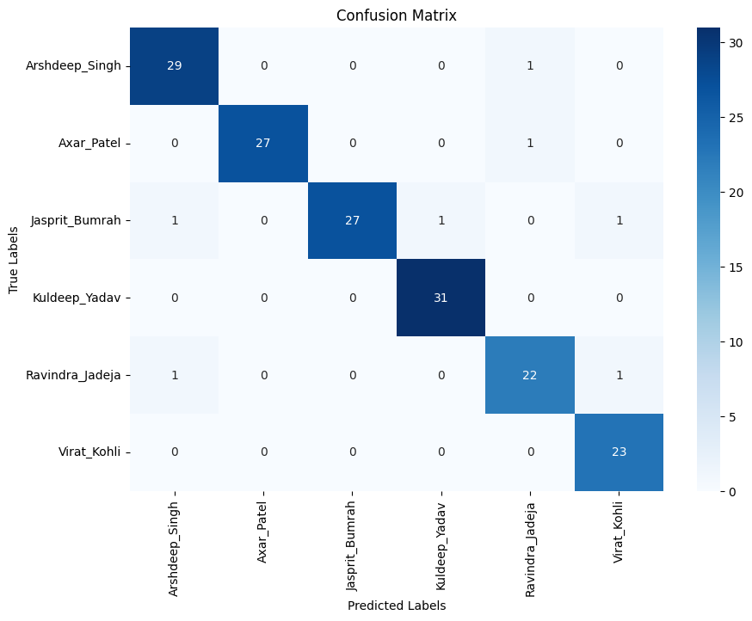

1. ResNet as a feature extractor and Decision Tree as a classifier

Classification Report:

precision recall f1-score support

Arshdeep_Singh 0.67 0.53 0.59 30

Axar_Patel 0.56 0.64 0.60 28

Jasprit_Bumrah 0.73 0.73 0.73 30

Kuldeep_Yadav 0.76 0.81 0.78 31

Ravindra_Jadeja 0.57 0.54 0.55 24

Virat_Kohli 0.67 0.70 0.68 23

accuracy 0.66 166

macro avg 0.66 0.66 0.66 166

weighted avg 0.66 0.66 0.66 166

Training Accuracy: 1.0

Testing Accuracy: 0.6626506024096386

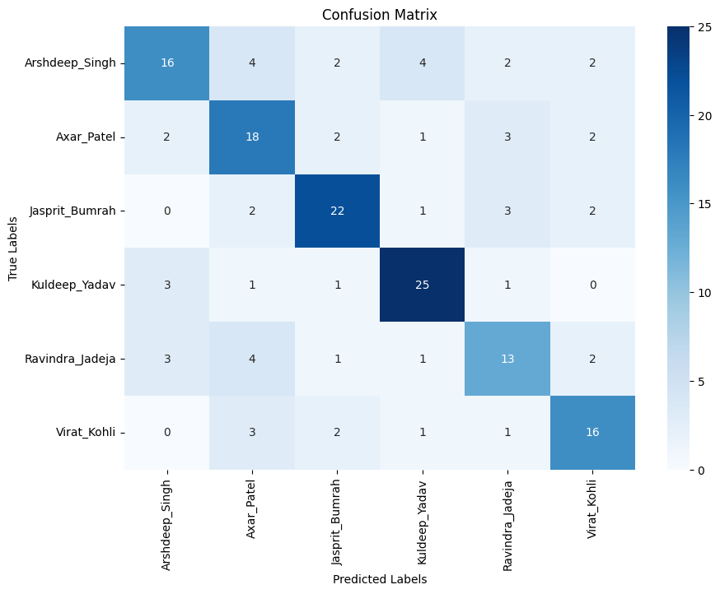

1. ResNet as a feature extractor and KNN as a classifier

Classification Report:

precision recall f1-score support

Arshdeep_Singh 0.91 0.97 0.94 30

Axar_Patel 0.97 1.00 0.98 28

Jasprit_Bumrah 1.00 0.87 0.93 30

Kuldeep_Yadav 0.97 1.00 0.98 31

Ravindra_Jadeja 1.00 0.92 0.96 24

Virat_Kohli 0.92 1.00 0.96 23

accuracy 0.96 166

macro avg 0.96 0.96 0.96 166

weighted avg 0.96 0.96 0.96 166

Training Accuracy: 0.9666666666666667

Testing Accuracy: 0.9578313253012049

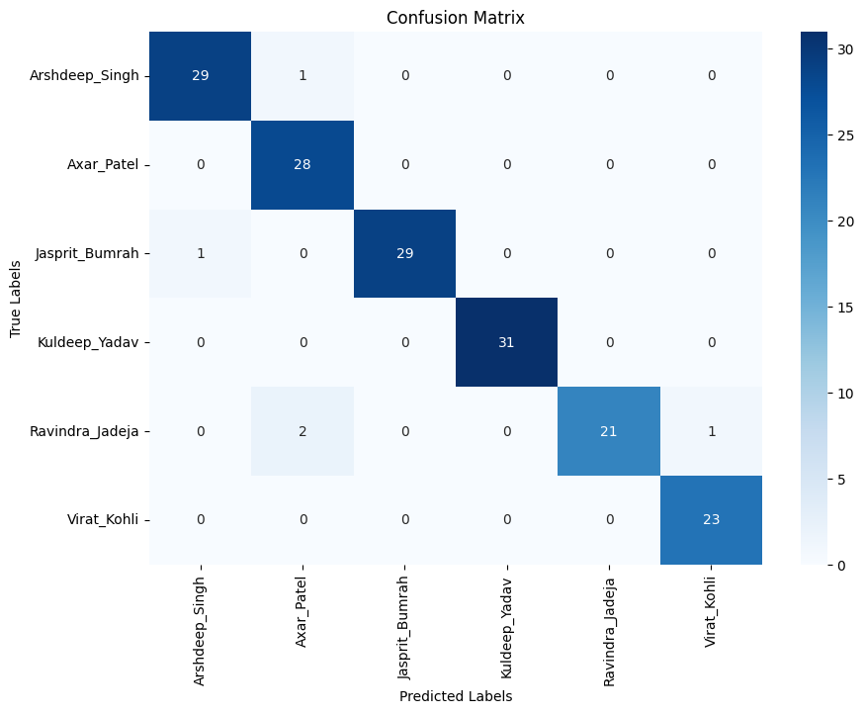

1. ResNet as a feature extractor and Gradient Boost Machine as a classifier

Classification Report:

precision recall f1-score support

Arshdeep_Singh 0.82 0.93 0.87 30

Axar_Patel 0.92 0.82 0.87 28

Jasprit_Bumrah 0.93 0.93 0.93 30

Kuldeep_Yadav 0.94 1.00 0.97 31

Ravindra_Jadeja 0.90 0.75 0.82 24

Virat_Kohli 0.92 0.96 0.94 23

accuracy 0.90 166

macro avg 0.91 0.90 0.90 166

weighted avg 0.91 0.90 0.90 166

Training Accuracy: 1.0

Testing Accuracy: 0.9036144578313253

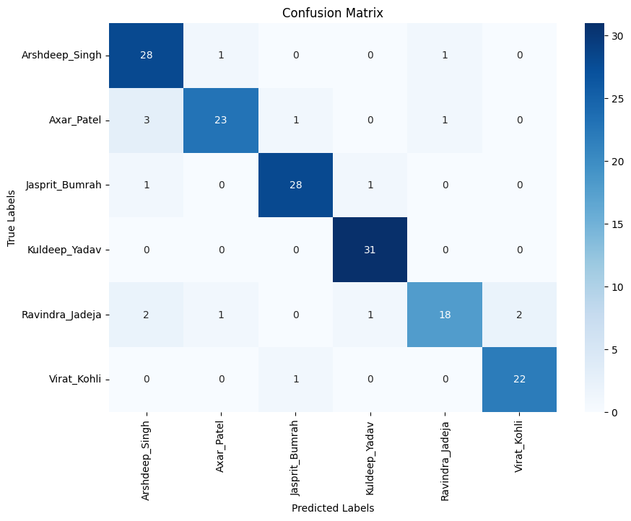

1. RestNet as a feature extractor and KNN and SVM as a classifier(Stacking)

Training Accuracy: 1.0

Testing Accuracy: 0.9939759036144579

Classification Report:

precision recall f1-score support

Arshdeep_Singh 0.97 1.00 0.98 30

Axar_Patel 1.00 1.00 1.00 28

Jasprit_Bumrah 1.00 0.97 0.98 30

Kuldeep_Yadav 1.00 1.00 1.00 31

Ravindra_Jadeja 1.00 1.00 1.00 24

Virat_Kohli 1.00 1.00 1.00 23

accuracy 0.99 166

macro avg 0.99 0.99 0.99 166

weighted avg 0.99 0.99 0.99 166

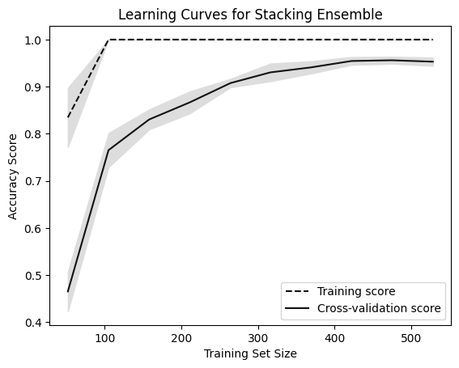

1. RestNet as a feature extractor and KNN and SVM as a classifier (Stacking) with tuning the parameters

Training Accuracy: 0.9848484848484849

Testing Accuracy: 0.9939759036144579

Classification Report:

precision recall f1-score support

Arshdeep_Singh 1.00 1.00 1.00 30

Axar_Patel 1.00 1.00 1.00 28

Jasprit_Bumrah 1.00 1.00 1.00 30

Kuldeep_Yadav 1.00 1.00 1.00 31

Ravindra_Jadeja 1.00 0.96 0.98 24

Virat_Kohli 0.96 1.00 0.98 23

accuracy 0.99 166

macro avg 0.99 0.99 0.99 166

weighted avg 0.99 0.99 0.99 166

1. RestNet as a feature extractor and KNN and SVM as a classifier(Voting Classifier) with tuning the parameters

Training Accuracy: 0.9681818181818181

Testing Accuracy: 0.9578313253012049

Classification Report:

precision recall f1-score support

Arshdeep_Singh 0.83 1.00 0.91 30

Axar_Patel 1.00 0.96 0.98 28

Jasprit_Bumrah 1.00 0.87 0.93 30

Kuldeep_Yadav 0.97 1.00 0.98 31

Ravindra_Jadeja 1.00 0.92 0.96 24

Virat_Kohli 1.00 1.00 1.00 23

accuracy 0.96 166

macro avg 0.97 0.96 0.96 166

weighted avg 0.96 0.96 0.96 166

1. RestNet as a feature extractor and KNN and SVM as a classifier(Decision Level Fusion ) with tuning the parameters

Training Accuracy: 0.9681818181818183

Testing Accuracy: 0.9578313253012049

Classification Report:

precision recall f1-score support

Arshdeep_Singh 1.00 1.00 1.00 30

Axar_Patel 1.00 1.00 1.00 28

Jasprit_Bumrah 1.00 1.00 1.00 30

Kuldeep_Yadav 1.00 1.00 1.00 31

Ravindra_Jadeja 1.00 0.96 0.98 24

Virat_Kohli 0.96 1.00 0.98 23

accuracy 0.99 166

macro avg 0.99 0.99 0.99 166

weighted avg 0.99 0.99 0.99 166

**RestNet as a feature extractor and KNN & SVM as a classifier(Stacking) with tuning the parameters**

Feature selection  
Get another model to extract features and then fuse it with resnet to get a fused feature vector

**TEMPORAL MODEL**

1. LSTM with the features step length, joint velocities, joint angles

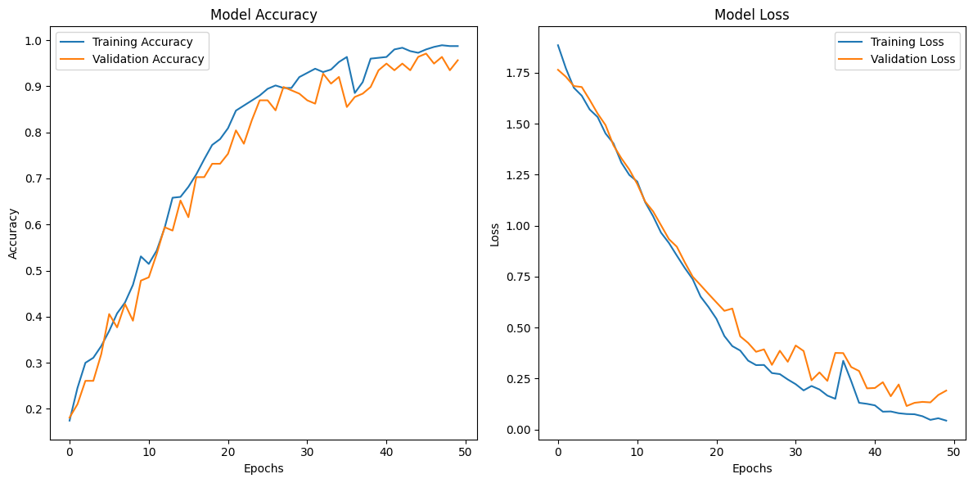

Train accuracy: 1.0

Test accuracy: 0.95652174949646

Classification Report:

precision recall f1-score support

Arshdeep_Singh 0.90 0.97 0.93 29

Axar_Patel 1.00 1.00 1.00 14

Jasprit_Bumrah 0.82 1.00 0.90 9

Kuldeep_Yadav 1.00 1.00 1.00 33

Ravindra_Jadeja 1.00 0.93 0.96 28

Virat_Kohli 0.96 0.88 0.92 25

accuracy 0.96 138

macro avg 0.95 0.96 0.95 138

weighted avg 0.96 0.96 0.96 138

1. LSTM with the features step length, joint velocities, joint angles (adjusted dropout)

Train accuracy: 0.9745454788208008

Test accuracy: 0.9420289993286133

Classification Report:

precision recall f1-score support

Arshdeep_Singh 0.91 1.00 0.95 29

Axar_Patel 0.92 0.86 0.89 14

Jasprit_Bumrah 0.90 1.00 0.95 9

Kuldeep_Yadav 0.97 0.91 0.94 33

Ravindra_Jadeja 0.93 0.93 0.93 28

Virat_Kohli 1.00 0.96 0.98 25

accuracy 0.94 138

macro avg 0.94 0.94 0.94 138

weighted avg 0.94 0.94 0.94 138

