Time Series Forecasting: Monthly Rainfall Jakarta (2010-2025)
2026-06-07
Table of Contents

1. Introduction
This document presents the full workflow for time series forecasting of monthly rainfall in Jakarta using data sourced from NASA/POWER MERRA-2. The original dataset consists of 2,192 daily observations spanning January 2020 to December 2025, which are aggregated into 72 monthly observations before modeling.
Monthly aggregation using total rainfall per month (mm/month) is chosen over daily data for the following reasons:
- Daily rainfall data contains high noise and many zero-value days, making it harder to detect seasonal patterns
- Monthly totals smooth out daily variability while preserving the wet-dry seasonal cycle
- All forecasting models (Seasonal Naive, TSR Seasonal, ARIMA, SARIMA, NN, LSTM, GRU) are evaluated on the same monthly scale, ensuring fair and direct comparison
This EDA section covers data structure, visualization, outlier analysis, stationarity testing, and preprocessing before fitting any model.

2. Library and Data Loading
library(readxl)
library(dplyr)
library(ggplot2)
library(lubridate)
library(tseries)
library(forecast)
library(moments)
library(zoo)
library(lmtest)
library(car)
library(nortest)
library(Metrics)
library(tidyr)
df_raw <- read_excel("C:/Users/nadya/OneDrive - Bina Nusantara/Desktop/Time Series AoL/Dataset16Tahun.xlsx")
names(df_raw)
## [1] "YEAR" "MO" "DOY" "PRECTOTCORR"
df_daily <- df_raw %>%
mutate(
Date = as.Date(
paste(YEAR, MO, DOY, sep = "-")
),
rain = as.numeric(PRECTOTCORR)
) %>%
arrange(Date)
cat("Daily data loaded:", nrow(df_daily), "observations\n")
## Daily data loaded: 5845 observations
cat("Period:", format(min(df_daily$Date)), "to", format(max(df_daily$Date)), "\n")
## Period: 2010-01-01 to 2026-01-01
head(df_daily)
## # A tibble: 6 × 6
## YEAR MO DOY PRECTOTCORR Date rain
## <dbl> <dbl> <dbl> <dbl> <date> <dbl>
## 1 2010 1 1 0.82 2010-01-01 0.82
## 2 2010 1 2 6.52 2010-01-02 6.52
## 3 2010 1 3 3.46 2010-01-03 3.46
## 4 2010 1 4 3.2 2010-01-04 3.2
## 5 2010 1 5 3.82 2010-01-05 3.82
## 6 2010 1 6 4.04 2010-01-06 4.04

3. Dataset Structure (Daily)

3.1 Basic Structure
str(df_daily)
## tibble [5,845 × 6] (S3: tbl_df/tbl/data.frame)
## $ YEAR : num [1:5845] 2010 2010 2010 2010 2010 2010 2010 2010 2010 2010 ...
## $ MO : num [1:5845] 1 1 1 1 1 1 1 1 1 1 ...
## $ DOY : num [1:5845] 1 2 3 4 5 6 7 8 9 10 ...
## $ PRECTOTCORR: num [1:5845] 0.82 6.52 3.46 3.2 3.82 4.04 8.93 7.91 32.8 4.14 ...
## $ Date : Date[1:5845], format: "2010-01-01" "2010-01-02" ...
## $ rain : num [1:5845] 0.82 6.52 3.46 3.2 3.82 4.04 8.93 7.91 32.8 4.14 ...

3.2 Observations per Year
df_daily %>%
group_by(YEAR) %>%
summarise(Total_Days = n()) %>%
knitr::kable(caption = "Daily observations per year")
Daily observations per year
YEAR | Total_Days
2010 | 365
2011 | 365
2012 | 366
2013 | 365
2014 | 365
2015 | 365
2016 | 366
2017 | 365
2018 | 365
2019 | 365
2020 | 366
2021 | 365
2022 | 365
2023 | 365
2024 | 366
2025 | 365
2026 | 1
Years 2012, 2016, 2020, and 2024 contain 366 observations (leap years). All other years have 365.

3.3 Missing Values and Data Quality
cat("Missing (NA) :", sum(is.na(df_daily$rain)), "\n")
## Missing (NA) : 0
cat("Sentinel -999 :", sum(df_daily$rain == -999, na.rm = TRUE), "\n")
## Sentinel -999 : 0
cat("Zero-rain days :", sum(df_daily$rain == 0, na.rm = TRUE), "\n")
## Zero-rain days : 263
cat("Duplicate dates:", sum(duplicated(df_daily$Date)), "\n")
## Duplicate dates: 0
The dataset is clean with no missing values or encoding errors. Zero-rainfall days represent valid dry days and are retained.

3.4 Descriptive Statistics (Daily)
summary_daily <- df_daily %>%
summarise(
N = n(),
Mean = round(mean(rain, na.rm = TRUE), 3),
Median = round(median(rain, na.rm = TRUE), 3),
SD = round(sd(rain, na.rm = TRUE), 3),
Min = round(min(rain, na.rm = TRUE), 3),
Q1 = round(quantile(rain, 0.25, na.rm = TRUE), 3),
Q3 = round(quantile(rain, 0.75, na.rm = TRUE), 3),
Max = round(max(rain, na.rm = TRUE), 3),
Skewness = round(skewness(rain, na.rm = TRUE), 3),
Kurtosis = round(kurtosis(rain, na.rm = TRUE), 3)
)
knitr::kable(t(summary_daily), col.names = "Value",
caption = "Descriptive statistics of daily rainfall (mm/day)")
Descriptive statistics of daily rainfall (mm/day)
 | Value
N | 5845.000
Mean | 6.581
Median | 3.940
SD | 8.815
Min | 0.000
Q1 | 1.220
Q3 | 8.380
Max | 106.280
Skewness | 3.521
Kurtosis | 22.769
Daily rainfall is strongly right-skewed (skewness > 3.5) due to many dry days near zero and occasional extreme monsoon events. The mean (6.58 mm/day) far exceeds the median (3.94 mm/day), a typical pattern for tropical precipitation.

4. Time Series Visualization

4.1 Daily Raw Series
ggplot(df_daily, aes(x = Date, y = rain)) +
geom_line(color = "#2C7BB6", linewidth = 0.3, alpha = 0.7) +
labs(title = "Daily Rainfall in Jakarta (2010-2025)",
subtitle = "Source: NASA/POWER MERRA-2",
x = "Date", y = "Rainfall (mm/day)") +
theme_bw(base_size = 11) +
theme(plot.title = element_text(face = "bold"))
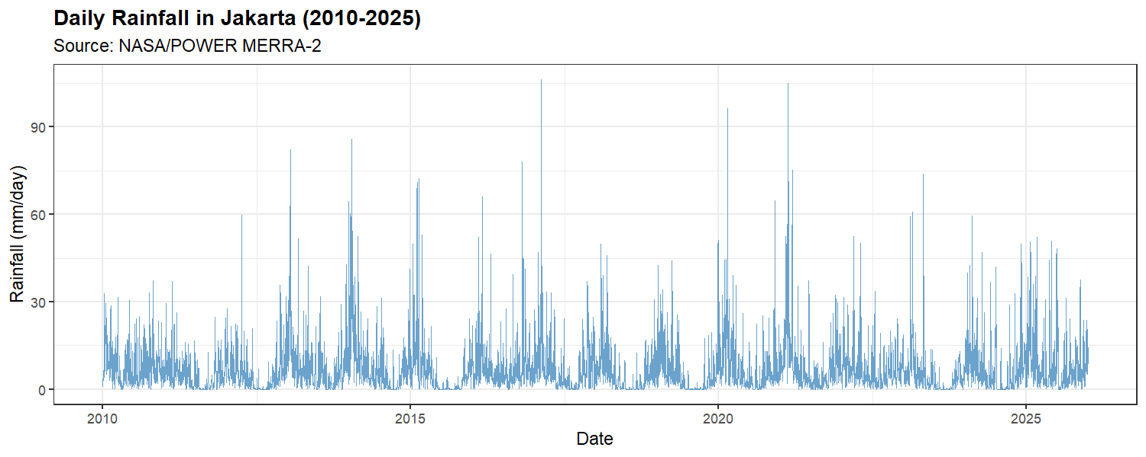
Daily data shows high volatility with many zero values and sharp spikes during monsoon events. This noise makes it difficult to model directly, which is one reason for monthly aggregation.

4.2 Histogram dan Distribusi Harian
par(mfrow = c(1, 2))
hist(df_daily$rain, breaks = 60, col = "#4575B4", border = "white",
main = "Daily Rainfall Distribution", xlab = "mm/day",
xlim = c(0, 110))
hist(log1p(df_daily$rain), breaks = 40, col = "#74ADD1", border = "white",
main = "Log(1+x) Transformed", xlab = "log(1 + mm/day)")
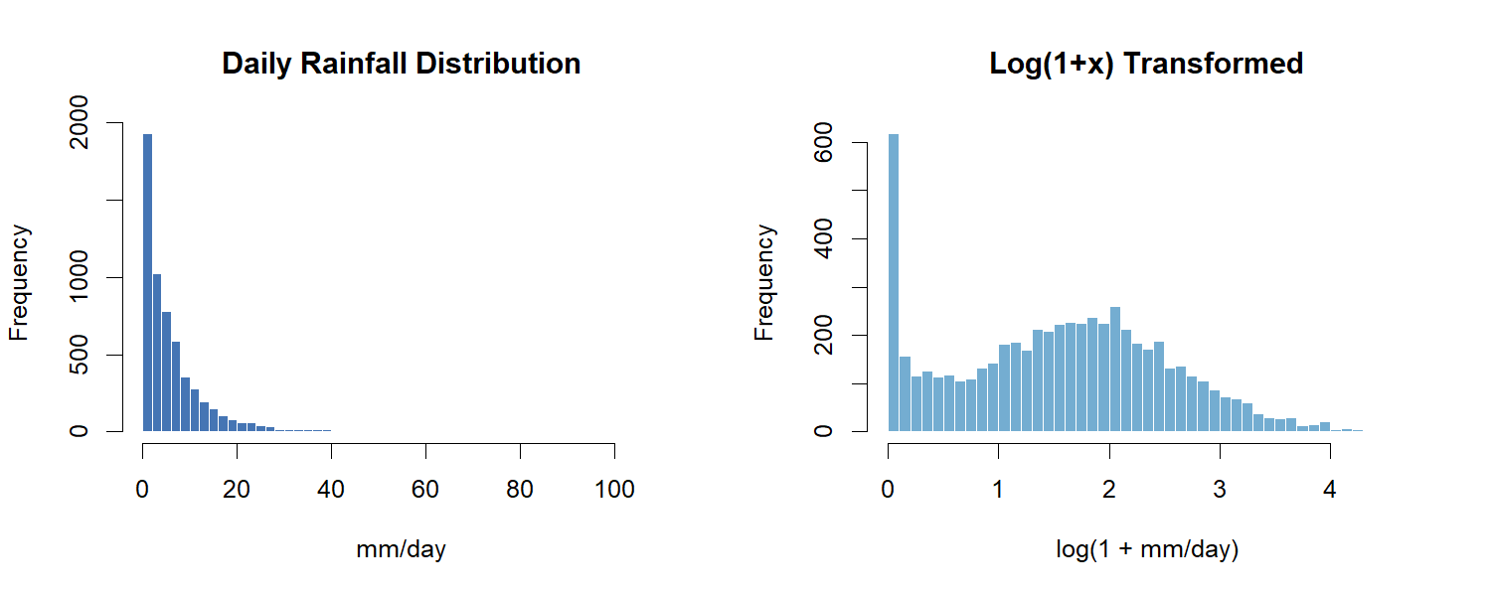
par(mfrow = c(1, 1))
The raw distribution is heavily right-skewed. Log transformation substantially reduces skewness and brings the distribution closer to symmetric, which improves fit for parametric models.

4.3 Monthly Total Rainfall
df_monthly_raw <- df_daily %>%
group_by(YEAR, MO) %>%
summarise(rain_monthly = sum(rain, na.rm = TRUE), .groups = "drop") %>%
mutate(YearMonth = as.Date(paste(YEAR, MO, "01", sep = "-")))
ggplot(df_monthly_raw, aes(x = YearMonth, y = rain_monthly)) +
geom_col(fill = "#4575B4", alpha = 0.85) +
geom_smooth(method = "loess", color = "#D73027", se = FALSE, linewidth = 1) +
labs(title = "Monthly Total Rainfall in Jakarta (2020-2025)",
x = "Month", y = "Total Rainfall (mm/month)") +
theme_bw(base_size = 11) +
theme(plot.title = element_text(face = "bold"))
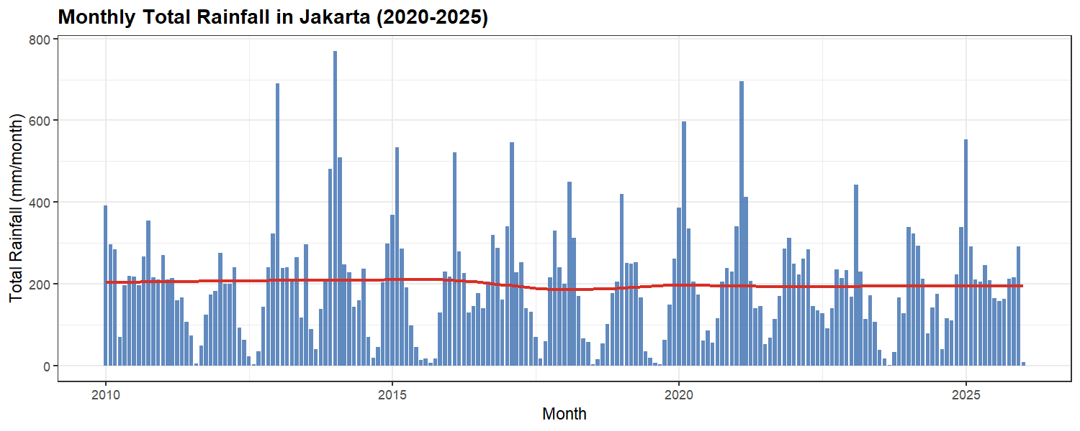
Monthly aggregation clearly reveals the wet-dry seasonal cycle. Rainfall peaks from November to March (monsoon season) and drops significantly from June to September (dry season). This annual pattern is consistent across all five years.

4.4 Seasonal Distribution by Month (Boxplot)
df_monthly_raw %>%
mutate(Month = factor(month.abb[MO], levels = month.abb)) %>%
ggplot(aes(x = Month, y = rain_monthly, fill = Month)) +
geom_boxplot(outlier.shape = 21, outlier.size = 2) +
scale_fill_brewer(palette = "RdYlBu", direction = -1) +
labs(title = "Monthly Rainfall Distribution by Month (2010-2026)",
x = "Month", y = "Total Rainfall (mm/month)") +
theme_bw(base_size = 11) +
theme(plot.title = element_text(face = "bold"), legend.position = "none")
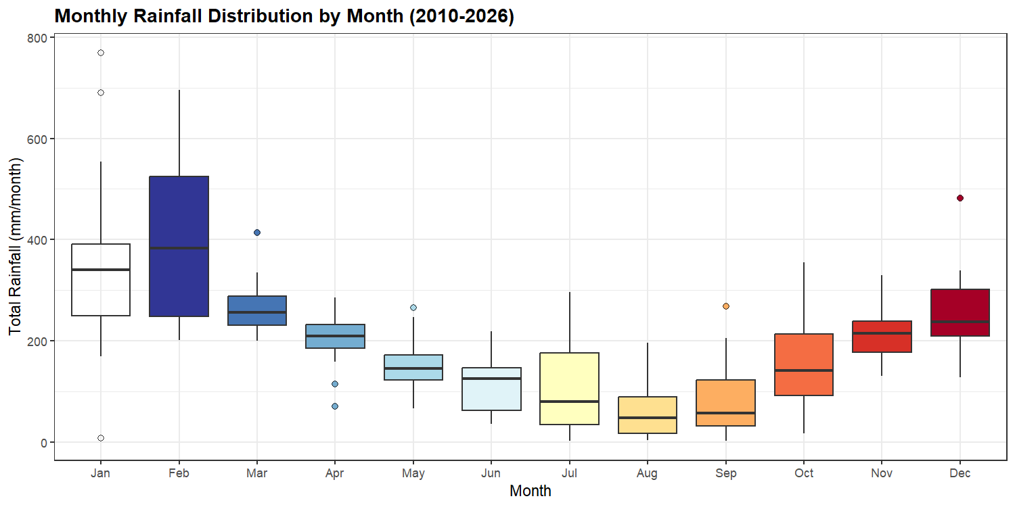
January and February consistently show the highest median monthly rainfall, while July and August are the driest. The spread within each month (interquartile range) is widest during the wet season, reflecting year-to-year variability in monsoon intensity.

5. Outlier Analysis (Daily Level)
Outlier analysis is performed on daily data before aggregation. Extreme daily values are caused by real meteorological events (heavy storms, monsoon surges), not measurement errors.

5.1 Identification with IQR
Q1 <- quantile(df_daily$rain, 0.25, na.rm = TRUE)
Q3 <- quantile(df_daily$rain, 0.75, na.rm = TRUE)
IQR_val <- IQR(df_daily$rain, na.rm = TRUE)
bound_mild <- Q3 + 1.5 * IQR_val
bound_extreme <- Q3 + 3.0 * IQR_val
cat("Q1 :", round(Q1, 2), "mm\n")
## Q1 : 1.22 mm
cat("Q3 :", round(Q3, 2), "mm\n")
## Q3 : 8.38 mm
cat("IQR :", round(IQR_val, 2), "mm\n")
## IQR : 7.16 mm
cat("Mild outlier threshold (1.5*IQR) :", round(bound_mild, 2), "mm\n")
## Mild outlier threshold (1.5*IQR) : 19.12 mm
cat("Extreme outlier threshold (3.0*IQR):", round(bound_extreme, 2), "mm\n\n")
## Extreme outlier threshold (3.0*IQR): 29.86 mm
df_daily <- df_daily %>%
mutate(outlier_cat = case_when(
rain > bound_extreme ~ "Extreme",
rain > bound_mild ~ "Mild",
TRUE ~ "Normal"
))
print(table(df_daily$outlier_cat))
##
## Extreme Mild Normal
## 153 250 5442
The IQR method uses 3x IQR (instead of the standard 1.5x) as the extreme threshold because daily rainfall follows a naturally heavy-tailed distribution. Using 1.5x would flag too many legitimate monsoon events as outliers.

5.2 Visualisasi Outlier
ggplot(df_daily, aes(x = Date, y = rain)) +
geom_line(color = "grey70", linewidth = 0.3) +
geom_point(data = filter(df_daily, outlier_cat == "Extreme"),
aes(color = "Extreme"), size = 1.8) +
geom_point(data = filter(df_daily, outlier_cat == "Mild"),
aes(color = "Mild"), size = 1.2, alpha = 0.6) +
scale_color_manual(values = c("Extreme" = "#D73027", "Mild" = "#FC8D59")) +
labs(title = "Identified Outliers in Daily Rainfall",
x = "Date", y = "Rainfall (mm/day)", color = "Outlier") +
theme_bw(base_size = 11) +
theme(plot.title = element_text(face = "bold"))
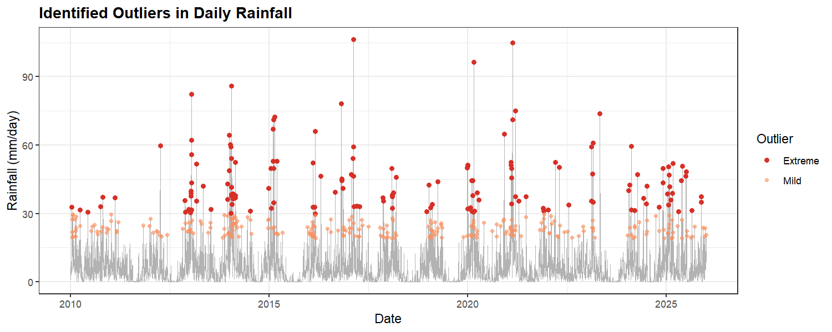

6. Monthly Aggregation
All models are fitted on monthly total rainfall. The daily data (after winsorizing) is aggregated to monthly totals.
df_monthly <- df_daily %>%
mutate(
YEAR = year(Date),
MO = month(Date)
) %>%
group_by(YEAR, MO) %>%
summarise(
rain_monthly = sum(rain, na.rm = TRUE),
.groups = "drop"
) %>%
arrange(YEAR, MO) %>%
mutate(
YearMonth = as.Date(
paste(YEAR, MO, "01", sep = "-")
),
t = row_number(),
rain_log = log1p(rain_monthly),
# dummy month (Jan baseline)
M2 = as.integer(MO == 2),
M3 = as.integer(MO == 3),
M4 = as.integer(MO == 4),
M5 = as.integer(MO == 5),
M6 = as.integer(MO == 6),
M7 = as.integer(MO == 7),
M8 = as.integer(MO == 8),
M9 = as.integer(MO == 9),
M10 = as.integer(MO == 10),
M11 = as.integer(MO == 11),
M12 = as.integer(MO == 12),
# monthly lags
lag1 = lag(rain_monthly, 1),
lag2 = lag(rain_monthly, 2),
lag3 = lag(rain_monthly, 3)
)
cat(
"Monthly data:",
nrow(df_monthly),
"observations\n"
)
## Monthly data: 193 observations
cat(
"Period:",
format(min(df_monthly$YearMonth)),
"to",
format(max(df_monthly$YearMonth)),
"\n"
)
## Period: 2010-01-01 to 2026-01-01
summary_monthly <- df_monthly %>%
summarise(
N = n(),
Mean = round(mean(rain_monthly), 2),
Median = round(median(rain_monthly), 2),
SD = round(sd(rain_monthly), 2),
Min = round(min(rain_monthly), 2),
Max = round(max(rain_monthly), 2),
Skewness = round(skewness(rain_monthly), 3)
)
knitr::kable(t(summary_monthly), col.names = "Value",
caption = "Descriptive statistics of monthly total rainfall (mm/month)")
Descriptive statistics of monthly total rainfall (mm/month)
 | Value
N | 193.000
Mean | 199.300
Median | 199.900
SD | 137.180
Min | 2.160
Max | 768.950
Skewness | 1.224

7. Stationarity Analysis (Monthly)

7.1 Monthly Time Series Object
rain_monthly_ts <- ts(df_monthly$rain_monthly, start = c(2010, 1), frequency = 12)

7.2 Visual Inspection
autoplot(rain_monthly_ts) +
labs(title = "Monthly Total Rainfall Time Series (2010-2025)",
x = "Year", y = "Total Rainfall (mm/month)") +
theme_bw(base_size = 11) +
theme(plot.title = element_text(face = "bold"))
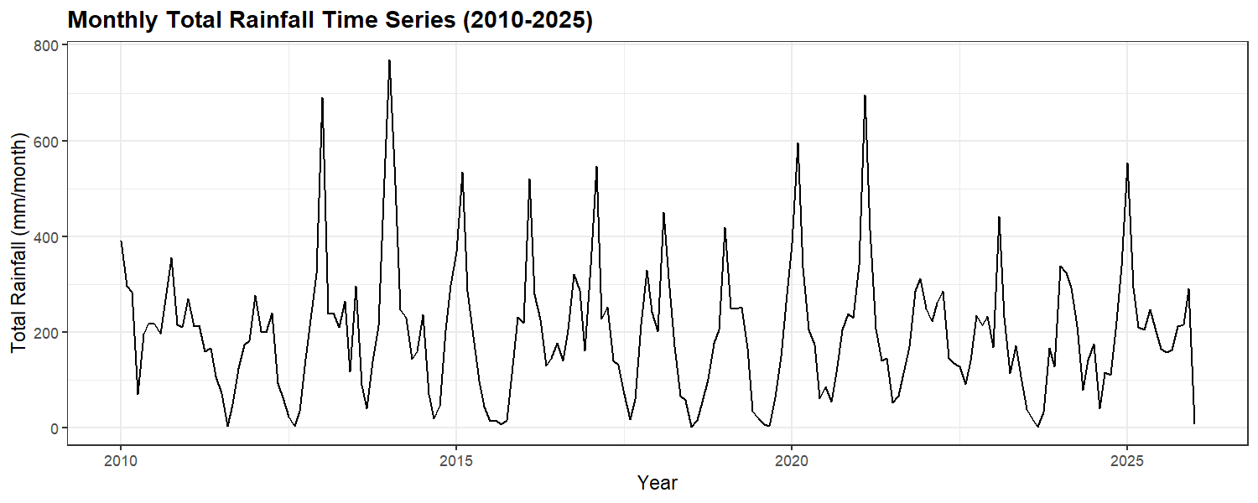

7.3 Decomposition Plot
plot(decompose(rain_monthly_ts, type = "additive"))
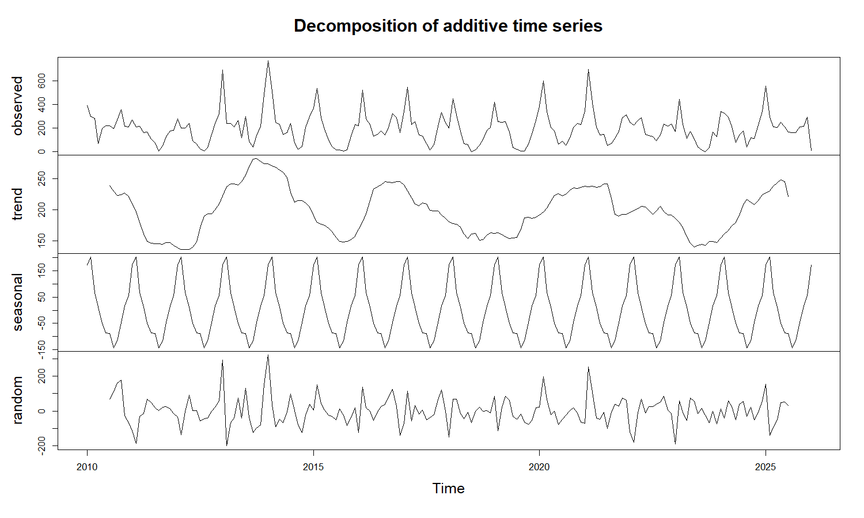
Decomposition separates the series into three components:
- Trend: no clear long-term upward or downward drift, consistent with stable climate over 5 years
- Seasonal: a strong and consistent annual cycle (S = 12) repeating every year
- Residual: the remaining random variation after removing trend and seasonal components
The additive model is appropriate here because the seasonal amplitude (height of the peaks) stays roughly constant across years, rather than growing proportionally with the trend.

7.4 Variance Stationarity
lambda_monthly <- BoxCox.lambda(rain_monthly_ts + 1)
cat("BoxCox lambda (monthly):", round(lambda_monthly, 4), "\n")
## BoxCox lambda (monthly): 0.6376
cat("Lambda mendekati 0 -> log transform disarankan\n")
## Lambda mendekati 0 -> log transform disarankan
cat("Lambda mendekati 1 -> varians sudah stabil\n\n")
## Lambda mendekati 1 -> varians sudah stabil
summary(powerTransform(rain_monthly_ts))
## bcPower Transformation to Normality
## Est Power Rounded Pwr Wald Lwr Bnd Wald Upr Bnd
## rain_monthly_ts 0.5142 0.5 0.3904 0.638
##
## Likelihood ratio test that transformation parameter is equal to 0
## (log transformation)
## LRT df pval
## LR test, lambda = (0) 79.98224 1 < 2.22e-16
##
## Likelihood ratio test that no transformation is needed
## LRT df pval
## LR test, lambda = (1) 50.09855 1 1.4622e-12
H0: lambda = 1 (variance stationary). If p-value < 0.05, log transformation is recommended.

7.5 ACF dan PACF (Monthly)
par(mfrow = c(1, 2))
acf(rain_monthly_ts, lag.max = 36, main = "ACF - Monthly Rainfall", col = "#2166AC")
pacf(rain_monthly_ts, lag.max = 36, main = "PACF - Monthly Rainfall", col = "#D73027")
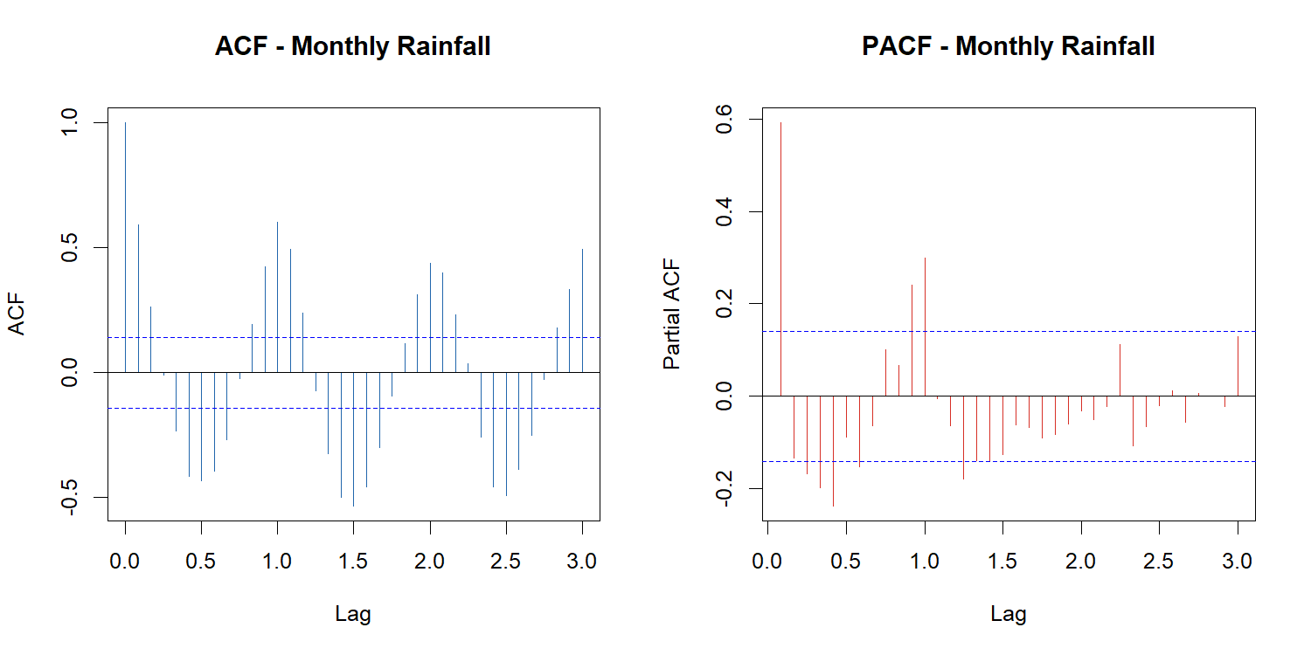
par(mfrow = c(1, 1))
ACF interpretation: The ACF shows a relatively strong positive autocorrelation at the first lag, indicating that monthly rainfall is influenced by rainfall in the preceding month. Significant spikes are also observed around lags 12, 24, and 36, suggesting the presence of a recurring annual seasonal pattern. The repeating peaks at multiples of 12 months indicate that rainfall behavior tends to repeat from year to year, which is consistent with the monsoonal climate of the study area. Furthermore, the autocorrelations do not cut off abruptly but instead decay gradually, implying that an autoregressive structure may be present in the series.
PACF interpretation: The PACF exhibits a dominant spike at lag 1 followed by substantially smaller values at subsequent lags. This pattern suggests that a low-order autoregressive component, particularly AR(1), may adequately capture the non-seasonal dependence in the data. Additional significant spikes around lag 12 provide further evidence of annual seasonality and indicate the possible inclusion of a seasonal autoregressive component.
Based on the ACF and PACF patterns, the monthly rainfall series appears to contain:
- A non-seasonal autoregressive component, likely AR(1)
- A strong annual seasonal cycle with period S=12
- Potential seasonal AR and/or seasonal MA effects

7.6 ADF Test
adf_monthly <- adf.test(rain_monthly_ts, alternative = "stationary")
print(adf_monthly)
##
## Augmented Dickey-Fuller Test
##
## data: rain_monthly_ts
## Dickey-Fuller = -7.8438, Lag order = 5, p-value = 0.01
## alternative hypothesis: stationary
if (adf_monthly$p.value < 0.05) {
cat("\np-value < 0.05 -> data STASIONER (d = 0)\n")
} else {
cat("\np-value > 0.05 -> data TIDAK stasioner -> pertimbangkan differencing (d = 1)\n")
}
##
## p-value < 0.05 -> data STASIONER (d = 0)

7.7 Log Transformation Check (Monthly)
par(mfrow = c(1, 2))
hist(df_monthly$rain_monthly, breaks = 20, col = "#4575B4", border = "white",
main = "Monthly Rainfall (Original)", xlab = "mm/month")
hist(df_monthly$rain_log, breaks = 20, col = "#74ADD1", border = "white",
main = "Log(1+x) Transformed", xlab = "log(1 + mm/month)")
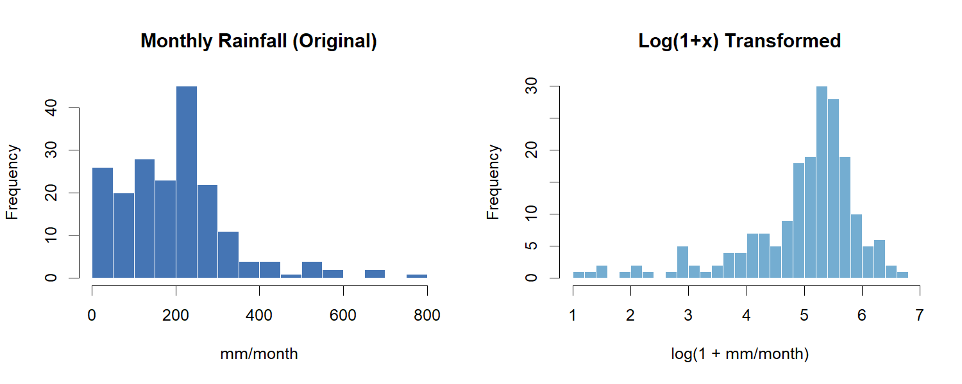
par(mfrow = c(1, 1))
cat("Skewness original :", round(skewness(df_monthly$rain_monthly), 3), "\n")
## Skewness original : 1.224
cat("Skewness log-tranform:", round(skewness(df_monthly$rain_log), 3), "\n")
## Skewness log-tranform: -1.552

8. Train-Test Split
All models use the same 80/20 split on monthly data. The split is sequential (not random) to preserve temporal order.
n_total <- nrow(df_monthly)
n_train <- floor(0.8 * n_total)
n_test <- n_total - n_train
train_df <- df_monthly[1:n_train, ]
test_df <- df_monthly[(n_train + 1):n_total, ]
cat("Total monthly obs :", n_total, "\n")
## Total monthly obs : 193
cat("Train:", n_train, "months |",
format(min(train_df$YearMonth)), "to", format(max(train_df$YearMonth)), "\n")
## Train: 154 months | 2010-01-01 to 2022-10-01
cat("Test :", n_test, "months |",
format(min(test_df$YearMonth)), "to", format(max(test_df$YearMonth)), "\n")
## Test : 39 months | 2022-11-01 to 2026-01-01
# ts objects
train_monthly_ts <- ts(
train_df$rain_monthly,
start = c(2010,1),
frequency = 12
)
test_monthly_ts <- ts(test_df$rain_monthly,
start = c(year(min(test_df$YearMonth)), month(min(test_df$YearMonth))), frequency = 12)
train_monthly_log <- ts(
train_df$rain_log,
start = c(2010,1),
frequency = 12
)
test_monthly_log <- ts(test_df$rain_log,
start = c(year(min(test_df$YearMonth)),
month(min(test_df$YearMonth))),
frequency = 12)
#Extra safe
train_monthly_ts <- ts(
train_df$rain_monthly,
start = c(2010,1),
frequency = 12
)
test_monthly_ts <- ts(
test_df$rain_monthly,
start = c(
year(min(test_df$YearMonth)),
month(min(test_df$YearMonth))
),
frequency = 12
)
train_monthly_log <- ts(
train_df$rain_log,
start = c(2010,1),
frequency = 12
)
test_monthly_log <- ts(
test_df$rain_log,
start = c(
year(min(test_df$YearMonth)),
month(min(test_df$YearMonth))
),
frequency = 12
)
df_monthly %>%
mutate(Set = ifelse(YearMonth <= max(train_df$YearMonth), "Training", "Test")) %>%
ggplot(aes(x = YearMonth, y = rain_monthly, color = Set)) +
geom_line(linewidth = 0.8) +
geom_point(size = 2) +
scale_color_manual(values = c("Training" = "#2166AC", "Test" = "#D73027")) +
labs(title = "Train-Test Split: Monthly Rainfall (80% / 20%)",
x = "Month", y = "Total Rainfall (mm/month)", color = "Set") +
theme_bw(base_size = 11) +
theme(plot.title = element_text(face = "bold"))
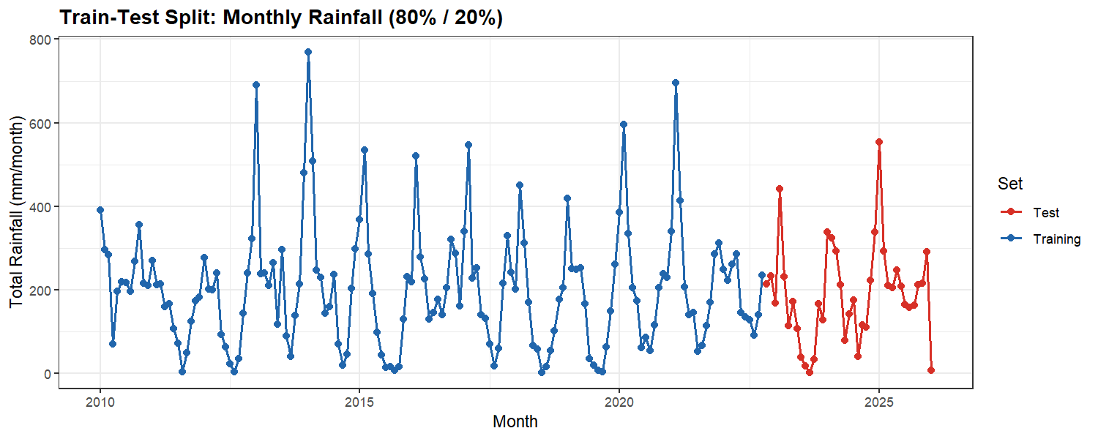

9. Modeling
Semua model difit dan dievaluasi pada data bulanan (mm/month). Evaluasi menggunakan tiga metrik:
- RMSE — sensitif terhadap error besar, unit sama dengan data
- MAE — rata-rata besar error, lebih robust terhadap nilai ekstrem
- MAPE — error dalam persentase
catatan: MAPE dapat tidak stabil ketika nilai aktual mendekati nol, sehingga RMSE dan MAE lebih diutamakan sebagai metrik utama
eval_metrics <- function(actual, predicted, model_name) {
mask <- actual > 0
rmse_val <- rmse(actual, predicted)
mae_val <- mean(abs(actual - predicted))
mape_val <- mean(abs((actual[mask] - predicted[mask]) / actual[mask])) * 100
cat(model_name, "\n")
cat(" RMSE:", round(rmse_val, 4), "| MAE:", round(mae_val, 4),
"| MAPE:", round(mape_val, 2), "%\n\n")
data.frame(Model = model_name,
RMSE = round(rmse_val, 4),
MAE = round(mae_val, 4),
MAPE = round(mape_val, 2))
}

9.1 Baseline Models
Sebelum model utama, ditetapkan dua baseline sederhana sebagai acuan minimum performa. Model yang baik seharusnya mengalahkan baseline ini. Jika tidak, perlu dievaluasi apakah model terlalu kompleks atau data memang sulit diprediksi.
actual_base <- as.numeric(test_monthly_ts)
# Seasonal Naive: prediksi = nilai bulan yang sama dari tahun sebelumnya
# baseline yang kuat untuk data dengan seasonality tahunan yang konsisten
snaive_fc <- snaive(train_monthly_ts, h = length(test_monthly_ts))
yhat_snaive <- as.numeric(snaive_fc$mean)
result_snaive <- eval_metrics(actual_base, yhat_snaive, "Seasonal Naive")
## Seasonal Naive
## RMSE: 109.2346 | MAE: 86.6115 | MAPE: 305.73 %
rmse_snaive <- result_snaive$RMSE
mae_snaive <- result_snaive$MAE
mape_snaive <- result_snaive$MAPE
Seasonal Naive sangat relevan untuk data curah hujan karena pola musiman Jakarta sangat kuat dan berulang setiap tahun. Jika model ML tidak mampu mengalahkan Seasonal Naive, itu menandakan model yg lebih kompleks tidak cocok pada dataset ini.

9.2 Time Series Regression Seasonal (TSR Seasonal)
TSR Seasonal meregresikan curah hujan bulanan terhadap dummy variabel bulan dan lag bulan sebelumnya. Setiap koefisien dummy menunjukkan perbedaan rata-rata curah hujan bulan tersebut dibandingkan Januari (baseline/referensi). Misalnya, jika koefisien M2 = +80, artinya Februari rata-rata 80 mm lebih basah dari Januari setelah mengontrol variabel lain.
df_train_tsr <- train_df %>%
filter(
!is.na(lag1),
!is.na(lag2),
!is.na(lag3)
)
cat("Training obs for TSR:",
nrow(df_train_tsr),
"\n")
## Training obs for TSR: 151
dummy_vars <- "M2+M3+M4+M5+M6+M7+M8+M9+M10+M11+M12"
m1 <- lm(as.formula(paste("rain_monthly ~", dummy_vars)), data = df_train_tsr)
m2 <- lm(as.formula(paste("rain_monthly ~ t +", dummy_vars)), data = df_train_tsr)
m3 <- lm(as.formula(paste("rain_monthly ~ lag1 + t +", dummy_vars)), data = df_train_tsr)
m4 <- lm(as.formula(paste("rain_monthly ~ lag1 + lag2 + t +", dummy_vars)), data = df_train_tsr)
m5 <- lm(as.formula(paste("rain_monthly ~ lag1 + lag2 + lag3 + t +", dummy_vars)),
data = df_train_tsr)
eval_tsr <- function(model, nama, train_data) {
actual <- train_data$rain_monthly
predicted <- fitted(model)
idx <- actual > 0
data.frame(
Model = nama,
Adj_R2 = round(summary(model)$adj.r.squared, 4),
RMSE = round(rmse(actual, predicted), 4),
MAE = round(mean(abs(actual - predicted)), 4),
MAPE = round(mean(abs((actual[idx] - predicted[idx]) / actual[idx])) * 100, 2),
AIC = round(AIC(model), 2),
DW = round(as.numeric(dwtest(model)$statistic), 4)
)
}
tabel_tsr <- bind_rows(
eval_tsr(m1, "Dummy Seasonal Only", df_train_tsr),
eval_tsr(m2, "Trend + Dummy", df_train_tsr),
eval_tsr(m3, "Lag1 + Trend + Dummy", df_train_tsr),
eval_tsr(m4, "Lag1+Lag2 + Trend + Dummy", df_train_tsr),
eval_tsr(m5, "Lag1+Lag2+Lag3 + Trend + Dummy", df_train_tsr)
)
knitr::kable(tabel_tsr, caption = "TSR Seasonal Model Comparison (Training Set)")
TSR Seasonal Model Comparison (Training Set)
Model | Adj_R2 | RMSE | MAE | MAPE | AIC | DW
Dummy Seasonal Only | 0.5369 | 92.9762 | 67.8328 | 123.79 | 1823.29 | 1.2281
Trend + Dummy | 0.5336 | 92.9700 | 67.7206 | 123.58 | 1825.27 | 1.2282
Lag1 + Trend + Dummy | 0.5967 | 86.1370 | 62.1143 | 94.12 | 1804.21 | 1.9308
Lag1+Lag2 + Trend + Dummy | 0.5946 | 86.0450 | 61.9000 | 95.62 | 1805.89 | 1.9647
Lag1+Lag2+Lag3 + Trend + Dummy | 0.5917 | 86.0320 | 61.9709 | 95.96 | 1807.84 | 1.9623
# tambahan
eval_tsr_test <- function(model, test_data, nama){
pred <- predict(model, newdata = test_data)
actual <- test_data$rain_monthly
idx <- actual > 0
data.frame(
Model = nama,
RMSE = round(rmse(actual, pred),4),
MAE = round(mae(actual, pred),4),
MAPE = round(mean(abs((actual[idx]-pred[idx])/
actual[idx]))*100,2)
)
}
tsr_test_compare <- bind_rows(
eval_tsr_test(
m1,
test_df,
"Dummy Seasonal Only"
),
eval_tsr_test(
m2,
test_df,
"Trend + Dummy"
),
eval_tsr_test(
m3,
test_df,
"Lag1 + Trend + Dummy"
),
eval_tsr_test(
m4,
test_df,
"Lag1+Lag2 + Trend + Dummy"
),
eval_tsr_test(
m5,
test_df,
"Lag1+Lag2+Lag3 + Trend + Dummy"
)
)
tsr_test_compare[order(tsr_test_compare$RMSE), ]
## Model RMSE MAE MAPE
## 3 Lag1 + Trend + Dummy 96.0512 67.5898 241.91
## 5 Lag1+Lag2+Lag3 + Trend + Dummy 96.4301 68.1683 244.87
## 4 Lag1+Lag2 + Trend + Dummy 96.4535 68.0319 245.27
## 1 Dummy Seasonal Only 96.8067 69.1081 259.39
## 2 Trend + Dummy 97.2334 69.3228 263.46
best_tsr_idx <- which.max(tabel_tsr$Adj_R2)
best_tsr <- list(m1, m2, m3, m4, m5)[[best_tsr_idx]]
cat("Best TSR model:", tabel_tsr$Model[best_tsr_idx], "\n\n")
## Best TSR model: Lag1 + Trend + Dummy
summary(best_tsr)
##
## Call:
## lm(formula = as.formula(paste("rain_monthly ~ lag1 + t +", dummy_vars)),
## data = df_train_tsr)
##
## Residuals:
## Min 1Q Median 3Q Max
## -292.361 -46.872 -8.565 38.850 309.280
##
## Coefficients:
## Estimate Std. Error t value Pr(>|t|)
## (Intercept) 277.03089 35.91870 7.713 2.28e-12 ***
## lag1 0.37703 0.07931 4.754 4.99e-06 ***
## t 0.02378 0.16897 0.141 0.888308
## M2 -6.34777 38.04482 -0.167 0.867734
## M3 -163.05219 38.86779 -4.195 4.87e-05 ***
## M4 -173.86737 36.21659 -4.801 4.08e-06 ***
## M5 -208.61251 36.45303 -5.723 6.33e-08 ***
## M6 -224.57601 37.29623 -6.021 1.50e-08 ***
## M7 -212.67784 38.14083 -5.576 1.26e-07 ***
## M8 -259.46956 38.20473 -6.792 3.09e-10 ***
## M9 -215.64005 39.57808 -5.448 2.29e-07 ***
## M10 -146.62065 38.79654 -3.779 0.000234 ***
## M11 -117.86663 37.81121 -3.117 0.002225 **
## M12 -100.40937 37.06077 -2.709 0.007603 **
## ---
## Signif. codes: 0 '***' 0.001 '**' 0.01 '*' 0.05 '.' 0.1 ' ' 1
##
## Residual standard error: 90.43 on 137 degrees of freedom
## Multiple R-squared: 0.6316, Adjusted R-squared: 0.5967
## F-statistic: 18.07 on 13 and 137 DF, p-value: < 2.2e-16
cat("VIF values (best model):\n")
## VIF values (best model):
print(round(vif(best_tsr), 2))
## lag1 t M2 M3 M4 M5 M6 M7 M8 M9 M10 M11 M12
## 2.34 1.00 1.96 2.04 1.91 1.93 2.02 2.11 2.12 2.28 2.19 1.93 1.86
cat("\nVIF > 10 = multikolinearitas serius\n")
##
## VIF > 10 = multikolinearitas serius
#ubah
# ==========================
# Recursive Forecast TSR
# ==========================
h <- nrow(test_df)
yhat_tsr <- numeric(h)
last_train <- tail(train_df$rain_monthly, 1)
for(i in 1:h){
row_i <- test_df[i, ]
row_i$lag1 <- last_train
pred_i <- predict(best_tsr, newdata = row_i)
yhat_tsr[i] <- pred_i
# update lag untuk step berikutnya
last_train <- pred_i
}
actual_tsr <- test_df$rain_monthly
idx <- actual_tsr > 0
rmse_tsr <- rmse(actual_tsr, yhat_tsr)
mae_tsr <- mae(actual_tsr, yhat_tsr)
mape_tsr <- mean(
abs((actual_tsr[idx] - yhat_tsr[idx]) /
actual_tsr[idx])
) * 100
cat("\nTSR Seasonal (Recursive Test Forecast)\n")
##
## TSR Seasonal (Recursive Test Forecast)
cat("RMSE:", round(rmse_tsr,4),
"| MAE:", round(mae_tsr,4),
"| MAPE:", round(mape_tsr,2), "%\n")
## RMSE: 98.0529 | MAE: 70.7198 | MAPE: 266.42 %
df_full_tsr <- bind_rows(train_df, test_df) %>%
mutate(lag1 = lag(rain_monthly, 1),
lag2 = lag(rain_monthly, 2),
lag3 = lag(rain_monthly, 3))
df_test_pred <- df_full_tsr %>% filter(YearMonth %in% test_df$YearMonth)
yhat_tsr_test <- predict(best_tsr, newdata = df_test_pred)
actual_tsr_test <- df_test_pred$rain_monthly
result_tsr <- eval_metrics(actual_tsr_test, yhat_tsr_test, "TSR Seasonal (Test)")
## TSR Seasonal (Test)
## RMSE: 96.0512 | MAE: 67.5898 | MAPE: 241.91 %
rmse_tsr <- result_tsr$RMSE
mae_tsr <- result_tsr$MAE
mape_tsr <- result_tsr$MAPE
n_lag_na <- n_train - length(fitted(best_tsr))
fitted_padded <- c(rep(NA, n_lag_na), fitted(best_tsr), rep(NA, n_test))
df_monthly %>%
mutate(Set = ifelse(YearMonth <= max(train_df$YearMonth), "Training", "Test"),
Fitted = fitted_padded) %>%
ggplot(aes(x = YearMonth)) +
geom_line(aes(y = rain_monthly, color = Set), linewidth = 0.7) +
geom_line(aes(y = Fitted), color = "#E24B4A", linewidth = 0.8,
linetype = "dashed", na.rm = TRUE) +
scale_color_manual(values = c("Training" = "#2166AC", "Test" = "grey50")) +
labs(title = paste("TSR Seasonal - Actual vs Fitted:", tabel_tsr$Model[best_tsr_idx]),
x = "Month", y = "Rainfall (mm/month)", color = "Set") +
theme_bw(base_size = 11) +
theme(plot.title = element_text(face = "bold"))
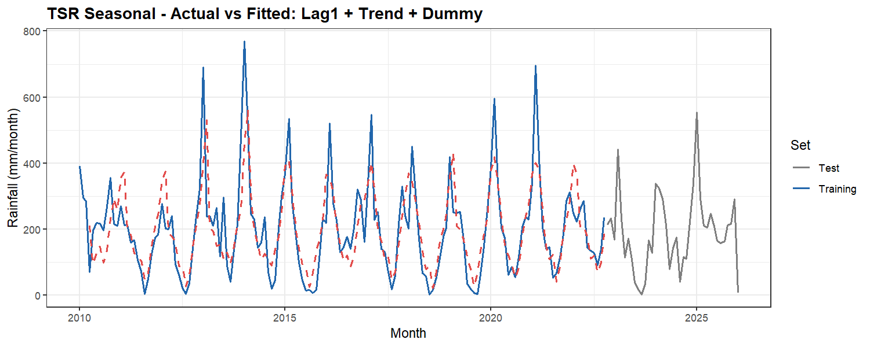
resid_tsr <- residuals(best_tsr)
fitted_tsr <- fitted(best_tsr)
par(mfrow = c(2, 2))
plot(fitted_tsr, resid_tsr, pch = 16, col = "#378ADD",
main = "Residuals vs Fitted - TSR",
xlab = "Fitted Values (mm/month)", ylab = "Residuals")
abline(h = 0, col = "#D73027", lty = 2)
hist(resid_tsr, breaks = 15, col = "#74ADD1", border = "white",
main = "Histogram of Residuals - TSR", xlab = "Residuals (mm/month)")
qqnorm(resid_tsr, main = "Q-Q Plot - TSR Residuals", col = "#378ADD", pch = 16)
qqline(resid_tsr, col = "#D73027", lwd = 2)
acf(resid_tsr, main = "ACF of Residuals - TSR", col = "#2166AC")
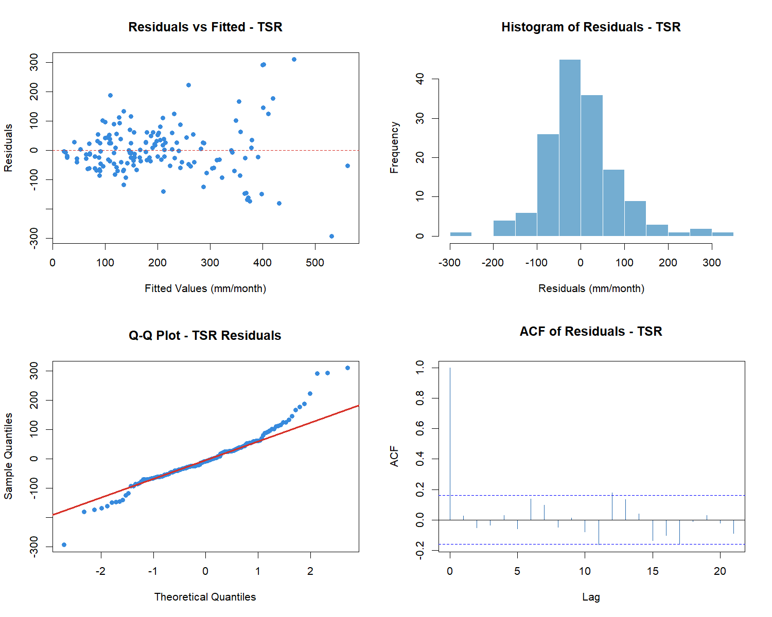
par(mfrow = c(1, 1))
Plot residual vs fitted menunjukkan apakah masih ada pola yang belum tertangkap. QQ plot dan histogram memeriksa normalitas residual. ACF residual memeriksa sisa autokorelasi — idealnya semua lag berada dalam batas signifikansi.

9.3 ARIMA
ARIMA (p,d,q) memodelkan dependensi linier antar observasi melalui komponen AR dan MA. Difit pada log-transformed monthly data untuk menstabilkan varians. Forecast dikembalikan ke skala asli dengan expm1().
summary(powerTransform(train_monthly_ts))
## bcPower Transformation to Normality
## Est Power Rounded Pwr Wald Lwr Bnd Wald Upr Bnd
## train_monthly_ts 0.4917 0.5 0.3534 0.63
##
## Likelihood ratio test that transformation parameter is equal to 0
## (log transformation)
## LRT df pval
## LR test, lambda = (0) 57.48838 1 3.3973e-14
##
## Likelihood ratio test that no transformation is needed
## LRT df pval
## LR test, lambda = (1) 43.82496 1 3.591e-11
adf.test(train_monthly_log)
##
## Augmented Dickey-Fuller Test
##
## data: train_monthly_log
## Dickey-Fuller = -6.1452, Lag order = 5, p-value = 0.01
## alternative hypothesis: stationary
par(mfrow = c(1, 2))
acf(train_monthly_log, lag.max = 24, main = "ACF - Monthly log(rain)", col = "#2166AC")
pacf(train_monthly_log, lag.max = 24, main = "PACF - Monthly log(rain)", col = "#D73027")
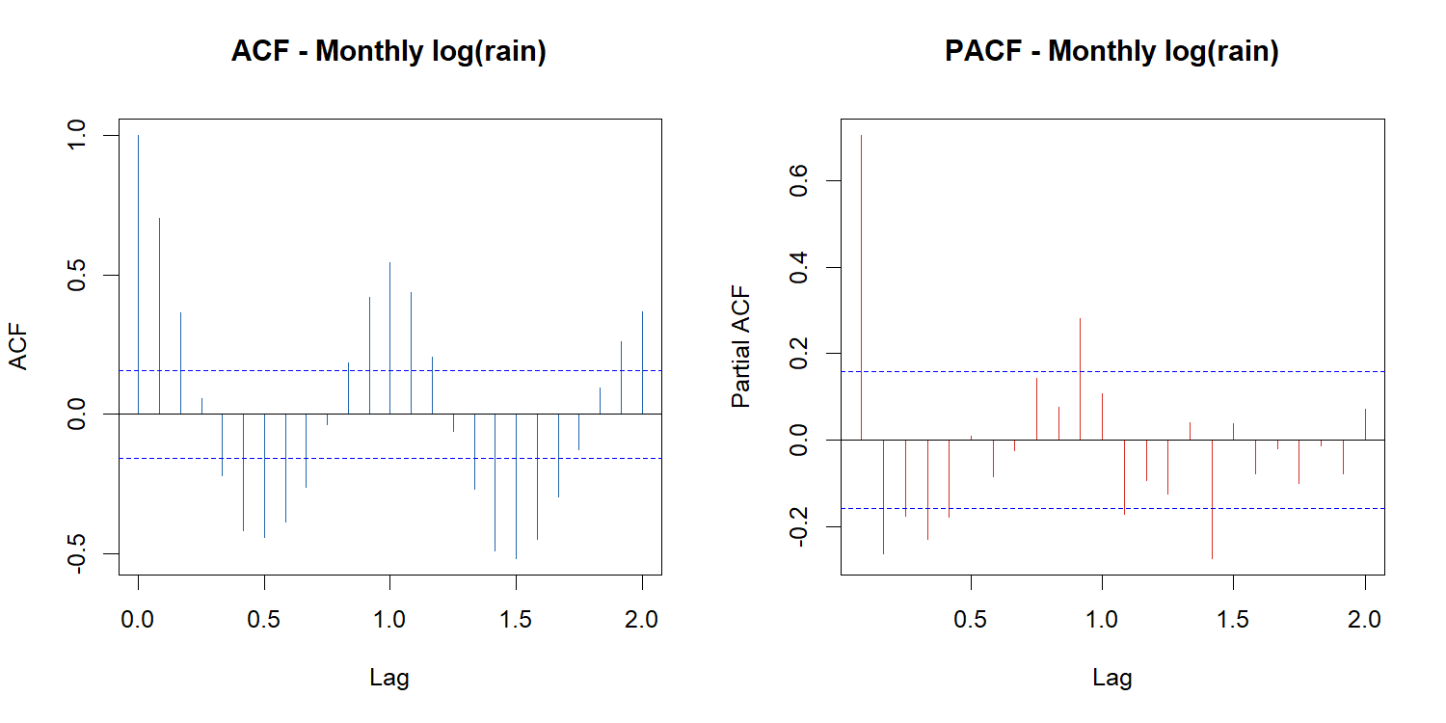
par(mfrow = c(1, 1))
arima_100 <- Arima(train_monthly_log, order = c(1,0,0))
arima_200 <- Arima(train_monthly_log, order = c(2,0,0))
arima_010 <- Arima(train_monthly_log, order = c(0,1,0))
arima_101 <- Arima(train_monthly_log, order = c(1,0,1))
arima_201 <- Arima(train_monthly_log, order = c(2,0,1))
arima_011 <- Arima(train_monthly_log, order = c(0,1,1))
arima_111 <- Arima(train_monthly_log, order = c(1,1,1))
arima_211 <- Arima(train_monthly_log, order = c(2,1,1))
arima_012 <- Arima(train_monthly_log, order = c(0,1,2))
arima_aic <- data.frame(
Model = c("ARIMA(1,0,0)","ARIMA(2,0,0)","ARIMA(0,1,0)",
"ARIMA(1,0,1)","ARIMA(2,0,1)","ARIMA(0,1,1)",
"ARIMA(1,1,1)","ARIMA(2,1,1)","ARIMA(0,1,2)"),
AIC = c(AIC(arima_100), AIC(arima_200), AIC(arima_010),
AIC(arima_101), AIC(arima_201), AIC(arima_011),
AIC(arima_111), AIC(arima_211), AIC(arima_012))
)
arima_aic[order(arima_aic$AIC), ]
## Model AIC
## 5 ARIMA(2,0,1) 322.9127
## 2 ARIMA(2,0,0) 333.9326
## 8 ARIMA(2,1,1) 335.8622
## 4 ARIMA(1,0,1) 337.3422
## 1 ARIMA(1,0,0) 343.2297
## 3 ARIMA(0,1,0) 360.9738
## 6 ARIMA(0,1,1) 361.7907
## 9 ARIMA(0,1,2) 363.3496
## 7 ARIMA(1,1,1) 363.5450
fit_auto_arima <- auto.arima(train_monthly_log, seasonal = FALSE)
summary(fit_auto_arima)
## Series: train_monthly_log
## ARIMA(2,0,1) with non-zero mean
##
## Coefficients:
## ar1 ar2 ma1 mean
## 1.4925 -0.7040 -0.6771 4.9634
## s.e. 0.0812 0.0631 0.0908 0.0829
##
## sigma^2 = 0.4553: log likelihood = -156.46
## AIC=322.91 AICc=323.32 BIC=338.1
##
## Training set error measures:
## ME RMSE MAE MPE MAPE MASE
## Training set 0.001446348 0.6659124 0.4867821 -3.9675 13.45032 0.7543659
## ACF1
## Training set -0.03754218
library(lmtest)
coeftest(arima_101)
##
## z test of coefficients:
##
## Estimate Std. Error z value Pr(>|z|)
## ar1 0.582768 0.083873 6.9483 3.698e-12 ***
## ma1 0.269484 0.093194 2.8917 0.003832 **
## intercept 4.981229 0.170683 29.1840 < 2.2e-16 ***
## ---
## Signif. codes: 0 '***' 0.001 '**' 0.01 '*' 0.05 '.' 0.1 ' ' 1
coeftest(arima_201)
##
## z test of coefficients:
##
## Estimate Std. Error z value Pr(>|z|)
## ar1 1.492501 0.081225 18.3749 < 2.2e-16 ***
## ar2 -0.704048 0.063084 -11.1605 < 2.2e-16 ***
## ma1 -0.677118 0.090802 -7.4571 8.848e-14 ***
## intercept 4.963361 0.082950 59.8359 < 2.2e-16 ***
## ---
## Signif. codes: 0 '***' 0.001 '**' 0.01 '*' 0.05 '.' 0.1 ' ' 1
library(nortest)
e_arima <- residuals(arima_201)
lillie.test(e_arima)
##
## Lilliefors (Kolmogorov-Smirnov) normality test
##
## data: e_arima
## D = 0.1111, p-value = 8.098e-05
Box.test(e_arima, lag = 12, type = "Ljung-Box")
##
## Box-Ljung test
##
## data: e_arima
## X-squared = 18.974, df = 12, p-value = 0.08916
checkresiduals(arima_201)
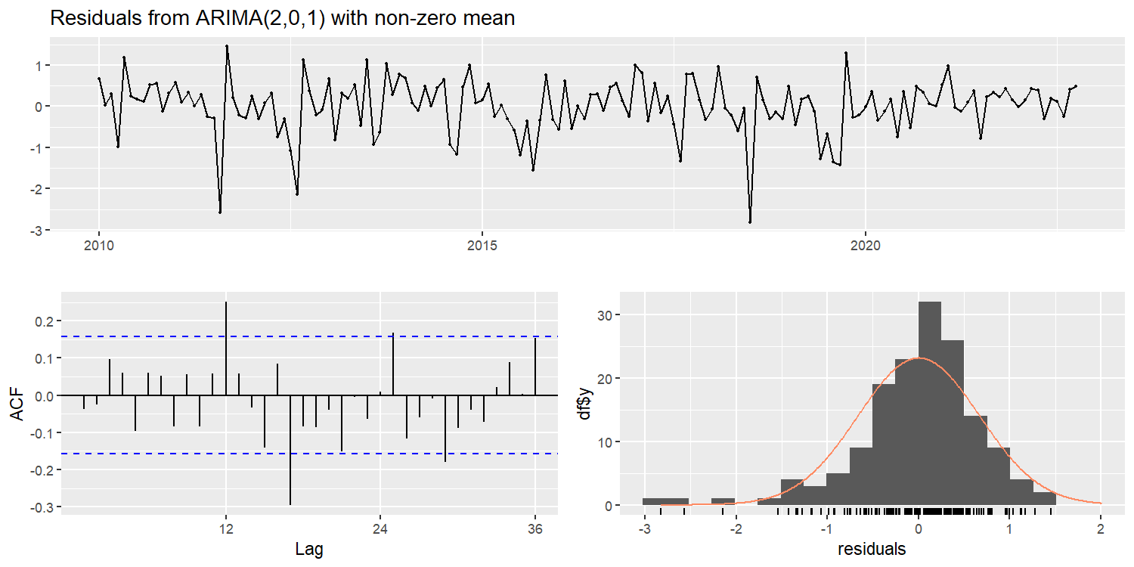
##
## Ljung-Box test
##
## data: Residuals from ARIMA(2,0,1) with non-zero mean
## Q* = 47.498, df = 21, p-value = 0.0008044
##
## Model df: 3. Total lags used: 24
H₀: residual berdistribusi normal H₁: residual tidak berdistribusi normal
H₀: residual merupakan white noise (tidak ada autokorelasi tersisa) H₁: residual masih mengandung autokorelasi
Karena kedua p-value jauh lebih kecil dari 0.05, maka: The residuals are not white noise and still exhibit significant autocorrelation. Therefore, the ARIMA(1,0,1) model has not fully captured the temporal dependence in the monthly rainfall series.
The ARIMA(2,0,1) model passed the Ljung–Box test at lag 12 (p = 0.1643), indicating no significant residual autocorrelation within the first year. However, when evaluated using a longer lag structure (24 lags), the residuals remained significantly autocorrelated (p = 0.0073). This suggests that the model captures short-term dependence adequately but may not fully account for longer-term seasonal patterns present in the monthly rainfall series.
best_arima <- arima_201 # ganti sesuai hasil coeftest + diagnostic
yhat_arima_train <- expm1(as.numeric(fitted(best_arima)))
actual_arima_train <- as.numeric(train_monthly_ts)
cat("ARIMA RMSE (train):", round(rmse(actual_arima_train, yhat_arima_train), 4), "\n\n")
## ARIMA RMSE (train): 104.3971
fc_arima <- forecast(best_arima, h = length(test_monthly_ts))
yhat_arima_test <- expm1(as.numeric(fc_arima$mean))
actual_arima_test <- as.numeric(test_monthly_ts)
result_arima <- eval_metrics(actual_arima_test, yhat_arima_test, "ARIMA (Test)")
## ARIMA (Test)
## RMSE: 123.1285 | MAE: 90.5517 | MAPE: 275.95 %
rmse_arima <- result_arima$RMSE
mae_arima <- result_arima$MAE
mape_arima <- result_arima$MAPE
autoplot(fc_arima) +
autolayer(test_monthly_log, series = "Actual (log scale)", color = "#D73027") +
labs(title = "ARIMA Forecast vs Actual (Monthly, log scale)",
x = "Time", y = "log(1 + Rainfall)") +
theme_bw(base_size = 11) +
theme(plot.title = element_text(face = "bold"))
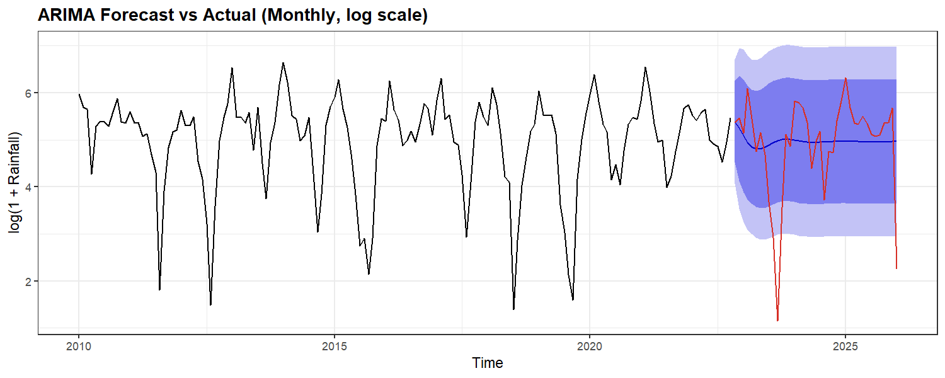
resid_arima <- residuals(best_arima)
fitted_arima <- as.numeric(fitted(best_arima))
par(mfrow = c(2, 2))
plot(fitted_arima, resid_arima, pch = 16, col = "#378ADD",
main = "Residuals vs Fitted - ARIMA",
xlab = "Fitted (log scale)", ylab = "Residuals")
abline(h = 0, col = "#D73027", lty = 2)
hist(resid_arima, breaks = 15, col = "#74ADD1", border = "white",
main = "Histogram of Residuals - ARIMA", xlab = "Residuals")
qqnorm(resid_arima, main = "Q-Q Plot - ARIMA Residuals", col = "#378ADD", pch = 16)
qqline(resid_arima, col = "#D73027", lwd = 2)
acf(resid_arima, main = "ACF of Residuals - ARIMA", col = "#2166AC")
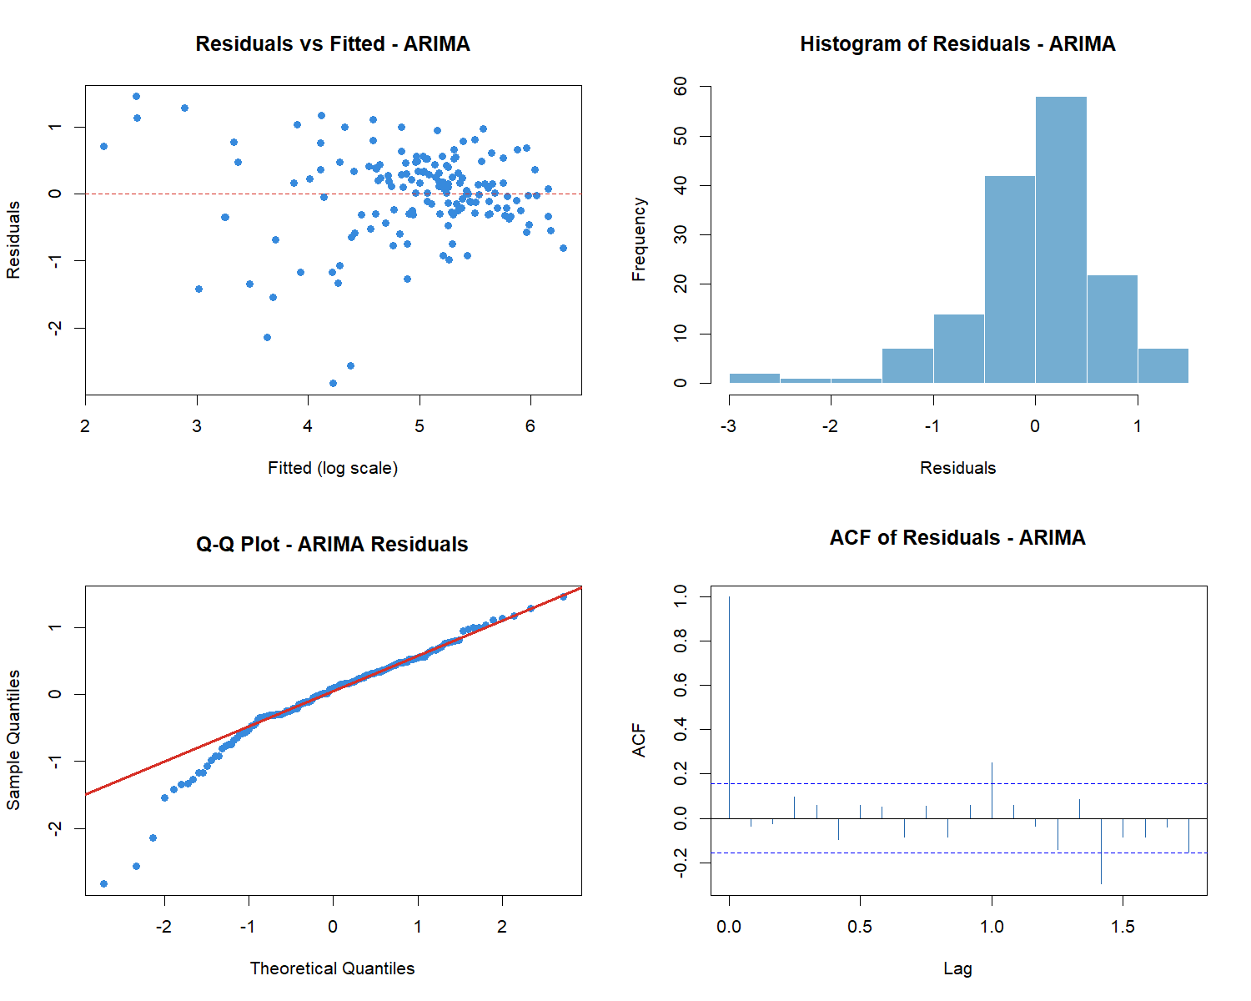
par(mfrow = c(1, 1))

9.4 SARIMA
SARIMA (p,d,q)(P,D,Q)[S] memperluas ARIMA dengan komponen seasonal eksplisit. Dengan data bulanan, seasonal period S = 12. Komponen (P,D,Q) menangkap autokorelasi yang berulang setiap 12 bulan (pola monsoon tahunan).
par(mfrow = c(1, 2))
Acf(train_monthly_log, lag.max = 36, main = "ACF - identifikasi Q seasonal (spike lag 12,24)")
Pacf(train_monthly_log, lag.max = 36, main = "PACF - identifikasi P seasonal (spike lag 12)")
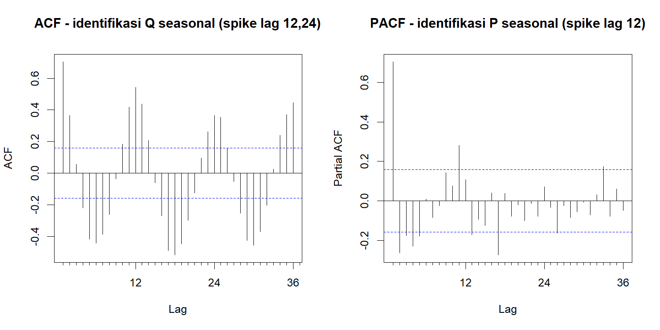
par(mfrow = c(1, 1))
sarima_1 <- Arima(train_monthly_log, order = c(1,0,0), seasonal = c(1,0,0))
sarima_2 <- Arima(train_monthly_log, order = c(2,0,0), seasonal = c(1,0,0))
sarima_3 <- Arima(train_monthly_log, order = c(1,0,1), seasonal = c(1,0,0))
sarima_4 <- Arima(train_monthly_log, order = c(2,0,1), seasonal = c(1,0,0))
sarima_5 <- Arima(train_monthly_log, order = c(1,0,1), seasonal = c(0,0,1))
sarima_6 <- Arima(train_monthly_log, order = c(1,0,1), seasonal = c(1,0,1))
sarima_7 <- Arima(train_monthly_log, order = c(1,1,1), seasonal = c(1,0,0))
sarima_8 <- Arima(train_monthly_log, order = c(1,1,1), seasonal = c(0,1,1))
sarima_9 <- Arima(train_monthly_log, order = c(2,0,2), seasonal = c(2,1,0))
sarima_aic <- data.frame(
Model = c("SARIMA(1,0,0)(1,0,0)12","SARIMA(2,0,0)(1,0,0)12",
"SARIMA(1,0,1)(1,0,0)12","SARIMA(2,0,1)(1,0,0)12",
"SARIMA(1,0,1)(0,0,1)12","SARIMA(1,0,1)(1,0,1)12",
"SARIMA(1,1,1)(1,0,0)12","SARIMA(1,1,1)(0,1,1)12", "SARIMA(2,0,2)(2,1,0)12"),
AIC = c(AIC(sarima_1), AIC(sarima_2), AIC(sarima_3), AIC(sarima_4),
AIC(sarima_5), AIC(sarima_6), AIC(sarima_7), AIC(sarima_8), AIC(sarima_9))
)
sarima_aic[order(sarima_aic$AIC), ]
## Model AIC
## 8 SARIMA(1,1,1)(0,1,1)12 297.4508
## 9 SARIMA(2,0,2)(2,1,0)12 307.2973
## 6 SARIMA(1,0,1)(1,0,1)12 310.6244
## 4 SARIMA(2,0,1)(1,0,0)12 312.5352
## 1 SARIMA(1,0,0)(1,0,0)12 314.7630
## 2 SARIMA(2,0,0)(1,0,0)12 314.8951
## 3 SARIMA(1,0,1)(1,0,0)12 315.2844
## 7 SARIMA(1,1,1)(1,0,0)12 315.6967
## 5 SARIMA(1,0,1)(0,0,1)12 317.6296
fit_auto_sarima <- auto.arima(train_monthly_log, seasonal = TRUE)
summary(fit_auto_sarima)
## Series: train_monthly_log
## ARIMA(2,0,2)(2,1,0)[12] with drift
##
## Coefficients:
## ar1 ar2 ma1 ma2 sar1 sar2 drift
## -0.2658 0.4189 0.9075 0.0504 -0.4940 -0.4014 0.0016
## s.e. 0.2746 0.1358 0.2842 0.1682 0.0829 0.0791 0.0060
##
## sigma^2 = 0.4643: log likelihood = -146.61
## AIC=309.22 AICc=310.3 BIC=332.87
##
## Training set error measures:
## ME RMSE MAE MPE MAPE MASE
## Training set -0.0162768 0.6380028 0.4576852 -3.311842 12.42347 0.7092744
## ACF1
## Training set 0.003780829
coeftest(sarima_8)
##
## z test of coefficients:
##
## Estimate Std. Error z value Pr(>|z|)
## ar1 0.600038 0.069084 8.6856 < 2.2e-16 ***
## ma1 -0.999999 0.070601 -14.1641 < 2.2e-16 ***
## sma1 -0.905271 0.153339 -5.9037 3.554e-09 ***
## ---
## Signif. codes: 0 '***' 0.001 '**' 0.01 '*' 0.05 '.' 0.1 ' ' 1
coeftest(sarima_9)
##
## z test of coefficients:
##
## Estimate Std. Error z value Pr(>|z|)
## ar1 -0.264713 0.273887 -0.9665 0.333791
## ar2 0.419967 0.135573 3.0977 0.001950 **
## ma1 0.906921 0.283436 3.1997 0.001376 **
## ma2 0.049615 0.167877 0.2955 0.767577
## sar1 -0.492894 0.082867 -5.9480 2.714e-09 ***
## sar2 -0.400068 0.079039 -5.0617 4.156e-07 ***
## ---
## Signif. codes: 0 '***' 0.001 '**' 0.01 '*' 0.05 '.' 0.1 ' ' 1

Diagnostic Checking — Round 1
library(nortest)
# evaluasi model dengan AIC terbaik terlebih dahulu
e_sarima_8 <- residuals(sarima_8)
cat("=== SARIMA(1,1,1)(0,1,1)12 [AIC terbaik] ===\n")
## === SARIMA(1,1,1)(0,1,1)12 [AIC terbaik] ===
lillie.test(e_sarima_8)
##
## Lilliefors (Kolmogorov-Smirnov) normality test
##
## data: e_sarima_8
## D = 0.1083, p-value = 0.0001435
ljung_8 <- Box.test(e_sarima_8, lag = 12, type = "Ljung-Box")
print(ljung_8)
##
## Box-Ljung test
##
## data: e_sarima_8
## X-squared = 12.349, df = 12, p-value = 0.4181
checkresiduals(sarima_8)
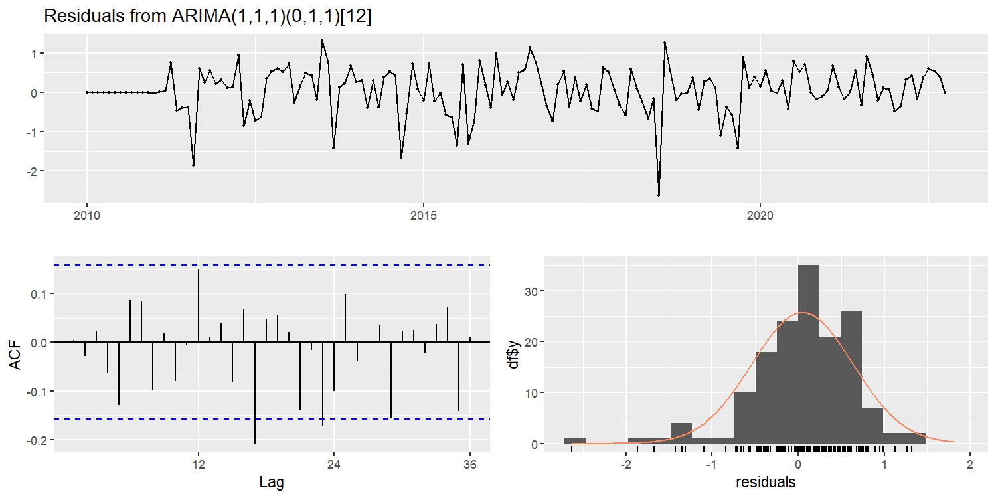
##
## Ljung-Box test
##
## data: Residuals from ARIMA(1,1,1)(0,1,1)[12]
## Q* = 33.995, df = 21, p-value = 0.03629
##
## Model df: 3. Total lags used: 24
Jika Ljung-Box p-value < 0.05, residual belum memenuhi asumsi white noise. Ini berarti masih ada autokorelasi yang belum ditangkap model. Langkah selanjutnya adalah mencoba model dengan ordo yang lebih tinggi untuk menyerap sisa autokorelasi tersebut.
# gunakan model yang telah diperbaiki
# best_sarima <- best_sarima_improved
best_sarima <- sarima_8
checkresiduals(best_sarima)
##
## Ljung-Box test
##
## data: Residuals from ARIMA(1,1,1)(0,1,1)[12]
## Q* = 33.995, df = 21, p-value = 0.03629
##
## Model df: 3. Total lags used: 24
yhat_sarima_train <- expm1(as.numeric(fitted(best_sarima)))
actual_sarima_train <- as.numeric(train_monthly_ts)
cat("\nSARIMA RMSE (train):", round(rmse(actual_sarima_train, yhat_sarima_train), 4), "\n\n")
##
## SARIMA RMSE (train): 91.8335
fc_sarima <- forecast(best_sarima, h = length(test_monthly_ts))
yhat_sarima_test <- expm1(as.numeric(fc_sarima$mean))
actual_sarima_test <- as.numeric(test_monthly_ts)
result_sarima <- eval_metrics(actual_sarima_test, yhat_sarima_test, "SARIMA (Test)")
## SARIMA (Test)
## RMSE: 103.2925 | MAE: 76.323 | MAPE: 219.43 %
rmse_sarima <- result_sarima$RMSE
mae_sarima <- result_sarima$MAE
mape_sarima <- result_sarima$MAPE
Jika setelah semua upaya perbaikan residual masih menunjukkan sisa autokorelasi (Ljung-Box p < 0.05), hal ini diakui secara transparan sebagai limitasi model. Pada data curah hujan bulanan yang bersifat highly stochastic dengan seri pendek (n = 72), sulit untuk mendapatkan residual yang sepenuhnya memenuhi asumsi white noise. Kondisi ini tidak membatalkan penggunaan model untuk keperluan perbandingan, namun perlu dicatat dalam interpretasi hasil bahwa SARIMA mungkin belum sepenuhnya menangkap semua dependensi temporal dalam data.
autoplot(fc_sarima) +
autolayer(test_monthly_log,
series = "Actual (log scale)",
color = "#D73027") +
labs(
title = "SARIMA(1,1,1)(0,1,1)[12] Forecast vs Actual",
x = "Time",
y = "log(1 + Rainfall)"
) +
theme_bw(base_size = 11) +
theme(plot.title = element_text(face = "bold"))
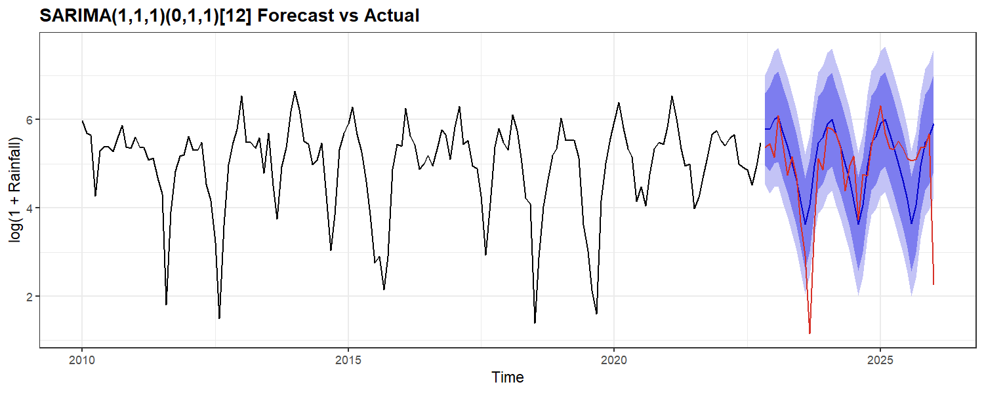
resid_sarima <- residuals(best_sarima)
fitted_sarima <- as.numeric(fitted(best_sarima))
par(mfrow = c(2, 2))
plot(fitted_sarima, resid_sarima, pch = 16, col = "#378ADD",
main = "Residuals vs Fitted - SARIMA",
xlab = "Fitted (log scale)", ylab = "Residuals")
abline(h = 0, col = "#D73027", lty = 2)
hist(resid_sarima, breaks = 15, col = "#74ADD1", border = "white",
main = "Histogram of Residuals - SARIMA", xlab = "Residuals")
qqnorm(resid_sarima, main = "Q-Q Plot - SARIMA Residuals", col = "#378ADD", pch = 16)
qqline(resid_sarima, col = "#D73027", lwd = 2)
acf(resid_sarima, main = "ACF of Residuals - SARIMA", col = "#2166AC")
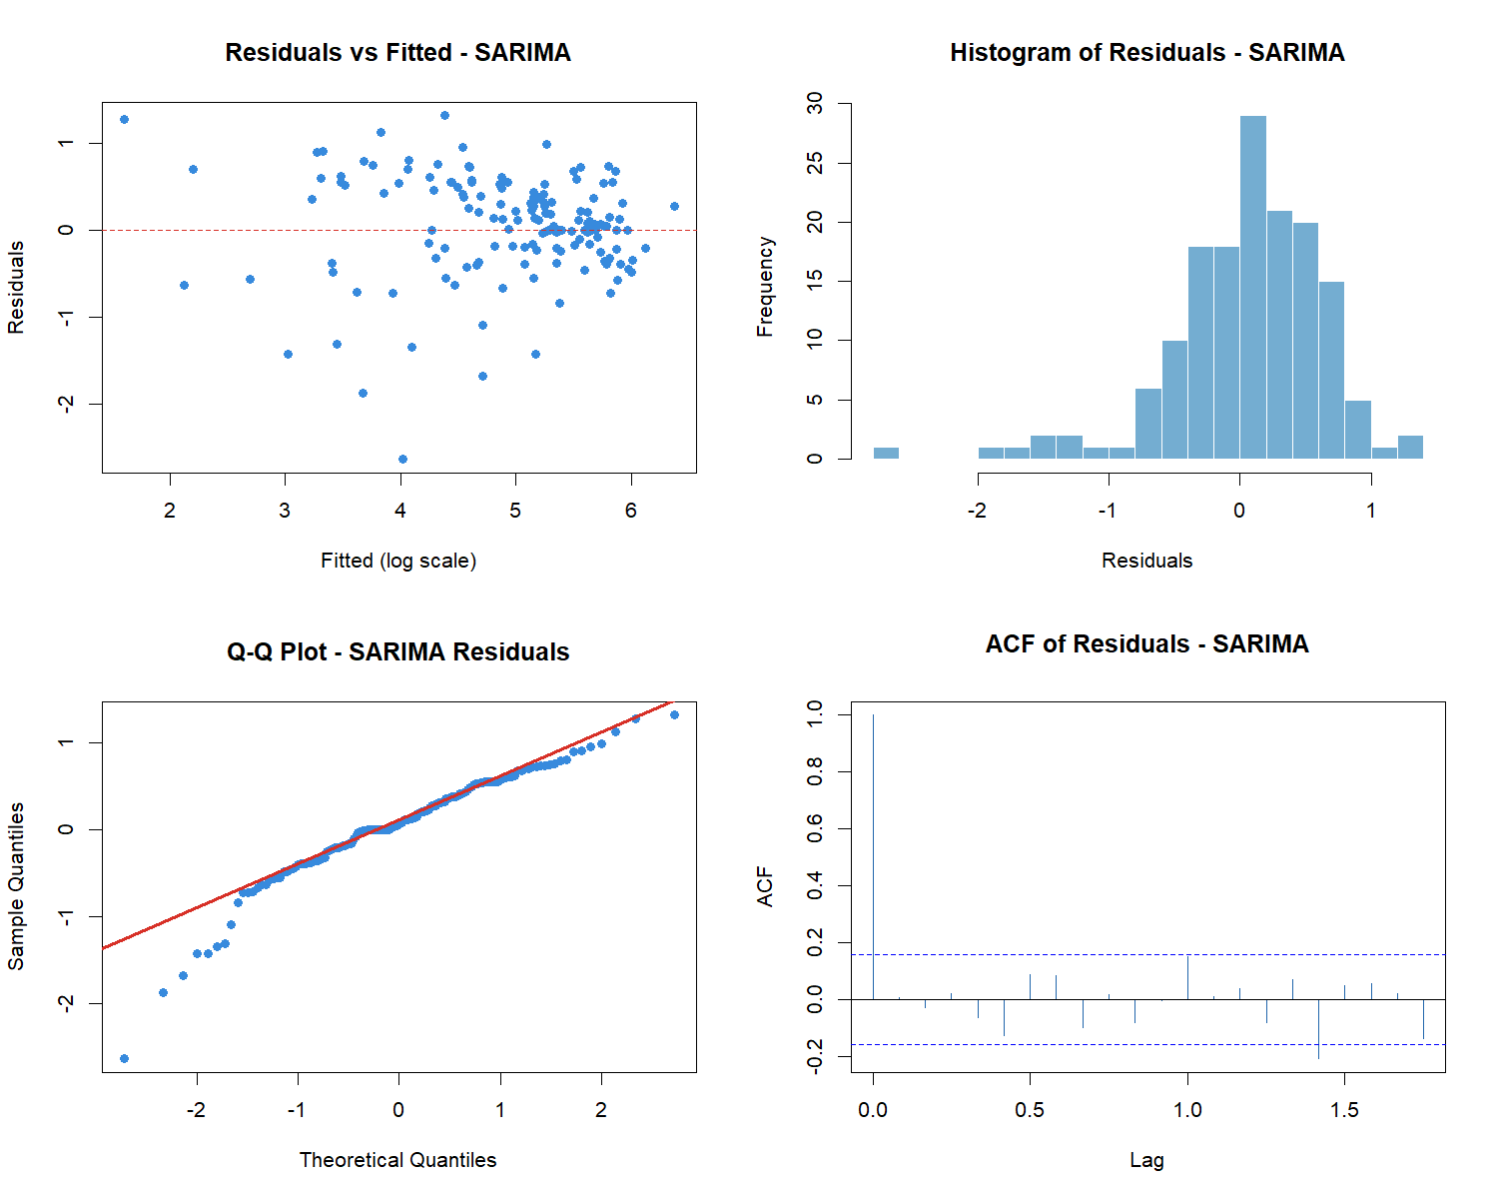
par(mfrow = c(1, 1))

9.5 Neural Network, LSTM, GRU
NN, LSTM, dan GRU dijalankan di Google Colab menggunakan data bulanan yang sama. Hasil dari Colab dimasukkan di section 9.6.

9.6 Model Comparison Summary
Catatan MAPE: MAPE dapat tidak stabil saat nilai aktual mendekati nol. RMSE dan MAE lebih diutamakan sebagai metrik perbandingan utama.
# dari Google Collab
rmse_nn_test <- 96.5494
mae_nn_test <- 69.4857
mape_nn_test <- 247.48
rmse_lstm_test <- 94.1221
mae_lstm_test <- 72.5429
mape_lstm_test <- 265.0799865722656
rmse_gru_test <- 92.0993
mae_gru_test <- 70.9792
mape_gru_test <- 244.10000610351562
comparison_table <- data.frame(
Model = c("Seasonal Naive",
"TSR Seasonal", "ARIMA", "SARIMA",
"Neural Network", "LSTM", "GRU"),
RMSE = round(c(rmse_snaive,
rmse_tsr, rmse_arima, rmse_sarima,
rmse_nn_test, rmse_lstm_test, rmse_gru_test), 4),
MAE = round(c(mae_snaive,
mae_tsr, mae_arima, mae_sarima,
mae_nn_test, mae_lstm_test, mae_gru_test), 4),
MAPE = round(c(mape_snaive,
mape_tsr, mape_arima, mape_sarima,
mape_nn_test, mape_lstm_test, mape_gru_test), 2)
)
knitr::kable(comparison_table,
caption = "Final Model Comparison - Monthly Test Set (mm/month)")
Final Model Comparison - Monthly Test Set (mm/month)
Model | RMSE | MAE | MAPE
Seasonal Naive | 109.2346 | 86.6115 | 305.73
TSR Seasonal | 96.0512 | 67.5898 | 241.91
ARIMA | 123.1285 | 90.5517 | 275.95
SARIMA | 103.2925 | 76.3230 | 219.43
Neural Network | 96.5494 | 69.4857 | 247.48
LSTM | 94.1221 | 72.5429 | 265.08
GRU | 92.0993 | 70.9792 | 244.10
library(ggplot2)
comp_plot <- comparison_table[!is.na(comparison_table$RMSE), ]
ggplot(comp_plot, aes(x = reorder(Model, RMSE), y = RMSE, fill = RMSE)) +
geom_col(width = 0.6, alpha = 0.85) +
geom_text(aes(label = round(RMSE, 1)), hjust = -0.1, size = 3.5) +
coord_flip() +
scale_fill_gradient(low = "#74ADD1", high = "#D73027") +
scale_y_continuous(limits = c(0, max(comp_plot$RMSE) * 1.2)) +
labs(title = "Model Comparison - RMSE on Monthly Test Set",
subtitle = "Lower RMSE = better | Baseline models shown for reference",
x = NULL, y = "RMSE (mm/month)") +
theme_bw(base_size = 11) +
theme(plot.title = element_text(face = "bold"), legend.position = "none")
