Weekly AoL Time Series
2026-05-28

Library and Data Loading
library(readxl)
## Warning: package 'readxl' was built under R version 4.4.3
library(dplyr)
## Warning: package 'dplyr' was built under R version 4.4.3
##
## Attaching package: 'dplyr'
## The following objects are masked from 'package:stats':
##
## filter, lag
## The following objects are masked from 'package:base':
##
## intersect, setdiff, setequal, union
library(ggplot2)
## Warning: package 'ggplot2' was built under R version 4.4.3
library(lubridate)
## Warning: package 'lubridate' was built under R version 4.4.2
##
## Attaching package: 'lubridate'
## The following objects are masked from 'package:base':
##
## date, intersect, setdiff, union
library(tseries)
## Warning: package 'tseries' was built under R version 4.4.2
## Registered S3 method overwritten by 'quantmod':
## method from
## as.zoo.data.frame zoo
library(forecast)
## Warning: package 'forecast' was built under R version 4.4.2
library(moments)
library(zoo)
## Warning: package 'zoo' was built under R version 4.4.2
##
## Attaching package: 'zoo'
## The following objects are masked from 'package:base':
##
## as.Date, as.Date.numeric
library(lmtest)
## Warning: package 'lmtest' was built under R version 4.4.3
library(car)
## Warning: package 'car' was built under R version 4.4.3
## Loading required package: carData
## Warning: package 'carData' was built under R version 4.4.2
##
## Attaching package: 'car'
## The following object is masked from 'package:dplyr':
##
## recode
library(nortest)
library(Metrics)
## Warning: package 'Metrics' was built under R version 4.4.3
##
## Attaching package: 'Metrics'
## The following object is masked from 'package:forecast':
##
## accuracy
library(tidyr)
## Warning: package 'tidyr' was built under R version 4.4.3
df_raw <- read_excel("C:/Users/nadya/OneDrive - Bina Nusantara/Desktop/Time Series AoL/Dataset16Tahun.xlsx")
names(df_raw)
## [1] "YEAR" "MO" "DOY" "PRECTOTCORR"
df_daily <- df_raw %>%
mutate(
Date = as.Date(
paste(YEAR, MO, DOY, sep = "-")
),
rain = as.numeric(PRECTOTCORR)
) %>%
arrange(Date)
cat("Daily data loaded:", nrow(df_daily), "observations\n")
## Daily data loaded: 5845 observations
cat("Period:", format(min(df_daily$Date)), "to", format(max(df_daily$Date)), "\n")
## Period: 2010-01-01 to 2026-01-01
head(df_daily)
## # A tibble: 6 × 6
## YEAR MO DOY PRECTOTCORR Date rain
## <dbl> <dbl> <dbl> <dbl> <date> <dbl>
## 1 2010 1 1 0.82 2010-01-01 0.82
## 2 2010 1 2 6.52 2010-01-02 6.52
## 3 2010 1 3 3.46 2010-01-03 3.46
## 4 2010 1 4 3.2 2010-01-04 3.2
## 5 2010 1 5 3.82 2010-01-05 3.82
## 6 2010 1 6 4.04 2010-01-06 4.04

Dataset Structure (Daily)

Basic Structure
str(df_daily)
## tibble [5,845 × 6] (S3: tbl_df/tbl/data.frame)
## $ YEAR : num [1:5845] 2010 2010 2010 2010 2010 2010 2010 2010 2010 2010 ...
## $ MO : num [1:5845] 1 1 1 1 1 1 1 1 1 1 ...
## $ DOY : num [1:5845] 1 2 3 4 5 6 7 8 9 10 ...
## $ PRECTOTCORR: num [1:5845] 0.82 6.52 3.46 3.2 3.82 4.04 8.93 7.91 32.8 4.14 ...
## $ Date : Date[1:5845], format: "2010-01-01" "2010-01-02" ...
## $ rain : num [1:5845] 0.82 6.52 3.46 3.2 3.82 4.04 8.93 7.91 32.8 4.14 ...

Observations per Year
df_daily %>%
group_by(YEAR) %>%
summarise(Total_Days = n()) %>%
knitr::kable(caption = "Daily observations per year")
Daily observations per year
YEAR | Total_Days
2010 | 365
2011 | 365
2012 | 366
2013 | 365
2014 | 365
2015 | 365
2016 | 366
2017 | 365
2018 | 365
2019 | 365
2020 | 366
2021 | 365
2022 | 365
2023 | 365
2024 | 366
2025 | 365
2026 | 1
Years 2012, 2016, 2020, and 2024 contain 366 observations (leap years). All other years have 365.

Missing Values and Data Quality
cat("Missing (NA) :", sum(is.na(df_daily$rain)), "\n")
## Missing (NA) : 0
cat("Sentinel -999 :", sum(df_daily$rain == -999, na.rm = TRUE), "\n")
## Sentinel -999 : 0
cat("Zero-rain days :", sum(df_daily$rain == 0, na.rm = TRUE), "\n")
## Zero-rain days : 263
cat("Duplicate dates:", sum(duplicated(df_daily$Date)), "\n")
## Duplicate dates: 0
The dataset is clean with no missing values or encoding errors. Zero-rainfall days represent valid dry days and are retained.

Descriptive Statistics (Daily)
summary_daily <- df_daily %>%
summarise(
N = n(),
Mean = round(mean(rain, na.rm = TRUE), 3),
Median = round(median(rain, na.rm = TRUE), 3),
SD = round(sd(rain, na.rm = TRUE), 3),
Min = round(min(rain, na.rm = TRUE), 3),
Q1 = round(quantile(rain, 0.25, na.rm = TRUE), 3),
Q3 = round(quantile(rain, 0.75, na.rm = TRUE), 3),
Max = round(max(rain, na.rm = TRUE), 3),
Skewness = round(skewness(rain, na.rm = TRUE), 3),
Kurtosis = round(kurtosis(rain, na.rm = TRUE), 3)
)
knitr::kable(t(summary_daily), col.names = "Value",
caption = "Descriptive statistics of daily rainfall (mm/day)")
Descriptive statistics of daily rainfall (mm/day)
 | Value
N | 5845.000
Mean | 6.581
Median | 3.940
SD | 8.815
Min | 0.000
Q1 | 1.220
Q3 | 8.380
Max | 106.280
Skewness | 3.521
Kurtosis | 22.769
Daily rainfall is strongly right-skewed (skewness > 3.5) due to many dry days near zero and occasional extreme monsoon events. The mean (6.58 mm/day) far exceeds the median (3.94 mm/day), a typical pattern for tropical precipitation.

Time Series Visualization

Daily Raw Series
ggplot(df_daily, aes(x = Date, y = rain)) +
geom_line(color = "#2C7BB6", linewidth = 0.3, alpha = 0.7) +
labs(title = "Daily Rainfall in Jakarta (2010-2025)",
subtitle = "Source: NASA/POWER MERRA-2",
x = "Date", y = "Rainfall (mm/day)") +
theme_bw(base_size = 11) +
theme(plot.title = element_text(face = "bold"))
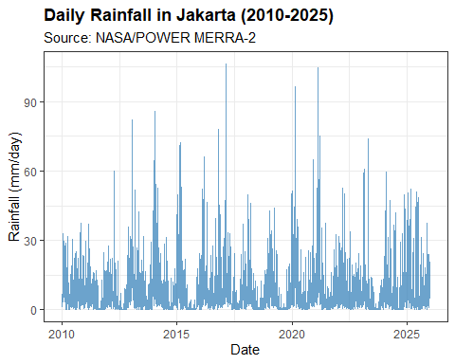
Daily data shows high volatility with many zero values and sharp spikes during monsoon events. This noise makes it difficult to model directly, which is one reason for monthly aggregation.

Histogram dan Distribusi Harian
par(mfrow = c(1, 2))
hist(df_daily$rain, breaks = 60, col = "#4575B4", border = "white",
main = "Daily Rainfall Distribution", xlab = "mm/day",
xlim = c(0, 110))
hist(log1p(df_daily$rain), breaks = 40, col = "#74ADD1", border = "white",
main = "Log(1+x) Transformed", xlab = "log(1 + mm/day)")
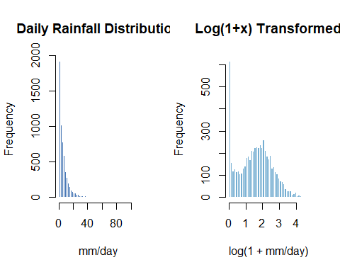
par(mfrow = c(1, 1))
The raw distribution is heavily right-skewed. Log transformation substantially reduces skewness and brings the distribution closer to symmetric, which improves fit for parametric models.

Outlier Analysis (Daily Level)
Outlier analysis is performed on daily data before aggregation. Extreme daily values are caused by real meteorological events (heavy storms, monsoon surges), not measurement errors.

Identification with IQR
Q1 <- quantile(df_daily$rain, 0.25, na.rm = TRUE)
Q3 <- quantile(df_daily$rain, 0.75, na.rm = TRUE)
IQR_val <- IQR(df_daily$rain, na.rm = TRUE)
bound_mild <- Q3 + 1.5 * IQR_val
bound_extreme <- Q3 + 3.0 * IQR_val
cat("Q1 :", round(Q1, 2), "mm\n")
## Q1 : 1.22 mm
cat("Q3 :", round(Q3, 2), "mm\n")
## Q3 : 8.38 mm
cat("IQR :", round(IQR_val, 2), "mm\n")
## IQR : 7.16 mm
cat("Mild outlier threshold (1.5*IQR) :", round(bound_mild, 2), "mm\n")
## Mild outlier threshold (1.5*IQR) : 19.12 mm
cat("Extreme outlier threshold (3.0*IQR):", round(bound_extreme, 2), "mm\n\n")
## Extreme outlier threshold (3.0*IQR): 29.86 mm
df_daily <- df_daily %>%
mutate(outlier_cat = case_when(
rain > bound_extreme ~ "Extreme",
rain > bound_mild ~ "Mild",
TRUE ~ "Normal"
))
print(table(df_daily$outlier_cat))
##
## Extreme Mild Normal
## 153 250 5442
The IQR method uses 3x IQR (instead of the standard 1.5x) as the extreme threshold because daily rainfall follows a naturally heavy-tailed distribution. Using 1.5x would flag too many legitimate monsoon events as outliers.

Visualisasi Outlier
ggplot(df_daily, aes(x = Date, y = rain)) +
geom_line(color = "grey70", linewidth = 0.3) +
geom_point(data = filter(df_daily, outlier_cat == "Extreme"),
aes(color = "Extreme"), size = 1.8) +
geom_point(data = filter(df_daily, outlier_cat == "Mild"),
aes(color = "Mild"), size = 1.2, alpha = 0.6) +
scale_color_manual(values = c("Extreme" = "#D73027", "Mild" = "#FC8D59")) +
labs(title = "Identified Outliers in Daily Rainfall",
x = "Date", y = "Rainfall (mm/day)", color = "Outlier") +
theme_bw(base_size = 11) +
theme(plot.title = element_text(face = "bold"))
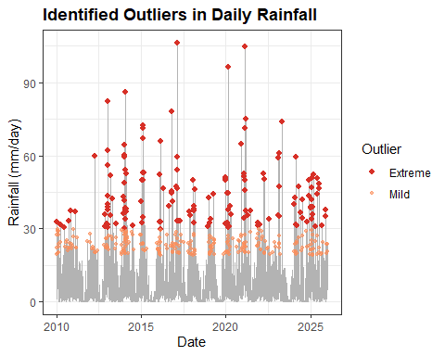

Handling: Winsorizing
Extreme values are capped (Winsorized) at the 3x IQR threshold. This approach:
- Retains all observations (no data deleted)
- Preserves the directional signal of extreme events
- Reduces the disproportionate influence of very high values on model fitting
df_daily <- df_daily %>%
mutate(rain_clean = ifelse(rain > bound_extreme, bound_extreme, rain))
cat("Cap value (3*IQR bound):", round(bound_extreme, 2), "mm\n")
## Cap value (3*IQR bound): 29.86 mm
cat("Values capped :", sum(df_daily$rain > bound_extreme), "\n")
## Values capped : 153

Weekly Aggregation
All models are fitted on weekly total rainfall. The daily data is aggregated into weekly totals to reduce daily noise and better capture seasonal patterns.
df_weekly <- df_daily %>%
mutate(
WEEK_ID = floor(as.numeric(Date - min(Date))/7) + 1
) %>%
group_by(WEEK_ID) %>%
summarise(
week_start = min(Date),
week_end = max(Date),
rain_weekly = sum(rain_clean, na.rm = TRUE),
.groups = "drop"
) %>%
arrange(WEEK_ID) %>%
mutate(
t = row_number(),
rain_log = log1p(rain_weekly),
lag1 = lag(rain_weekly,1),
lag2 = lag(rain_weekly,2),
lag3 = lag(rain_weekly,3)
)
cat("Weekly data:", nrow(df_weekly), "observations\n")
## Weekly data: 835 observations
cat(
"Period:",
format(min(df_weekly$week_start)),
"to",
format(max(df_weekly$week_end)),
"\n"
)
## Period: 2010-01-01 to 2026-01-01
head(df_weekly)
## # A tibble: 6 × 9
## WEEK_ID week_start week_end rain_weekly t rain_log lag1 lag2 lag3
## <dbl> <date> <date> <dbl> <int> <dbl> <dbl> <dbl> <dbl>
## 1 1 2010-01-01 2010-01-07 30.8 1 3.46 NA NA NA
## 2 2 2010-01-08 2010-01-14 94.2 2 4.56 30.8 NA NA
## 3 3 2010-01-15 2010-01-21 149. 3 5.01 94.2 30.8 NA
## 4 4 2010-01-22 2010-01-28 77.6 4 4.36 149. 94.2 30.8
## 5 5 2010-01-29 2010-02-04 73.8 5 4.31 77.6 149. 94.2
## 6 6 2010-02-05 2010-02-11 44.2 6 3.81 73.8 77.6 149.
summary_weekly <- df_weekly %>%
summarise(
N = n(),
Mean = round(mean(rain_weekly), 2),
Median = round(median(rain_weekly), 2),
SD = round(sd(rain_weekly), 2),
Min = round(min(rain_weekly), 2),
Max = round(max(rain_weekly), 2),
Skewness = round(skewness(rain_weekly), 3)
)
knitr::kable(t(summary_weekly), col.names = "Value",
caption = "Descriptive statistics of weekly total rainfall (mm/week)")
Descriptive statistics of weekly total rainfall (mm/week)
 | Value
N | 835.000
Mean | 43.360
Median | 38.650
SD | 34.020
Min | 0.000
Max | 198.940
Skewness | 1.168

Stationarity Analysis (Weekly)

Weekly Time Series Object
rain_weekly_ts <- ts(
df_weekly$rain_weekly,
frequency = 52
)

Visual Inspection
autoplot(rain_weekly_ts) +
labs(title = "Weekly Total Rainfall Time Series (2010-2026)",
x = "Year", y = "Total Rainfall (mm/week)") +
theme_bw(base_size = 9) +
theme(plot.title = element_text(face = "bold"))
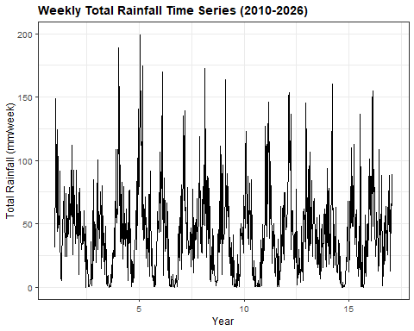
Q1_week <- quantile(df_weekly$rain_weekly, 0.25, na.rm = TRUE)
Q3_week <- quantile(df_weekly$rain_weekly, 0.75, na.rm = TRUE)
IQR_week <- IQR(df_weekly$rain_weekly, na.rm = TRUE)
bound_mild_week <- Q3_week + 1.5 * IQR_week
bound_extreme_week <- Q3_week + 3.0 * IQR_week
cat("Q1 :", round(Q1_week, 2), "mm/week\n")
## Q1 : 17.4 mm/week
cat("Q3 :", round(Q3_week, 2), "mm/week\n")
## Q3 : 60.18 mm/week
cat("IQR :", round(IQR_week, 2), "mm/week\n")
## IQR : 42.78 mm/week
cat(
"Mild outlier threshold (1.5*IQR) :",
round(bound_mild_week, 2),
"mm/week\n"
)
## Mild outlier threshold (1.5*IQR) : 124.35 mm/week
cat(
"Extreme outlier threshold (3.0*IQR):",
round(bound_extreme_week, 2),
"mm/week\n\n"
)
## Extreme outlier threshold (3.0*IQR): 188.52 mm/week
# Classification
df_weekly <- df_weekly %>%
mutate(
outlier_cat = case_when(
rain_weekly > bound_extreme_week ~ "Extreme",
rain_weekly > bound_mild_week ~ "Mild",
TRUE ~ "Normal"
)
)
table(df_weekly$outlier_cat)
##
## Extreme Mild Normal
## 2 23 810
ggplot(df_weekly, aes(x = week_start, y = rain_weekly)) +
geom_line(color = "grey70", linewidth = 0.4) +
geom_point(
data = filter(df_weekly, outlier_cat == "Extreme"),
aes(color = "Extreme"),
size = 2.2
) +
geom_point(
data = filter(df_weekly, outlier_cat == "Mild"),
aes(color = "Mild"),
size = 1.6,
alpha = 0.7
) +
scale_color_manual(
values = c(
"Extreme" = "#D73027",
"Mild" = "#FC8D59"
)
) +
labs(
title = "Identified Outliers in Weekly Rainfall",
x = "Week Start",
y = "Weekly Rainfall (mm/week)",
color = "Outlier"
) +
theme_bw(base_size = 11) +
theme(
plot.title = element_text(face = "bold")
)
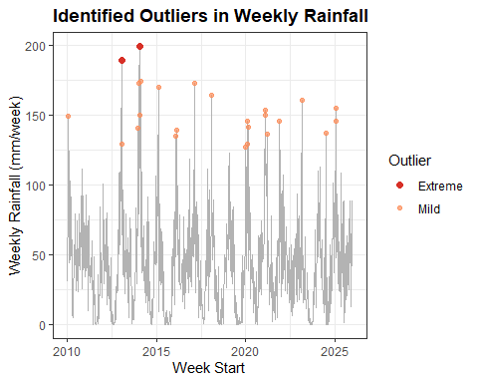

Decomposition Plot
plot(decompose(rain_weekly_ts, type = "additive"))
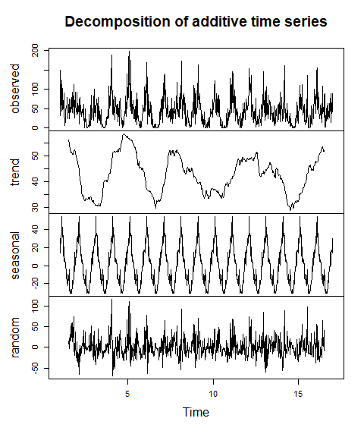
Decomposition separates the series into three components:
- Trend: no clear long-term upward or downward drift, consistent with stable climate over 5 years
- Seasonal: a strong and consistent annual cycle (S = 52) repeating every year
- Residual: the remaining random variation after removing trend and seasonal components
The additive model is appropriate here because the seasonal amplitude (height of the peaks) stays roughly constant across years, rather than growing proportionally with the trend.

Variance Stationarity
lambda_weekly <- BoxCox.lambda(rain_weekly_ts + 1)
cat("BoxCox lambda (weekly):", round(lambda_weekly, 4), "\n")
## BoxCox lambda (weekly): 0.9333
cat("Lambda mendekati 0 -> log transform disarankan\n")
## Lambda mendekati 0 -> log transform disarankan
cat("Lambda mendekati 1 -> varians sudah stabil\n\n")
## Lambda mendekati 1 -> varians sudah stabil
summary(powerTransform(rain_weekly_ts + 1))
## bcPower Transformation to Normality
## Est Power Rounded Pwr Wald Lwr Bnd Wald Upr Bnd
## rain_weekly_ts + 1 0.4462 0.5 0.3884 0.5039
##
## Likelihood ratio test that transformation parameter is equal to 0
## (log transformation)
## LRT df pval
## LR test, lambda = (0) 257.5052 1 < 2.22e-16
##
## Likelihood ratio test that no transformation is needed
## LRT df pval
## LR test, lambda = (1) 298.9179 1 < 2.22e-16
H0: lambda = 1 (variance stationary). If p-value < 0.05, log transformation is recommended.

ACF dan PACF (Monthly)
par(mfrow = c(1, 2))
acf(rain_weekly_ts, lag.max = 36, main = "ACF - Weekly Rainfall", col = "#2166AC")
pacf(rain_weekly_ts, lag.max = 36, main = "PACF - Weekly Rainfall", col = "#D73027")
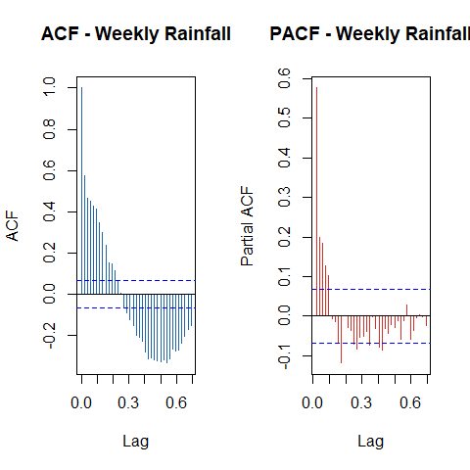
par(mfrow = c(1, 1))

ADF Test
adf_weekly <- adf.test(rain_weekly_ts, alternative = "stationary")
## Warning in adf.test(rain_weekly_ts, alternative = "stationary"): p-value
## smaller than printed p-value
print(adf_weekly)
##
## Augmented Dickey-Fuller Test
##
## data: rain_weekly_ts
## Dickey-Fuller = -6.685, Lag order = 9, p-value = 0.01
## alternative hypothesis: stationary
if (adf_weekly$p.value < 0.05) {
cat("\np-value < 0.05 -> data STASIONER (d = 0)\n")
} else {
cat("\np-value > 0.05 -> data TIDAK stasioner -> pertimbangkan differencing (d = 1)\n")
}
##
## p-value < 0.05 -> data STASIONER (d = 0)

Log Transformation Check (Weekly)
par(mfrow = c(1, 2))
hist(df_weekly$rain_weekly, breaks = 20, col = "#4575B4", border = "white",
main = "Weekly Rainfall (Original)", xlab = "mm/month")
hist(df_weekly$rain_log, breaks = 20, col = "#74ADD1", border = "white",
main = "Log(1+x) Transformed", xlab = "log(1 + mm/month)")
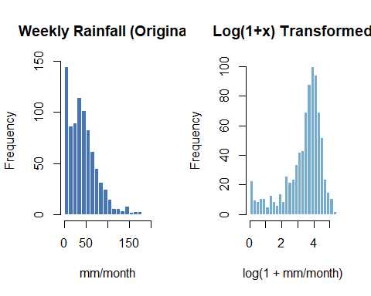
par(mfrow = c(1, 1))
cat("Skewness original :", round(skewness(df_weekly$rain_weekly), 3), "\n")
## Skewness original : 1.168
cat("Skewness log-tranform:", round(skewness(df_weekly$rain_log), 3), "\n")
## Skewness log-tranform: -1.236

Train-Test Split
All models use the same 80/20 split on weekly data. The split is sequential (not random) to preserve temporal order.
n_total <- nrow(df_weekly)
n_train <- floor(0.8 * n_total)
n_test <- n_total - n_train
train_df <- df_weekly[1:n_train, ]
test_df <- df_weekly[(n_train+1):n_total, ]
# ts objects
train_weekly_ts <- ts(
train_df$rain_weekly,
frequency = 52
)
test_weekly_ts <- ts(
test_df$rain_weekly,
frequency = 52
)
train_weekly_log <- ts(
train_df$rain_log,
frequency = 52
)
test_weekly_log <- ts(
test_df$rain_log,
frequency = 52
)
cat("Total weekly obs :", n_total, "\n")
## Total weekly obs : 835
cat(
"Train:", n_train, "weeks |",
format(min(train_df$week_start)),
"to",
format(max(train_df$week_end)),
"\n"
)
## Train: 668 weeks | 2010-01-01 to 2022-10-20
cat(
"Test :", n_test, "weeks |",
format(min(test_df$week_start)),
"to",
format(max(test_df$week_end)),
"\n"
)
## Test : 167 weeks | 2022-10-21 to 2026-01-01
c(
nrow(df_weekly),
length(train_weekly_ts),
frequency(train_weekly_ts),
start(train_weekly_ts),
end(train_weekly_ts)
)
## [1] 835 668 52 1 1 13 44
df_weekly %>%
mutate(
Set = ifelse(
WEEK_ID <= max(train_df$WEEK_ID),
"Training",
"Test"
)
) %>%
ggplot(
aes(
x = week_start,
y = rain_weekly,
color = Set
)
) +
geom_line(linewidth = 0.3) +
geom_point(size = 1) +
scale_color_manual(
values = c(
"Training" = "#2166AC",
"Test" = "#D73027"
)
) +
labs(
title = "Train-Test Split: Weekly Rainfall (80% / 20%)",
x = "Week",
y = "Total Rainfall (mm/week)",
color = "Set"
) +
theme_bw(base_size = 9) +
theme(
plot.title = element_text(face = "bold")
)
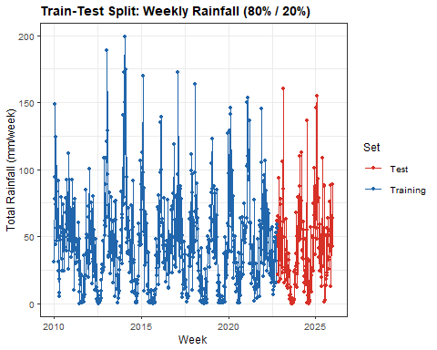

9. Modeling
Semua model difit dan dievaluasi pada data bulanan (mm/month). Evaluasi menggunakan tiga metrik:
- RMSE — sensitif terhadap error besar, unit sama dengan data
- MAE — rata-rata besar error, lebih robust terhadap nilai ekstrem
- MAPE — error dalam persentase
catatan: MAPE dapat tidak stabil ketika nilai aktual mendekati nol, sehingga RMSE dan MAE lebih diutamakan sebagai metrik utama
eval_metrics <- function(actual, predicted, model_name) {
mask <- actual > 0
rmse_val <- rmse(actual, predicted)
mae_val <- mean(abs(actual - predicted))
mape_val <- mean(abs((actual[mask] - predicted[mask]) / actual[mask])) * 100
cat(model_name, "\n")
cat(" RMSE:", round(rmse_val, 4), "| MAE:", round(mae_val, 4),
"| MAPE:", round(mape_val, 2), "%\n\n")
data.frame(Model = model_name,
RMSE = round(rmse_val, 4),
MAE = round(mae_val, 4),
MAPE = round(mape_val, 2))
}

9.1 Baseline Models
Sebelum model utama, ditetapkan dua baseline sederhana sebagai acuan minimum performa. Model yang baik seharusnya mengalahkan baseline ini. Jika tidak, perlu dievaluasi apakah model terlalu kompleks atau data memang sulit diprediksi.
snaive_model <- snaive(
train_weekly_ts,
h = length(test_weekly_ts)
)
train_fit_snaive <- fitted(snaive_model)
# remove NA caused by first seasonal cycle
valid_idx <- !is.na(train_fit_snaive)
actual_train_snaive <- as.numeric(train_weekly_ts)[valid_idx]
pred_train_snaive <- as.numeric(train_fit_snaive)[valid_idx]
result_snaive_train <- eval_metrics(
actual_train_snaive,
pred_train_snaive,
"Seasonal Naive (Train)"
)
## Seasonal Naive (Train)
## RMSE: 36.0425 | MAE: 26.9668 | MAPE: 657.37 %
rmse_snaive_train <- result_snaive_train$RMSE
mae_snaive_train <- result_snaive_train$MAE
mape_snaive_train <- result_snaive_train$MAPE
pred_test_snaive <- as.numeric(snaive_model$mean)
actual_base <- as.numeric(test_weekly_ts)
result_snaive_test <- eval_metrics(
actual_base,
pred_test_snaive,
"Seasonal Naive (Test)"
)
## Seasonal Naive (Test)
## RMSE: 39.3476 | MAE: 30.2422 | MAPE: 2725.9 %
rmse_snaive <- result_snaive_test$RMSE
mae_snaive <- result_snaive_test$MAE
mape_snaive <- result_snaive_test$MAPE
cat("\n=== Seasonal Naive ===\n")
##
## === Seasonal Naive ===
cat("\nTrain RMSE :", round(rmse_snaive_train, 4))
##
## Train RMSE : 36.0425
cat("\nTrain MAE :", round(mae_snaive_train, 4))
##
## Train MAE : 26.9668
cat("\nTrain MAPE :", round(mape_snaive_train, 4), "%\n")
##
## Train MAPE : 657.37 %
cat("\nTest RMSE :", round(rmse_snaive, 4))
##
## Test RMSE : 39.3476
cat("\nTest MAE :", round(mae_snaive, 4))
##
## Test MAE : 30.2422
cat("\nTest MAPE :", round(mape_snaive, 4), "%\n")
##
## Test MAPE : 2725.9 %
Seasonal Naive sangat relevan untuk data curah hujan karena pola musiman Jakarta sangat kuat dan berulang setiap tahun. Jika model ML tidak mampu mengalahkan Seasonal Naive, itu menandakan model yg lebih kompleks tidak cocok pada dataset ini.

9.2 Time Series Regression Seasonal (TSR Seasonal)
TSR Seasonal meregresikan curah hujan bulanan terhadap dummy variabel bulan dan lag bulan sebelumnya. Setiap koefisien dummy menunjukkan perbedaan rata-rata curah hujan bulan tersebut dibandingkan Januari (baseline/referensi). Misalnya, jika koefisien M2 = +80, artinya Februari rata-rata 80 mm lebih basah dari Januari setelah mengontrol variabel lain.
df_train_tsr <- train_df %>%
mutate(
WEEK_F = factor(
((WEEK_ID - 1) %% 52) + 1
)
) %>%
filter(
!is.na(lag1),
!is.na(lag2),
!is.na(lag3)
)
cat(
"Training obs for TSR:",
nrow(df_train_tsr),
"\n"
)
## Training obs for TSR: 665
str(df_train_tsr)
## tibble [665 × 11] (S3: tbl_df/tbl/data.frame)
## $ WEEK_ID : num [1:665] 4 5 6 7 8 9 10 11 12 13 ...
## $ week_start : Date[1:665], format: "2010-01-22" "2010-01-29" ...
## $ week_end : Date[1:665], format: "2010-01-28" "2010-02-04" ...
## $ rain_weekly: num [1:665] 77.6 73.8 44.2 124.3 83.1 ...
## $ t : int [1:665] 4 5 6 7 8 9 10 11 12 13 ...
## $ rain_log : num [1:665] 4.36 4.31 3.81 4.83 4.43 ...
## $ lag1 : num [1:665] 148.9 77.6 73.8 44.2 124.3 ...
## $ lag2 : num [1:665] 94.2 148.9 77.6 73.8 44.2 ...
## $ lag3 : num [1:665] 30.8 94.2 148.9 77.6 73.8 ...
## $ outlier_cat: chr [1:665] "Normal" "Normal" "Normal" "Normal" ...
## $ WEEK_F : Factor w/ 52 levels "1","2","3","4",..: 4 5 6 7 8 9 10 11 12 13 ...
dummy_vars <- "M2+M3+M4+M5+M6+M7+M8+M9+M10+M11+M12"
m1 <- lm(
rain_weekly ~ WEEK_F,
data = df_train_tsr
)
m2 <- lm(
rain_weekly ~ t + WEEK_F,
data = df_train_tsr
)
m3 <- lm(
rain_weekly ~ lag1 + t + WEEK_F,
data = df_train_tsr
)
m4 <- lm(
rain_weekly ~ lag1 + lag2 + t + WEEK_F,
data = df_train_tsr
)
m5 <- lm(
rain_weekly ~ lag1 + lag2 + lag3 + t + WEEK_F,
data = df_train_tsr
)
eval_tsr <- function(model, nama, train_data) {
actual <- train_data$rain_weekly
predicted <- fitted(model)
idx <- actual > 0
data.frame(
Model = nama,
Adj_R2 = round(summary(model)$adj.r.squared, 4),
RMSE = round(rmse(actual, predicted), 4),
MAE = round(mean(abs(actual - predicted)), 4),
MAPE = round(mean(abs((actual[idx] - predicted[idx]) / actual[idx])) * 100, 2),
AIC = round(AIC(model), 2),
DW = round(as.numeric(dwtest(model)$statistic), 4)
)
}
tabel_tsr <- bind_rows(
eval_tsr(m1, "Dummy Seasonal Only", df_train_tsr),
eval_tsr(m2, "Trend + Dummy", df_train_tsr),
eval_tsr(m3, "Lag1 + Trend + Dummy", df_train_tsr),
eval_tsr(m4, "Lag1+Lag2 + Trend + Dummy", df_train_tsr),
eval_tsr(m5, "Lag1+Lag2+Lag3 + Trend + Dummy", df_train_tsr)
)
knitr::kable(tabel_tsr, caption = "TSR Seasonal Model Comparison (Training Set)")
TSR Seasonal Model Comparison (Training Set)
Model | Adj_R2 | RMSE | MAE | MAPE | AIC | DW
Dummy Seasonal Only | 0.3828 | 25.7931 | 19.5655 | 859.89 | 6315.83 | 1.2872
Trend + Dummy | 0.3818 | 25.7926 | 19.5616 | 859.31 | 6317.80 | 1.2873
Lag1 + Trend + Dummy | 0.4583 | 24.1241 | 18.1488 | 656.71 | 6230.86 | 2.0381
Lag1+Lag2 + Trend + Dummy | 0.4601 | 24.0649 | 18.0230 | 629.07 | 6229.59 | 2.0091
Lag1+Lag2+Lag3 + Trend + Dummy | 0.4708 | 23.8055 | 17.8261 | 568.40 | 6217.18 | 2.0178
best_tsr_idx <- which.min(tabel_tsr$RMSE)
best_tsr <- list(m1, m2, m3, m4, m5)[[best_tsr_idx]]
cat("Best TSR model:", tabel_tsr$Model[best_tsr_idx], "\n\n")
## Best TSR model: Lag1+Lag2+Lag3 + Trend + Dummy
summary(best_tsr)
##
## Call:
## lm(formula = rain_weekly ~ lag1 + lag2 + lag3 + t + WEEK_F, data = df_train_tsr)
##
## Residuals:
## Min 1Q Median 3Q Max
## -75.46 -14.63 -3.24 12.37 102.86
##
## Coefficients:
## Estimate Std. Error t value Pr(>|t|)
## (Intercept) 31.563937 8.007611 3.942 9.03e-05 ***
## lag1 0.317941 0.039835 7.981 7.22e-15 ***
## lag2 0.021806 0.041869 0.521 0.602693
## lag3 0.145385 0.039800 3.653 0.000282 ***
## t 0.001109 0.005033 0.220 0.825744
## WEEK_F2 14.254778 10.160576 1.403 0.161141
## WEEK_F3 5.607305 10.168923 0.551 0.581551
## WEEK_F4 12.183781 9.985410 1.220 0.222877
## WEEK_F5 2.248095 10.005681 0.225 0.822302
## WEEK_F6 16.084813 10.006803 1.607 0.108488
## WEEK_F7 25.943376 10.013743 2.591 0.009805 **
## WEEK_F8 8.077829 10.048788 0.804 0.421791
## WEEK_F9 3.186120 10.079285 0.316 0.752031
## WEEK_F10 1.291719 10.088834 0.128 0.898164
## WEEK_F11 -0.931366 10.016627 -0.093 0.925948
## WEEK_F12 -14.643327 9.992372 -1.465 0.143314
## WEEK_F13 3.126928 10.006534 0.312 0.754776
## WEEK_F14 -15.398525 9.981835 -1.543 0.123434
## WEEK_F15 -3.569322 9.989726 -0.357 0.720992
## WEEK_F16 -12.453695 9.987209 -1.247 0.212890
## WEEK_F17 -7.472519 9.984600 -0.748 0.454505
## WEEK_F18 -12.969342 9.984965 -1.299 0.194474
## WEEK_F19 -7.782710 9.996461 -0.779 0.436549
## WEEK_F20 -20.734994 9.993455 -2.075 0.038419 *
## WEEK_F21 -17.474337 10.032205 -1.742 0.082044 .
## WEEK_F22 -19.231845 10.050032 -1.914 0.056138 .
## WEEK_F23 -13.228421 10.069467 -1.314 0.189436
## WEEK_F24 -23.358294 10.062722 -2.321 0.020601 *
## WEEK_F25 -19.865225 10.097652 -1.967 0.049601 *
## WEEK_F26 -26.890349 10.107558 -2.660 0.008010 **
## WEEK_F27 -12.008881 10.155290 -1.183 0.237459
## WEEK_F28 -18.152180 10.125052 -1.793 0.073501 .
## WEEK_F29 -13.436787 10.126423 -1.327 0.185038
## WEEK_F30 -21.820951 10.085422 -2.164 0.030882 *
## WEEK_F31 -26.510312 10.108449 -2.623 0.008945 **
## WEEK_F32 -29.371430 10.146519 -2.895 0.003931 **
## WEEK_F33 -27.007869 10.200728 -2.648 0.008315 **
## WEEK_F34 -23.490990 10.233162 -2.296 0.022039 *
## WEEK_F35 -25.640059 10.236787 -2.505 0.012516 *
## WEEK_F36 -22.388844 10.240834 -2.186 0.029179 *
## WEEK_F37 -25.718986 10.225094 -2.515 0.012150 *
## WEEK_F38 -19.889125 10.235866 -1.943 0.052467 .
## WEEK_F39 -22.798545 10.209158 -2.233 0.025902 *
## WEEK_F40 -10.365151 10.207635 -1.015 0.310304
## WEEK_F41 -22.781818 10.145964 -2.245 0.025100 *
## WEEK_F42 -16.073144 10.154956 -1.583 0.113989
## WEEK_F43 -11.745027 10.118939 -1.161 0.246220
## WEEK_F44 -0.155829 10.101572 -0.015 0.987697
## WEEK_F45 -14.054321 10.252072 -1.371 0.170919
## WEEK_F46 0.055101 10.237701 0.005 0.995707
## WEEK_F47 7.379602 10.197263 0.724 0.469537
## WEEK_F48 -10.264660 10.181562 -1.008 0.313777
## WEEK_F49 -8.710816 10.185670 -0.855 0.392775
## WEEK_F50 -1.555578 10.191595 -0.153 0.878738
## WEEK_F51 1.929981 10.169243 0.190 0.849540
## WEEK_F52 6.463707 10.161793 0.636 0.524964
## ---
## Signif. codes: 0 '***' 0.001 '**' 0.01 '*' 0.05 '.' 0.1 ' ' 1
##
## Residual standard error: 24.88 on 609 degrees of freedom
## Multiple R-squared: 0.5146, Adjusted R-squared: 0.4708
## F-statistic: 11.74 on 55 and 609 DF, p-value: < 2.2e-16
cat("VIF values (best model):\n")
## VIF values (best model):
print(round(vif(best_tsr), 2))
## GVIF Df GVIF^(1/(2*Df))
## lag1 2.02 1 1.42
## lag2 2.24 1 1.50
## lag3 2.02 1 1.42
## t 1.00 1 1.00
## WEEK_F 2.78 51 1.01
cat("\nVIF > 10 = multikolinearitas serius\n")
##
## VIF > 10 = multikolinearitas serius
#ubah
# ==========================
# Recursive Forecast TSR
# ==========================
h <- nrow(test_df)
yhat_tsr <- numeric(h)
lag1_last <- tail(train_df$rain_weekly, 1)
lag2_last <- tail(train_df$rain_weekly, 2)[1]
lag3_last <- tail(train_df$rain_weekly, 3)[1]
for(i in 1:h){
row_i <- test_df[i, ]
row_i$lag1 <- lag1_last
row_i$lag2 <- lag2_last
row_i$lag3 <- lag3_last
row_i$WEEK_F <- factor(
((row_i$WEEK_ID - 1) %% 52) + 1,
levels = levels(df_train_tsr$WEEK_F)
)
pred_i <- predict(m5, newdata = row_i)
yhat_tsr[i] <- pred_i
lag3_last <- lag2_last
lag2_last <- lag1_last
lag1_last <- pred_i
}
actual_tsr <- test_df$rain_weekly
idx <- actual_tsr > 0
rmse_tsr <- rmse(actual_tsr, yhat_tsr)
mae_tsr <- mae(actual_tsr, yhat_tsr)
mape_tsr <- mean(
abs(
(actual_tsr[idx] - yhat_tsr[idx]) /
actual_tsr[idx]
)
) * 100
cat(
"\nTSR Weekly (Recursive Forecast)\n"
)
##
## TSR Weekly (Recursive Forecast)
cat(
"RMSE:", round(rmse_tsr,4),
"| MAE:", round(mae_tsr,4),
"| MAPE:", round(mape_tsr,2), "%\n"
)
## RMSE: 26.9513 | MAE: 20.3781 | MAPE: 1890.25 %

9.3 ARIMA
ARIMA (p,d,q) memodelkan dependensi linier antar observasi melalui komponen AR dan MA. Difit pada log-transformed monthly data untuk menstabilkan varians. Forecast dikembalikan ke skala asli dengan expm1().
min(train_weekly_ts)
## [1] 0
sum(train_weekly_ts <= 0)
## [1] 3
plot(train_weekly_ts)
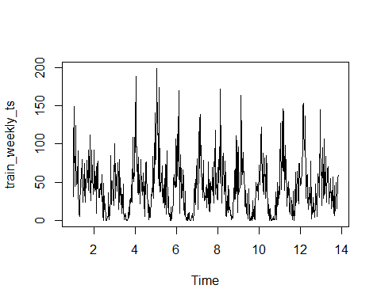
summary(powerTransform(train_weekly_ts + 1))
## bcPower Transformation to Normality
## Est Power Rounded Pwr Wald Lwr Bnd Wald Upr Bnd
## train_weekly_ts + 1 0.4426 0.5 0.378 0.5072
##
## Likelihood ratio test that transformation parameter is equal to 0
## (log transformation)
## LRT df pval
## LR test, lambda = (0) 201.5244 1 < 2.22e-16
##
## Likelihood ratio test that no transformation is needed
## LRT df pval
## LR test, lambda = (1) 242.8442 1 < 2.22e-16
adf.test(train_weekly_log)
## Warning in adf.test(train_weekly_log): p-value smaller than printed p-value
##
## Augmented Dickey-Fuller Test
##
## data: train_weekly_log
## Dickey-Fuller = -5.6678, Lag order = 8, p-value = 0.01
## alternative hypothesis: stationary
lambda_weekly
## [1] 0.9332919
par(mfrow = c(1, 2))
acf(
train_weekly_log,
lag.max = 104,
main = "ACF Weekly Rainfall"
)
pacf(
train_weekly_log,
lag.max = 104,
main = "PACF Weekly Rainfall"
)
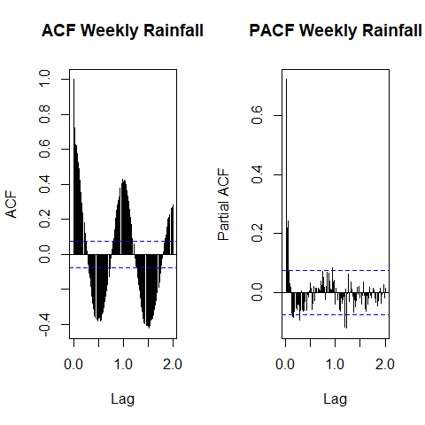
par(mfrow = c(1, 1))
train_weekly_ts <- ts(
train_df$rain_weekly,
start = c(2010, 1),
frequency = 52
)
test_weekly_ts <- ts(
test_df$rain_weekly,
start = c(
2010 + floor(n_train/52),
(n_train %% 52) + 1
),
frequency = 52
)
train_weekly_log <- ts(
train_df$rain_log,
start = c(2010, 1),
frequency = 52
)
test_weekly_log <- ts(
test_df$rain_log,
start = c(
2010 + floor(n_train/52),
(n_train %% 52) + 1
),
frequency = 52
)
# ===== Weekly ARIMA Candidates =====
arima_100 <- Arima(train_weekly_log, order = c(1,0,0))
arima_200 <- Arima(train_weekly_log, order = c(2,0,0))
arima_300 <- Arima(train_weekly_log, order = c(3,0,0))
arima_101 <- Arima(train_weekly_log, order = c(1,0,1))
arima_201 <- Arima(train_weekly_log, order = c(2,0,1))
arima_301 <- Arima(train_weekly_log, order = c(3,0,1))
arima_202 <- Arima(train_weekly_log, order = c(2,0,2))
arima_302 <- Arima(train_weekly_log, order = c(3,0,2))
arima_aic <- data.frame(
Model = c(
"ARIMA(1,0,0)",
"ARIMA(2,0,0)",
"ARIMA(3,0,0)",
"ARIMA(1,0,1)",
"ARIMA(2,0,1)",
"ARIMA(3,0,1)",
"ARIMA(2,0,2)",
"ARIMA(3,0,2)"
),
AIC = c(
AIC(arima_100),
AIC(arima_200),
AIC(arima_300),
AIC(arima_101),
AIC(arima_201),
AIC(arima_301),
AIC(arima_202),
AIC(arima_302)
)
)
arima_aic[order(arima_aic$AIC), ]
## Model AIC
## 8 ARIMA(3,0,2) 1519.267
## 6 ARIMA(3,0,1) 1543.041
## 3 ARIMA(3,0,0) 1544.887
## 7 ARIMA(2,0,2) 1548.576
## 5 ARIMA(2,0,1) 1553.079
## 4 ARIMA(1,0,1) 1553.401
## 2 ARIMA(2,0,0) 1584.550
## 1 ARIMA(1,0,0) 1615.230
fit_auto_arima <- auto.arima(train_weekly_log, seasonal = FALSE)
summary(fit_auto_arima)
## Series: train_weekly_log
## ARIMA(3,0,1) with non-zero mean
##
## Coefficients:
## ar1 ar2 ar3 ma1 mean
## 0.7743 -0.0698 0.1890 -0.2837 3.3705
## s.e. 0.1225 0.0768 0.0508 0.1227 0.1948
##
## sigma^2 = 0.5828: log likelihood = -765.52
## AIC=1543.04 AICc=1543.17 BIC=1570.07
##
## Training set error measures:
## ME RMSE MAE MPE MAPE MASE ACF1
## Training set -0.001675585 0.7605382 0.57195 -Inf Inf 0.6160712 0.001154437
library(lmtest)
coeftest(arima_302)
##
## z test of coefficients:
##
## Estimate Std. Error z value Pr(>|z|)
## ar1 2.173224 0.068132 31.8971 < 2.2e-16 ***
## ar2 -1.401454 0.127473 -10.9941 < 2.2e-16 ***
## ar3 0.217369 0.060588 3.5877 0.0003336 ***
## ma1 -1.747433 0.050801 -34.3979 < 2.2e-16 ***
## ma2 0.778339 0.047623 16.3436 < 2.2e-16 ***
## intercept 3.355237 0.082658 40.5916 < 2.2e-16 ***
## ---
## Signif. codes: 0 '***' 0.001 '**' 0.01 '*' 0.05 '.' 0.1 ' ' 1
library(nortest)
e_arima <- residuals(arima_302)
lillie.test(e_arima)
##
## Lilliefors (Kolmogorov-Smirnov) normality test
##
## data: e_arima
## D = 0.064174, p-value = 7.128e-07
Box.test(
e_arima,
lag = 12,
type = "Ljung-Box"
)
##
## Box-Ljung test
##
## data: e_arima
## X-squared = 9.9215, df = 12, p-value = 0.6228
checkresiduals(arima_302)
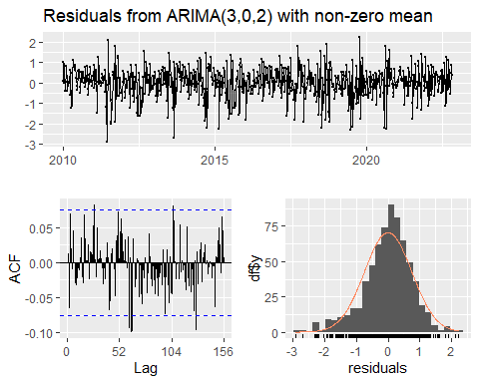
##
## Ljung-Box test
##
## data: Residuals from ARIMA(3,0,2) with non-zero mean
## Q* = 101.03, df = 99, p-value = 0.4243
##
## Model df: 5. Total lags used: 104
H₀: residual berdistribusi normal H₁: residual tidak berdistribusi normal
H₀: residual merupakan white noise (tidak ada autokorelasi tersisa) H₁: residual masih mengandung autokorelasi
best_arima <- arima_302 # ganti sesuai hasil coeftest + diagnostic
# ---- Train performance ----
yhat_arima_train <- expm1(
as.numeric(fitted(best_arima))
)
actual_arima_train <- as.numeric(
train_weekly_ts
)
cat(
"ARIMA RMSE (Train):",
round(
rmse(
actual_arima_train,
yhat_arima_train
),
4
),
"\n"
)
## ARIMA RMSE (Train): 26.0724
# ---- Forecast Test ----
fc_arima <- forecast(
best_arima,
h = length(test_weekly_ts)
)
# back-transform ke skala asli
yhat_arima_test <- expm1(
as.numeric(fc_arima$mean)
)
actual_arima_test <- as.numeric(
test_weekly_ts
)
# ---- Test metrics ----
result_arima <- eval_metrics(
actual_arima_test,
yhat_arima_test,
"ARIMA (Weekly Test)"
)
## ARIMA (Weekly Test)
## RMSE: 34.4754 | MAE: 25.4518 | MAPE: 2802.74 %
rmse_arima <- result_arima$RMSE
mae_arima <- result_arima$MAE
mape_arima <- result_arima$MAPE
autoplot(train_weekly_log, series = "Training") +
autolayer(fc_arima, series = "Forecast") +
autolayer(
test_weekly_log,
series = "Actual",
color = "#D73027"
) +
labs(
title = "ARIMA Forecast vs Actual (Weekly, log scale)",
x = "Year",
y = "log(1 + Rainfall)"
) +
theme_bw(base_size = 11) +
theme(
plot.title = element_text(face = "bold")
)
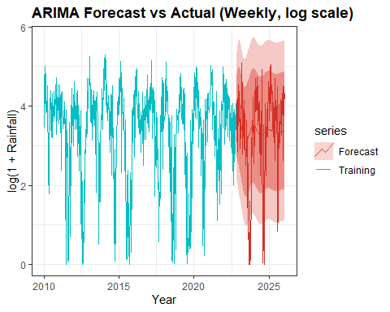
resid_arima <- residuals(best_arima)
fitted_arima <- as.numeric(fitted(best_arima))
par(mfrow = c(2, 2))
plot(fitted_arima, resid_arima, pch = 16, col = "#378ADD",
main = "Residuals vs Fitted - ARIMA",
xlab = "Fitted (log scale)", ylab = "Residuals")
abline(h = 0, col = "#D73027", lty = 2)
hist(resid_arima, breaks = 15, col = "#74ADD1", border = "white",
main = "Histogram of Residuals - ARIMA", xlab = "Residuals")
qqnorm(resid_arima, main = "Q-Q Plot - ARIMA Residuals", col = "#378ADD", pch = 16)
qqline(resid_arima, col = "#D73027", lwd = 2)
acf(resid_arima, main = "ACF of Residuals - ARIMA", col = "#2166AC")
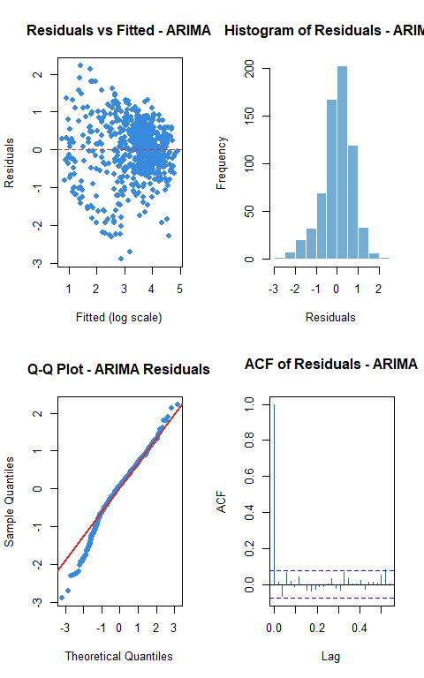
par(mfrow = c(1, 1))
# ARIMA train metrics (add to your script)
yhat_arima_train <- expm1(as.numeric(fitted(best_arima)))
actual_train <- as.numeric(train_weekly_ts)
idx_tr <- actual_train > 0
cat("ARIMA Train RMSE:", round(rmse(actual_train, yhat_arima_train), 4), "\n")
## ARIMA Train RMSE: 26.0724
cat("ARIMA Train MAE :", round(mae(actual_train, yhat_arima_train), 4), "\n")
## ARIMA Train MAE : 18.4905
cat("ARIMA Train MAPE:", round(mean(abs((actual_train[idx_tr] - yhat_arima_train[idx_tr]) /
actual_train[idx_tr])) * 100, 2), "%\n")
## ARIMA Train MAPE: 254.99 %

9.4 SARIMA
SARIMA (p,d,q)(P,D,Q)[S] memperluas ARIMA dengan komponen seasonal eksplisit. Dengan data bulanan, seasonal period S = 12. Komponen (P,D,Q) menangkap autokorelasi yang berulang setiap 12 bulan (pola monsoon tahunan).
par(mfrow = c(1,2))
Acf(
train_weekly_log,
lag.max = 104,
main = "ACF - Weekly log(rain)"
)
Pacf(
train_weekly_log,
lag.max = 104,
main = "PACF - Weekly log(rain)"
)
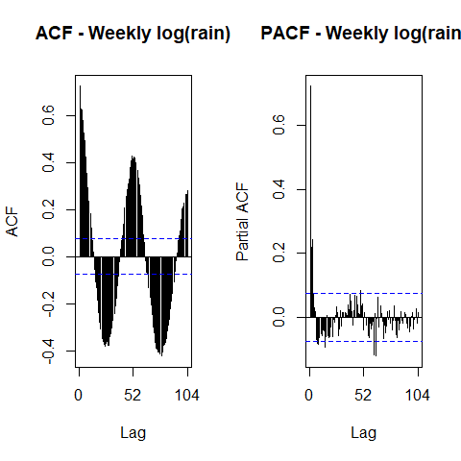
par(mfrow = c(1,1))
library(forecast)
sarima_1 <- Arima(
train_weekly_log,
order = c(1,0,0),
seasonal = list(order = c(1,1,0), period = 52)
)
sarima_2 <- Arima(
train_weekly_log,
order = c(2,0,0),
seasonal = list(order = c(1,1,0), period = 52)
)
sarima_3 <- Arima(
train_weekly_log,
order = c(1,0,1),
seasonal = list(order = c(1,1,0), period = 52)
)
sarima_4 <- Arima(
train_weekly_log,
order = c(2,0,1),
seasonal = list(order = c(1,1,0), period = 52)
)
sarima_5 <- Arima(
train_weekly_log,
order = c(1,0,1),
seasonal = list(order = c(0,1,1), period = 52)
)
sarima_6 <- Arima(
train_weekly_log,
order = c(1,0,1),
seasonal = list(order = c(1,1,1), period = 52)
)
sarima_7 <- Arima(
train_weekly_log,
order = c(2,0,2),
seasonal = list(order = c(1,1,0), period = 52)
)
sarima_8 <- Arima(
train_weekly_log,
order = c(2,0,2),
seasonal = list(order = c(0,1,1), period = 52)
)
sarima_9 <- Arima(
train_weekly_log,
order = c(4,0,4),
seasonal = list(order = c(1,1,0), period = 52)
)
sarima_aic <- data.frame(
Model = c(
"SARIMA(1,0,0)(1,1,0)[52]",
"SARIMA(2,0,0)(1,1,0)[52]",
"SARIMA(1,0,1)(1,1,0)[52]",
"SARIMA(2,0,1)(1,1,0)[52]",
"SARIMA(1,0,1)(0,1,1)[52]",
"SARIMA(1,0,1)(1,1,1)[52]",
"SARIMA(2,0,2)(1,1,0)[52]",
"SARIMA(2,0,2)(0,1,1)[52]",
"SARIMA(4,0,4)(1,1,0)[52]"
),
AIC = c(
AIC(sarima_1),
AIC(sarima_2),
AIC(sarima_3),
AIC(sarima_4),
AIC(sarima_5),
AIC(sarima_6),
AIC(sarima_7),
AIC(sarima_8),
AIC(sarima_9)
)
)
sarima_aic[order(sarima_aic$AIC), ]
## Model AIC
## 8 SARIMA(2,0,2)(0,1,1)[52] 1509.884
## 5 SARIMA(1,0,1)(0,1,1)[52] 1520.941
## 6 SARIMA(1,0,1)(1,1,1)[52] 1522.940
## 7 SARIMA(2,0,2)(1,1,0)[52] 1669.199
## 9 SARIMA(4,0,4)(1,1,0)[52] 1670.289
## 4 SARIMA(2,0,1)(1,1,0)[52] 1675.516
## 3 SARIMA(1,0,1)(1,1,0)[52] 1678.801
## 2 SARIMA(2,0,0)(1,1,0)[52] 1719.433
## 1 SARIMA(1,0,0)(1,1,0)[52] 1733.688
fit_auto_sarima <- auto.arima(
train_weekly_log,
seasonal = TRUE
)
summary(fit_auto_sarima)
## Series: train_weekly_log
## ARIMA(4,0,4) with non-zero mean
##
## Coefficients:
## ar1 ar2 ar3 ar4 ma1 ma2 ma3 ma4
## 0.9815 0.5354 -0.1973 -0.3515 -0.5403 -0.7318 0.0450 0.3189
## s.e. 0.4399 0.7792 0.4225 0.1941 0.4404 0.5886 0.2445 0.1632
## mean
## 3.3541
## s.e. 0.0830
##
## sigma^2 = 0.5581: log likelihood = -749.36
## AIC=1518.71 AICc=1519.05 BIC=1563.76
##
## Training set error measures:
## ME RMSE MAE MPE MAPE MASE ACF1
## Training set 0.0007669896 0.7420304 0.5624927 -Inf Inf 0.6058843 0.004110326
coeftest(sarima_8)
##
## z test of coefficients:
##
## Estimate Std. Error z value Pr(>|z|)
## ar1 0.518204 0.162850 3.1821 0.001462 **
## ar2 0.379092 0.145448 2.6064 0.009150 **
## ma1 -0.122327 0.153799 -0.7954 0.426400
## ma2 -0.398104 0.088098 -4.5189 6.217e-06 ***
## sma1 -0.999998 0.108119 -9.2490 < 2.2e-16 ***
## ---
## Signif. codes: 0 '***' 0.001 '**' 0.01 '*' 0.05 '.' 0.1 ' ' 1
coeftest(sarima_9)
##
## z test of coefficients:
##
## Estimate Std. Error z value Pr(>|z|)
## ar1 0.827173 0.676818 1.2221 0.2217
## ar2 0.034999 0.678033 0.0516 0.9588
## ar3 0.223552 0.408028 0.5479 0.5838
## ar4 -0.177756 0.306579 -0.5798 0.5620
## ma1 -0.445911 0.676210 -0.6594 0.5096
## ma2 -0.192842 0.454753 -0.4241 0.6715
## ma3 -0.099983 0.293042 -0.3412 0.7330
## ma4 0.162253 0.150990 1.0746 0.2826
## sar1 -0.482989 0.035504 -13.6038 <2e-16 ***
## ---
## Signif. codes: 0 '***' 0.001 '**' 0.01 '*' 0.05 '.' 0.1 ' ' 1
# Fit the restricted model: drop ma1, keep ma2 → SARIMA(2,0,1) as approximation
# Actually the cleaner restriction is to fix ma1 = 0
sarima_8_restricted <- Arima(
train_weekly_log,
order = c(2, 0, 1), # q=1 means only one MA term (effectively ma2 renamed ma1)
seasonal = list(order = c(0, 1, 1), period = 52)
)
cat("Full model SARIMA(2,0,2)(0,1,1)[52] AIC:", AIC(sarima_8), "\n")
## Full model SARIMA(2,0,2)(0,1,1)[52] AIC: 1509.884
cat("Restricted SARIMA(2,0,1)(0,1,1)[52] AIC:", AIC(sarima_8_restricted), "\n")
## Restricted SARIMA(2,0,1)(0,1,1)[52] AIC: 1516.073
coeftest(sarima_8_restricted)
##
## z test of coefficients:
##
## Estimate Std. Error z value Pr(>|z|)
## ar1 1.090808 0.070268 15.5236 < 2.2e-16 ***
## ar2 -0.149963 0.057419 -2.6117 0.009009 **
## ma1 -0.724361 0.054587 -13.2699 < 2.2e-16 ***
## sma1 -0.999979 0.107387 -9.3119 < 2.2e-16 ***
## ---
## Signif. codes: 0 '***' 0.001 '**' 0.01 '*' 0.05 '.' 0.1 ' ' 1

Diagnostic Checking — Round 1
library(nortest)
# evaluasi model dengan AIC terbaik terlebih dahulu
e_sarima_8 <- residuals(sarima_8)
cat("=== SARIMA(1,1,1)(0,1,1)12 [AIC terbaik] ===\n")
## === SARIMA(1,1,1)(0,1,1)12 [AIC terbaik] ===
lillie.test(e_sarima_8)
##
## Lilliefors (Kolmogorov-Smirnov) normality test
##
## data: e_sarima_8
## D = 0.084697, p-value = 2.45e-12
ljung_8 <- Box.test(e_sarima_8, lag = 52, type = "Ljung-Box")
print(ljung_8)
##
## Box-Ljung test
##
## data: e_sarima_8
## X-squared = 34.536, df = 52, p-value = 0.9704
checkresiduals(sarima_8)
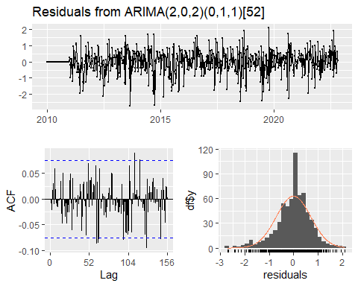
##
## Ljung-Box test
##
## data: Residuals from ARIMA(2,0,2)(0,1,1)[52]
## Q* = 92.288, df = 99, p-value = 0.6702
##
## Model df: 5. Total lags used: 104
Jika Ljung-Box p-value < 0.05, residual belum memenuhi asumsi white noise. Ini berarti masih ada autokorelasi yang belum ditangkap model. Langkah selanjutnya adalah mencoba model dengan ordo yang lebih tinggi untuk menyerap sisa autokorelasi tersebut.
# gunakan model yang telah diperbaiki
# best_sarima <- best_sarima_improved
best_sarima <- sarima_8
checkresiduals(best_sarima)
##
## Ljung-Box test
##
## data: Residuals from ARIMA(2,0,2)(0,1,1)[52]
## Q* = 92.288, df = 99, p-value = 0.6702
##
## Model df: 5. Total lags used: 104
# =========================
# TRAIN PERFORMANCE
# =========================
yhat_sarima_train <- expm1(as.numeric(fitted(best_sarima)))
actual_sarima_train <- as.numeric(train_weekly_ts)
cat(
"\nSARIMA RMSE (train):",
round(rmse(actual_sarima_train, yhat_sarima_train), 4),
"\n\n"
)
##
## SARIMA RMSE (train): 24.4486
# =========================
# TEST FORECAST
# =========================
fc_sarima <- forecast(
best_sarima,
h = length(test_weekly_ts)
)
yhat_sarima_test <- expm1(as.numeric(fc_sarima$mean))
actual_sarima_test <- as.numeric(test_weekly_ts)
result_sarima <- eval_metrics(
actual_sarima_test,
yhat_sarima_test,
"SARIMA (Test)"
)
## SARIMA (Test)
## RMSE: 29.4886 | MAE: 20.839 | MAPE: 908.05 %
rmse_sarima <- result_sarima$RMSE
mae_sarima <- result_sarima$MAE
mape_sarima <- result_sarima$MAPE
result_sarima
## Model RMSE MAE MAPE
## 1 SARIMA (Test) 29.4886 20.839 908.05
fc_sarima_df <- data.frame(
week = test_df$week_start,
mean = as.numeric(fc_sarima$mean),
lower80 = fc_sarima$lower[,1],
upper80 = fc_sarima$upper[,1],
lower95 = fc_sarima$lower[,2],
upper95 = fc_sarima$upper[,2]
)
actual_weekly_df <- data.frame(
week = test_df$week_start,
actual = as.numeric(test_weekly_log)
)
ggplot() +
geom_line(
data = actual_weekly_df,
aes(x = week, y = actual, color = "Actual"),
linewidth = 0.8
) +
geom_ribbon(
data = fc_sarima_df,
aes(x = week, ymin = lower95, ymax = upper95),
fill = "#9E9AC8",
alpha = 0.35
) +
geom_ribbon(
data = fc_sarima_df,
aes(x = week, ymin = lower80, ymax = upper80),
fill = "#6A51A3",
alpha = 0.45
) +
geom_line(
data = fc_sarima_df,
aes(x = week, y = mean, color = "Forecast"),
linewidth = 0.9
) +
scale_color_manual(
values = c(
"Actual" = "black",
"Forecast" = "#2166AC"
)
) +
labs(
title = "SARIMA Forecast vs Actual (Weekly, log scale)",
x = "Week",
y = "log(1 + Rainfall)",
color = NULL
) +
theme_bw(base_size = 11) +
theme(
plot.title = element_text(face = "bold"),
legend.position = "top"
)
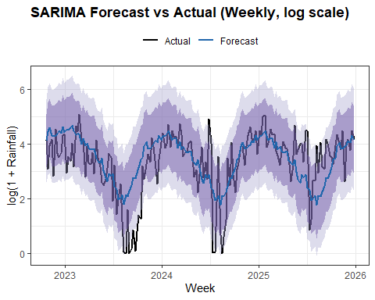
resid_sarima <- residuals(best_sarima)
fitted_sarima <- as.numeric(fitted(best_sarima))
par(mfrow = c(2, 2))
plot(
fitted_sarima,
resid_sarima,
pch = 16,
col = "#378ADD",
main = "Residuals vs Fitted - SARIMA",
xlab = "Fitted (log scale)",
ylab = "Residuals"
)
abline(h = 0, col = "#D73027", lty = 2)
hist(
resid_sarima,
breaks = 15,
col = "#74ADD1",
border = "white",
main = "Histogram of Residuals - SARIMA",
xlab = "Residuals"
)
qqnorm(
resid_sarima,
main = "Q-Q Plot - SARIMA Residuals",
col = "#378ADD",
pch = 16
)
qqline(
resid_sarima,
col = "#D73027",
lwd = 2
)
acf(
resid_sarima,
main = "ACF of Residuals - SARIMA"
)
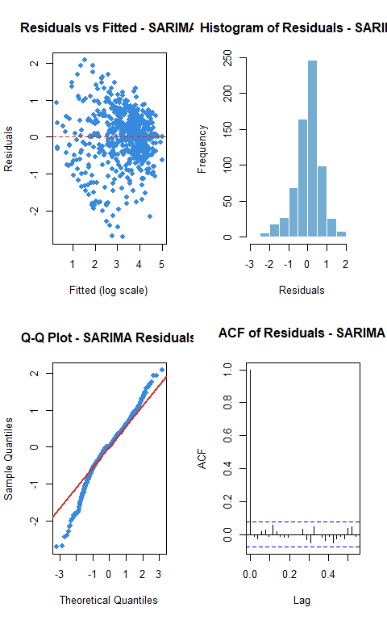
par(mfrow = c(1,1))
# SARIMA train metrics (add to your script)
yhat_arima_train <- expm1(as.numeric(fitted(best_sarima)))
actual_train <- as.numeric(train_weekly_ts)
idx_tr <- actual_train > 0
cat("SARIMA Train RMSE:", round(rmse(actual_train, yhat_sarima_train), 4), "\n")
## SARIMA Train RMSE: 24.4486
cat("SARIMA Train MAE :", round(mae(actual_train, yhat_sarima_train), 4), "\n")
## SARIMA Train MAE : 16.6414
cat("SARIMA Train MAPE:", round(mean(abs((actual_train[idx_tr] - yhat_sarima_train[idx_tr]) /
actual_train[idx_tr])) * 100, 2), "%\n")
## SARIMA Train MAPE: 217.43 %

9.5 Neural Network, LSTM, GRU
NN, LSTM, dan GRU dijalankan di Google Colab menggunakan data bulanan yang sama. Hasil dari Colab dimasukkan di section 9.6.

9.6 Model Comparison Summary
Catatan MAPE: MAPE dapat tidak stabil saat nilai aktual mendekati nol. RMSE dan MAE lebih diutamakan sebagai metrik perbandingan utama.
# dari Google Collab
rmse_nn_test <- 33.1963
mae_nn_test <- 22.6467
mape_nn_test <- 1614.42
rmse_lstm_test <- 32.4571
mae_lstm_test <- 23.1068
mape_lstm_test <- 1803.6199951171875
rmse_gru_test <- 33.478
mae_gru_test <- 23.4008
mape_gru_test <- 1450.3499755859375
comparison_table <- data.frame(
Model = c(
"Seasonal Naive",
"TSR Seasonal",
"ARIMA",
"SARIMA",
"Neural Network",
"LSTM",
"GRU"
),
RMSE = round(c(
result_snaive_test$RMSE,
rmse_tsr, rmse_arima, rmse_sarima,
rmse_nn_test, rmse_lstm_test, rmse_gru_test
), 4),
MAE = round(c(
result_snaive_test$MAE,
mae_tsr, mae_arima, mae_sarima,
mae_nn_test, mae_lstm_test, mae_gru_test
), 4),
MAPE = round(c(
result_snaive_test$MAPE,
mape_tsr, mape_arima, mape_sarima,
mape_nn_test, mape_lstm_test, mape_gru_test
), 2)
)
# order by RMSE (smallest = best)
comparison_table <- comparison_table[
order(comparison_table$RMSE),
]
knitr::kable(
comparison_table,
caption = "Final Model Comparison - Weekly Test Set (Ordered by RMSE)"
)
Final Model Comparison - Weekly Test Set (Ordered by RMSE)
 | Model | RMSE | MAE | MAPE
2 | TSR Seasonal | 26.9513 | 20.3781 | 1890.25
4 | SARIMA | 29.4886 | 20.8390 | 908.05
6 | LSTM | 32.4571 | 23.1068 | 1803.62
5 | Neural Network | 33.1963 | 22.6467 | 1614.42
7 | GRU | 33.4780 | 23.4008 | 1450.35
3 | ARIMA | 34.4754 | 25.4518 | 2802.74
1 | Seasonal Naive | 39.3476 | 30.2422 | 2725.90
library(ggplot2)
comp_plot <- comparison_table[!is.na(comparison_table$RMSE), ]
modelCom <- ggplot(comp_plot, aes(x = reorder(Model, RMSE), y = RMSE, fill = RMSE)) +
geom_col(width = 0.6, alpha = 0.85) +
geom_text(aes(label = round(RMSE, 1)), hjust = -0.1, size = 3.5) +
coord_flip() +
scale_fill_gradient(low = "#74ADD1", high = "#D73027") +
scale_y_continuous(limits = c(0, max(comp_plot$RMSE) * 1.2)) +
labs(title = "Model Comparison - RMSE on Weekly Test Set",
subtitle = "Lower RMSE = better | Baseline models shown for reference",
x = NULL, y = "RMSE (mm/week)") +
theme_bw(base_size = 11) +
theme(plot.title = element_text(face = "bold"), legend.position = "none")

MORE PLOTS
snaive_fc <- snaive(
train_weekly_ts,
h = length(test_weekly_ts)
)
yhat_snaive <- as.numeric(snaive_fc$mean)
df_snaive <- data.frame(
Index = seq_along(test_weekly_ts),
Actual = as.numeric(test_weekly_ts),
Forecast = yhat_snaive
)
pNaive <- ggplot(df_snaive, aes(Index)) +
geom_line(aes(y = Actual, color = "Actual")) +
geom_line(aes(y = Forecast, color = "Seasonal Naive")) +
labs(
title = "Seasonal Naive Forecast vs Actual",
x = "Week Index",
y = "Rainfall (mm/week)"
) +
scale_color_manual(values = c(
"Actual" = "black",
"Seasonal Naive" = "#2C7FB8"
)) +
theme_bw()
df_tsr <- data.frame(
Index = seq_along(actual_tsr),
Actual = actual_tsr,
Forecast = yhat_tsr
)
p_tsr <- ggplot(df_tsr, aes(Index)) +
geom_line(aes(y = Actual, color = "Actual")) +
geom_line(aes(y = Forecast, color = "TSR")) +
labs(
title = "TSR Forecast vs Actual",
x = "Week Index",
y = "Rainfall (mm/week)"
) +
scale_color_manual(values = c(
"Actual" = "black",
"TSR" = "#2C7FB8"
)) +
theme_bw()
p_tsr
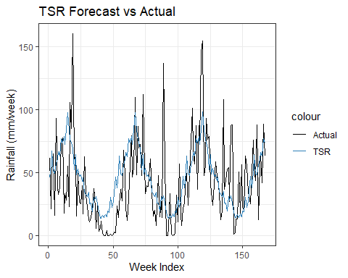
ggsave(
"05_TSR.png",
p_tsr,
width = 10,
height = 5,
dpi = 300
)
df_arima <- data.frame(
Index = seq_along(actual_arima_test),
Actual = actual_arima_test,
Forecast = yhat_arima_test
)
pARIMA <- ggplot(df_arima, aes(Index)) +
geom_line(aes(y = Actual, color = "Actual")) +
geom_line(aes(y = Forecast, color = "ARIMA")) +
labs(
title = "ARIMA Forecast vs Actual",
x = "Week Index",
y = "Rainfall (mm/week)"
) +
scale_color_manual(values = c(
"Actual" = "black",
"ARIMA" = "#2C7FB8"
)) +
theme_bw()
df_sarima <- data.frame(
Index = seq_along(actual_sarima_test),
Actual = actual_sarima_test,
Forecast = yhat_sarima_test
)
pSARIMA <- ggplot(df_sarima, aes(Index)) +
geom_line(aes(y = Actual, color = "Actual")) +
geom_line(aes(y = Forecast, color = "SARIMA")) +
labs(
title = "SARIMA Forecast vs Actual",
x = "Week Index",
y = "Rainfall (mm/week)"
) +
scale_color_manual(values = c(
"Actual" = "black",
"SARIMA" = "#2C7FB8"
)) +
theme_bw()
ggsave(
filename = "compareW.png",
plot = modelCom,
width = 10,
height = 5,
dpi = 300
)

