code_eda_reliability

Library
library(readxl)
library(dplyr)
##
## Attaching package: 'dplyr'
## The following objects are masked from 'package:stats':
##
## filter, lag
## The following objects are masked from 'package:base':
##
## intersect, setdiff, setequal, union
library(tidyr)
library(ggplot2)
library(psych)
##
## Attaching package: 'psych'
## The following objects are masked from 'package:ggplot2':
##
## %+%, alpha
library(corrplot)
## corrplot 0.95 loaded
library(lavaan)
## This is lavaan 0.6-21
## lavaan is FREE software! Please report any bugs.
##
## Attaching package: 'lavaan'
## The following object is masked from 'package:psych':
##
## cor2cov
library(semPlot)
library(semTools)
##
## ###############################################################################
## This is semTools 0.5-8
## All users of R (or SEM) are invited to submit functions or ideas for functions.
## ###############################################################################
##
## Attaching package: 'semTools'
## The following objects are masked from 'package:psych':
##
## reliability, skew

Load Data
data <- read_excel("/Users/vaniawyanet/Documents/SEMS_6/MULTIVARIATE/kuesioner_aol.xlsx")
item_vars <- paste0("x", 1:24)

EDA
# Descriptive statistics per item
describe(data[, item_vars])
## vars n mean sd median trimmed mad min max range skew kurtosis se
## x1 1 104 3.88 1.47 4 3.92 1.48 1 6 5 -0.20 -1.06 0.14
## x2 2 104 3.05 1.47 3 2.94 1.48 1 6 5 0.53 -0.50 0.14
## x3 3 104 3.11 1.47 3 3.06 1.48 1 6 5 0.31 -0.99 0.14
## x4 4 104 4.00 1.31 4 4.07 1.48 1 6 5 -0.48 -0.22 0.13
## x5 5 104 3.11 1.37 3 3.02 1.48 1 6 5 0.53 -0.65 0.13
## x6 6 104 4.12 1.16 4 4.18 1.48 1 6 5 -0.39 -0.15 0.11
## x7 7 104 2.79 1.52 2 2.65 1.48 1 6 5 0.70 -0.66 0.15
## x8 8 104 3.89 1.55 4 3.94 1.48 1 6 5 -0.23 -1.16 0.15
## x9 9 104 3.60 1.45 4 3.58 1.48 1 6 5 -0.02 -1.08 0.14
## x10 10 104 4.57 1.16 5 4.69 1.48 1 6 5 -0.80 0.58 0.11
## x11 11 104 3.50 1.63 4 3.50 1.48 1 6 5 -0.03 -1.20 0.16
## x12 12 104 4.19 1.34 4 4.31 1.48 1 6 5 -0.71 -0.02 0.13
## x13 13 104 4.43 0.96 5 4.48 1.48 2 6 4 -0.55 0.19 0.09
## x14 14 104 4.57 0.90 5 4.60 1.48 2 6 4 -0.40 -0.35 0.09
## x15 15 104 4.76 1.02 5 4.86 1.48 2 6 4 -0.71 0.00 0.10
## x16 16 104 4.33 1.18 4 4.39 1.48 2 6 4 -0.36 -0.73 0.12
## x17 17 104 3.71 1.31 4 3.74 1.48 1 6 5 -0.23 -0.79 0.13
## x18 18 104 3.67 1.29 4 3.67 1.48 1 6 5 -0.03 -0.77 0.13
## x19 19 104 3.81 1.29 4 3.79 1.48 1 6 5 0.00 -0.87 0.13
## x20 20 104 3.53 1.39 3 3.50 1.48 1 6 5 0.09 -0.94 0.14
## x21 21 104 3.62 1.36 4 3.63 1.48 1 6 5 -0.09 -1.02 0.13
## x22 22 104 4.63 1.13 5 4.76 1.48 1 6 5 -0.89 0.50 0.11
## x23 23 104 4.58 1.07 5 4.64 1.48 2 6 4 -0.44 -0.44 0.10
## x24 24 104 4.79 0.96 5 4.87 1.48 2 6 4 -0.67 0.34 0.09
# Compute dimension scores
data <- data %>%
mutate(
sum_afektif = x1 + x2 + x3 + x4,
sum_kognitif = x5 + x6 + x7 + x8,
sum_perilaku = x9 + x10 + x11 + x12,
sum_sosmed = sum_afektif + sum_kognitif + sum_perilaku,
sum_diri_positif = x13 + x14 + x15 + x16,
sum_diri_negatif = x17 + x18 + x19 + x20,
sum_penerimaan = x21 + x22 + x23 + x24,
sum_self_esteem = sum_diri_positif + sum_diri_negatif + sum_penerimaan
)
# Descriptive statistics per dimension
dim_vars <- c("sum_afektif", "sum_kognitif", "sum_perilaku", "sum_sosmed",
"sum_diri_positif", "sum_diri_negatif", "sum_penerimaan", "sum_self_esteem")
describe(data[, dim_vars])
## vars n mean sd median trimmed mad min max range skew
## sum_afektif 1 104 14.04 4.43 14.0 14.06 4.45 4 24 20 -0.02
## sum_kognitif 2 104 13.91 4.20 14.0 13.81 4.45 5 24 19 0.28
## sum_perilaku 3 104 15.86 4.32 16.0 15.95 4.45 4 24 20 -0.23
## sum_sosmed 4 104 43.81 11.63 43.5 43.62 12.60 13 72 59 0.11
## sum_diri_positif 5 104 18.09 3.41 19.0 18.19 2.97 8 24 16 -0.42
## sum_diri_negatif 6 104 14.72 3.61 15.0 14.62 2.97 8 24 16 0.24
## sum_penerimaan 7 104 17.62 3.05 17.0 17.57 2.97 10 24 14 0.11
## sum_self_esteem 8 104 50.43 8.57 51.0 50.35 7.41 30 72 42 0.14
## kurtosis se
## sum_afektif -0.51 0.43
## sum_kognitif -0.18 0.41
## sum_perilaku -0.03 0.42
## sum_sosmed 0.05 1.14
## sum_diri_positif -0.15 0.33
## sum_diri_negatif -0.08 0.35
## sum_penerimaan -0.22 0.30
## sum_self_esteem 0.19 0.84
# Histogram of total scores
par(mfrow = c(1, 2))
hist(data$sum_sosmed,
main = "Total Score Distribution\nSocial Media Usage",
xlab = "Total Score (x1–x12)",
col = "#2E5FA3", border = "white", breaks = 10)
abline(v = mean(data$sum_sosmed), col = "red", lwd = 2, lty = 2)
legend("topright",
legend = paste("Mean =", round(mean(data$sum_sosmed), 2)),
col = "red", lty = 2, cex = 0.8)
hist(data$sum_self_esteem,
main = "Total Score Distribution\nSelf-Esteem",
xlab = "Total Score (x13–x24)",
col = "#E07B39", border = "white", breaks = 10)
abline(v = mean(data$sum_self_esteem), col = "red", lwd = 2, lty = 2)
legend("topright",
legend = paste("Mean =", round(mean(data$sum_self_esteem), 2)),
col = "red", lty = 2, cex = 0.8)
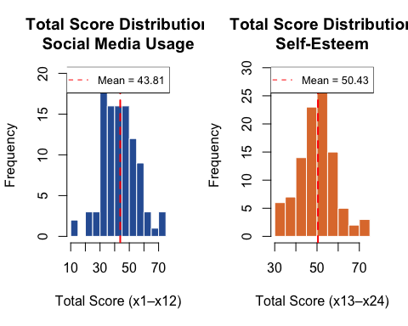
par(mfrow = c(1, 1))
# Boxplot per dimension
dim_6 <- c("sum_afektif", "sum_kognitif", "sum_perilaku",
"sum_diri_positif", "sum_diri_negatif", "sum_penerimaan")
label_6 <- c("Aff.", "Cog.", "Beh.", "Pos.Self", "Neg.Self", "Self-Acc.")
boxplot(data[, dim_6],
names = label_6,
main = "Dimension Score Boxplots",
ylab = "Score",
col = c(rep("#2E5FA3", 3), rep("#E07B39", 3)),
border = c(rep("#1a3a6e", 3), rep("#a0522d", 3)),
las = 1)
legend("topright",
legend = c("Social Media", "Self-Esteem"),
fill = c("#2E5FA3", "#E07B39"),
border = c("#1a3a6e", "#a0522d"),
cex = 0.85)
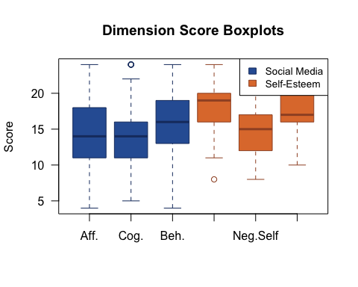
# Heatmap
cor_matrix <- cor(data[, item_vars], use = "complete.obs")
corrplot(cor_matrix,
method = "color",
type = "full",
tl.cex = 0.7, tl.col = "black",
col = colorRampPalette(c("#2166AC", "white", "#D6604D"))(200),
addCoef.col = "black",
number.cex = 0.35,
title = "Correlation Heatmap — All 24 Items",
mar = c(0, 0, 1.5, 0))
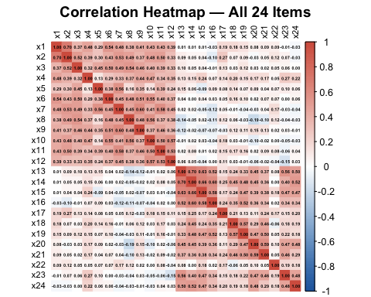

Data Preparation
# Missing values
missing_count <- colSums(is.na(data[, item_vars]))
missing_count
## x1 x2 x3 x4 x5 x6 x7 x8 x9 x10 x11 x12 x13 x14 x15 x16 x17 x18 x19 x20
## 0 0 0 0 0 0 0 0 0 0 0 0 0 0 0 0 0 0 0 0
## x21 x22 x23 x24
## 0 0 0 0
# Duplicate rows
dup_count <- sum(duplicated(data[, item_vars]))
dup_count
## [1] 2
if (dup_count > 0) print(which(duplicated(data[, item_vars])))
## [1] 62 82
# Scale range check (expected: 1–6)
range_check <- sapply(data[, item_vars], range)
min(range_check) # Global Min
## [1] 1
max(range_check) # Global Max
## [1] 6
# Outlier detection (z-score, threshold |z| > 3)
z_scores <- scale(data[, item_vars])
outlier_rows <- which(apply(abs(z_scores) > 3, 1, any))
outlier_cells <- which(abs(z_scores) > 3, arr.ind = TRUE)
# row with at least 1 outlier
length(outlier_rows)
## [1] 3
for (i in seq_len(nrow(outlier_cells))) {
r <- outlier_cells[i, 1]; c <- outlier_cells[i, 2]
cat(sprintf(" Row %d, %s: value = %g, z = %.3f\n",
r, item_vars[c], data[[item_vars[c]]][r], z_scores[r, c]))
}
## Row 23, x10: value = 1, z = -3.065
## Row 76, x10: value = 1, z = -3.065
## Row 70, x22: value = 1, z = -3.209
# Final clean dataset (24 items only, no sum columns)
data_clean <- data[, item_vars]
nrow(data_clean)
## [1] 104
ncol(data_clean)
## [1] 24

Validity Testing
uji_item_total <- function(items, skor_total, nama_dimensi) {
cat(sprintf("\n>> Dimension: %s (n items = %d)\n", nama_dimensi, length(items)))
cat(sprintf("%-6s %-10s %-10s %-12s %s\n",
"Item", "r (cor)", "t-stat", "p-value", "Decision"))
cat(strrep("-", 55), "\n")
results <- list()
for (item in items) {
ct <- cor.test(data[[item]], skor_total)
valid <- ifelse(ct$p.value < 0.05, "VALID ✓", "NOT VALID ✗")
cat(sprintf("%-6s %-10.4f %-10.4f %-12.6f %s\n",
item, ct$estimate, ct$statistic, ct$p.value, valid))
results[[item]] <- list(r = ct$estimate, t = ct$statistic,
p = ct$p.value, valid = (ct$p.value < 0.05))
}
return(invisible(results))
}
r_afektif <- uji_item_total(c("x1","x2","x3","x4"),
data$sum_afektif, "Affective (Social Media)")
##
## >> Dimension: Affective (Social Media) (n items = 4)
## Item r (cor) t-stat p-value Decision
## -------------------------------------------------------
## x1 0.8275 14.8870 0.000000 VALID ✓
## x2 0.8516 16.4086 0.000000 VALID ✓
## x3 0.7202 10.4847 0.000000 VALID ✓
## x4 0.6898 9.6215 0.000000 VALID ✓
r_kognitif <- uji_item_total(c("x5","x6","x7","x8"),
data$sum_kognitif, "Cognitive (Social Media)")
##
## >> Dimension: Cognitive (Social Media) (n items = 4)
## Item r (cor) t-stat p-value Decision
## -------------------------------------------------------
## x5 0.6956 9.7785 0.000000 VALID ✓
## x6 0.7432 11.2182 0.000000 VALID ✓
## x7 0.8359 15.3783 0.000000 VALID ✓
## x8 0.7181 10.4211 0.000000 VALID ✓
r_perilaku <- uji_item_total(c("x9","x10","x11","x12"),
data$sum_perilaku, "Behavioral (Social Media)")
##
## >> Dimension: Behavioral (Social Media) (n items = 4)
## Item r (cor) t-stat p-value Decision
## -------------------------------------------------------
## x9 0.7193 10.4583 0.000000 VALID ✓
## x10 0.7593 11.7852 0.000000 VALID ✓
## x11 0.8296 15.0075 0.000000 VALID ✓
## x12 0.7792 12.5537 0.000000 VALID ✓
r_dp <- uji_item_total(c("x13","x14","x15","x16"),
data$sum_diri_positif, "Positive Self (Self-Esteem)")
##
## >> Dimension: Positive Self (Self-Esteem) (n items = 4)
## Item r (cor) t-stat p-value Decision
## -------------------------------------------------------
## x13 0.8331 15.2136 0.000000 VALID ✓
## x14 0.8650 17.4133 0.000000 VALID ✓
## x15 0.8488 16.2136 0.000000 VALID ✓
## x16 0.8212 14.5320 0.000000 VALID ✓
r_dn <- uji_item_total(c("x17","x18","x19","x20"),
data$sum_diri_negatif, "Negative Self (Self-Esteem)")
##
## >> Dimension: Negative Self (Self-Esteem) (n items = 4)
## Item r (cor) t-stat p-value Decision
## -------------------------------------------------------
## x17 0.5238 6.2106 0.000000 VALID ✓
## x18 0.7442 11.2533 0.000000 VALID ✓
## x19 0.7833 12.7251 0.000000 VALID ✓
## x20 0.6912 9.6596 0.000000 VALID ✓
r_pd <- uji_item_total(c("x21","x22","x23","x24"),
data$sum_penerimaan, "Self-Acceptance (Self-Esteem)")
##
## >> Dimension: Self-Acceptance (Self-Esteem) (n items = 4)
## Item r (cor) t-stat p-value Decision
## -------------------------------------------------------
## x21 0.7180 10.4186 0.000000 VALID ✓
## x22 0.5169 6.0989 0.000000 VALID ✓
## x23 0.7805 12.6076 0.000000 VALID ✓
## x24 0.6780 9.3166 0.000000 VALID ✓
# Summary
all_results <- list(r_afektif, r_kognitif, r_perilaku, r_dp, r_dn, r_pd)
all_valid <- all(sapply(unlist(all_results, recursive = FALSE), function(x) x$valid))
all_valid # if pval < 0.05 -> TRUE
## [1] TRUE

Reliability Testing
# Cronbach's Alpha per first-order dimension (threshold: α ≥ 0.50)
hitung_alpha <- function(items, nama) {
a <- psych::alpha(data_clean[, items])
cat(sprintf("%-24s : alpha = %.4f -> %s\n",
nama,
a$total$raw_alpha,
ifelse(a$total$raw_alpha >= 0.50, "RELIABLE ✓", "NOT RELIABLE ✗")))
return(invisible(a$total$raw_alpha))
}
alpha_afektif <- hitung_alpha(c("x1","x2","x3","x4"), "Affective")
## Affective : alpha = 0.7765 -> RELIABLE ✓
alpha_kognitif <- hitung_alpha(c("x5","x6","x7","x8"), "Cognitive")
## Cognitive : alpha = 0.7332 -> RELIABLE ✓
alpha_perilaku <- hitung_alpha(c("x9","x10","x11","x12"), "Behavioral")
## Behavioral : alpha = 0.7690 -> RELIABLE ✓
alpha_dp <- hitung_alpha(c("x13","x14","x15","x16"), "Positive Self")
## Positive Self : alpha = 0.8568 -> RELIABLE ✓
alpha_dn <- hitung_alpha(c("x17","x18","x19","x20"), "Negative Self")
## Negative Self : alpha = 0.6221 -> RELIABLE ✓
alpha_pd <- hitung_alpha(c("x21","x22","x23","x24"), "Self-Acceptance")
## Self-Acceptance : alpha = 0.5872 -> RELIABLE ✓

save dataset
# write.csv(data_clean,
# "/Users/vaniawyanet/Documents/SEMS_6/MULTIVARIATE/kuesioner_clean.csv",
# row.names = FALSE)

