Freight Rate Prediction - Approach & Validation Report

1. Data and problem
Labeled data: 48,000 loads from 2025-01-01 to 2025-10-31. Target loads: 12,000 loads from 2025-11-01 to 2025-12-31 (no labels). The target period is entirely in the FUTURE of the labeled data, so the model has to extrapolate in time, not only interpolate.

2. Split and validation approach
- Random K-fold was rejected: it mixes months, lets the model see the market regime of the test period and gives optimistic scores.
- Rolling-origin temporal validation instead: train on months <= 6 and test on 7-8; train <= 7 test 8-9; train <= 8 test 9-10. Each fold mimics the real task (train on the past, predict the future).
- Corrupted-label filtering is fitted on the training part of each fold only (no test leakage). Errors are reported both on all rows and on non-corrupted labels, since ~1.4% of labels are unpredictable noise and dominate RMSE.
- Metrics: MAE, RMSE, MAPE and median APE. A baseline (median rate-per-mile by equipment x distance) is included.
- Unseen-city stress test: 8 cities never appear in train but appear in the target set (12% of target rows). I hold out 8 cities from training and score loads touching them.

3. Data-quality issues and handling
Issue | What I found | Handling
Corrupted labels (677 rows, 1.4%) | Rate per mile is 0.2-0.4x or 2.2-5.4x the expected value, spread evenly over months/equipment. | Flagged with an out-of-fold robust model (|log residual| > 0.30) and removed from training only. They are not removed from evaluation of 'all rows'.
weight: 300 missing in train, 165 in target | Missing values. | Median by equipment (learned on train) + missing indicator.
weight: 292 negative values | Sign errors (absolute value looks plausible). | abs() + indicator.
weight: ~1,200 rows exactly at +/-47,500 | Values are capped/censored. | Clipped to 47,500; tree model handles the pile-up.
market_index: 374 missing train / 249 target | Missing; is a daily series plus small noise. | Not used in the final model (see below).
distance vs coordinates | Reported distance is road distance (~1.18x haversine); 214 rows have ratio > 1.5. | Added haversine and distance/haversine ratio features. No rows dropped.
Unseen cities | 8 cities in the target set are absent from train. | No city-ID or target encoding; geography enters through coordinates (constant per city) and distance, so new cities work. Stress test shows only ~0.1 pp MAPE degradation.

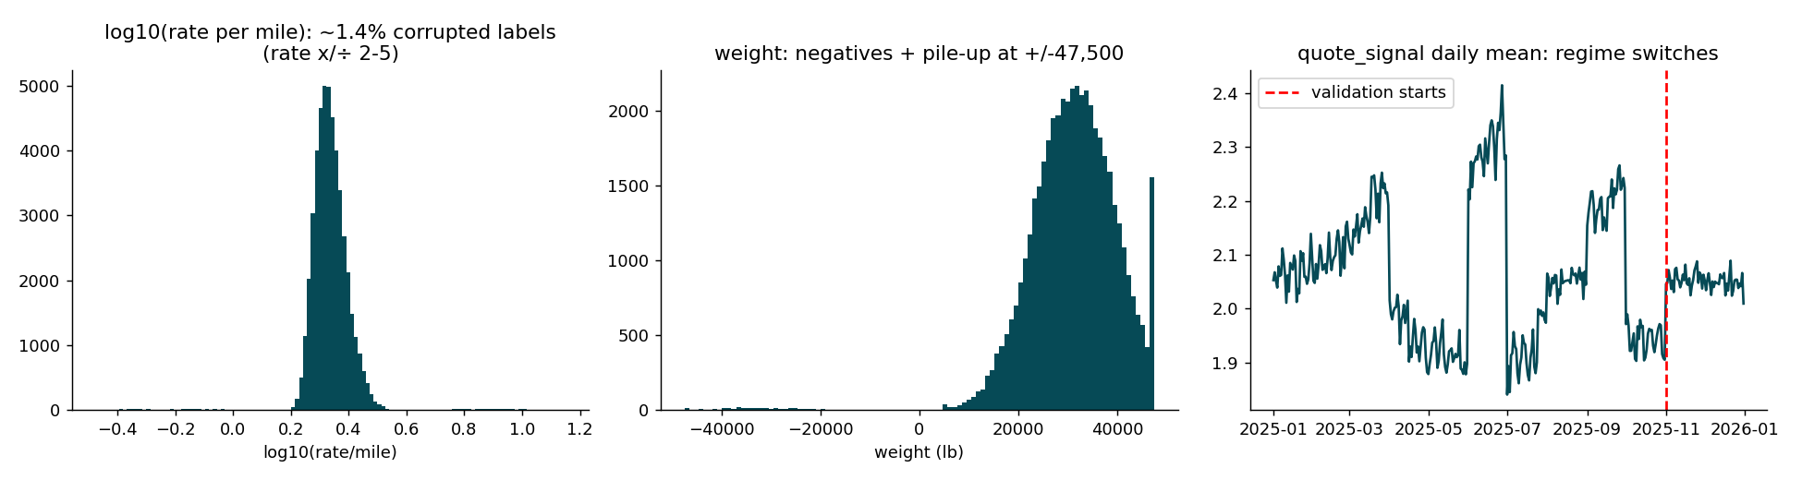

4. Model
- Target: log(rate per mile). Rate is ~linear in distance (corr 0.91); modelling the per-mile rate removes that effect and makes errors relative. Predictions = exp(pred) x distance.
- Model: mean (in log space) of two scikit-learn HistGradientBoostingRegressor models, one with squared-error loss and one with absolute-error loss (robust to residual noise). Gradient boosting captures interactions such as equipment x distance x geography without manual engineering.
- Features: distance, log distance, cleaned weight (+ flags), equipment, pickup/delivery coordinates, haversine, distance ratio, day of week.
- Excluded on evidence: market_index (worse in every fold - it drifts and the target period sits at a level rarely seen in training) and quote_signal (see section 5).

5. Results (mean over the 3 rolling folds)
Configuration (clean labels) | MAE $ | RMSE $ | MAPE | MdAPE
baseline: median rpm x distance | 178.1 | 264.0 | 8.07% | 6.74%
final (features as chosen) | 46.0 | 67.7 | 1.94% | 1.64%
with market_index | 91.5 | 122.2 | 3.84% | 3.61%
with market_index (daily mean) | 94.1 | 125.2 | 3.94% | 3.74%
with quote_signal | 62.3 | 99.9 | 2.88% | 1.67%
without coordinates | 58.7 | 81.2 | 2.69% | 2.26%
without day-of-week | 48.6 | 71.5 | 2.04% | 1.72%
without haversine/ratio | 45.9 | 67.5 | 1.94% | 1.63%

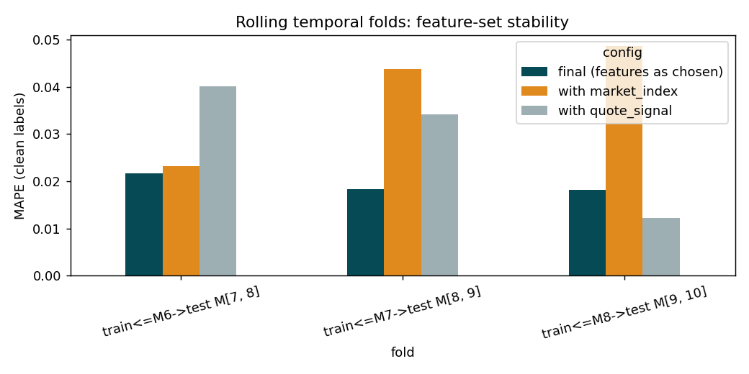
quote_signal judgement call: it helps strongly only in the last fold (MAPE 1.2% vs 1.8%), where the training window already contains the same regime, and hurts in the two older folds (3.4-4.0% vs 1.8-2.2%). Its daily mean switches between regimes (~1.9 / ~2.05 / ~2.25) and its relation to price is U-shaped, so it is not stable over time. Because the target period is unseen, I chose the option that is robust across all folds. Relative variants (signal minus daily mean, ratio) did not fix this.
Unseen-city test (last fold, clean labels): MAPE 1.84% with the cities in training vs 1.95% without them.

6. Fixed December prediction chart
Produced with the provided score.py. The chart inputs contain no market_index/quote_signal, which is one more reason the final model does not rely on them. Only the date changes, so the curve reflects the learned day-of-week pattern (~+/-1%). The model has no information about December-specific demand (holidays, seasonality) because no December labels exist; the chart should not be read as a forecast of trend.
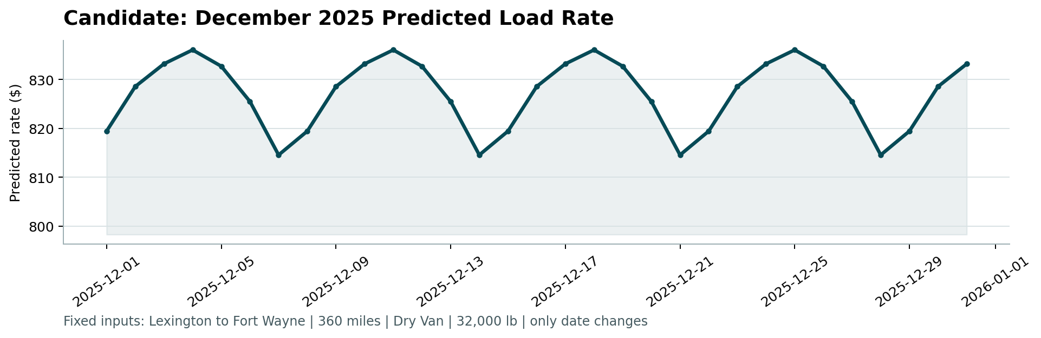

7. Limitations
- Label noise (1.4%) is unpredictable; all-row RMSE stays ~620 regardless of model.
- No labels for Nov-Dec: a market-level shift in these months cannot be learned and would add a bias to all predictions.
- The validation-set regime of quote_signal could make it useful; I kept it out for robustness, at a measurable cost in the best-case fold.

