**Table of Contents**

**JDBC**

**Servlet/Jsp**

[JDBC Tutorial | What is Java Database Connectivity(JDBC) - javatpoint](https://www.javatpoint.com/java-jdbc)

**JDBC:-** JDBC is a Java API to connect and execute the query with the database. It is a part of JavaSE (Java Standard Edition). JDBC API uses JDBC drivers to connect with the database. There are four types of JDBC drivers:

* JDBC-ODBC Bridge Driver,
* Native Driver,
* Network Protocol Driver, and
* Thin Driver

Database:-1.CUI2.GUI3.API-----a. Using V.S. API(vendor specific api)b. Using ODBC(Open Databse Connectivity) APIc. Using Jdbc(Java Database Connectivity) API----- a. jdbc api (java.sql) b. jdbc driver (venders jar)JDBC Drivers-:1. Type 1 (Jdbc-Odbc Bridge)2. Type 2 (Native Driver)3. Type 3 (Network Protocol Driver)4. Type 4 (Thin Driver)d. ORM (Object Relational Mapping)Koi bhi database hain wo teen tarike ke option deta hain datastore krne ke liye

* Command line and workbench cui hain
* Table bina command ke create krna work bench main option hota hainuse gui bolte hain
* Kisi bhi database main data store krna ho to uske liye API use krte hain -inbuilt library and predefined funcationlity in any programming langaunge is called api.

**\*\*\*\*\*\*\*\*\*\*\*\*\*\*Har database khud main ek vender specific hota hain**

Har database ki apnni **API** hoti hain aur jitane bhi database hain unki coding ki gayi hogi kisi na kisi bhasha main but muje nahi pata hain kis bhasha main ki gayi hain

Aur sab database ke andar kuch na kuch functions hote hain aur uske andar engine bhi hote hain jise mysql engine bhi kahate hain

**Jab apko java ke program main for example mysql database ko use krna to uski api ko program main lana hoga aur usko implement krna hoga but ye implement krna iatana asaan nahi hain wo jis lenaguage hoga usi api main imeplement krna hoga aur apne kr bhi diya to agar apko dusra database use krna hain to phir apko phir hatan hain padega phir jis use kerna chahate hain to uske liye implemention krna padega.**

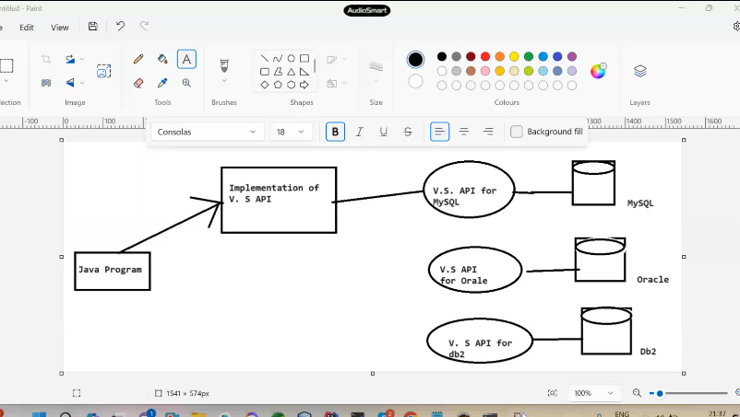

**Aur uske baad Microsoft wale odbc ka concept le ke aye isme inhone c languanee jitane bhi database hain unko ek jagah per likh diya aur uska naam odbc api rakh diya aur unhone odbce driver and ***odbc api dono ko purea naam odbc rakh diya \*\*\*\*\***

**Odbc driver nothing but odbc driver is the imp of odbc api**

**Odbc kewal Microsoft mai kewal windos available hota hain mac,linux mai nahi hota hain ye iske saath ek samsya hoti hain aur platform dependent bhi hoti thi**

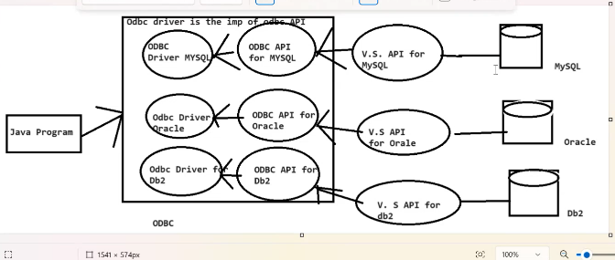

**Jdbc api java main hoti hain aur isme bhi dono cheez hoti hain ek jdbc driver aur dusra jdbc api aur isko java main likha gaya hain aur ye platform independt hain -jdbc api java language main hain**

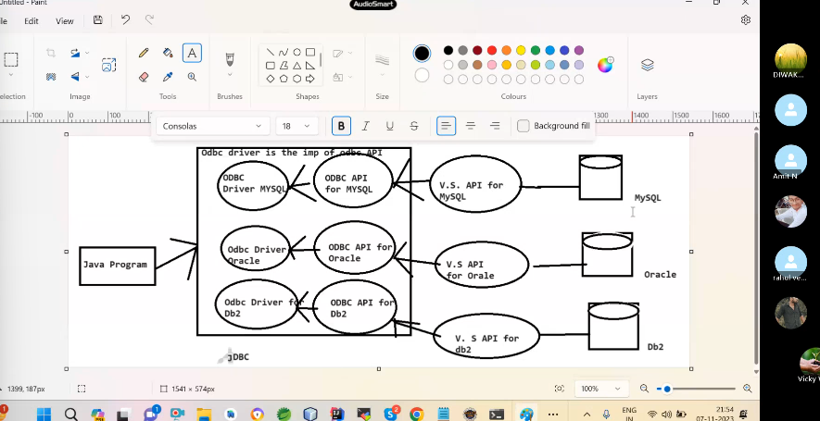

 A list of popular *interfaces* of JDBC API are given below:

* Driver interface
* Connection interface
* Statement interface
* PreparedStatement interface
* CallableStatement interface
* ResultSet interface
* ResultSetMetaData interface
* DatabaseMetaData interface
* RowSet interface

A list of popular *classes* of JDBC API are given below:

* DriverManager class
* Blob class
* Clob class
* Types class

### Jdbc1. Jdbc Api (java.sql)a)- Driver (I)b)- DriverManager (C)c)- Connection (I)d)- Statement (I)e)- PreparedStatement (I)f)- ResultSet (I)g)- RessultSetMeteData (I)f)- DatabaseMeteData (I)h)- SQlException (C)I)- CallableStatemnt(I)2. Jdbc Driver---imp of all jdbc Api.Venders jar file.Why Should We Use JDBC

Before JDBC, ODBC API was the database API to connect and execute the query with the database. But, ODBC API uses ODBC driver which is written in C language (i.e. platform dependent and unsecured). That is why Java has defined its own API (JDBC API) that uses JDBC drivers (written in Java language).

We can use JDBC API to handle database using Java program and can perform the following activities:

1. Connect to the database
2. Execute queries and update statements to the database
3. Retrieve the result received from the database.

# **JDBC Driver**

1. [JDBC Drivers](https://www.javatpoint.com/jdbc-driver)
   1. [JDBC-ODBC bridge driver](https://www.javatpoint.com/jdbc-driver#driver1)
   2. [Native-API driver](https://www.javatpoint.com/jdbc-driver#driver2)
   3. [Network Protocol driver](https://www.javatpoint.com/jdbc-driver#driver3)
   4. [Thin driver](https://www.javatpoint.com/jdbc-driver#driver4)

|  |
| --- |
| JDBC Driver is a software component that enables java application to interact with the database. There are 4 types of JDBC drivers:   1. JDBC-ODBC bridge driver 2. Native-API driver (partially java driver) 3. Network Protocol driver (fully java driver) 4. Thin driver (fully java driver) |

### 1) JDBC-ODBC bridge driver

|  |
| --- |
| The JDBC-ODBC bridge driver uses ODBC driver to connect to the database. The JDBC-ODBC bridge driver converts JDBC method calls into the ODBC function calls. This is now discouraged because of thin driver. |

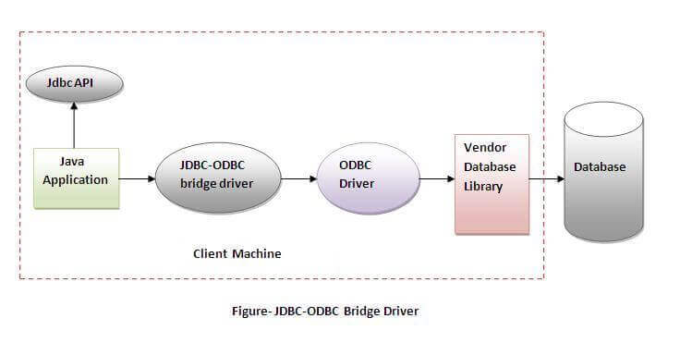

#### **In Java 8, the JDBC-ODBC Bridge has been removed.**

Oracle does not support the JDBC-ODBC Bridge from Java 8. Oracle recommends that you use JDBC drivers provided by the vendor of your database instead of the JDBC-ODBC Bridge.

### Advantages:

* easy to use.
* can be easily connected to any database.

### Disadvantages:

* Performance degraded because JDBC method call is converted into the ODBC function calls.
* The ODBC driver needs to be installed on the client machine.

### 2) Native-API driver

|  |
| --- |
| The Native API driver uses the client-side libraries of the database. The driver converts JDBC method calls into native calls of the database API. It is not written entirely in java. |

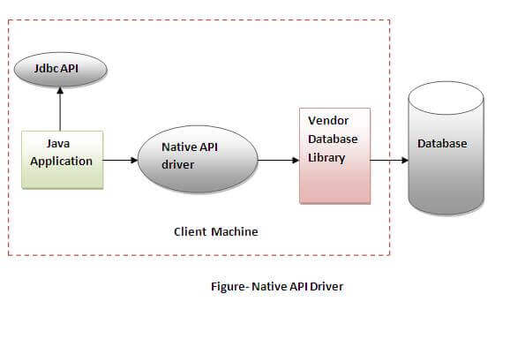

### Advantage:

* performance upgraded than JDBC-ODBC bridge driver.

### Disadvantage:

* The Native driver needs to be installed on the each client machine.
* The Vendor client library needs to be installed on client machine.

### 3) Network Protocol driver

The Network Protocol driver uses middleware (application server) that converts JDBC calls directly or indirectly into the vendor-specific database protocol. It is fully written in java.

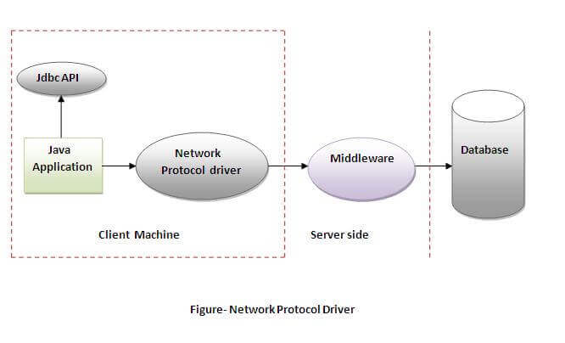

### Advantage:

* No client side library is required because of application server that can perform many tasks like auditing, load balancing, logging etc.

### Disadvantages:

* Network support is required on client machine.
* Requires database-specific coding to be done in the middle tier.
* Maintenance of Network Protocol driver becomes costly because it requires database-specific coding to be done in the middle tier.

### 4) Thin driver

|  |
| --- |
| The thin driver converts JDBC calls directly into the vendor-specific database protocol. That is why it is known as thin driver. It is fully written in Java language. |

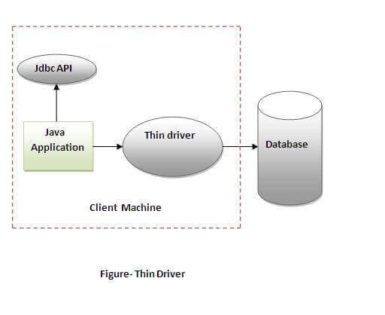

### Advantage:

* Better performance than all other drivers.
* No software is required at client side or server side.

### Disadvantage:

* Drivers depend on the Database.

**Steps to connect a java program with database :-Note : Before any jdbc connection we have to set the class path of venders jar file (mysql-connector.jar)C:\Program Files (x86)\MySQL\Connector J 8.0\mysql-connector-java-8.0.21.jar;1. register the Driver with Drivermanager.2. getConnection3. get required Statement 4. execute the query5. close the connection**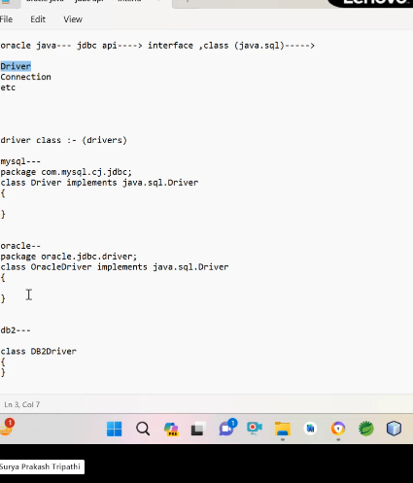

**Ye sab connectivity ke liye banaya jata hain database ko server bol dete hain aur java program ko client bol dete hain**

**Driver ek aisa mdayam hain jo ek langaguge ko dusre language main call krta hain**

**Driver ek interface hota hain isko banaya hain sun microsystem ne aur iska implemention vendor deta hain (oracle,mysql etc) aur wo implemention jar file ke andar deta hain**

Inside Jdk:package java.sql;interface Driver{Connection connect(String url,Properties info);}package java.sql;interface Connection{}package java.sql;class DriverManager{Driver driver;public static void registerDriver(Driver d){driver=d;}public static Connection getConnection(String url,String uname,String pass){Properties prop=new Properties();p.put("uname",uname);p.put("upass",pass);Connection c=driver.connect(url,prop);return c;} }Outside JDk (MySqlConnector.jar)MySQL- Vender---package com.mysql.cj.jdbc;class Driver implements java.sql.Driver{Connection connect(String url,Properties info){return new ConnectionImpl();}static {DriverManager.registerDriver(new com.mysql.cj.jdbc.Driver());}}class ConnectionImpl implements Connection{--- sockte Connection----}

**Register with driver many ways –**

* Driver ek interface hota hain aur driver ko implement krne wale class driver class kahalti hain
* Class for name -ye sahi hota hain kyuki yaha per hum fix bhi kr sakate hain aur runtime per de sakate hain
* Static load-java.sql.Driver d=new com.mysql.jdbc.Driver();
* DriverManager.registerDriver(new com.mysql.cj.jdbc.Driver());//ye fixed hota hain isliye use nahi krna chaiye
* Path set kr do to likhne ki jaroorat bhi nahi hogi\
* Driver manager ek class hoti hain jo driver mange krne ke liye use ki jaate hian

**Get connection so many ways:-**connection ek interface hota hain

**newnewInstnacefactory Patternhttps://www.digitalocean.com/community/tutorials/java-design-patterns-example-tutoriallone**

**\*\*\*\*\*\*\*\*\*\*\*\*get connnction method ek static and factory patttren method hain jiska return type connection hain aur connection ek interface hain to uski implement class hogi uske return type milega aur jab hum drivermanger ka get connection method chaleyenge to wo connection interface ko implementio krne wali class ka return type de dega \*\*\*\*\*\*\*\*\*\***

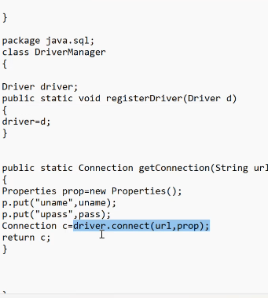

# **Java Database Connectivity with 5 Steps**

1. [5 Steps to connect to the database in java](https://www.javatpoint.com/steps-to-connect-to-the-database-in-java)
   1. [Register the driver class](https://www.javatpoint.com/steps-to-connect-to-the-database-in-java#step1)
   2. [Create the connection object](https://www.javatpoint.com/steps-to-connect-to-the-database-in-java#step2)
   3. [Create the Statement object](https://www.javatpoint.com/steps-to-connect-to-the-database-in-java#step3)
   4. [Execute the query](https://www.javatpoint.com/steps-to-connect-to-the-database-in-java#step4)
   5. [Close the connection object](https://www.javatpoint.com/steps-to-connect-to-the-database-in-java#step5)

|  |
| --- |
| There are 5 steps to connect any java application with the database using JDBC. These steps are as follows:   * Register the Driver class * Create connection * Create statement * Execute queries * Close connection |

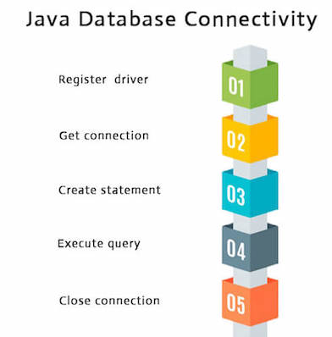

### 1) Register the driver class

|  |
| --- |
| The **forName()** method of Class class is used to register the driver class. This method is used to dynamically load the driver class. |

### Syntax of forName() method

1. **public** **static** **void** forName(String className)**throws** ClassNotFoundException

#### **Note: Since JDBC 4.0, explicitly registering the driver is optional. We just need to put vender's Jar in the classpath, and then JDBC driver manager can detect and load the driver automatically.**

### Example to register the OracleDriver class

Here, Java program is loading oracle driver to esteblish database connection.

1. Class.forName("oracle.jdbc.driver.OracleDriver");

### 2) Create the connection object

|  |
| --- |
| The **getConnection()** method of DriverManager class is used to establish connection with the database. |

### Syntax of getConnection() method

1. 1) **public** **static** Connection getConnection(String url)**throws** SQLException
2. 2) **public** **static** Connection getConnection(String url,String name,String password)
3. **throws** SQLException

### Example to establish connection with the Oracle database

1. Connection con=DriverManager.getConnection(
2. "jdbc:oracle:thin:@localhost:1521:xe","system","password");

### 3) Create the Statement object

|  |
| --- |
| The createStatement() method of Connection interface is used to create statement. The object of statement is responsible to execute queries with the database. |

### Syntax of createStatement() method

1. **public** Statement createStatement()**throws** SQLException

### Example to create the statement object

1. Statement stmt=con.createStatement();

### 4) Execute the query

|  |
| --- |
| The executeQuery() method of Statement interface is used to execute queries to the database. This method returns the object of ResultSet that can be used to get all the records of a table. |

### Syntax of executeQuery() method

1. **public** ResultSet executeQuery(String sql)**throws** SQLException

### Example to execute query

1. ResultSet rs=stmt.executeQuery("select * from emp");
3. **while**(rs.next()){
4. System.out.println(rs.getInt(1)+" "+rs.getString(2));
5. }

### 5) Close the connection object

|  |
| --- |
| By closing connection object statement and ResultSet will be closed automatically. The close() method of Connection interface is used to close the connection. |

### Syntax of close() method

1. **public** **void** close()**throws** SQLException

### Example to close connection

1. con.close();

#### **Note: Since Java 7, JDBC has ability to use try-with-resources statement to automatically close resources of type Connection, ResultSet, and Statement.**

**Driver :-**Driver is basically interfacewhich is founding java.sql package this interface providing sunmicrosystem and implemention of providing this driver different -2 vendors accordingly and implemention of this object is totally response acess the data java application and database in other word we can say that driver is a medium by which we can share the data one technology and another technology

The driver is that interface which interface providing sun microsystem implemention of providing different -2 user and sun microsystem itself depending situation

And driver class so many types

Type 1,type 2,type3 ,type4 providing sunmircosystem type 1,2,3 deprictted only used type 4

Driver class and interface both but driver interface providing sunmircosystem and implemention class different vendor and type1 both providing sun microsystem because of this complexity increase

**Driver Manger**:- driver manger class which founding java.sql package totally mangeing drivers

**How to manging drivers**

**Some methods use manging drivers -**

* Register driver
* De register driver etc

The popular method this get connetion method passing url username and password

It wil return connection

**Connection -connetion is a interface and implementing object this interface we will getting this object**

**How will getting connection object -**by calling manger get connection method you can call direct connect method we call driver manger calling so that we will connection

**Statement -**statement also interface this statement perform db opration

**ResultSet**- is interface implemention providing by vendor

**Problems with Statement:-**1.Each time query is compiled in database and then executed.baar -2 query compile jiske karna performance issu hota hain 2.Some times we need to pass dynamic data in the query and for this we need to perform concatination which is again a complex job for programmer.3.poor efficiency of an application.4. SQL Injection-baar-2 ko sql injection bolate hain Advanatage:-The Only advantage of staement is it can execute various queries it meansthe same statement object can be use to execute insert,slect,delete tect query.**Sol:-PreparedStatement.**

# **PreparedStatement interface**

The PreparedStatement interface is a subinterface of Statement. It is used to execute parameterized query.

Let's see the example of parameterized query:

1. String sql="insert into emp values(?,?,?)";

As you can see, we are passing parameter (?) for the values. Its value will be set by calling the setter methods of PreparedStatement.

### Why use PreparedStatement?

**Improves performance**: The performance of the application will be faster if you use PreparedStatement interface because query is compiled only once.

Batch Updation:-Batch udtation provides the facility to execute the similar queries in batch.The Advantage of this approach is the reducation of Network traffic.Note:-select quary can not be executed in a batch.steps to execute the query in a Batch:-1.Add the query in the batch.-public void addBatch(String query)-public void addBatch()2.Execute the quary.public int[] executeBatch() Transction:-A transaction is represented by set of logically related operationex:-transfering the amount from one account to another account.from java programing point of view a transaction is represented by set of logically statement or prepared statement.step1:-Disable the auto commit mode of the Connection.step2:-Commit the query after the sucessful execution of query.Note:-Connection interface also provides rollback method to rollback the partially commited queis.public void rollBack()Properties of ResultSet:-1-ResultSetType:-NavigationSenstivity2.ResultSetConcurrency

**Java :-**Core Java:- JSE :-Desktop AWT/SWINGJDBCAdvance Java :- JEE (Java Enterprice Edition)Web,Site,Webpage,static webpage,dynamic webpage

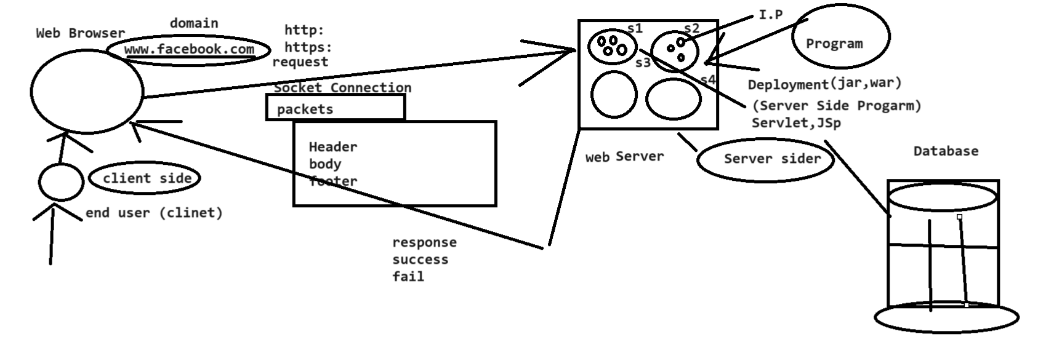

[Content Type - javatpoint](https://www.javatpoint.com/content-type)

**Server :-** is software -weblogic ,glassfish,tomcate ,jboss etc

How many types of server -java point of view

* Web Server
* Application Server

[www.facebook.com](http://www.facebook.com) DNS(Domain name System) system kis bhi application ka nickname hota hain there are many types like in,org etc.

**Domain provider :**- Bigrock, GoDaddy

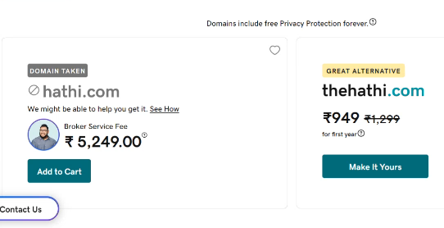

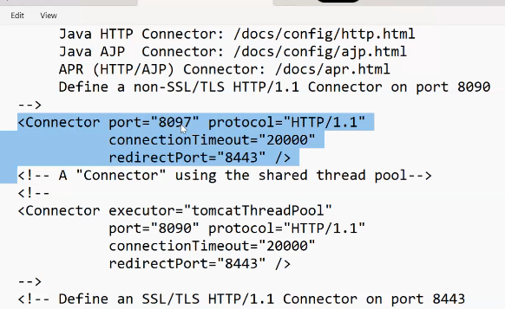

**clientIPAddressportproticalhttp://localhost:8097/||doaminserver(portNumber)(hostAddress)**

(192.168.1.7)

**Hosting** :-main internet per ek area khariduga machine aur wo installed hoga

Hosting raja etc hosting ki bhi kai type hote hain

Types of server in java:-Web Server & Application Serverhttps://www.facebook.com -> called Domain Name and there are various type of like dot com,dot net, dot inetc.com means commercial or worldwideorg means organizationin stands from india

**Webpage :-** html/css combination se banaya jata hain button checkbox **what is static page?**A static page is nothing but a collection or a combination of html,css,bootstrap and javascript.which are store in the server and get the same response to every client.**Her user ko same response de use static webpage kahate hainwhat is dynamic page?**dynamic page are nothing but a page which appear dynamic data or dynamic response depending on the user which comes from the database at the time of request by the client.And this dynamic programmig is done by the help of server side programming language.

**\*\*\*\*Database se connect krne ke liye ke hota hain aur ye dotnut,php,java se banaya jata hain**

**Dynamic page main logic likhate hain****What is Server-side ?**Server-side development is the process of creating applications which run on a 'server' rather than on the end-users 'client' computer. The application running on Server can then be accessed by several clients simultaneously keeping processing centralized at one place. webbrowsser**What is Client-side ?**Client side language is required to create a webpages for faster responses. Client side languages work on the browser itself saving flow of information over the network and hence improving performance. Server per hi hota hain**Why Build Web Pages Dynamically?**A dynamic web page is a page that changes based on the user. It responds to the user's needs, and provides necessary information to meet them, by accessing information in a connected database.**Difference Between Server Side And Client SideClient Side** **Server Side**Client Side programs run on the user's computer. Server side codes are executed in server and result is displayed in web browser as HTML.Client Side programming is less secure. Server-side scripts are more secure than client-side.The code which is run on the user's computer using scripts like Javascript can or may be blocked. Server-side scripting does not have any limitation of any browser.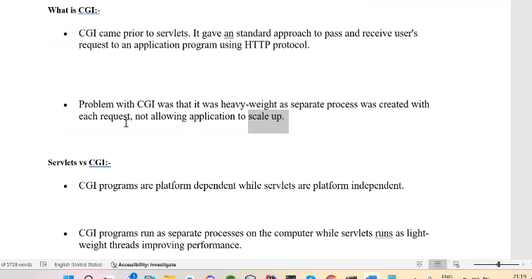

Ye server side programming c++ main hoti thi jise cgi boltate hain but isme kuch kami hoti thi heavy wight bhi hota tha ,secure bhi nahi hoti thi

**Steps to create Servlet Program:**1)**Need to Create Directive Structure-** a)create a folder and give it a name(project Name) b)inside that folder create a new folder and name it as WEB-INF c)All the static resouce will be directly store in the project. d)Inside the WEB-INF folder there we will create a folder with the name of class and after that need to create one more folder by the name of lib and after that need to create a file wih the name of web.xml**C:\Users\naeem\OneDrive\Desktop\New folder>jar cvf abcd.war webprime**

**C:\Users\naeem\OneDrive\Desktop\New folder\webprime>jar cvf abcd.war *.\***

2) **How to do hot deployment in server?**Copy the whole project and go to the server folder and fid the folder webapp and paste that project over there.3)Start the server by going to the bin folder there you will find the start by clicking it it will start the server.4)go to browser and put the web address as localhost followed by the port number and the project name.**Steps to create servlet program or dynamic file**.a)create a java file any where in your desktop but not inside your project. create a class by any name but must be implemented by servlet interface to create a servlet class and after that need to over ride all the methods of the servlet interface and these method are also know as life cycle method of servlet interface. And the methods are:- init service destroy getServletInfo getServletConfig after this you need to map that class inside the web.xml filewhere the servlet interface is found?the servlet interface is found inside the server. how to create jar file using command line jar cvf fileName.war *.*;

**Server ke do tarike hote hain**

* Hard deploy -localhost/8978/
* Colde deploy -ye second wala hain

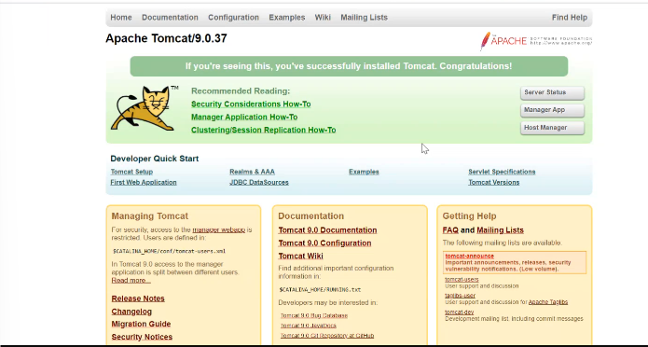

**Server Steps:-**

**1.hard-static page**

* First web project banao
* Tomcat start kro
* localhost:8978/servlet

**2.dynamic page –**

* Static page step
* Classes main byte servlet ka
* xml name dena
* localhost:8978/dynamic/MyServlet

**3.cold method**

* localhost:8978-mangerapp
* user name password dalna
* cmd- C:\Users\naeem\OneDrive\Desktop\New folder\servletwar>jar cvf hathi.war*.*
* war deploy path- C:\Users\naeem\OneDrive\Desktop\New folder\servletwar\hathi.war
* localhost:8978/hathi

or

choose the file

**Servlet:-**

* Servlet is very first java based programing language
* Servlet is server side programming language hain jis se hum dynamic page banate hain
* Web site development main do tarike ke page hote hain

1. Dynamic page hain
2. Static page

Aur dynamic page ka development hota hain wo servlet per hota hain

* Servlet is a api-isko kisi teeser adami ne banaya aur uske baad usko j2ee technology main add kr diye
* **Definition**-Servlet is a very first java based server side programming language
* Servlet is use to create dynamic web page
* Servlet is an API which was created by 3rd party and later was added by java. Which find servlet javax.servlet.http ;package
* Servlet is also an interface (coding point) and this interface implements class called servlet class

**1995 -java bani thi isi samay aur isi samay hain servlet bhi ban gaya tha aur wo sab 1998 main 3 parts main divid ho gaya tha but us samay servlet itna world wide famous nahi tha**  --- Java---Java Devidede in 3 parts—aur ye 1998 main divide hui thi1. J2SE--- core (jdk)-java bola gya 2. J2EE--- advance----> Web,

# **Servlets | Servlet Tutorial**



**Servlet** technology is used to create a web application (resides at server side and generates a dynamic web page).

**Servlet** technology is robust and scalable because of java language. Before Servlet, CGI (Common Gateway Interface) scripting language was common as a server-side programming language. However, there were many disadvantages to this technology. We have discussed these disadvantages below.

There are many interfaces and classes in the Servlet API such as Servlet, GenericServlet, HttpServlet, ServletRequest, ServletResponse, etc.

## **What is a Servlet?**

Servlet can be described in many ways, depending on the context.

* Servlet is a technology which is used to create a web application.
* Servlet is an API that provides many interfaces and classes including documentation.
* Servlet is an interface that must be implemented for creating any Servlet.
* Servlet is a class that extends the capabilities of the servers and responds to the incoming requests. It can respond to any requests.
* Servlet is a web component that is deployed on the server to create a dynamic web page.

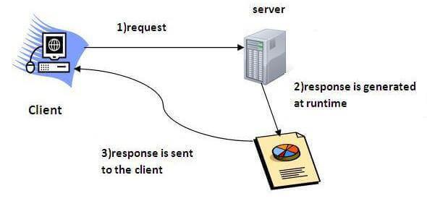

Enterprice-isi main servlet a gayi thi 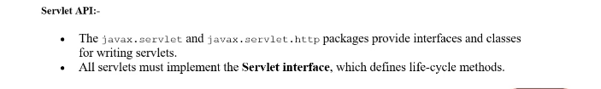

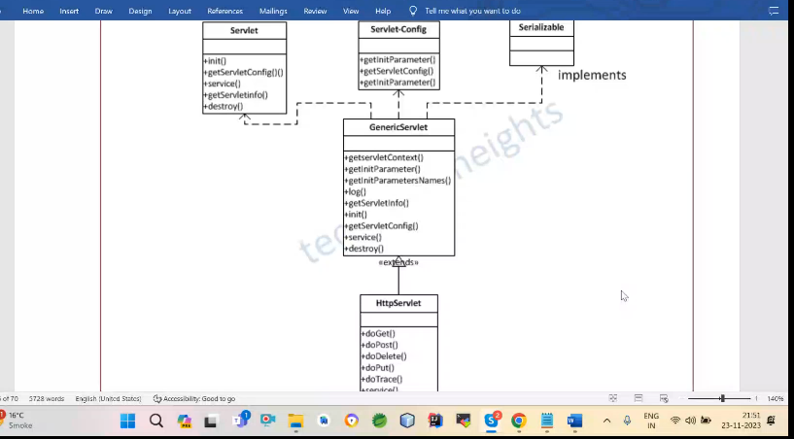

**\*\*\*\*jab bhi browser se request jati hain aur response ati hain to http protocol use hota hain kyuki browse http ko smajta hain to socha gaya uske specific koi interface ho to asani ho jayegi isliye sabase best ye hi hota hain interface ye sab j2ee se pahle hota tha**

### What is a web application?

A web application is an application accessible from the web. A web application is composed of web components like Servlet, JSP, Filter, etc. and other elements such as HTML, CSS, and JavaScript. The web components typically execute in Web Server and respond to the HTTP request.

### CGI (Common Gateway Interface)

CGI technology enables the web server to call an external program and pass HTTP request information to the external program to process the request. For each request, it starts a new process.

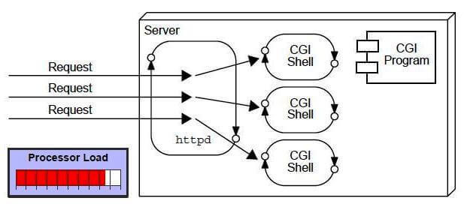

### Disadvantages of CGI

There are many problems in CGI technology:

1. If the number of clients increases, it takes more time for sending the response.
2. For each request, it starts a process, and the web server is limited to start processes.
3. It uses platform dependent language e.g. [C](https://www.javatpoint.com/c-programming-language-tutorial), [C++](https://www.javatpoint.com/cpp-tutorial), [perl](https://www.javatpoint.com/perl-tutorial).

### Advantages of Servlet

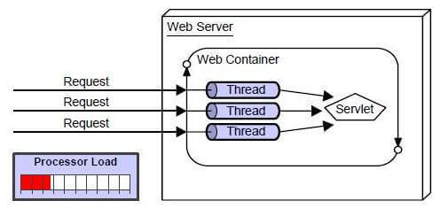

There are many advantages of Servlet over CGI. The web container creates threads for handling the multiple requests to the Servlet. Threads have many benefits over the Processes such as they share a common memory area, lightweight, cost of communication between the threads are low. The advantages of Servlet are as follows:

1. **Better performance:** because it creates a thread for each request, not process.
2. **Portability:** because it uses Java language.
3. **Robust:** [JVM](https://www.javatpoint.com/jvm-java-virtual-machine) manages Servlets, so we don't need to worry about the memory leak, [garbage collection](https://www.javatpoint.com/Garbage-Collection), etc.
4. **Secure:** because it uses java language.

# **Web Terminology**

|  |  |
| --- | --- |
| **Servlet Terminology** | **Description** |
| [Website: static vs dynamic](https://www.javatpoint.com/website-static-vs-dynamic) | It is a collection of related web pages that may contain text, images, audio and video. |
| [HTTP](https://www.javatpoint.com/http) | It is the data communication protocol used to establish communication between client and server. |
| [HTTP Requests](https://www.javatpoint.com/http-requests) | It is the request send by the computer to a web server that contains all sorts of potentially interesting information. |
| [Get vs Post](https://www.javatpoint.com/get-vs-post) | It gives the difference between GET and POST request. |
| [Container](https://www.javatpoint.com/container) | It is used in java for dynamically generating the web pages on the server side. |
| [Server: Web vs Application](https://www.javatpoint.com/server-web-vs-application) | It is used to manage the network resources and for running the program or software that provides services. |
| [Content Type](https://www.javatpoint.com/content-type) | It is HTTP header that provides the description about what are you sending to the browser. |

**Generic Servlet :**

**why there is need to keep the generic Servlet when we have httpServlet?**

Generic Servlet is a general purpose class use to create any type of protocol or any type of servlet.

Suppose we are using http protocol this time , supose a new protocol is being created then

that protocol specific can be create using this generic servlet .

servlet ke program teen tarike se bana sakte hain

* servlet interface se
* generic servlet class se
* http servlet class extends se best ye kyuki iske pass sabke feature hain aur browser se request and response lene ke liye ke liye kiya jata hain wo protocol se hota hain

**\*\*\*\*\*servlet ko banaye third party ne usi ke pass package aur iski implemention vendor dega vendor matlab server banana bali company(tomcate_etc) wo inhi class ko apne hisab se implement krengi inko apne hisab se class banyengi aur apne hisab directy structure create krnengi aur aise krne se problem ho gayi thi ki jaise tomcate apne structre ko follow kreg aur glassface apna structre follow krega hum ye nahi kr sakate hain ki tomcat ke structre ko glassface per chala de aur glassface ke tomcate per chalade is problem ko dur krne ke liye j2ee picture main aya   
Hum jab main method nahi banate hain to usko mange servlet engine krta hain wo servlet engine jo servlet ke program ko chalati hain wo deti hain such tomcate**

# **Servlet API**

1. [Servlet API](https://www.javatpoint.com/servlet-api)
2. [Interfaces in javax.servlet package](https://www.javatpoint.com/servlet-api#servletapi1)
3. [Classes in javax.servlet package](https://www.javatpoint.com/servlet-api#servletapi2)
4. [Interfaces in javax.servlet.http package](https://www.javatpoint.com/servlet-api#servletapi3)
5. [Classes in javax.servlet.http package](https://www.javatpoint.com/servlet-api#servletapi4)

The javax.servlet and javax.servlet.http packages represent interfaces and classes for servlet api.

The **javax.servlet** package contains many interfaces and classes that are used by the servlet or web container. These are not specific to any protocol.

The **javax.servlet.http** package contains interfaces and classes that are responsible for http requests only.

Let's see what are the interfaces of javax.servlet package.

### Interfaces in javax.servlet package

There are many interfaces in javax.servlet package. They are as follows:

1. Servlet
2. ServletRequest
3. ServletResponse
4. RequestDispatcher
5. ServletConfig
6. ServletContext
7. SingleThreadModel
8. Filter
9. FilterConfig
10. FilterChain
11. ServletRequestListener
12. ServletRequestAttributeListener
13. ServletContextListener
14. ServletContextAttributeListener

### Classes in javax.servlet package

There are many classes in javax.servlet package. They are as follows:

1. GenericServlet
2. ServletInputStream
3. ServletOutputStream
4. ServletRequestWrapper
5. ServletResponseWrapper
6. ServletRequestEvent
7. ServletContextEvent
8. ServletRequestAttributeEvent
9. ServletContextAttributeEvent
10. ServletException
11. UnavailableException

### Interfaces in javax.servlet.http package

There are many interfaces in javax.servlet.http package. They are as follows:

1. HttpServletRequest
2. HttpServletResponse
3. HttpSession
4. HttpSessionListener
5. HttpSessionAttributeListener
6. HttpSessionBindingListener
7. HttpSessionActivationListener
8. HttpSessionContext (deprecated now)

### Classes in javax.servlet.http package

There are many classes in javax.servlet.http package. They are as follows:

1. HttpServlet
2. Cookie
3. HttpServletRequestWrapper
4. HttpServletResponseWrapper
5. HttpSessionEvent
6. HttpSessionBindingEvent
7. HttpUtils (deprecated now)

j2ee tech or standards:-aur isi ko naam diya j2ee framework aur isne standards follow kiya 1. Component:-ko servlet bolate hain j2ee technology main aur isko do part main divide kr diya gaya

* 1. web component (Servlet,jsp)-web component those component which responsible for dynamic page -servlet is web component
  2. EJB enterprise java bean component (ejb[Sessionbean, Message drivean bean (MDB), Entity bean](RMI,WebService) etc.-ise agar hum kisi website main business logic likhana ho to ise use kre

ejb is use to create pure business logic . It can be used with servlet and jsp.

when we only want to write pure business logic.

Then we can use ejb component.

2. Container :-container is runtime environment for web component(servlet engine ko container bolate hain) and inside find server

web container ejb containercontainer is responsible to execute the component and it provide the runtime enviroment.

We have 2 types of container ie web container and ejb container.

It is found inside the server.

Server is categorized in two parts.

3. Server web server application server4. Directory Stracture5. Commmunication (protal)6. Serviceetc-3. J2ME---- mobile

http:-

https

framework-set of api -framwork ka real word ka matlab hota hain jaise frame ka photo uske dyare main rahana hain -set of api which works predefined algoritham -aise api jisme logic likhane ki jaroorat na pade isme pahale se de diya jaye logic and alogarthim jise use kre

Ejb is the distributed component or interoperable means that any technology can use it or call it.Distributed means application is created in one technology and can be called by different othertechnology too.Container provide a runtime enviroment for any kind of component.Container container contain two things 1)JEE Api implementation2)JRE web container - for the web componentsejb conatianer - for the ejb componentThere are also two types of server1)web server2)Application Serverwhat is server?It is a application software program which is intall into any machine.what is difference between web server and application server?web server provide a web component for the run time enviroment.It is also a leight weight.It provide less feature rather than ejb conatinerIt is fast.it consume less memory.Application Server provide both web and ejb component for the run time enviroment.It is also a heavy weight.It provide more feature rather than web conatinerIt is slow.it consume vast memoryIn apache tomcat, the tomcat is the name of the container.

J2ee ko implement krke jar banate hain vendor jaise tomcate servlet.jsp ko implement kiya hain aise bahut se hain

Servlet mai do version hota hain

* Web xml based version -2.3
* And annotation based version-3 ke baad wala

HTML-Hper text marcap leangue ye kewal degining ke liye use ki jaati hain web page ki isko browser samjata hain ye not case sensitive

XML-xtension marcap language ye designing ke saath database ke roop main kaam karti hain partilly database html kewal data ko desin krati hain ye iska limitation hain aur xml sath main database ko bhi rakhati hain ye case sensitive

Aaj kal xml ki jagah jnson use hota hain

Xml ek aise technology hoti hain jaise do programming language hain aur ek programming language duseri programming langunge se baat krana chahati hain to waha per hum xml use krte hain aur isi ko hum age use krenge jise we service kahate hain aur java main container sabase pahale isi file ko read krta hain aur uske andar ki information ko nikalta hain phir usko server per run krata hain aur xml complex hota hain aur iski jagh per hum jsson use krte hain

400 wale client error hote hain aur 500 wale server site error hote hain

<?xml version=*"1.0"* encoding=*"UTF-8"*?>ye html ka version hota hain

<!DOCTYPE web-app PUBLIC "-//Sun Microsystems, Inc.//DTD Web ise html ka doc file bolate hain-jo tag yaha use kr rahe ho unki information

Application 2.3//EN" "http://java.sun.com/dtd/web-app_2_3.dtd">

<web-app id=*"WebApp_ID"*>ye batata hain ye we application hain

<display-name>ServletProject</display-name>optional hota hain

<servlet>

<servlet-name>MyServlet</servlet-name>

<display-name>MyServlet</display-name>

<description></description>

<servlet-class>p.MyServlet</servlet-class>

</servlet>

<servlet-mapping>

<servlet-name>MyServlet</servlet-name>

<url-pattern>/MyServlet</url-pattern>

</servlet-mapping>

<welcome-file-list>ye jaroori hoti hain isme se koi bhi file hogi usko server run kr dega

<welcome-file>index.html</welcome-file>aur isme jaroori nahi itani file rakhni hainn apne hisab se jo use krni hain wahi rakho

<welcome-file>index.htm</welcome-file>

<welcome-file>index.jsp</welcome-file>

<welcome-file>default.html</welcome-file>

<welcome-file>default.htm</welcome-file>

<welcome-file>default.jsp</welcome-file>

</welcome-file-list>

</web-app>

Jab bhi humari application chalati hain sabse pahle request service ke pass jati hainn wo request container ke pass jaati hain aur wo container humari file ko doondta hain agar wo file mil gayi to wo chal jayega

MangeObject:-servalet ek mange object hota hain-mange object are those object whose creation and management by special environment

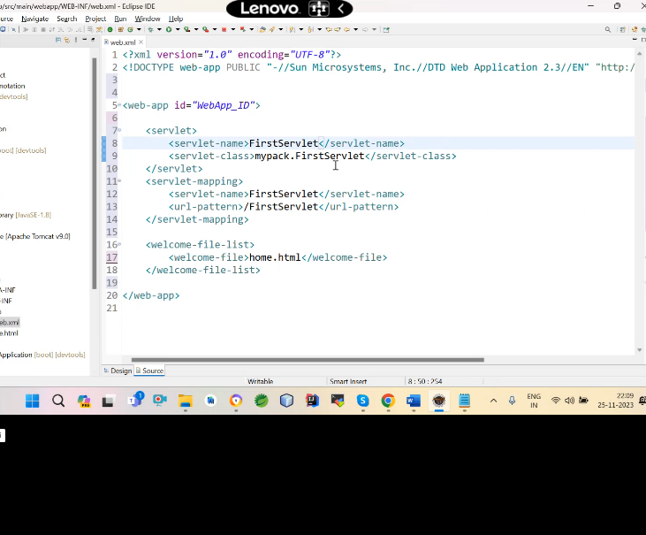

Isme teen name hote hain

Servlet class ,servlet name and url pattern servlet class ka name nahi badal sakate hain baki sab sab badal sakate hain

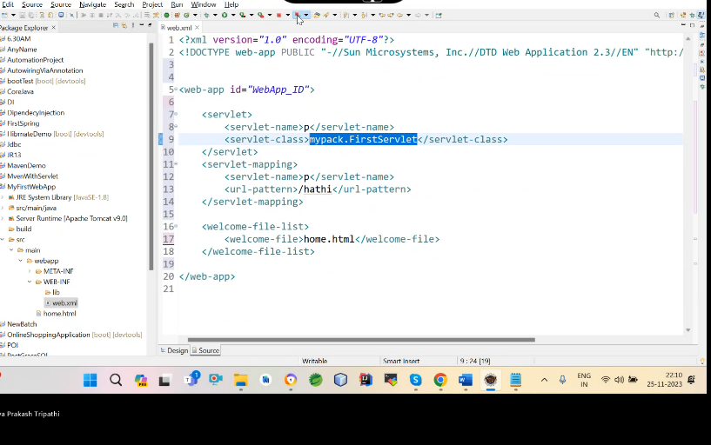

**url pattern se sevlet ko browser per bulate hain jo name hoga wahi dikhega aur jab servlet pattern milta hain uske baad dekha jata hain iski mapping kis se hui servlet name aur uske baad us class ka naam servlet c life cycle of servlet:**load the servlet instantiate the servletinitialize the servletexecute the servletdestroy the servlet class

*****init method and destroy bhi puri life cycle main ek baar chalata hain

Destroy method last main chalta hain code clean up krne ke liye hain memory destroyed se pahle server ke band hone se pahle chalta hain

**ServletRequest and ServletResponse they both are an interface.ServletRequest is an interface which is responsible to handle the request from client side.ServletResponse is an interface which is use to respond the response to any clint side request.**

**init method call by container only once then servlet intilize**

**service method :-**

* isme do parameter hain ServletRequest and ServletResponse jo dono interface hain
* 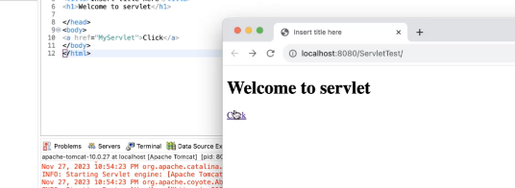
* Jaise app click kroge click button per app request bhej rahe ho server ko
* But ye request server per jati kaise hain yaha per data byte ke form main jata hain iske liye mana ye request local host ke ek server ke liye ja raha hain jiska port number 8978 hain aur us application ka naam hain ServletTest aur usme jo MyServlet naam ka url pattern usko hum request bhej rahe hain
* Jab browser se request server per jaati hain to project ke pass configuration file hoti hain jise xml file bolte hain aur us file main hoti hain index file hoti hain aur server ko pata hain agar usme index file hain to muje use sabse pahle chala dena hain aur iske baad isme jab aap click marate ho to
* Jab hum index file per click krate hain to welcome page khula aur use page per click button hain us per click kiya to ye request bhej rahe ho server ko aur click krne ke baad jo dekhega wo response hoga aur is response ko deal krnke ka kaam servletResponse krega
* Jab browser se request server per gayi to project main hoti hain xml file aur use file main index file hoti hain aur server ko pata hain agar xml main index file hain to use sabase pahle chala dena hain
* **How to work Servlet?**
* **Jab app click button per click kiya to browser ki request server ke pass gayi to server ne uske application ko call kiya aur application ko web.xml ne call kiya aur web.xml url per request a raha tha usko application ne uthaya aur uska name dekha aur uska logical name dekha aur uske baad class ko dekha aur jab wo class mili to wo use run time per load kr deta hain aur uske baad container servlet config ka object banata hain aur config banana ke baad init method ko call krta hain then uske baad container ek thread banata hain aur us thread per container do object create krta hain wo servlet request and servletresponse ka hota hain aur ye dono interface hain to container unki implemention class ka object banake serveice ko call krta hain aur wo call krne per humare browser dynamic page banata hain wo page hum browser per wo response dekh jata hain**
* Hole cycle =jaise aap application ko deploye krte hain matlab run krte ho to humara container puri application ke liye ek single object banta hain aur uske baad server web.xml file ko call krta h ain welcome file list ko khojata hain aur agar usme file mil gayi to usko dekha deta hain jise static page bolate hain
* Aur uske baad click button jaise hi app request server per bhejoge request ka packet bana aur packet ka body (head footer ) section bana aur uske baad server ne us packet ko read kiya (footer header) aur packet ko read krke usne usme se url pattern uthaya aur us url pattern ko xml file main dekha wo exit kr rahi hain ki nahi aur uske baad url paatern ke corrsopnding servlet name dekha aur uske baad servlet class dekha aur class tak pahuchne ke baad
* Yahi se servlet ki life cycle suru ho jati hain

Class c=Class.forName(“MyServlet”);,load the class

Servlet s=c.newInstance();initiliaze the class aur yahi par sevlet config object banata hain

s.init(servletconfig);//call krta hain

uske baad thread banata h ain aur us per do object banata hain servletrequest and servletresponse ke

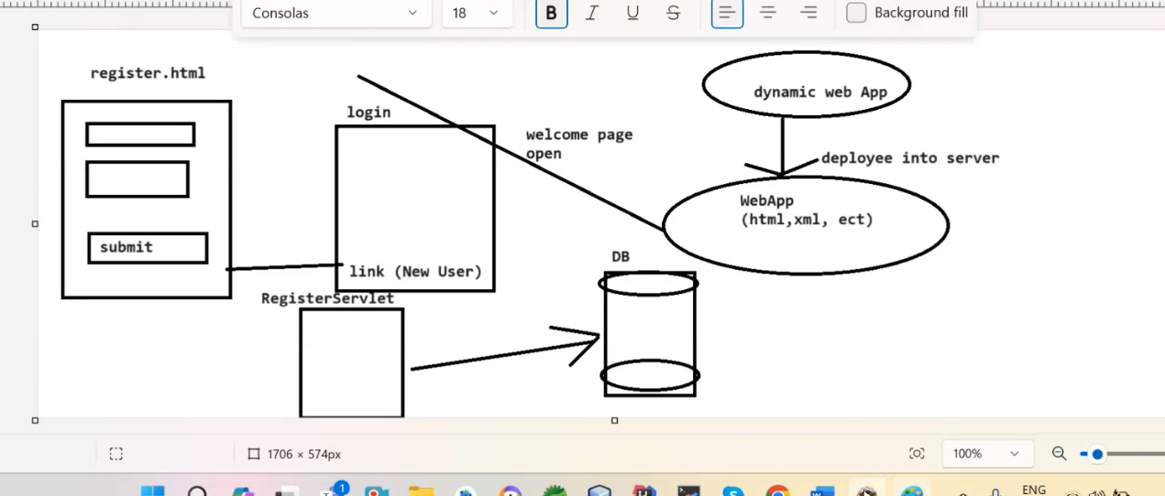

**How many Ways are used to create a servlet program:-**1. By Implementing Servlet interface2. By extends GenericServlet class3. By extends HttpServlet Class (best aproach)1.class MyServlet implemens Servlet{overide all 5 methods (init(),service(),destorye(),getServletInfo(),getServletConfig())}Note:-abstract class GenericServlet implements Servlet{overide all 4 methods (init(),destorye(),getSerletInfo(),getServletConfig()) expect service}2.class MyServlet extends GenericServlet{override service only}

**Http:-**

package mypack; public class MyServlet extends HttpServlet { private static final long serialVersionUID = 1L; public void service(ServletRequest request,ServletResponse response) throws ServletException, IOException { PrintWriter out = response.getWriter(); out.println("original service....");} protected void service(HttpServletRequest request, HttpServletResponse response) throws ServletException, IOException { PrintWriter out = response.getWriter(); out.println("http service...."); }protected void doGet(HttpServletRequest request, HttpServletResponse response) throws ServletException, IOException { PrintWriter out = response.getWriter(); out.println("do get...."); }protected void doPost(HttpServletRequest request, HttpServletResponse response) throws ServletException, IOException { PrintWriter out = response.getWriter(); out.println("do Post ...."); }}

**Note:-**ye char method hain http ke inmse se kisi main bhi hum logic likh Sakata hain but hum jisme logic likhe usi ko program main use kre isme service method override bhi hain aur overloaded bhi hain agar humne 4 ko override kr diya to isme original wal chlega but agar original wala hahi hain to http wala service chalega

Aur agar dono service nahi hue to dekha jayega ki request kis method se ayi hain agar get se ayi hain to get chalega aur agar post se ayi hain to post chalega

Jab bhi browsersr se request ati hain to browser se bhejne ka kaam http protocol krta hain but http ke do methods hote hain ek ka name get hota hain dusre ka naam post hota hain, jo dono browser se request ko leke jate hain aur agr hum method kaam name nahi likhate hain html main to hamesha get method se request jati hain .

Waise jab hum gete likhenge to doget method chelega aur jab hum post likhenge to dopost method chalega but do get not secure doget method jab chalata hain to waha browser per jo data hain wo dikhata hain but dopost chlata hain to browser per data nahi dikhata hain ye secure hota hain.

<https://www.guru99.com/difference-get-post-http.html>

life cycle:

Class c=Class.forName("MyServlet");Servlet s=(Servlet)c.newInstance();s.init();s.service();s.destorye();

Ye method to servlet ke but http ke method kaise call ho jaate hain service,dopost and doget to wo aise call ho jate hain servlet ka service method ke andar se service http wala method call hota hain

package javax.servlet.http;abstract class HttpServlet extends GenericServlet{public void service(ServletRequest req,ServletResponse res){ service(HttpServletRequest req,HttpServletResponse res); ye call hota hain

}protected void service(HttpServletRequest req,HttpServletResponse res){String name = request.getMethod();if(name.equals("GET")){doGet(req,res);}else{doPost(req,res);} }protected void doGet(HttpServletRequest req,HttpServletResponse res){}protected void doPost(HttpServletRequest req,HttpServletResponse res){}}

Aur doget and dopost name likhne per kaise call hota hain to service http ke andar condition likhi hoti hain ki konsa ka call hona hain aur agar koi condition nahi hain to doget call hota hain .

**What is difference between get and post ?**

**get:-**

* ye static data ke liye hota hain conventially
* get method html ki body ka data browser per dekha deta hain
* not secure get method main data body ke threw bhjeta hain isliye get ki limitation hoti hain but post ki koi limition nahi hoti hain apporx 2kb data bhej skata hain
* server se data lena hain to get ka use kro **
* idempotent limitation
* get firster than post

**post:**

* post method main nahi dekhata hain data browser per
* secure hota hain but post main aisa algortham likha hain jis se data browser per nahi dekhata hain but post no limition hota hain
* sensitive information
* aur server per data post krna hain to posts ka use kro
* no idempotent -no limitation

**SendDirect method:-**

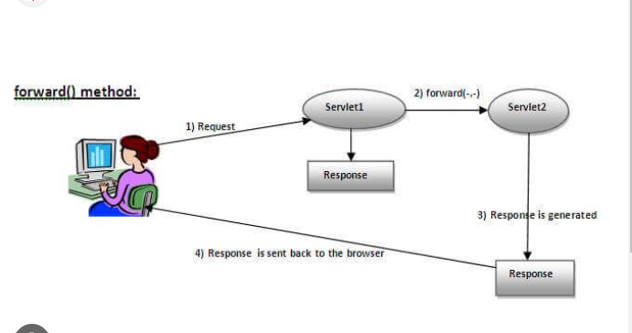

HttpServletResponse ka method sendDirect hain jo forward kr deta hain dusre servlet per jis servlet per aap chahate ho

**getRequestDispatcher method:-**

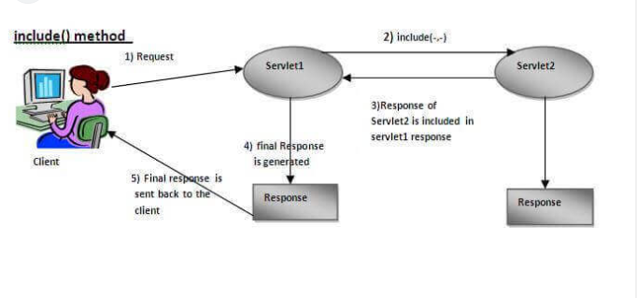**RequestDispatcher interface ka method hain wo jisme forward wala age le jaata hain aur include wala usi calling jo ho raha hain un dono ka include ko response deta hain**

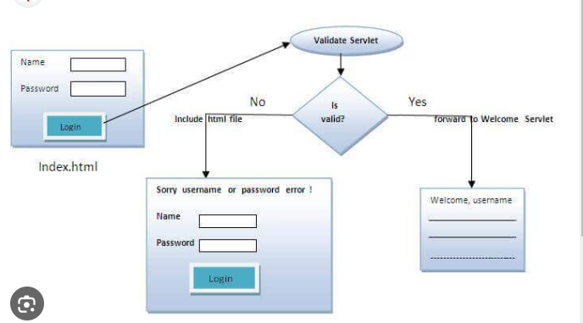

**What is difference between send direct and requestDapatur forward method?**

* **Send direct forward krta hain naya request response hota hain but requestDepartur jis per hota hain usi ke request response per hota hain**
* **Senddirect se hum bahar bhi ja sakate hain but us se nahi ja sakate hain**
* 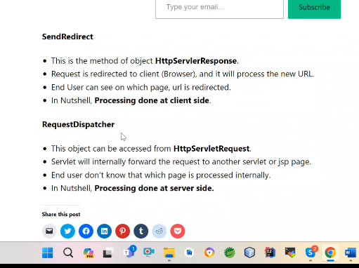

ServletConfig :-ye runtime per banata hain jab servlet call hota hain to servlet ka object banata hain aur usi time servletconfig ka object banata hain

**Servlet Context**:-servletcontext ek interface hota hain aur uski implement class ka object hain jab application deploye hoti hain to servlet context ka object banata hain puri hole application ke liye banata hain jo application main jitane bhi servlet honge sabke liye common object hoga agar aap ek sevlet main data get kro to aap dusre main set kr sakate ho servlet ke object se ye webcontainer banata hain **isi ko intercwhat is ServletContext?**

**ServletContext** is an interface whose object is created at the time of deployment time when the whole project is deployed into the server.For the whole project an object is created and it is called ServletContext object.who's is responsible to create an object of Servletweb container is responsible to create the object of ServletContext object.And its says that one ServetContext object per web application.It is kind of address for the application.**How to get ServletContext object?**

we can get servletcontext object by two way by this.getServletContext or by first we need to bring the servletconfig object and by the servletConfig object we can get servletContext object.inter application communication can be done with ServletContext**Life cycle of Servlet.**when a client send a request through the browser to the server during that processa request packet is being generated and this packet contain header footer and body which carry thedata from browser to server and it is done by the help of http protocol .After hitting the url, the url go to the container and create a servletContext object and after creatingthe object the container goes to the deployment descriptor file to find the matching url and ifthe url is found then it find out the corresponding Servletclass. After finding the Servlet class the class is loaded by the help of Class.forName and by the help of new instance its Servlet class object is created and at the same time there is also one other object is created called ServleConfig object . After that container call the init method and pass the servletConfig object in its parameter and after that a thread is created and inside that thread two more object is created that is ServletRequest object and ServletResponse objet and pass it to the service method and call the service method . And before the servlet destroyit call the destroy method .**what is Context-Param?**The Context param is basically a tag it is used to when we want same output to every servlet eg like databaseconnectivity . For that we can use context param tag inside our web.xml file and store the staticresource in it and we can use it anywhere and in any Servlet . To get the value of request paramfirst we need to get ServletContext object in our class and through the servletContext object wewill able to call initparameter by this method we will able to get the value of context param.**what is Init-Param**Init param is just like same as context param, but only difference is that it cannot be used globallymeans it would only be used for that specific servlet where we have mentioned that init param tag.ommunication krnke liye hota hainn

**Servelt context ke do tarike hain:-**

ServletConfig servletConfig = this.getServletConfig();

ServletContext servletContext = servletConfig.getServletContext(); ServletContext servletContext2 = this.getServletContext();

**Param se bhi ho jata hain data -configuration bola jata hain**

org.apache.catalina.core.StandardWrapperFacade@227f7baf

org.apache.catalina.core.ApplicationContextFacade@51c492c6

com.mysql.jdbc.Driver

jdbc:mysql://localhost:3306/form

root

1234

**\*\*\*\*Init param servlet ke init object per get hota hain but context param sabke liye same hota hain jitane bhi servlet hote hain**

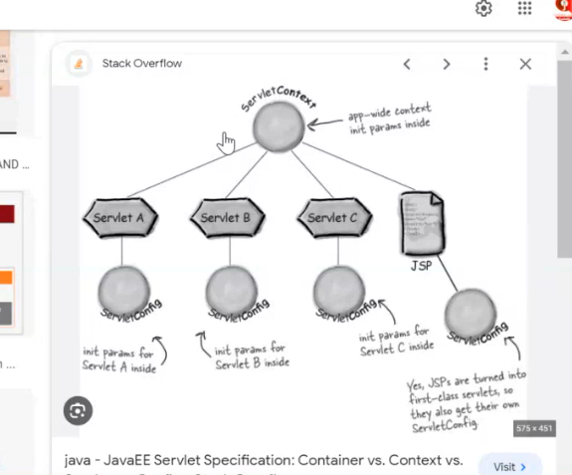

**Serveletcontext use:-**

* Ek servlet main data set and dusre main data get kro -isi ko dynamic data sharing bolate hain-index,loginServlet
* Servletcontext se hum ek servlet main anchor tag banake bhi data set get kr skate hain jo maine rajeshji app main index2,ServletConfig_Context and welcome servlet isme ek
* Only context2 -total kitane user ki request ayi hain to is servlet ke code se pata kre
* InterAppLication bhi kr sakte hain -do application ek dusre se baat kr sakate hain
* Aise bahut se cheeze jo pure project ke liye same to use web.xml main rakhan chaiye isliy hum driver ,value etc rakhate hain
* Param bhi use kr sakate ho

**Config Use:-**

* Web.xml main koi data and koi file int param banakar jis servlet main rakhoge usi main get hogi
* Config servlet se us servlet ka naam nikal sakate hain

Request:-

Get.header

host:localhost:8978  
connection:keep-alive  
sec-ch-ua:"Not_A Brand";v="8", "Chromium";v="120", "Microsoft Edge";v="120"  
sec-ch-ua-mobile:?0  
sec-ch-ua-platform:"Windows"  
upgrade-insecure-requests:1  
user-agent:Mozilla/5.0 (Windows NT 10.0; Win64; x64) AppleWebKit/537.36 (KHTML, like Gecko) Chrome/120.0.0.0 Safari/537.36 Edg/120.0.0.0  
accept:text/html,application/xhtml+xml,application/xml;q=0.9,image/webp,image/apng,*/*;q=0.8,application/signed-exchange;v=b3;q=0.7  
sec-fetch-site:none  
sec-fetch-mode:navigate  
sec-fetch-user:?1  
sec-fetch-dest:document  
accept-encoding:gzip, deflate, br  
accept-language:en-US,en;q=0.9

RefreshServlet:ye bhi kr sakate hain

ContentType:isko bhi badal sakte ho jisme kroge usi main jayega

**Session Tracking:**

**Identity**

**state**

* Jab bhi hum browser se request server ke pass bhejte hain -jab browser se request server ke pass jaati hain to browser us request ko leke ek connection establish krta hain jise hum http connection bolate hain
* Jab hume response milata hain to uske baad connection close ho jata hain
* Aise kyu hota hain-aisa isliye hota hain kyuki jab server per request jaati hain to http protocol hi le jata hain aur http stateless hota hain isliye server her request ko ek naya request(fresh request) samjne lagata hain but hume aise kahi jagah jaha per connection **close nahi chaiye isliye isi ko maintain krnke liye session trakcing use hota hain**
* Hot sakate hain hum servel1 se data utake servlet2 le jana hain aur t2 s 3 per etc…
* 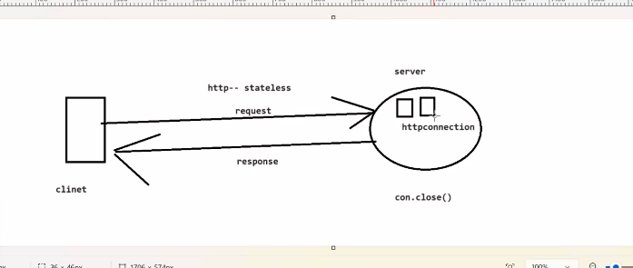
* **Session tracking 4 tarike se hoti hain**

1. **Cookies**
2. **Hidden Form Field**
3. **URI Rewriting**
4. **Http Session interface**

**Session tracking main for example hum jab online shopping krte hain to sabse pahle hum login krte hain aur phir ek page kabhi dusre page pe kabhi 3 sere page etc add kr lete hain uske baad hum ek page pe aake payment krte hain to isi ko mange krneke liye session tracking picture main**

**Session tracking ke do main parpose hota hain**

* **Client ki idenetity mange kran**
* **Client ki state(data) mange krna**

Client aise mange ho rahi hain ki jab hum sara shopping kiya jo parchase kiya wo main apne card main add kiya to wo mere ghar a jayega to ye client ki identiy manage ho rahi aur add to cart ka matalb data manger ho raha hainn

**Ek tarika hota hain agar hume ek servlet se dusre servlet per jana hain to hum contextConfig se bhej sakate hain but ye sahi nahi hota hain kyuki sare user ke liye same data ho jayega aur pahle servlet per set kiya to data mila gaya dusre per aur agr hum dusre per set kre to kya dusre per mil jayega nahi mil payega isliye hum session tracking krate hain**

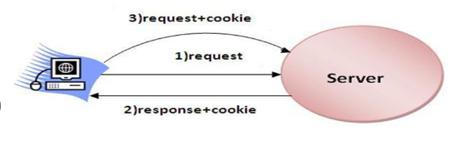

**Cookies:-cookies ek class hoti ye conecept http ka hain jab app pahle baar request bhejte ho to jab response ata hain to uske sath ek cookies ati hain wo bata thi hain abhi aage badana hain aur jab ye cookie ati hain to ye browser ki cookies se deal krti hain**

**Cookies Cons:-**1.public Cookies(String name,String value)Method of Cookies class:--public void setMaxAge(long sec)-public void setDomain(String domainName)-public String getName()-public String getValue()addCookie():-method of HttpServletRequest-public void addCookie(Cookie ck)getCookie():-method of HttpServletRequest-public Cookie[] getCookies()Advantage of Cookie:-the only advantage of cookie is it can not be modified.Apart from state managementcookie can be ues to remember the user name,password,advertisement,customization of web page etc.**Disadvantage:-**1.Cookie contain only string data.2.the maximum size of file that contain cookie can be up to 4kb;3.A browser can accept 20 cookie per web applicaation and 400 cookie total.4.Cookie highly browser independent and all the browser do not support the conceptof cookie and the browsers that support this facility also provide the feture to delete the cookie by the client.**If Cookie is Disable:-**In this case session-id is send by java programer explicity by using the concept ofencode url.Encode url method is define in the HttpServletRequest interface that rewrite the specified url by appending the session id.public String encodeURL(String url) e.g.Changing the ServletLogin code:-...String encodeUrl=response.encodeURL("next");out.println(encodeUrl);out.println("<br><a href=+encodeUrl">Next</a>");}}**Method of HttpServlet interface:-**-public void setAttribute(String name,Object value)-public Object getAttribute(String name)-public Enumeraton getAttribute()-public void removeAttribute(String name)-public boolean isNew()-public void invalidate()-public void setMaxInactiveInterval(int sec)

**Cookies:-** is the textbale data which is the form and value pair whenever we are sendimg any request from browser to server,So server will automatic create the cookies and providing the cookies in the form of request

**Cookies ek aisa textable data hota hain jise server banata hain aur clinet ki machine or browser ke cache main store ho jata hain ,jab ye clinet ki machine main store hota hain to c drive main cookies naam ka ek folder banata hain waha per ek text naam ki file banati hain aur waha per encrypted data pada rahe tha hain**

**Jab pahlie baar request jati hain to response ke saath cookies ata hain aur jab dubara request bhejete hain to wo request ke sath jata hain**

**Types of cookies**

**Parmanent Cookies-parchase cookies hoti hain jo client main permanent store hoti hain**

**Temparary Cookies:reverse**

**Cookies Life Cycle:**

* Sabse pahle request server ki bheji aur usi time humne cookies ka object banaya (bur parchase walie main cookies apne aap object banayegi)aur use response ke sath cookies ko clienet per bhej diya
* Aur hum jaise request age forward krenge to cookies main data hain uso hum get krlenge ,kyuki jab hum request bhejenge to cookies +request jayegi
* Cookies ko hum disable krenge to hum apni request forward nahi kr payenge
* Limtions bhi hoti hain 20 page kr sakta hain

**Dao ,dto ek design pattern hote hain-design pattern not implementions isko use krne se bl and pl logic alag -2 ho jata hain isko use krne se code redundancy kam hoti hain aur memory kam lagati hain**

**Http Session :-**

**HttpSession httpsession =request. HttpSession(true) naya object -true**

**False-old object**

Ye request ko check krta hain agar naya request ke to uske liye naya session ka object de deta hain aur agar porana request hain to uske liye porana session ke liye object de deta hain us

Agr naya rquest hain to us session ke liye object banayega aur sath main eik id create create krta hain jise session id bolate hain aur ek cookies banata hain jise jsession id add krke bhej bhi diya jata hain

**\*\*\*\*\*\*\*Encodeurel method se cookies disable hone per bhi data bhej sakate hain**

**String encodeUrl=response.encodeURL("next");**

**out.println(encodeUrl);**

**out.println("<br><a href="+encodeUrl+">Next</a>");**

**out.println("</body>");**

**out.println("</html>");**

**}**

**}**

when we call getSession method on request object , first it check that the request is fresh request or not , if the request is fresh then it will create a session id for the perticular request and sets with the cookies and send it with the resoponse and we further get the httpSession implementing class object.if the request is not not fresh then it will return the same object.It will also stop working when we disable the cookies from our browser, cause httpSesion internallyuses cookies to manage the data and identity.sakate

**session do tarike se exipirey hota hain**

1. invalidate method se
2. inactive intervale method timing di hoti hain 20 min main expiry ho jaye
3. ek aur hota hain html file main set kr doge sessionConfig tag se ye pori application ke liye hota hai

<session-config> <session-timeout>30</session-timeout> </session-config>

**private** **static** **final** **long** ***serialVersionUID*** = 1L;j

jab data network pe travel krta hain to use serilize hona chiye usi version id hoti hain

jo bhi class hain wo serilizable interface ce type ko hoti hain

**JSP:-**

jsp complexity servlet ki complexity ko door krta hain ye bl and pl dono ko alag kr deti hain iske pass nine implicit object hote hain

**Jsp is the extension of servlet not replacement of servlet**

**Httpsession.isNew()-same true true and false true 0r true false**

jsp remove the complexity of servlet.jsp is the extension of servlet.

jsp is the extension of servlet.It is also another way create dynamic web pages.Jsp have resolve the complexity which we were facing inside servlet like writing html was very complex.Jsp provides us tag Scripting elements of the jsp. 1)Scriptlet Tag <% %> 2)Expression Tag<%= %> 3)Declaration Tag<%! %> 4)Comment Tag<%-- -- %>Directive Tag 1)page Directive <%@page %> 2)Include Directive <%@include %> 3)Taglib Directive <%@taglib %>Action Tag 1)Include <jsp: include> 2)Forward <jsp: forward> 3)param 4)use bean 5)SetPropertywhat was the need to bring when we already have servlet for the server side programming language?To write the html to in servlet was complex.And also cannot be possible to do the desingning.

**JSP -->tags---->1)- Scripting Eleement:- a)- Scriptlet Tag ( <% %> )-java code ko likhane ke liye hota hain-isme jo declara kroge wo sirf usi ke liye hoga**

**b)- Expression Tag ( <%= %> )-out.println ka kaam krta hain aur method ko bhi print kr sakate hain**

**c)- Decleartion Tag ( <%! %> )-kisi bhi variable ya method ko decleare krne ke liye =ye method ya variable gloabal hota hain d)- Comment ( <%-- --%> )2)- Diracative Tag a)- page (<%@page %>) b)- include (<%@include %>) c)- taglib (<%@taglib %>)3)- Action TaG a)- include (<jsp:include>) b)- forward (<jsp:forword>) c)- param d)- usebean e)- setProperty f)- getProperty ect. 4. EL-expression language & JSTL-jsp tag library 4. Custom TAGModel -- dto/java beanView-- jspController-- filter/servlet/listner -data ko idhar udhar leke jaye**

**Mvc-ek design pattern hota hain**

**Action Tag:-runtime per kaam krta hain-**

<jsp:useBean id="dto" class="com.userdto.UserDto"></jsp:useBean>-ye object banayega

<jsp:setProperty property=*"*"* name=*"dto"*/>-ye data ko set kr dega

UserDto dto=new UserDto(name,email,password,mobile)

Both same hain

**Directive Tag : unka kaam hota hain direction dena hota hain**

Directive tag ka kaam hota hain apne jsp engine ko information dena jsp ke andar internal jo servlet ban rahi hain uske sath import krna hota hain

Ye tag page ke translation time per kaam krte hain

Har tag ke attribute hote hain language,contentType etc

Page directive-jsp page ki information jsp generated servlet tak pahucha tha

pageEncoding-jab koi editor pe koi data likha jata hain to uski koi stayle hoti hain koi utf 8and koi utf 16 ko but ye by default utf18 hain ko support kr rahi

**\*\*\*file direct war banake use krte hain jsp use vedio 129 last 10 mint**

<jsp:useBean id=*"dao"* class=*"com.dao.UserDao"* scope=*"session"* ></jsp:useBean>

Agar scope likhane se 4 kaam kr sakate hain session ,application,same request,page

Aur iska by defulat scope page scope hota hain

* **IsErrorPage=”true”; iske likhane 9 wa object dekhane lagata hain jo exception ob jet hota hain**
* **Session tracking by default hoti hain jsp main session=”true”**
* **Global exception handling main kya krte hain hum error.jsp ka page banate hain aur usi per hum handle krte hain exception page directive ke attribute hote hain error ko handle krne ke liye**
* **Jo synchroneous hoti hain wo thread safe hoti hain jo ek krke follow kre but jsp main by defulte synchroneous hota hain**
* **Out.prinltn ki maximum size 8kb hota hain aur chahe to bada sakate hain**
* **Autoflush ki value by defulte true hoti hain jo source ka data desitantion main by default pahucha deta hain flush ka matlab browser se data 100% server per pahuch jata hain**
* **<%@ page language="java" contentType="text/html; charset=ISO-8859-1" pageEncoding="ISO-8859-1" import="java.util.*,java.sql.*" info="SURYA is dveloper" session="true" errorPage="error.jsp" extends="p1.A" isThreadSafe="true" buffer="8kb" autoFlush="true" %>** [**https://www.geeksforgeeks.org/directives-in-jsp/**](https://www.geeksforgeeks.org/directives-in-jsp/)
* **Jab hum jsp page main koi class extend krna chahate hain to extend krna padata hain**

The JSP API

The JSP API consists of two packages:

1. javax.servlet.jsp
2. javax.servlet.jsp.tagext

javax.servlet.jsp package

The javax.servlet.jsp package has two interfaces and classes.The two interfaces are as follows:

1. JspPage
2. HttpJspPage

The classes are as follows:

* JspWriter
* PageContext
* JspFactory
* JspEngineInfo
* JspException
* JspError

The JspPage interface

According to the JSP specification, all the generated servlet classes must implement the JspPage interface. It extends the Servlet interface. It provides two life cycle methods.

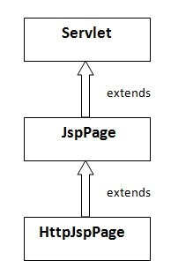

* Jab jsp walo ne jsp banai to use related jsp walo ne api banayi
* **javax.servlet.jspjavax.servlet.jsp.tagext**-two packages 2-**interface- two interface JspPage-**public void jspInit(): public void jspDestroy(): **HttpJspPage-**
* public void _jspService()**class-**JspWriterPageContextJspFactoryJspEngineInfoJspExceptionJspErrorhome.jsp-----> home_jsp.javaclass home_jsp extends org.apache.jasper.runtime.HttpJspBase{}public abstract class org.apache.jasper.runtime.HttpJspBase extends javax.servlet.http.HttpServlet implements javax.servlet.jsp.HttpJspPage { public java.lang.String getServletInfo(); public ServletConfig getServletConfig(); public final void service(javax.servlet.http.HttpServletRequest request, javax.servlet.http.HttpServletResponse response) throws public void init(); public void jspInit(); public void jspDestroy(); public abstract void _jspService(javax.servlet.http.HttpServletRequest arg0, javax.servlet.http.HttpServletResponse arg1) throws }\*\***in interface ka use hum nahi krate hain jsp se ban ne wali class hoti hain wo krati hain jab hum jsp file banate hain for example home.jsp wo transfer ho jati hain java class main home_jsp.java main ye tomcate main transfer huti but alag alag server -2 alag name banati hain aur ye class extend krati hain vendor specfice class ko jo server khud banata hain her server ki apni apni class hoti hain aur jo tomcate ki vendor specfice class wo extends krati hain httpjsppage ko**
* home.jsp-----> home_jsp.javaclass home_jsp extends org.apache.jasper.runtime.HttpJspBase{}
* **public abstract class org.apache.jasper.runtime.HttpJspBase extends javax.servlet.http.HttpServlet implements javax.servlet.jsp.HttpJspPage { }**

**Life cycle of JSP-**

**Jsp file servlet engine ke andar jati hain to container uska translation servlet main kr deta hain**

**Jsp se banana wali class ek normal class main difference lane ke liye inhone iske naye method la diye aur jsp ki api bana diya jsp se banana wali class vendor specific se extends krke banayi jati hain aur vendor sepcfice class wo extends krati hain servlet ko aur actual main servlet ka init method chalta hain aur uske andar se jsp ka init method chalata hain internally servlet life cycle call hoti hain**

**Agar kisi class ko jsp main extend kroge to usko apko vendor se pahle hi extend krna hoga nahi to multiple inheritance a jayega jo java main supporte nahi krta hain isliye hume jis bhi class ki extends krana hain to use hum vendor specific class ko extends kra denge to jo humne jsp file banayi wo java file main convert hoke jo file extends kr rahe ho usko extends krne lagegi jis multilevel inheritance hoga jo java support krti hain**

A Java Server Page life cycle is defined as the process that started with its creation which later translated to a servlet and afterward servlet lifecycle comes into play. This is how the process goes on until its destruction.

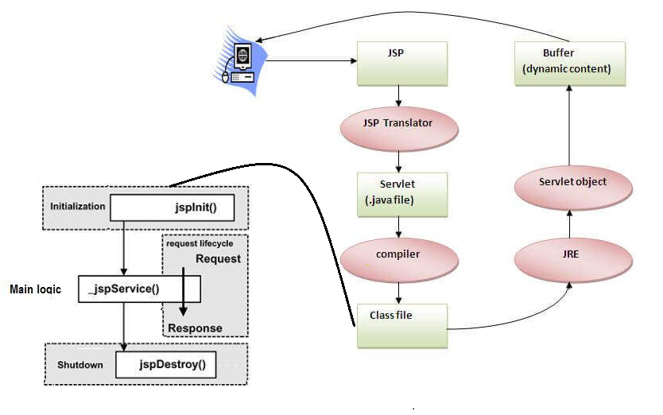

*Lifecycle of JSP*

Following steps are involved in the JSP life cycle:

1. Translation of JSP page to Servlet
2. Compilation of JSP page(Compilation of JSP into test.java)
3. Classloading (test.java to test.class)
4. Instantiation(Object of the generated Servlet is created)
5. Initialization(jspInit() method is invoked by the container)
6. Request processing(_jspService()is invoked by the container)
7. JSP Cleanup (jspDestroy() method is invoked by the container)

*We can override jspInit(), jspDestroy() but we can’t override _jspService() method.*

**Translation of JSP page to Servlet:**

This is the first step of the JSP life cycle. This translation phase deals with the Syntactic correctness of JSP. Here test.jsp file is translated to test.java.

1. **Compilation of JSP page:** Here the generated java servlet file (test.java) is compiled to a class file (test.class).
2. **Classloading:**The classloader loads the Java class file into the memory. The loaded Java class can then be used to serve incoming requests for the JSP page.
3. **Instantiation:**Here an instance of the class is generated. The container manages one or more instances by providing responses to requests.
4. **Initialization:**jspInit() method is called only once during the life cycle immediately after the generation of the Servlet instance from JSP.
5. **Request processing:** _jspService() method is used to serve the raised requests by JSP. It takes request and response objects as parameters. This method cannot be overridden.
6. **JSP Cleanup:**In order to remove the JSP from the use by the container or to destroy the method for servlets jspDestroy()method is used. This method is called once, if you need to perform any cleanup task like closing open files, or releasing database connections jspDestroy() can be overridden.
7. **Jo synchroneous hoti hain wo thread safe hoti hain jo ek krke follow kre but jsp main by defulte synchroneous hota hain-jo ek krke handle kre wo thread safe mana jata hain request**
8. **Out.prinltn ki maximum size 8kb hota hain aur chahe to bada sakate hain**
9. **Autoflush ki value by defulte true hoti hain jo source ka data desitantion main by default pahucha deta hain flush ka matlab browser se data 100% server per pahuch jata hain**

**<%@ page language="java" contentType="text/html; charset=ISO-8859-1" pageEncoding="ISO-8859-1" import="java.util.*,java.sql.*" info="SURYA is dveloper" session="true" errorPage="error.jsp" extends="p1.A" isThreadSafe="true" buffer="8kb" autoFlush="true" %>**

**includeDirective:-** header and footer ko add krna hota hain

**include action tag run time per work krta hain ye request dispatcher ke method ke jaisa same hota hain aur is se data ko bhi bhej sakate ho**

**include directive translation time per work krta hain**

* **Component-1. Web (Servlet,JSP) (dao,dto)2. EJB (Enterprise java bean)-iski jagah pe webservices use ki jati hain**
* **Ye complex bhi hota hain aur memory bhi jada consume krta tha a.Session Beanb.Entity Beanc.Message Driven Bean (MDB)Vs.JavaBean-must compulsory implements serializable interface ye persestensi ke liye**
* **Har javabean pojo but her ek pojo javabean nahi ho sakati hain**
* **Javabean not distrubeted but enterprises java bean distributed hoti hain**

**Annotation** –

* annotation main hum web.xml file bana bhi sakate hain aur nahi bhi Annotation ek symbole symbolic instruction hota hain jiski meaning apke jvm and compiler main fixed hoti hain aur wo @ ke sath likha jata hain
* annotation is symbole whose meaning is defined in the runtime environment in the jvm it is the meta data it is single data
* metadata ka matlab jo ek jada data ko representd krta hain jais -dictionary

# **Java Annotations**

* Java **Annotation** is a tag that represents the *metadata* i.e. attached with class, interface, methods or fields to indicate some additional information which can be used by java compiler and JVM.
* Annotations in Java are used to provide additional information, so it is an alternative option for XML and Java marker interfaces.
* First, we will learn some built-in annotations then we will move on creating and using custom annotations.
* <https://www.javatpoint.com/java-annotation>
* Do typw Ke hote hain userdefined and predefined

JNDI(Java Naming and Directory Interface):-When ejb container create the proxy obj the container wants to put it inside,but it need the location which is called DirectoryServer.DirectoryServer is a resource where where object is bind.DirectoryServer is in build in application server.For implementing the directory server on server we need a Api which is JNDI.the implementation is InitialContext class.method isbind()lookup()Life Cycle of Stateless SessionBean:-1.A stateless session has two state one is does not exit and second is methodReady.A stateless bean is in the does not exit state when the bean has not been instantiated.2.When a stateless is created the ejb cotainer invokes the newInstance method on the stateless bean class.This method create a new Instance of the stateless sessionbean and allocates the required memory.3.The container then invokes the session bean set SessionContext(SessionContext ctx)method on the bean instance.This method sets the bean refrence to the session context.A session context enables,the enterprise bean to intract with a container.4.The ejbCreate() method is finally invoked thid method is similor to the container of the class.It is invoked onlyonce in the lifeCycle of the stateless session bean.When the client invokes the ejbcreate() must not take any arguments as stateless session bean does not store any information in the instance variable.5.The ejbremove() method is called by the container before it remove its refrences to the components and allows its memory to be reclaimed.Any resources that where allocated int ejbcreate() should be deallocated here.6.The container Never passivate and never activate a stateless beans it means the two method ejb activate and ejbpassivate() will never be called EJB EJB stands for enterprise java bean.It is a dirstributed component. It is use to created distributed component.Distributed mean interoperable or can be used by anyone.It very heavy weight and complex to use it.Consumes large amount of memory.It is a inhasment of RMI.But it does not use servlet and jsp.eg. created in java and can be used by different language.It provide different type of flavour.a)SessionBean (WebServices)b)EntityBean (Hibernate)c)Message Driven Bean(MDB) (kafka)Ejb version 2.x and 3.xVSjavaBeanDifferent between javabean class and pojo class?Normal class having setter and getter method is called pojo class and may or may not implement other interface.Normal class having setter and getter method but implements serializable interface.what is annotation?It is an alternate of xml which was introduce in java 1.5.Annotation is the symbolic instruction who's meaning are already reserved in the compiler or the jvm.It provide the metadata(means data about data)It provide an additional information.

<jsp:useBean id="loginobj" class="mypack.LoginBean" scope="request"/><jsp:setProperty name="loginobj" property="*"/><%if(loginobj.validate()){%><jsp:forward page="welcome.jsp"/><%}else{response.sendRedirect("index.jsp?msg=invalid");}%>

**Kya servlet ka object deployment time per create kr sakate hain**

<load-on-startup>1</load-on-startup> is tag se kr sakate hain aur apne program main pata krne ke liye hum static block constructor bana lenge to pata chal jayega

<web-app><servlet><servlet-name>Hathi</servlet-name><servlet-class>DemoServlet</servlet-class><load-on-startup>1</load-on-startup></servlet><servlet-mapping><servlet-name>Hathi</servlet-name><url-pattern>/one</url-pattern></servlet-mapping></web-app>

1 ka matalb humre app main login hain aur register hain to hum chahte hain login ka pahle object bane uske baad register ka to hum login ko 1 denge aur register 2 de denge

**Kya hum ek servlet ke multiple instance create kr sakate hain ?**

**import javax.servlet.*;import java.io.*;public class DemoServlet implements Servlet,SingleThreadModel{public void init(ServletConfig con){System.out.println("init");}public void service(ServletRequest req,ServletResponse res) throws ServletException,IOException{res.setContentType("text/html");PrintWriter out=res.getWriter();out.println("<html><body>");out.println("hello servlet from demoservlet.................");out.println("</body></html>");}public void destroy(){System.out.println("destroy");}public ServletConfig getServletConfig(){return null;}public String getServletInfo(){return null;}}**

**<web-app><servlet><servlet-name>Hathi</servlet-name><servlet-class>DemoServlet</servlet-class></servlet><servlet-mapping><servlet-name>Hathi</servlet-name><url-pattern>/one</url-pattern></servlet-mapping><servlet><servlet-name>Hathi1</servlet-name><servlet-class>DemoServlet</servlet-class></servlet><servlet-mapping><servlet-name>Hathi1</servlet-name><url-pattern>/one</url-pattern></servlet-mapping></web-app>**

**FileUploading:-koi binary data ko server le jake store krna servlet 2.x main koi machnisam hi nahi thi file uploading ho sake but 3.x main aisi facility hain jis se hum file uploading kr sakate hain**

**Agar aap 2.x se file uploading kr rahe hain to app ko jar file apne system main dalni padegi agar aap 3.x se kr rahe ho to koi nahi direct kr sakate ho**

**File uploading man kuch baate yaad rakhan hoga**

1. Html main post method likhana hoga kyuki yahi binary data le ja Sakata hain
2. enctype=”multipart/form-data” ye binary form k data le jaane ke liye banate hain network per data travel krta hain uske liye use kiya jata hain
3. import javax.servlet.*;import java.io.*;import javax.servlet.http.*; import com.oreilly.servlet.*; public class LoginServlet extends HttpServlet{public void service(HttpServletRequest request,HttpServletResponse response)throws ServletException,IOException{response.setContentType("text/html");PrintWriter out=response.getWriter();out.println("<html><body bgcolor=yellow>");String nm=request.getParameter("txtname");out.println("user Id:"+nm);String p=this.getServletConfig().getServletContext().getRealPath("upload");MultipartRequest mpr=new MultipartRequest(request,p,20*1024*1024);//ye digit hota ye size hain String st=mpr.getOriginalFileName("file");out.println(st);String id=mpr.getParameter("txtname");out.println("user Id="+id);out.println(st+"file uloaded.....");out.println("</body></html>");out.close();}}

**Downloading:**

* <a href="DownLoadServlet?name=a.doc">download WordIsme download ke baad jo question marks laga hain use query string bolate hain

**View Servlet:-same hain downloading ki tarah but kuch problem a raha hain**

**package p1;import javax.servlet.*;import java.io.*;import javax.servlet.http.*; public class ViewServlet extends HttpServlet{public void service(HttpServletRequest request,HttpServletResponse response)throws ServletException,IOException{String name=request.getParameter("name");File f=new File(name);String fname=f.getName();response.setContentType("aplication/octet-stream");//OutputStream out1=response.getOutputStream();PrintWriter out1 = response.getWriter();String downPath="D:\\MicroServices10PM\\JspPriject\\src\\main\\webapp"+"\\"+fname;FileInputStream fin=new FileInputStream(downPath);byte b[]=new byte[fin.available()];fin.read(b);out1.print(b);out1.close();fin.close();}}**

**Listners:-**event handling ke liye listners use kiya jata hain for example jaise meri application hain wo deployment hoti hain to servlet context ka object banata hain to ye bhi ek event hain isi event ko handle krne ke liye hum listners use krte hain

**Filter:-iska kaam hota hain filtering krna**

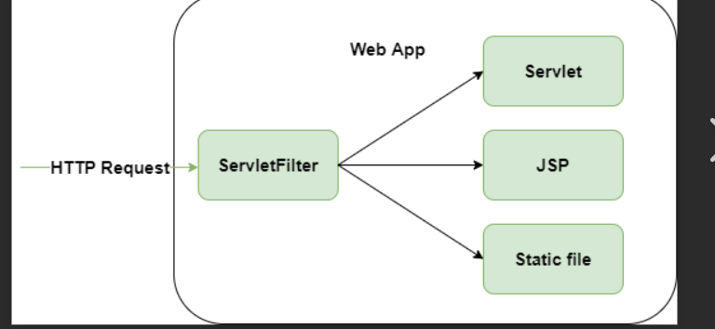

**Filter:-**A filter is a component that sits b/w web-browser and a web component(servlet,jsp,html).And can be used to pre-processing the request as well as post processing the response.

Normally kya hota tha jab aap browser se request bhejte ho server per ,server hume response de deta hain ,filter kya krta hain jab aap request bhejte ho server per wo direct server per na jaake filter ke pass jaati hain aur waha use request ki pre processing krta hain

Aap request server se jaane se pahale aap jo bhi activity krna chahate ho to aap filter se kr sakate ho aur usme aap logic likho aur kr lo

**\*\*\*\*Servlet and jsp ki filtering krta hain agar password and user or servlet sahi hain to browser per jaye request or na jaye same hain servlet ki like but ye dynamic page nahi bana Sakata hainNeed/Advantage:-**Filter can be used to apply the common code that are need to multiple web component.In other words filter reduces the work load of web components as well as provides reusebility of common code.**exThe API of Filter is Represented by fallowing Interfaces:-1.javax.servlet.Filter;2.javax.servlet.FilterConfig3.javax.servlet.FilterChainFilter interfece method:-**1.public void init(FilterConfig con)2.public void doFilter(ServletRequest req,ServletResponse res,FilterChain chain)throws ServletException,IOExceptionLogical Struture of doFilter:-**--doFilter(-,-,-){preprocessing logicforwarding Logicpostprocessing logic}3.public void destroy()FilterChain interface:-**This interface contains one method which is doFilter() which is use to forward the request to the Next filter in the Chain if any or to the intended request resource.**public void doFilter(ServletRequest req,S.R res)FilterConfig:-**This is used to read the filterSpecific initilization parameter that are passed form the web.xml.**method:-**1.public Sring getParameter(String name)2.public Enumeration getParameterNames()3.public ServletConfig getServletConfig()etc.**ample:-Authentication,Logging etc.**

**\*\*\*Filter ki chalane ke liye apko servlet ke url pattern se same krna padega aur agar kai servlete unke sath chalana hain to filter ke url pattern ke sath * laga denge**

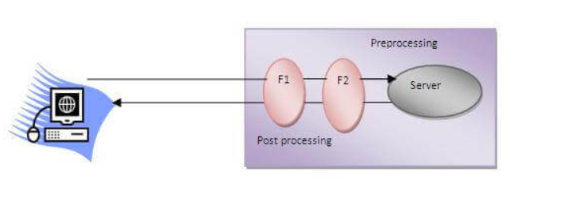

**Filters in servlet**Filter is similar like servlet . To create filter we need to implement our user define class with the Filterinterface or extends our class with the httpFilter class.It contain methods like init,doFilter,destroy,FilterChain and FilterConfig.every thing is just like servlet . The only difference is that filter does not create any dynamic web page.Filter acts as a mideator or sits between the pre-process and post process .When we need same code written to be on every servlet instead of that we will create a filter and pass the url pattern of the every servlet class and this filter will be responsible for every servlet class.eg: suppose we need to check the creadential of the user then we can write that code in filter class.or we need to check the authorities of the user for every servlet then in such case we can use filter class.we can create n number of filter class for a perticular servlet class.