M.NAEEM KAYANI
BSE231102
SCD Lab 13
Section 01
Calculator.JAVA
public class Calculator {
public int add(int a, int b){
return a + b;
}
}

CalculatorTest.JAVA

import static org.junit.Assert.*;

import org.junit.Test;

public class CalculatorTest {

@Test

public void testAddition() {

Calculator calc = new Calculator();
int result = calc.add(5,3);
assertEquals(8,result);
}
}

OUTPUT:
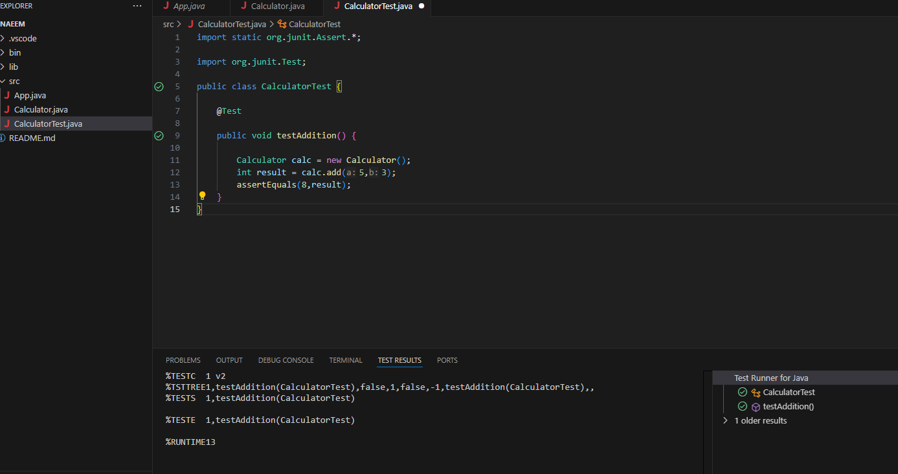

LifecycleTest.JAVA
import org.junit.Before;
import org.junit.Test;
import static org.junit.Assert.*;
import org.junit.After;

public class LifecycleTest {

Calculator calc;

@Before
public void setup() {
calc = new Calculator();
}

@Test
public void testAdd() {
assertEquals(10, calc.add(7, 3));
}

@After
public void cleanup() {
calc = null;
}
}

OUTPUT:
