**Statistical Models In**

**Simulation**

**Presented by**

Shariful Islam

20

CSE

008

# Overview

* For a model-builder, probabilistic rather than deterministic approach is used.
* Statistical models may describe the variations.
* An appropriate model can be developed by sampling the phenomenon of interest.
* Selection of a distribution through educated guesses.

# Random Variable(X)

**A random variable is a variable whose value is unknown or a function that assigns values to each of an experiment's outcomes.** There are **two** types of random variable:

* **Discrete random variable**
* **Continuous random variable**

**N. B.** A Random Variable is different from the variable in algebra as it has whole set of values and it can take any of those randomly. Variable used in algebra cannot have more than a single value at a time.

## Discrete Random Variable

A **discrete random variable** is one which may take on only a countable number of distinct values such as 0,1,2,3,4,........ Discrete random variables are usually (but not necessarily) counts. If a random variable can take only a finite number of distinct values, then it must be discrete.

Examples:

1. Number of children in a family.
2. Attendance of a class.
3. Number of patients in a doctor's surgery.

# Probability Mass Function(PMF)

The **Probability Mass Function (PMF)** is also called a **probability function** or **frequency function** which characterizes the distribution of a **discrete random variable**. Let X be a discrete random variable of a function, then the probability mass function of a random variable X is given by

**P (x) = P( X=x )**, For all x belongs to the range of X

It is noted that the probability function should fall on the condition :

* **P (x) ≥ 0 and**
* **∑ P(x) = 1**

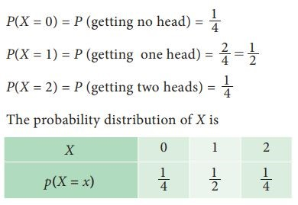**Example**

Let us assume two coin toss experiment:

# Continuous Random Variable

A ***continuous random variable*** is a random variable that has only continuous values. Continuous values are uncountable and are related to real numbers.

Examples:

1. The time it takes to complete an exam for a 60 minute test. Possible values = all real numbers on the interval [0,60]
2. Age of a fossil. Possible values = all real numbers on [min age, max age]
3. Weight of a man. Possible values = all real numbers on [min weight, max weight]

# Probability Density Function(PDF)

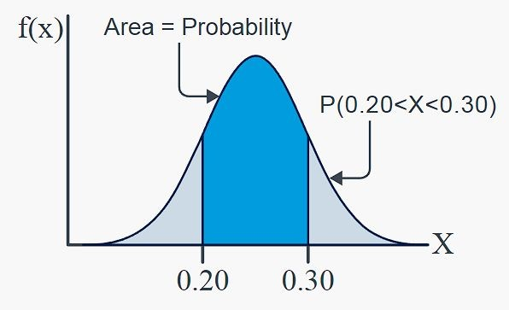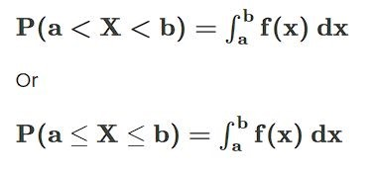The Probability Density Function defines the probability function representing the density of a continuous random variable lying between a specific range of values.

The Probability density function formula is given as,

# Cumulative Distribution Function

The **Cumulative Distribution Function (CDF)**, of a real-valued random variable X, evaluated at x, is the probability function that X will take a value less than or equal to x.

If X is discrete,

F(x)=P(X≤x), for all x∈R.

And if X is continuous, 

Here, f is PDF

# Expected value

The **expected value** of a discrete random variable *X*, symbolized as *E(X)*, is often referred to as the long-term average or **mean** (symbolized as ***μ***). This means that over the long term of doing an experiment over and over, you would expect this average. If X is discrete,

E(X) = ∑x.P(x) ; for all x If X is continuous,

;

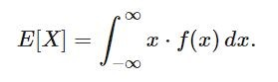

# Variance

Var**iance** measures how far each number in a data set is from the mean(average), and thus from every other number in the set. Variance is often depicted by this symbol: σ2

