**Energy used and Methane Emission**

Methane is one of the greenhouse gasses that can be emitted in different sectors of energy production fields. Greenhouse gasses have the nature of moving upward in the atmosphere and creating a blanket to the earth that raises the heat. Methene absorbs significant energy and makes the environment heated. In the world, Methane comes after the emission of CO2. Metene is 25% more capable of absorbing heat and making the environment with greenhouse effects. In this assignment, the relationship will be identified between the energy consumed by the people in the countries and the overall world with the emission of methane. So, the data has been collected primarily, the indicators have been chosen along with the countries as follows:

* Methane emissions (kt of CO2 equivalent)
* Energy use (kg of oil equivalent per capita)
* Turkey
* Germany
* India
* France
* Iraq
* World (not a country)

The data has been categorised into two segments. The first segment contains the records of the data concerning the indicators and countries with years on the columns and the second segment has the countries with indicators on the columns. The country names and the indicators have been combined for a better understanding of the data. Primaly, the statitsyuc has been analyzed by the countries for the values of Methane emission and energy emissions and these are shown below:

* Turkey

Methane emission by Turkey is 4334998.9

Energy use by Turkey is 2029133.13

* Germany

Methane emission by Germany is 4383120.37

Energy use by Germany is 2031826.97

* India

Methane emission by India is 4738433.55

Energy use by India is 27977472.15

* France

Methane emission by France is 4363332.26

Energy use by France is 2031451.24

* Iraq

Methane emission by Iraq are 4316211.26

Energy use by Iraq is 27977938.4

So, it can be seen that the emotion of methane is different in the selected country and the same for the using the energy. To understand the statistic more clearly, the bar chart has been generated through which the value of energy consumption and methane emission can be viewed. The bar charts are as follows:

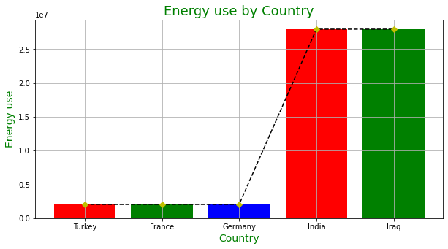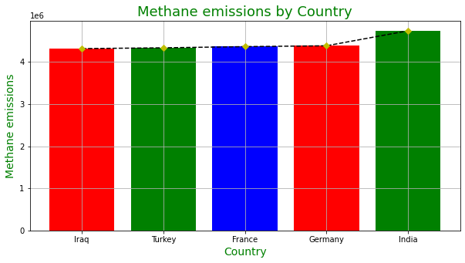

It can be seen that the emission of methane is highest for India and also for the Energy used (2nd place). Now, from the chart, it can be understood that the emission of methane and energy used is not the same for all countries. To understand the fact, correlation of the features in the second data has been applied. This helps to identify the relationship between the feature of the selected countries and the world. The correlation is shown below:

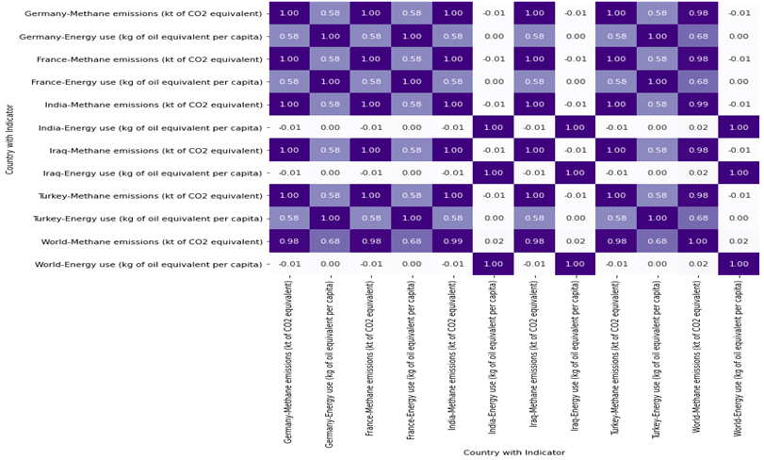

To visualise the correlation, a heatmap chart has been chosen as it facilitates to visualisation of the correlation values of the features by country. From the chart, it can be seen that except for India and Iraq, most countries have a correlation value of 0.58. Som, it can be concluded that the correlation between energy used and the emission of methane is correlated for most countries. It also indicates the fact that if more energy will be used by a country, more methane will be emitted into the atmosphere.