COMSATS UNIVERSITY, ISLAMABAD
Department of Computer Science
Assignment - 4, Spring 2026
[CLO5]: Develop cloud native applications using current DevOps tools

Name: | Naeem ud din
Registration No: | SP23-BDS-038
Instructor: | Qasim Malik

1. Introduction
This assignment demonstrates the deployment of a cloud-native Next.js web application and a MongoDB database onto a local Kubernetes cluster using Minikube. The deployment utilizes declarative YAML manifests to define Pods, Deployments, Services (NodePort), Persistent Volume Claims (PVC), and a Horizontal Pod Autoscaler (HPA).

2. Kubernetes Manifests
The application infrastructure was defined using multiple YAML files inside the `k8s/` directory. This included configuring a PVC to ensure MongoDB data persists across pod restarts, and setting up NodePort services to expose both the database and the web application.
web-deployment.yaml snippet:
apiVersion: apps/v1
kind: Deployment
metadata:
name: web-deployment
...

3. Minikube Initialization
Minikube was initialized on the AWS EC2 instance using the Docker driver. Essential addons, such as the metrics-server (required for HPA) and the dashboard, were enabled.
$ minikube start --driver=docker
😄 minikube v1.38.1 on Ubuntu 22.04
✨ Using the docker driver based on user configuration
👍 Starting control plane node minikube in cluster minikube
...
$ minikube addons enable metrics-server
🌟 The 'metrics-server' addon is enabled

4. Docker Image Build & Deployment
A lightweight Docker image was built utilizing a pre-compiled Next.js standalone build. The image was loaded directly into Minikube's internal Docker daemon to optimize deployment speed and bypass external registry pulls.
$ docker build -t medmcq-web:latest -f Dockerfile.fast .
$ minikube image load medmcq-web:latest
$ kubectl apply -f k8s/
deployment.apps/mongo-deployment created
persistentvolumeclaim/mongo-pvc created
service/mongo-service created
deployment.apps/web-deployment created
horizontalpodautoscaler.autoscaling/web-hpa created
service/web-service created

5. Verification of Resources
The status of all deployed resources was verified using kubectl. Both pods successfully transitioned to the Running state, and the HPA began monitoring CPU utilization.
$ kubectl get pods,svc,hpa
NAME READY STATUS RESTARTS AGE
pod/mongo-deployment-56d578... 1/1 Running 0 31s
pod/web-deployment-766bc75... 1/1 Running 0 31s
NAME TYPE CLUSTER-IP PORT(S)
service/kubernetes ClusterIP 10.96.0.1 443/TCP
service/mongo-service NodePort 10.110.220.108 27017:30017/TCP
service/web-service NodePort 10.110.91.12 3000:30080/TCP
NAME REFERENCE TARGETS
horizontalpodautoscaler.autoscaling/web-hpa Deployment/web-deployment <unknown>/50%

6. Screenshots
Below are the screenshots capturing the Minikube dashboard and the deployed Web Application accessed via secure port-forwarding tunnels.
Minikube Dashboard Overview
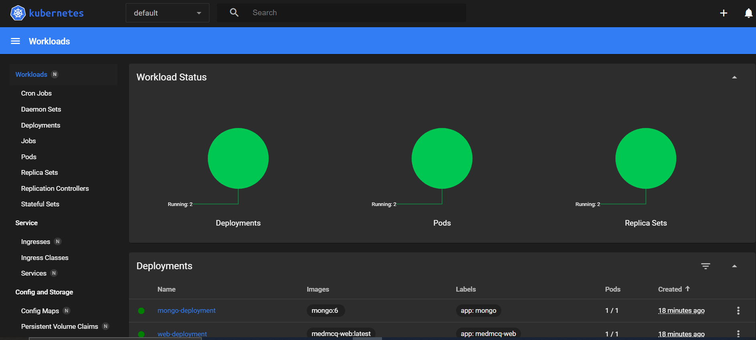

Minikube Deployments and Pods
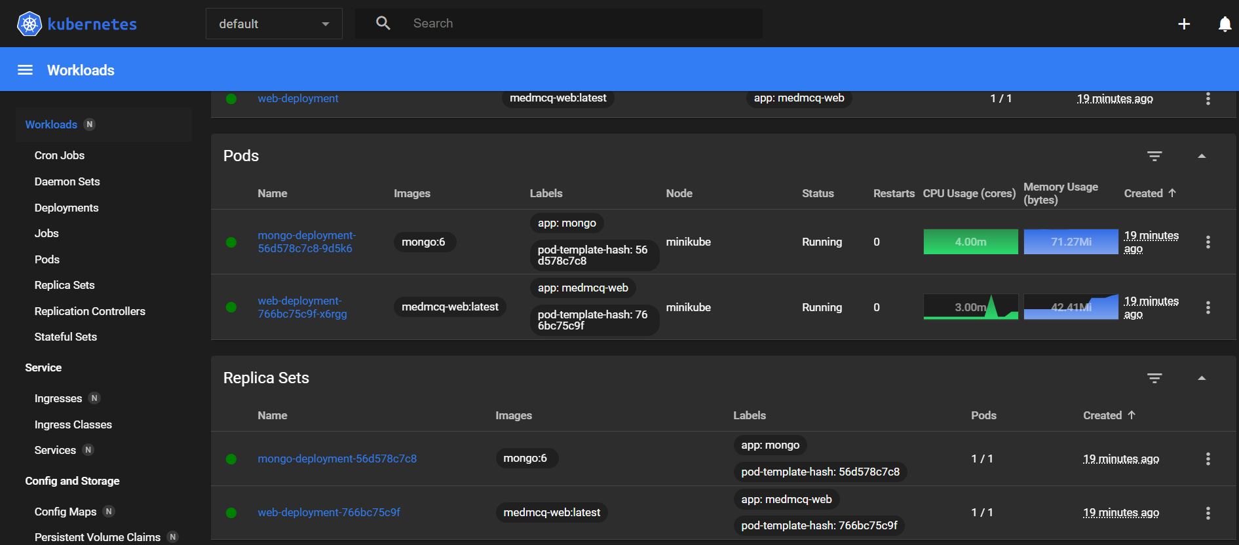

Running Next.js Web Application (Port 3000)
