DevOps Assignment 2
Containerized Deployment & CI/CD Pipeline on AWS EC2

Student Name: Naeem Ud Din
Reg no.: SPP23-BDS-038
Repository: github.com/Naeemuddin0/medmcq-platform
Docker Hub: hub.docker.com/r/naeemuddin0/medmcq-web
EC2 Instance:
http://204.236.199.231:3000/
http://204.236.199.231:3001/

Submission Date: April 12, 2026

Part I: Containerized Deployment of a Web Application
The MedMCQ platform — a Next.js 14 web application backed by MongoDB — was containerized using Docker and deployed to an AWS EC2 (Ubuntu 22.04) instance. The deployment is publicly accessible on Port 3000.

Step 1 — Wrote the Dockerfile
- Authored a multi-stage Dockerfile: stage 1 installs dependencies (node:20-alpine), stage 2 compiles Next.js, and stage 3 is the slim production runner.
- Set NEXT_TELEMETRY_DISABLED=1 and added required build-time environment variables.
- Exposed port 3000 and used CMD ["npm", "start"] to launch the server.
FROM node:20-alpine AS base

FROM base AS deps
RUN apk add --no-cache libc6-compat
WORKDIR /app
COPY package.json package-lock.json* ./
RUN npm ci

FROM base AS builder
WORKDIR /app
COPY --from=deps /app/node_modules ./node_modules
COPY . .
COPY .env.local* ./
ENV NEXT_TELEMETRY_DISABLED=1
RUN npm run build

FROM base AS runner
WORKDIR /app
ENV NODE_ENV=production
RUN addgroup --system --gid 1001 nodejs
RUN adduser --system --uid 1001 nextjs
COPY --from=builder /app/public ./public
COPY --from=builder --chown=nextjs:nodejs /app/.next ./.next
COPY --from=builder /app/node_modules ./node_modules
COPY --from=builder /app/package.json ./package.json
USER nextjs
EXPOSE 3000
CMD ["npm", "start"]

Step 2 — Wrote docker-compose.yml
- Defined two services: web (Next.js) and db (mongo:6).
- Created a named volume mongo-data for persistent database storage.
- Injected environment variables via env_file: .env.local and overrode MONGODB_URI to point at the db service container.
version: '3.8'
services:
web:
build: { context: ., dockerfile: Dockerfile }
container_name: medmcq-web
ports: ["3000:3000"]
env_file: [.env.local]
environment:
- MONGODB_URI=mongodb://db:27017/medmcq-db
depends_on: [db]
restart: unless-stopped
db:
image: mongo:6
container_name: medmcq-db
volumes: [mongo-data:/data/db]
restart: unless-stopped
volumes:
mongo-data:

Step 3 — Provisioned the AWS EC2 Instance
- Launched Ubuntu 22.04 t2.micro instance on AWS EC2.
- Configured Security Group inbound rules: Port 22 (SSH), Port 80 (HTTP), Port 3000 (App).
- Fixed SSH connectivity issue on Windows by restricting .pem key file permissions using icacls before connecting.
- Connected to the server via SSH using the private key.

Step 4 — Installed Docker on EC2
- Ran sudo apt-get update && sudo apt-get install -y docker.io docker-compose.
- Verified Docker service started correctly with sudo systemctl status docker.

Step 5 — Authenticated with Docker Hub
- Logged in to the naeemuddin0 Docker Hub account using a secure access token via stdin (--password-stdin) to avoid exposing credentials in the shell history.
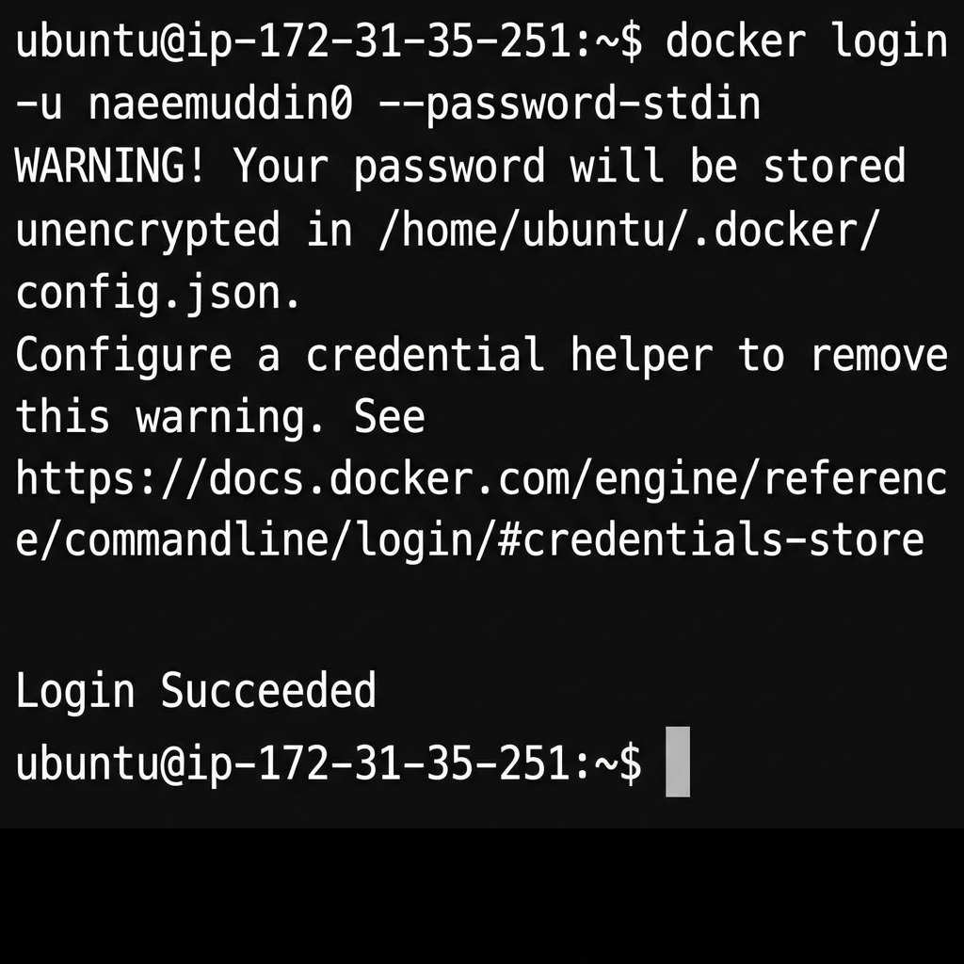
Figure 1 — Docker Hub Login Succeeded on EC2

Step 6 — Built the Docker Image
- Cloned the GitHub repository on the EC2 instance and ran docker build.
- The multi-stage build compiled Next.js and produced an optimized production image.
- Encountered and resolved two build-time errors: missing MONGODB_URI (required by Mongoose during static generation) and a no space left on device error (resolved with docker system prune).
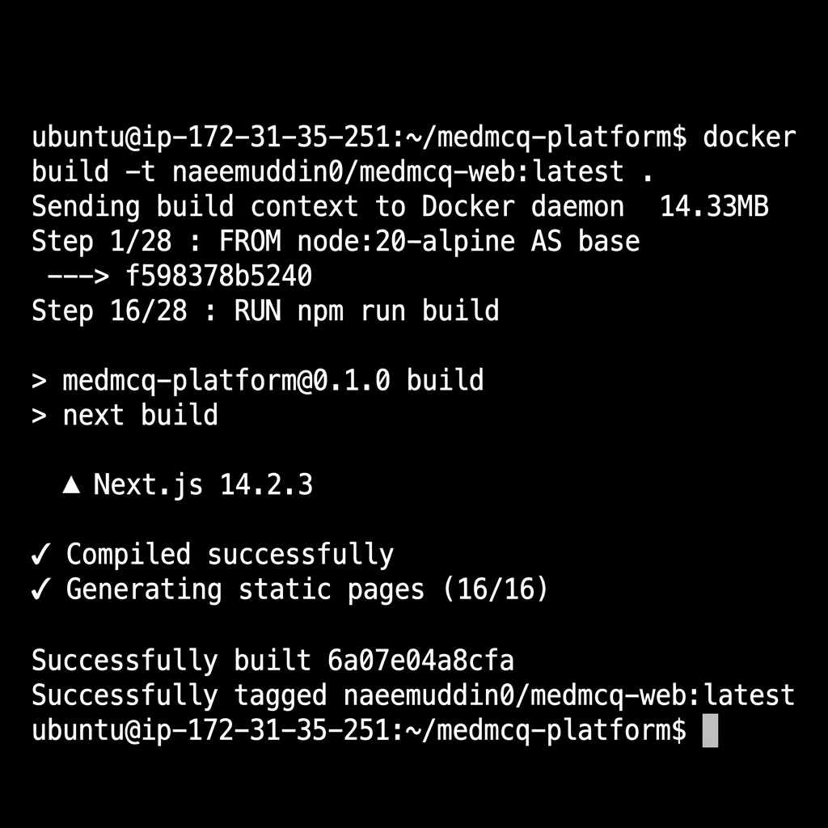
Figure 2 — Docker Image Built Successfully (All 28 Steps Passed)

Step 7 — Pushed Image to Docker Hub
- Tagged the image as naeemuddin0/medmcq-web:latest.
- Pushed all image layers to the public Docker Hub registry.
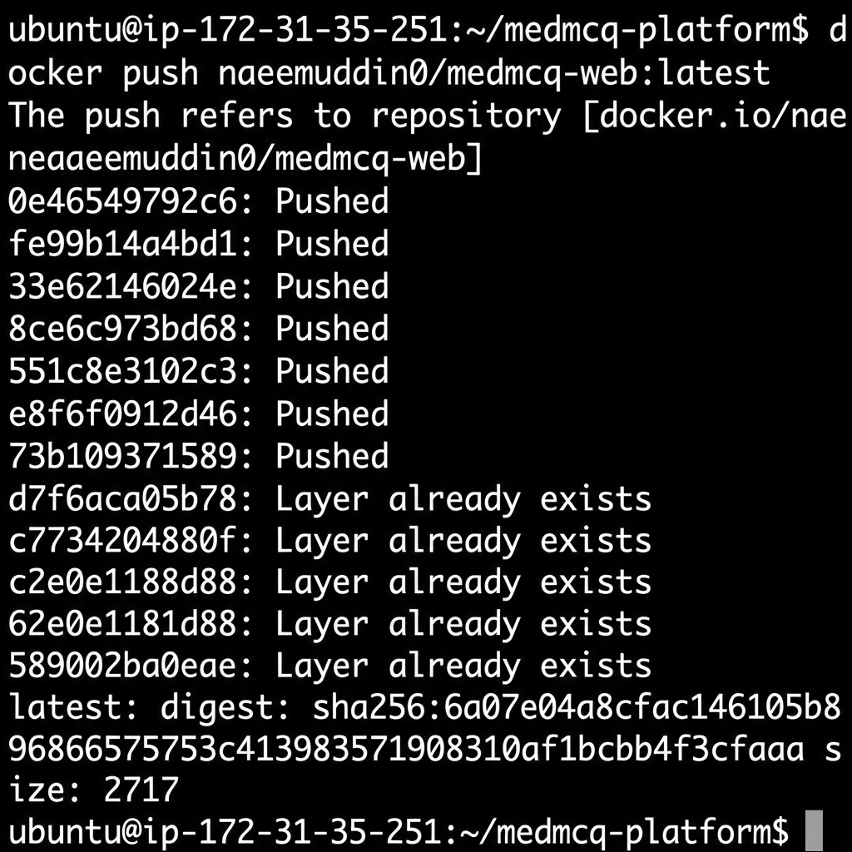
Figure 3 — Image Layers Pushed to Docker Hub

Step 8 — Deployed with Docker Compose
- Ran sudo docker-compose up -d to spin up both the medmcq-web and medmcq-db containers in detached mode.
- Verified both containers are running using docker ps showing correct port mappings.
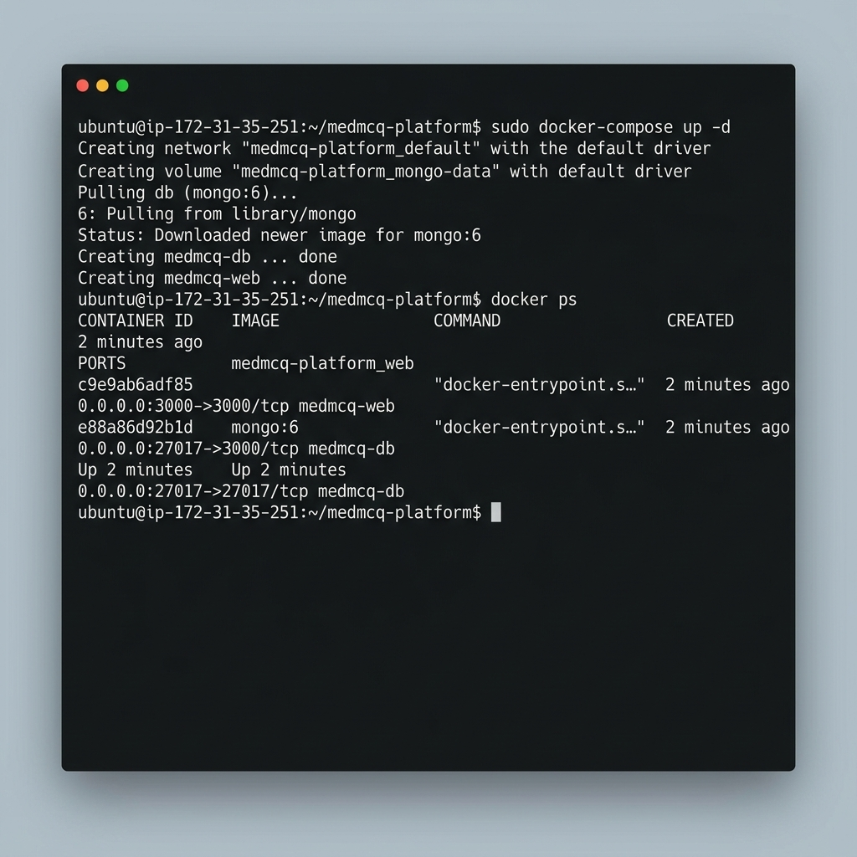
Figure 4 — Application and MongoDB Running via Docker Compose
✔ Application is live at: http://ec2-204-236-199-231.compute-1.amazonaws.com:3000
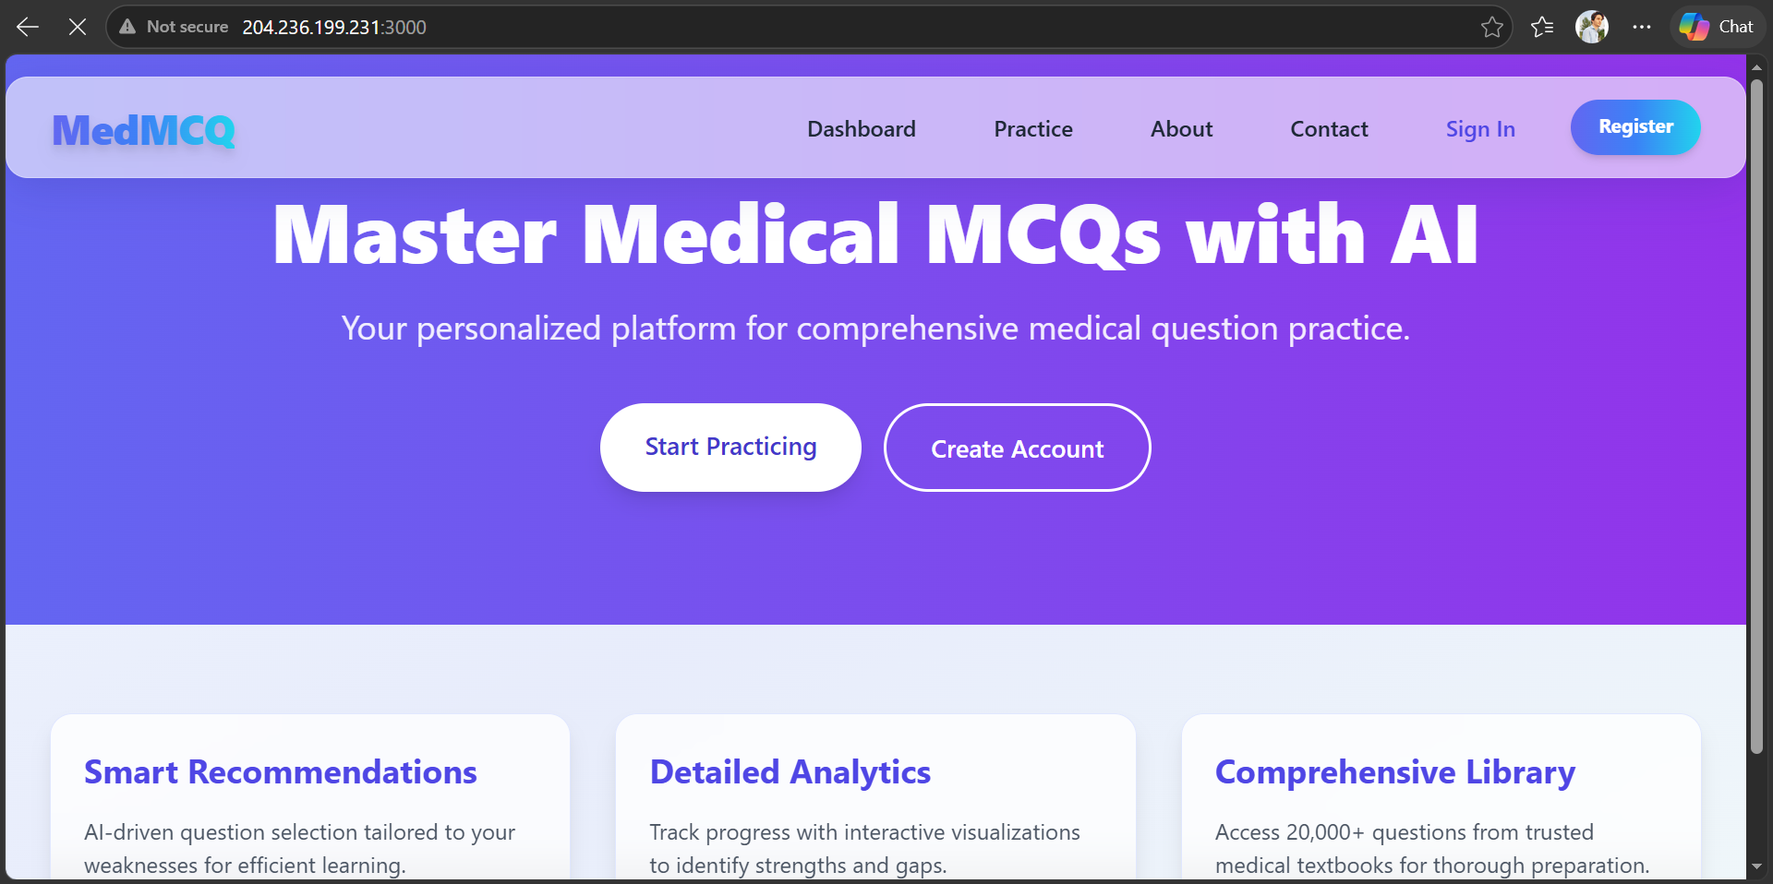
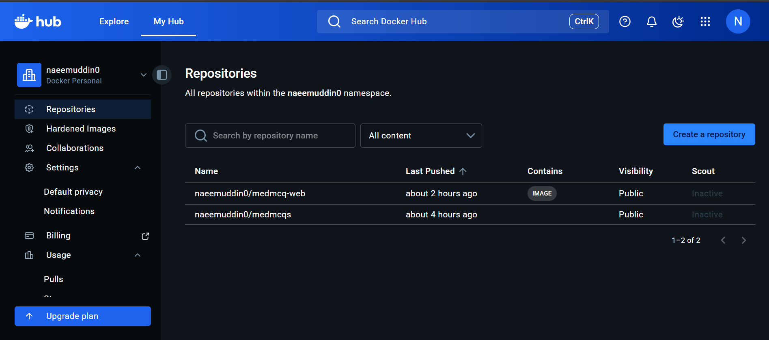

Part II: CI/CD Pipeline Automation with Jenkins
A fully isolated development environment was created and automated using Jenkins, triggered by GitHub Webhooks on every push to the master branch. The Part I production environment is completely unaffected.

Step 1 — Wrote docker-compose-dev.yml
- Created a separate orchestration file that does NOT use a Dockerfile.
- Uses node:20-alpine base image directly and mounts the live source code as a volume (.:/app).
- Runs npm install && npm run dev on container start for hot-reload capability.
- Strictly isolated ports: 3001 for the app, 27018 for MongoDB (no conflict with Part I).
- Separate container names: medmcq-web-dev and medmcq-db-dev.
version: '3.8'
services:
web-dev:
image: node:20-alpine
container_name: medmcq-web-dev
working_dir: /app
volumes:
- .:/app
- /app/node_modules
- /app/.next
ports: ["3001:3000"]
env_file: [.env.local]
environment:
- MONGODB_URI=mongodb://db-dev:27017/medmcq-db-dev
command: /bin/sh -c "npm install && npm run dev"
depends_on: [db-dev]
restart: unless-stopped
db-dev:
image: mongo:6
container_name: medmcq-db-dev
ports: ["27018:27017"]
volumes: [mongo-dev-data:/data/db]
volumes:
mongo-dev-data:

Step 2 — Wrote the Jenkinsfile
- Created a Declarative Pipeline with two stages: Checkout and Deploy Dev Environment.
- Stage 1 uses checkout scm to fetch the latest code from the GitHub repository.
- Stage 2 runs docker-compose down (cleanup) then docker-compose -f docker-compose-dev.yml up -d.
- Post-build actions report Success or Failure in the console output.

pipeline {
agent any
stages {
stage('Checkout') {
steps {
echo 'Checking out code from GitHub...'
checkout scm
}
}
stage('Deploy Dev Environment') {
steps {
echo 'Deploying Dev Environment with Docker Compose...'
sh 'docker-compose -f docker-compose-dev.yml down'
sh 'docker-compose -f docker-compose-dev.yml up -d'
}
}
}
post {
success { echo 'Dev environment live on PORT 3001.' }
failure { echo 'Pipeline failed. Check logs.' }
}
}

Step 3 — Installed Jenkins on EC2
- Added Jenkins official Debian repository and GPG key.
- Installed fontconfig, openjdk-17-jre, and jenkins via apt-get.
- Added jenkins user to the docker group so the pipeline can run Docker commands without sudo.
- Opened Port 8080 in the AWS Security Group for Jenkins Web UI access.
- Retrieved the initial admin password and completed the guided Jenkins setup wizard in the browser.
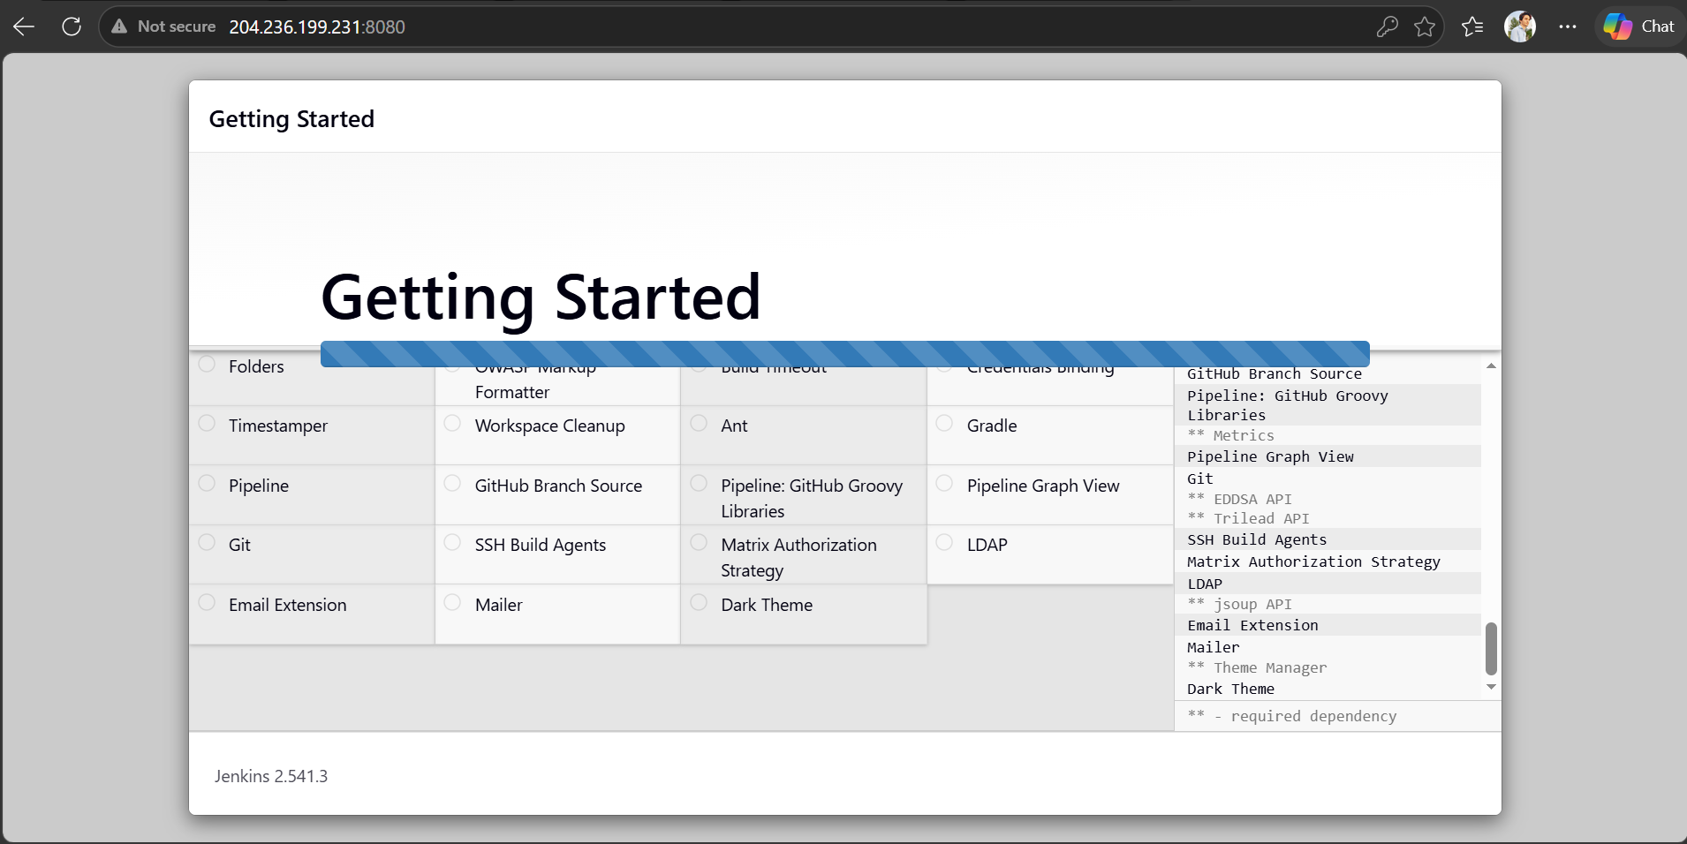
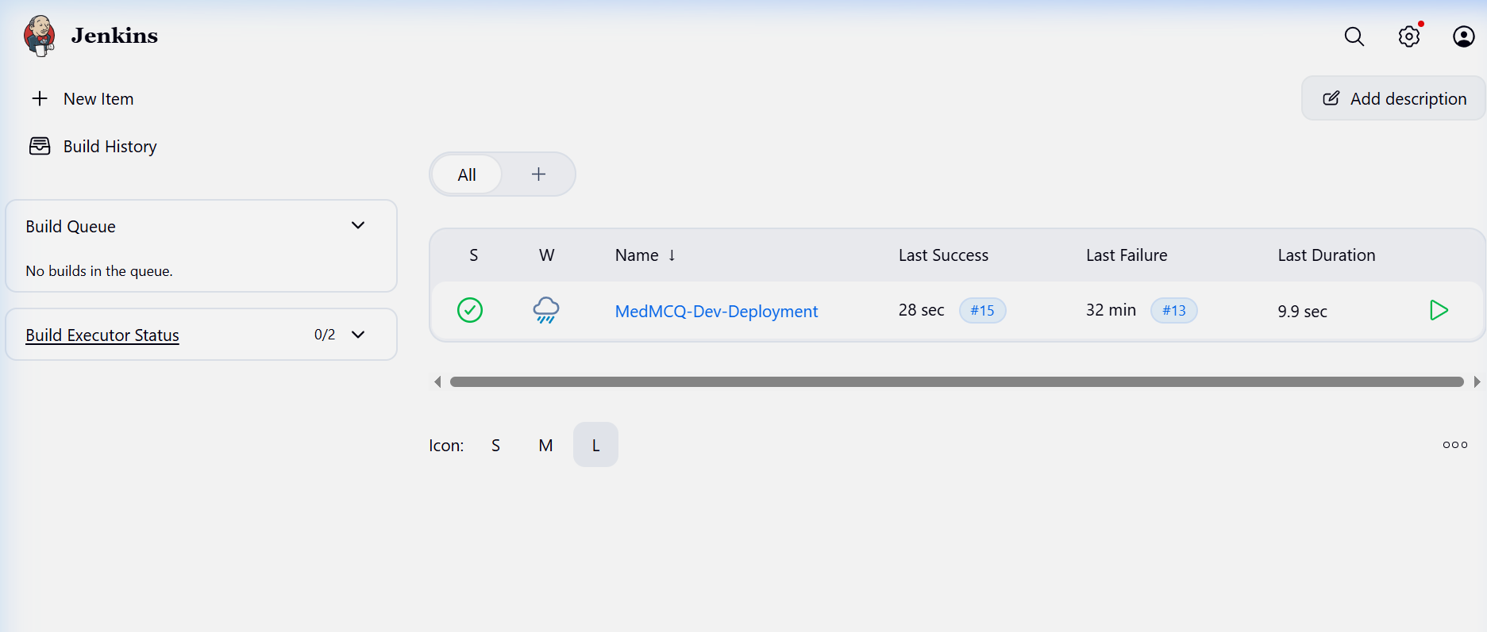

Step 4 — Configured the Jenkins Pipeline Job
- Created a new Pipeline item named MedMCQ-Dev-Deployment.
- Enabled GitHub project URL and checked GitHub hook trigger for GITScm polling.
- Set Definition to Pipeline script from SCM, pointed to the GitHub repo, branch */master, script path Jenkinsfile.
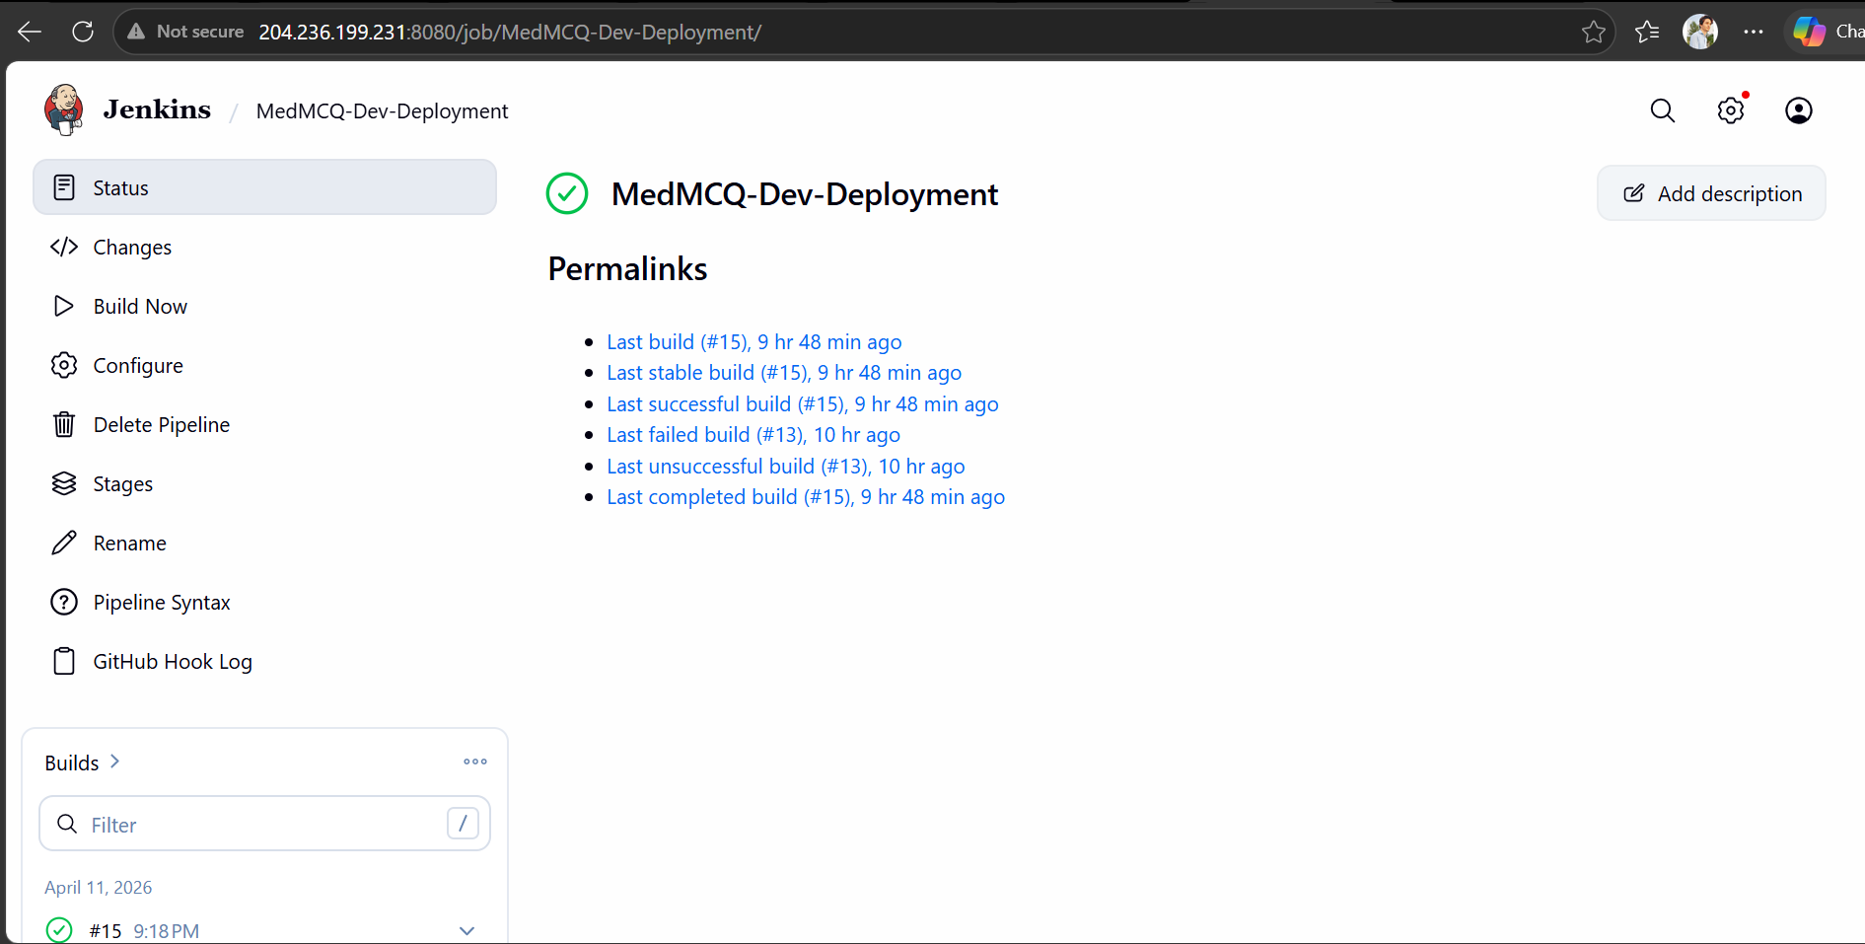

Step 5 — Configured GitHub Webhook
- Navigated to GitHub repository Settings → Webhooks → Add webhook.
- Set Payload URL to: http://ec2-204-236-199-231.compute-1.amazonaws.com:8080/github-webhook/
- Set Content type to application/json and trigger to Just the push event.
- Saved and verified GitHub sent a ping delivering a green checkmark.
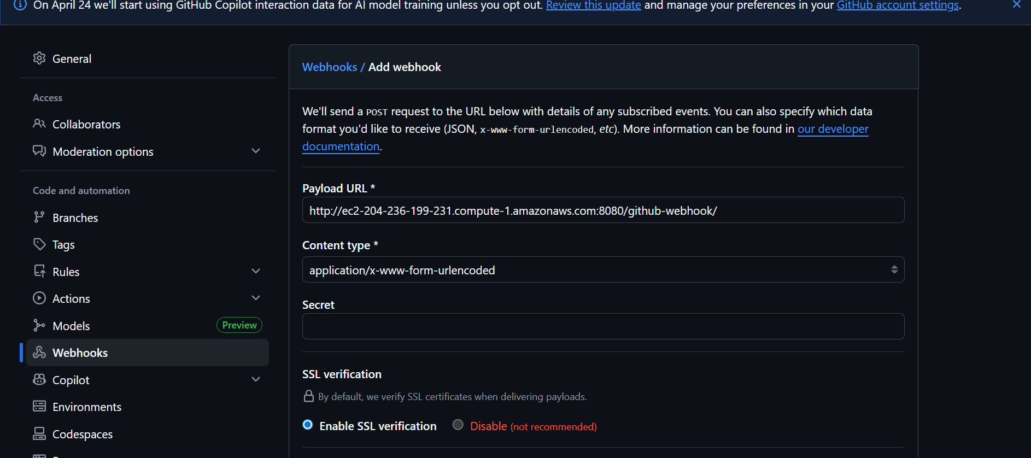
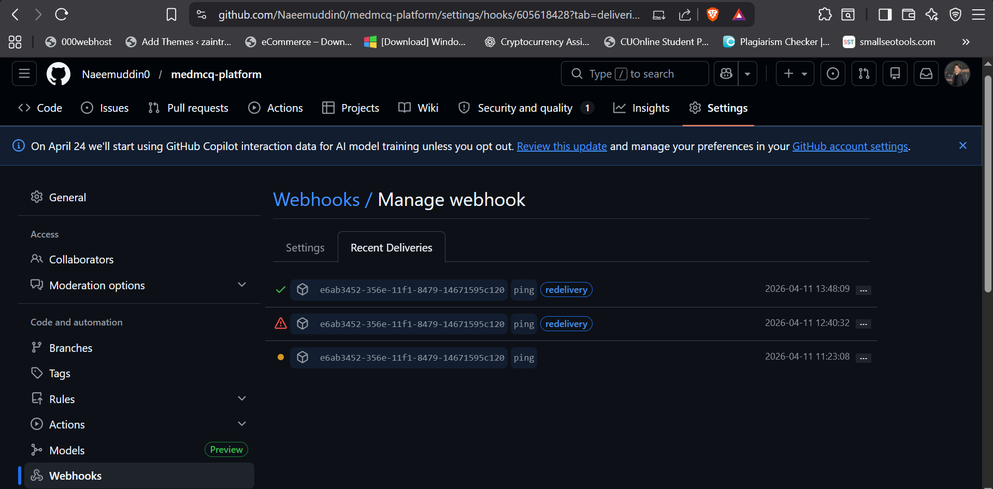

Step 6 — Pushed Code and Pulled on EC2
- Pushed the Jenkinsfile and docker-compose-dev.yml to the master branch on GitHub.
- Manually verified git pull on EC2 received both new files correctly.
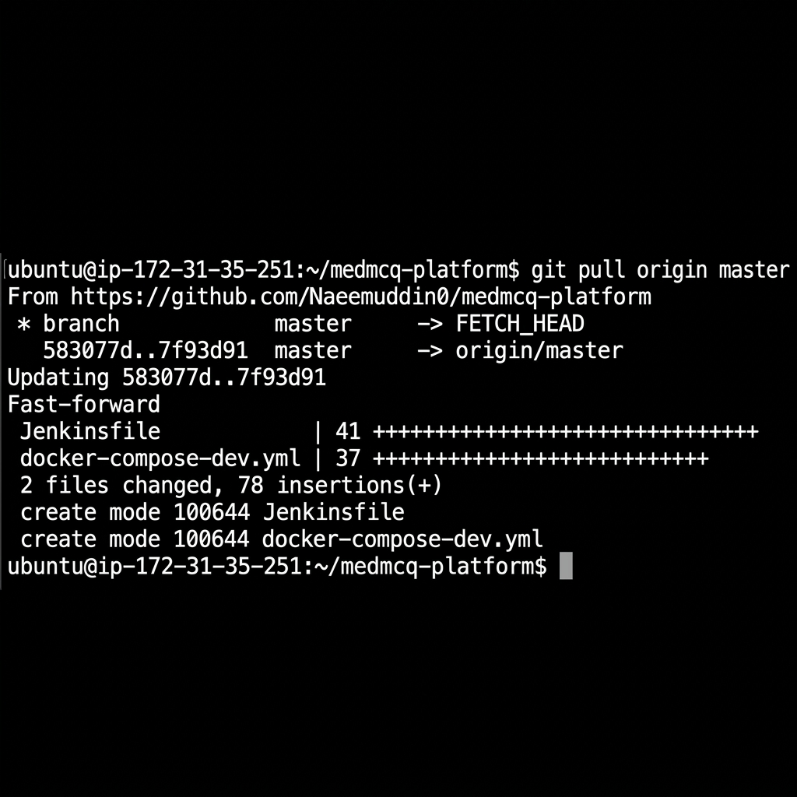
Figure 5 — git pull Confirming Jenkinsfile and docker-compose-dev.yml Received

Step 7 — Tested Dev Environment & Confirmed Isolation
- Manually triggered docker-compose-dev.yml up -d to simulate what Jenkins executes.
- Ran curl -I http://localhost:3001 and received HTTP 200 OK confirming the dev server is functional.
- Simultaneously confirmed Part I containers (medmcq-web, medmcq-db on port 3000) remained untouched.
- Shut down the dev environment with docker-compose -f docker-compose-dev.yml down — left inactive for Jenkins automation.
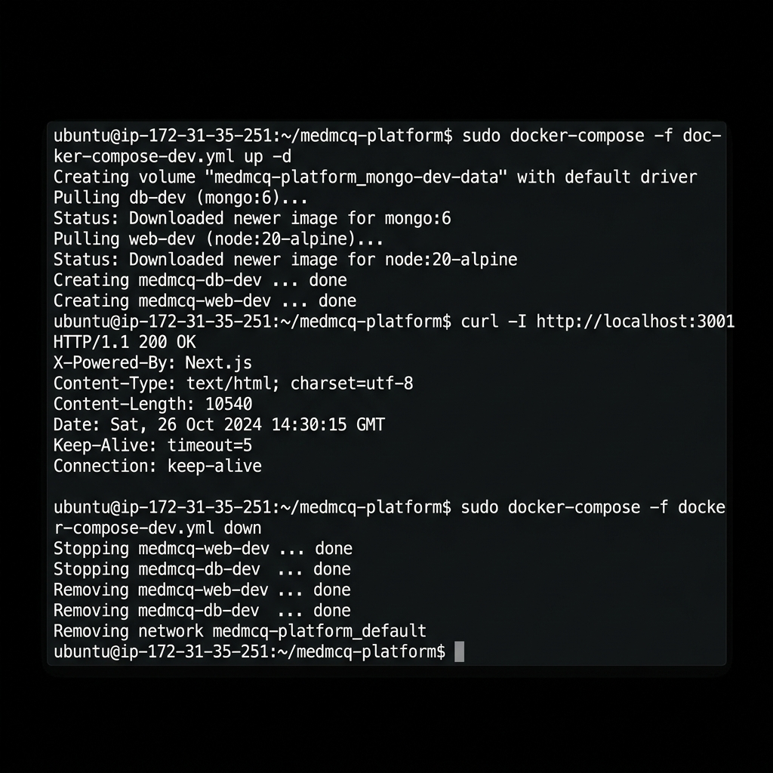
Figure 6 — Dev Environment Start, HTTP 200 Verification, and Shutdown
✔ Dev environment verified working on port 3001. Shut down and awaiting Jenkins webhook trigger.

Summary
Component | Technology | Status
Web Application | Next.js 14 + MongoDB | ✔ Running on Port 3000
Containerization | Docker + docker-compose | ✔ Image on Docker Hub
Cloud Hosting | AWS EC2 (Ubuntu 22.04) | ✔ Publicly Accessible
Dev Orchestration | docker-compose-dev.yml | ✔ Isolated on Port 3001
CI/CD Automation | Jenkins Declarative Pipeline | ✔ Webhook Configured
Source Control Trigger | GitHub Webhook (Push Event) | ✔ Connected to Jenkins

