OCL - Modeling HW6 (50 points)

Q1:

The following is a Class Model for a simple order processing system (SOPS). In the diagram, the class Order has an attribute, status with an enumerated type. Status can be one of the following values: Pending, Invoiced, Cancelled. A pending order is one that has not been filled. An invoiced order is one that has been filled (i.e., stocked items have been allocated to all the order items of the order) and a cancelled order is one that has been cancelled by the customer. Each order item of an order is also associated with a status that can have one of the following values: Filled, NotFilled. The Warehouse class represents warehouses that contain products (items). For each type of product (item) stored in a warehouse (a Warehouse object) there is a StockItemDesc that contains information about the total number of products of the type stored in the warehouse and the total number of reserved products of the type. Order items that are filled are linked to the StockItemDesc object from which products have been allocated. An invoiced order is linked to all the warehouses (objects of Warehouse) from which order items are filled.

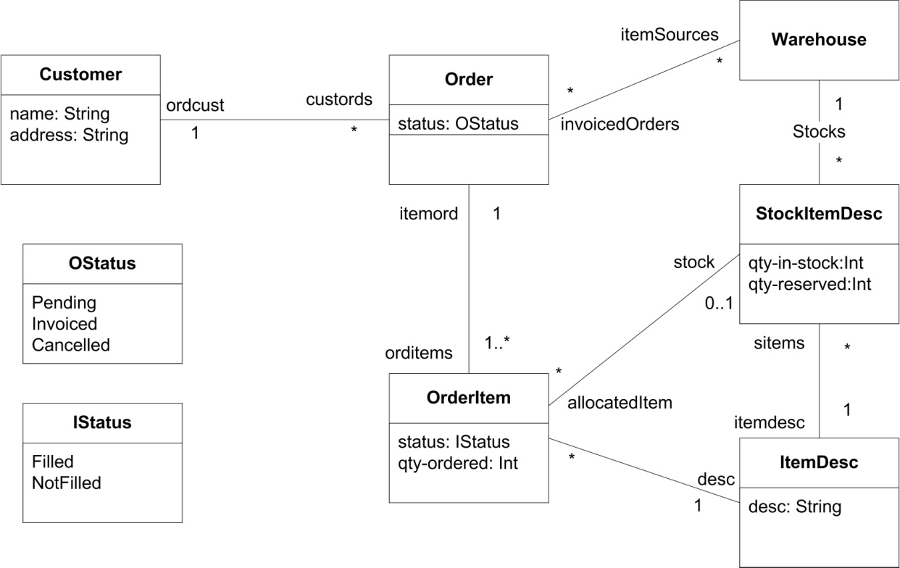

Part A: Evaluate the following OCL expressions using the SOPS object diagram given below. The expressions all return collections of objects. Use object names shown in the object diagram to refer to objects, for example, the expression
C1.Order.orditems evaluates to {Item1, Item2, Item3, Item4, Item5, Item6}, that is,
C1.O1.orditems = {Item1, Item2, Item3, Item4} (10 points)
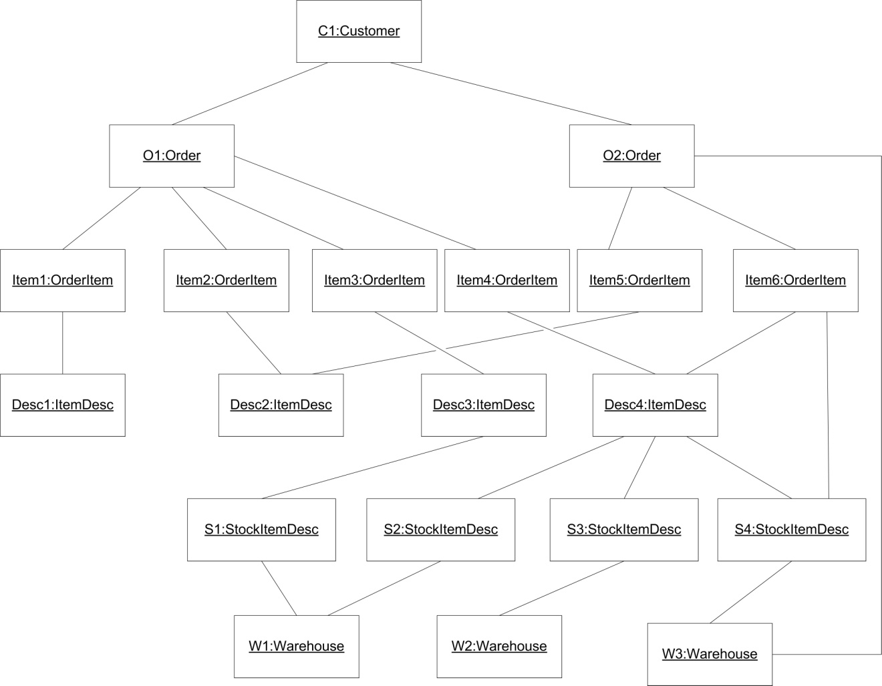

- (2 points) O2.OrderItem.ItemDesc.StockItemDesc = {S2, S3 S4}
- (2 points) W1.StockItemDesc.itemdesc.OrderItem = {Item3, Item4, Item6}
- (3 points) O1.OrderItem → select(i | i.ItemDesc.StockItemDesc-->isEmpty()) =
{Item1, Item2}
- (3 points) O1.OrderItem → select(i | i.ItemDesc.StockItemDesc-->size() > 1) =
{Item4}
Part B: Complete the following OCL constraints (10 points):
- (3 points) If an order is invoiced then all its order items are filled.
context Order
inv: if self.status = OStatus::Invoiced
then self.Order → forAll(item | item.status = Filled )
- (3 points) If an order item is filled then it is linked to a StockItemDesc object.
context OrderItem
inv: if self.status = IStatus::Filled
then self.stock → notEmpty()
- (4 points) If an order item is linked to a StockItemDesc object then the associated order is linked to the warehouse linked to the StockItemDesc object.
context OrderItem
inv: if self.stock → notEmpty()
then self.itemord.itemSources → includesAll(self.stock )
Q2:

The following questions pertain to the class model for an airline reservation system shown below. The diagram describes a system that maintains information about flights (instance of Flight) and bookings (instances of Booking). Passengers are booked on flights and are assigned seats (instances of FlightSeat) at the time of booking. A flight is operated by a flight plane (instance of FlightPlane) on a particular date.
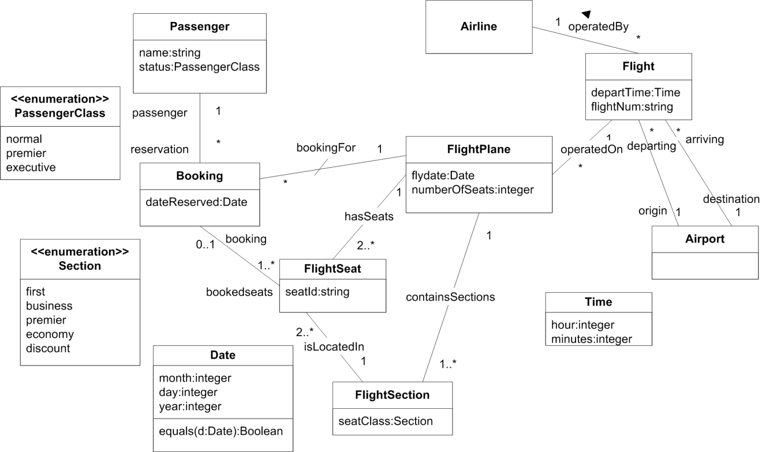

The following are OCL statements associated with model elements in the domain model. State in English the constraints they express:
- (5 points)
Context Booking
inv: self.bookedseats.hasSeats → forAll(f |f = self.bookingFor)

Every seat that the booking includes is located in the same flight that the booking is part of.

- (5 points)
Context FlightPlane
inv: self.numberOfSeats = self.hasSeats → size()

The number of seats attribute for a FlightPlane instance is the same exact number of FlightSeat instances it is associated with.

- (5 points)
Context FlightSection
inv: (seatClass = Section::first or seatClass = Section::business or

seatClass = Section::premier)

implies isLocatedIn → collect (f.booking.passenger.status) →

forAll(s | s = PassengerClass:: executive or s = PassengerClass:: premier)
If the class of Seat section is first class, business class, or premier, it is implied that the passenger status of each passenger associated with each flight seat within that section is either premier or executive.

Q3: What are operation contracts? What are the advantages and disadvantages of using OCL in specification of operation contracts? Justify your answer by giving an example. (5 points)
Method contracts define the name of the method, and any references associated with said method. This includes references to said method from elsewhere in the domain, as well as methods that will be called from within the method for the method contract. Method contracts also define pre conditions and post conditions. For both of these types of conditions, variables required to enter or exit the method are defined as well as any possible state that the program must be in for the method to execute correctly. Post conditions may also define data structure modifications or changes of state to the program – not just the return variable. The benefit of operation contracts is that they don't specify the implementation of the operation. However, OCL is really only best useful when defining the rules or laws of a domain. Operation contracts are used during modelling, but perhaps if minimal requirements are known at a given time, it may not be benficial to use OCL for operation contracts because of the miniscule gain for this situation, and associated overhead with creating the operation contracts using this formal specification.

Q4: (10 Points)
Write the OCL equivalent of the following invariants for the given model

- Give an OCL invariant that specifies that the sum attribute cannot be negative.

Context Order
inv: self.sum >= 0

- Give an OCL invariant that specifies that the sum attribute will be zero if no DVDs are ordered.
Context Order
inv: if self.OrderedVideos → isEmpty() then self.sum = 0

- Give an OCL invariant that specifies that the sum attribute really describes the price of the DVDs ordered.
Context Order
inv: DVDs → iterate (d : DVD;
answer: Integer = self.sum |
answer += d.price)

- Give an OCL invariant that specifies that different instances of DVD have different Id
Context DVD
inv: DVD::allInstances → isUnique(Id)

