HOTEL ROOM BOOKING SYSTEM
GROUP 4

Functional Requirements
The hotel needs to build an online room booking system to support room reservation and cancellation, room searching, member management and hotel operations. The system includes the following main features:
- Search room information
- Guests and members can search for available room types by entering check-in date, check-out date, price range and guest capacity.
- Results can be sorted by price (ascending/descending) or average rating score.
- Search Results Display: The system displays room type information including: Room Type name, price per night, capacity, description, amenities, and current available room count.
- Register and manage member accounts
- Users can register for a member account by providing full name, date of birth, gender, phone number, email, and password.
- The system checks for duplicate emails and enforces a minimum password length of 6 characters. Passwords are stored in encrypted form.
- Members can log in, log out, and update their profile details at any time.
- Members can request a password reset by entering their registered email. The system verifies the email, sends a verification code or reset link, and allows the user to set a new password.
- Book rooms and payment
- Only logged-in members can perform room bookings.
- When booking, the system verifies room availability for the selected dates and room type.
- Members must pay 100% of the total booking cost online via integrated payment gateways to complete the reservation.
- Upon successful payment, the system creates a booking record (Status: Confirmed), records transaction details (Payment date, Method, Reference ID), and generates an electronic receipt.
- Cancel bookings :
- Members can cancel their bookings before the check-in date.
- The system applies a cancellation policy based on the time of cancellation: If the member cancels more than 48 hours before check-in, no fee is charged.
- If cancellation occurs between 24 and 48 hours before check-in, the member receives 50% refund
- If cancellation occurs within 24 hours of check-in, the member loses 100% of the paid amount . After cancellation, the system updates the room status back to "Available" and records the cancellation history.
- Manage booking history
- Members can view the list of rooms they are currently booking, the expected check-out dates, and the history of previous bookings.
- Write reviews after stay:
- After check-out, members can write reviews and rate the specific room types they stayed in.
- The review includes a star rating (from 1 to 5) and a text comment. Submitted reviews are published immediately on the room details page.
- Members can view all their previous reviews and edit or delete them within 24 hours of submission.
Receptionist functions: the receptionist has the following functions:
- Managing Reservations: The receptionist can view the list of all booking slips of all members, filtered by check-in date, booking status, or guest name.
- Walk-in Guest Booking: For walk-in guests, the receptionist creates a quick member account on their behalf using the guest's basic information before generating the booking record.
- Check-in Handling: When guests arrive, the receptionist confirms check-in, assigns a specific physical Room Number to the booking, and updates the room status from Available to Occupied.
- Check-out Handling: Upon guest departure, the receptionist confirms check-out, completes the booking record (Status: Completed), and updates the room status from Occupied back to Available.
System Administration: The administrator has the following functions:
- Room management
- The administrator manages rooms with full CRUD (Create, Read, Update, Delete) operations. This includes adding new rooms, editing room details (room number, room type, price per night, capacity, description, amenities), updating room status (Available/Occupied/Maintenance), and deleting rooms that are no longer in service
- User management
- The administrator manages user accounts with the ability to lock or unlock member accounts when they violate policies (such as frequent cancellations).
- The administrator can create new receptionist accounts and assign appropriate permissions.
- For security, the administrator can only delete accounts that have no transaction history; accounts with existing bookings are deactivated instead of permanently deleted to maintain data integrity
- Booking management
- The administrator manages all booking records and can view detailed information about any booking in the system.
- In special cases such as natural disasters or emergencies, the administrator can cancel bookings and process full refunds to members.
- Reports and Statistics
- View comprehensive reports including revenue reports by day/month/year and by room type, occupancy rate reports, and statistics on frequent/loyal customers.
- Review Management
- View all submitted reviews, with authority to hide inappropriate content or permanently delete spam reviews.
- Non-Functional Requirements
- Usability
- The system shall provide a simple and clear user interface so that members,receptionist , administrator can use the system without special training
- Friendly and easy-to-use system interface
- System access should be quick and easy.
- Reliability
- In case of system downtime, the system must ensure 99.9% recovery within 24 hours.
- The system must prevent double booking of the same room for the same time period.
- All user transactions must be reliably recorded even if the system crashes.
- The system must ensure data consistency across all database tables.
- The system must validate all input data to prevent errors and data corruption.
- The system must handle errors gracefully without crashing or losing data.
- The system must provide confirmation messages after successful operations (booking, payment, cancellation).
- Transaction logs must be maintained for all critical operations to enable data recovery.
- Performance
- The system shall respond to normal user actions within 2 seconds under standard operating conditions.
- The system load capacity when many people access it must ensure normal operation
- Security
- User accounts and passwords shall be stored securely and shall not be saved in plain text.
- The system shall restrict system functions based on user roles
- The stored information must be strictly protected by the system to prevent information leakage to the outside.
- Design Constraints
- The Hotel Room Booking System uses the programming language Python with a relational database MySQL
- Data Flow Diagram
- Level 0 :
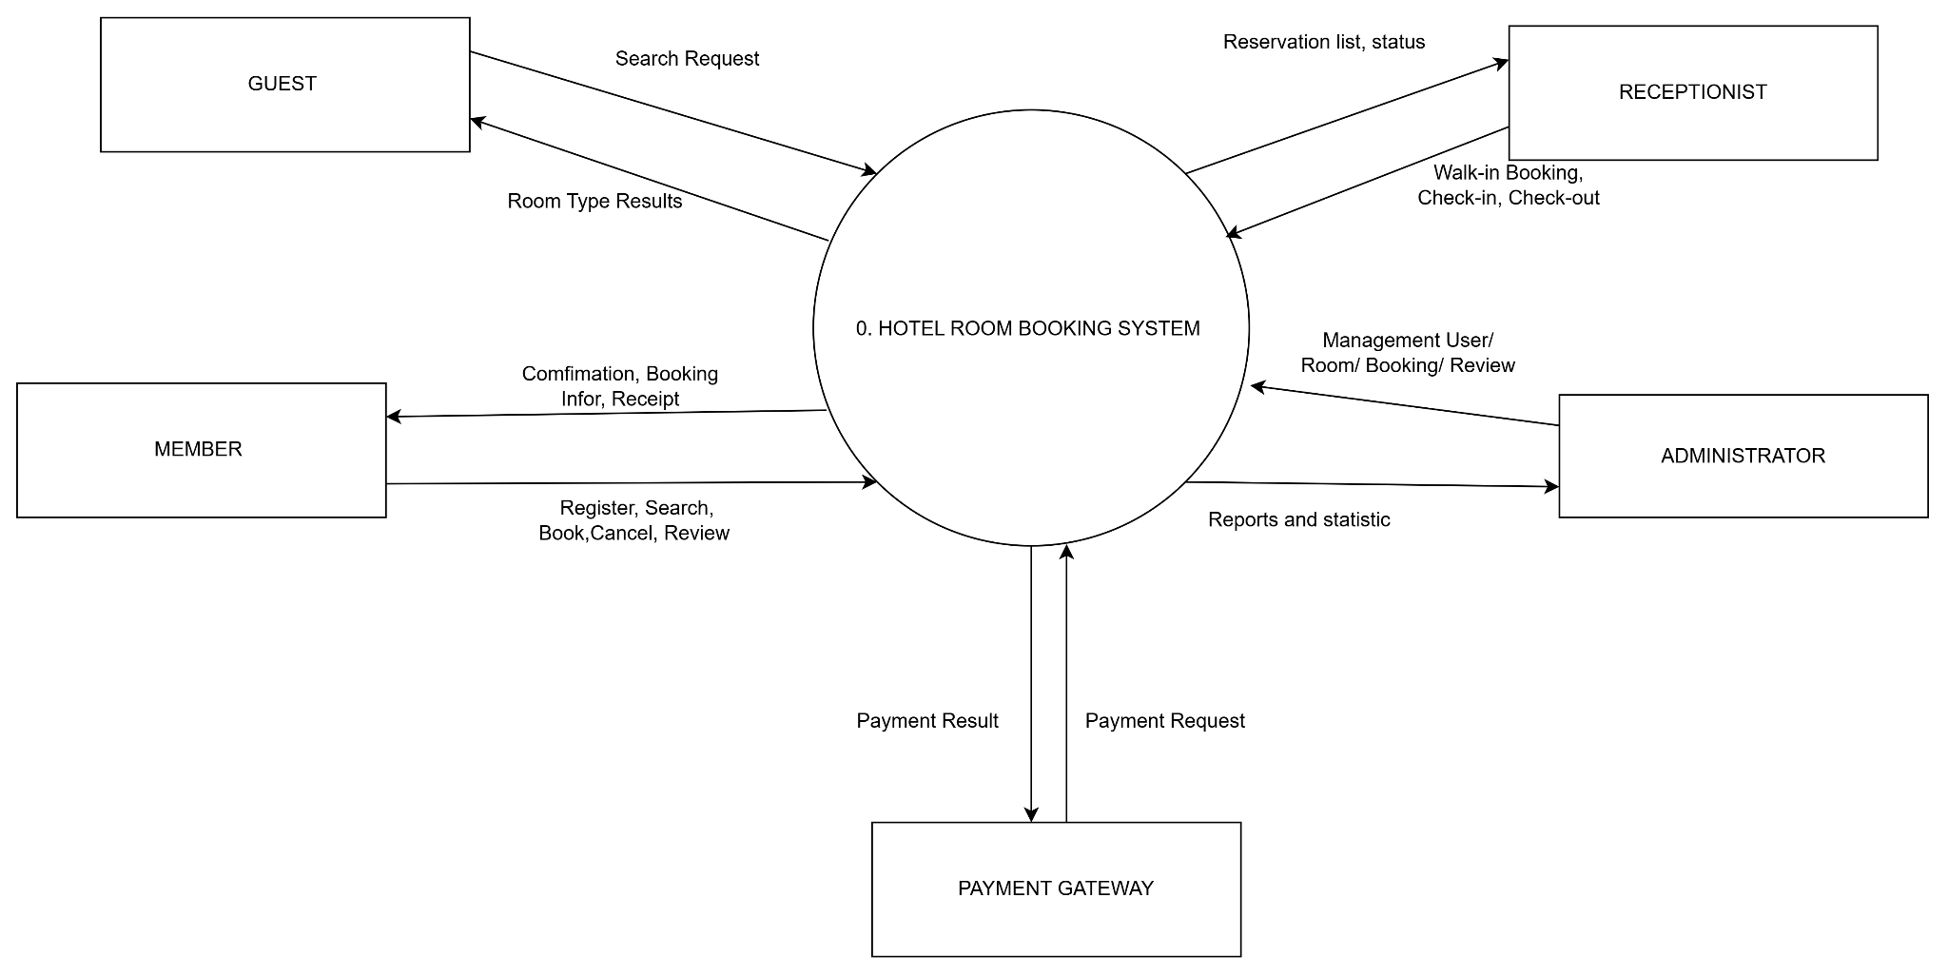
- Level 1:
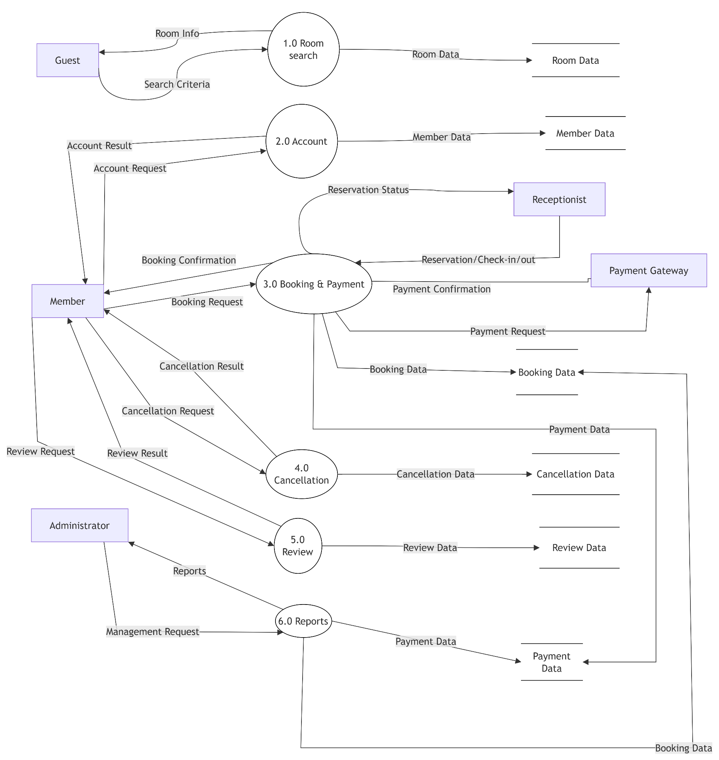
- Use case Diagram

4.1. Overview Diagram :
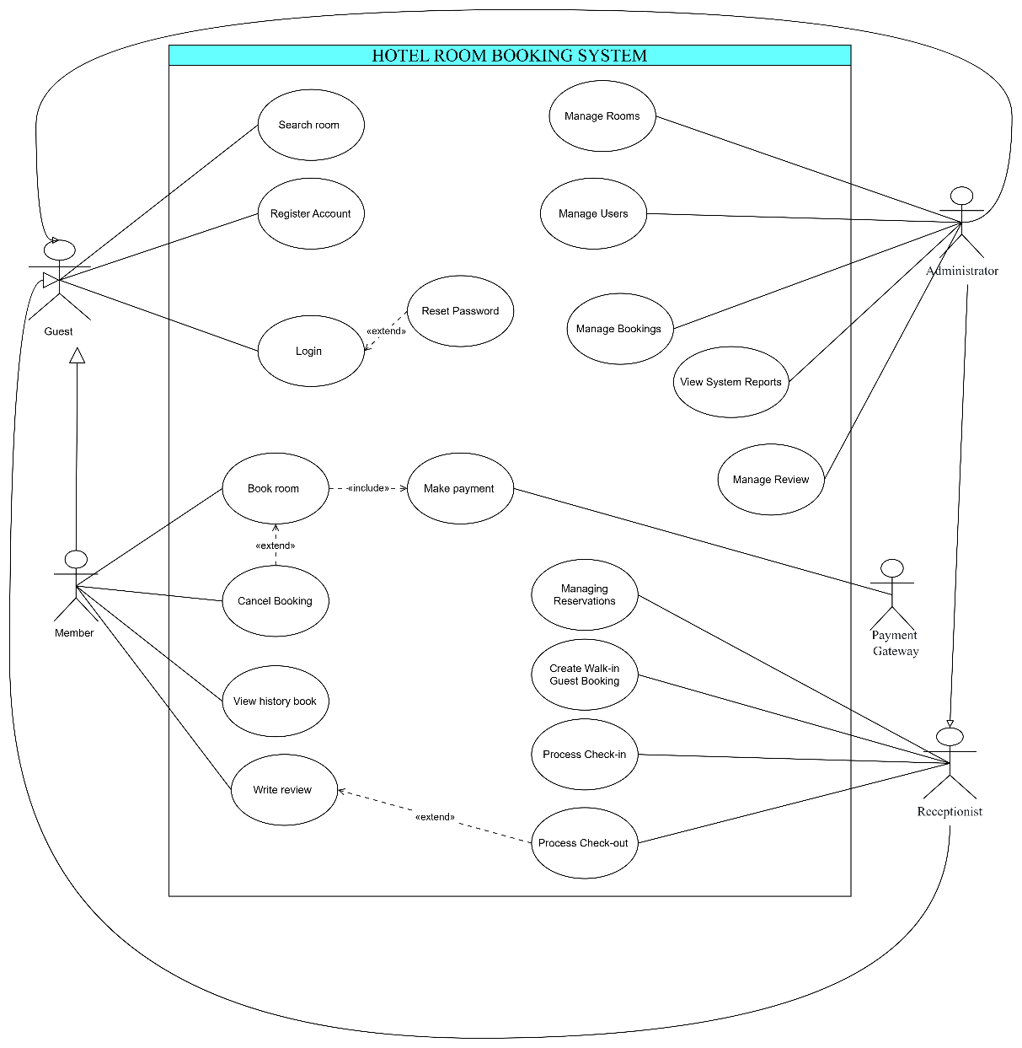

4.2 Actor List
No. | Actor | Description
1 | Guest | Unauthenticated visitor browsing the system
2 | Member | Registered user who has logged in
3 | Receptionist | Front desk staff managing room reservations
4 | Administrator | System administrator
5 | Payment Gateway | Third-party online payment system

4.3. Use Case List
No. | Use Case | Description
1 | Search Room | Search for available rooms based on dates and criteria
2 | Register Account | Register a new user account
3 | Login | Authenticate into the system
4 | Reset Password | Recover account password when forgotten
5 | Book room | Reserve a room for selected dates
6 | Make payment | Process payment for the room reservation
7 | View history book | View past and current reservation history
8 | Cancel Booking | Cancel an existing booking
9 | Write review | Submit ratings and feedback for completed stays
10 | Managing Reservations | Overview and manage daily room bookings
11 | Create Walk-in Guest Booking | Create instant bookings for walk-in customers
12 | Process Check-in | Perform arrival procedure and assign rooms
13 | Process Check-out | Perform departure procedure and finalize billing
14 | Manage Rooms | Add, edit, or delete room types and room details
15 | Manage Users | Manage customer and staff accounts
16 | Manage Bookings | View and adjust all system reservations
17 | View System Reports | View revenue and operational reports
18 | Manage Review | Moderate or delete customer reviews

4.4. Use Case Description

4.4.1. Use-case: Search Room
Description: Allows users to search for available rooms based on stay dates and filter criteria.
Flow of Events:
- Main Flow:
- The user selects the room search function.
- The user enters the check-in date, check-out date, price range, and guest capacity.
- The system searches for available room types that match the selected criteria.
- The system displays the room type name, price per night, capacity, description, amenities, and current available room count.
- The user can sort the results by price in ascending/descending order or by average rating score.
- Alternative/Exception Flow: If no matching room types are available, the system displays an appropriate notification.
Special Requirements: The search operation should respond within 2 seconds under standard operating conditions.
Pre-conditions: None.
Post-conditions: The matching available room types are displayed to the user.
Extension Points: None.

4.4.2 Use-case: Register Account
Description: Allows a guest to create a new member account in the system.
Flow of Events:
Main Flow:
- The user selects the "Register" option.
- The system displays the registration form.
- The user enters Full Name, Date of Birth, Gender, Phone Number, Email, Password, and Confirm Password.
- The system validates the entered information.
- The system checks whether the email already exists.
- The system verifies that the password contains at least 6 characters and that the confirmation password matches.
- The system securely stores the account information.
- The system displays a registration success message
Alternative/Exception Flow: If the email already exists, the password is shorter than 6 characters, or the passwords do not match, the system displays an error message and asks the user to correct the information.
Special Requirements: Passwords must not be stored in plain text.
Pre-conditions: The user is not logged in.
Post-conditions: A new member account is created and stored in the database.
Extension Points: None.

4.4.3 Use-case: Login
Description: Authenticates user credentials to grant system access.
Flow of Events:
Main Flow:
- The user enters their registered Email and Password.
- The system validates the account credentials against the database.
- The system checks the user's account status and assigned role.
- Upon successful authentication, the system redirects the user to the interface corresponding to their assigned role.
Alternative/Exception Flow: If the credentials are invalid or the account is locked/deactivated, the system displays an appropriate error message.
Special Requirements: User credentials must be transmitted and stored securely.
Pre-conditions: The user has a registered account and the system is available
Post-conditions: The user is successfully authenticated and logged in according to their assigned role.
Extension Points: Password recovery (when selecting "Forgot Password").

4.4.4. Use-case: Reset Password
Description: Allows users to generate a new password when they forget their current one.
Flow of Events:
Main Flow:
- The user selects the "Reset Password" option on the login screen.
- The system prompts the user to enter their registered Emai
- The system verifies the Email. If the Email exists, the system sends a verification code or password reset link to the user's registered email.
- The user enters the verification code or follows the reset link.
- The system allows the user to enter a new password.
- The system updates the password and displays a confirmation message
Alternative/Exception Flow: If the email does not exist in the system, an error message is displayed.
Special Requirements: The verification code or reset link must have a limited validity period. The new password must contain at least 6 characters and must be stored securely.
Pre-conditions: The user has a registered account with a valid email address.
Post-conditions: The user's password is successfully updated.
Extension Points: None.

4.4.5 Use-case: Book room
Description: Allows a logged-in user to select rooms, provide guest details, and initiate a reservation.
Flow of Events:
Main Flow:
- The member searches for and selects the desired room type.
- The member enters the check-in date, check-out date, and guest capacity.
- The system verifies room availability for the selected dates.
- The system displays the booking details and total cost.
- The member confirms the booking.
- The system triggers the Make Payment use case.
- Upon successful payment, the system creates a confirmed booking record, generates a booking code, records the payment transaction, and generates an electronic receipt.
Alternative/Exception Flow: If the selected room type is no longer available, the system displays an availability error and asks the member to select another room type or date.
Special Requirements: The system must prevent double booking and ensure that room availability is accurately maintained during the booking process.
Pre-conditions: User is logged in as a Member.
Post-conditions: A new booking record with Confirmed status is created and the payment transaction is recorded.
Extension Points: Uses an <<include>> relationship to Make payment.

4.4.6 Use-case: Make payment
Description: Processes online payment transactions for room reservations.
Flow of Events:
Main Flow:
- The system calculates the total booking cost.
- The member selects an available online payment method.
- The system sends the payment request to the integrated payment gateway.
- The member completes the payment through the payment gateway.
- The payment gateway returns the transaction result.
- If the payment is successful, the system records the payment date, payment method, and reference ID.
- The system marks the payment as "Paid".
- The system updates the booking status to "Confirmed".
- The system generates an electronic receipt.
Alternative/Exception Flow: If the transaction fails due to insufficient funds, incorrect information, or user cancellation, the system displays an error message and allows the member to retry or select another payment method.
Special Requirements: Payment transactions must be transmitted securely.
Pre-conditions: The Book Room use case has been initiated and valid booking details have been provided.
Post-conditions: The payment transaction and its status are stored in the database. Upon successful payment, the booking status is Confirmed.
Extension Points: Included (<<include>>) by Book room.

4.4.7 Use-case: View Booking History
Description: Allows a Member to look up and view details of their historical booking records.
Flow of Events:
Main Flow:
- The user navigates to "Booking History".
- The system lists all reservations (Booked, Completed, Cancelled).
- The user selects a specific record to view details.
- The system displays full details: Booking Code, Room Name, Stay Dates, Total Cost, and Order Status.
Alternative/Exception Flow: If no history exists, an empty state notice is displayed.
Special Requirements: Only the authenticated member's own booking information can be displayed
Pre-conditions: User is logged in as a Member.
Post-conditions: The member's booking history is displayed.
Extension Points: Extends to Cancel room if the reservation meets cancellation criteria.

4.4.8 Use-case: Cancel Booking
Description: Allows users to cancel an active reservation.
Flow of Events:
Main Flow:
- The member opens the booking details and selects "Cancel Booking".
- The system displays the cancellation terms and applicable refund information.
- The member confirms the cancellation.
- The system verifies the time remaining before the check-in date.
- The system calculates the applicable cancellation fee and refund amount according to the cancellation policy.
- The system updates the booking status to "Cancelled".
- The system releases the room availability.
- The system processes the applicable refund and records the cancellation history.
- The system displays a cancellation confirmation.
Alternative/Exception Flow: If the booking cannot be cancelled because the cancellation deadline has passed, the system rejects the cancellation request and displays an error message.
Special Requirements: The system must accurately calculate cancellation fees and refund amounts according to the cancellation policy.
Pre-conditions: The booking status is "Confirmed" and the payment status is "Paid".
Post-conditions: The booking status is updated to "Cancelled", the room availability is released, and the applicable refund is recorded.
Extension Points: None

4.4.9 Use-case: Write review
Description: Allows Members to submit ratings and feedback following a completed stay.
Flow of Events:
Main Flow:
- The user selects a completed booking ("Checked-out") from history and clicks "Write Review".
- The system displays a star-rating widget (1–5 stars) and a text review input box.
- The user completes the evaluation and submits.
- The system records the feedback and publishes it to the corresponding room detail page.
Alternative/Exception Flow: If the stay is incomplete, review options are disabled.
Special Requirements: Automated filtering for profanity and offensive language.
Pre-conditions: Reservation status must be "Checked-out".
Post-conditions: Review record is linked to the room type.
Extension Points: None.

4.4.10 Use-case: Managing Reservations
Description: Allows receptionists to monitor, search, and track daily operational bookings.
Flow of Events:
Main Flow:
- The receptionist opens the "Daily Reservations" dashboard.
- The system displays all bookings scheduled for check-in, check-out, and currently occupied rooms for the selected day.
- The receptionist filters bookings by check-in date, booking status, guest name, booking code, or phone number.
- The system displays the matching reservation information.
Alternative/Exception Flow: None.
Special Requirements: Real-time automatic dashboard updates.
Pre-conditions: Receptionist is logged into the system.
Post-conditions: The requested reservation information is displayed to the receptionist.
Extension Points: None

4.4.11 Use -case: Create Walk-in Guest Booking
Brief Description: Allows receptionists to process instant reservations for walk-in guests at the front desk.
Flow of Events:
Main Flow:
- The receptionist selects the "Walk-in reservation" function.
- The receptionist checks and selects an available room type or specific room.
- The receptionist enters guest information.
- The receptionist accepts direct payment (e.g., cash or bank transfer) and confirms the transaction.
- The system creates the reservation and updates the room status.
Alternative/Exception Flow:If the requested room type is unavailable, the system displays a notification.
Special Requirements: None
Pre-conditions: Receptionist is logged into the system.
Post-conditions: A new booking record is added to the database.
Extension Points: None.

4.4.12 Use-case: Process Check-in
Description: Allows receptionists to handle guest arrivals and assign physical room keys.
Flow of Events:
Main Flow:
- The receptionist searches for the booking using a Booking Code or identification document.
- The system displays reservation details.
- The receptionist validates guest ID credentials and assigns an available physical room number.
- The receptionist clicks "Confirm Check-in".
- The system changes booking status to "Checked-in" and physical room status to "Occupied".
Alternative/Exception Flow: None
Special Requirements: Real-time synchronization of physical room inventories.
Pre-conditions: Booking status is "Confirmed".
Post-conditions: Room state is updated to be occupied by checked-in guests.
Extension Points: None.

4.4.13 Use-case: Process Check-out
Description: Allows receptionists to handle guest departures, process extra charges, and release room inventory.
Flow of Events:
Main Flow:
- The receptionist selects the guest's active booking.
- The system displays the booking details.
- The receptionist confirms the guest's check-out.
- The system updates the booking status to "Completed".
- The system updates the room status from "Occupied" to "Available".
- The system displays a check-out confirmation.
Alternative/Exception Flow: If the booking cannot be found or is not in the appropriate status, the system displays an error message.
Special Requirements: The system must reliably record the completed booking.
Pre-conditions: Booking status is "Checked-in".
Post-conditions: The booking status is "Completed" and the room status is "Available"
Extension Points: None.

4.4.14 Use-case: Manage Rooms
Description: Allows administrators to manage room type categories and physical room inventories.
Flow of Events:
Main Flow:
- The administrator selects "Room Management".
- The system displays room categories and individual room units.
- The administrator chooses an action: Add new room, Edit details (Rates, Amenities, Description), or Delete a room.
- The system validates entries and saves changes to the database.
Alternative/Exception Flow: If an admin attempts to delete a room with active or future bookings, the system rejects the deletion.
Special Requirements: Enforcement of database referential integrity.
Pre-conditions: Administrator is logged into the system.
Post-conditions: Room configuration records are updated.
Extension Points: None.

4.4.15 Use-case: Manage Users
Description: Allows administrators to manage system accounts and user permissions.
Flow of Events:
Main Flow:
- The administrator selects "User Management".
- The system lists accounts categorized by role (Member, Receptionist, Admin).
- The administrator executes actions: Create staff accounts, modify access rights, or Lock/Unlock accounts.
- The system confirms and updates account states.
Alternative/Exception Flow: System blocks an admin from locking or deleting their own currently active session account.
Special Requirements: User listing must support pagination.
Pre-conditions: Administrator is logged into the system.
Post-conditions: Account data records are updated in CSDL.
Extension Points: None.

4.4.16. Use-case: Manage Bookings
Description: Allows administrators to oversee and manually override all system reservations.
Flow of Events:
Main Flow:
- The administrator selects "Booking Management".
- The system displays all generated booking records.
- The administrator views details, modifies stay dates, changes room assignments, or triggers manual cancellations/refunds.
- The system applies updates and writes to the audit trail.
Alternative/Exception Flow: If the booking cannot be modified, the system displays an appropriate error message.
Special Requirements: All booking changes must be recorded for data integrity and auditing
Pre-conditions: Administrator is logged into the system.
Post-conditions: The booking information is updated and recorded
Extension Points: None.

4.4.17. Use-case: View System Reports
Description: Allows administrators to view statistical reports on revenue performance and room occupancy metrics.
Flow of Events:
- Main Flow:
- The administrator selects the report type.
- The system generates revenue reports by day, month, and year.
- The system provides revenue information by room type.
- The system displays occupancy rate reports.
- The system displays statistics on frequent and loyal customers.
Alternative/Exception Flow: If no data is available for the selected period, the system displays an appropriate notification.
Special Requirements: Reports should accurately reflect recorded booking and payment data
Pre-conditions: Administrator is logged into the system.
Post-conditions: The requested report is displayed.
Extension Points: None.

Use-case: Manage Reviews
Description: Allows administrators to moderate and manage customer reviews and feedback.
Flow of Events:
Main Flow:
- The administrator views all submitted reviews.
- The administrator reviews the submitted content.
- The administrator can hide inappropriate reviews.
- The administrator can permanently delete spam reviews.
Alternative/Exception Flow: If the selected review cannot be modified or deleted, the system displays an appropriate error message.
Special Requirements: Review moderation actions must be recorded
Pre-conditions: Administrator is logged into the system.
Post-conditions: The selected review is hidden or deleted when applicable.
Extension Points: None.

Class Diagram
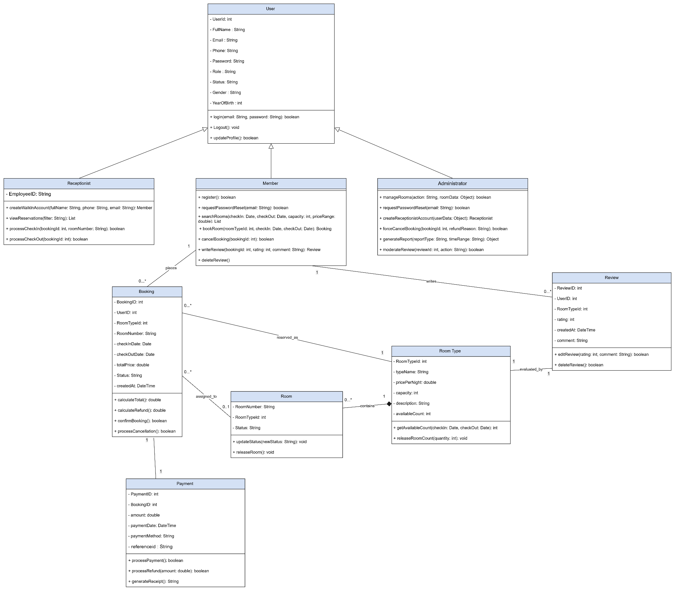

Data Model
