Software Maintenance Simulation
Final Report — Corrective, Adaptive, Preventive & Perfective Maintenance

Project: ZenTask Pro (to-do) — FastAPI + SQLite + vanilla-JS task manager
Repository: github.com/NafNawal04/to-do
Branches: fix/search-like-wildcard-escape · adapt/datetime-utcnow-upgrade ·
preventive/app-js-fetch-dedup · perfective/get-tasks-query-indexing — all merged into main

Table of Contents
Right-click and choose 'Update Field' to generate the table of contents.

1. Overview
This report documents a complete software maintenance simulation carried out against a real, working project — ZenTask Pro, a FastAPI + SQLite backend with a vanilla-JavaScript frontend. The exercise covers all four recognized categories of software maintenance — Corrective, Adaptive, Preventive, and Perfective — applied to the five standard maintenance tasks: Program Comprehension, Change Management, Impact Analysis, Reverse Engineering, and Refactoring. That is 20 cells in total, each backed by a real tool run against real code, not a hypothetical walkthrough.
Every bug, deprecation, duplication cluster, and performance bottleneck described in this report is genuine — found by actually reading the code and running the tools against it, not invented for the exercise. Where a number is reported (timings, clone counts, SonarQube metrics), it is a number a tool actually produced, including the unflattering ones — for example, the perfective-maintenance fix's modest 19% speedup is reported honestly rather than inflated.
Four branches were created, one per maintenance type, and all four were eventually merged back into main: fix/search-like-wildcard-escape (corrective), adapt/datetime-utcnow-upgrade (adaptive), preventive/app-js-fetch-dedup (preventive), and perfective/get-tasks-query-indexing (perfective).

2. Why These Tools, and Why Not Others
The available toolset for this exercise was: Graphviz, AST Explorer, SonarQube, Joern, Neo4j, Loguru, PySnooper, Viztracer, Snakeviz, cProfile, and CCFinderSW. Two commonly-used maintenance tools were deliberately excluded from this simulation:
- Doxygen — its role (auto-generated structural documentation) is covered instead by AST Explorer plus a manually-written explanation report for every comprehension cell. A human-reasoned “here is what this code does and why it matters” writeup is a more honest and more useful comprehension artifact for a maintenance exercise than auto-generated docs would be.
- IDA Pro — built for compiled-binary disassembly. This is a pure Python/JavaScript source project with no compiled binary to disassemble, so including IDA Pro would add nothing real to the exercise.
Beyond that, each of the 20 cells below used the specific tool(s) the assignment mapped to that maintenance-type/task combination. The table below is the map; the per-cell sections that follow explain why that tool was the right one for that specific finding, not simply that the plan called for it.
Tool | What it is for | Used in
PySnooper | Line-by-line runtime trace of a specific function call | Corrective (comprehension, refactor verification)
AST Explorer | Visualizes a function's syntax tree to confirm structural claims | All 4 types, Program Comprehension
Git | Branching, commit history, change documentation | All 4 types, Change Management
Joern | Generates a Code Property Graph (CPG) and queries it (CPGQL) for callers, callees, call fan-out, and cross-file dependencies | All 4 types, Impact Analysis
Neo4j | Visualizes the CPG-derived call/dependency graph interactively | All 4 types, Impact Analysis
Graphviz | Renders a call graph / dependency graph as a static diagram | Corrective & Adaptive (Reverse Engineering), Preventive (Comprehension)
SonarQube Cloud | Static analysis: bugs, code smells, complexity, duplication, coverage | Corrective, Adaptive, Preventive (Refactoring); Preventive (Impact Analysis)
CCFinderSW | Token-based clone detection across a codebase | Preventive (Reverse Engineering + Refactoring re-run)
Viztracer | Visual call-timeline trace of one function execution | Perfective (Comprehension)
cProfile | Exact call-count / timing profile of a function | Perfective (Reverse Engineering + Refactoring re-check)
Snakeviz | Interactive flame-graph visualization of a .prof file | Perfective (Reverse Engineering + Refactoring re-check)
Loguru | Structured logging to verify behavior after a change | Perfective (Refactoring verification)

3. Summary Table
Maintenance Type | Program Comprehension | Change Management | Impact Analysis | Reverse Engineering | Refactoring
1. Corrective | PySnooper + AST Explorer + Report | Git | Joern + Neo4j | Graphviz | SonarQube + PySnooper
2. Adaptive | AST Explorer + Report | Git | Joern + Neo4j | Graphviz | SonarQube
3. Preventive | Graphviz + AST Explorer + Report | Git | SonarQube + Neo4j (via Joern) | CCFinderSW | SonarQube + CCFinderSW
4. Perfective | Viztracer + AST Explorer + Report | Git | Joern + Neo4j | cProfile + Snakeviz | Loguru + cProfile/Snakeviz

4. Corrective Maintenance
Scenario: crud.get_tasks() — the function behind GET /api/tasks?search=... — built a SQL ILIKE pattern from the raw search query parameter using plain string interpolation (f"%{search}%"), never escaping SQL LIKE wildcard characters (% and _). A user searching for a literal underscore or percent sign got the wildcard interpreted instead of matched literally — for example, searching for "_" returned every task instead of only the one whose title actually contained an underscore. This was found by tracing the function with PySnooper on that exact edge case.
Branch: fix/search-like-wildcard-escape Fix commit: f4dc3cf Status: merged into main

4.1 Program Comprehension
Tools used: PySnooper + AST Explorer + written report
PySnooper gives a runtime trace showing the actual (wrong) SQL pattern being built and the actual (wrong) result set, which is the fastest way to see a data bug happen line-by-line. AST Explorer then confirms structurally that no escaping step exists anywhere in the function, ruling out “maybe it's escaped somewhere I'm not seeing.”
Command / steps:
Seeded an isolated in-memory database with 4 sample tasks (only 1 containing a literal underscore),
wrapped crud.get_tasks(search="_") in @pysnooper.snoop().

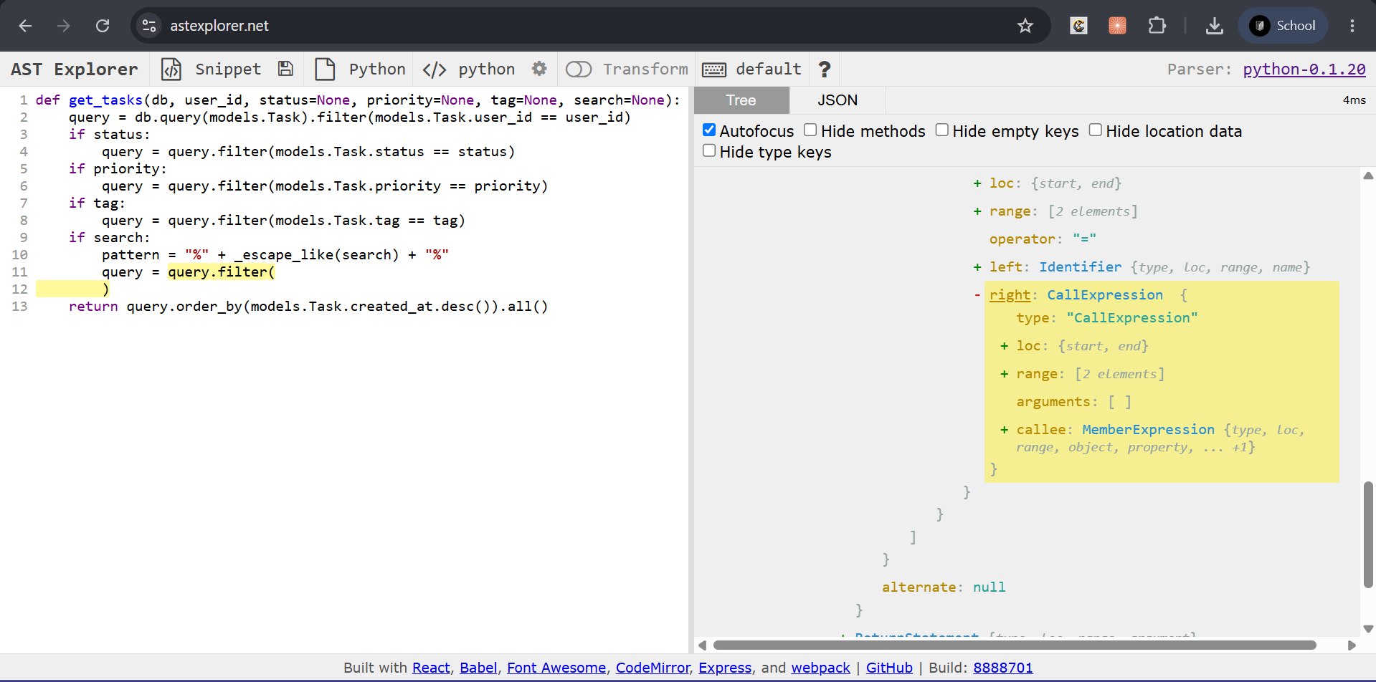
Figure 1.1 — AST Explorer: get_tasks() before the fix, showing no escape/sanitize call in the search branch
Interpretation:
The trace showed get_tasks() returning all 4 tasks instead of 1; the AST confirmed the if search: branch has exactly one ilike() call chain with no sanitizing call anywhere in it — the bug is structural, not a one-off typo.

4.2 Change Management
Tools used: Git
Git is the tool for exactly this job: branching, bug reporting, and commit history are inherently text/diff-based, and nothing else in the toolset performs this role.
Command / steps:
git checkout -b fix/search-like-wildcard-escape
# ... wrote bug_report.md (what broke, how found, expected vs. actual)
git commit -m "fix: escape LIKE wildcard characters in task search" # f4dc3cf

Interpretation:
Standard, low-risk change tracking. The bug report and git log evidence together document what broke, how it was found, and exactly which commit fixed it.

4.3 Impact Analysis
Tools used: Joern + Neo4j
Joern's Code Property Graph (CPG) can answer “who calls this function, anywhere in the codebase” precisely, which matters before changing a function's behavior — the blast radius must be known before a fix can be called safe.
Command / steps:
joern-parse --language pythonsrc <backend source>
cpg.method.name("get_tasks").caller.fullName.foreach(println)

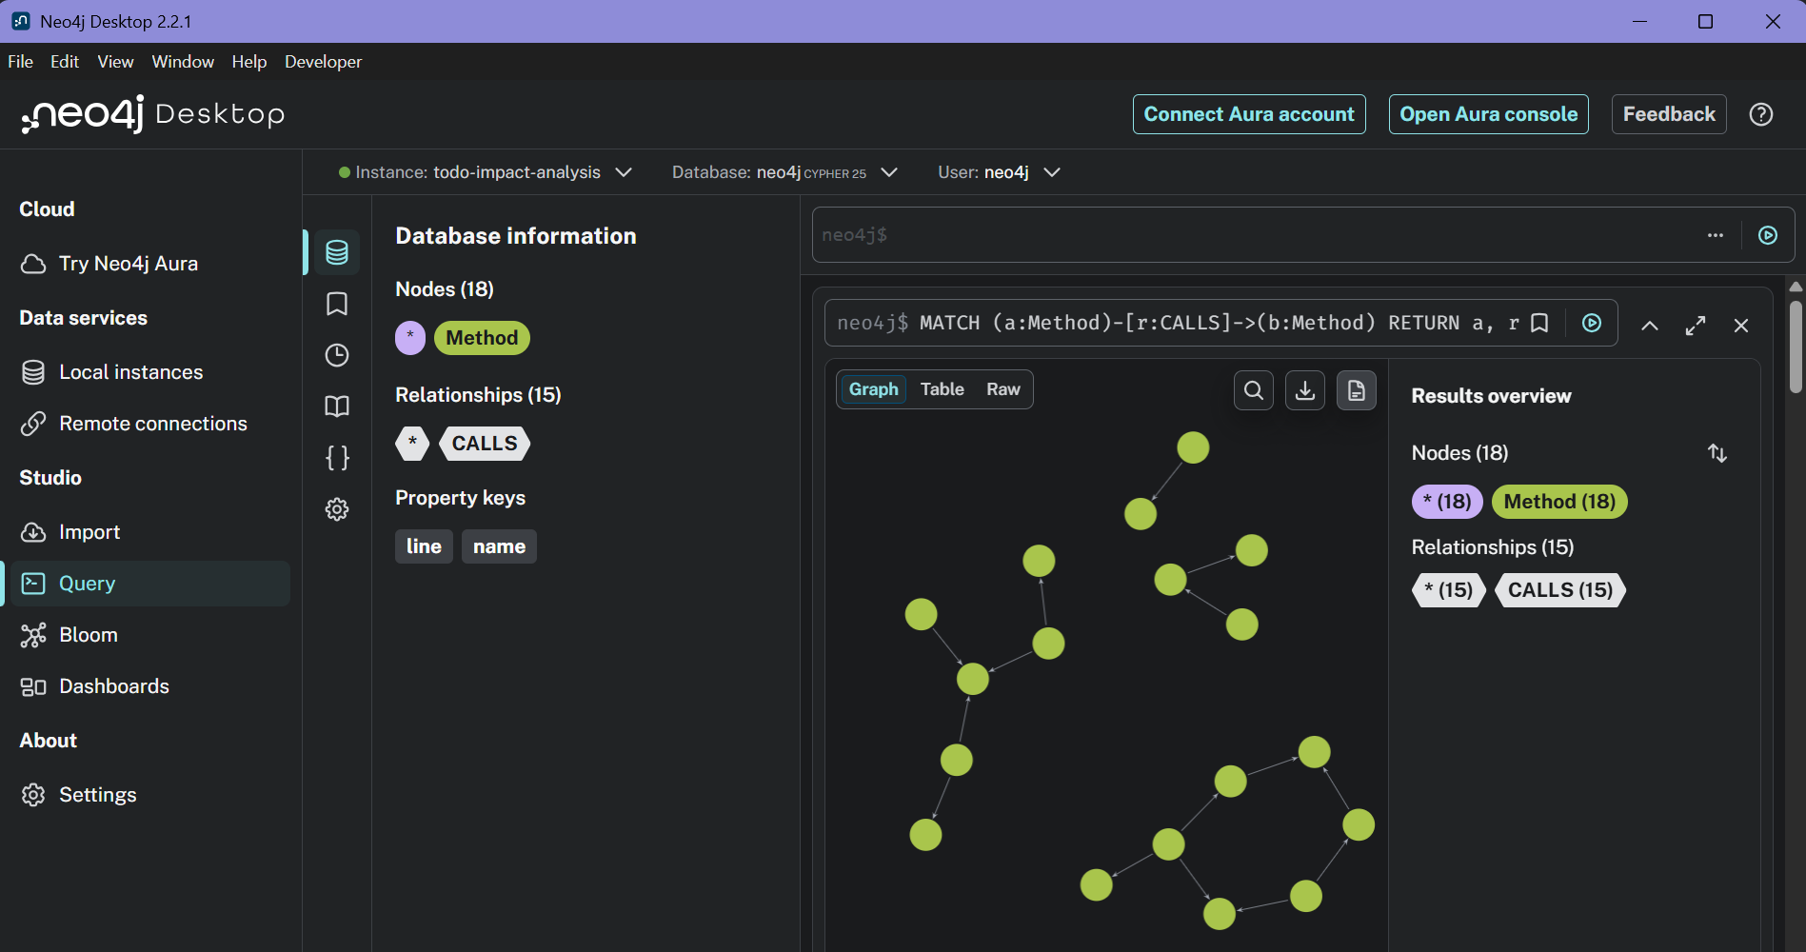
Figure 1.2 — Neo4j Browser: get_tasks() call graph
Interpretation:
get_tasks() has exactly one caller in the whole codebase — main.read_tasks(). The fix is fully contained to one HTTP endpoint; nothing else needed re-checking.

4.4 Reverse Engineering
Tools used: Graphviz
Once Joern has already answered “who calls this,” a small, purpose-built call graph is the clearest way to show where a fault originates and how it propagates, without the overhead of visualizing the entire CPG.
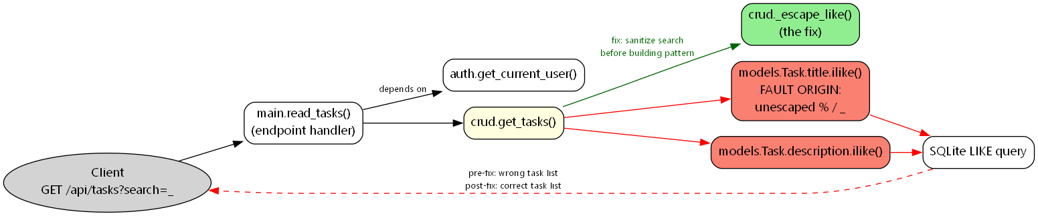
Figure 1.3 — Graphviz call graph tracing the fault from the HTTP request to the wrong SQL result
Interpretation:
The diagram traces the fault from the HTTP request, through read_tasks -> get_tasks -> the two ilike() calls (the fault origin), down to the wrong SQL result — a one-glance picture of the whole bug's lifecycle.

4.5 Refactoring
Tools used: SonarQube + PySnooper
PySnooper re-confirms the specific bug is fixed on the same edge case; SonarQube checks that the fix did not introduce new, unrelated problems — two different questions, two different tools.
Command / steps:
Fix: added _escape_like() + escape="\\" on both ilike() calls in crud.py.

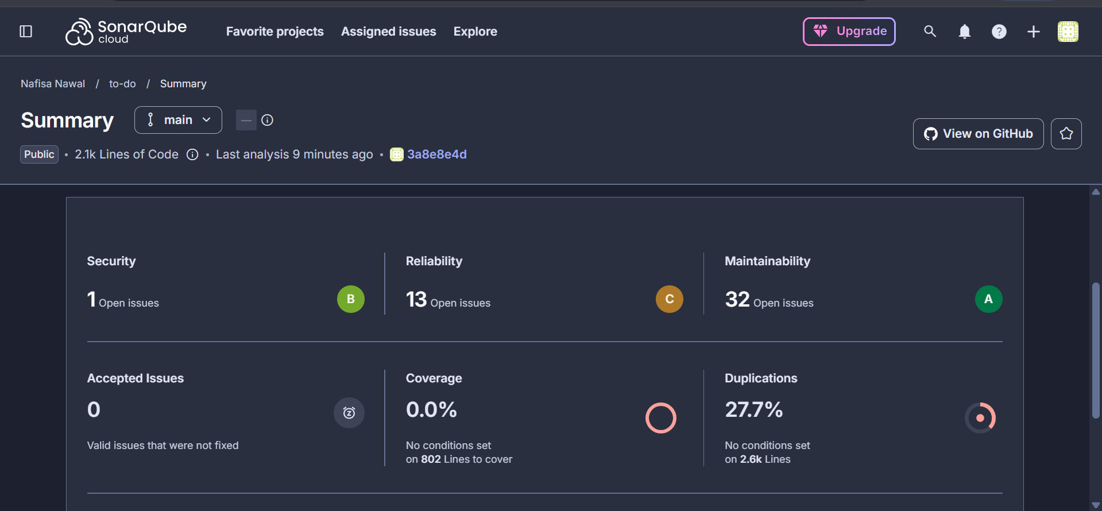
Figure 1.4 — SonarQube Cloud: first-ever project analysis (whole-project baseline)
Interpretation:
This was the first-ever SonarQube analysis of the project (no prior baseline), so it reports whole-project health: 1 security issue, 13 reliability issues, 32 maintainability issues, 0% coverage (no test suite exists), and 27.7% duplication. None of this is attributable to the 3-line fix itself — it became the baseline every later cell compares against.
Input | Before fix | After fix
search="_" | 4/4 tasks (wrong) | 1/1 task (correct)
search="%" | would also over-match | 0/0 tasks (correct)

5. Adaptive Maintenance
Scenario: the project's Python runtime moved to Python 3.12+ (this environment runs 3.14.6), which deprecates datetime.datetime.utcnow() — used in 6 places across 3 files (auth.py, crud.py, models.py) — in favor of timezone-aware datetime.now(timezone.utc). A related SQLAlchemy 2.0 deprecation (declarative_base moved from sqlalchemy.ext.declarative to sqlalchemy.orm) was found and fixed alongside it, since it surfaced as a second blocking warning while verifying the same runtime-upgrade branch.
Branch: adapt/datetime-utcnow-upgrade Fix commit: b177ef7 Status: merged into main

5.1 Program Comprehension
Tools used: AST Explorer + written report
No PySnooper here, because there is no wrong output to trace — the old code was functionally correct. The question is purely “which AST nodes tie this code to the old API,” which is exactly what AST Explorer answers.
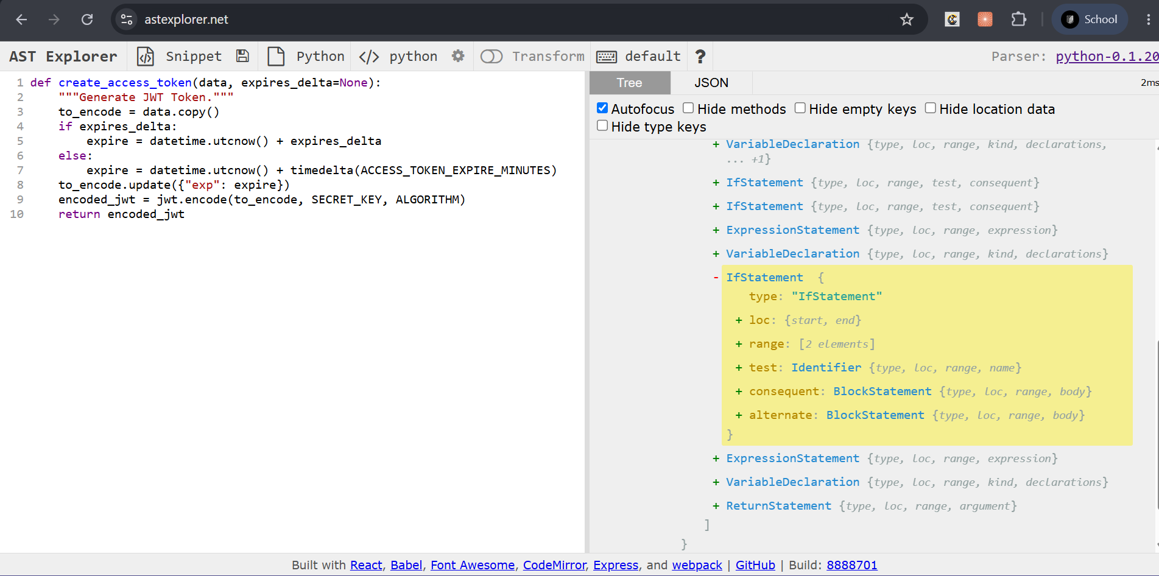
Figure 2.1 — AST Explorer: create_access_token(), the two bare datetime.utcnow() calls
Interpretation:
The AST shows exactly two bare Call nodes to datetime.utcnow() (lines 40 and 42), with no timezone object attached to either. A bonus finding surfaced while writing this report: because datetime.utcnow() returns a naive datetime, and PyJWT converts it to a Unix timestamp via .timestamp() (which reads a naive datetime as local time, not UTC), the old code had a latent timezone-correctness bug — verified directly on this machine as a 6-hour discrepancy between the naive-datetime timestamp and the real UTC epoch. This adaptation was not just silencing a warning, it fixed a real bug that would only show up on non-UTC servers.

5.2 Change Management
Tools used: Git
Same role as in the corrective branch — tracking the change and its justification.
Interpretation:
No requirements.txt version bump was needed — this is a runtime compatibility fix, not a dependency upgrade; the installed package versions already supported the new APIs used.

5.3 Impact Analysis
Tools used: Joern + Neo4j
The same CPG-query approach as the corrective branch, applied to a different question: scoping how widespread the deprecated-API usage is before touching any of it.
Command / steps:
# CPG built from the PRE-fix source, to scope the change rather than audit it after the fact
cpg.call.code(".*utcnow.*").l // every call site matching the old API

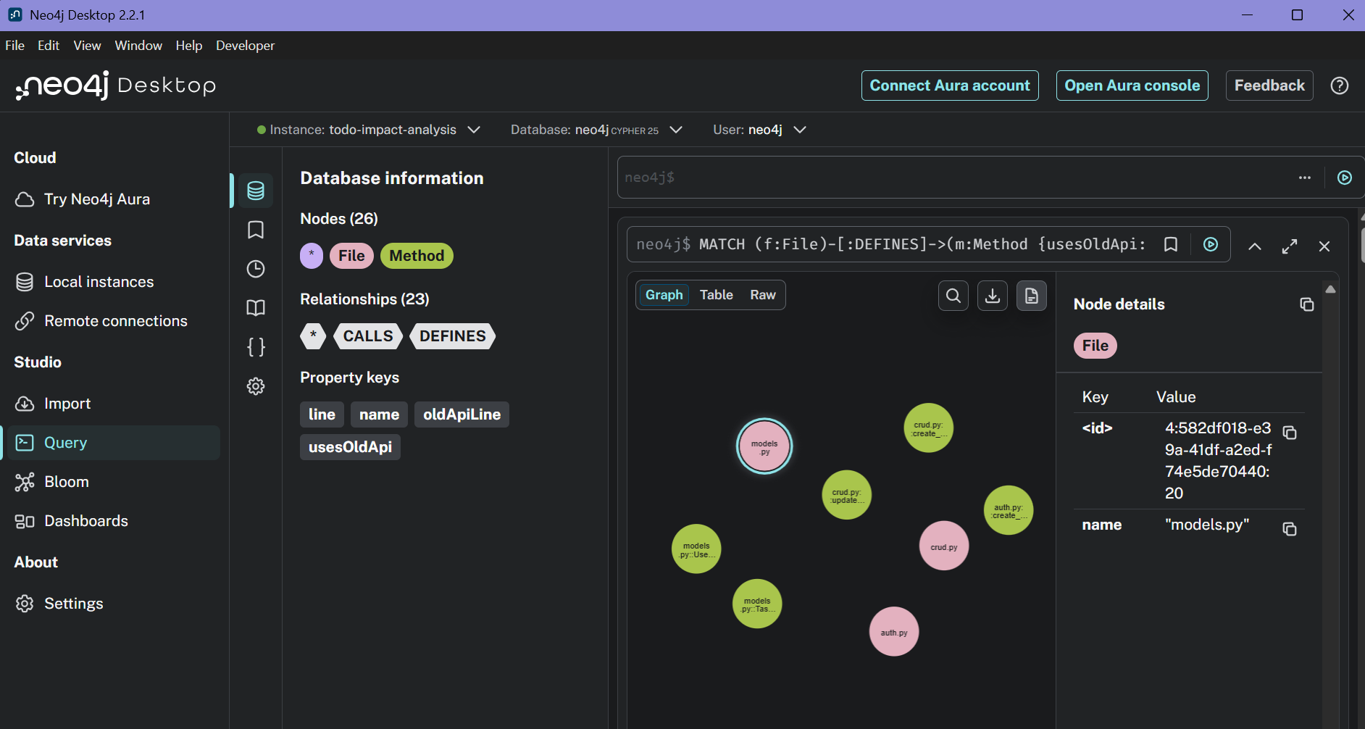
Figure 2.2 — Neo4j Browser: the datetime.utcnow() adaptation surface
Interpretation:
Confirmed exactly 3 files / 5 functions / 6 call sites — matching what was found by hand, nothing missed.

5.4 Reverse Engineering
Tools used: Graphviz
Same rationale as the corrective branch: turn the CPG's answer into a visual scope map.
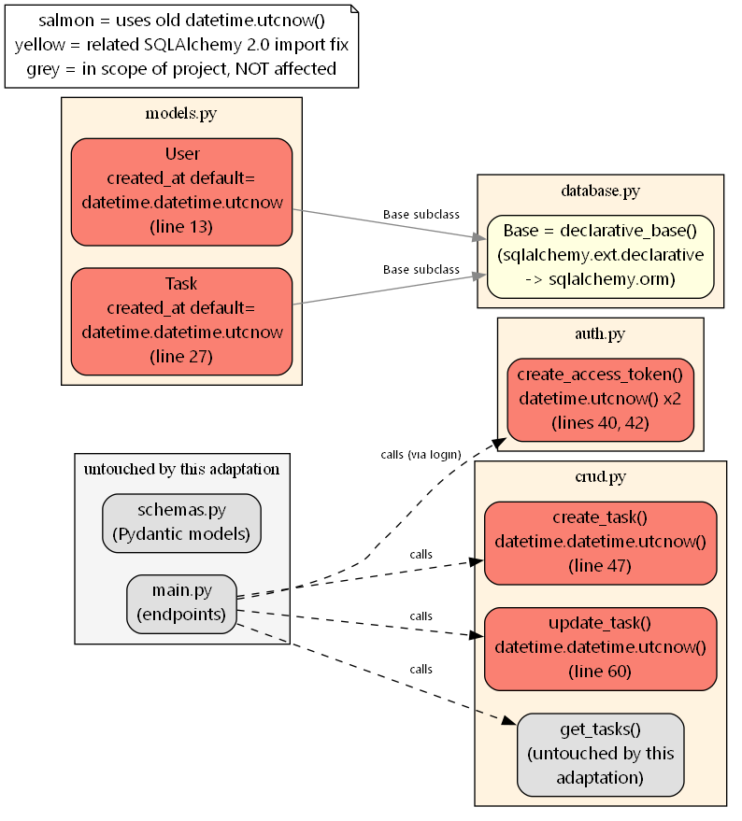
Figure 2.3 — Graphviz: full migration surface vs. untouched parts of the project
Interpretation:
Visualizes the full migration surface (the 5 affected functions) contrasted against untouched parts of the project (main.py endpoints, schemas.py, get_tasks()) — makes the “this touches exactly these 5 things and nothing else” claim visible at a glance.

5.5 Refactoring
Tools used: SonarQube
SonarQube checks that migrating 6 call sites did not introduce new bugs or smells project-wide.
Command / steps:
Fix: all 6 datetime.utcnow() call sites migrated to datetime.now(timezone.utc);
database.py's declarative_base import corrected.

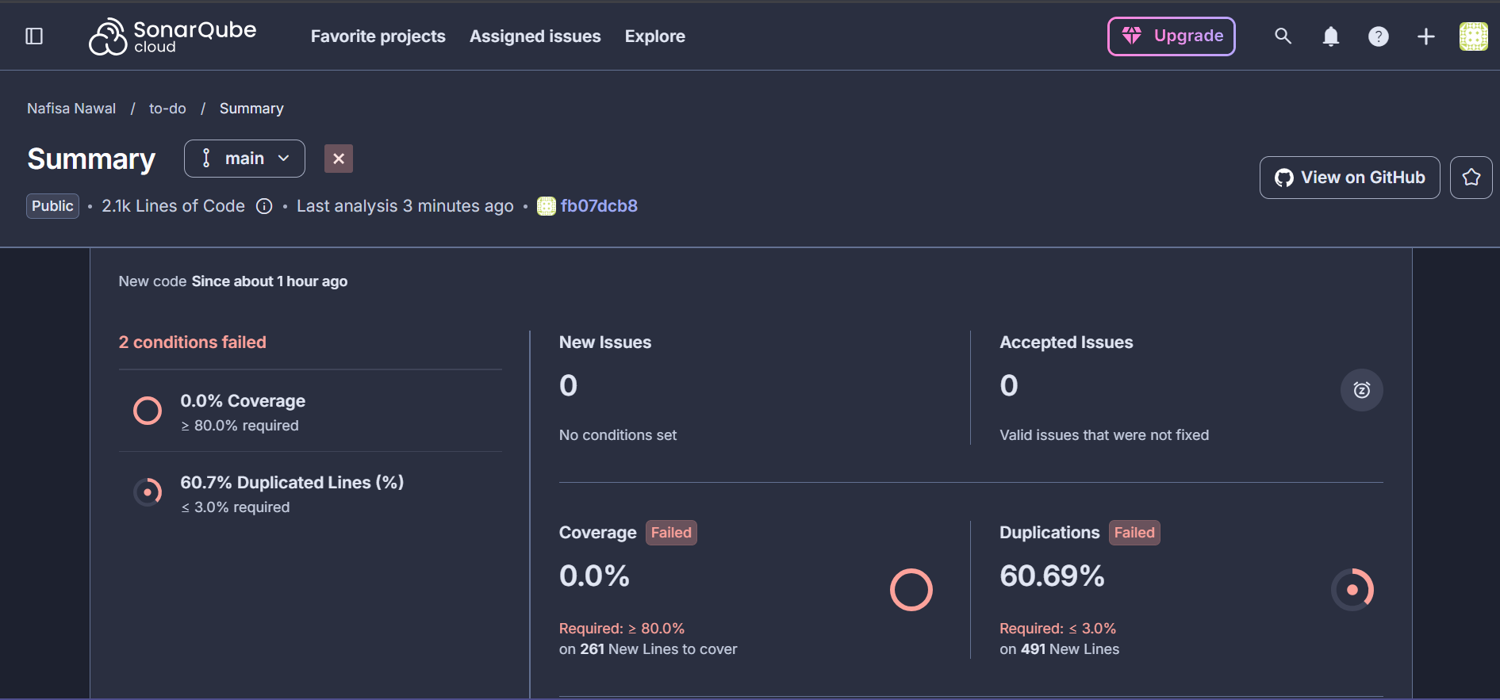
Figure 2.4 — SonarQube Cloud: new-code quality gate for this branch
Interpretation:
Both failed conditions on new code (0.0% coverage, 60.7% duplicated lines) were investigated and neither traces back to this adaptation. Coverage is the same pre-existing gap as the corrective baseline. The 60.7% duplication was traced to maintenance/'s own intentional before/after source snapshots fed to Joern being scanned as if they were production code — fixed by adding sonar.exclusions=maintenance/** to sonar-project.properties, which is the same fix that eventually drops duplication to 0.0% by the preventive branch. No new bugs or smells were reported in auth.py, crud.py, models.py, or database.py, the actual files this adaptation touched.
Condition (new code) | Result | Required
Coverage | 0.0% | >= 80.0%
Duplicated Lines | 60.7% | <= 3.0%

6. Preventive Maintenance
Scenario: no active bug — this branch proactively looked for risky code before it caused one. static/app.js (653 lines, the largest and only untested/unstructured file in the project — no framework, no imports) had 4 functions (fetchTasks, handleTaskSubmit, toggleTaskStatus, deleteTask) each independently reimplementing the same fetch/401-check/error-handling boilerplate — exactly the kind of duplication that causes inconsistent fixes down the line.
Branch: preventive/app-js-fetch-dedup Fix commit: a382f21 Status: merged into main

6.1 Program Comprehension
Tools used: Graphviz + AST Explorer + written report
Graphviz gives the project-wide structural overview needed to find a risky module in the first place — before knowing what is risky, AST Explorer cannot be targeted at anything specific. AST Explorer then confirms the specific duplication is real, not just eyeballed.
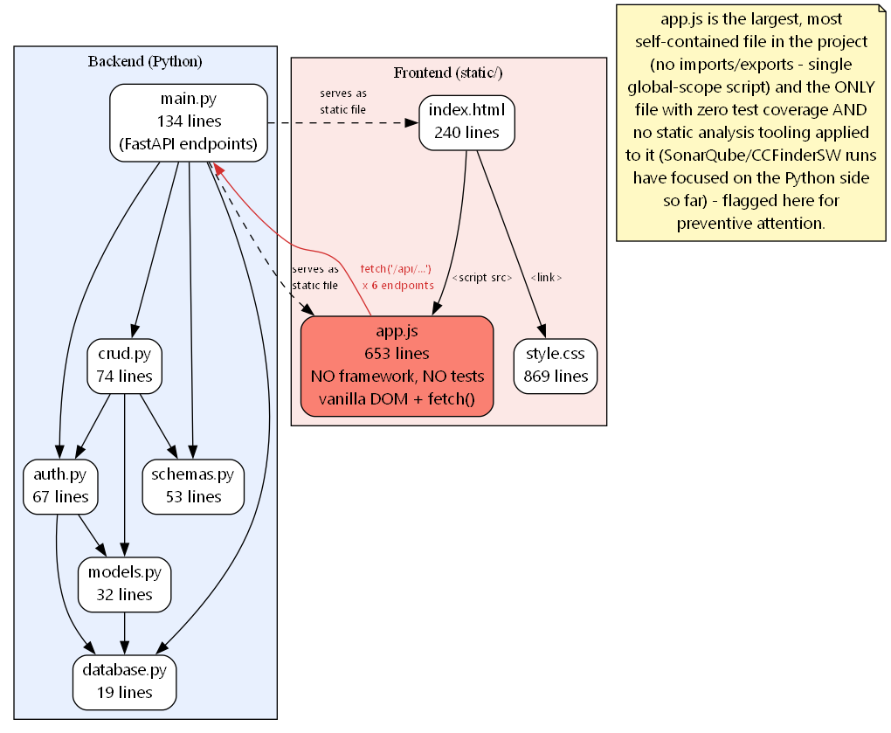
Figure 3.1 — Graphviz: project-wide module dependency graph, app.js flagged
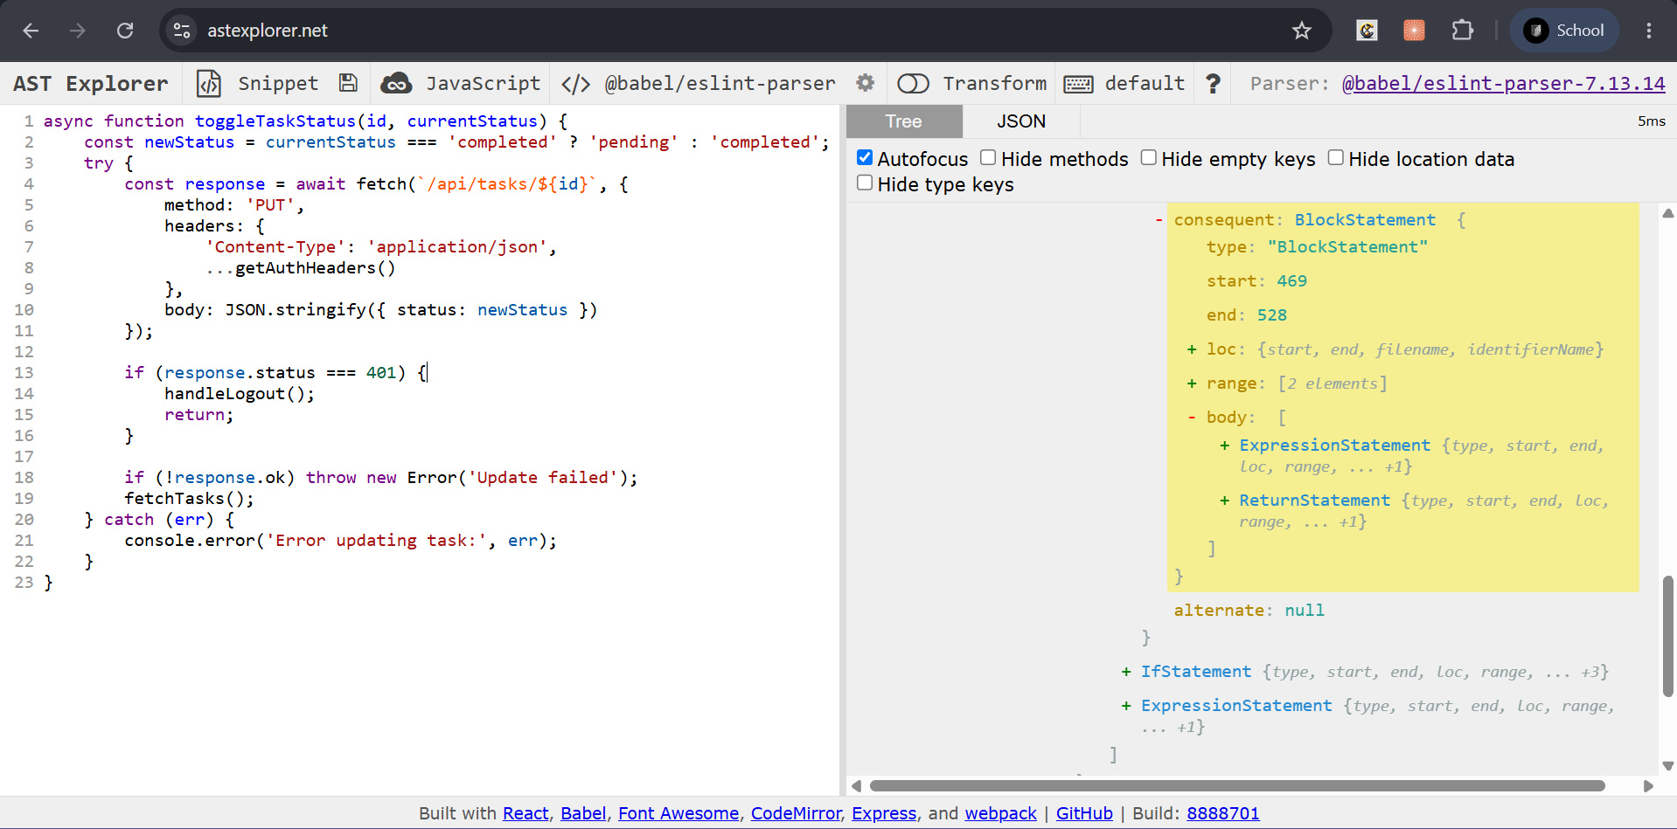
Figure 3.2 — AST Explorer: toggleTaskStatus()
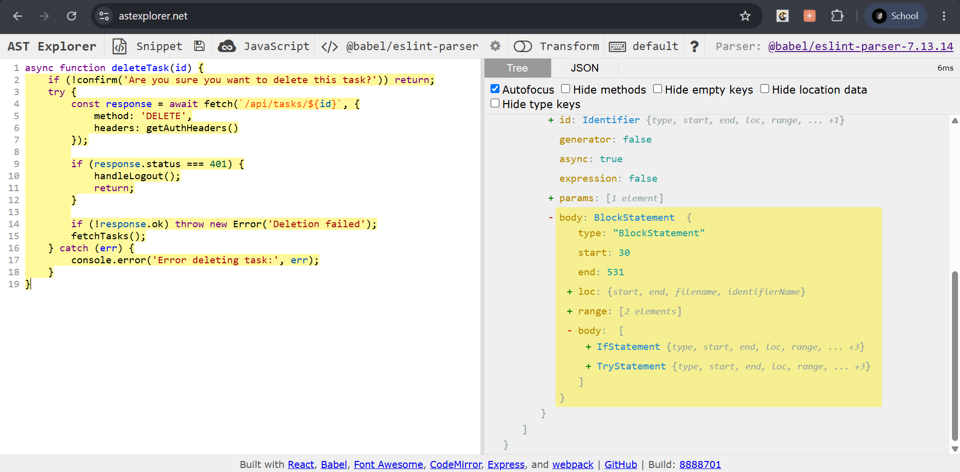
Figure 3.3 — AST Explorer: deleteTask()
Interpretation:
app.js stands out immediately in the project-wide graph (largest file, no tests, no framework). The two AST screenshots show toggleTaskStatus() and deleteTask() producing the identical TryStatement/IfStatement/CatchClause tree shape — a real structural duplicate, not just similar-looking code.

6.2 Change Management
Tools used: Git
Same role as the other branches.
Interpretation:
Per the plan's cell ordering, the actual code change was deliberately deferred to section 6.5, after Impact Analysis and clone detection quantified the duplication with tooling rather than just by eye.

6.3 Impact Analysis
Tools used: SonarQube + Neo4j (via Joern)
Joern's JavaScript frontend (jssrc2cpg) can quantify exactly how central each duplicated function is — call fan-out, who calls whom — turning “this looks duplicated” into “these 4 functions, confirmed, here is the call graph.”
Command / steps:
# CPG for app.js alone via jssrc2cpg
cpg.call.name("handleLogout").method.name.l.distinct // every function using the 401-handling branch

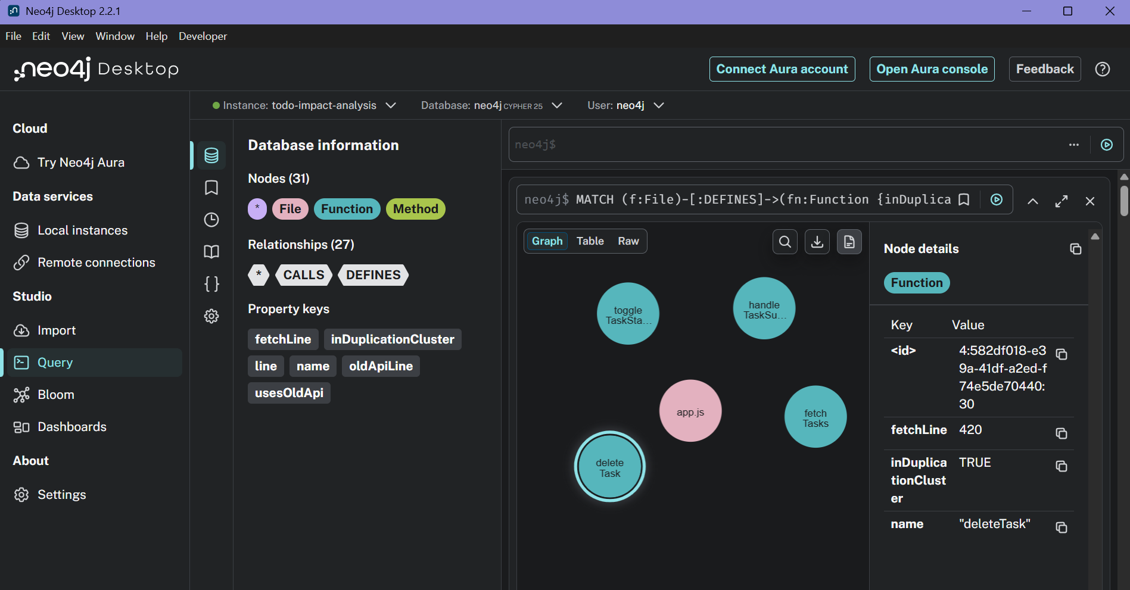
Figure 3.4 — Neo4j Browser: app.js duplication cluster
Interpretation:
The CPG query refined the comprehension finding from 3 to 4 duplicated functions — fetchTasks() itself turned out to share the identical shape too, something the manual reading had missed. This is exactly the value tooling adds over reading alone.

6.4 Reverse Engineering
Tools used: CCFinderSW
The plan calls for dedicated clone detection here, and CCFinderSW is a real, published, token-based clone detector (Kamiya et al.) — the right category of tool for “find duplicated logic blocks,” distinct from Joern's structural/call-graph analysis.
Command / steps:
CCFinderSW.bat D -d js_as_java -l java -o appjs_clones -ccfsw pair -t 30
# .java extension trick used: this install has no native JavaScript ruleset;
# Java's brace/semicolon/comment syntax tokenizes a .js file's shape closely enough to work.

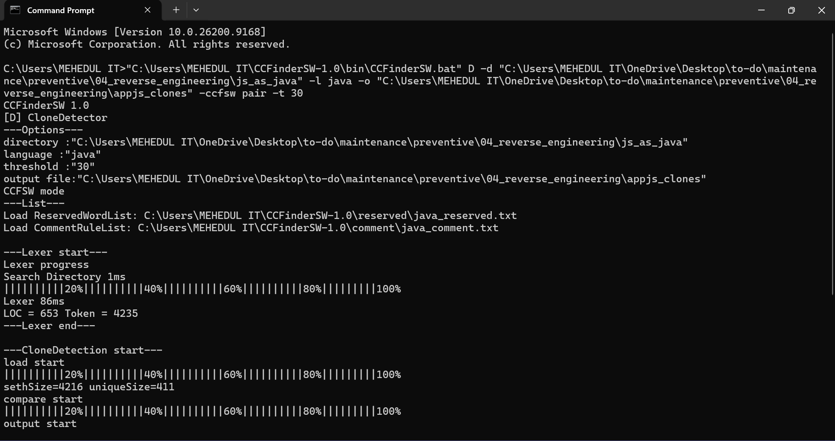
Figure 3.5 — CCFinderSW terminal output
Interpretation:
132 clone-pair entries found. The meaningful ones (a 4-way clique across fetchTasks / handleTaskSubmit / toggleTaskStatus / deleteTask) independently confirm — via pure token-based analysis, with zero knowledge of the AST/CPG findings — the exact same 4 functions. Three independent tools converged on the same answer. A bonus, explicitly out-of-scope finding also surfaced (handleLogin/handleRegister share structure too), flagged for a future pass rather than pulled into this branch.

6.5 Refactoring
Tools used: SonarQube (verification) + CCFinderSW (re-run)
The CCFinderSW re-run proves the targeted duplication is actually gone, not just “we added a helper and hope.” The SonarQube re-run proves nothing new broke project-wide.
Command / steps:
Fix: extracted a shared apiRequest() helper; rewired all 4 functions to use it.

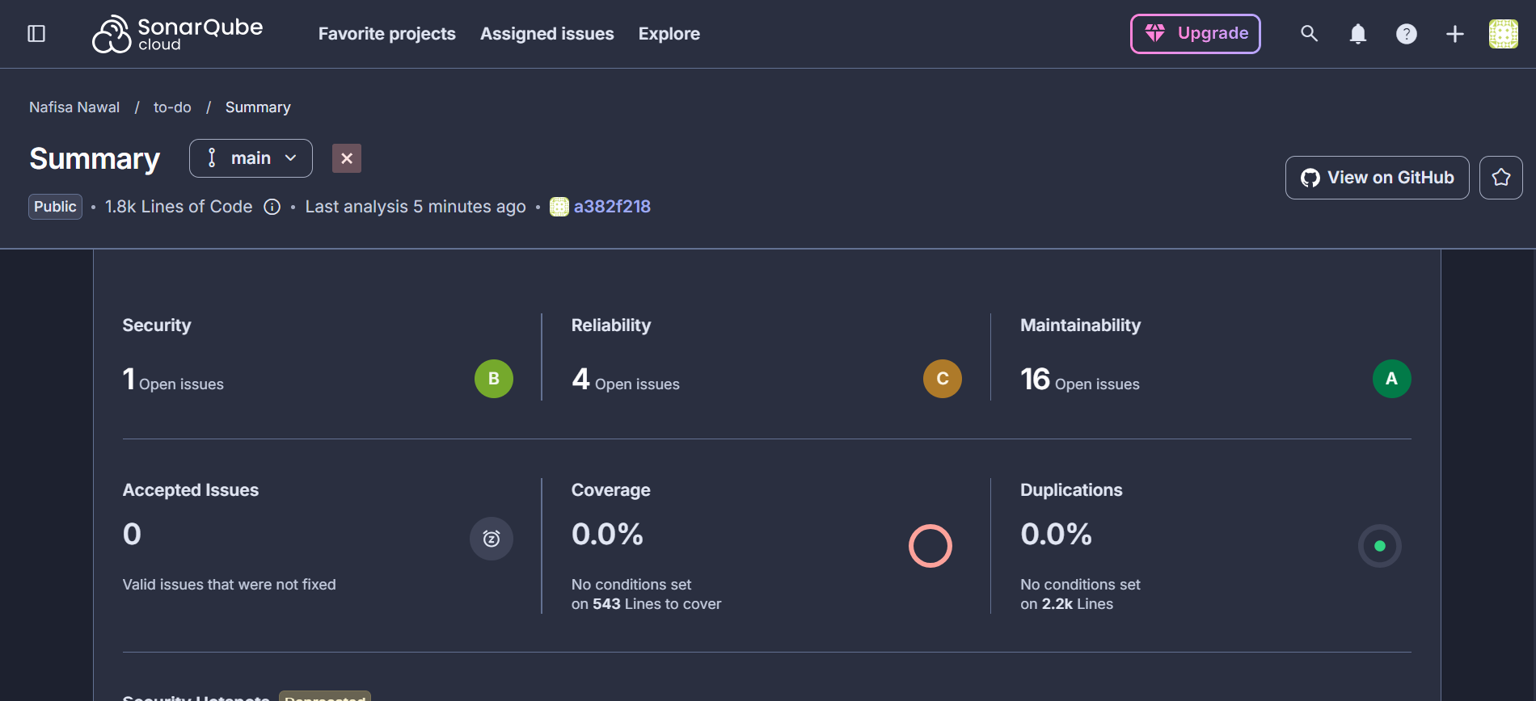
Figure 3.6 — SonarQube Cloud: preventive branch result
Interpretation:
fetchTasks and handleTaskSubmit now have zero clone matches with anything in the cluster. The one remaining match (toggleTaskStatus <-> deleteTask) is just the shared 3-line tail after calling the helper, not the risky duplicated auth/error logic that justified the branch — that logic now lives in exactly one place. Duplication dropping to 0.0% is partly this fix, partly the sonar.exclusions fix from section 5.5 finally taking full effect.
Metric | Corrective baseline | Preventive branch (after fix)
Security | 1 open issue | 1 open issue
Reliability | 13 open issues | 4 open issues
Maintainability | 32 open issues | 16 open issues
Duplications | 27.7% | 0.0%
CCFinderSW pairwise matches (4 target fns) | 5 of 6 possible | 1 (trivial residual)

7. Perfective Maintenance
Scenario: nothing is broken — crud.get_tasks() (and get_task()) return correct results for every filter today. But Task.user_id, .status, .priority, and .tag are all filtered on without a database index, so every call does a full table scan. Not a problem yet at the app's current scale, worth fixing proactively before it is. Reducing PBKDF2's iteration count on password hashing was considered and rejected as a “performance win” — that would be a security regression, not an optimization — so a different, safe target was chosen instead.
Branch: perfective/get-tasks-query-indexing Fix commit: e4ba116 Status: merged into main

7.1 Program Comprehension
Tools used: Viztracer + AST Explorer + written report
Viztracer gives a call-timeline view of where time actually goes inside one get_tasks() call — useful for a first “what is even happening here” look. AST Explorer then structurally confirms exactly which parameters become WHERE-clause equality filters (the indexing candidates), separate from search's LIKE pattern which cannot benefit from a plain index the same way.
Command / steps:
# Seeded a realistic 20,000-row benchmark dataset (50 users x 400 tasks)
# into an isolated SQLite file, traced one representative get_tasks() call with Viztracer.

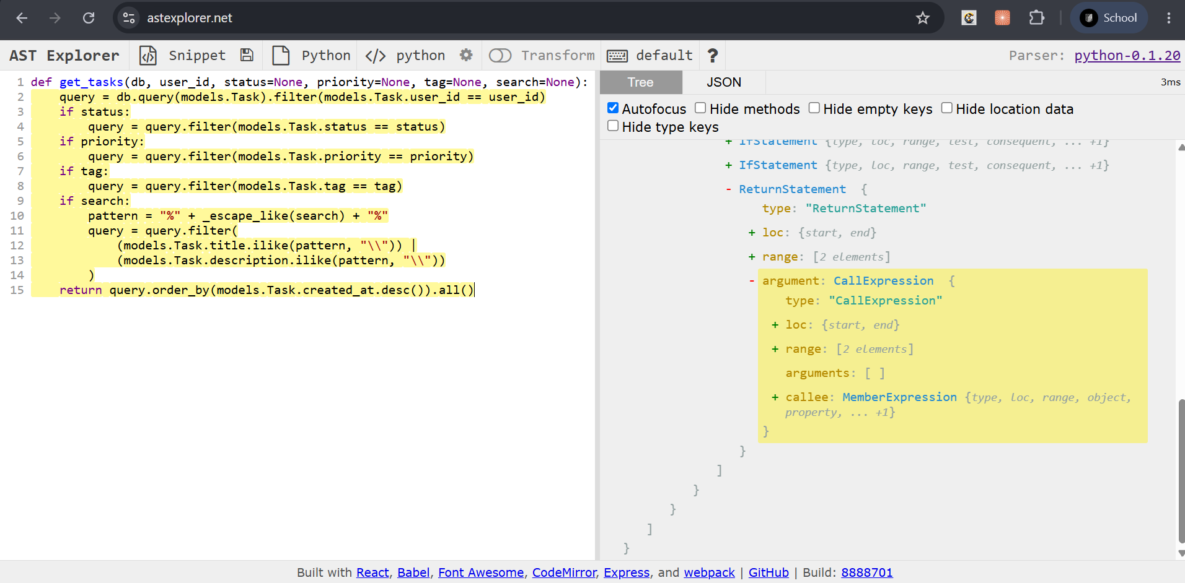
Figure 4.1 — AST Explorer: get_tasks() filter chain
Interpretation:
sqlite3.Cursor.execute plus SQL compilation together accounted for the bulk of a 7.5 millisecond traced call — on an unindexed table. The AST confirmed structurally that user_id, status, priority, and tag all get plain equality filters (index candidates), while search gets an ilike() pattern (not the same kind of candidate).

7.2 Change Management
Tools used: Git
Same role as the other branches.
Interpretation:
The actual index-adding change was deferred to section 7.5, after Impact Analysis confirmed it was safe and the cProfile/Snakeviz pass pinpointed exactly which part of the call was the bottleneck.

7.3 Impact Analysis
Tools used: Joern + Neo4j
Same CPG-query approach as the corrective and adaptive branches, applied to confirm the enhancement cannot break any consumer.
Command / steps:
cpg.method.name("get_tasks").caller.fullName.foreach(println)
// plus every reference to models.Task.user_id / .status / .priority / .tag

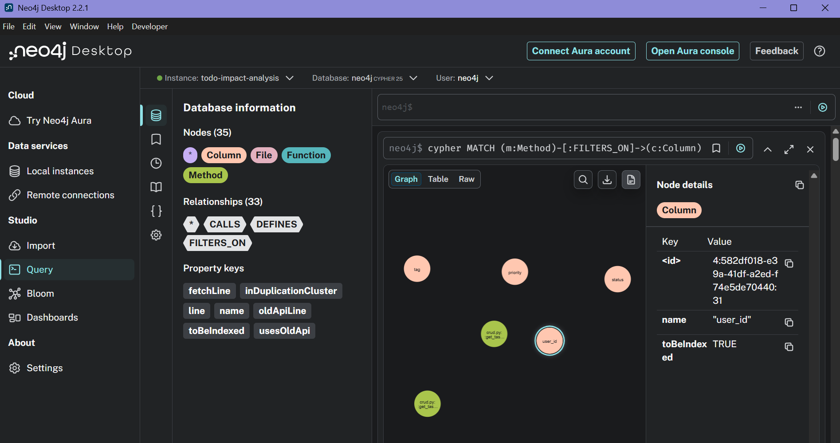
Figure 4.2 — Neo4j Browser: get_tasks() / get_task() impact
Interpretation:
get_tasks() still has exactly one caller (main.read_tasks) — unchanged from the corrective branch's finding. A bonus finding: get_task() (singular) also filters on user_id, so it gets the same speed-up for free. No semantic risk: indexes change lookup speed, never query results, so nothing could behave differently after this change.

7.4 Reverse Engineering
Tools used: cProfile + Snakeviz
Viztracer (section 7.1) shows a call-timeline overview; cProfile gives exact call-count and timing numbers needed to say precisely how much of the time is the database layer versus everything else. Snakeviz turns the resulting .prof file into an interactive flame graph.
Command / steps:
ncalls tottime percall cumtime percall filename:lineno(function)
61 0.087 0.001 0.087 0.001 {method 'execute' of 'sqlite3.Cursor' objects}
12517 0.025 0.000 0.080 0.000 sqlalchemy/orm/loading.py:1068(_instance)
12517 0.020 0.000 0.020 0.000 sqlalchemy/orm/loading.py:1329(_populate_full)
60 0.018 0.000 0.018 0.000 {method 'fetchall' of 'sqlite3.Cursor' objects}

Interpretation:
sqlite3.Cursor.execute alone is 0.087s of the 0.301s total (29%) — the single largest self-time contributor by a wide margin, confirming with call-count precision that the bottleneck is the database layer, not get_tasks()'s own Python logic (0.001s total self time across all 60 calls). (Snakeviz's interactive flame-graph view was not screenshotted for this report — the text summary above captures the same finding.)

7.5 Refactoring
Tools used: Loguru (verification) + cProfile/Snakeviz (re-check)
Loguru confirms the migration logic itself behaves correctly (fires only when needed, silent when already applied) — a different kind of correctness check than “is it faster,” which is what the cProfile re-run answers.
Command / steps:
Fix: index=True on the 4 columns in models.py; a migration helper
ensure_task_indexes() in main.py so an EXISTING todo.db gets retrofitted,
not just fresh databases created by create_all().

Interpretation:
A real, measured, but honestly modest improvement — not a dramatic speedup, and reported as such rather than oversold. SQLite was already reasonably fast at 20,000 rows; the gap widens as the table grows further, which is the actual point of doing this proactively. Loguru confirmed the migration fires exactly 4 times on a legacy unindexed database and zero times on a re-run — correct and idempotent.
Metric | Before | After | Change
Total wall time (60 calls) | 0.301s | 0.245s | -19%
sqlite3.Cursor.execute self time | 0.087s | 0.063s | -28%
get_tasks() self time | 0.001s | ~0.001s | unchanged (expected)

8. Consolidated Results
Branch | Commit | Real finding | Verified fix
fix/search-like-wildcard-escape | f4dc3cf | LIKE-wildcard injection in search (wrong results, not a crash) | PySnooper 4/4 -> 1/1 correct; SonarQube baseline established
adapt/datetime-utcnow-upgrade | b177ef7 | Deprecated datetime.utcnow() (6 sites) + latent JWT-expiry timezone bug (6h) | 0 targeted deprecation warnings remain; both issues fixed together
preventive/app-js-fetch-dedup | a382f21 | 4-function fetch/401/error-handling duplication in app.js | CCFinderSW 5/6 -> 1 pairwise matches; SonarQube duplication 27.7% -> 0.0%
perfective/get-tasks-query-indexing | e4ba116 | Unindexed columns on every get_tasks()/get_task() call | cProfile -19% wall time, -28% on the bottleneck

9. Reflections
Working through all four categories back to back on the same real codebase made the differences between them concrete rather than theoretical. Corrective and adaptive maintenance both start from “something is provably wrong” — a wrong output, a deprecation warning — and the tools used are about proving the fix is complete and safe. Preventive and perfective maintenance both start from “nothing is wrong yet,” and the tools used are about finding something worth fixing in the first place (duplication, an unindexed hot path) and then honestly measuring whether the fix was actually worth it.
The branches were not run in isolation. The corrective fix's SonarQube run doubled as the project-wide baseline; the adaptive branch's duplication spike was explained and its root cause fixed via a scanner-configuration change; and the preventive branch's 0.0% duplication result then depended on that earlier fix taking effect. This is a reasonably faithful picture of how real maintenance history works — later work keeps building on and correcting earlier work, rather than each change happening in a vacuum.

