INFORMATION SECURITY · CLO 4
AI-Powered Intrusion Detection Solution
with Real-Time Threat Detection
Machine-learning augmentation of SecureNet Corp.'s Network Intrusion Detection System on UNSW-NB15
Student | Muhammad Nafay Aftab
Enrolment | 03-134222-087
Class | BSCS-8A
Course | Information Security
Aligned CLO | CLO 4 — Create solutions to real-life scenarios using security-related tools
Instructor | Dr. Nadeem Sarwar
Deliverable | Assignment 1 Report (CLO 4)
GitHub | https://github.com/Nafay-Aftab/CLO4-IDS-ML-Solution

Department of Computer Science

1. Executive Summary
SecureNet Corp.'s CISO requested a proof-of-concept that augments the existing signature-based NIDS with machine learning, classifying every network flow as normal or malicious in real time. We built a leak-free scikit-learn pipeline (one-hot encoding, log1p and robust scaling) that feeds a tuned Random Forest champion. It was trained on the modern UNSW-NB15 benchmark (257,673 flows, nine attack families) and benchmarked against a Decision-Tree baseline. On the untouched 20 % test fold the champion reaches 94.71% accuracy, 94.60% attack recall, 97.05% precision, 95.81% F1-score and a 5.09% false-alarm rate (ROC-AUC 0.9915). It cuts missed attacks by 43% versus the baseline and scores flows in 6.4 µs each in batched mode (157,418 flows/s). The ≥ 95 % target was met for F1 but missed by 0.3–0.4 percentage points on accuracy and recall. A controlled validation experiment indicates the gap stems from overlap in the data rather than from tuning, and we report the result as measured. We recommend deploying the model as an augmenting detection layer with the threshold managed as SOC policy.
CISO Executive Takeaways
- The model catches 94.6% of intrusions, and only 5.1% of benign flows raise an alert. That is ≈ 345 missed attacks and ≈ 184 false alarms per 10,000 flows.
- Its blind spots are stealthy families that resemble normal traffic: Fuzzers (68.3%) and Analysis (85.2%). These need complementary controls such as DPI and host telemetry.
- Batched inference runs at 157,418 flows/s on one laptop CPU, which is line-rate capable for flow-export pipelines.

2. Introduction & Real-World Scenario
Firewalls enforce static port and address rules, and signature-based IDS engines match known byte patterns. Both miss zero-day exploits and attacks that ride permitted services such as HTTP, DNS and TLS. A learning-based detector instead models traffic behaviour (volumes, timing, TTL fingerprints, connection fan-out), so it can flag anomalous flows that no rule anticipates.
Scenario. As a security analyst at SecureNet Corp., we were tasked by the CISO with judging whether ML is viable as an extra NIDS layer. The objective is a tool that (i) separates normal from malicious flows with high attack recall, (ii) keeps false alarms within a budget the SOC can absorb, (iii) runs fast enough for real-time use, and (iv) explains its alerts to analysts. The complete, reproducible implementation (notebook, pipeline, SOC dashboard) is public on GitHub.

3. Methodology

3.1 Dataset & Threat-Landscape Justification
UNSW-NB15 [1], [2] was generated on the IXIA PerfectStorm testbed. It mixes real modern benign traffic with attacks drawn from a continuously updated CVE library, across nine families that map onto real SOC threat categories (Figure 1). We chose it over KDD'99/NSL-KDD, which are over 25 years old, heavily redundant and lack contemporary attacks [5]. We also chose it over CIC-IDS2017, whose multi-gigabyte captures exceed a laptop-scale PoC. The two official partitions (82,332 + 175,341 rows, 42 features: 3 categorical, 39 numerical) were merged and re-split, as described below.
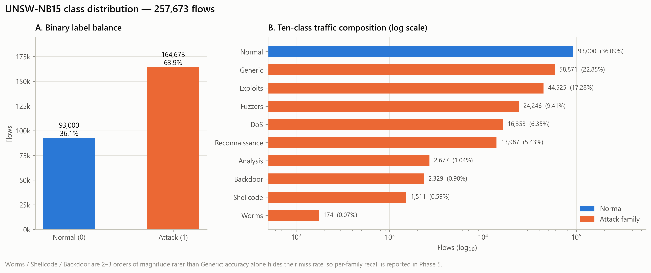
Figure 1. Class distribution: binary balance (A) and ten-class composition on a log scale (B). Worms are 340× rarer than Generic, so per-family recall must be reported.

3.2 Data Preprocessing & Leak-Free Pipeline
- Integrity. Headers were read as UTF-8-with-BOM, which removes the stray \ufeffid artefact. The data contains 0 missing and 0 infinite values, so no imputation was needed. The row identifier was dropped.
- Stratified 80/20 split before any fitting. The split is stratified on the ten-class label (seed 42), giving 206,138 training and 51,535 test flows with an identical 63.91% attack rate. All transformers are fitted on the training fold only. We verified that the training scaler's statistics differ from pooled ones, which confirms no test information leaked.
- Categorical encoding. OneHotEncoder(handle_unknown='ignore') is applied to proto, service and state (156 columns). 133 protocols exist, and 126 of them appear only in attack traffic. The test fold contains the TCP state PAR, which never occurs in training; it is encoded safely as an all-zero vector instead of crashing the pipeline.
- Normalisation. log1p is applied to the nine heavy-tailed volume and timing features. For example, sbytes skewness drops from 47.9 to 1.15, and sload spans 10 orders of magnitude. RobustScaler (median/IQR) is then applied to all numerical features, so that DDoS-scale outliers cannot dominate. The result is 195 model features.
- Class imbalance. We used class_weight='balanced_subsample' instead of SMOTE, because interpolating flow records synthesises physically impossible packets (e.g. fractional flag counts) [7].

3.3 Machine-Learning Tool Design
Baseline: a depth-10 Decision Tree, which is interpretable and sets the empirical floor. Champion: a Random Forest [3]. Bagging many de-correlated trees reduces the variance of a single tree. The forest handles non-linear feature interactions, is insensitive to the collinear feature clusters found in EDA (e.g. tcprtt~synack ρ = 0.996), and provides Gini importances that SOC analysts can interpret. Hyper-parameters were tuned with a 24-configuration grid search (3-fold CV, F1 scoring, on a stratified 61,841-row training subsample). The best configuration was n_estimators = 150, max_depth = None, min_samples_split = 5, min_samples_leaf = 2, max_features = √p (CV F1 0.9529). Threshold calibration: τ* was chosen on the forest's out-of-bag probabilities, which are leak-free validation scores, as the τ in [0.30, 0.70] that maximises attack recall subject to FPR < 5 %. The result was τ* = 0.50. All tooling is scikit-learn [4].

4. Results & Security Analysis

4.1 Comparative Model Performance
Model (untouched test fold) | τ | Accuracy | Precision | Recall | F1 | FPR | AUC
Decision Tree (baseline) | 0.50 | 92.92% | 98.29% | 90.50% | 94.23% | 2.80% | 0.9859
Tuned Random Forest | 0.50 | 94.71% | 97.05% | 94.60% | 95.81% | 5.09% | 0.9915

The forest raises recall by 4.1 pp over the baseline, recovering 1,350 attacks the single tree missed. The price is 427 extra false alarms, which is the expected ensemble trade-off. Honest gate assessment: F1 (95.81%) clears 95 %. Accuracy (94.71%) and recall (94.60%) fall just short, and FPR (5.09%) sits marginally above the 5 % budget. A validation-only experiment on the training fold tested an alternative tree ensemble (ExtraTrees) and five engineered ratio features. None lifted recall above ≈ 94.3 % under FPR < 5 %, and exact-duplicate label conflicts explain only 0.26 % of errors. The remaining gap is genuine overlap between benign and stealthy attack flows, so we report the measured result rather than tune against the test set.

4.2 Confusion Matrix & Operational Trade-offs
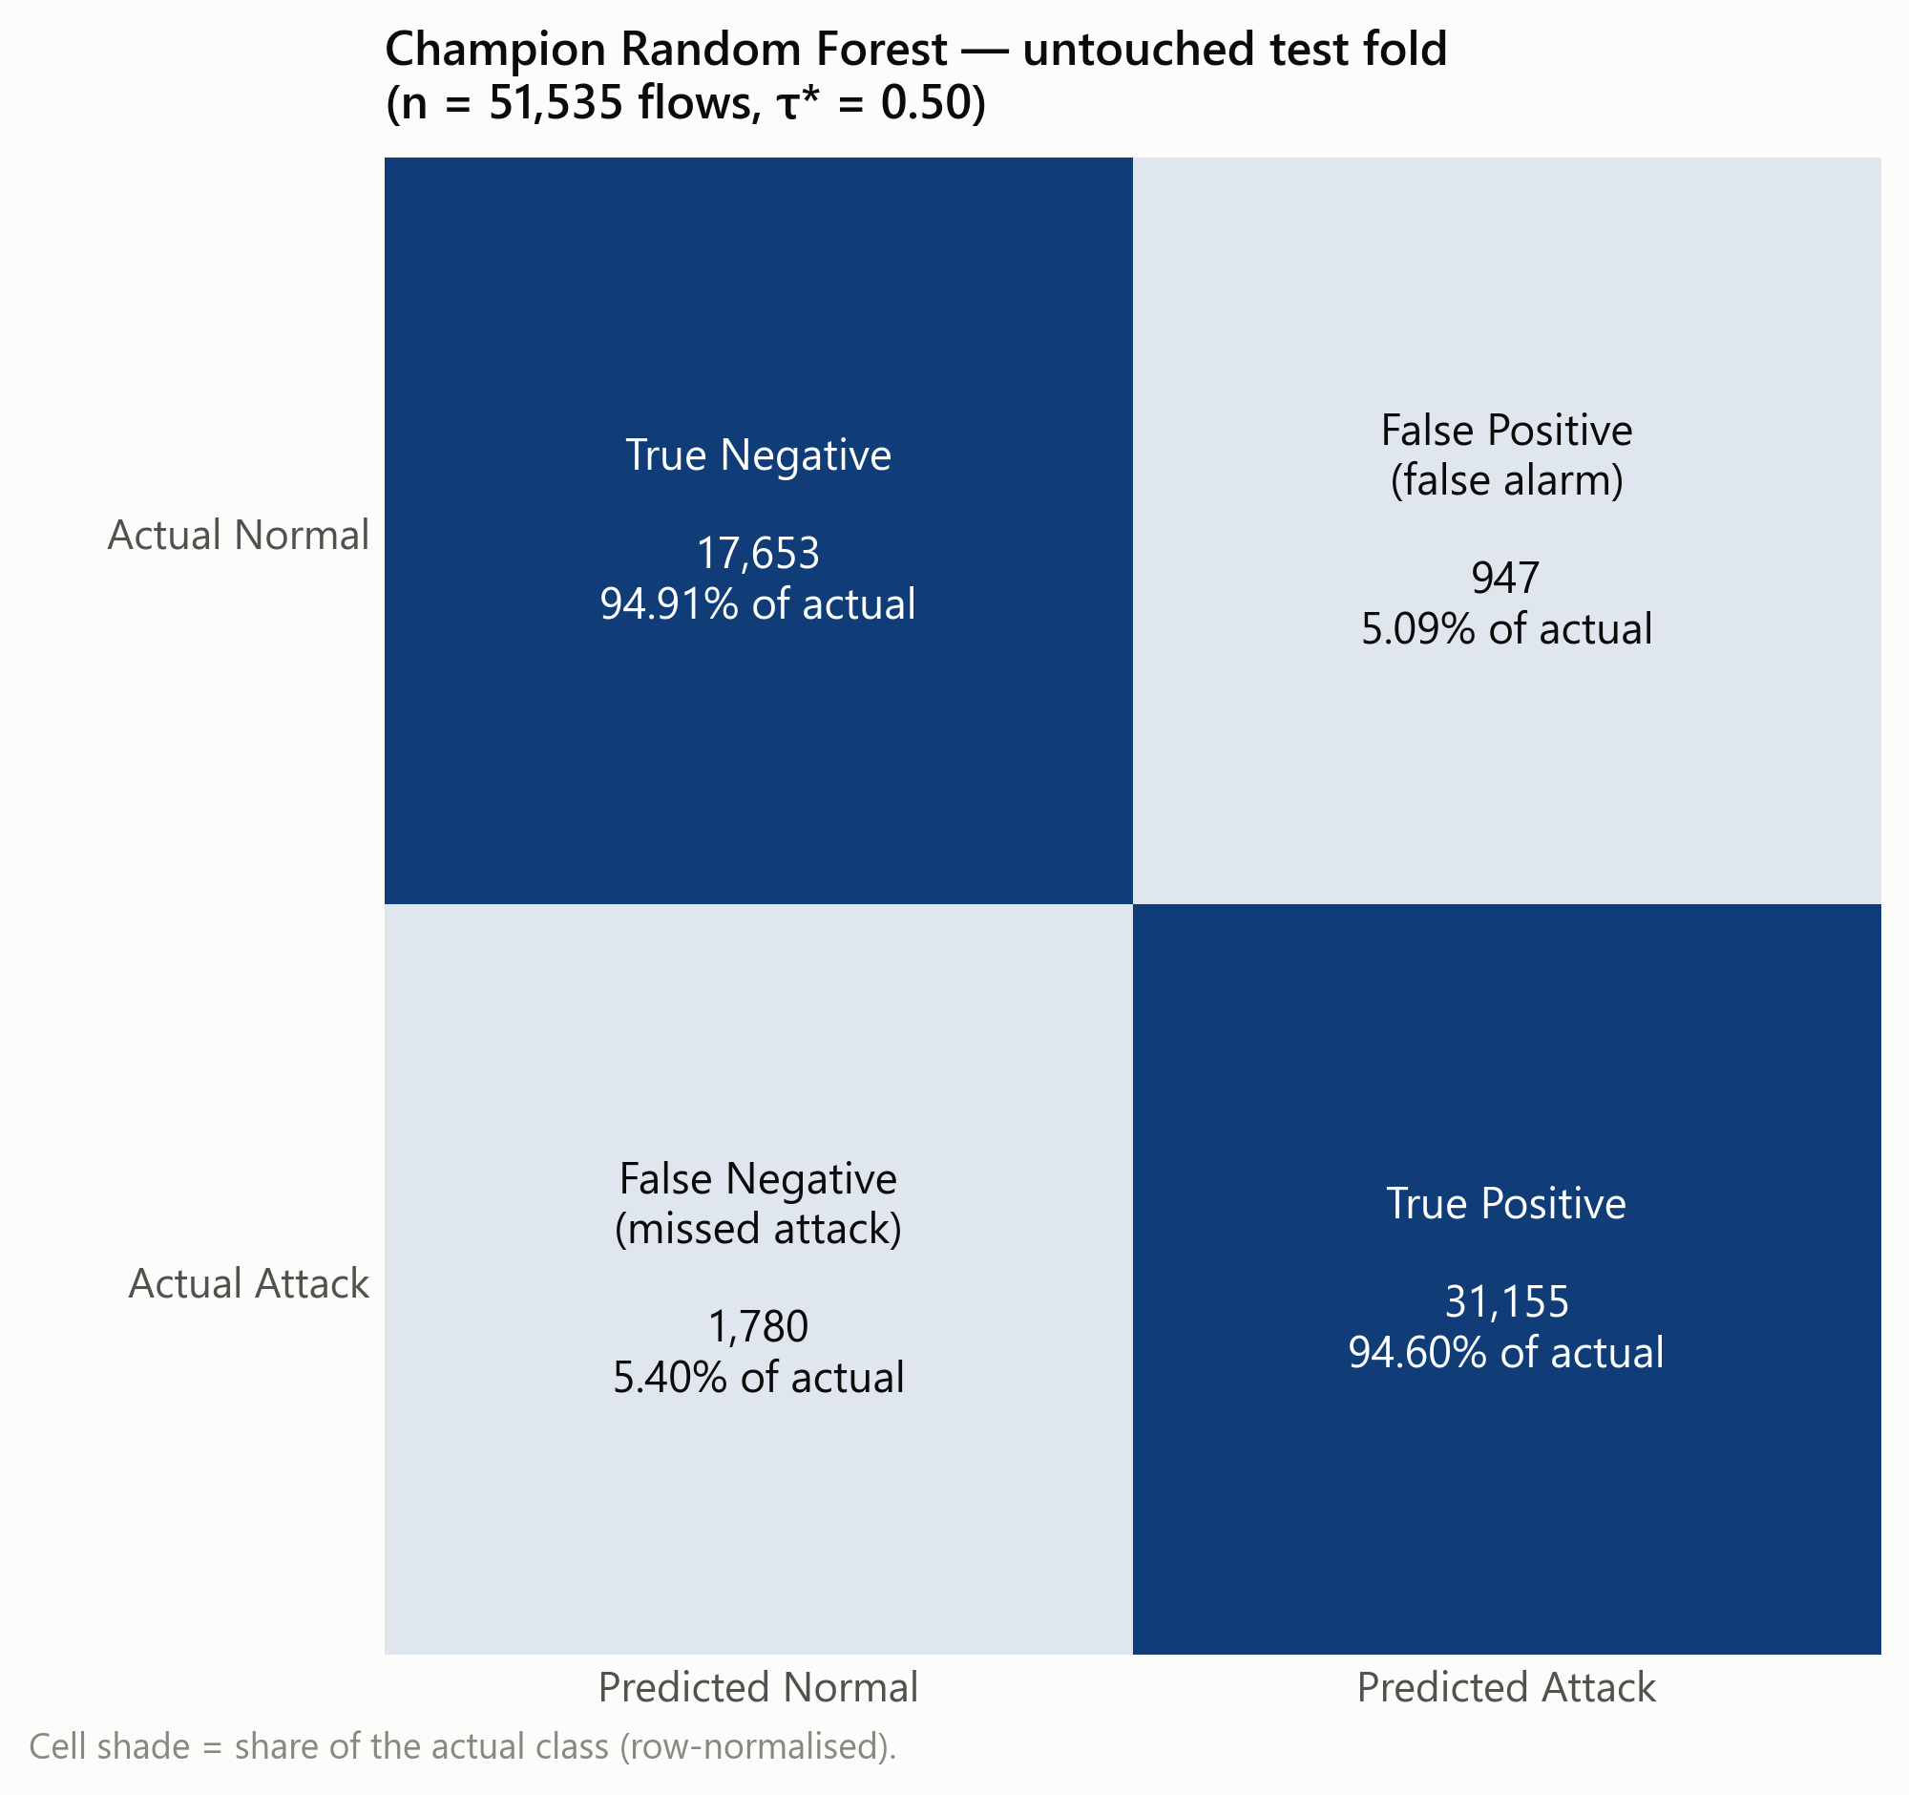 | 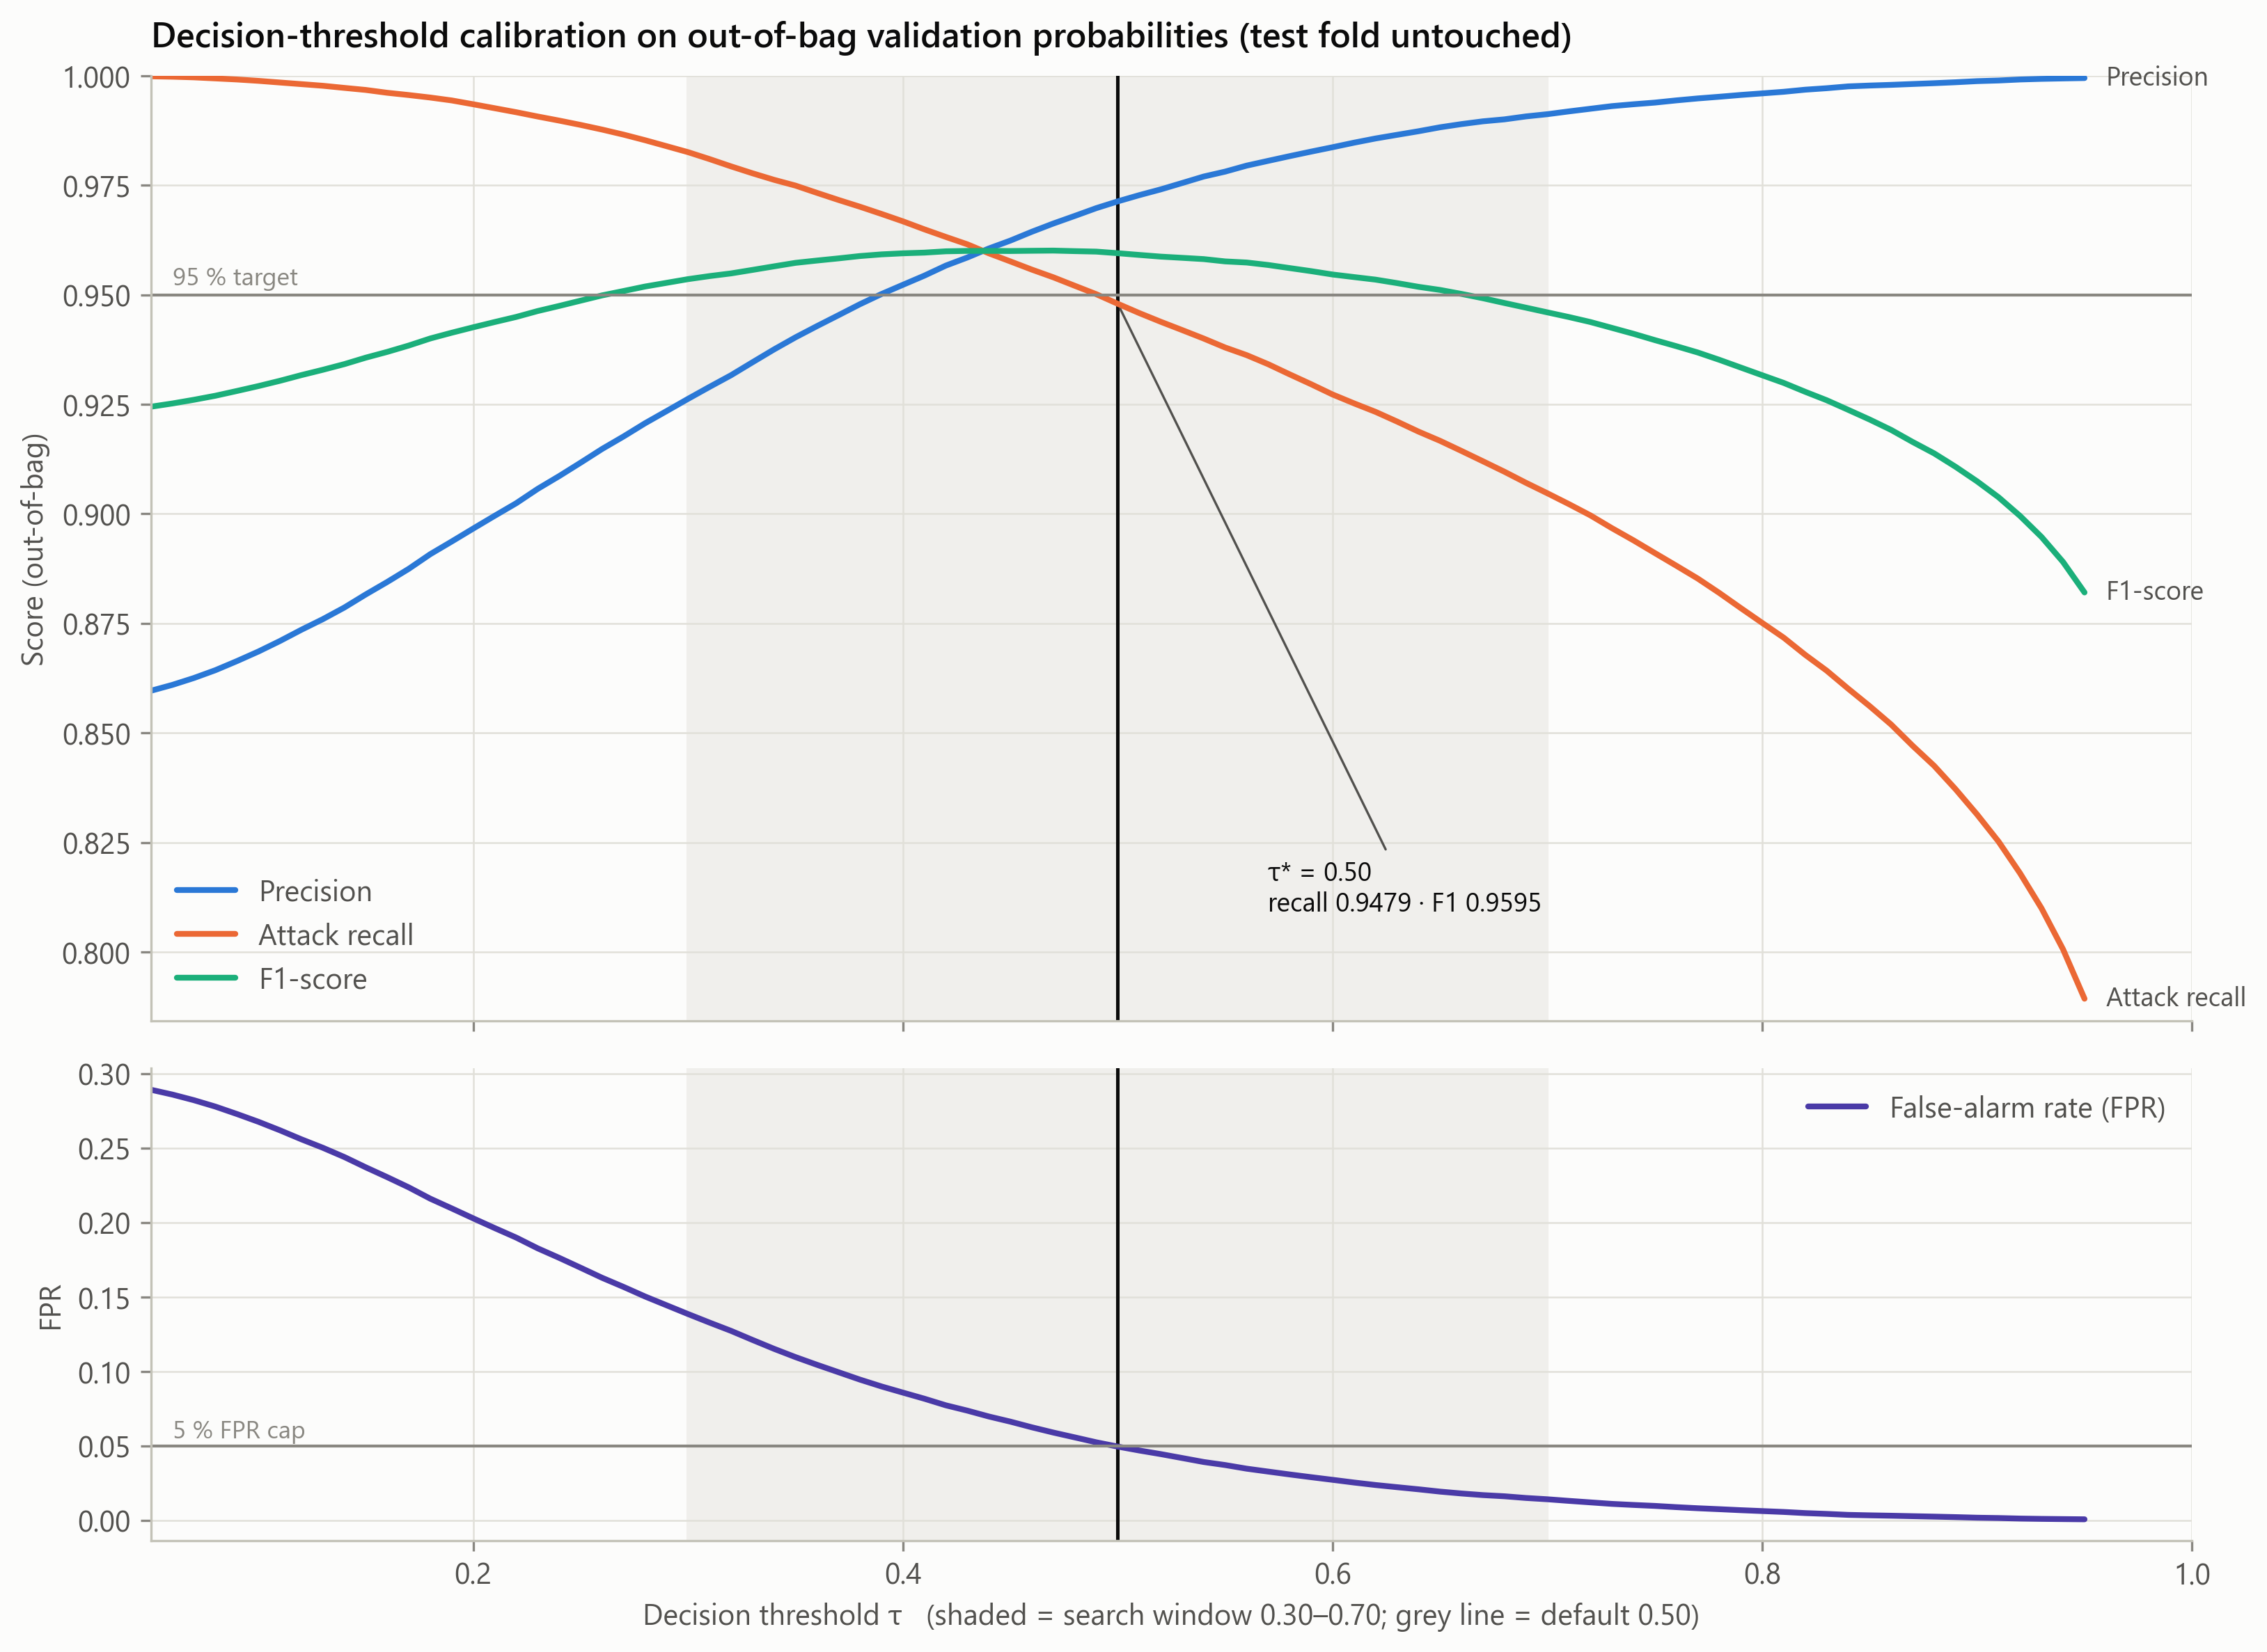
Figure 2. Champion confusion matrix (test fold). | Figure 3. OOB precision/recall/F1 and FPR against τ.

The champion produced 31,155 true positives and 17,653 true negatives, alongside 947 false positives and 1,780 false negatives. The two errors carry very different costs. A false positive costs analyst triage minutes and, at volume, alert fatigue. A false negative lets an intruder establish persistence, move laterally and exfiltrate data undetected, and is typically orders of magnitude costlier. Figure 3 makes the policy explicit. Lowering τ below 0.50 buys recall, but the out-of-bag FPR immediately breaches the 5 % budget. The CISO can move τ along this curve as threat levels change.

4.3 Granular Attack-Family Detection Analysis
Seven of the nine families exceed 95 % recall (Figure 5): Backdoor 100.0%, Worms 100.0%, Generic 100.0%, Reconnaissance 99.7%, DoS 99.6%, Exploits 98.6%, Shellcode 95.7%. The weak spots are Fuzzers (68.3%) and Analysis (85.2%), and Fuzzers alone accounts for 86% of all missed attacks (1,537 of 1,780). Many fuzzing sessions are short, low-volume exchanges whose byte, TTL and timing profile matches benign clients. In fact, the only exact feature-vector collisions between classes in the dataset are Normal↔Fuzzers. Security implication: an adversary fuzzing an internet-facing service for a zero-day would largely go unobserved, so detection would shift to the far more damaging exploitation phase. The 79 missed Analysis flows likewise leave vulnerability probing unlogged. The rarest families buck the usual expectation. Worms and Backdoor are detected at 100 % thanks to distinctive TTL and state fingerprints, although Worms' interval reaches down to 90% with only 35 test flows. Flow statistics alone cannot close the Fuzzers gap, so payload inspection and host telemetry must complement the model.

4.4 Feature Attribution & Security Insights
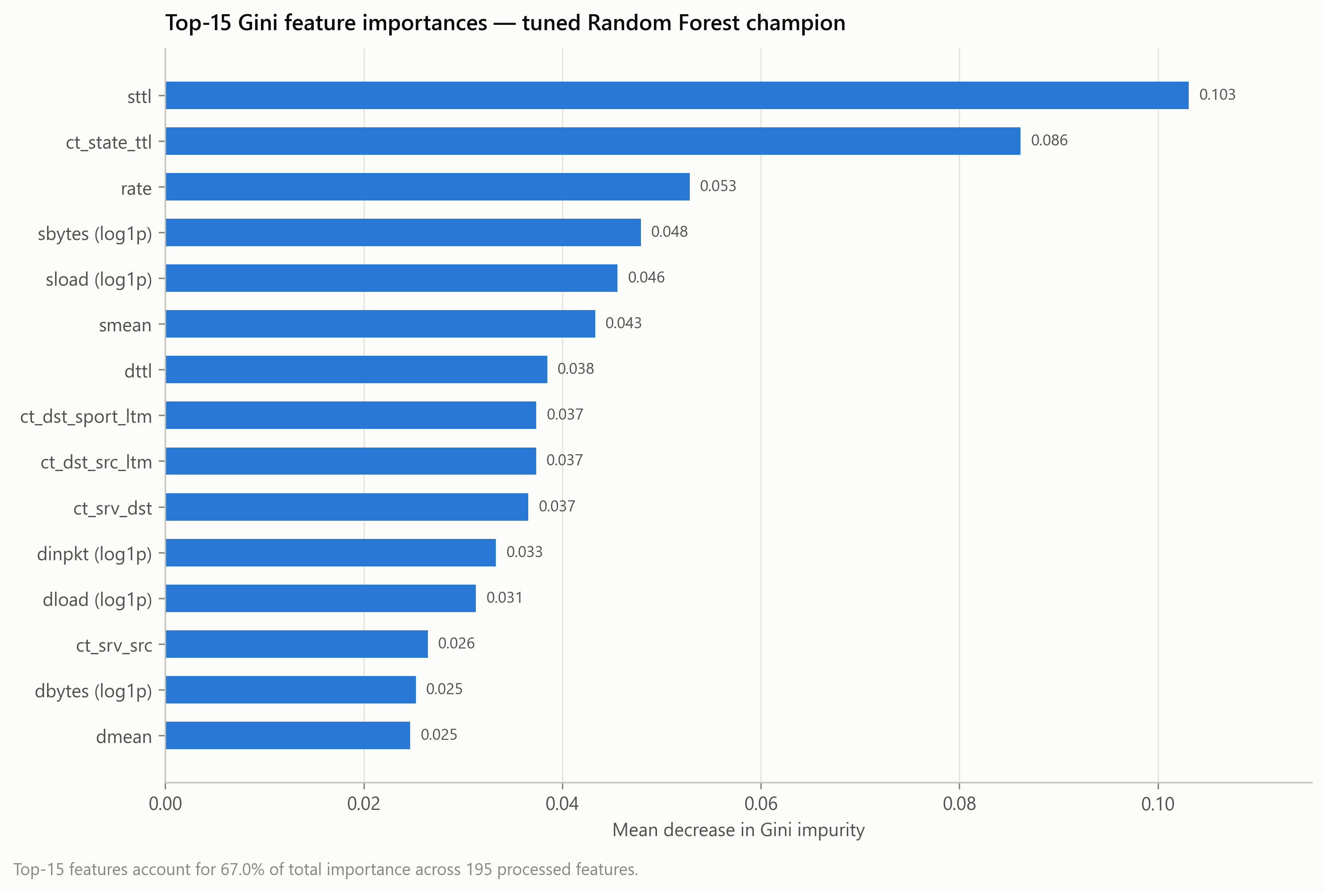 | 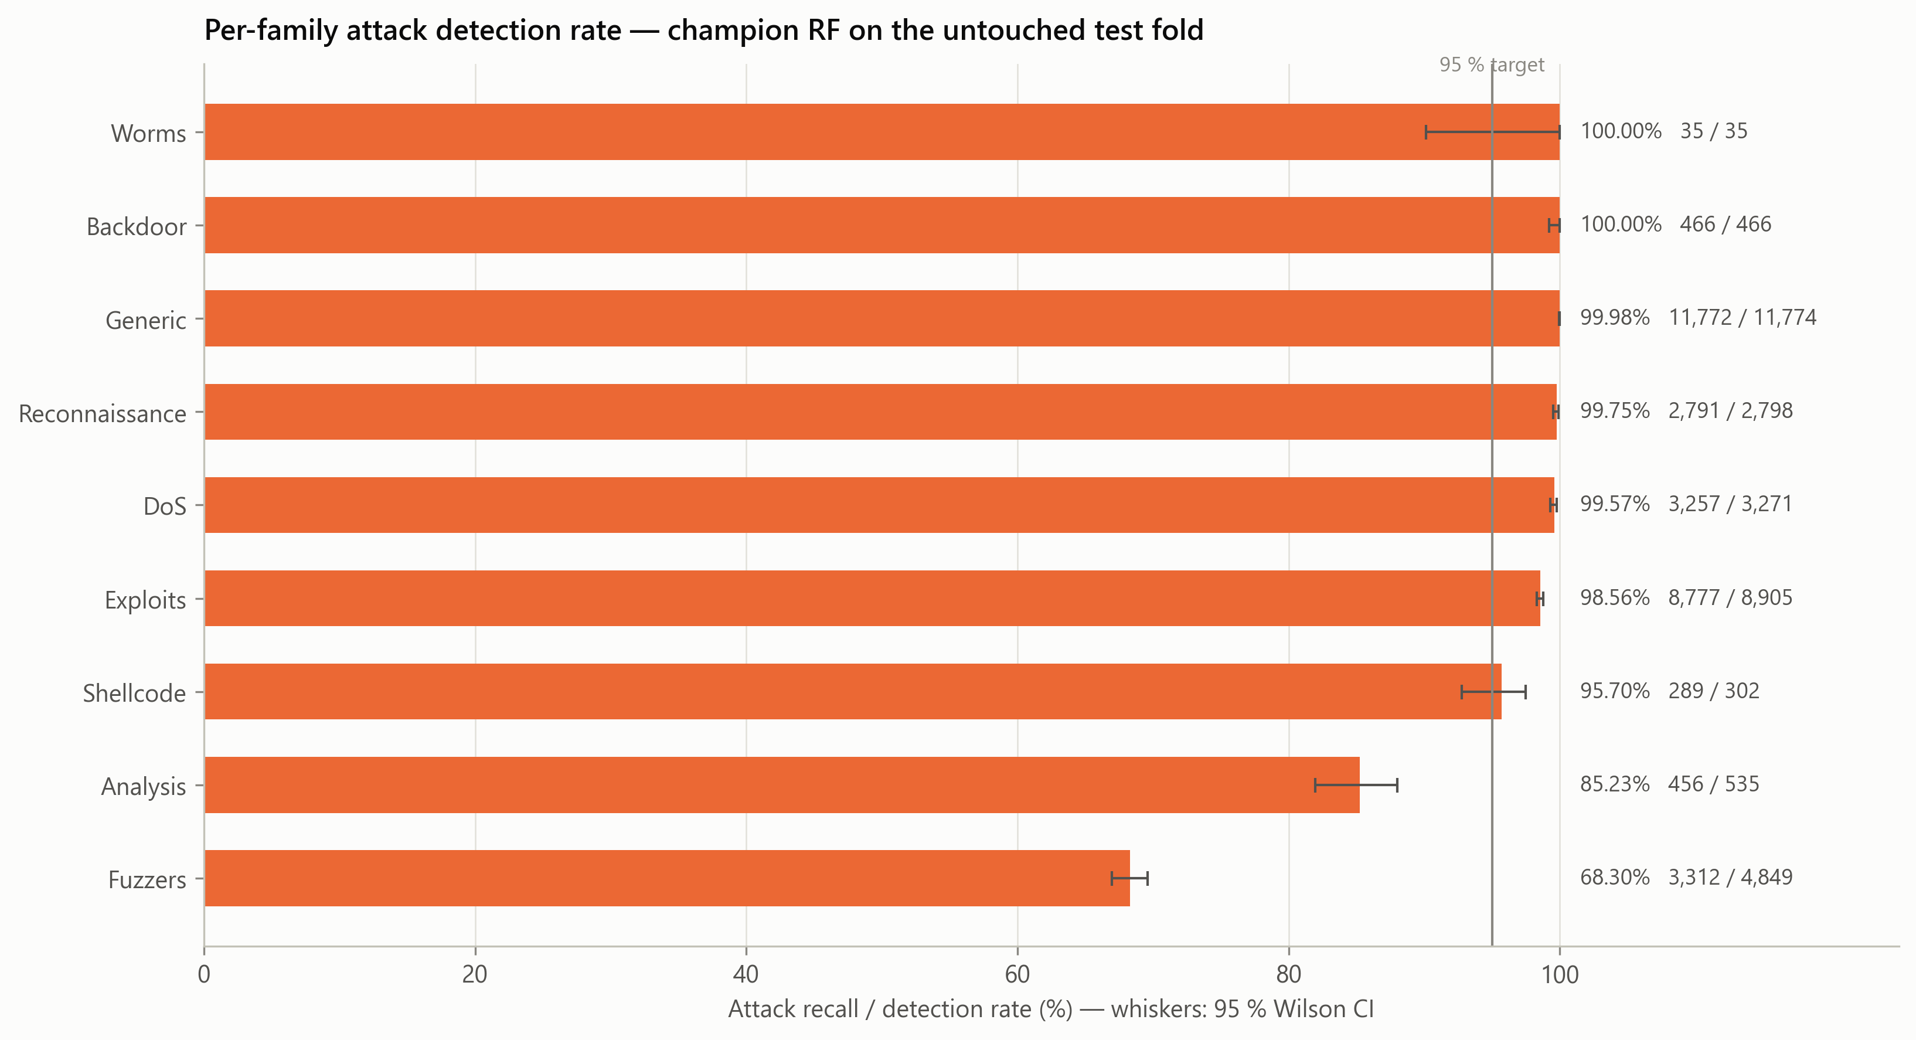
Figure 4. Top-15 Gini importances (champion RF). | Figure 5. Per-family recall with 95 % Wilson intervals.

The most influential features are sttl, ct_state_ttl, rate, sbytes (log1p), sload (log1p), smean. TTL features (sttl, ct_state_ttl) capture the characteristic initial TTL and TTL/state combinations emitted by attack tooling, the same OS/tool fingerprint used in threat hunting. Byte and mean-packet-size features expose payload anomalies, from oversized buffer-overflow requests to tiny, uniform probes. Connection-count features (ct_srv_dst, ct_dst_src_ltm) measure fan-out across the last 100 connections, which is the behavioural signature of scanning. Because the model relies on real packet behaviour rather than identifiers, SOC analysts can validate every alert against these features.

4.5 Real-Time Performance & Line-Rate Feasibility
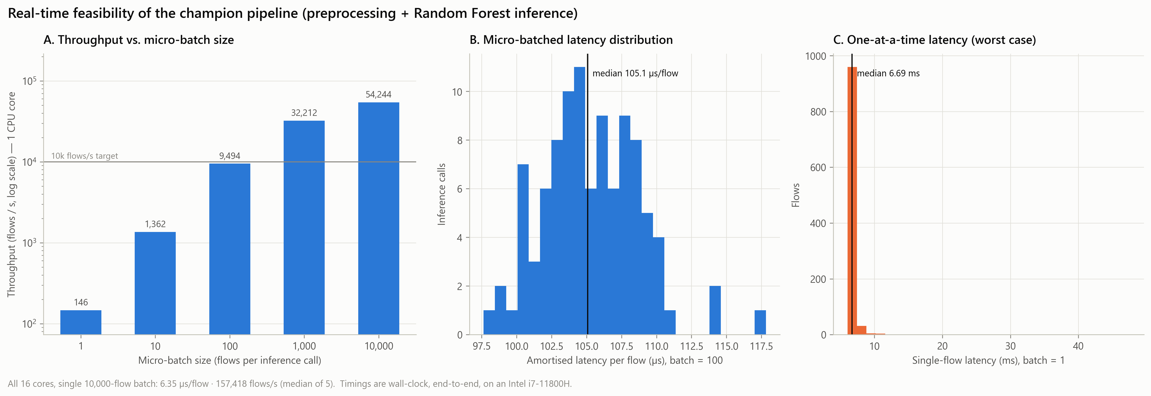
Figure 6. End-to-end latency and throughput (preprocessing + RF inference) on an Intel i7-11800H.
All timings are wall-clock and end-to-end, covering both preprocessing and inference. Scoring a 10,000-flow batch across all cores takes 6.35 µs per flow (157,418 flows/s). On a single core, micro-batches of 1,000 achieve 31.0 µs/flow. Scoring flows strictly one at a time costs 6.8 ms, because per-call overhead across all 150 trees dominates. Flow exporters (NetFlow/IPFIX, Zeek) already deliver records in batches, so the batched figures apply, and they exceed multi-gigabit flow rates. A streaming SIEM engine attaches a family label to each alert using a stage-2 classifier (accuracy 75.3%, macro-F1 0.57), and emits time-stamped alerts with confidence, severity and an automated action (TCP RST/block or rate-limit).

4.6 SOC Web Dashboard
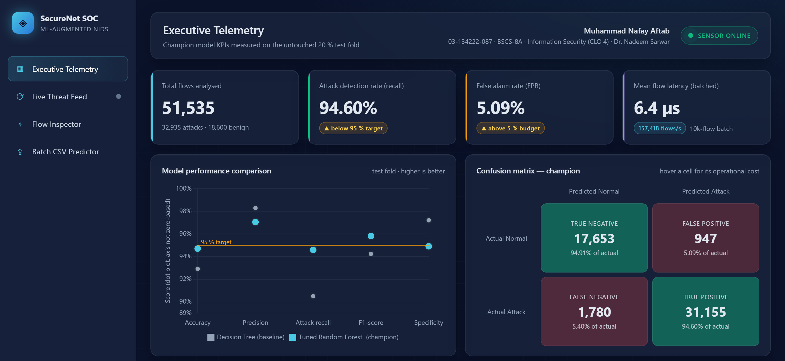
Figure 7. SecureNet SOC dashboard (FastAPI + Chart.js): executive telemetry view, top section.
The model is operationalised through a single-command web dashboard (python -m src.app) with four views: executive KPI telemetry computed live on the test fold; a real-time streaming threat feed; a single-flow inspector with attack-injection presets; and a batch CSV predictor that exports enriched predictions.

5. Conclusion & Future Enhancements
This proof-of-concept shows that ML is a viable NIDS augmentation for SecureNet Corp. A tuned Random Forest detects 94.6% of attacks at a 5.1% false-alarm rate. It explains its alerts through interpretable packet-behaviour features and runs at line rate when batched. The analysis also shows its limits: stealthy, low-volume families remain partly indistinguishable at the flow level. That limit is why the tool should augment, not replace, the existing signature NIDS [6]. Roadmap:
- Deep packet inspection & TLS fingerprinting (e.g. JA3), to separate Fuzzers and Analysis traffic from benign sessions. This is the single largest source of missed attacks.
- Cost-sensitive and family-specific thresholds, to raise Fuzzers and Analysis recall while holding Worms, Backdoor and Shellcode at their near-perfect detection.
- Continuous learning & drift monitoring, retraining on SOC triage outcomes and alerting on unseen protocols or feature drift.
- Inline zero-trust integration, using a compiled forest (Treelite/ONNX) behind the flow exporter, with alerts correlated against host EDR telemetry in the SIEM.

6. References
[1] N. Moustafa and J. Slay, "UNSW-NB15: A comprehensive data set for network intrusion detection systems," in Proc. Military Commun. Inf. Syst. Conf. (MilCIS), Canberra, Australia, 2015, pp. 1–6.
[2] N. Moustafa and J. Slay, "The evaluation of network anomaly detection systems: Statistical analysis of the UNSW-NB15 data set and the comparison with the KDD99 data set," Inf. Secur. J.: A Global Perspective, vol. 25, no. 1–3, pp. 18–31, 2016.
[3] L. Breiman, "Random forests," Machine Learning, vol. 45, no. 1, pp. 5–32, 2001.
[4] F. Pedregosa et al., "Scikit-learn: Machine learning in Python," J. Mach. Learn. Res., vol. 12, pp. 2825–2830, 2011.
[5] M. Tavallaee, E. Bagheri, W. Lu, and A. A. Ghorbani, "A detailed analysis of the KDD CUP 99 data set," in Proc. IEEE Symp. Comput. Intell. Secur. Defense Appl. (CISDA), 2009, pp. 1–6.
[6] R. Sommer and V. Paxson, "Outside the closed world: On using machine learning for network intrusion detection," in Proc. IEEE Symp. Security and Privacy, 2010, pp. 305–316.
[7] N. V. Chawla, K. W. Bowyer, L. O. Hall, and W. P. Kegelmeyer, "SMOTE: Synthetic minority over-sampling technique," J. Artif. Intell. Res., vol. 16, pp. 321–357, 2002.

Appendix — GitHub Repository & Setup
Repository: https://github.com/Nafay-Aftab/CLO4-IDS-ML-Solution · GitHub profile: https://github.com/Nafay-Aftab
pip install -r requirements.txt && python -m src.champion && python -m src.realtime
python -m src.app # SOC dashboard at http://localhost:8000
notebooks/CLO4_IDS_ML_Solution.ipynb # full reproducible notebook

