

**Group Members:**

*Muhammad Abdul Nafay [19P-0117]*

*Muhammad Usman [19P-0116]*

*Sheheryar Ali [19P-0120]*

Table of Contents

Basic Setup 3

Username/Passwords 4

Basic Guide 4

Academics Side: 4

Teachers/Faculty Side: 4

Students Side: 5

# Basic Setup

* Extract the zip file in htdocs folder
* Open the file
* Open XAMPP and open the shell.
* Run the following:
* CREATE Database FLEX
* USE FLEX
* Source “Insert filepath of sql here”, (In my case: source C:\xampp\htdocs\FLEX\sidebar\FLEX.sql)

After this, you should have the following tables in the database. (Don’t worry about the data in the database, I might have more data in the tables.)

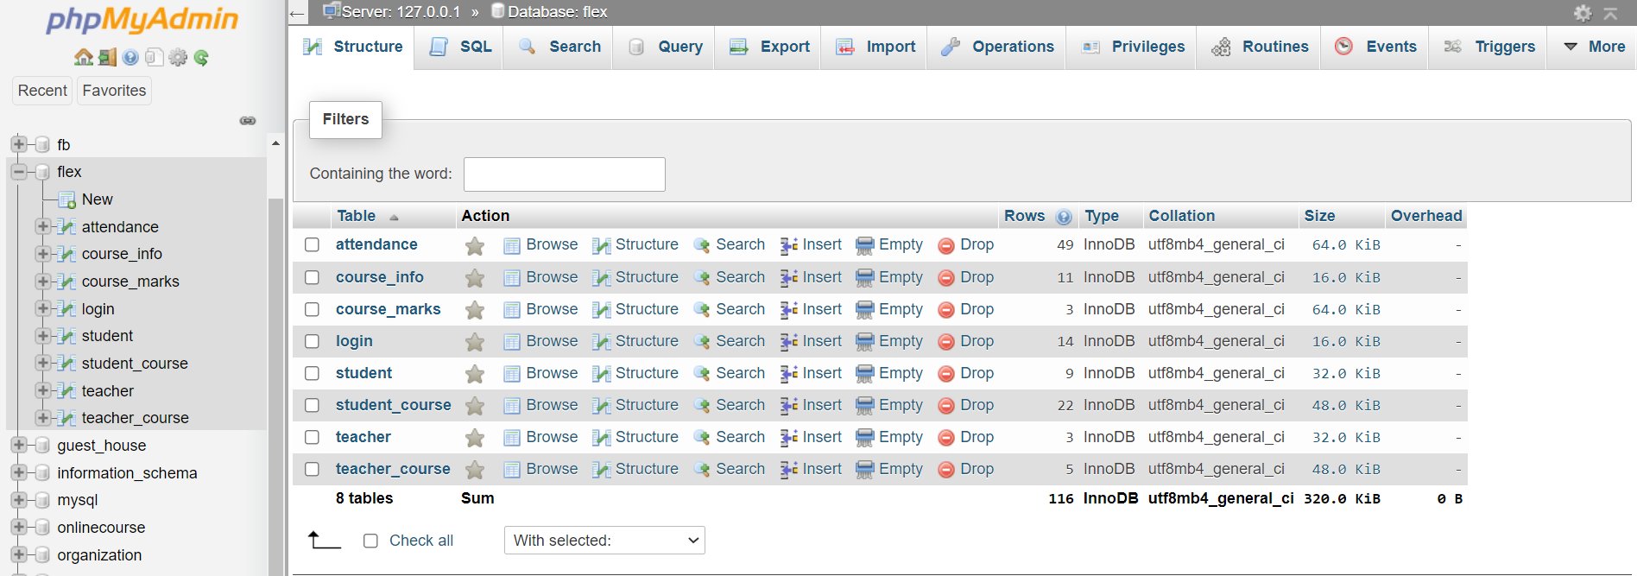

Now open new tab in your browser and type <http://localhost/FLEX/sidebar/MainPage.html>.

This will take you here:



# Username/Passwords

Here are the list of usernames and passwords: (Note: *This is Case Sensitive*)

|  |  |
| --- | --- |
| **Academics** | |
| **Username** | **Password** |
| admin | admin |

|  |  |
| --- | --- |
| **Students** | |
| **Usernames** | **Passwords** |
| S001 | S001 |
| S002 | S002 |
| S003 | S003 |
| S004 | S004 |
| S005 | S005 |
| S006 | S006 |
| S007 | S007 |
| S008 | S008 |
| S009 | S009 |
| S010 | S010 |

|  |  |
| --- | --- |
| **Teachers** | |
| **Usernames** | **Passwords** |
| T001 | T001 |
| T002 | T002 |
| T003 | T003 |

**(These entries were already inserted; you can also add more Teachers/Students)**

Basic Guide

## Academics Side

Obviously as the name says, this is the **Academics portal**, so they can:

* ***Add*** OR ***offer*** the courses to the Students & Faculty side for which they can decide to register or not.
* ***Drop*** the Course, which will remove the course from the offered list.
* ***Register*** OR ***remove*** the ***students.***
* Can see all the information of all the ***student’s*** registered.
* ***Register*** OR ***Remove*** the ***Teachers/Faculty***.
* Can see all the information of all the ***Teachers*** registered.

## Teachers/Faculty Side

This is the **faculty side**, and so each account can:

* See their personal information
* ***Register/drop*** courses, which means they will teach this course OR no longer teach this course.
* Can see all the courses that are ***registered***
* Marks ***Students attendance*** that are ***registered*** in the course that you are teaching.
* Marks ***Students Exams*** (Sessional-I, Sessional-II, Final) and generate reports (which will contain their total marks, and their GPA), which then the teacher will upload, so that the student can see.

## Students Side

Finally, the **student’s side**, which basically will see everything that the teacher uploaded, according to the student’s account. All students can:

* See their personal information
* ***Register/drop*** courses.
* See all the courses that are ***registered.***
* Check their ***attendance*** for a specific ***registered course***, on a specific date.
* Check their whole ***marked report*** of the chosen course.