Semi-Automated Language Sample Analysis for Autistic Youth: A Pilot End-to-End Speech–NLP Pipeline with Human-Rater Validation

Abstract—Speech-language pathologists (SLPs) use language samples to examine communication in autistic youth. Preparing these samples requires transcription, speaker identification, and utterance labeling, with errors potentially affecting language measures. We developed a semi-automated pipeline combining MOSS-Transcribe-Diarize 0.9B, brief human identification of the participant speaker, and custom rules using spaCy sentence and dependency output to identify utterances and calculate 11 language measures. We evaluated 37 recordings from 10 autistic participants aged 8–17 years. Corrected transcripts scored with TAALED and CLAN provided a comparison under shared automatic utterance rules. Rater 1’s manual labels provided a separate reference for 10 participant samples from 14 recordings. Pooled word error rate was 9.04%, and median participant WER was 10.28%. Median lexical errors against corrected software scores ranged from 0.96% to 3.71%. Against human labels, median absolute percentage errors were 6.31% for utterance count, 6.40% for word-based mean utterance length, and 16.76% for length standard deviation. Custom segmentation had lower median errors than ordinary sentence splitting. Pairwise human agreement was evaluated separately. The rules were refined on the evaluated recordings; performance on independent participants and workflow time savings remain untested.
Keywords—automated language analysis, autistic youth, lexical diversity, natural conversation, utterance segmentation

Introduction
Speech-language pathologists (SLPs) use language samples to examine how autistic youth communicate in conversation. These samples complement structured tests by showing the words and utterances used during an exchange. The American Speech-Language-Hearing Association (ASHA) includes language sampling and narrative analysis in its guidance for autism assessment [1]. Word counts, vocabulary diversity, and utterance length describe parts of a sample, but a full assessment also considers comprehension, speech production, and social communication.
Language sample analysis (LSA) usually involves recording a conversation or narrative, transcribing it, identifying the child’s utterances, applying coding rules, and calculating measures. Clinical tutorials describe Computerized Language ANalysis (CLAN), Systematic Analysis of Language Transcripts (SALT), and Sampling Utterances and Grammatical Analysis Revised (SUGAR) for assessment and treatment planning [2], [3]. These tools support score calculation from prepared transcripts. Researchers and clinicians still need to identify speakers and decide how to handle repetitions, fillers, and utterance boundaries. Comparison databases also differ in the populations and speaking tasks they cover [2].
The speaking task and conversation partner also affect the language observed. Automated measures differed across conversation, narrative, and interview samples from autistic participants [4]. Minimally and low-verbal autistic children and adolescents produced more speech and greater lexical diversity with parents at home than with examiners in a laboratory [5]. Comparisons across people or sessions therefore need consistent sampling procedures and a clear description of the task.
The time needed to prepare samples remains a practical barrier. In a survey of 337 U.S. SLPs, 60% reported using LSA during the previous year, usually with their own protocols. Nonusers cited limited time (74%), resources (59%), and expertise (41%) [6]. Automatic speech recognition (ASR) could reduce transcription work, but errors in the transcript do not affect every language measure in the same way [7]. An automated system should therefore be evaluated for word accuracy, utterance boundaries, and the measures calculated from them.
We developed a semi-automated pipeline to process a selected participant’s speech and calculate 11 language measures. The open-source MOSS-Transcribe-Diarize 0.9B model produces transcripts, timestamps, and speaker labels [8]. A researcher listens briefly to identify the participant speaker. Our software then uses spaCy sentence predictions and grammatical dependencies [9], with added rules for conversational utterance boundaries. It also standardizes words and grammatical tags for scoring. The pipeline saves predicted utterances and the reason for each boundary so that researchers can review the output.
We evaluated 37 recordings from 10 autistic participants aged 8–17 years. Corrected transcripts scored with the Tool for the Automatic Analysis of Lexical Diversity (TAALED) and Computerized Language ANalysis (CLAN) provided a comparison under the same automatic boundary rules. Rater 1’s manual labels provided a separate reference for 14 sampled recordings, combined into 10 participant samples. We also checked calculations against CLAN using identical inputs, measured pairwise agreement among three human raters, and compared our rules with ordinary spaCy sentence splitting. These tests examine transcription, boundary decisions, and calculation separately. The system contribution is the combination of these steps in one conversation-to-measurements workflow, together with inspectable rules for utterance segmentation.

Related Work
Barokova et al. [10] developed Eliciting Language Samples for Analysis–Adolescents (ELSA-A) and studied 46 minimally and low-verbal autistic participants aged 6 years 6 months to 19 years 7 months. Trained listeners marked utterances to calculate utterance and conversational-turn frequencies without transcribing every word. For 10 participants tested again, intraclass correlations were .774 and .798, respectively. This study supports measuring utterances in an age range that overlaps ours. It did not evaluate ASR, lexical diversity, or utterance-length variability. Our pipeline retains word-level transcripts and examines how boundaries affect these additional measures.
In a related study, Barokova et al. [5] compared samples from 33 minimally and low-verbal autistic children and adolescents. Parents collected home samples for 22 participants. Participants produced approximately twice as much speech with parents as with examiners and showed greater lexical diversity. Parents collected longer samples while completing fewer activities. Because the partner and setting changed together, the study could not separate their effects. This finding shows why sampling conditions must be considered when interpreting differences in language scores.
MacFarlane et al. [4] analyzed human-transcribed samples from 64 highly verbal autistic participants aged 6–23 years. Their six measures included mean utterance length in morphemes, distinct word roots, and C-units per minute. The speaking context affected every measure. All measures except repetition proportion showed good reliability over four weeks, with median concordance coefficients of .73–.88. Their results support using consistent tasks and testing stability across sessions. The study did not evaluate ASR, and its morpheme-based and C-unit measures differ from our word-based mean length and utterance-length standard deviation.
Fox et al. [7] evaluated ASR and real-time transcription for 42 narrative samples from school-age children with developmental language disorder. Google Cloud Speech had a mean weighted word error rate (WER) of 30%, yet correlations with four reference language scores were .89–.97. The study included only good quality recordings. Recording quality, speaking task, and linguistic diversity limited how widely the results could apply, and transcript errors could still affect interpretation of the child’s language. The study supports checking language measures directly. Its population and narrative task differ from our autistic-youth conversations.
Pelfrey et al. [11] evaluated the IDEAS pipeline in a preschool classroom. For children’s own speech, median WER was 62.75%. Median absolute relative errors were 9.29% for mean utterance length and 17.43% for type–token ratio (TTR). The evaluation used manually timestamped speaker data and reference measures calculated with the MATLAB NLP toolbox. Overlapping speech and the lack of validation for automatic speaker assignment limited the study. The reference measures were also calculated automatically. These limitations support separate checks of speaker selection, scoring, and human utterance boundaries. Differences in age, setting, and error aggregation prevent a direct ranking against our pipeline.
TAALED is a research tool that calculates lexical-diversity measures [12]. Baese-Berk et al. [13] used TAALED with conversational transcripts to calculate TTR and moving-average type–token ratio (MATTR) with a 50-word window. Covington and McFall [14] introduced the moving-average method. These studies support using TAALED for lexical scoring in research. Our normalization and content/function rules are described below. They do not establish clinical norms or routine SLP use of TAALED for autistic youth.
CLAN analyzes transcripts in the Codes for the Human Analysis of Transcripts (CHAT) format [15]. Clinical tutorials describe its use in language assessment and therapy planning [2], [3]. We used CLAN to check word-based mean length of utterance and length variability because its output identifies the words and utterances counted. CLAN calculates scores from the boundaries supplied in the transcript. A human reference is therefore needed to test whether automatic boundaries are correct.
Samples of 50–100 utterances have a long history in clinical language sampling, but the required length depends on the measure, population, and task [2], [16]. Guo and Eisenberg [16] found that about 10 minutes, or 91 C-units, were desirable for reliable global lexical and morpheme-based length measures in parent-elicited samples from 3-year-olds. This provides a reason to examine a sample of nearly 100 units. It does not establish that 100 utterances are sufficient for automatic segmentation or length-SD measurement in autistic youth. We used these focused samples to examine boundary decisions and did not test whether they represented the full conversations.
Previous studies provide methods for collecting samples and calculating language measures, but they do not validate our automatic utterance rules. Our study examines custom post-processing of spaCy output within a pipeline that also calculates vocabulary and utterance measures. We use corrected transcripts, human boundaries, identical-input calculation checks, and a sentence baseline to examine where errors arise. Further work needs to test new recordings and measure the time required for human review.

System and Evaluation Methods

Pipeline and Reference Comparisons
Fig. 1 shows the pipeline and its two reference comparisons. MOSS-Transcribe-Diarize 0.9B produces a transcript with timestamps and speaker labels [8]. A researcher identifies the participant, and the pipeline retains that speaker’s turns. The upper branch calculates measures with our software. The middle branch scores corrected transcripts with TAALED and CLAN. In the lower branch, human raters listen to the video, review the wording, and label utterances in a focused sample. Each reference is compared separately with the pipeline.
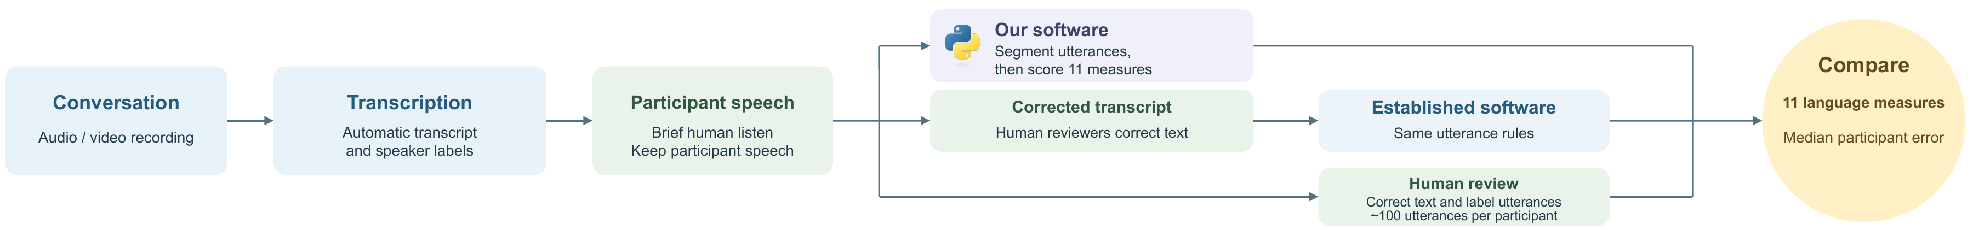
Fig. 1. Conversation-to-measurements workflow. The pipeline identifies utterances and calculates 11 measures. Corrected transcripts are scored with TAALED and CLAN under the same automatic rules. Human review supplies a separate reference for wording and utterance labels. The two references are compared separately with the pipeline.
The pipeline joins consecutive rows from the target speaker into turns. It can continue a turn across another speaker’s “mhm,” “mm-hmm,” “uh-huh,” or “yeah” if the preceding target-speaker row has no sentence-ending punctuation. This rule does not use a pause-duration threshold. Custom rules then revise spaCy sentence boundaries using grammatical dependencies. A coordinated clause is split when it has its own subject and predicate and a qualifying conjunction such as “and,” “but,” “or,” or “yet.” Guards avoid splitting inside subordinate and relative clauses. A separate check reparses text after “but” and requires a subject and predicate before accepting that boundary. Other rules suppress unpunctuated splits after filler-only fragments or repetitions and keep recognized dependent fragments with the preceding clause. Short responses and abandoned statements are retained. The pipeline saves each utterance and boundary reason. Boundary decisions use transcript grammar, without acoustic pause or intonation information.
For example, the pipeline splits “I went home and I made dinner” into “I went home” and “and I made dinner.” It keeps “I went home and made dinner” together because the second phrase shares the subject. It also keeps “I went home because I was tired” together because the second clause is dependent. Without sentence-ending punctuation, proposed splits after filler-only fragments or repeated words are suppressed. Each accepted boundary is saved with the rule that produced it.
For the corrected-text comparison, we used human-corrected wording from all 37 recordings. Both corrected and uncorrected text were segmented with the same automatic rules before scoring with TAALED and CLAN. This comparison examines the effect of transcript changes under shared segmentation; it does not independently test the boundary rules. Corrected transcripts lacked speaker-turn timestamps, so original target-speaker turn breaks were mapped to the corrected word stream by minimum-edit alignment. Of 1,350 source turn breaks, 379 required review because the surrounding words did not align exactly. These approximate turn mappings are a limitation of the corrected-text reference.
The main human reference was Rater 1’s wording and utterance labels in the focused samples. We analyzed 14 source recordings across 10 participants and combined each participant’s sampled speech before scoring. Abbreviations and ellipses were protected when parsing explicit label delimiters. We did not infer new grammatical boundaries within the human labels. Word sequences matched between this reference and the pipeline, allowing us to examine boundary and scoring differences while keeping the words fixed. Automatic worksheet rows were not treated as human utterances.

Participants and Recordings
The dataset contained 37 natural conversation recordings, about eight minutes each, from 10 autistic participants aged 8–17 years at a university-affiliated autism and neurodevelopment research center. P1 contributed two recordings, P7 three, and each other participant four. Recordings from the same participant are repeated observations. Human annotation targeted approximately 100 utterances per participant. The parsed labels contained 95–136 utterances per participant, totaling 1,147. P1, P5, P6, and P10 each had sampled speech from two recordings; the other participants had one. The manual comparison therefore covered 14 recordings and 10 participant samples. P1 was analyzed in the same way as the other participants: its 97 automatic worksheet rows yielded 111 human-marked utterances, compared with 96 pipeline utterances over the paired sampled text.

Human Annotation Protocol
Three researchers manually labeled utterances using the same instructions, based on CHAT/CLAN guidance [15]. Each worksheet contained automatically segmented target-speaker text, start and end times, the filename, and a manual-utterance column. Each researcher entered manual labels while able to see the automatic segments. These were manual judgments with visible automatic text, not blinded annotations. Raters listened to the video and used grammar and conversation context to label utterances. The instructions allowed them to retain transcript wording when speech was difficult to understand and to add notes in another column.
Raters retained repetitions and fillers, as in “I I I missed that class.” A main clause usually stayed with its dependent clause, as in “I stayed home because I was sick.” The written instructions called for splitting conjoined clauses while keeping phrases together and listed conjunctions including “and,” “but,” and “although.” Short responses such as “yeah” or “no” could stand alone, while “Yeah, I went to class” stayed together. Abandoned or interrupted statements were kept without adding words to complete them. Fillers were retained in the labels but excluded from some scoring and agreement analyses, as described below. Labels were entered in worksheets rather than fully coded CHAT transcripts.

Language Measures and Scoring Policy
We calculated 11 measures: total words, different words, content words, different content words, function words, different function words, type–token ratio (TTR), moving-average TTR with a 50-word window (MATTR-50), utterance count, word-based mean length of utterance (MLU-W), and utterance-length standard deviation (SD). The six word counts distinguish the amount of speech from the variety of words used. Content categories include nouns, proper nouns, lexical verbs, adjectives, and selected adverbs. Other categories, including pronouns, determiners, auxiliaries, and prepositions, are treated as function words.
TTR divides the number of different normalized word types by the number of normalized word tokens and depends on sample length [13]. MATTR-50 averages TTR across overlapping 50-word windows [13], [14]. spaCy supplies lemmas, or base word forms, and part-of-speech tags. Our post-processing excludes listed fillers, punctuation, numeric tokens, and a fixed exclusion-list entry (“becuase”), lowercases lemmas, and assigns content/function categories. A different word type is a distinct lemma–part-of-speech pair, not simply a different spelling. Adverbs ending in “-ly” and “well” are treated as content words; other adverbs are function words. This is a practical heuristic rather than a full identification of manner adverbs. These scores describe the sample, not vocabulary knowledge or communication ability in other settings.
Utterance count records how many conversational units were identified. MLU-W divides counted surface words by the number of eligible utterances. Population SD describes how utterance lengths vary around that mean. A sample with many short responses and a few long utterances can have a larger SD than one with similar-length utterances. These are length measures, not direct measures of grammatical accuracy or social communication. They depend on the task, sample length, and scoring rules and are not age-normed clinical scores.
Fillers such as uh, um, hmm, huh, mm, and oh remain in saved utterances and total utterance count. Lexical scoring excludes listed fillers, punctuation, and numeric tokens but retains repetitions. Filler-only units and units containing unintelligibility markers are omitted from MLU-W and from the cleaned text used for lexical scoring. MLU-W retains numeric words and counts contractions and hyphenated words as single surface words. Length SD uses the population denominator. The manual comparison reports total utterance count, while CLAN counts only MLU-eligible utterances. Lexical word counts and MLU-W surface-word counts also use different tokenization and exclusions.

Reference Comparisons and Error Calculation
TAALED provides lexical scores, and CLAN provides word-based utterance scores [12], [15]. Comparing corrected and uncorrected text under the same automatic rules examines transcript effects. Comparing pipeline boundaries with human labels examines utterance identification. The software comparison shares normalization and segmentation rules.
For each score pair, absolute percentage error (APE) was 100 times the absolute pipeline–reference difference divided by the reference value. In the main human comparison, we combined each participant’s sampled utterances and calculated all 11 measures. Utterances were not merged across recordings, although MATTR-50 used the combined word stream. Median absolute percentage error (MdAPE) was the median of the 10 participant APEs. In a separate analysis, we scored the 14 recording portions individually, averaged their APEs within each participant, and took the median of those 10 averages. The corrected transcript comparison used this recording-based method across 37 recordings. Thus, its median error summarizes participant averages. We did not set a threshold for clinically acceptable error.
WER compared the uncorrected participant transcript with its corrected version. It was calculated as 100 times the number of substitutions, deletions, and insertions divided by the number of corrected-reference words. Minimum-edit alignment ignored case and punctuation and standardized apostrophes. Fillers, repetitions, and numeric tokens were retained. We averaged recording WER within each participant and then took the median across participants. We also calculated pooled WER by combining edits and reference words across all recordings. The median weighs participants equally, and the pooled value weighs the words in the dataset.
We checked calculations separately by giving our software and CLAN identical CHAT inputs: 37 uncorrected and 37 corrected files. Word and eligible utterance counts matched exactly. MLU-W and population SD matched within CLAN’s three-decimal display precision. This verifies calculations for those inputs, not transcription or boundary accuracy. Summary word and utterance counts use one decimal place; percentages, MLU-W, and SD use two; TTR, MATTR-50, and Cohen’s κ use three. Calculations and plotted values use unrounded results.
We compared ordinary spaCy sentence splitting with our added utterance rules. Both methods used the same words, speaker turns, human labels, and scoring rules. We compared both with Rater 1’s labels in all 14 sampled recordings, combining each participant’s recordings and also scoring each recording separately. This comparison measures the overall effect of the rules; it does not isolate each rule’s contribution. Analysis used spaCy 3.8.14, en_core_web_sm 3.8.0, TAALED 0.32, and pylats 0.64. Saved code, paired scores, and boundary records support checking the calculations.
We calculated 95% confidence intervals with 10,000 participant bootstrap samples. Each sample drew 10 participants with replacement and kept each selected participant’s recordings together. We recalculated median errors, median participant WER, and pooled boundary F1. The 2.5th and 97.5th percentiles formed the intervals. Baseline and current-method comparisons used the same resampled participants. These intervals describe uncertainty from the small participant sample. They do not establish performance on new recordings because the rules were developed on the recordings used for evaluation.

Human Boundary Agreement
Rater 1 provided the main labels. Pairwise human reliability compared Rater 1 with Rater 2 on P2 and P9 and with Rater 3 on P4 and P7. All three followed the video-based labeling protocol and could see the automatic segments. For human-to-human agreement, we excluded fillers and standardized case, punctuation, and apostrophes. We evaluated boundary presence at gaps between exactly aligned adjacent words, excluding gaps beside unintelligibility markers. Percentage agreement, boundary F1, and Cohen’s κ [17] were calculated for each recording and from pooled counts. F1 combines boundary precision and recall; κ accounts for chance agreement under the observed label distributions. Raters 2 and 3 labeled different participants, so these are pairwise comparisons, not three-way reliability on common recordings. Unaligned text was excluded. Alignment coverage is the evaluated gaps divided by possible adjacent-word gaps in the relevant word stream.
Pipeline boundary agreement with Rater 1 used all 14 sampled recordings. We retained fillers and compared boundaries at exactly aligned eligible word gaps. Separate comparisons with Raters 2 and 3 used the same policy. Human-to-human agreement excluded fillers because raters differed in whether they included them. These results must be interpreted within their respective scopes: agreement between software and a rater does not measure agreement between human raters.

Results

Transcript Word Error Rate
Across 37 recordings, the uncorrected and corrected transcripts differed by 2,144 word edits: 780 substitutions, 435 deletions, and 929 insertions. The corrected reference contained 23,708 words. Median participant WER was 10.28% (95% CI: 5.07–21.45%), and pooled WER was 9.04%. Individual recording WER ranged from 1.77% to 59.81%. Fig. 2 shows each recording and its participant mean. The spread within participants shows that transcription accuracy varied across recordings. The median gives equal weight to participant means, while the pooled value weights reference words. A low error in word count does not imply accurate wording: substitutions and offsetting insertions and deletions can leave that count unchanged.
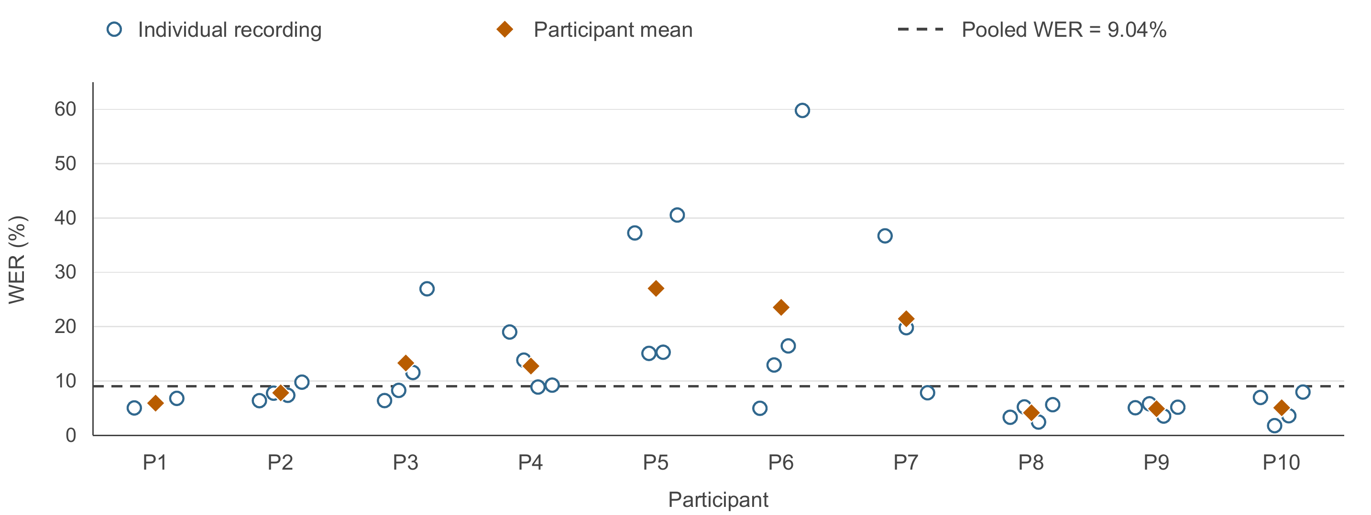
Fig. 2. Word Error Rate Across Participants and Recordings. Open circles show individual recording WER values, orange diamonds show each participant’s mean recording WER, and the dashed line shows pooled WER of 9.04%. Median participant WER is 10.28% (95% CI: 5.07–21.45%). The 37 recording values are shown individually; horizontal offsets separate overlapping points and have no substantive meaning.

Comparison with Corrected TAALED and CLAN Scores
Under the same automatic boundary rules, median participant errors were 0.96% for MATTR-50 and 2.26% for TTR. Errors for the six vocabulary counts ranged from 2.39% to 3.71% (Fig. 3 and Table I). Median errors were 3.38% for eligible utterance count, 3.77% for MLU-W, and 4.73% for length SD. The 95% error intervals were 1.80–7.99% for MLU-W and 3.92–5.52% for SD. Median participant MLU-W was 7.88 words in the reference and 8.19 in our pipeline. These results compare the pipeline with corrected TAALED/CLAN scores. Because both versions use the same automatic boundary rules, the results do not establish boundary accuracy.
- Pipeline comparison with corrected software scores in 37 recordings
Language measure | Pipeline median | Reference median | Median error
All words | 570.4 | 563.0 | 3.71%
Different words | 181.9 | 182.1 | 2.39%
Content words | 207.5 | 214.2 | 2.56%
Different content words | 109.2 | 110.4 | 2.99%
Function words | 362.9 | 348.8 | 3.18%
Different function words | 72.6 | 71.8 | 2.57%
TTR | 0.337 | 0.337 | 2.26%
MATTR-50 | 0.706 | 0.711 | 0.96%
Eligible utterance count | 69.7 | 72.9 | 3.38%
MLU-W | 8.19 | 7.88 | 3.77%
Utterance length SD | 6.68 | 6.73 | 4.73%
Recording scores and APEs are averaged separately within each participant; the columns show medians across 10 participants. Median error is calculated from paired APEs, not from the displayed score medians. CLAN counts MLU-eligible utterances. Both transcript versions use the same automatic boundary rules.
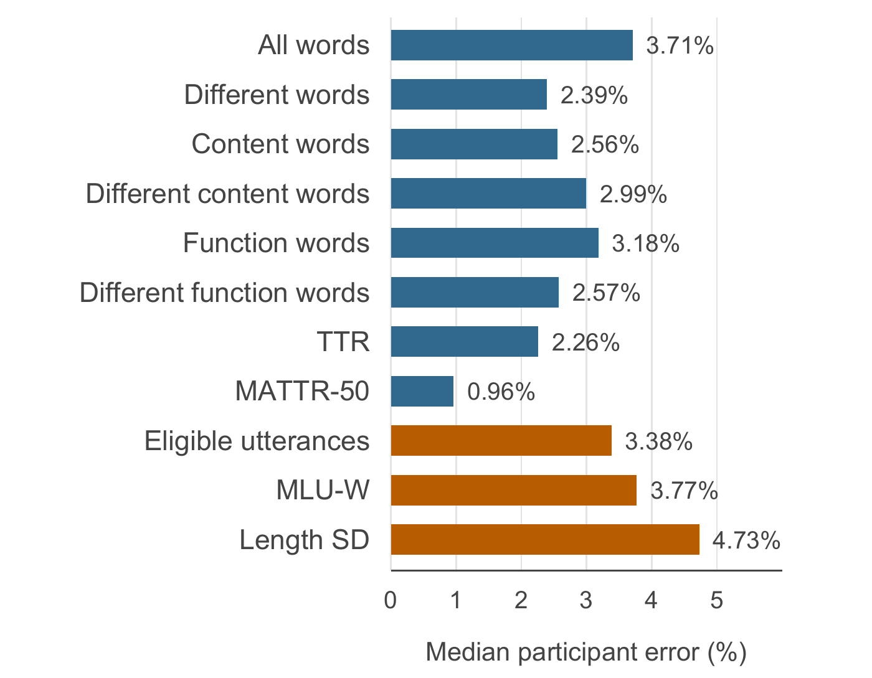
Fig. 3. Pipeline comparison with corrected TAALED and CLAN scores across 37 recordings. Recording APEs are averaged within participant, then the median is taken across participants. Blue bars show lexical errors and orange bars show utterance errors. Both transcript versions use the same automatic boundary rules.

Comparison with Manually Labeled Samples
We compared all 10 complete participant samples with Rater 1’s human labels (Fig. 4 and Table II). Vocabulary MdAPE ranged from 0.00% to 0.53%, with 0.08% for MATTR-50 and 0.30% for TTR. MdAPE was 6.31% for utterance count, 6.40% for MLU-W, and 16.76% for length SD. Both pipeline and human count medians were 112.5 utterances. Median MLU-W was 7.30 pipeline versus 6.77 human words; median SD was 6.09 versus 5.19 words. When recording portions were scored separately and errors averaged within participant, median errors were 6.28%, 6.40%, and 16.76%. These summaries use the same labels but combine the recordings differently.
- Pipeline comparison with Rater 1 labels in complete participant samples
Language measure | Pipeline median | Rater 1 median | Median error
All words (fixed text) | 811.0 | 811.0 | 0.00%
Different words | 275.5 | 275.5 | 0.30%
Content words | 327.0 | 326.0 | 0.37%
Different content words | 177.5 | 178.5 | 0.53%
Function words | 484.0 | 485.0 | 0.26%
Different function words | 96.0 | 95.0 | 0.41%
TTR | 0.307 | 0.307 | 0.30%
MATTR-50 | 0.711 | 0.708 | 0.08%
Total utterance count | 112.5 | 112.5 | 6.31%
MLU-W | 7.30 | 6.77 | 6.40%
Utterance length SD | 6.09 | 5.19 | 16.76%
Columns show medians across 10 complete participant samples, covering 14 recordings and 1,147 human utterances. We combine each participant’s sampled speech before scoring and calculate MdAPE from paired errors. Total utterance count includes filler-only responses; MLU-W and SD use eligible units. Lengths are in words; diversity values are proportions.
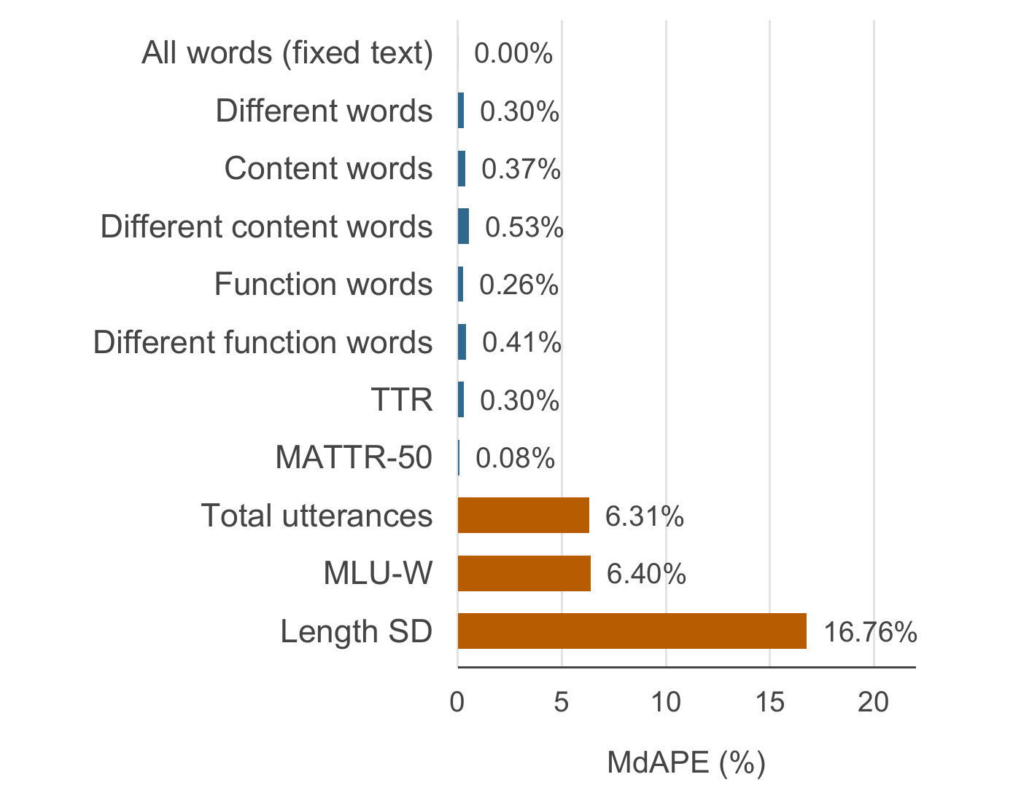
Fig. 4. Pipeline comparison with Rater 1 labels across 10 complete participant samples from 14 recordings. Bars show MdAPE after combining each participant’s sampled speech. Blue shows lexical errors and orange shows utterance errors. Matching words give zero total-count error, while content/function assignments can differ.
Total-word error was exactly zero for every participant because the normalized word sequences matched. Content and function words add up to that total, so changes in category assignment can be canceled. For P1, both samples contained 1,325 words. The pipeline counted 472 content and 853 function words; the human sample counted 468 and 857. The differences between +4 and −4 cancel in total but produce positive category errors. These zero total-count errors therefore do not establish transcription accuracy. Equal score medians can also occur when individual paired errors are nonzero. We did not test whether these samples represented the whole conversation.

Pairwise Human Interrater Reliability
Human interrater comparison covered 2,840 evaluated word gaps across four recordings (Fig. 5). Pooled agreement was 96.34%, Cohen’s κ was 0.834, and boundary F1 was 85.47%. Recording κ ranged from 0.749 to 0.889. Only aligned text was scored: coverage in Rater 1’s word stream ranged from 65.40% to 98.89%. Fig. 5 also reports each recording’s F1 and coverage. Percentage agreement includes gaps where both raters place no boundary, which are common. F1 focuses on agreement about boundary placement.
Rater 1 and Rater 2 were compared across 2,336 eligible gaps in P2 and P9. Pooled agreement was 96.70%, κ was 0.797, and F1 was 81.53%. Rater 1 and Rater 3 were compared across 504 gaps in P4 and P7, with agreement of 94.64%, κ of 0.872, and F1 of 90.97%. Because the subsets contain different participants, these scores cannot rank the raters. The individual gap counts were 1,163, 1,173, 281, and 223 for P2, P9, P4, and P7. Unaligned words and gaps beside unintelligibility markers were excluded.
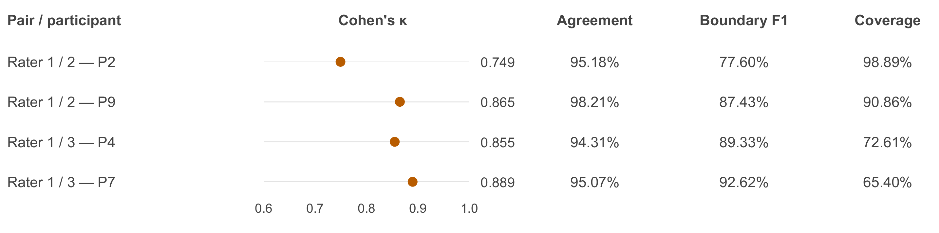
Fig. 5. Pairwise human boundary agreement for four recordings. Each row compares Rater 1 with Rater 2 (P2 and P9) or Rater 3 (P4 and P7). Dots show Cohen’s κ. Agreement and boundary F1 are calculated on aligned gaps; coverage is the proportion of possible gaps evaluated in Rater 1’s word stream. Fillers are excluded from both streams. Pooled agreement is 96.34% (κ = 0.834; F1 = 85.47%) across 2,840 gaps. These are pairwise results, not three-way reliability.

Pipeline Agreement with Additional Human Raters
Pipeline comparisons with Raters 2 and 3 covered 2,777 evaluated word gaps. Pooled agreement was 98.70%, Cohen’s κ was 0.935, and boundary F1 was 94.23%. Recording κ ranged from 0.850 to 0.981. The comparisons covered 62.89–89.71% of possible gaps in the pipeline word streams. These scores apply only to the aligned portions of the samples. The rules were revised while inspecting the available recordings, so this comparison does not test performance on new data.

Sentence Baseline and Participant Variation
The current method had lower median count, MLU-W, and length-SD errors than the sentence baseline against Rater 1’s complete samples (Table III). Across all 14 recordings, the current boundary agreement was 96.99%, κ was 0.869, and pooled F1 was 88.64%, compared with baseline F1 of 85.30%. Precision was 89.85% and recall was 87.47%. Both methods had zero word edits and covered all 8,446 eligible gaps. Missed boundaries decreased from 216 to 142, while extra boundaries increased from 100 to 112. This comparison covers the full eligible text, unlike the partially aligned comparisons with Raters 2 and 3.
- Sentence baseline and current method compared with Rater 1 labels
Measure | Sentence  baseline | Current  method | Current  95% CI
Utterance count | 10.77 | 6.31 | 3.54–10.45
MLU-W | 13.73 | 6.40 | 3.82–10.64
Length SD | 32.22 | 16.76 | 1.26–32.40
Boundary F1 | 85.30 | 88.64 | 82.35–93.96
The first three rows show MdAPE (%) across 10 complete participant samples; lower values indicate less error. Boundary F1 (%) pools eligible gaps across 14 recordings. Higher values indicate closer boundary agreement. CIs resample participants. Both methods use the same sampled words and Rater 1 labels.
Complete-sample SD MdAPE was 15.46 percentage points below baseline. The paired 95% CI for this reduction was −5.19–23.24, which includes zero. The count and MLU-W reduction intervals also included zero (−2.18–9.56 and −1.55–12.77 percentage points). Thus, the lower medians do not establish improvement beyond sampling uncertainty. Current SD MdAPE had a 95% CI of 1.26–32.40%, and participant errors ranged from 0.20% to 106.96%. Scoring recordings separately gave the same rounded median SD error of 16.76%, but a different CI of 6.76–30.74%. Identical medians do not make the two calculations equivalent.

Complete Samples by Participant
Table IV compares each participant’s complete sampled speech with Rater 1’s labels using the same procedure. Rater 1 labeled 1,147 utterances, compared with 1,117 identified by the pipeline. P1 had 111 human-marked and 96 pipeline utterances. Its MLU-W was 11.27 human versus 13.03 pipeline words, and its SD was 6.63 versus 13.72 words, giving the largest SD error (106.96%). P6 and P10 had SD errors below 1%.
- Complete participant samples compared with Rater 1 annotations
ID | Utterance  count | MLU-W  (words) | SD  (words) | SD APE  (%)
P1 | 96 / 111 | 13.03 / 11.27 | 13.72 / 6.63 | 106.96
P2 | 119 / 136 | 9.89 / 8.72 | 6.32 / 5.72 | 10.44
P3 | 116 / 107 | 9.23 / 10.01 | 6.40 / 8.05 | 20.47
P4 | 109 / 113 | 4.46 / 4.26 | 4.37 / 3.87 | 13.06
P5 | 109 / 119 | 6.11 / 5.60 | 5.85 / 4.65 | 25.78
P6 | 121 / 122 | 5.27 / 5.23 | 3.75 / 3.79 | 0.93
P7 | 123 / 121 | 2.92 / 2.97 | 2.20 / 2.17 | 1.26
P8 | 105 / 112 | 8.49 / 7.95 | 8.42 / 6.06 | 39.03
P9 | 101 / 95 | 12.92 / 13.74 | 7.14 / 9.62 | 25.81
P10 | 118 / 111 | 4.86 / 5.17 | 4.52 / 4.53 | 0.20
Paired cells list the pipeline value first and Rater 1’s value second. Each participant’s sampled speech is combined; P1, P5, P6, and P10 each have two recording portions. SD uses a population denominator over MLU-eligible utterances. APE is calculated separately for each participant's sample.

Discussion
The comparisons answer different questions. WER measures changes in words between uncorrected and corrected transcripts. Corrected software scores show how these changes affect language measures under the same automatic rules, including approximate turn mapping. Human labels provide a separate check of utterance boundaries and the measures derived from them. Identical-input CLAN checks examine calculation alone. Keeping these tests separate explains why their errors differ and avoids treating agreement with software as independent boundary validation.
Vocabulary scores were closer to the reference than WER alone would suggest. A substitution can leave the word count unchanged, and insertions can offset deletions. MATTR-50 averages vocabulary diversity within local windows, so two transcripts can have similar scores despite differing words or meanings. Researchers should still inspect the transcript when interpretation depends on the wording. Prior studies [7], [11] also show why derived language measures need direct evaluation.
Length SD was more sensitive to boundaries than lexical measures. Fig. 6 uses a 20-word example with utterance lengths of 4, 6, 4, and 6 words. MLU-W is 5.00 and population SD is 1.00. Merging the last two utterances gives lengths of 4, 6, and 10 words: the total remains unchanged, but MLU-W rises to 6.67 and SD to 2.49. A missed boundary therefore changes both the number of eligible units and the distribution of their lengths. Correct calculations alone cannot establish that boundaries are appropriate.
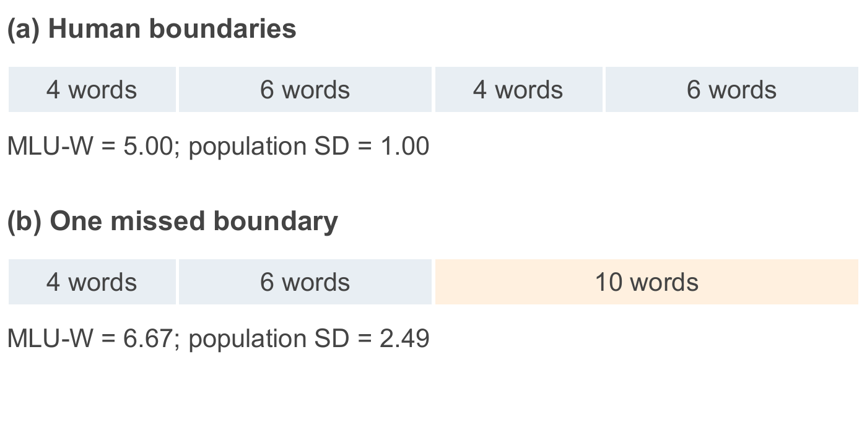
Fig. 6. Calculated illustration of a missed utterance boundary. Merging the last two units keeps the total at 20 words but changes MLU-W from 5.00 to 6.67 words and population SD from 1.00 to 2.49 words. This is an illustration, not a participant result.
P1 shows why participant results need to be examined alongside the median. With the same paired text, the pipeline identified fewer utterances and produced larger MLU-W and SD values than the human labels. The large SD difference is consistent with an altered distribution of utterance lengths, including longer units, but this comparison does not identify the cause of each boundary error. It should not be interpreted as a clinical difference between participants. Even after custom segmentation, length-SD errors varied widely, so summaries of variability require careful review.
Our main technical contribution is custom post-processing of spaCy output within a conversation-to-measurements pipeline. Ordinary sentence splitting does not always match conversational utterance boundaries, especially around independent coordinated clauses, fillers, repetitions, and incomplete speech. The added rules use these features while keeping dependent clauses and phrases together. Boundary F1 rose from 85.30% with sentence splitting to 88.64% with custom segmentation. Missed boundaries fell from 216 to 142, while extra boundaries rose from 100 to 112. Median count, MLU-W, and length-SD errors were lower, although their paired confidence intervals included zero. Saved boundary reasons make these choices inspectable. These results describe the evaluated recordings rather than performance on new participants.
The study included 10 participants, despite having 37 recordings. Repeated recordings do not provide 37 independent participants. Median summaries describe a typical participant but can hide large errors, as Table IV shows. The rules were refined on recordings used in evaluation, and no independent participant test set was available. The baseline comparison therefore does not establish generalization or isolate the contribution of each rule. Participant bootstrap intervals preserve repeated-recording structure but cannot remove this development overlap.
We did not test whether the focused samples represented whole conversations, establish clinical error thresholds, assess diagnostic outcomes, or measure workflow time savings. Human reliability was evaluated pairwise, and raters could see automatic segments; it does not establish three-way or blinded reliability. The pipeline uses transcript grammar, while human labels can use video and conversation context. Further work should test independent participants, document annotation procedures and visibility, and measure transcription and review time. Consistent speaking tasks across sessions are also important [4]. Clinical deployment and diagnostic validity have not been established.

Conclusion
The pipeline combines automatic transcription, human participant-speaker identification, and custom spaCy post-processing to identify utterances and calculate 11 language measures. It was evaluated on 37 recordings from 10 autistic youth. Corrected TAALED/CLAN scores, Rater 1’s manual labels, pairwise human reliability, and identical-input CLAN checks each address a different source of error. Against Rater 1, median errors were 6.31% for utterance count, 6.40% for MLU-W, and 16.76% for length SD. The custom rules had lower median errors than ordinary sentence splitting, with uncertainty that included no improvement. The results support further evaluation of reviewable automated LSA methods; independent-participant and workflow studies are needed before drawing conclusions about clinical use or workload reduction.

References
- American Speech-Language-Hearing Association, “Autism and autism spectrum disorder,” Practice Portal. Accessed: Oct. 7, 2026. [Online]. Available: https://www.asha.org/Practice-Portal/Clinical-Topics/Autism/
- M. J. Pezold, C. M. Imgrund, and H. L. Storkel, “Using computer programs for language sample analysis,” Lang. Speech Hear. Serv. Schools, vol. 51, no. 1, pp. 103–114, Jan. 2020, doi: 10.1044/2019_LSHSS-18-0148.
- N. Bernstein Ratner and B. MacWhinney, “Assessment and therapy goal planning using free computerized language analysis software,” Perspect. ASHA Spec. Interest Groups, vol. 8, no. 1, pp. 19–31, Feb. 2023, doi: 10.1044/2022_PERSP-22-00156.
- H. MacFarlane et al., “Consistency and reliability of automated language measures across expressive language samples in autism,” Autism Res., vol. 16, no. 4, pp. 802–816, Apr. 2023, doi: 10.1002/aur.2897.
- M. D. Barokova, S. Hassan, C. Lee, M. Xu, and H. Tager-Flusberg, “A comparison of natural language samples collected from minimally and low-verbal children and adolescents with autism by parents and examiners,” J. Speech Lang. Hear. Res., vol. 63, no. 12, pp. 4018–4028, Dec. 2020, doi: 10.1044/2020_JSLHR-20-00343.
- A. Wilder and S. M. Redmond, “Updates on clinical language sampling practices: A survey of speech-language pathologists practicing in the United States,” Lang. Speech Hear. Serv. Schools, vol. 55, no. 4, pp. 1151–1166, Oct. 2024, doi: 10.1044/2024_LSHSS-24-00035.
- C. B. Fox, M. Israelsen-Augenstein, S. Jones, and S. L. Gillam, “An evaluation of expedited transcription methods for school-age children’s narrative language: Automatic speech recognition and real-time transcription,” J. Speech Lang. Hear. Res., vol. 64, no. 9, pp. 3533–3548, Sep. 2021, doi: 10.1044/2021_JSLHR-21-00096.
- MOSI.AI, “MOSS Transcribe Diarize Technical Report,” arXiv:2601.01554, 2026, doi: 10.48550/arXiv.2601.01554. [Online]. Available: https://arxiv.org/abs/2601.01554
- M. Honnibal, I. Montani, S. Van Landeghem, and A. Boyd, “spaCy: Industrial-strength Natural Language Processing in Python,” Zenodo, 2020, doi: 10.5281/zenodo.1212303.
- M. D. Barokova et al., “Eliciting Language Samples for Analysis (ELSA): A new protocol for assessing expressive language and communication in autism,” Autism Res., vol. 14, no. 1, pp. 112–126, Jan. 2021, doi: 10.1002/aur.2380.
- G. L. Pelfrey, L. M. Justice, H. Gonzalez Villasanti, and T. J. Foster, “Evaluating the accuracy of automated processing of child and adult language production in preschool classrooms,” Front. Psychol., vol. 15, Jun. 2024, Art. no. 1322665, doi: 10.3389/fpsyg.2024.1322665.
- K. Kyle, S. A. Crossley, and S. Jarvis, “Assessing the validity of lexical diversity indices using direct judgements,” Lang. Assess. Quart., vol. 18, no. 2, pp. 154–170, 2021, doi: 10.1080/15434303.2020.1844205.
- M. M. Baese-Berk, S. Drake, K. Foster, D.-Y. Lee, C. Staggs, and J. M. Wright, “Lexical diversity, lexical sophistication, and predictability for speech in multiple listening conditions,” Front. Psychol., vol. 12, Jun. 2021, Art. no. 661415, doi: 10.3389/fpsyg.2021.661415.
- M. A. Covington and J. D. McFall, “Cutting the Gordian knot: The moving-average type–token ratio (MATTR),” J. Quant. Linguistics, vol. 17, no. 2, pp. 94–100, May 2010, doi: 10.1080/09296171003643098.
- B. MacWhinney, The CHILDES Project: Tools for Analyzing Talk, 3rd ed. Mahwah, NJ, USA: Lawrence Erlbaum Associates, 2000.
- L.-Y. Guo and S. Eisenberg, “Sample length affects the reliability of language sample measures in 3-year-olds: Evidence from parent-elicited conversational samples,” Lang. Speech Hear. Serv. Schools, vol. 46, no. 2, pp. 141–153, Apr. 2015, doi: 10.1044/2015_LSHSS-14-0052.
- J. Cohen, “A coefficient of agreement for nominal scales,” Educ. Psychol. Meas., vol. 20, no. 1, pp. 37–46, Apr. 1960, doi: 10.1177/001316446002000104.

