1. LED ON Using Arduino UNO in Proteus 8

void setup()
{
pinMode(13, OUTPUT); // Set digital pin 13 as output
}

void loop()
{
digitalWrite(13, HIGH); // Turn ON LED
}

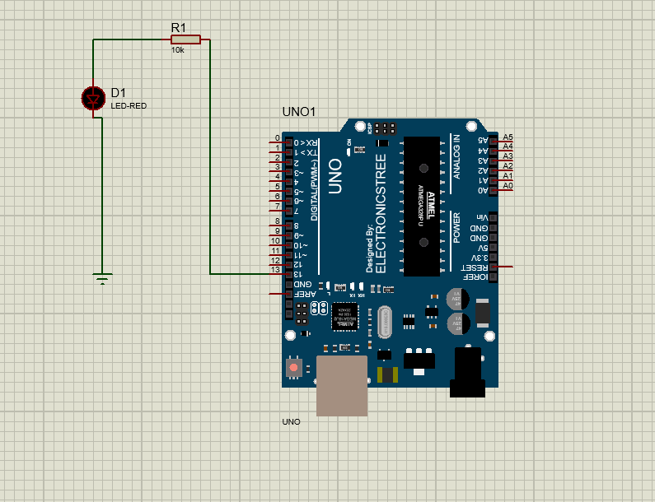

2. Blinking both internal and external Light Emitting Diode
(LED) using Arduino UNO and Interfacing switches with Arduino
UNO

Component Name (Proteus) | Quantity
Arduino UNO R3 | 1
LED-RED | 1
Resistor 220Ω | 1
Push Button | 1
Resistor 10kΩ | 1
Ground (GND) | 1

int extLED = 12; // External LED pin
int button = 2; // Switch pin

void setup()
{
pinMode(13, OUTPUT); // Internal LED
pinMode(extLED, OUTPUT); // External LED
pinMode(button, INPUT); // Switch input
}

void loop()
{
if (digitalRead(button) == HIGH)
{
digitalWrite(13, HIGH);
digitalWrite(extLED, HIGH);
delay(500);

digitalWrite(13, LOW);
digitalWrite(extLED, LOW);
delay(500);
}
else
{
digitalWrite(13, LOW);
digitalWrite(extLED, LOW);
}
}
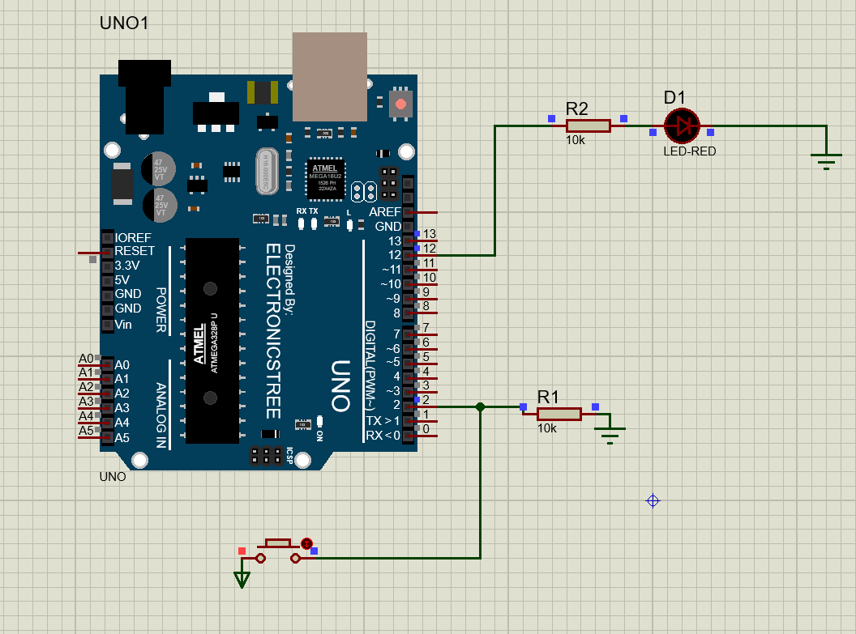

3. Design and implement Interfacing switches with Arduino
UNO

Component Name | Quantity
Arduino UNO R3 | 1
Push Button Switch | 1
LED-RED | 1
Resistor 220Ω | 1
Resistor 10kΩ | 1
Ground (GND) | 1

int led = 13; // Internal LED
int button = 2; // Switch pin

void setup()
{
pinMode(led, OUTPUT);
pinMode(button, INPUT);
}

void loop()
{
if (digitalRead(button) == HIGH)
{
digitalWrite(led, HIGH); // LED ON
}
else
{
digitalWrite(led, LOW); // LED OFF
}
}
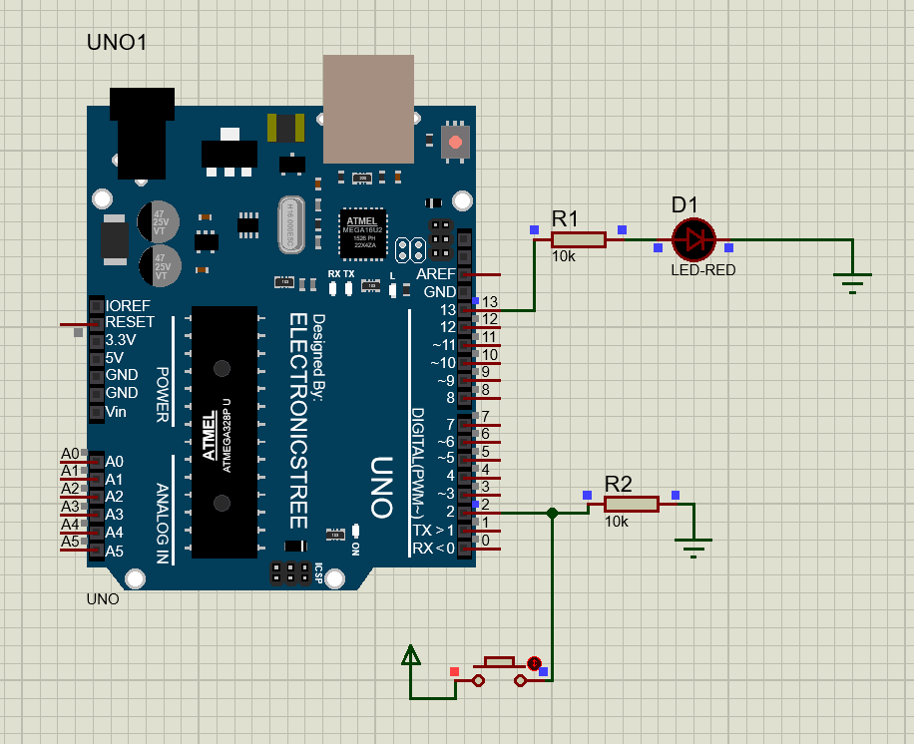

4. Design and implement interfacing a 7-segment display with Arduino UNO

Component Name (Proteus) | Quantity
Arduino UNO R3 | 1
7-Segment Display (Common Cathode) | 1
Resistor 220Ω | 7
Ground (GND) | 1

// Common Cathode 7-Segment Display

int segPins[7] = {2, 3, 4, 5, 6, 7, 8};

// Segment patterns for 0–9 (a b c d e f g)
int numbers[10][7] = {
{1,1,1,1,1,1,0}, // 0
{0,1,1,0,0,0,0}, // 1
{1,1,0,1,1,0,1}, // 2
{1,1,1,1,0,0,1}, // 3
{0,1,1,0,0,1,1}, // 4
{1,0,1,1,0,1,1}, // 5
{1,0,1,1,1,1,1}, // 6
{1,1,1,0,0,0,0}, // 7
{1,1,1,1,1,1,1}, // 8
{1,1,1,1,0,1,1} // 9
};

void setup()
{
for (int i = 0; i < 7; i++)
{
pinMode(segPins[i], OUTPUT);
}
}

void loop()
{
for (int num = 0; num <= 9; num++)
{
for (int seg = 0; seg < 7; seg++)
{
digitalWrite(segPins[seg], numbers[num][seg]);
}
delay(1000); // 1 second delay
}
}
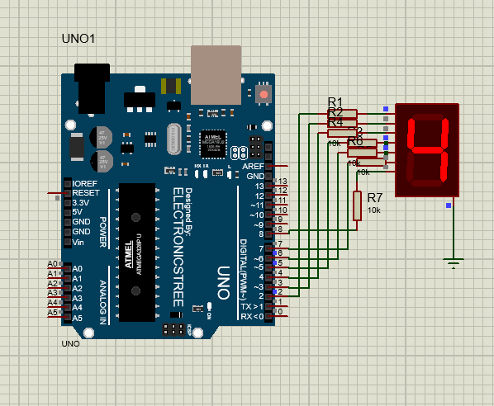
5. Design and Implementation of Interfacing Multiple 7-Segment Displays with Arduino UNO (Proteus 8)

Component | Quantity
Arduino UNO R3 | 1
7-Segment Display (Common Cathode) | 2
Resistor 220Ω | 7
Resistor 1kΩ | 2
Ground (GND) | 1

// 1st Display (Pins 13 to 7)
int disp1[7] = {13,12,11,10,9,8,7};

// 2nd Display (Pins 6 to 0)
int disp2[7] = {6,5,4,3,2,1,0};

// Segment pattern for Common Cathode (a b c d e f g)
int numbers[10][7] = {
{1,1,1,1,1,1,0}, // 0
{0,1,1,0,0,0,0}, // 1
{1,1,0,1,1,0,1}, // 2
{1,1,1,1,0,0,1}, // 3
{0,1,1,0,0,1,1}, // 4
{1,0,1,1,0,1,1}, // 5
{1,0,1,1,1,1,1}, // 6
{1,1,1,0,0,0,0}, // 7
{1,1,1,1,1,1,1}, // 8
{1,1,1,1,0,1,1} // 9
};

void setup()
{
for(int i=0;i<7;i++)
{
pinMode(disp1[i], OUTPUT);
pinMode(disp2[i], OUTPUT);
}
}

void loop()
{
for(int num = 0; num < 100; num++)
{
int tens = num / 10;
int ones = num % 10;

for(int i=0;i<7;i++)
{
digitalWrite(disp1[i], numbers[tens][i]);
digitalWrite(disp2[i], numbers[ones][i]);
}

delay(1000); // 1 second delay
}
}
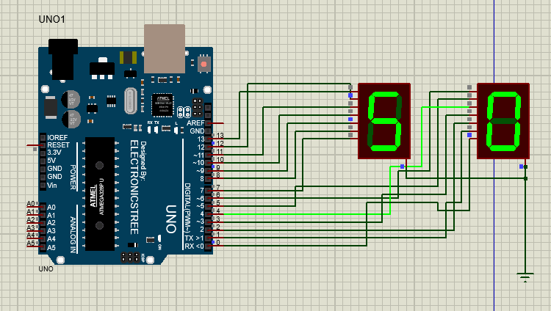

6.Implementation and Design of ADC and Analog Temperature Sensor
Using Arduino.

#include<LiquidCrystal.h>

LiquidCrystal lcd(12,11,5,4,3,2);
void setup() {
// put your setup code here, to run once:
lcd.begin(16,2);

}

void loop() {
// put your main code here, to run repeatedly:
int reading = analogRead(A0);
float voltage = reading*(5.0/1023.0);
float tempC = voltage * 100;
lcd.clear();
lcd.setCursor(0, 0);
lcd.print("TEMP: ");
lcd.setCursor(0, 1);
lcd.print(String(tempC));
delay(1000);
}

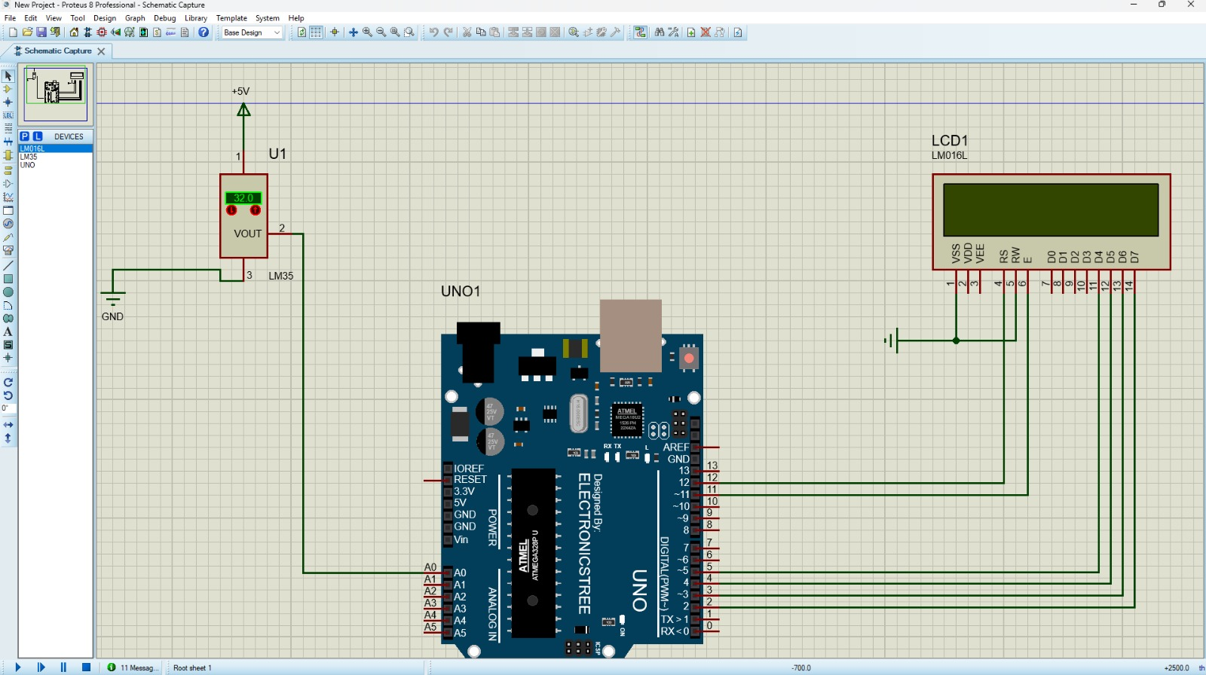

7. Design and implement a system to detect darkness/light using LDR using Arduino

#include<LiquidCrystal.h>
LiquidCrystal lcd(12,11,5,4,3,2);
int ldr_port = A0;
void setup() {
// put your setup code here, to run once:
lcd.begin(16,2);
pinMode(7, OUTPUT);

}
void loop() {
// put your main code here, to run repeatedly:
int reading = analogRead(ldr_port);
lcd.clear();
lcd.setCursor(0, 0);
lcd.print("LDR: ");
lcd.setCursor(0, 1);
lcd.print(String(reading));
delay(1000);

}
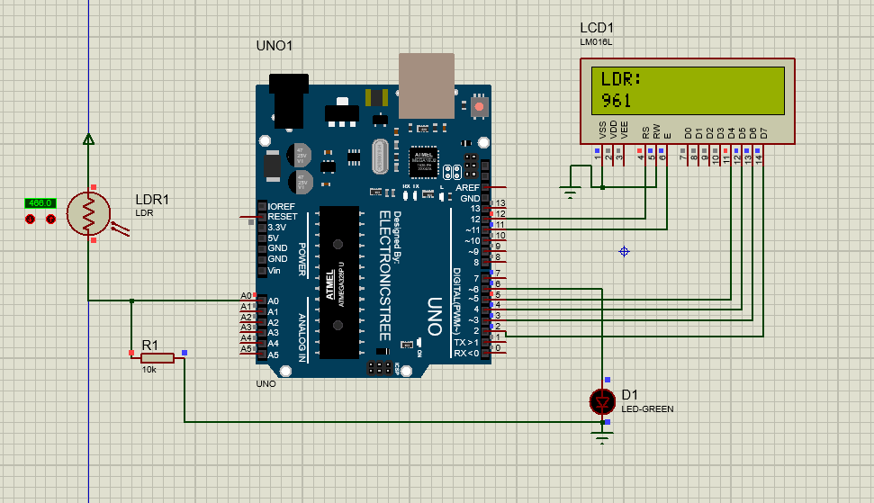

8. Design and Implement 16*2 LCD Display to print “Welcome To CSE, FEC” using Arduino give me step by step procedure for lab using proteus 8
#include<LiquidCrystal.h>
LiquidCrystal lcd(12,11,5,4,3,2);
void setup(){
lcd.begin(16,2);
}
void loop(){
lcd.clear();
lcd.setCursor(0,0);
lcd.print("Welcome to CSE");
lcd.setCursor(6, 1);
lcd.print("FEC");
delay(1000);
}

