## Covid 19 Pakistan Situation:

                                  Covid 19 is disease caused by novel corona virus. This serious pandemic is affecting every country but it does not mean that it has effected everyone in same way. This disease caused many deaths around the world. Analysis is done in order to know how it has affected Pakistan and its Regions. Facilities provided to regions, News, Calls and others are also visualized in order to get detailed information.

### Total Deaths and Recovered by province:

[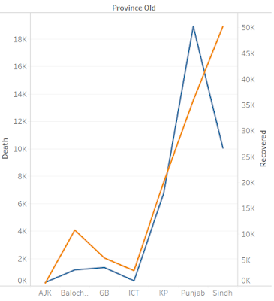](https://1.bp.blogspot.com/-FUqHkCCMenI/Xs3_jzrS8gI/AAAAAAAAAWc/BJpyctHcpZgeVvspdwxds-tKW3nNdRQdwCLcBGAsYHQ/s1600/tb2.PNG)

The graph shows the trends of death and recovered by province old and colors shows details of recovered and deaths.The highest deaths occurred in Punjab and highest recovery rate is in sindh.

### Sum of quarantine facilities by province:

[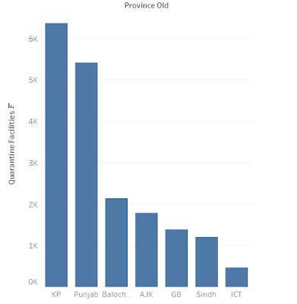](https://2.bp.blogspot.com/-QW0q-vvDS0M/Xs32WELGPQI/AAAAAAAAAVs/r5oPIYUL9_AX4haq0rOo4tNFywi8k2UHwCLcBGAsYHQ/s1600/tb3.PNG)

sum of quarantine facilities for each province, filter by date which applies 34 by 34 members. More facilities were provided to KP, Punjab and Baluchistan than the other provinces.

### Sum of transmission by foreign and others :

[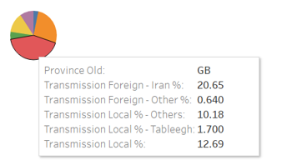](https://1.bp.blogspot.com/-guNWb0s6y4I/Xs34zzYl2RI/AAAAAAAAAWA/hzcO4bxXgi8F-_30mDLFTTTsTAw8A_aOwCLcBGAsYHQ/s1600/tb4.PNG)

Sum of foreign and others who transfer to Pakistan During Covid by percentage.Province old is shown by color. There was less transmission in AJK as compared to Gilgit Baltistan.

### Trends of Admitted Critical,Admitted stable,Admitted ventilator:

[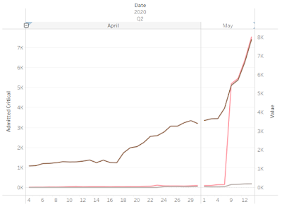](https://4.bp.blogspot.com/-J_LLSAPsihs/Xs36kz_Sd9I/AAAAAAAAAWQ/3iPJzRC78Z8cd11ABm1ImYevTOJhhmCMQCLcBGAsYHQ/s1600/tb5.PNG)

The trends of Admitted Critical, Admitted Critical, Admitted Stable and Admitted Venilator for Date Day broken down by Date Year, Date Quarter and Date Month. Color shows details about Admitted Critical, Admitted Stable and Admitted Venilator. The data is filtered on Province Old, which keeps 7 of 7 members.

### Covid Beds available by Month/Date:

[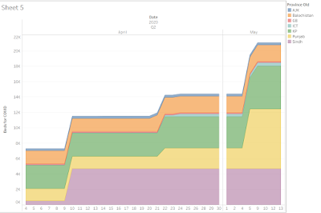](https://2.bp.blogspot.com/-ys1fuVjqpKs/Xs4AZFbAQhI/AAAAAAAAAWk/fDkgIEgczk4rKq06hBCMy4FUFePYfsBNgCLcBGAsYHQ/s1600/tb6.PNG)

Sum of Beds for COVID for each Date Day broken down by Date Year, Date Quarter and Date Month. Color shows details about Province Old. Sindh has highest number of Beds provided on 29 of  April. Punjab has highest number of beds on 13 of May.

### New arrivals in last 24 hours by Quarantine Facilities Available by Region:

#### (Quarantine detail)

[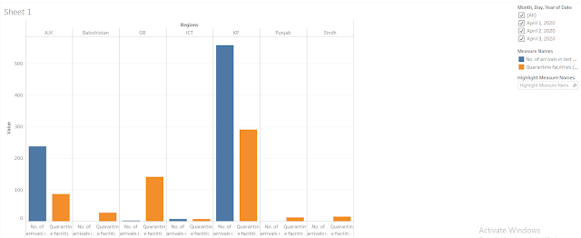](https://public.tableau.com/profile/nafesa#!/)

Facilities available 558 were newly arrived and 291 Facilities were available.In last 24 hours in Gil-git Baltistan  3 were new arrivals and facilities available were 141.In Azad Kashmir and GB the facilities were less than the people arrived in Last 24 hours according to data.

### Helpline Calls by Month:

[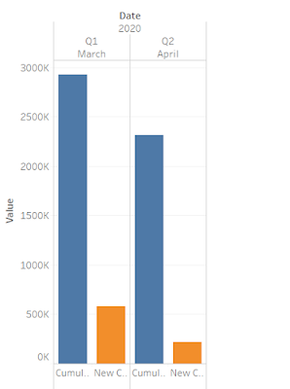](https://4.bp.blogspot.com/-3PLfgucV3L0/Xs4Gw8DSTlI/AAAAAAAAAWw/ygFX5Weh7ZUCmiIErNDtMQdtk-5DpTxpQCLcBGAsYHQ/s1600/tb7.PNG)

Cumulative Calls and New Calls for each Date Month broken down by Date Year and Date Quarter. Color shows details about Cumulative Calls and New Calls. There were more calls in Month of April as compared to May.

### Returnees that are Advised self-Quarantine:

[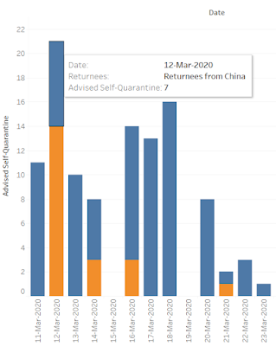](https://1.bp.blogspot.com/-fBOpgarv4M4/Xs4HqtwcBSI/AAAAAAAAAW4/dcDBWTJV9jUHJ1tBoxc7xmbL2JtSzZ75QCLcBGAsYHQ/s1600/tb8.PNG)

Sum of Advised Self-Quarantine for each Date. Color shows details about Returnees.Blue color shows returnees and orange color shows returnees from Iran.

### Travelers suspected and screened at point of entry:

[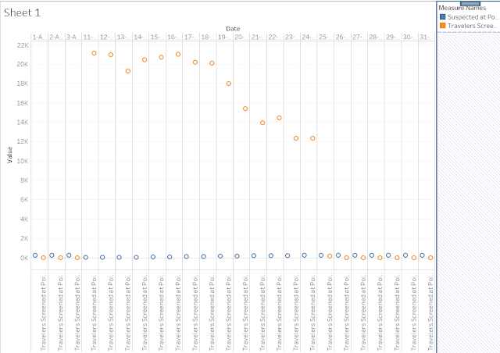](https://1.bp.blogspot.com/-xhkg23HuEp4/Xs4KKBdmg-I/AAAAAAAAAXE/b5V4tzlwFt4oqAP6jbur8N8H9nWqtPwcACLcBGAsYHQ/s1600/tb9.PNG)

Suspected at Points of Entry and Travelers Screened at Points of Entry in last 24 hours for each Date. Color shows details about Suspected at Points of Entry and Travelers Screened at Points of Entry in last 24 hours.

### Total Number of Test and Test positive by province:

[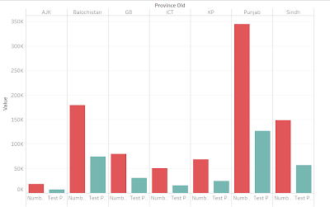](https://1.bp.blogspot.com/-r3qHkgik-xk/XtCqJ1W2dzI/AAAAAAAAAXQ/VV8Yyc2HnK8ScRFSWecFZ-Ncz9dtoZHJQCLcBGAsYHQ/s1600/tb10.PNG)

### Number of Tests and Test Positive Cases for each Province Old. Color shows details about Number of Tests and Test Positive Cases. The data is filtered on Date Month, which keeps April and May.Punjab has the highest positive test cases and AJK has lowest Test cases.

### Cumulative Test performed and cumulative Test positive:

[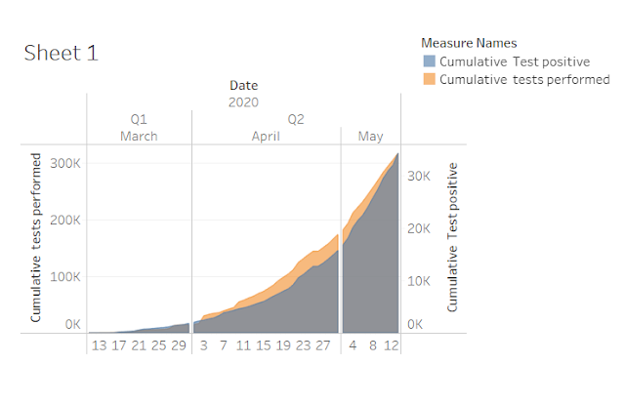](https://1.bp.blogspot.com/-REUyAwshRmY/XtCx_D4Ql0I/AAAAAAAAAX8/kGzVoS7lzis0CcegP45s1HpnQ6VZfWsMACLcBGAsYHQ/s1600/tb14.PNG)

Cumulative tests performed and Cumulative Test positive for each Date Day broken down by Date Year, Date Quarter and Date Month. Color shows details about Cumulative tests performed and Cumulative Test positive.

### Sum of expired in each region by date:

[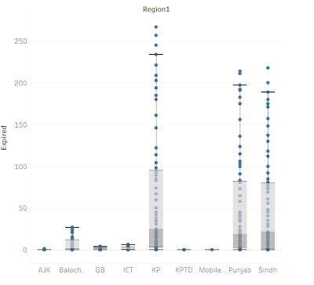](https://2.bp.blogspot.com/-lHy3I4io-Mk/XtCvHGyvM2I/AAAAAAAAAXk/9QEto0bL-o4pvP6RdyVJOD1wNYW3dixIQCLcBGAsYHQ/s1600/tb12.PNG)

Sum of Expired for each Region. Details are shown for Date.

### Sum of discharged by date:

[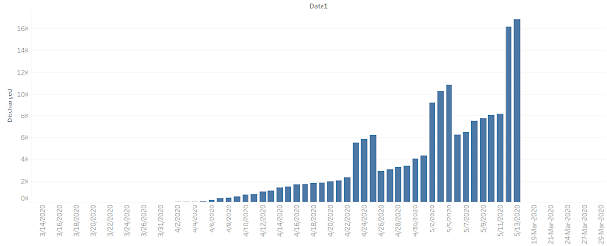](https://3.bp.blogspot.com/-VZFGOOV79gs/XtCwBUwbXzI/AAAAAAAAAXw/w8BNjPrDTS0B7npd0br5gNVQ22-k8LL2gCLcBGAsYHQ/s1600/tb13.PNG)

Sum of Discharged for each Date 1. The view is filtered on Date 1, which keeps 70 of 70 members.

### Aggregated province preparedness by date:

[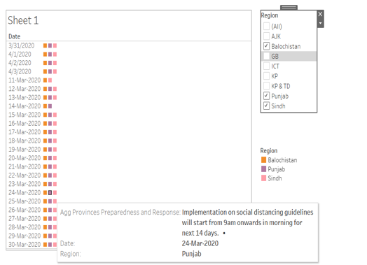](https://3.bp.blogspot.com/-pDj1JGe4NHs/XtC1_Awy4AI/AAAAAAAAAYQ/Ep0-0uLUBd847bslaXewjlJYEfQZa-asgCLcBGAsYHQ/s1600/tb16.PNG)

Region (color) broken down by Date. Details are shown for Aggregated Provinces Preparedness and Response. The view is filtered on Region, which keeps Baluchistan, Punjab and Sindh.

### Aggregated NIH preparedness by date:

[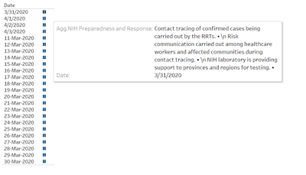](https://1.bp.blogspot.com/-wyx1E2AMIPw/XtC3hTIVVLI/AAAAAAAAAYc/CKVxiGw1Mco-kS1NjXEw5qelaY5idmOmACLcBGAsYHQ/s1600/tb17.PNG)

The view is broken down by Date. Details are shown for Aggregated NIH Preparedness and Response.

### Aggregated News by date:

[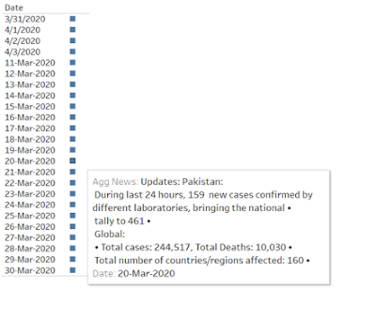](https://1.bp.blogspot.com/-iM3HxVhVLEo/XtC47cvK-sI/AAAAAAAAAYo/1e4bkTRjcok08ou71RD7lQcKVgzdhIfRACLcBGAsYHQ/s1600/tb18.png)

The view is broken down by Date. Details are shown for Aggregated News.

### NIH Risk Assessment by date:

[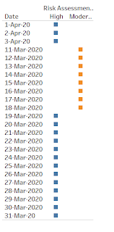](https://1.bp.blogspot.com/-ZwaH5wm71p0/XtDAFYOiaSI/AAAAAAAAAY0/0oPwdB5oEX01maWjRtlvBmzrRv1xHA4QACLcBGAsYHQ/s1600/tb19.PNG)

Risk High and Moderate is shown by date

### About Data:

[Go to Dataset](https://www.kaggle.com/mesumraza/corona-virus-pakistan-dataset-2020)

[Explore Visuals](https://public.tableau.com/profile/nafesa#!/?newProfile=&activeTab=0)