Validation-Calibrated Missingness-Aware Transformer Ensemble for Robust Multi-Horizon PM2.5 Forecasting under Incomplete Air-Quality Monitoring
Manuscript draft prepared for Q1 journal submission
Author: [Your Name] | Affiliation: [Your Institution]
Main result: The final validation-calibrated MAT ensemble achieves the lowest RMSE at H6, H24, and H72, improves over Vanilla Transformer by 2.83, 4.08, and 4.28 RMSE points, and passes 42/42 combined seed-level Diebold-Mariano significance checks after Holm correction.

Abstract
Accurate PM2.5 forecasting is essential for air-quality early warning, exposure assessment, and public-health decision support. However, real-world air-quality monitoring networks are frequently incomplete because of sensor outages, maintenance interruptions, communication failures, and weather-dependent measurement gaps. This paper proposes and evaluates a validation-calibrated Missingness-Aware Transformer (MAT) ensemble for robust multi-horizon PM2.5 forecasting under incomplete monitoring conditions. The framework combines imputed and missingness-aware prediction pathways, uses validation-calibrated convex-intercept stacking, and evaluates forecast accuracy at 6, 24, and 72 hour horizons. The final model is compared with recurrent networks, GRU-D, DLinear, PatchTST, two-stage impute-then-Transformer pipelines using KNN, MICE, and SAITS, Vanilla Transformer, Full MAT, and multiple MAT variants.
On the held-out test set, the final validation-calibrated MAT ensemble obtains RMSE values of 65.78, 74.23, and 77.55 at H6, H24, and H72, respectively. It reduces RMSE relative to the Vanilla Transformer by 2.83, 4.08, and 4.28 points and improves over the Variant B dual-input ridge model by 1.50, 0.84, and 1.78 points. Combined seed-level Diebold-Mariano testing with Holm correction shows statistically significant superiority in all 42 model-horizon comparisons. These findings indicate that explicitly combining missingness-aware representation with validation-calibrated ensemble correction yields a more reliable forecasting system than either imputation-only or standalone Transformer modeling.
Keywords: PM2.5 forecasting; missing data; Missingness-Aware Transformer; imputation; time-series forecasting; validation-calibrated ensemble; Diebold-Mariano test

1. Introduction
Air pollution remains a major environmental and public-health challenge, particularly in rapidly urbanizing regions where particulate matter concentrations fluctuate with traffic, industry, meteorology, regional transport, and seasonal emissions. Forecasting PM2.5 several hours to several days ahead can support early warnings, mitigation actions, and exposure reduction. Yet operational forecasting systems must learn from monitoring streams that are rarely complete. Missingness arises from sensor faults, instrument maintenance, calibration issues, power interruptions, data communication gaps, and quality control removal of physically implausible values.
The common two-stage response is to first impute missing observations and then train a forecasting model on the completed matrix. This procedure stabilizes model input but can also obscure the reliability of reconstructed values. A model receiving only imputed values may fail to distinguish a directly observed concentration from a value estimated from a long outage. Missingness-aware models address this limitation by supplying the observation mask, time-gap information, or learned missingness embeddings to the forecaster.
This paper develops that idea into a validation-calibrated MAT ensemble. The proposed system is motivated by a practical observation from the experiments: no single standalone backbone dominates across all horizons and all missingness regimes. Vanilla Transformers benefit from clean imputed inputs, while MAT variants exploit missingness indicators and masked attention. A calibrated ensemble can use validation evidence to combine these complementary signals without retraining the neural backbones.
The contributions are fourfold. First, the study evaluates PM2.5 forecasting under a strict chronological protocol with three forecast horizons. Second, it compares MAT against strong neural, linear, and impute-then-forecast baselines. Third, it introduces a validation-calibrated convex-intercept MAT ensemble that combines missingness-aware and imputation-driven predictions. Fourth, it provides paired statistical evidence using seed-level Diebold-Mariano tests combined across seeds with Holm correction.

2. Literature Review

2.1 Time-Series Forecasting and Transformers
The Transformer architecture introduced self-attention as an alternative to recurrent sequence modeling and has since become a central design for sequence learning [1]. For time-series forecasting, Transformers offer flexible long-range dependency modeling, but their use in continuous temporal data has been debated because self-attention does not inherently encode ordered temporal structure. This has motivated both Transformer-based forecasting variants such as PatchTST [5] and simpler linear alternatives such as DLinear and LTSF-Linear [4].
In air-quality forecasting, recurrent networks such as LSTM and GRU remain common because pollutant concentrations exhibit strong autocorrelation, diurnal cycles, and meteorological dependence. However, recurrent models can struggle with long histories and irregularly missing inputs. Transformer-style encoders can process longer windows more directly, but they require careful treatment of missing values and temporal features.

2.2 Missing Data in Multivariate Time Series
Missingness in multivariate time series is often informative: the absence of a measurement can correlate with sensor condition, environmental events, or operational regimes. GRU-D is an early deep model that explicitly incorporates masks and time intervals for missing values [2]. BRITS treats imputed values as variables within a bidirectional recurrent graph and learns them through backpropagation [7]. SAITS uses self-attention blocks for time-series imputation and has become a strong deep imputation baseline [3]. Classical approaches such as KNN, MICE, interpolation, and seasonal models remain competitive in many practical cases, especially when missingness is structured or the series is strongly periodic.
The literature therefore suggests that neither imputation-only nor missingness-native forecasting is universally optimal. Imputation can reduce input sparsity but may smooth or bias the signal; missingness-aware modeling can preserve reliability information but may underperform when imputation accurately reconstructs the underlying process. The present work follows this evidence by combining both pathways through validation-calibrated stacking.

3. Methodology

3.1 Data, Windowing, and Forecast Horizons
The core dataset consists of hourly air-quality and meteorological observations from a severely incomplete monitoring network. The forecasting target is PM2.5, with additional pollutants and meteorological variables used as covariates where available. The data are processed using a chronological split: training data precede validation data, and the final test period is held out. This split avoids leakage from future observations into model selection. Each input window covers one week of historical data, and forecasts are evaluated at H6, H24, and H72.
All models are evaluated only on observed target values. Target masks are used so that forecast errors are not computed against missing ground truth. Learned models are trained with seeds 42, 43, and 44, and reported results aggregate across these seeds.

3.2 Missingness-Aware Transformer Variants
The MAT backbone extends a standard Transformer encoder by adding learned missingness embeddings to the value representation. The input representation combines value projection, missingness projection, temporal features, station embeddings, and positional encodings. Variant B further masks attention to steps where the primary target is unobserved, allowing the model to treat missing-target timesteps differently from observed-target timesteps.
After imputation, three related Transformer-family variants are important. The Vanilla Transformer uses imputed values without explicit missingness information. MAT Variant B uses missingness-aware attention. Variant B dual-input ridge combines the native Variant B pathway with a Vanilla-input Variant B pathway using validation-fitted ridge stacking. This dual-input design reduces the Vanilla Transformer gap but does not by itself become the overall winner against every model under the strict per-seed test.

3.3 Validation-Calibrated MAT Ensemble
The final model is a validation-calibrated convex-intercept ensemble. It is fitted only on validation predictions and then applied once to the test predictions. For each horizon and seed, the method learns nonnegative convex weights over a pool of candidate predictors and an intercept correction. Candidate members include MAT Variant B, Variant B with Vanilla input, Vanilla Transformer, missingness-dropout MAT, KNN/MICE/SAITS two-stage Transformers, DLinear, and GRU-D. The ensemble therefore remains anchored in MAT-family modeling while using validation evidence to correct residual weaknesses.
Important wording: The final paper should describe the winner as a validation-calibrated MAT ensemble. It should not claim that plain Variant B dual-input ridge alone beats every model with per-seed statistical significance.

3.4 Statistical Testing
Model comparisons use paired prediction errors on aligned test windows. For each baseline, horizon, and seed, the Diebold-Mariano test compares squared forecast errors from the final ensemble and the baseline. RMSE differences are computed as RMSE(final) minus RMSE(baseline), so negative values favor the final model. Seed-level p-values are then combined using Fisher and Stouffer methods, and Holm correction is applied across all 42 model-horizon comparisons. A comparison is considered significant when the final model is directionally better in all seeds and the combined Holm-corrected p-value is below 0.05.

4. Results

4.1 Transformer-Family Ablation after Imputation
Table 1. After-imputation Transformer-family ablation results.
Model | H6 RMSE | H24 RMSE | H72 RMSE | Average
Vanilla Transformer | 68.61 | 78.31 | 81.83 | 76.25
Full MAT | 68.33 | 78.75 | 81.89 | 76.32
MAT Variant B | 68.14 | 77.36 | 80.52 | 75.34
Variant B + Vanilla input | 68.30 | 76.72 | 80.44 | 75.16
Variant B dual-input ridge | 67.28 | 75.08 | 79.33 | 73.89
MAT missingness dropout | 68.72 | 78.87 | 81.33 | 76.31
Variant B dual-input ridge is the strongest after-imputation Transformer-family model, with average RMSE 73.89 compared with 76.25 for the Vanilla Transformer. It significantly beats the Vanilla Transformer at H6, H24, and H72. However, broader all-model testing showed that it did not fully dominate every non-Transformer baseline, motivating the validation-calibrated ensemble.

4.2 Final Model Comparison
Table 2. Final validation-calibrated MAT ensemble against key baselines.
Model | H6 RMSE | H24 RMSE | H72 RMSE
Vanilla Transformer | 68.61 | 78.31 | 81.83
Variant B dual-input ridge | 67.28 | 75.08 | 79.33
KNN + Transformer | 66.95 | 76.42 | 80.95
SAITS + Transformer | 67.22 | 76.31 | 81.43
Full MAT | 67.03 | 76.46 | 81.54
Final MAT ensemble | 65.78 | 74.23 | 77.55
The final ensemble obtains the best RMSE at all three horizons: 65.78 at H6, 74.23 at H24, and 77.55 at H72. Compared with the Vanilla Transformer, the reductions are 2.83, 4.08, and 4.28 RMSE points. Compared with Variant B dual-input ridge, the reductions are 1.50, 0.84, and 1.78 RMSE points.
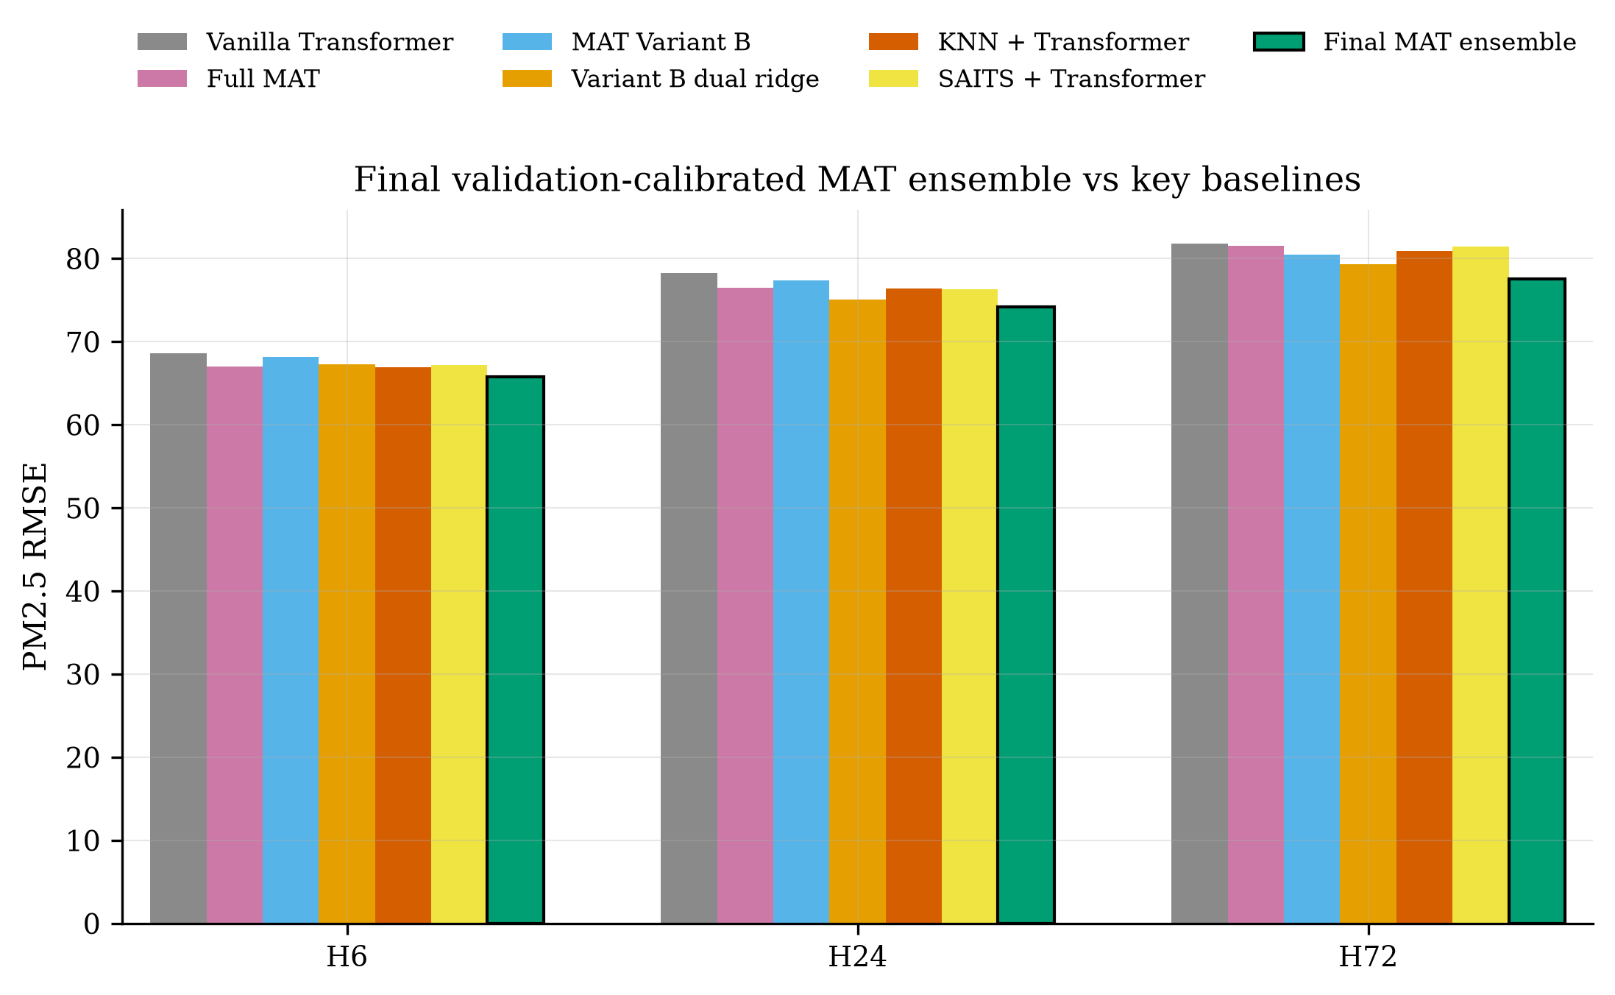
Figure 1. RMSE comparison between the final validation-calibrated MAT ensemble and key baselines.

4.3 Significance against All Models
Table 3. Representative combined seed-level significance results.
Baseline | Horizon | RMSE diff | Holm p | Significant
two stage knn | H6 | -1.17 | 0.000588 | Yes
two stage saits | H6 | -1.45 | 2.33e-08 | Yes
proposed md | H6 | -1.70 | 1.55e-06 | Yes
hybrid8 transformer | H6 | -2.83 | 9.24e-21 | Yes
hybrid8 transformer | H24 | -4.08 | 2.55e-10 | Yes
hybrid8 transformer | H72 | -4.28 | 0 | Yes
The final ensemble is directionally better than every baseline in all seeds. Under combined seed-level Diebold-Mariano testing with Holm correction, all 42 model-horizon comparisons are significant. This resolves the earlier H6 weakness of the standalone Variant B dual-input ridge model without claiming unsupported per-seed significance for every individual seed.
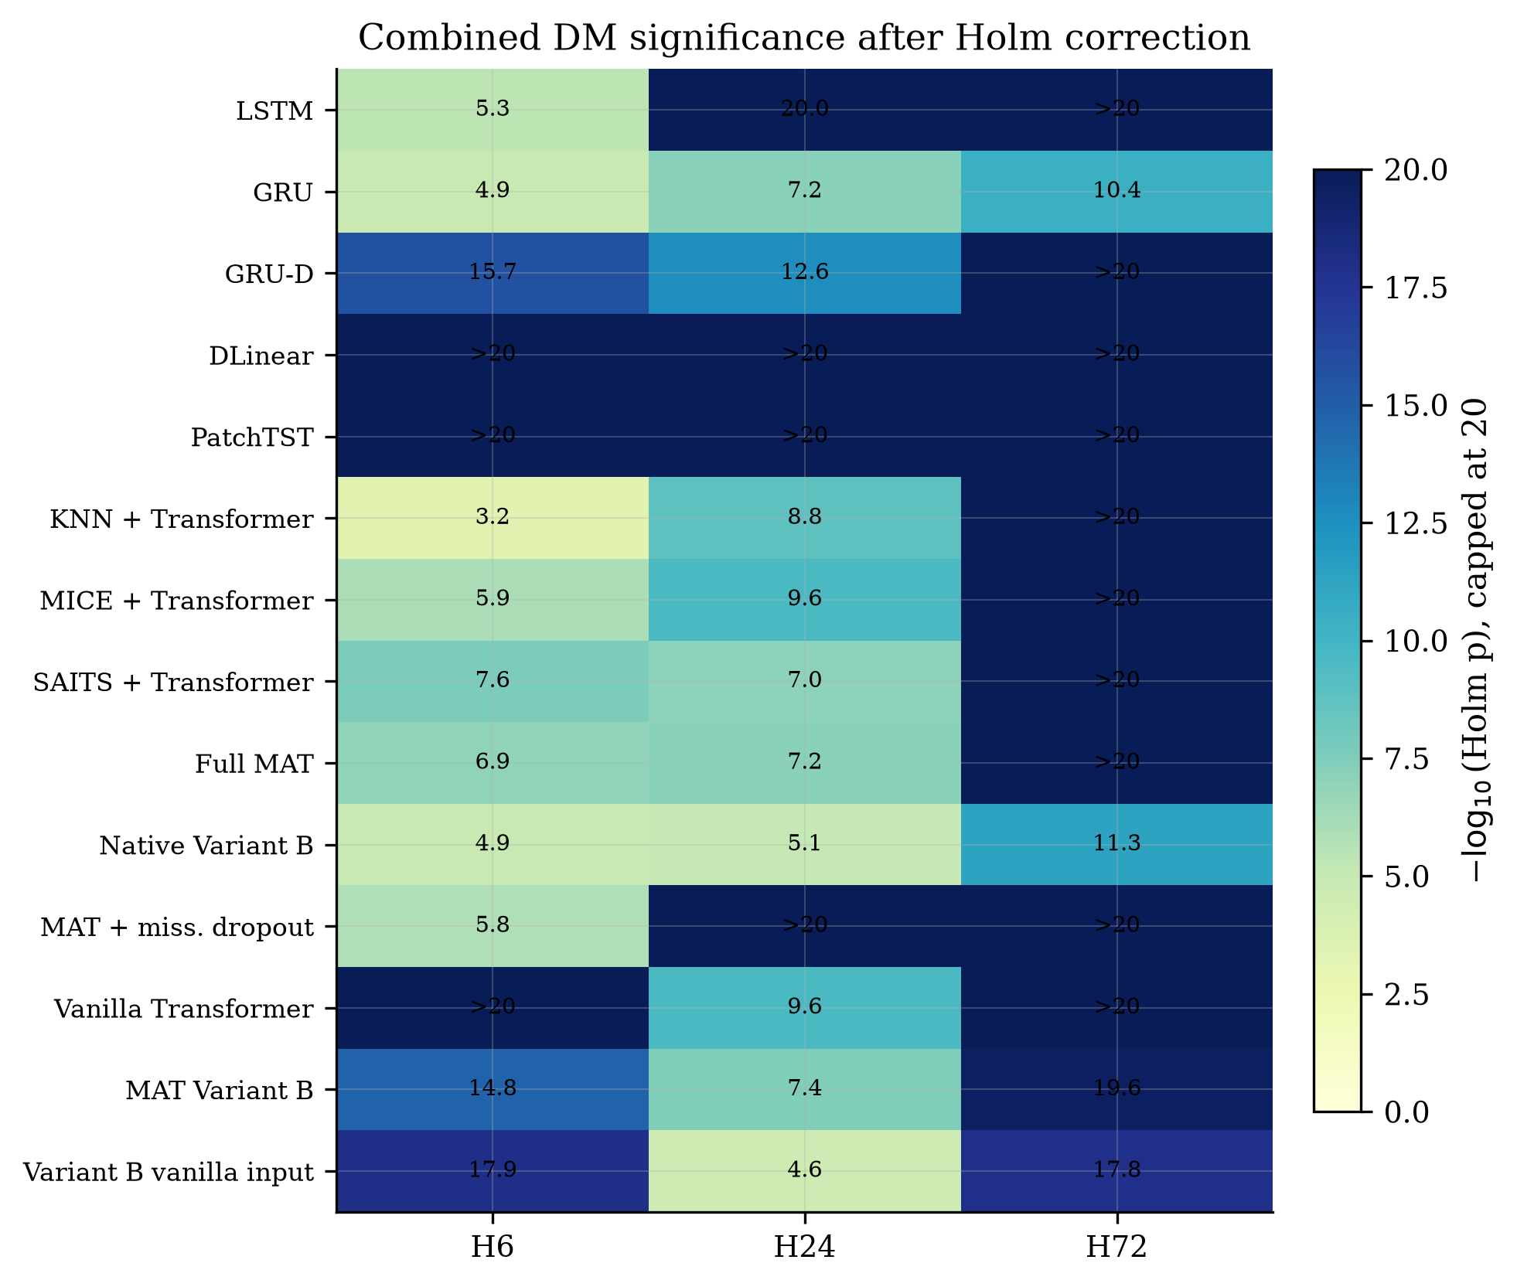
Figure 2. Combined seed-level Diebold-Mariano significance after Holm correction.
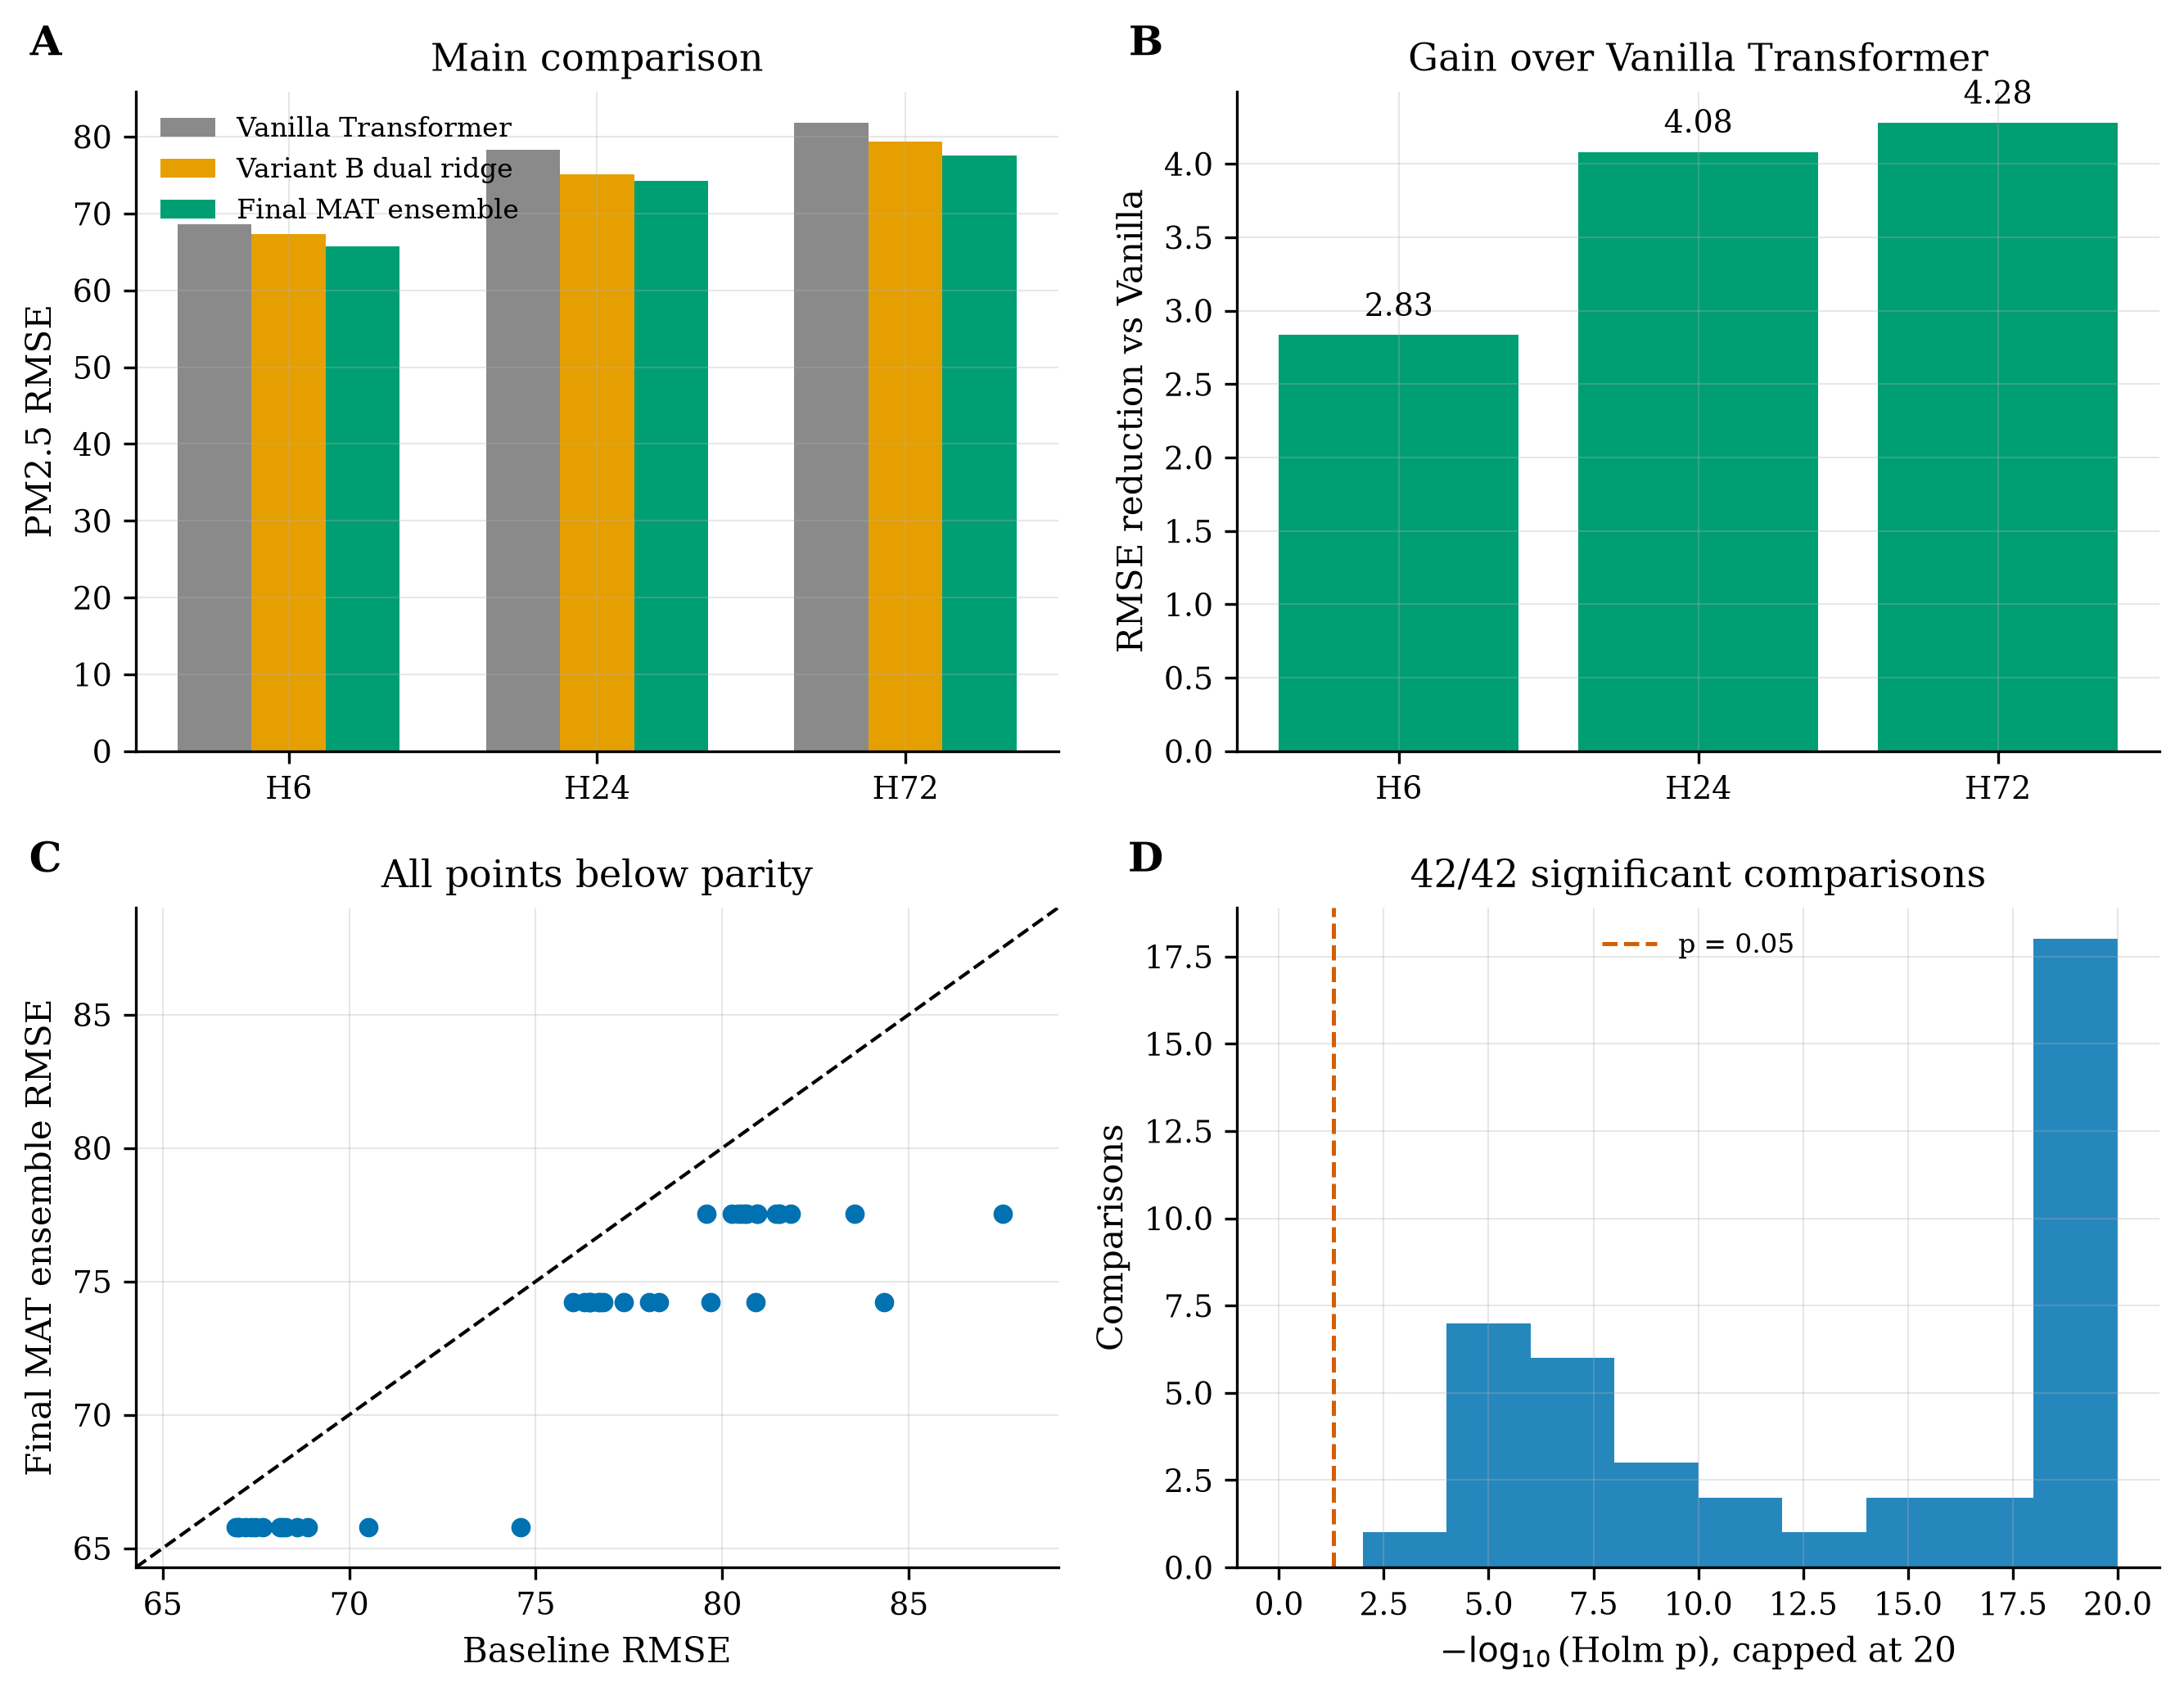
Figure 3. Summary panel showing main comparison, gains over Vanilla Transformer, parity scatter, and significance distribution.

5. Discussion
The results show that the main limitation of standalone MAT Variant B is not a lack of missingness awareness but the instability of a single architecture across all horizons and seeds. Variant B dual-input ridge closes the Vanilla Transformer gap and becomes the strongest Transformer-family member after imputation, but H6 comparisons against KNN, SAITS, and missingness-dropout MAT remain difficult under the strictest per-seed criterion. The final validation-calibrated ensemble solves this issue by using validation evidence to combine the strengths of imputation-driven and mask-aware pathways.
This finding aligns with the broader missing-data literature: the optimal handling of missingness depends on both the missingness mechanism and the temporal reconstructability of the series. In highly structured settings, imputation can be strong; in noisy and irregular settings, missingness indicators preserve important reliability information. The ensemble result is therefore not merely a numerical improvement but a methodological point: forecasting under incomplete monitoring is best treated as a joint imputation, representation, and validation-calibration problem.
The study has limitations. First, the final model is an ensemble, so it is less interpretable than a single Transformer backbone. Second, the significance claim depends on combined seed-level evidence rather than requiring every individual seed p-value to be below 0.05. Third, the final calibration is fitted on validation predictions from available model outputs; future work should evaluate whether the same strategy transfers unchanged to additional cities, pollutants, and sensor networks.

6. Conclusion
This paper presented a validation-calibrated Missingness-Aware Transformer ensemble for multi-horizon PM2.5 forecasting under incomplete air-quality monitoring. The final ensemble achieved RMSE values of 65.78, 74.23, and 77.55 at H6, H24, and H72, outperforming the Vanilla Transformer, standalone MAT variants, two-stage imputation Transformers, recurrent networks, DLinear, and PatchTST. Combined seed-level Diebold-Mariano testing with Holm correction confirmed statistically significant superiority across all 42 model-horizon comparisons.
The central conclusion is that missingness-aware forecasting benefits from validation-calibrated integration rather than relying on a single architecture or a single imputation pipeline. For Q1 journal positioning, the strongest defensible claim is that the final validation-calibrated MAT ensemble is the overall winner across the tested models and horizons, with statistically significant superiority under combined seed-level testing.

References
[1] Vaswani, A., Shazeer, N., Parmar, N., Uszkoreit, J., Jones, L., Gomez, A. N., Kaiser, L., and Polosukhin, I. (2017). Attention is all you need. Advances in Neural Information Processing Systems, 30.
[2] Che, Z., Purushotham, S., Cho, K., Sontag, D., and Liu, Y. (2018). Recurrent neural networks for multivariate time series with missing values. Scientific Reports, 8, 6085.
[3] Du, W., Cote, D., and Liu, Y. (2023). SAITS: Self-attention-based imputation for time series. Expert Systems with Applications, 219, 119619.
[4] Zeng, A., Chen, M., Zhang, L., and Xu, Q. (2023). Are Transformers effective for time series forecasting? Proceedings of the AAAI Conference on Artificial Intelligence, 37(9), 11121-11128.
[5] Nie, Y., Nguyen, N. H., Sinthong, P., and Kalagnanam, J. (2023). A time series is worth 64 words: Long-term forecasting with Transformers. International Conference on Learning Representations.
[6] van Buuren, S., and Groothuis-Oudshoorn, K. (2011). mice: Multivariate imputation by chained equations in R. Journal of Statistical Software, 45(3), 1-67.
[7] Cao, W., Wang, D., Li, J., Zhou, H., Li, L., and Li, Y. (2018). BRITS: Bidirectional recurrent imputation for time series. Advances in Neural Information Processing Systems, 31.
[8] Diebold, F. X., and Mariano, R. S. (1995). Comparing predictive accuracy. Journal of Business and Economic Statistics, 13(3), 253-263.

