
University of Asia Pacific
Department of Computer Science & Engineering

Course Name: Computer Networks Lab
Course Code: CSE 320

Name of Project: Hotel Management System

Date of Submission: 04-05-2025

Submitted by: Submitted To:
Name: Nafis Fuad Barshan Molla Rashied Hussein
Reg. No.:21201166 Assistant Professor
Name: Most. Mahomuda Aktar Department of Computer Science & Engineering
Reg. No.:22101171 University of Asia Pacific
Name: Marwa Jamal
Reg. No.:22101163
Name: Md. Hadi Sarker Pappu
Reg. No.: 22101165
Section: D1

Introduction
The Vic Modern Hotel requires a secure, scalable, and efficient network infrastructure to support its three-floor operations, including departments like Reception, Finance, HR, IT, and Admin. This project designs and simulates the hotel’s network using Cisco Packet Tracer, ensuring:
- Segmented VLANs for departmental isolation.
- OSPF dynamic routing for inter-floor communication.
- Wi-Fi access for guests and staff.
- DHCP & SSH for automated IP assignment and secure remote management.
Objective:
- Build a fault-tolerant network where all devices communicate seamlessly.
- Implement security measures (port security, VLANs, SSH).
Motivation
Modern hotels rely on robust networks for:
- Guest services (Wi-Fi, digital check-in).
- Staff operations (POS, VoIP, surveillance).
- Security (VLAN segregation, port security).
Why Cisco Packet Tracer?
- Simulates enterprise networks without physical hardware.
- Validates configurations (OSPF, DHCP, VLANs) before real-world deployment.
Methodology
Network Topology
- 3 Routers (1 per floor) connected via Serial DCE (10.10.10.0/30 subnets).
- 3 Switches (1 per floor) with VLANs:
  - 1st Floor: Reception (VLAN 80), Store (VLAN 70), Logistics (VLAN 60).
  - 2nd Floor: Finance (VLAN 50), HR (VLAN 40), Sales (VLAN 30).
  - 3rd Floor: IT (VLAN 10), Admin (VLAN 20).
- Wi-Fi: Separate SSIDs for staff/guests.
- Printers: 1 per department.

Configurations
- Turn on Routers:
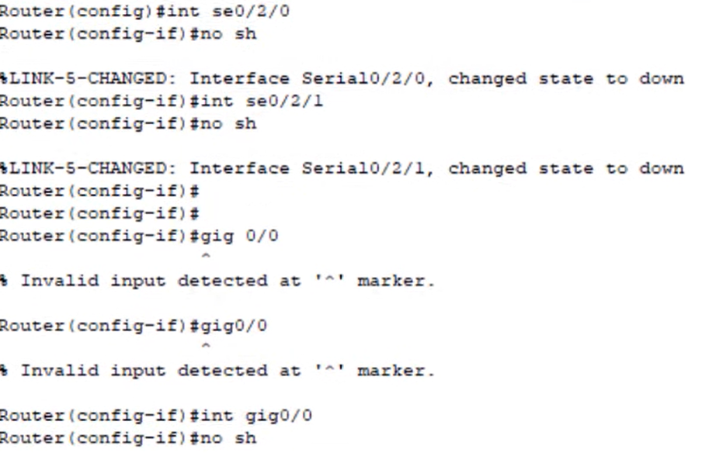

- Enable Clock Rate into Serial DCE Interphases:
Enabling clock rate to some particular (clock signed) interphases is required
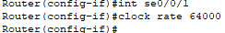
- VLANs:
(1st Floor)
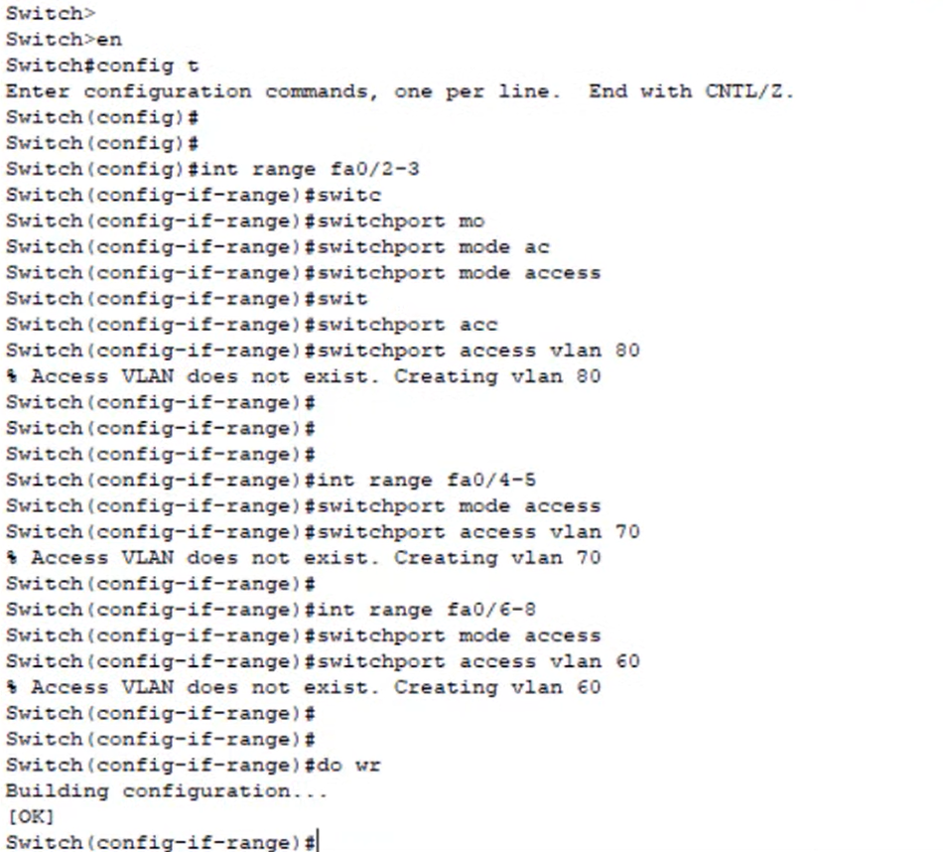

(2nd Floor)
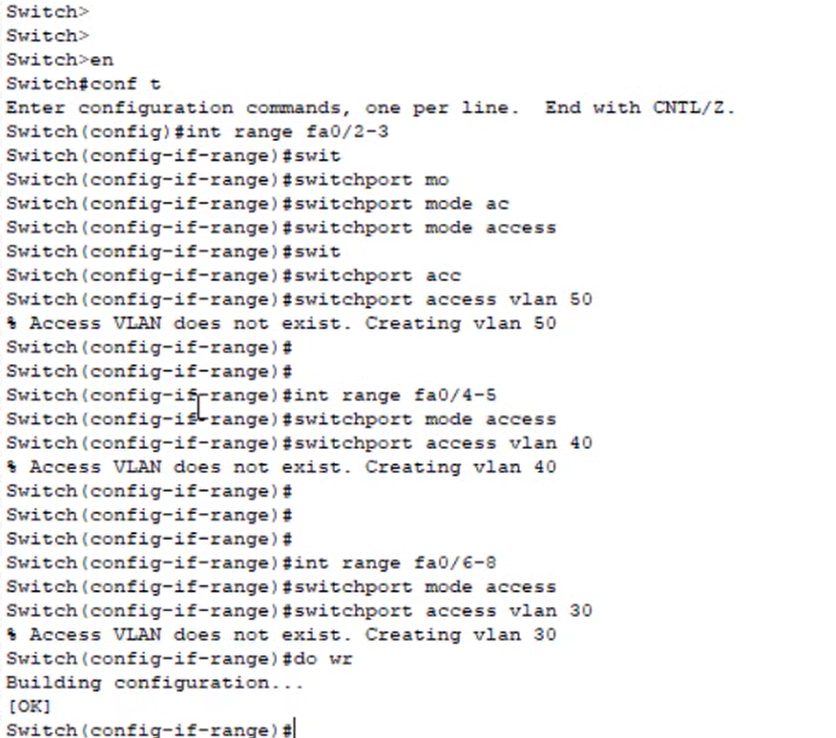
(3rd Floor)
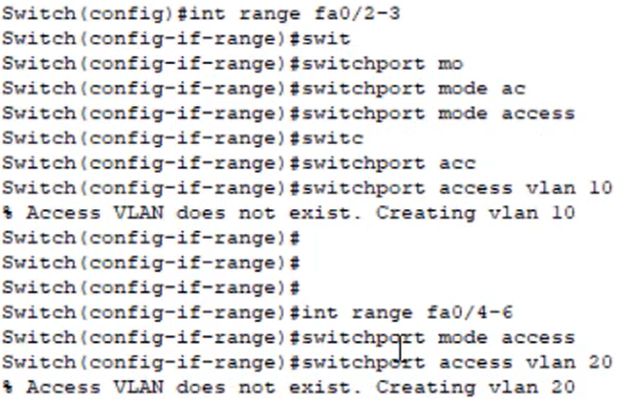
Trunking:
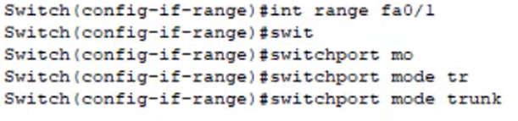
- Inter-Router IP Configuration:
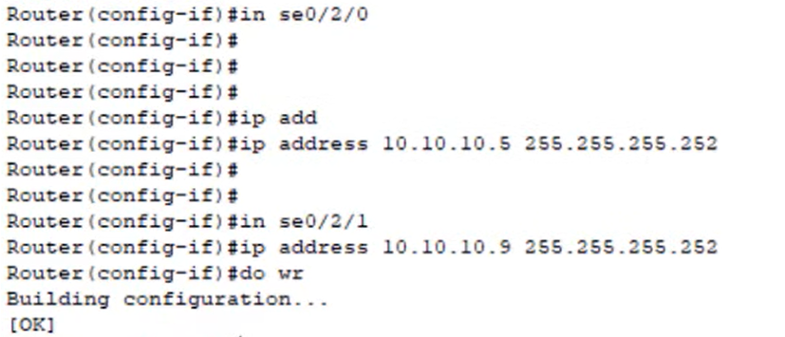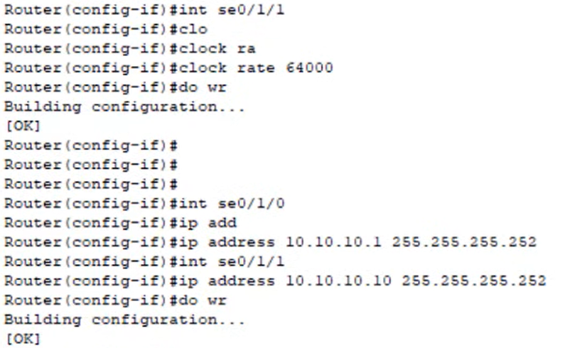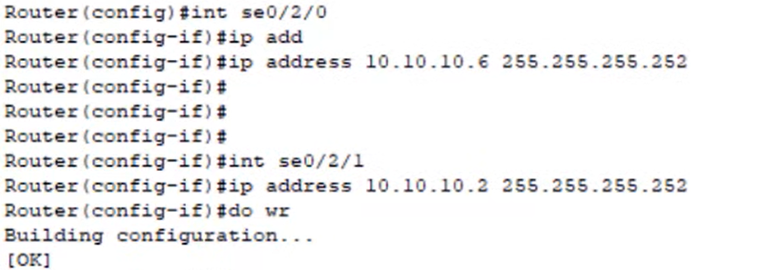

- Inter-VLAN Configuration:
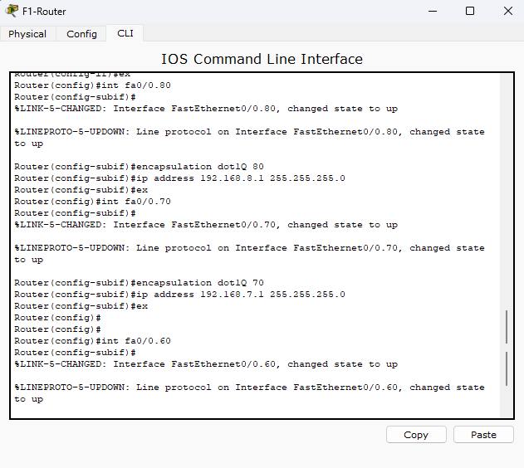
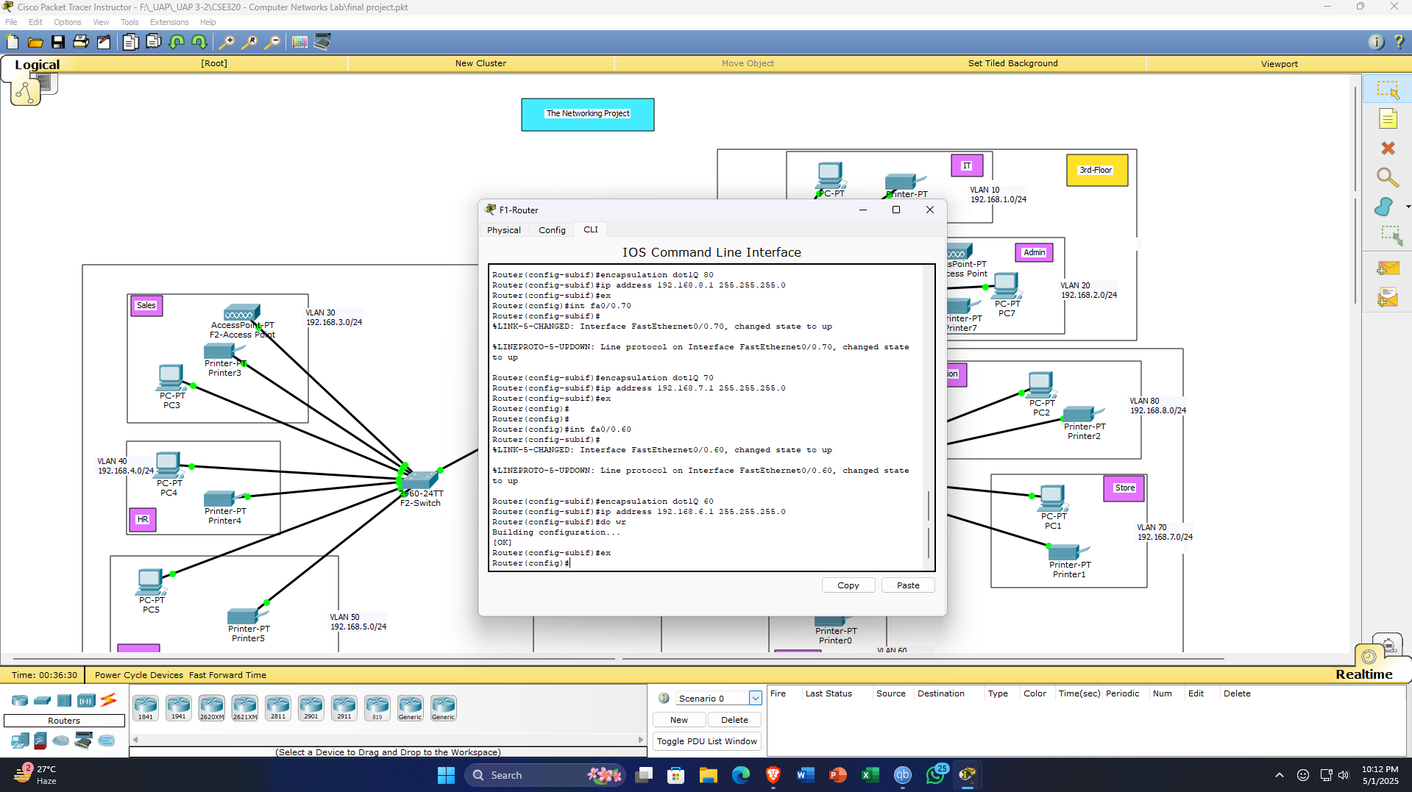
(Only for the router of the 1st floor are being shown here)
- DHCP:
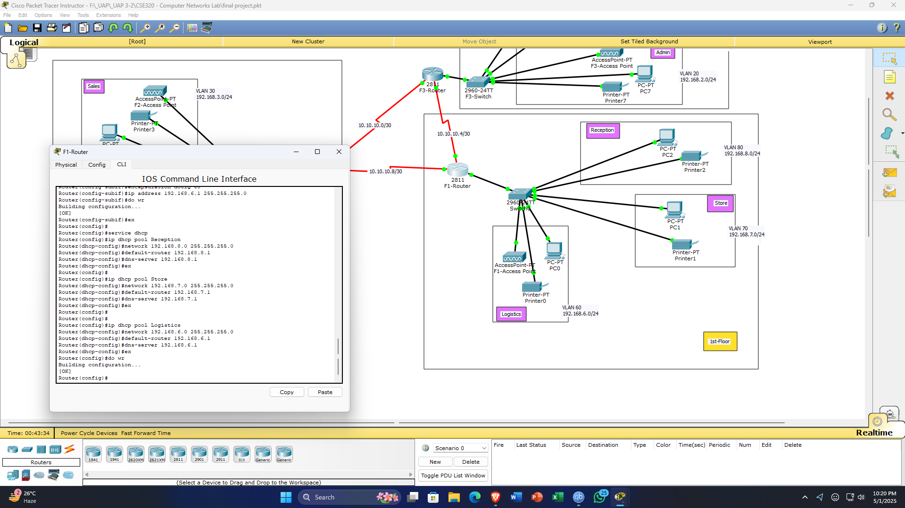
(Only for the router of the 1st floor are being shown here)
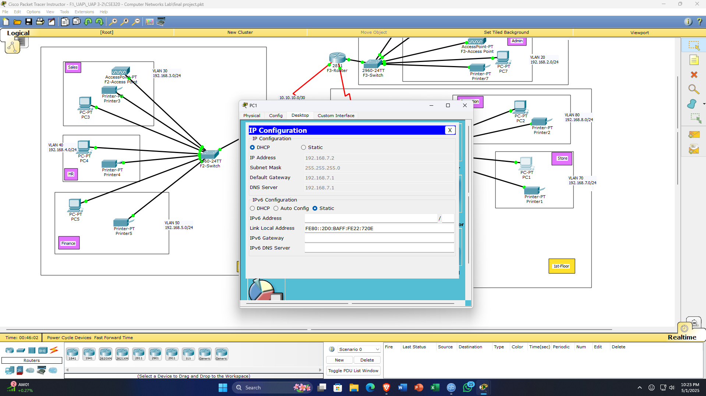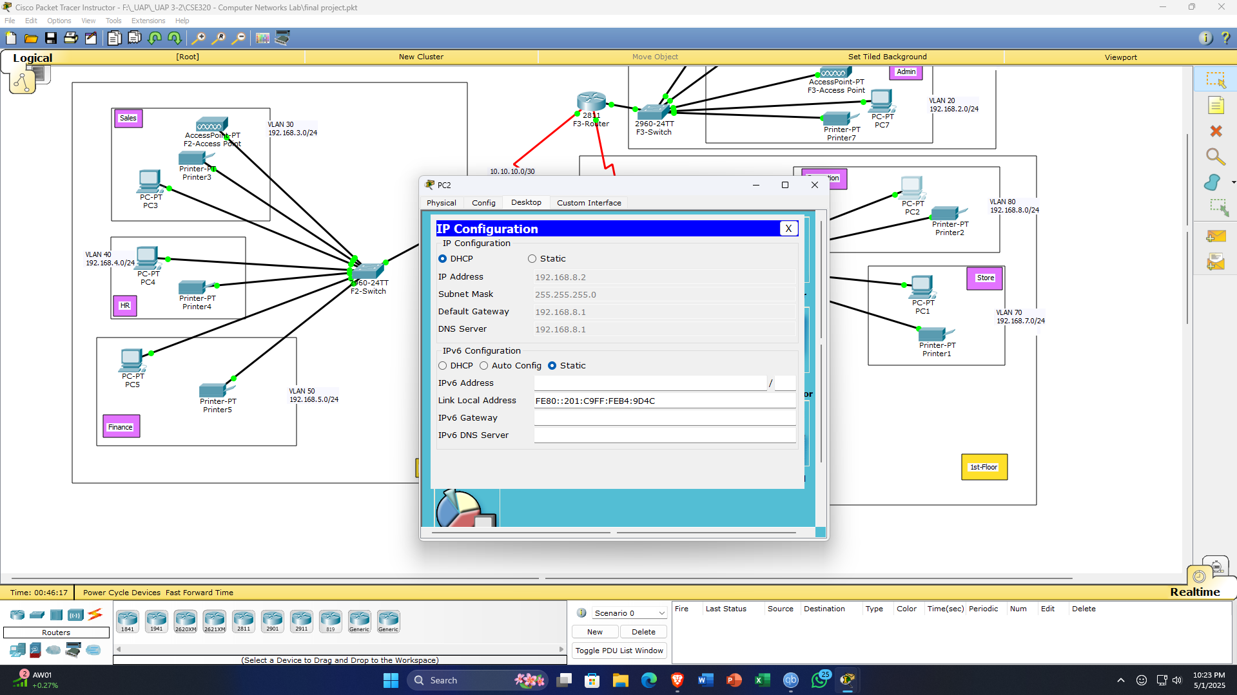
As a result, after enabling DHCP, the ip address for PCs and Printers will being automatically generated via the system.
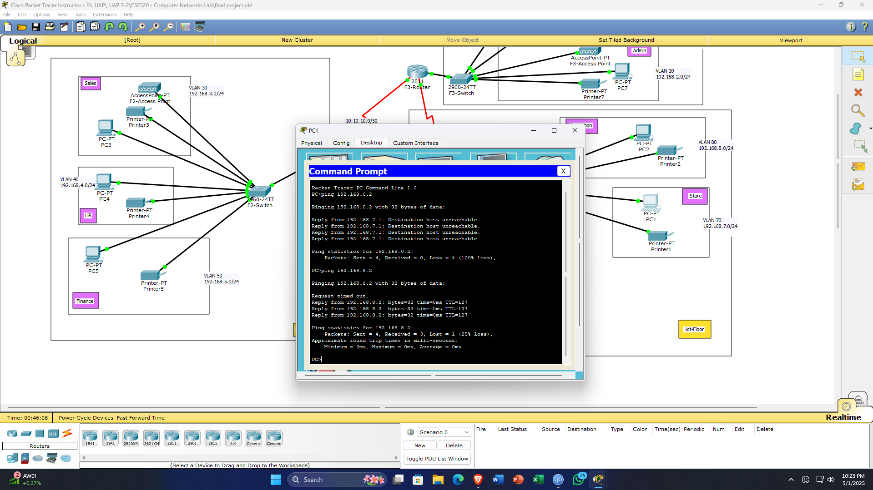
Transaction between intra-floor VLANs PCs were connectable but unreachable for inter-floor connections.

- OSPF Routing:
(1st Floor)
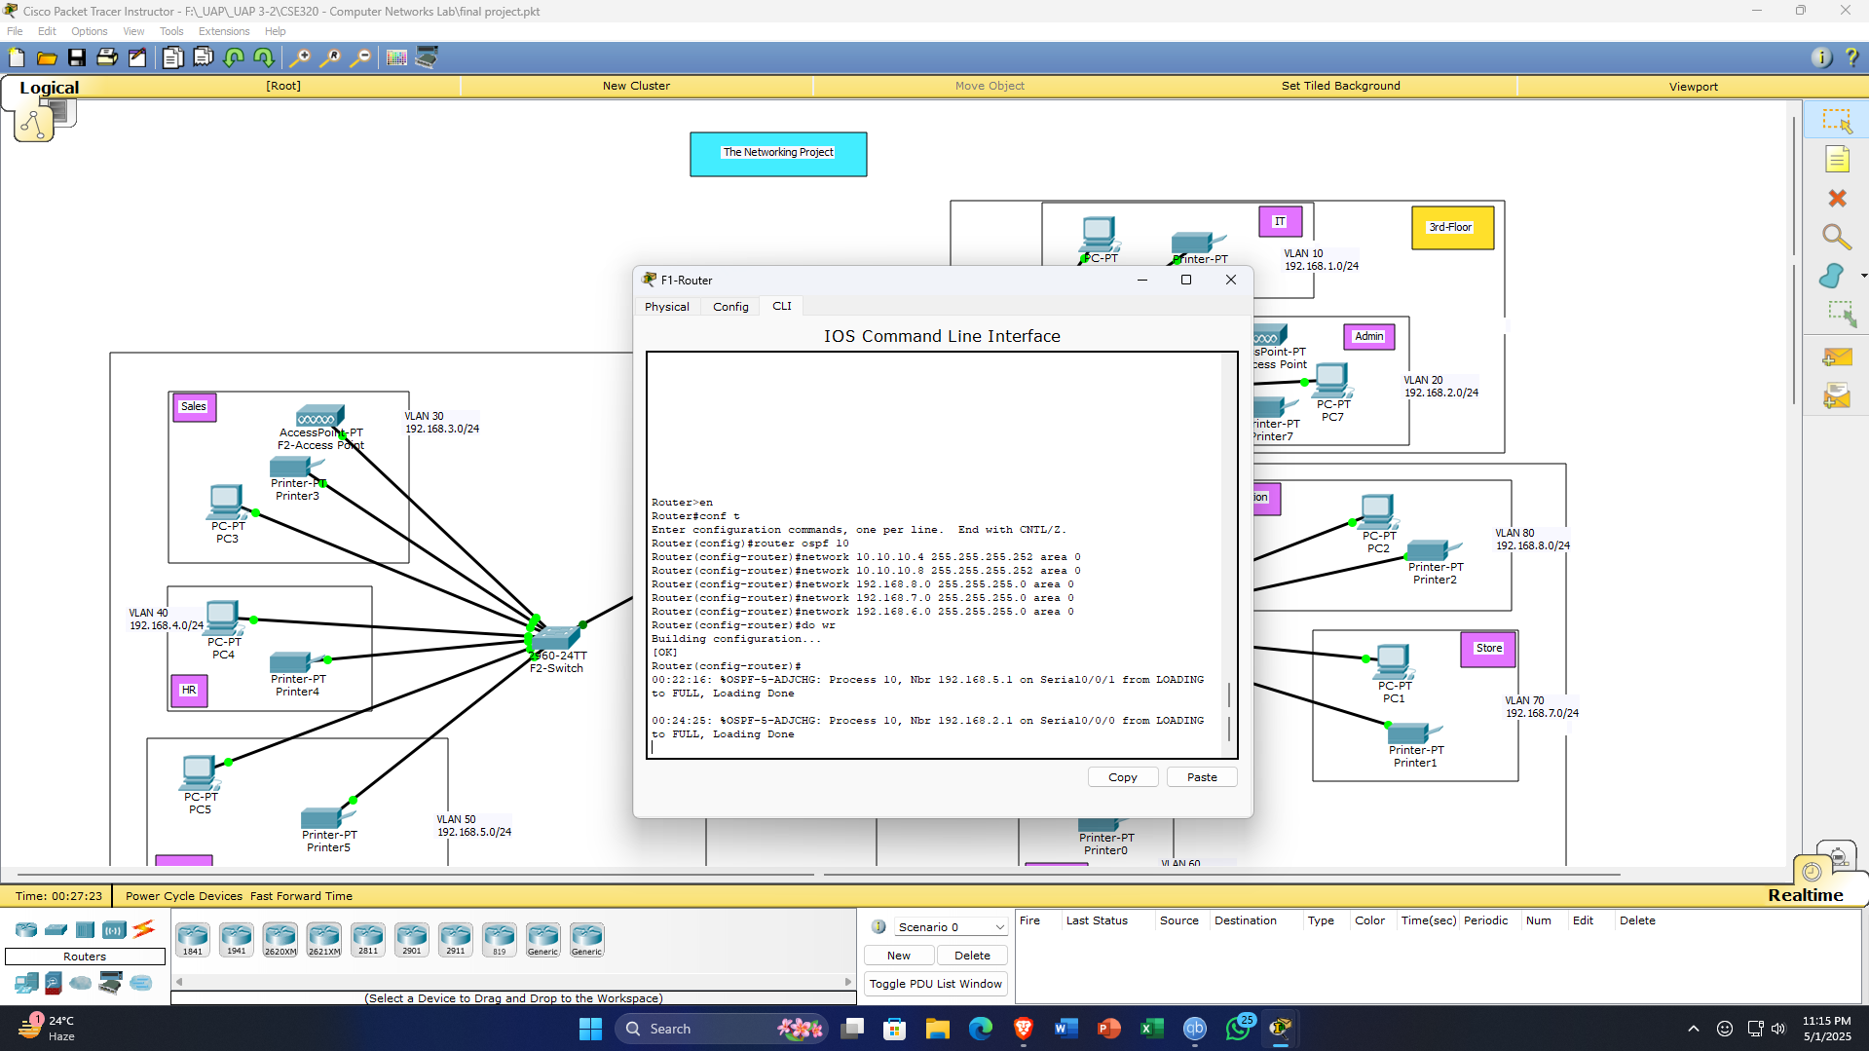
(2nd Floor)
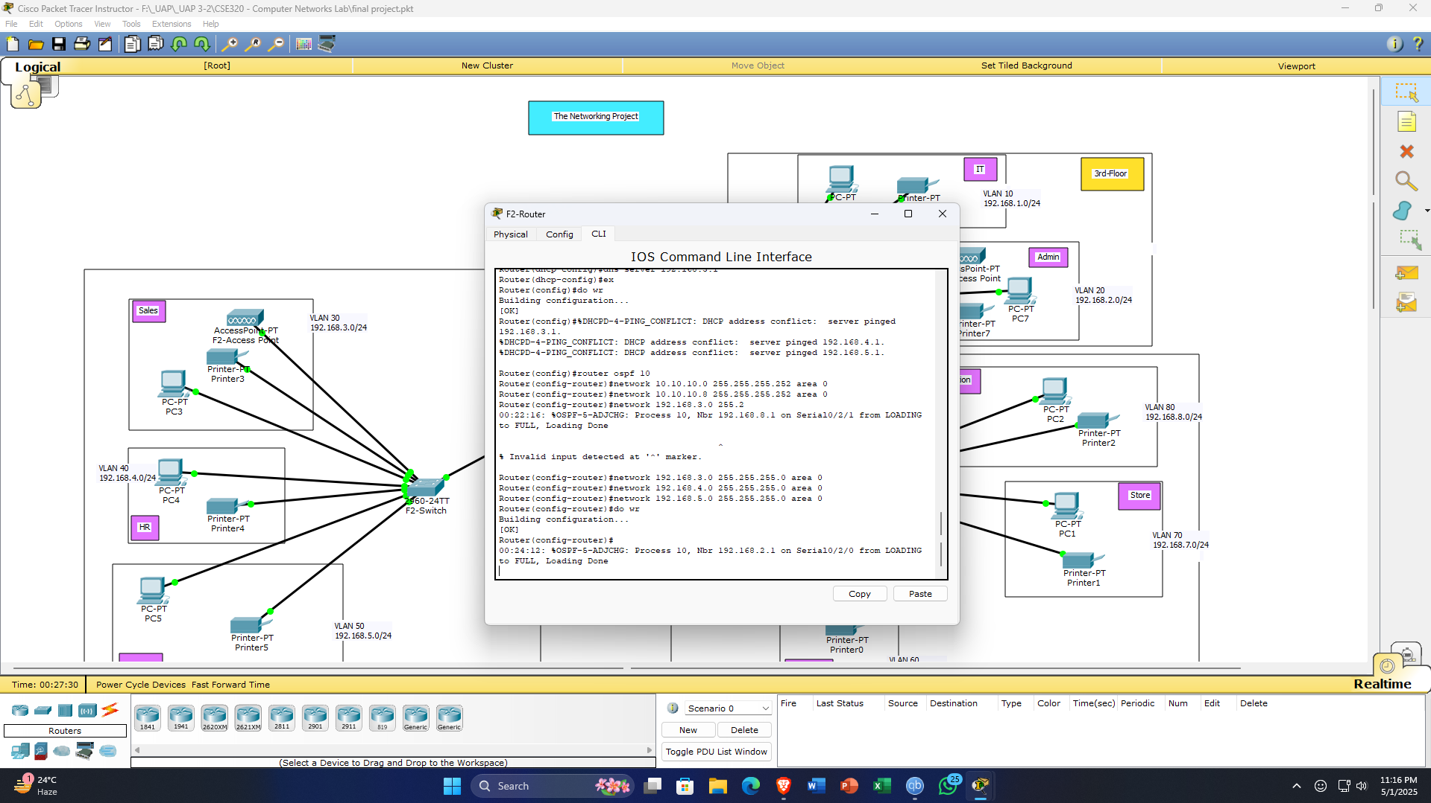
(3rd Floor)
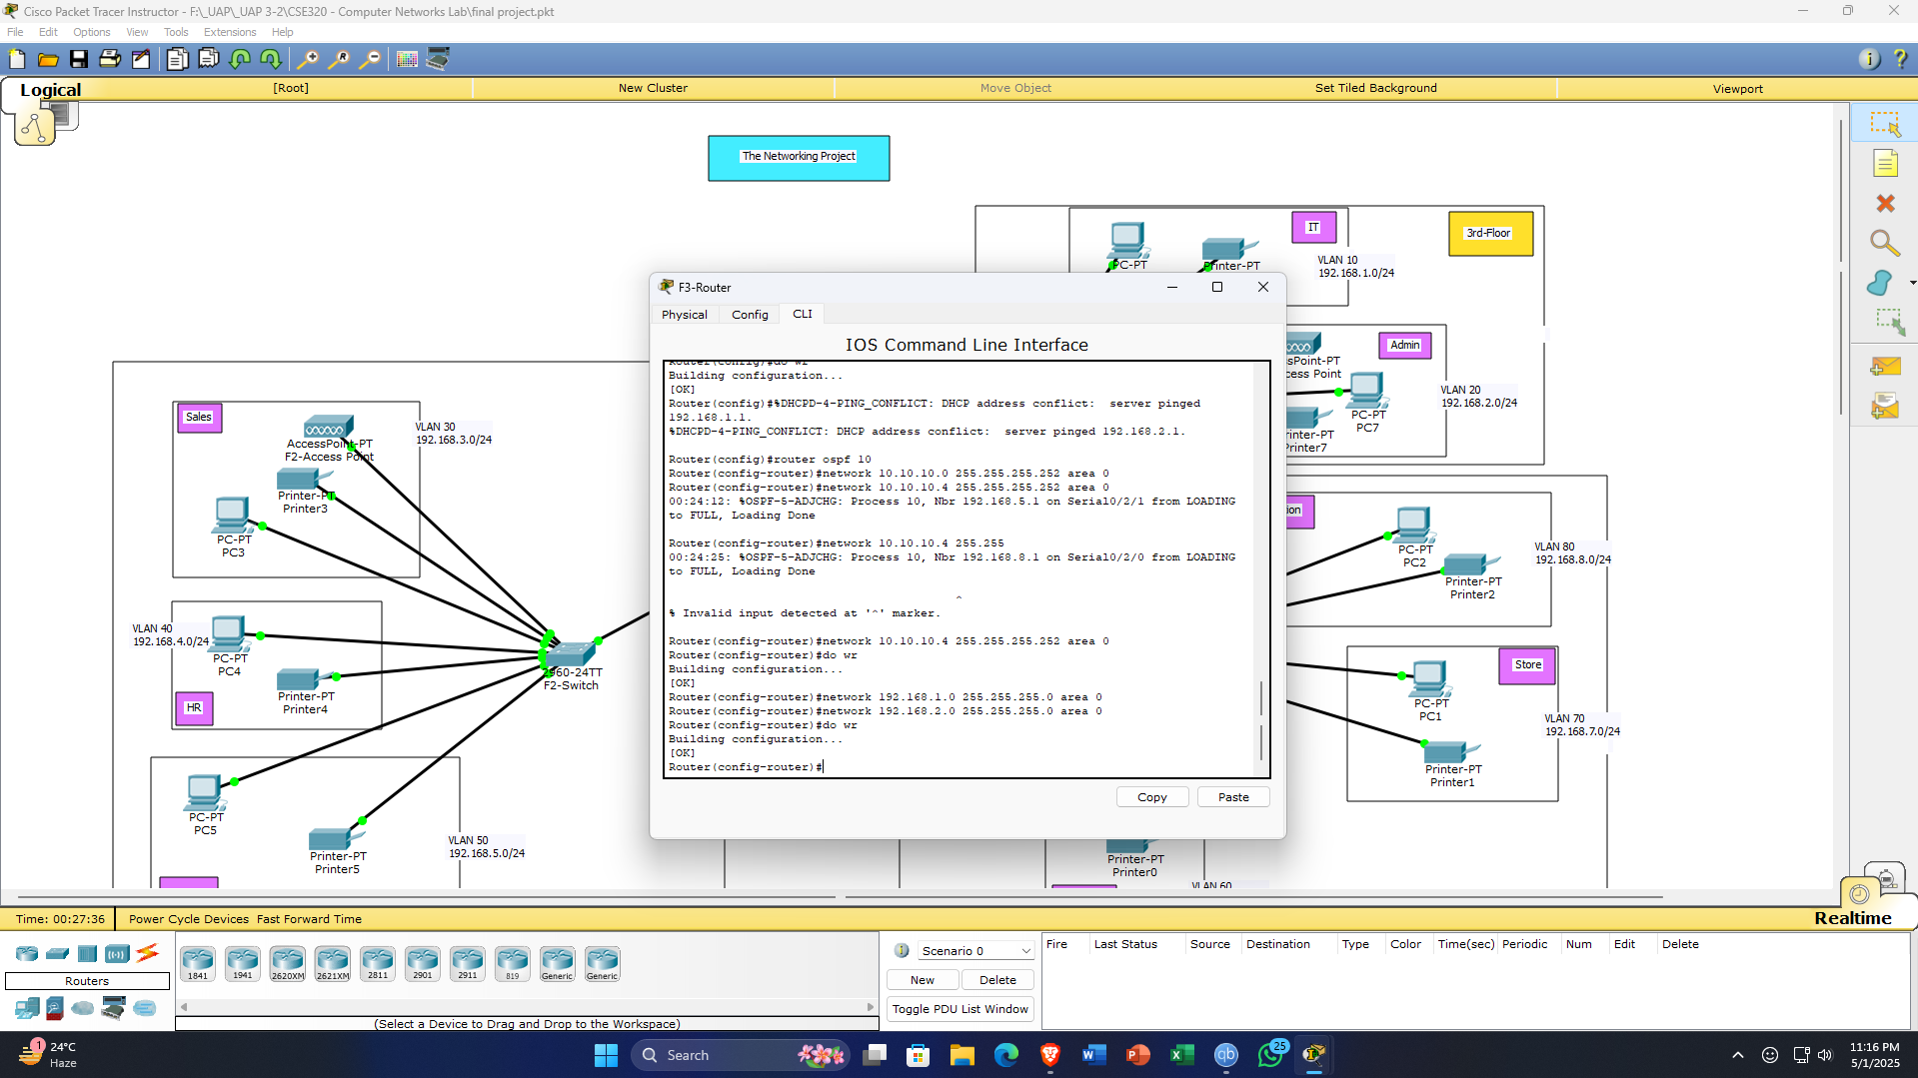
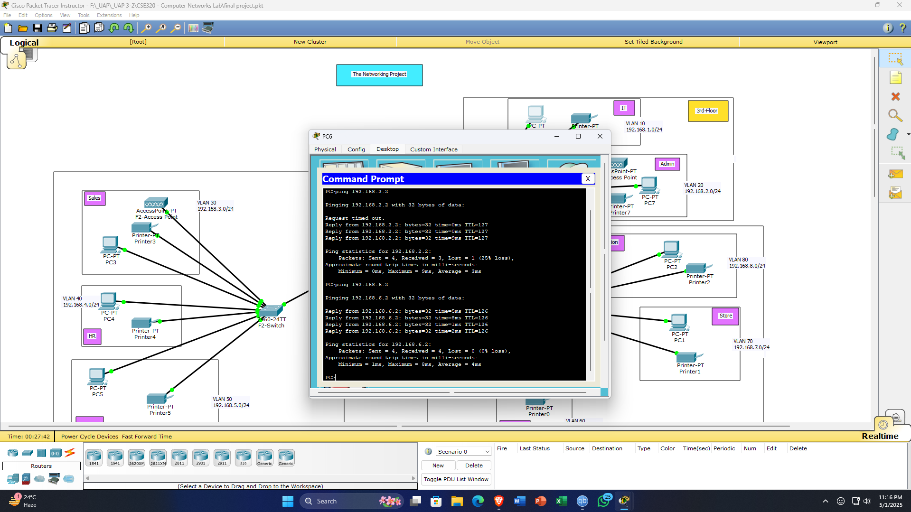
As a result, connection between devices from different floor have been secure.
- Wi-Fi Connections to Laptops & Phones:
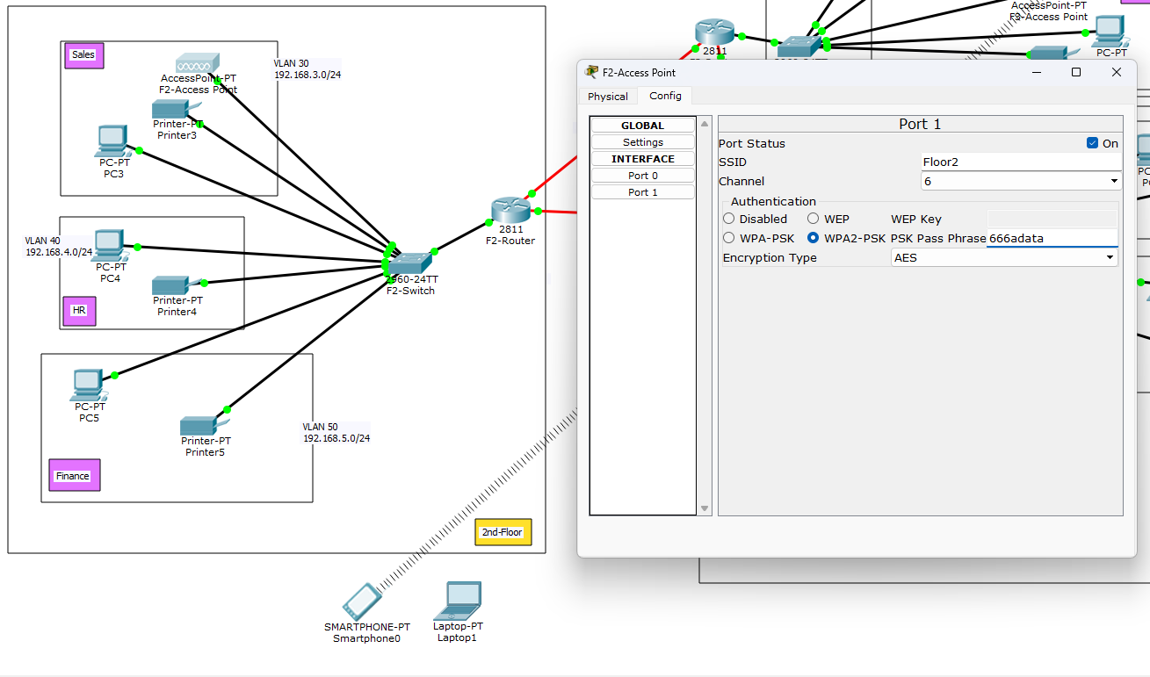
SSID and password for wi-fi being given.
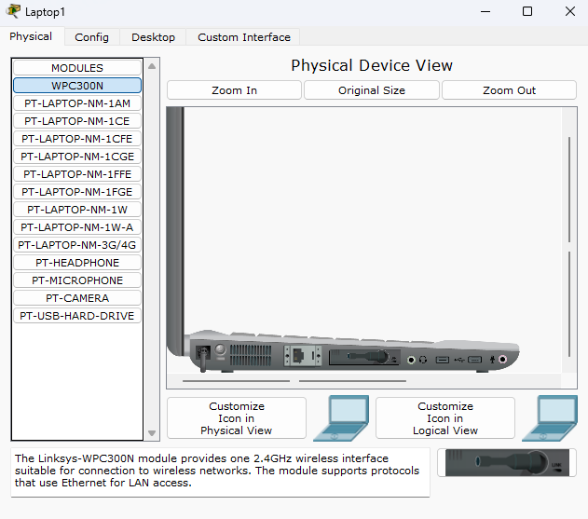
Laptop must be turned off and then WPC300In extension should be put on and then turn on the laptop.
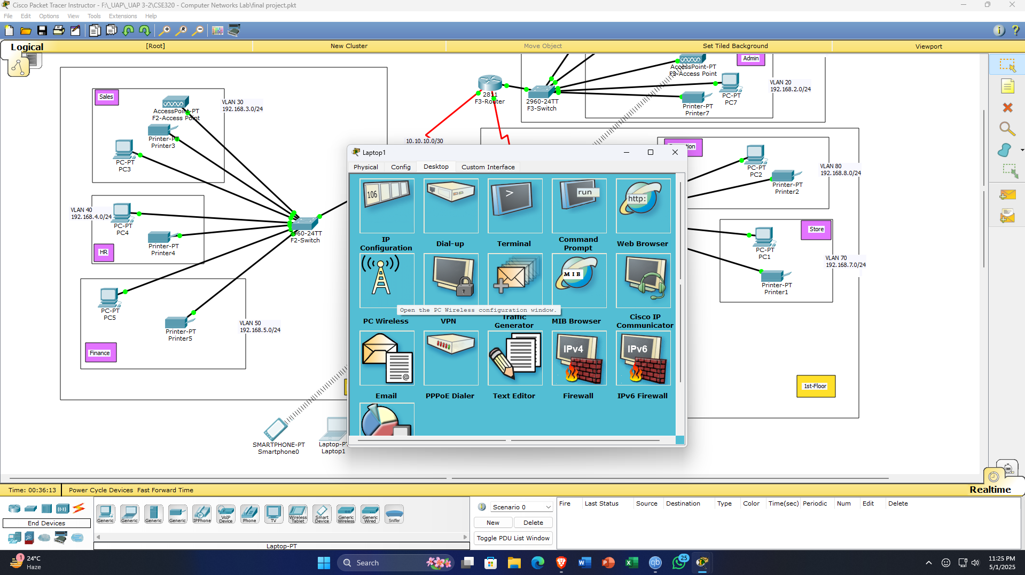
In laptops pc configuration, go to PC wireless and then give refresh and connect to desired wi-fi through password.
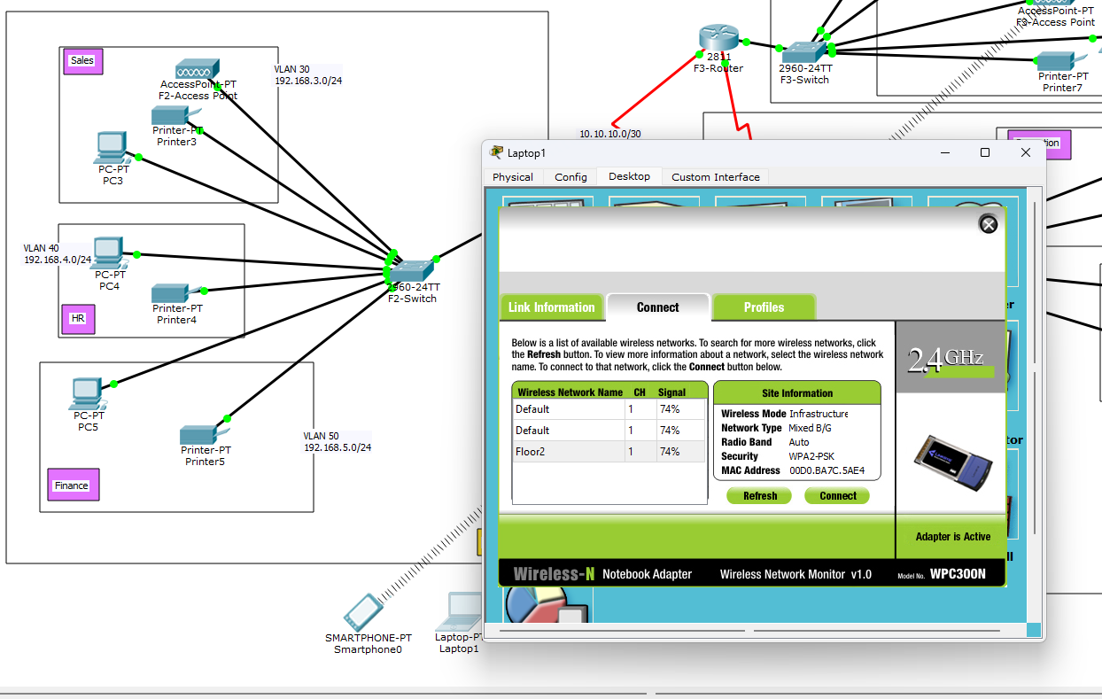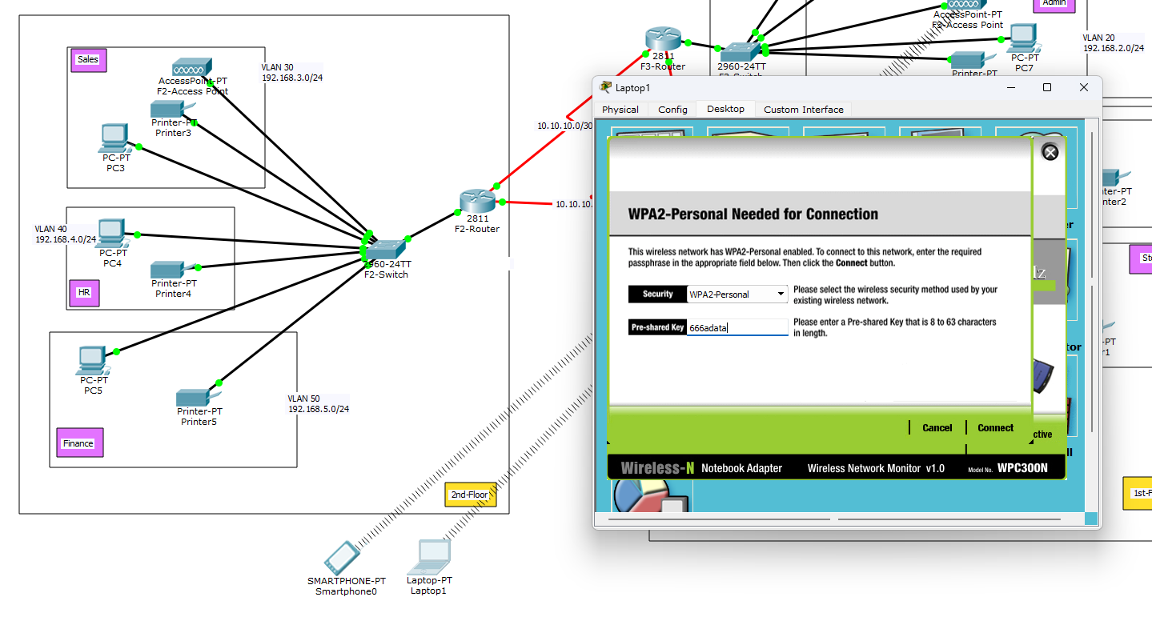
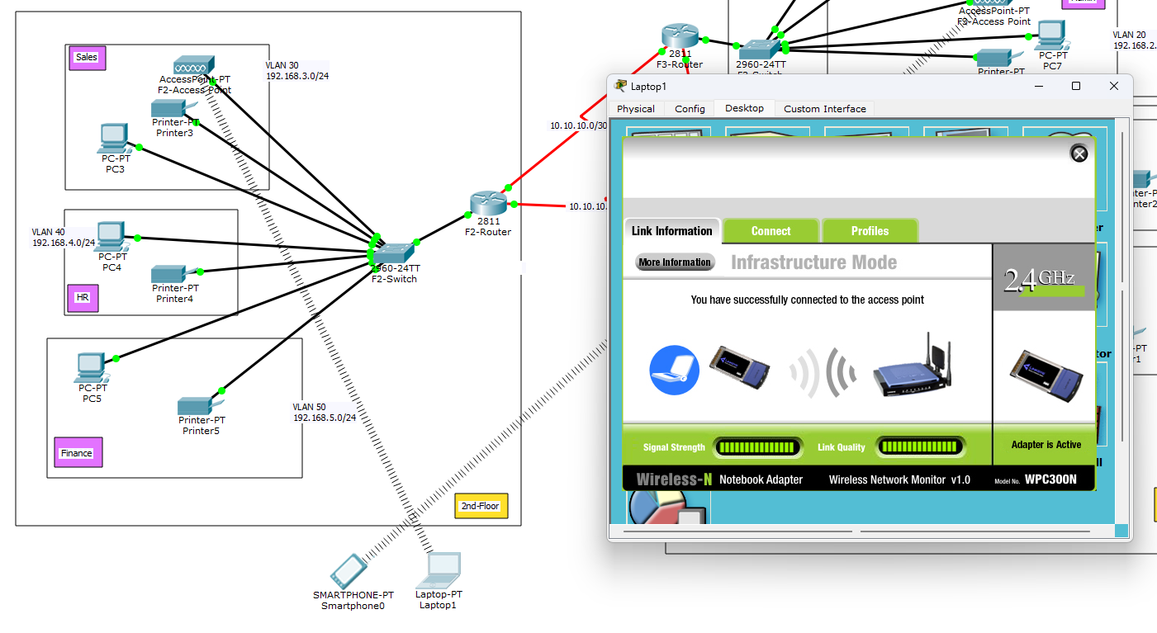
As a result, Laptop is now successfully connected to the wi-fi.
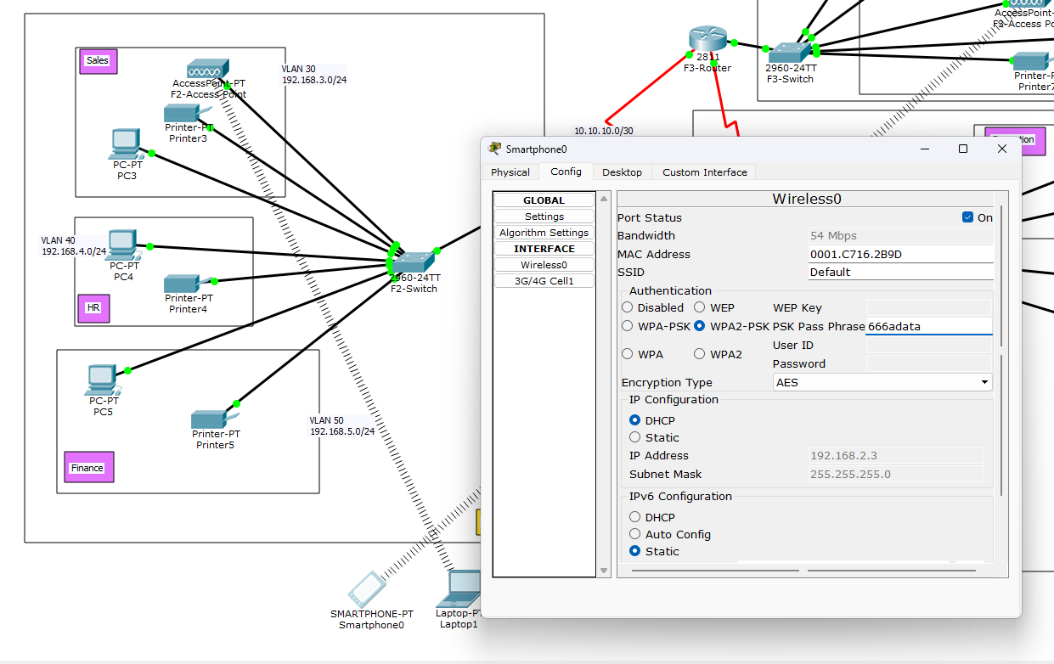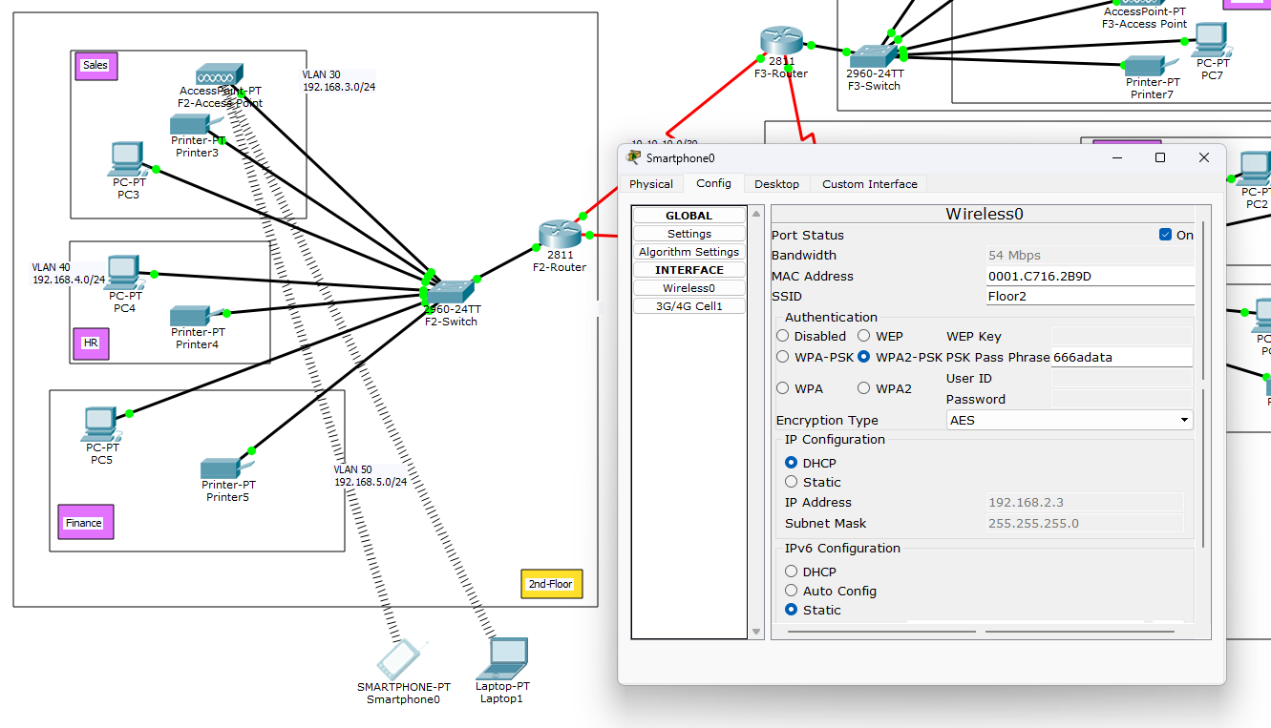
Similar case goes for smartphone.

- SSH & Port Security:
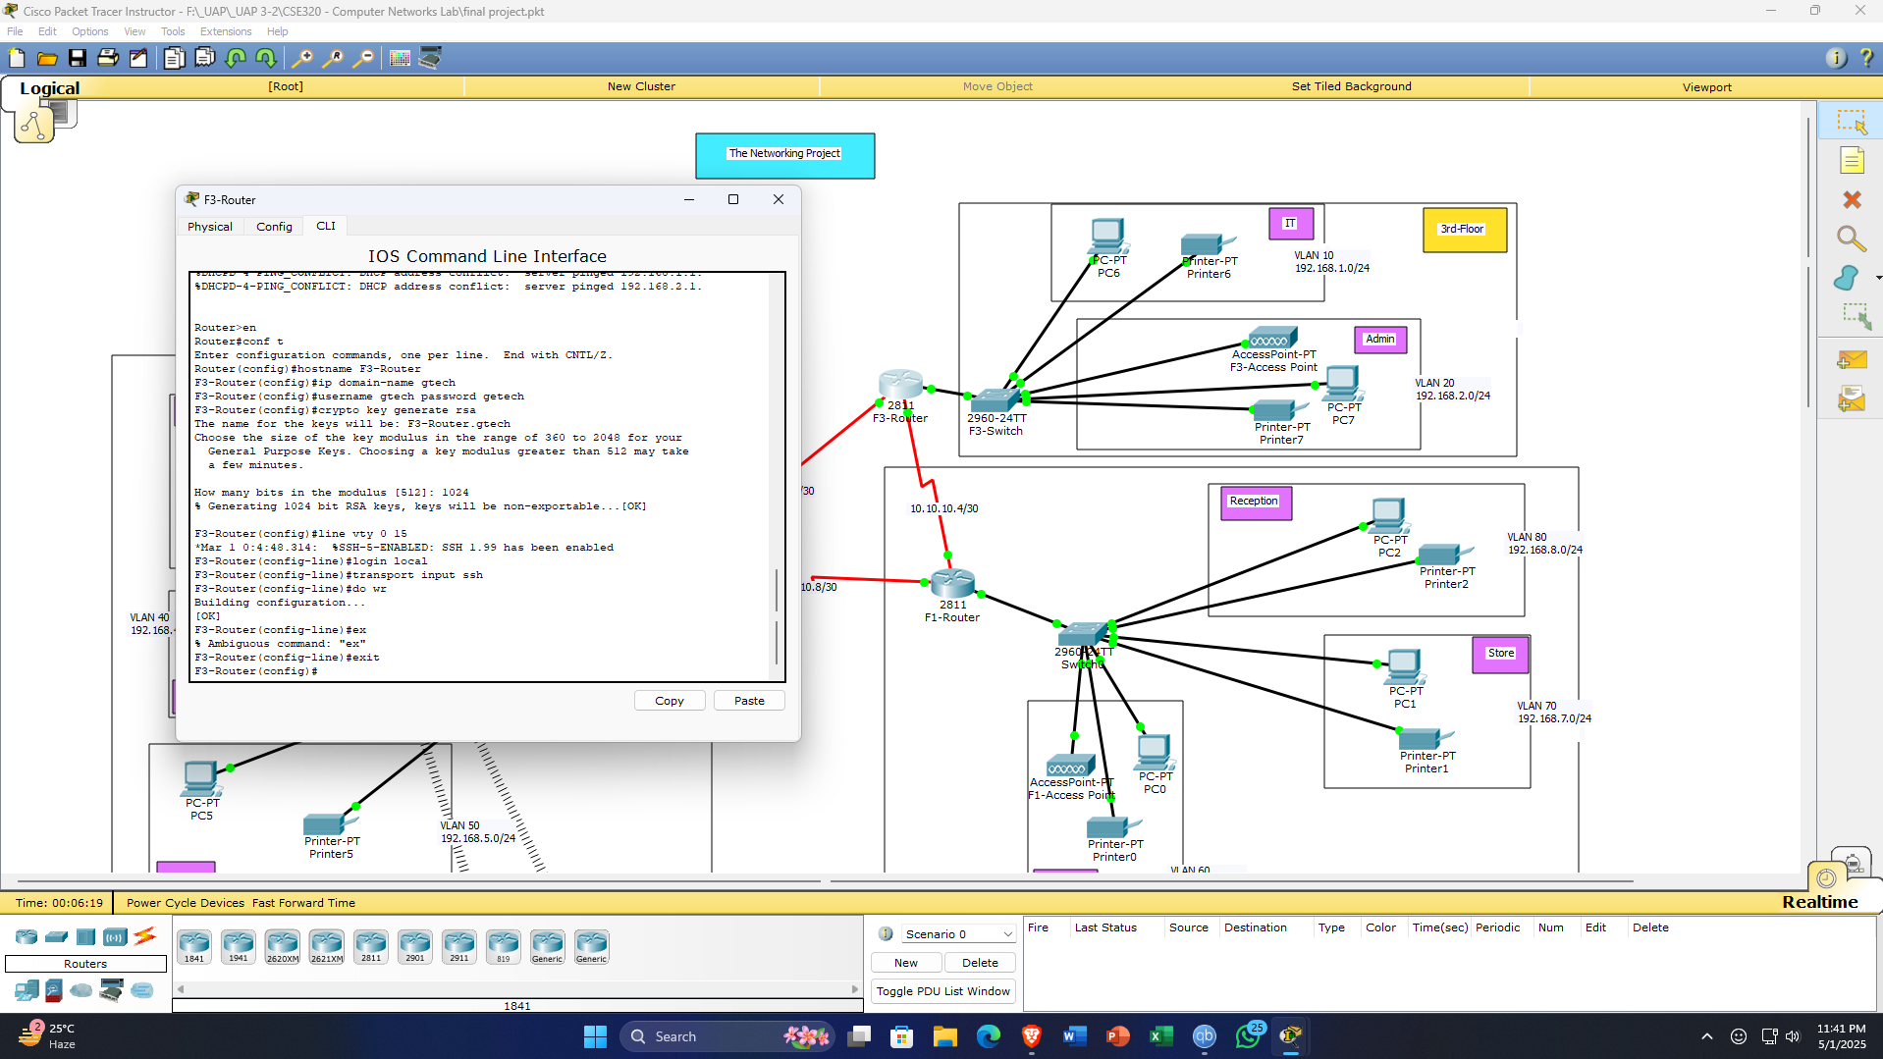
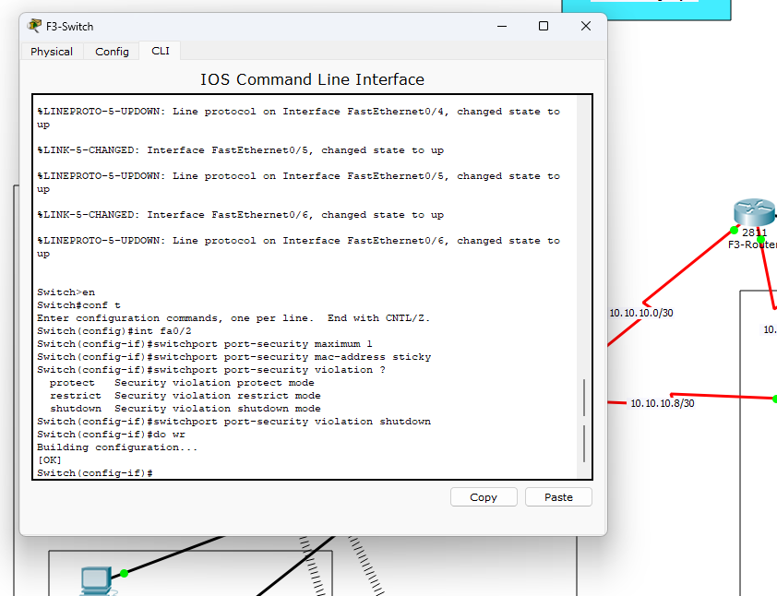
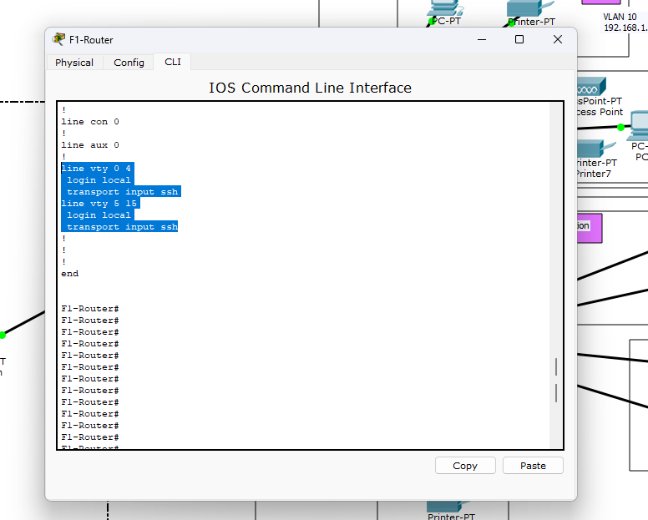

4. Simulation & Results
Tests Conducted
- Inter-VLAN Communication:
  - PCs in Reception (VLAN 80) could ping Finance (VLAN 50) via OSPF.

- DHCP Verification:
  - All devices received correct IPs from their VLAN’s DHCP pool.

- SSH Access:
  - Test-PC in IT successfully logged into routers via SSH.
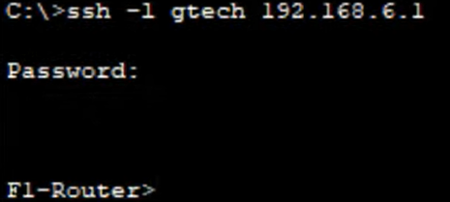
- Port Security:
  - Unauthorized devices on IT-Switch Fa0/2 triggered port shutdown.


Full Setup:

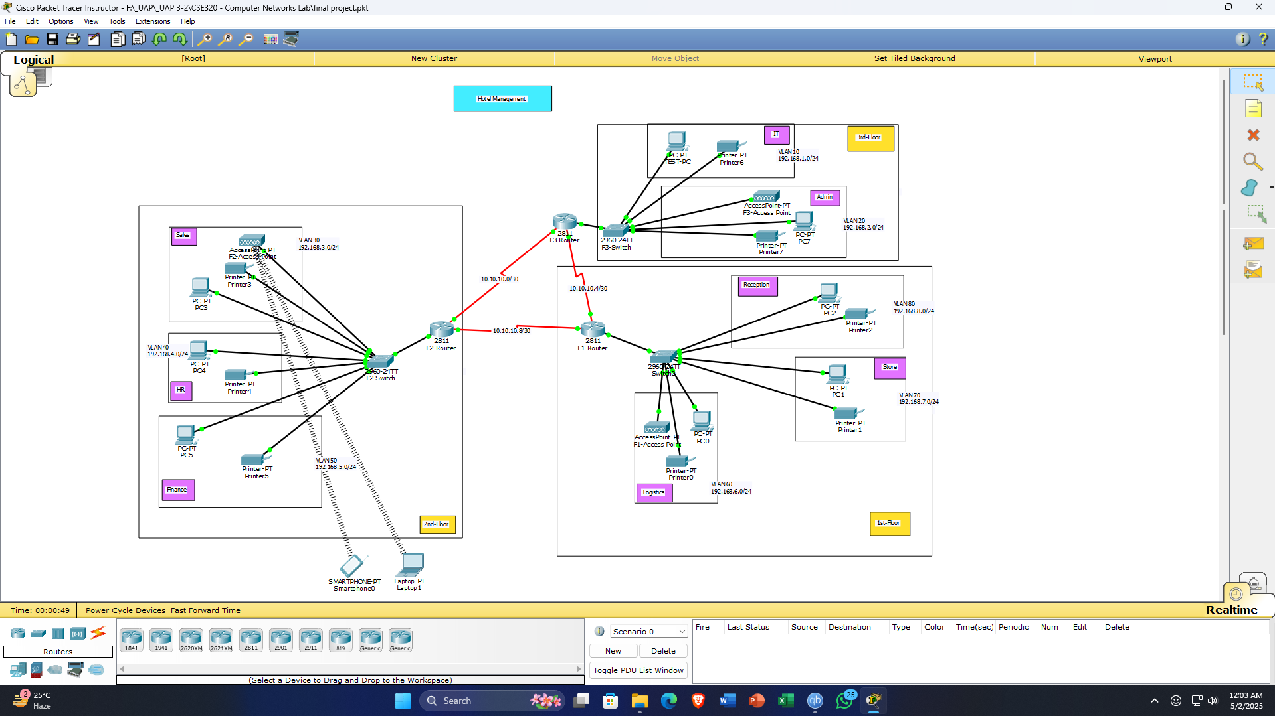
5. Conclusion
This simulation project successfully demonstrates a realistic and secure network design for a hotel management system. It reflects industry practices in segmenting departmental traffic, ensuring secure communication, and incorporating both wired and wireless devices. The project provided hands-on experience with VLANs, routing, and logical topology design using Cisco Packet Tracer.
The project successfully implemented a secure, VLAN-segmented hotel network with:
- Dynamic routing (OSPF) for inter-floor connectivity.
- Controlled access via port security and SSH.
- Scalability for future expansions (e.g., IoT devices).

