
AMERICAN INTERNATIONAL
UNIVERSITY-BANGLADESH
Choose an item.

Choose an item.

Assignment Title: | Mid Assignment
Assignment No: | 1 |  | Date of Submission: | 3 May 2025
Course Title: | Machine learning
Course Code: | Click here to enter text. |  | Section: | A
Semester: | Spring | 2024-25 | Course Teacher: | Prof. Dr. Md. Asraf Ali

Declaration and Statement of Authorship:
- I/we hold a copy of this Assignment/Case-Study, which can be produced if the original is lost/damaged.
- This Assignment/Case-Study is my/our original work and no part of it has been copied from any other student’s work or from any other source except where due acknowledgement is made.
- No part of this Assignment/Case-Study has been written for me/us by any other person except where such collaboration has been authorized by the concerned teacher and is clearly acknowledged in the assignment.
- I/we have not previously submitted or currently submitting this work for any other course/unit.
- This work may be reproduced, communicated, compared and archived for the purpose of detecting plagiarism.
- I/we give permission for a copy of my/our marked work to be retained by the faculty for review and comparison, including review by external examiners.
- I/we understand that Plagiarism is the presentation of the work, idea or creation of another person as though it is your own. It is a formofcheatingandisaveryseriousacademicoffencethatmayleadtoexpulsionfromtheUniversity. Plagiarized material can be drawn from, and presented in, written, graphic and visual form, including electronic data, and oral presentations. Plagiarism occurs when the origin of their arterial used is not appropriately cited.
- I/we also understand that enabling plagiarism is the act of assisting or allowing another person to plagiarize or to copy my/our work.

* Student(s) must complete all details except the faculty use part.
** Please submit all assignments to your course teacher or the office of the concerned teacher.
No | Name | ID | Program | Signature
1 | Nafisa Sharmin Sadia | 21-45162-2 | Bsc.CSE

Faculty use only
FACULTY COMMENTS | Marks Obtained
 | Total Marks

- Feature Selection:
- Color Histograms: Selecting RGB or HSV color channels to identify dominant colors.
- Edge Detection: Using algorithms like Sobel, Canny to detect object boundaries.
- 3.Texture: Evaluating local patterns using filters like Gabor or LBP
- Feature Extraction:
- SIFT (Scale-Invariant Feature Transform): Identifies keypoints that are invariant to
- scale androtation.
- HOG (Histogram of Oriented Gradients): Extracts features related to object shapes and contours. CNN Features: Deep learning models like VGG16 can be used to extract semantic features
- Visualization Techniques:
- 1.Heatmaps: Overlay heatmaps to indicate regions of high importance.
- PCA/t-SNE: Reduce dimensions and visualize feature distribution.
- Superpixel Segmentation: Groups pixels into perceptually meaningful segments
- for better regionunderstanding.
- This image, with its complex textures, colors, and shapes, is suitable for testing such techniques in segmentation, object recognition, and pattern detection

- Feature Extraction Techniques:
- 1.Color Features
- 2.Shape Features (Edge Detection)
- 3.Shape-Based: Contour Detection
- Pixel Features
- Types of Features Extracted:
- Feature extraction is identifying important characteristics or patterns in an image and using them for analysis, classification, or other tasks. Instead of using the raw pixel data, which can be large and complex, we extract meaningful information (features) to simplify the problem.

- Features:
- 1.Pixel Features
- -These features use the brightness values of each pixel in the image.
- -Each pixel in a grayscale image has a value between 0 (black) and 255 (wlute).
- 2.Color Features
- -These features describe the color composition of an image.
- -For example, you can calculate the average red, green, and blue (RGB) values in the image
- Shape Features
- Shape features capture the edges, boundaries, or structure of objects in the image

- Input
- import cv2
- import numpy as np
- import matplotlib.pyplot as plt
- def load_image(image_path):
- """Load and convert image to RGB format for display"""
- image = cv2.imread(image_path)
- if image is None:
- raise FileNotFoundError(f"Image not found at {image_path}")
- image_rgb = cv2.cvtColor(image, cv2.COLOR_BGR2RGB)
- return image, image_rgb
- def extract_color_features(image):
- """Extract average color values for each channel"""
- average_color = image.mean(axis=(0, 1))
- return average_color
- def extract_shape_features(image_gray):
- """Extract edge features using Canny edge detection"""
- edges = cv2.Canny(image_gray, threshold1=100, threshold2=200)
- return edges
- def extract_contours(image_gray):
- """Extract contours from the image"""
- # Apply threshold to create binary image
- _, thresh = cv2.threshold(image_gray, 127, 255, cv2.THRESH_BINARY)
- # Find contours
- contours, _ = cv2.findContours(thresh, cv2.RETR_TREE, cv2.CHAIN_APPROX_SIMPLE)
- # Create blank image for drawing contours
- contour_img = np.zeros_like(image_gray)
- # Draw all contours
- cv2.drawContours(contour_img, contours, -1, (255, 255, 255), 1)
- return contour_img
- def extract_pixel_features(image_gray):
- """Extract raw pixel values from grayscale image"""
- pixel_features = image_gray.flatten()
- return pixel_features
- def display_results(original, processed, title1="Original Image", title2="Processed"):
- """Display original and processed images side by side"""
- plt.figure(figsize=(10, 5))
- plt.subplot(1, 2, 1)
- plt.imshow(original)
- plt.title(title1)
- plt.axis("off")
- plt.subplot(1, 2, 2)
- plt.imshow(processed, cmap="gray")
- plt.title(title2)
- plt.axis("off")
- plt.show()
- def main():
- # Load the image (replace with your image path)
- image_path = "owl.jpg"
- image, image_rgb = load_image(image_path)
- image_gray = cv2.cvtColor(image, cv2.COLOR_BGR2GRAY)
- # 1. Color Features
- avg_color = extract_color_features(image)
- print("Average Color (B, G, R):", avg_color)
- # 2. Shape Features - Edge Detection
- edges = extract_shape_features(image_gray)
- display_results(image_rgb, edges, "Original Image", "Edge Detection")
- # 3. Shape Features - Contour Detection
- contours = extract_contours(image_gray)
- display_results(image_rgb, contours, "Original Image", "Contour Detection")
- # 4. Pixel Features
- pixel_features = extract_pixel_features(image_gray)
- print("Pixel Features (First 10 values):", pixel_features[:10])
- if __name__ == "__main__":
- main()

Output:
Average Color (B, G, R):

[72.5621150387.00053883 121.61384487]

Texture-Based: Edge Detection (Canny):

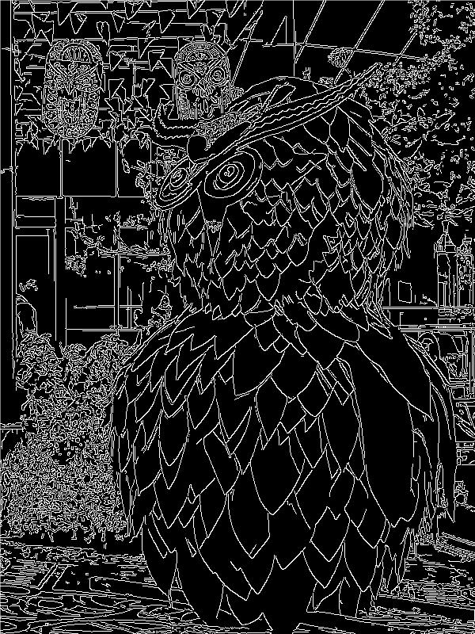

Shape-Based: Contour Detection:

