ID: 19-41283-3

Name: Nafiz Ahmed

Dataset Import:

Structure of data:
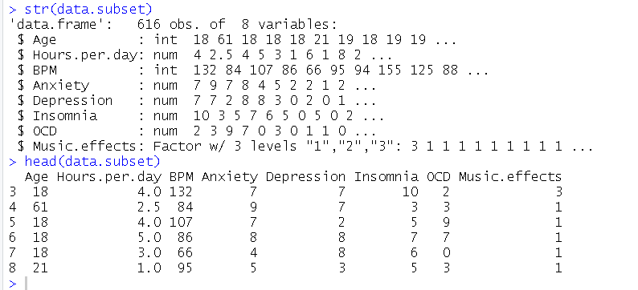

Normalization of data:
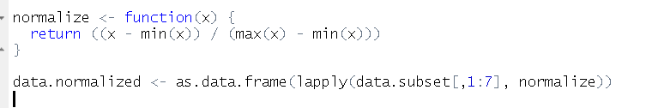

Classifier Accuracy:
I used first strategy which is Separate Training and Test Sets and used KNN as model for testing
Here I took 70% as Training and 30% as Test dataset randomly,

Model Accuracy (KNN)
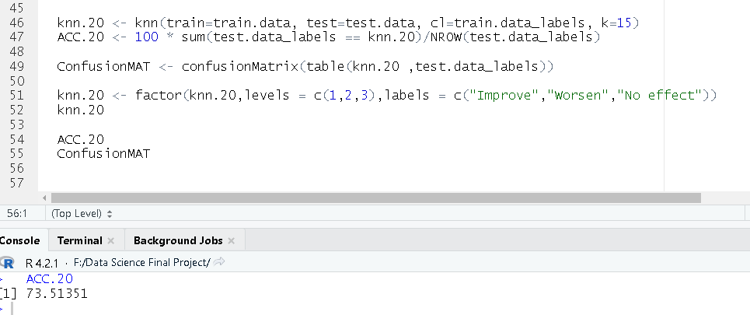
Figure 1: Accuracy is 73.51%

Confusion Matrix:
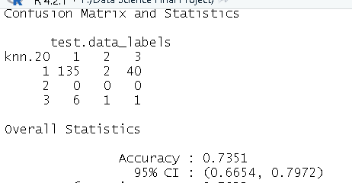

Source:https://www.kaggle.com/datasets/catherinerasgaitis/mxmh-survey-results

