

American International University-Bangladesh (AIUB)  
**Department of Computer Science  
Faculty of Science &Technology (FST)  
Summer 21 22**

**PARKING MANAGEMENT SYSTEM**

Software Requirement Engineering

Sec: **A/ C**

Project submitted

By

*Nafiz Azad (18-39268-3)*

*Student Name (Student ID)*

*Student Name (Student ID)*

*Student Name (Student ID)*

**Checked By Industry Personnel**

Name: Tafsir Ahamed KHAN

Designation: Developer

Company: Asha

Sign: tafsir

Date:

1. **PROBLEM DOMAIN**
   1. **Background to the Problem**

Our nation's population is growing every day, yet the amount of traffic on the highways is not keeping up with the rate of population growth. In order to service this enormous population, all forms of transportation are obviously insufficient, which is why, depending on their financial status, so many individuals choose to possess their own cars. As a result, there are more automobiles on the road every day, and finding a parking place is one of the most challenging tasks for both drivers and car owners. Unlike other industrialized nations, we don't have a designated parking area next to the road. However, parking must be done. This makes parking difficult most of the time. Since there is already so much traffic on the route and parking there is not permitted, finding a parking space may sometimes be a pain. Additionally, parking anywhere causes traffic to worsen on Dhaka's already congested roads. Accidents can occur as a result of unauthorized parking on the road, and ambulances occasionally fail to get at the hospital in time, endangering the lives of patients. Therefore, we must take this issue seriously.

* 1. **Solution to the Problem**

The suggested solution of this problem to create an app that would assist users in locating the closest open parking space based on their current location. This option is especially suited given the abundance of structures, shopping centers, residential complexes, and parking lots with spaces accessible for a certain period of time. The majority of individuals who own vehicles utilize them instead of leaving them parked. As a result, their designated parking space remains empty when they utilize their automobile at that time our software will detect those spot and users can park in those spots. When that time comes, nearby automobiles may utilize the space in return for paying a fee per hour in the payment option of the software, which will help address the parking issue. The software will serve as a guide to find the available space for parking. In this manner, the software will take an hourly payment for the parking space and for the provided service, while the user will save the inconvenience of looking for a parking space. The primary goal in this situation is to resolve the parking issue. Additionally, the user must use a lot of time, energy, and fuel when looking for a parking space, which is harmful for both the environment and the driver at the same time since it requires more oil. Presently, Robi workers may use the "Robi E-Parking" app, also there are some other companies like “get my parking” which is currently accessible in relation with our project. For its staff alone, their app finds the parking slot and location that are nearest available. Our software is for everyone. The major objective of this software is to lessen the parking issue, prevent additional fuel use.

1. **SOLUTION DESCRIPTION**
   1. **System Features**
2. Account creation for new users
3. Login feature for existing users
4. User profile
5. Payment option
6. Real-time info. of a parking spot
7. Navigation using GPS
8. Automatic generated bill
9. Booking spot
10. Status of the parking place
11. Payment option.

**2.1.1**

**System quality attributes**

1. **Performance:**

**PE-1:** Performance requirements define how well or how rapidly the system must perform specific functions.

**PE-2:** System will run in 8 seconds or less over a 60 Kbps internet.

**Priority Level:** High

1. **Efficiency:** EF-1: Efficiency is a measure of how well a system makes use of its available resources, such as memory, disk space, and communication bandwidth.

**EF-2:** at least 35% of the required processing power for this system.

**EF-3:** All future standard Android devices must have at least 1GB of RAM, according to this system.

**Priority Level:** High

**3. Flexibility:**

**FL-1:** Flexibility gauges how simple it is to include new features into the product.

**FL-2:** A maintenance programmer may quickly add fresh copy output to the product, including testing and code adjustments.

**FL-3:** The programmer can test this system in 1 hour.

**Priority Level:** Medium

**4. Integrity:**

**IN-1:** Integrity, a term that includes security, refers to preventing information loss, ensuring that software is virus-free, and maintaining the privacy and security of data submitted into the system. Integrity also refers to preventing unauthorized access to system operations.

**IN-2:** Only users who have Auditor access privileges shall be able to access our system.

**Priority Level:** High

**5. Portability:**

**PR-1:** Our system is open for all platforms such as android, ios, windows etc. Priority **Level:** High

* 1. **UML Diagrams**

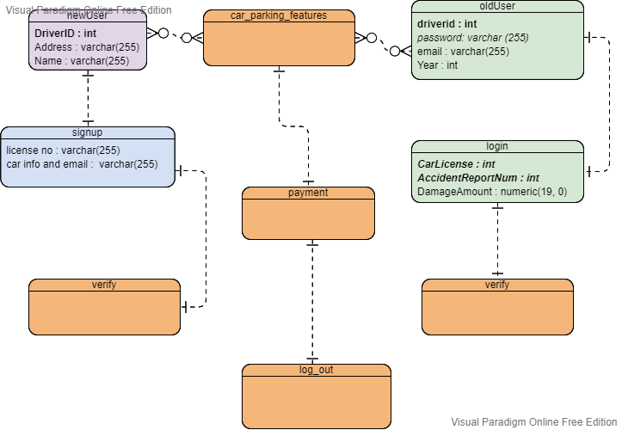

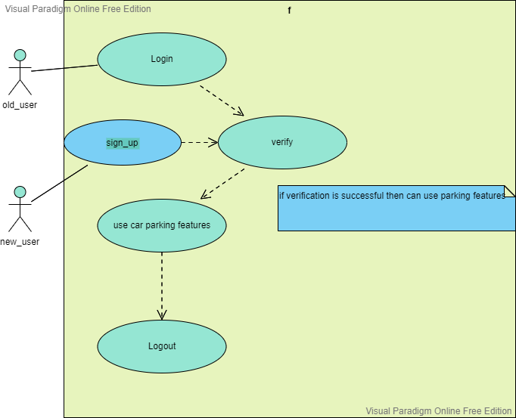

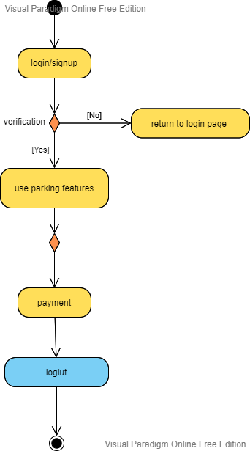

1. **Social Impact**

The project will be a very useful after gets implemented. It will solve many problems like traffic jam, car parking problem and also it will be financial benefit for the users. For this a lots of problem can be solved like shortage of space on the road ,accident due to car parking , parking on road ,damage of car will be solved . The users who are looking for space to park their car will get the space. By this project many people can get a job which is helpful for the society and the people. The vacant place might need to clean frequent so our project will assign a cleaner worker. That’s how jobs in all category can be created by implementing the project.

1. **Development Plan with Project Schedule**

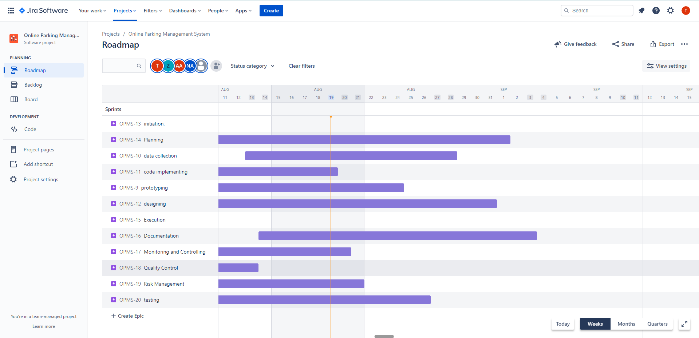

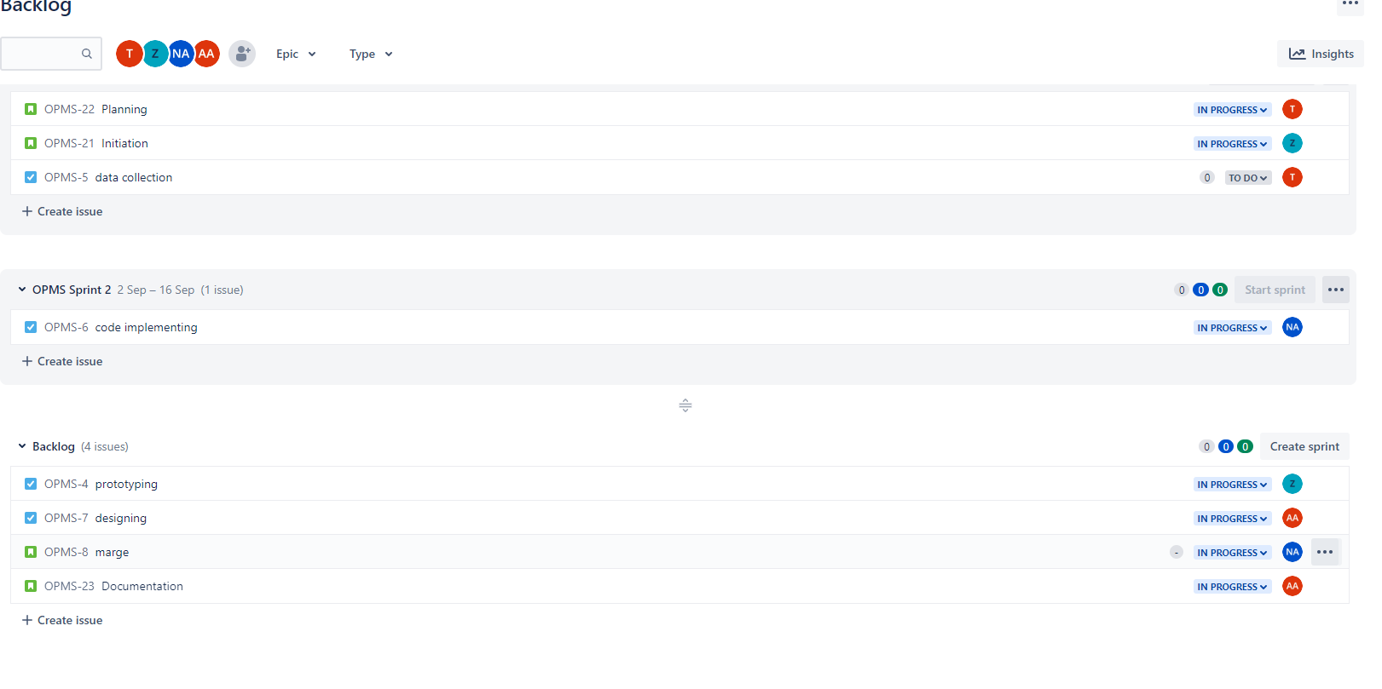

**5. Marketing Plan**

Initially, we can advertise more and more using the video marketing. We can show a demo video through which audience will get the idea of the project.

Second we can make a website which will work as a sale person. Through the website audience will get the idea of the project and also get the interest of using the website.

Third we can put the website on a review website so that audience can get authentic reviews and also it will help us to gain their trust.

Lastly we can do paid advertisements. Through this we can achieve more audience.

1. **Cost and Profit Analysis**

|  |  |
| --- | --- |
| **Cost Elements** | **Total Estimated Cost** |
| Consultation & assessment | BDT 12,3000 |
| Software Development | BDT 6,45,111 |
| Integration & Training | BDT 2200,00 |
| Marketing | BDT 12,20,00 |
| Discount | BDT 0 |
| **Total** | **BDT 999,411** |

|  |  |
| --- | --- |
| **Cost Elements** | **Total Estimated Cost** |
| Government tax | BDT 80,800 |
| Government Certificate | BDT 510 |
|  |  |
|  |  |
|  |  |
| **Total** | **BDT 81,310** |

**Estimated profit analysis:**

|  |  |
| --- | --- |
| **Profit criteria** | **Amount (in hour)** |
| For car | 60 taka |
| For bike | 40 taka |
| For pickup truck | 80 taka |
| Total (daily) | 2070 taka |
| Total (monthly) | 62100 taka |

On weekdays there are 20 cars, 30 bikes and 10 pickup trucks are estimated per spot for parking. It will be the initial start then the number can increase or decline according to the service provided by the software.

1. **Reference**

Get my parking

<https://www.getmyparking.com/>

Visual-paradigm

<https://online.visual-paradigm.com/>

Jira

[www.Atlassian.net/Jira](http://www.Atlassian.net/Jira)