Software Requirements Specification

For

MIST Automated Attendance System (MAAS)

Group - 05

Prepared by

|  |  |
| --- | --- |
|  |  |
| 201714013 : | Zobayer Ajmir |
| 201714023 : | Farzana Faruk Jhumu |
| 201714027 : | Masrur Hasan Mahin |
| 201714030 : | Md.Ariful Islam Tarek |
| 201714043 : | Nafiz Imtiaz Khan |
| 201714059 : | Sumaiya Nuha Mustafina |

# Table of Contents

1. Table of contents………………………………………………………………………………..2
2. Preface………………………………………………………………………………………….. 3
3. Introduction……………………………………………………………………………………...4
4. Glossary… 5
5. User Requirements 6-8
6. System Architecture 9-10
7. System Requirements Specifications .11-15
8. System Model……………………………………………………………………………...15-26
   1. Context Diagram………………………………………………………………………….16
   2. Activity Diagram…………………………………………………………………………..17
   3. Use Case Diagram…………………………………………………………………...18-24
   4. Sequence Diagram..…………………………………………………………………25-26
9. System Evolution……………………………………………………………………………..27
10. Appendices…………………………………………………………………………………28-31
11. References…………………………………………………………………………………….32
12. Index…..………………………………………………...………………………….………….33

|  |  |
| --- | --- |
|  |  |

# Preface

Today most information is available on the internet and that is why students skip their schools or colleges more frequently. But as we all know that education is not only getting information over the course but also the development of personality and gaining wisdom, to make it happen it becomes essential for the students to incorporate with teachers/professors. That is why educational institutions are still there and are successfully running even in today’s high-tech era.

With manual **student attendance system**, proper record is tough to enter because of the challenges that people face while calculating the proximity. In most of the educational institutions student attendance is taken by the instructor himself, which is time consuming & also there is always a chance of tempering with this method. So, with this system we can’t ensure 100% reliability. To prevent proxy system in some institutions, there is a system developed by RFID tag implanted in their ID card, which is also not proper solution as anyone can carry other’s ID card & cast his presence.

Some of them have a tendency of coming late which causes destruction for the instructors and other students. He is also affected as he missed some of his class lecture. Other than that, for absence in a valid reason a student has to deposit an application and it’s a problematic process. They can’t even know the current state of their eligibility also about the fines. Instructors also have to calculate percentage of every student after the semester which may sometime prevent accuracy. Moreover, the fine system is also not appropriate.

In order to maintain proper **student attendance system**, a reliable **educational attendance system** proves to be an asset to the educational institutes. MAAS (MIST Automated Attendance System) is a system design to overcome the problem discussed above.

# Introduction

MAAS (MIST Automated Attendance System) is a Biometric system for ensure 100% accuracy, user friendly attendance system which will use finger print as the unique feature to distinguish between two students.

This system is an overall attendance system for an institution to ensure the presence of the students. Fingerprint module and Arduino UNO are used to take and keep the attendance. LED sensors are used to ensure the entry after the scanning of finger print. As soon as our system detects a fingerprint it will send this to our database [firebase]. The data will be fetched from the database with our website & display it in live mode. The stakeholder/actor can access the related data through a webpage. There is a primary login page for the users. They can login to their dashboard and see the required data.

A student can see the attendance, their eligibility, their fine and can apply for leave of absence. They have to put the required field and can see their subject wise and presence and overall percentage. An instructor can see the attendance, can update or edit when it’s necessary. An application can be automatically submitted and accepted without any paper work. The attendance is also update automatically.

There are many benefits of [**integrating biometrics**](http://www.m2sys.com/bioplugin/?utm_source=blog&utm_medium=blog%20post&utm_campaign=student%20attendance%20management) with student attendance management systems in educational institutions. Biometric attendance systems provide a convenient way to automatically track student check-in and check-out times and do not require complex technical knowledge so students can easily use the system with minimal training and can check-in or out through this system by simply placing their fingers or palm on a biometric hardware device. Using biometrics for student attendance has additional benefits for students and educational institutions including:

**Accurate Attendance:** The main benefits of using biometrics for student attendance tracking is the accuracy it provides. Educational institutions can centrally and accurately monitor student attendance to prevent proxy attendance and errors which are common problems when using traditional check-in and check-out methods.

**Convenience**: Biometric student attendance systems provide a convenient way to check-in and check-out into the system by simply scanning their biometrics. Since biometric attendance systems are automated and do not require any technical knowledge, students can check-in or out quickly and easily.

**Saves Time**: MAAS will cut down the time to record class attendance. These systems can track student attendance in mere seconds which saves teachers a lot of time rectifying attendance data errors from traditional methods.

**Increases Efficiency**: Biometric systems not only eliminate errors related to tracking attendance data but also speed up data verification which reduces administration time and creates efficiencies.**Increases Security and Protects Privacy:** In the enrollment process, biometric systems convert scanned biometric templates to computer code and store the information in a database for matching and verification, making it virtually impossible to duplicate the original image for spoofing or fraud purpos

# Glossary

|  |  |
| --- | --- |
| TERM | DEFINITION |
| Software Requirements Specification | A document that completely describes all of the functions of a proposed system and the constraints under which it must operate. For example, this document. |
| Stakeholder | Any person with an interest in the project who is not a developer. |
| User | Reviewer or Author. |
| QA | Quality assurance |
| Web Site | A place on the world wide web |
| Database | Collection of all the information monitored by this system. |
| Use Case Diagram | A graphic depiction of the interactions among the elements of a system. |
| Sequence Diagram | Simply depicts interaction between objects in a sequential order i.e. the order in which these interactions take place. |
| DFD | Data Flow Diagram |
| LDR | Light Dependent Resistor |
| SQAP | Software Quality Assurance Plan |

# User Requirements

**Elicitation Process:**

For the requirement we interviewed the stakeholders. Market analysis and cost analysis is also done for system requirements. As interviewing was the main source of information, several stakeholders has faced some common question.

* + - 1. Are you familiar with automated attendance system?
      2. What is the problem of current attendance system in the educational institutions?
      3. If an attendance system is made through biometric system, how much do you think it will be effective?
      4. What kinds of features are needed?
      5. How do you think it will help you as a student? (Only for student)
      6. How the teachers are benefited by the system, as per your opinion?(Only for teaches)
      7. What is your opinion about the attendance notification? (Only for guardian)

Some other general question was asked and some discussion was held. For above questions answers were as such:

1.Almost everyone said that they know about the system but for educational institution this is not common

2. According to the teachers student can give proxy, come late, can bunk the class from middle and it take some time from the classes.

According to the students proxy giving tendency is supported by current system. If one of them is absent they have to call teacher but sometimes it is forgotten by teachers. They also face problem to know the current percentage of their attendance.

3.One of the teachers said, “If there is any unique way of taking attendance like finger print scanning then it will be more effective.” Others also support biometric as a unique system.

4. As the question has a vast scope many suggestion were came. But After many discussions

Some important features were suggested.

One Lecturer from CSE dept. said, “As the system is based on biometric specifically on finger print a secure database is a must. You also have to ensure the entry time and total student of a class. For labs there have to be more data than the classrooms as a lab is shared by many dept.”

One student said, “If you can add an application system so that we can apply for leave due to a reason our applications will be saved.” Another said, “Percentage of attendance and non-collegiate and dis-collegiate students list may show in the institution’s website.”

5.Many students were interviewed. Many of them were agreed to percentage and non-collegiate and dis-collegiate list. Some of them even didn’t support the system.

6. One of our respected teacher support it highly as the system is automatic, so they don’t have to spent time for taking attendance. But he demand a time of taking attendance so that late coming tendency is decreased. After class automatic update is demanded by the teachers.

7. We offered them a system which will give them a massage if their children are absent so that they can learn about them. Some said it’s a good idea but some said it’s not that much important.

During the interview many of the stockholder was concerned about the cost. So we also faced some questions by them.

1. Do the scanner and whole system will cost high?

2. How will you ensure the proper attendance system as there is more than one door?

3. How to make sure about the entry?

As per stockholder concern we analysis the market to know about the current features available in the market. And also cost analysis is done by which we learn that it will not cost a lot.

Two finger print scanner in both inside and outside can solve the problem.

A LED scanner will ensure the entry within ten seconds after the scanning.

From the elicitation process we get the following requirements:

4.1. Attendance will be taken using fingerprint sensor.

4.2. All fingerprint patterns, attendance, schedules will be stored

4.3. Number of students present in the class and the amount of time a student is outside of class during class time will be tracked

4.4. The project will keep track of which class is going on

4.5. Sensor will entry the attendance within a certain time

4.6. After each class the attendance will be automatically updated

4.7. After completion of the course the eligibility to give exam will be shown

4.8. Fine will be calculated for a particular student

4.9 Security will be maintained.

4.10. Application system for non-collegiate and dis-collegiate students will be available in the system.

# System Architecture

**Architecture Diagram of MIST Automated Attendance System:**

|  |
| --- |
| **Web Browser** |

|  |
| --- |
| **Login Administrator Attendance System Application System**  **Faculty Students Eligibility (Collegiate Non-collegiate ) Management**  **Fine Management** |

|  |
| --- |
| **Scanning Fingerprints Automatic Attendance Update LDR Scanning**  **Applications And Fine Manager** |

|  |
| --- |
| **Fingerprint Scanner Database LDR sensor** |

This is the architecture diagram of our MIST automated attendance system. This architecture has divided the system into a set of layers, each of which provide a set of services. Each layer depends on the lower level layers like a dependency hierarchy.

Lower level layer shows the basic requirements for implementing our project. We need fingerprint scanner which will scan fingerprints and match with the database. Database stores the fingerprints, different information and provides the data whenever is needed. And LDR sensor is used to track students activity of going outside or entering the class.

Then the very next level of lowest level shows the implementations of the basic requirements mentioned in the lowest level. By fingerprint sensor we will scan students fingerprint match it and update his attendance. If someone don’t scan his finger is not presented in that class. This is how we will provide attendance. During a class if a student enters in class or go out from class then he has to scan his finger then enter or go outside. Otherwise LDR scanner will alert the instructor.

And then the top most layer of our system is the web browser by which users will interact with the system. Here we provide login facilities of administration, students and faculties. Student can see there attendance of a term by subject and can apply for their missed classes. They can also know about the fine for non-collegiate subjects. Faculties have the authority to change the attendance manually, have the collegiate and non-collegiate list of his/her courses and other

facilities. And finally admin can control everything. Admin provides the routine of each classroom. These are the facilities provided by each layer of our architecture of system.

# System Requirements

7.1 Finger print scanningThe job of taking attendance have to be done using one fingerprint sensor which will be implemented outside the classroom. When a student enters the class, the scanner will take his fingerprint as input. If the scanner can not recognize the finger print at the first time, the student can try two more times. After the third attempt he can not enter his attendance anymore and the system would automatically determine that, information of this student is not enrolled in the database.

7.2 Storing Information  
Some certain information must have to be stored in the database

* Fingerprint image of every student, teacher and staff
* Attendance of each Student
* Class schedule

Real time database shall be used in this project. When a student enters his fingerprint in the system, it will find the match in database. If the finger print matches, then the system would take the attendance of the students and add this automatically in the database. If a student a can not give his attendance in the system for some technical issue or system bug, he would inform his class teacher and the teacher would take the input manually.

7.3 Tracking Presence of Student

If any student go out from the class during class time, system must have to be able to detect it using LDR sensor and total time student remains in the class have to be calculated. The LDR sensors will remain off during the first 5 minutes of the class. Then the LDR sensors would be activated automatically. If a student wants to get out of the class for some reason, he must enter his fingerprint in the system. First he would press a button which is installed inside the class, it will deactivate the LDR censor for ten seconds. By this time he has to get out of the class and enter his fingerprint on the finger print scanner. If he can not enter the finger print within 10 seconds or try to escape without entering the finger print at all, the alarm will start buzzing .By ensuring that no student is going out without giving the fingerprint ,at any particular time how many students are in the classroom will be calculated.

When a student will go outside the class, a timer would be turned on for him. The duration of the timer will be next 10 minutes .Student who went out must have to come between 10 minutes otherwise ,after ten minutes the timer will automatically turned off and the attendance of the student will be cancel for the particular class. This timer can also be activated for multiple students at the same time.

7.4 Tracking ClassesRoutine will be provided to the system. By this, system will always know that which class is running. The class management staff will upload the full class schedule of a particular class before the starting of the semester.

There are 6 periods in MIST during the time duration of 8 am to 2:40 pm. In this 6 periods there will 3 things that is mandatory to entering into the system.

* Who is taking the class.
* Which department’s class is this
* Which batch is attending the class.

If the class schedule is not up to date for the current semester, the system would remain manual for this particular classroom or lab room till the class schedules latest update.

7.5 Time limit

5 minutes Before and after starting of a class , attendance will be taken as regular attendance and after 5 minutes of starting any class, attendance will be counted as late attendance. After thirty minutes, no attendance will be counted. In that case, if the teacher wants to consider, he can give the student attendance manually.

7.6 Updating Attendance

No extra server will be used in this project. Firebase server which is powered by google ,will be used. It is a real time database which will keep itself updated in Json format. With each fingerprint sensor, arduino will be integrated .Data will go from Arduino to wi-fi module .From the wi-fi module data will be uploaded to firebase.

7.7 Eligibility

After completing of a course, Student will be classified into 3 categories

* Non-Collegiate : Who have attendance more than 75 percent and less then 90 percent
* Dis-Collegiate : Who have attendance below 75 percent
* Collegiate : Who have attendance more than 90 percent

Student will be available to check his/her attendance and teacher will be able to check the average attendance of his whole class as well as individual student attendance.

7.8 Fine Calculation

After completing of any semester, the fine(if any) which needs to be paid by a particular student will be calculated and the student will be notified

7.9 Security

Security of the system will be ensured by using firebase authentication .Stakeholders will be able to log in to the system using gmail id .For logging in, stakeholders must need to sign up to the system .There will be three option like

* Sign up as Teacher
* Sign up as a Student
* Sign up as a management staff

While Signing up stakeholders must need to give their institutional ID and all relevant information.

No password will be given by the system to the stakeholders as google will take care of authenticating each user.

7.10. Application Form

Student will be able to submit application using the system. System will provide an application form to the non collegiate and dis collegiate students. In the application form, student must need to fill up two things

* Date of Class/classes a student was absent
* Reason for being absent

With the application, any attachment can also be added.

At first, the application form will be forwarded to the Course Coordinator . If CC validates application, then it will be forwarded to the respective course teacher. If course teacher validates it, then the attendance of the particular student for those classes/class will be considered as present.

**Requirements Classification:**

|  |  |  |  |
| --- | --- | --- | --- |
| Ser. | User Requirements | Types of Requirement | |
| Functional | Non-  Functional |
| 01. | Attendance taking using fingerprint sensor. |  |  |
| 02. | All Information will be stored so that it can be accessed anytime |  |  |
| 03. | Tracking no of students present during class hour. |  |  |
| 04. | Tracking which class is going on |  |  |
| 05. | Attendance taken within a time limit |  |  |
| 06. | Attendance will be updated automatically |  |  |
| 07. | Eligibility of giving exam will be calculated with respect to attendance. |  |  |
| 08. | Fine calculation. |  |  |
| 09. | Ensuring security |  |  |
| 10. | Application system for non-collegiate and dis-collegiate student will be available. |  |  |

**Text Description**

* Taking attendance using fingerprint sensor is both a functional and non functional requirement .As this requirement describe the service provided by the system and the technical functionality of the system, so it is a functional requirement. Again this requirement can be categorized as product requirement under non functional requirement. As using fingerprint sensor improves the performance by saving time ,and it takes less response time, so it is a performance requirement as if the response time is high then productivity will be reduced. So this requirement is also a non functional requirement.
* Eligibility of giving exam (categorized as collegiate,non collegiate, dis collegiate) is also a functional and non functional requirement .As this requirement is describing the service that will be provided by the system so this can be considered as a functional requirement .This requirement also hits the organizational requirement part. Because there is a restriction in MIST in allowing students for giving exams according to their percentage of attendance . So this requirement is a non functional requirement also.

# System Model

To represent our system graphically we have drawn

* Context Diagram
* Activity Diagram
* Use case Diagram
* Sequence Diagrag

Here we include graphical system models showing the relationships between the system components and the system and its environment. Behavioral models are models of the dynamic behavior of a system as it is executing. They show what happens or what is supposed to happen when a system responds to a stimulus from its environment. These show the system’s responses to stimuli so are often used for modelling real-time systems. State machine models show system states as nodes and events as arcs between these nodes. When an event occurs, the system moves from one state to another (Fig-2). Use case diagrams and sequence diagrams are used for interaction modeling. Use cases were developed originally to support requirements elicitation and each use case represents a discrete task that involves external interaction with a system. In this system we will see two use case scenario. A sequence diagram shows the sequence of interactions that take place during a particular use case or use case instance. Here for first use case we will see a sequence diagram in (Fig-5) and second use case the sequence diagram is in (Fig-6). The objects and actors involved are listed along the top of the diagram, with a dotted line drawn vertically from these. Interactions between objects are indicated by annotated arrows.



Fig: 8.1 Context Diagram Of MAAS



Fig: 8.2 Activity Diagram Of MAAS**Scenario 1**

**Use Case:** Fingerprint Scanning

**Primary Actor:** Students

**Secondary Actor:**

**Pre-condition:** Finger will be kept on the scanner.

**Post-Condition:**

**Main Flow:**

* Students will put their fingers on the scanner.
* The scanner will take the fingerprint pattern as input.
* The pattern will be matched with the pattern stored in the database.

**Use Case:** LDR Detection

**Primary Actor:** Students

**Secondary Actor:**

**Pre-condition:** Students will have to enter the class where LDR sensor can detect them .

**Post-Condition:**

**Main Flow:**

* After fingerprint scanning the LDR sensor will be activated .
* It will detect the presence of a person (if a person enters in class).

**Use Case:** Update Attendance

**Primary Actor:** System

**Secondary Actor:** Faculty Members

**Pre-condition:** Fingerprint scanning and LDR detection

**Post-Condition:**

**Main Flow:**

* If a fingerprint is matched then LDR will be activated
* If the LDR detects a person entering in the class then attendance of that student(whose fingerprint matched) will be automatically updated.

**Use Case:** Permission

**Primary Actor:** Faculty Members

**Secondary Actor:**

**Pre-condition:** The students will ask for permission from the class teacher

**Post-Condition:**

**Main Flow:**

* If a student wants to go out during class hours then he will ask for the teacher’s permission.
* If the teacher permits then he will set a timer using the attendance system and if that student comes back within the time limit then his attendance won’t be discarded.

**Use Case:** Going out during class

**Primary Actor:** Students

**Secondary Actor**: Faculty member

**Pre-condition:**

**Post-Condition:**

**Main Flow:**

* After getting permission from the teacher the student will enter his fingerprint in the fingerprint scanner and the LDR scanner will detect that someone is going out of the class.
* And when the student will come back ,he will again provide his fingerprint.
* If the student doesn’t come back within the time limit ,then his attendance will be discarded by the system automatically.



Fig: 8.3 Use Case Scenario 1 of MAAS

**Scenario 2:**

**Use Case:** View attendance

**Primary Actor:** System

**Secondary Actor:** Faculty member, student

**Pre-condition:** Login.

**Post-Condition:**

**Main Flow:**

* A student can see his subject wise attendance in his dashboard
* A faculty member can see his subject’s and also can see a particular student’s attendance
* An admin can see the total student present in a particular class

**Use Case:** Online application

**Primary Actor:** Students

**Secondary Actor:**

**Pre-condition:** Login

**Post-Condition:**

**Main Flow:**

* An online application option will be in every student dashboard.
* They can fill the form and go to the next page where there will be an option for attachment a document

**Use Case:** View non-collegiate list

**Primary Actor:** System

**Secondary Actor:** Faculty Member, student

**Pre-condition:** Login

**Post-Condition:**

**Main Flow:**

* After login there will be an option for every actor to view the current status of attendance
* Faculty member can see the total students list of non-collegiate or dis-collegiate
* Students can only see their percentage in particular subjects

**Use Case:** View online application

**Primary Actor:** System

**Secondary Actor:** Faculty member

**Pre-condition:** Login

**Post-Condition:** Maybe he can grant a leave.

**Main Flow:**

* When a student he can apply for a leave with proper document attached.
* When an application is submitted following faculty member will get a notification
* He can check it or discard it, if he wants to check the document he can click on view document.

**Use Case:** Modify

**Primary Actor:** Faculty member

**Secondary Actor**:

**Pre-condition:** Grand leave

**Post-Condition:**



<<Include>>

View attendence

Student

Online Application

<<Include>>

login

Admin

<<Include>>

view non-collegiate list

<<Include>>

<<Extend>>

grant leave

View online Application

Faculty

<<Include>>

Modify

Fig: 8.4 Use Case Scenario 2 of MAAS

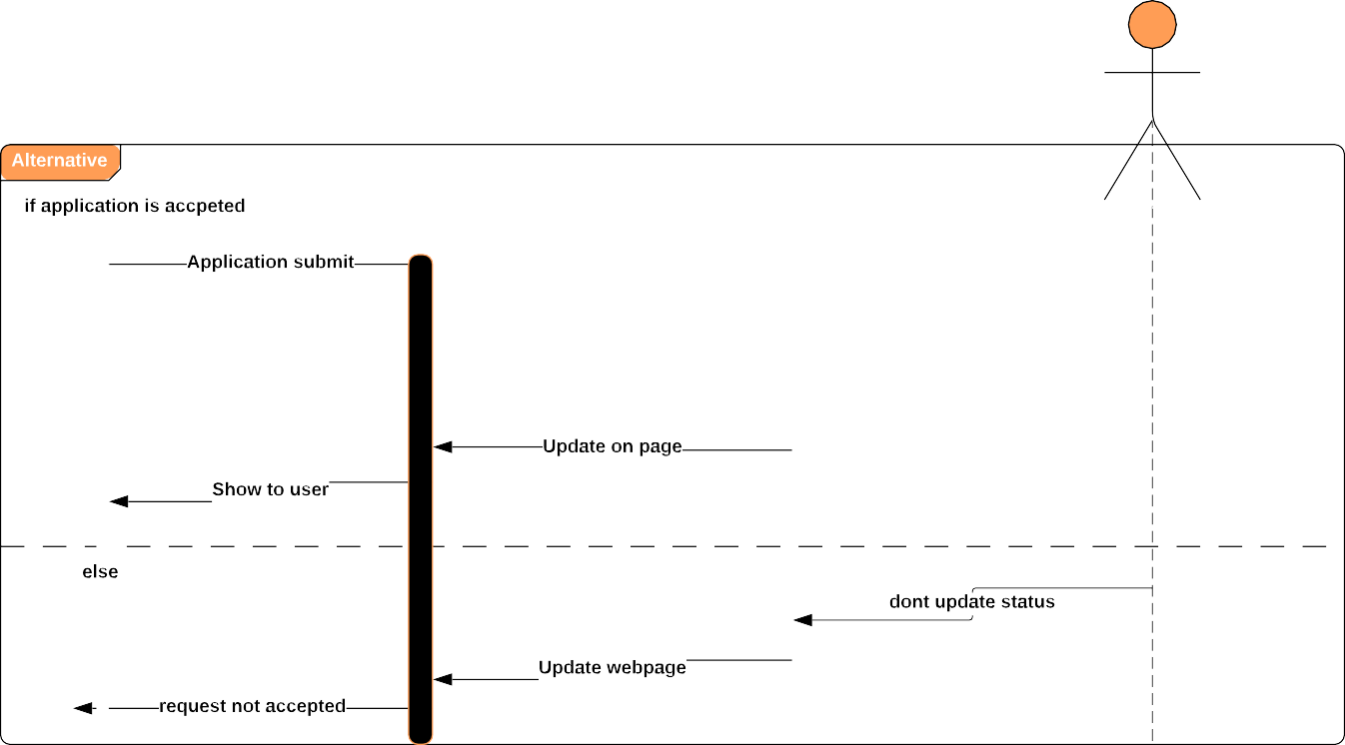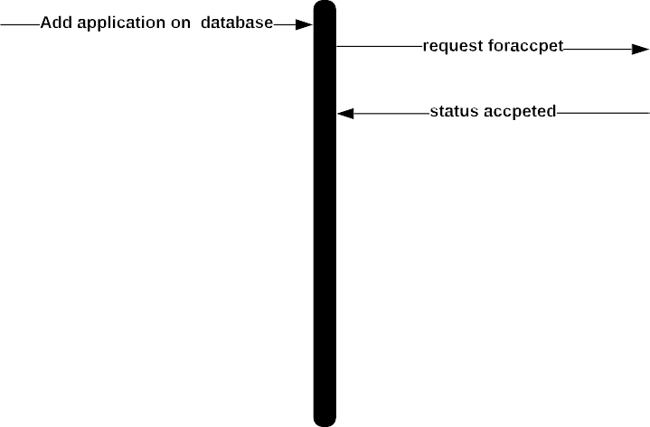

Fig: 8.5 Sequence Diagram 1 of MAAS

# System Evolution

The anticipated changes of our system are-

Attendance of the staff

This system will ensure attendance of the staff as it does for the students. As it holds the information of the staff so using this information it will ensure the attendance of the office staff and the lab assistance of the institute. It will hold the information when they arrived and when they left office. Again how many days they were absent in their working place. Their monthly report will be sent to the admin panels.

Non-Collegiate fee

As day by day online banking infrastructure is developing. Student who are in non-collegiate list will see their fine and deposit the money through online. And after depositing the required money they will become a collegiate student

Sms to the absent students

Whenever a class will be finished this system will figure out the absent students for the respected class and it will send a sms to their mobile phone about their absence

Produce admit card

After depositing all the fines the system will produce admit card for the collegiate students for each term exam. In order to produce admit card Non-collegiate students have to pay the fine or by showing any valid reason first they to become collegiate. Dis-collegiate students who fails to submit proper paper won’t be able to become collegiate and won’t be able to get admit card for the exam.

# Appendices

Appendix a1: Survey Data

These are the Data what we have collected from Google form Survey. We received over 50 responses

These are the questions and the feedback what we got from the stakeholders.

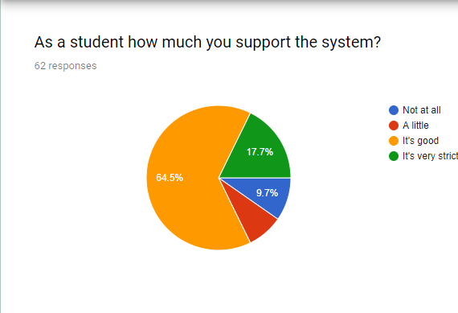

From this pie chart we can see 64.5 percent people supported the Automated Attendance System,17.7 percent people voted that it will be very strict and 9.7 person people did not supported the system at all.

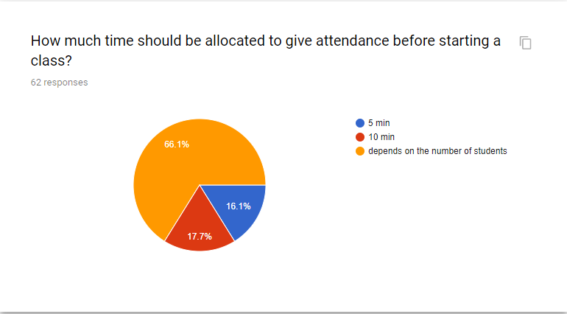

From this pie chart we can see that time allocation to give attendance was asked.66.1 percent stakeholder voted that time depends on the number of students,17.7 percent stakeholder voted for 10 minutes and rest voted for 5 minutes

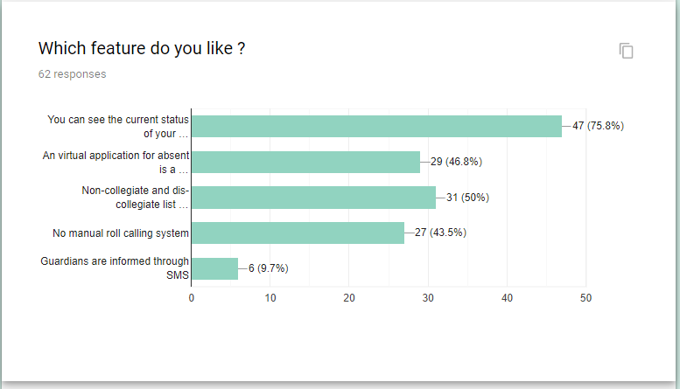

From this pie chart we can see that, Student will be able to see the current attendance status of him/her that feature is liked by most of the stakeholders

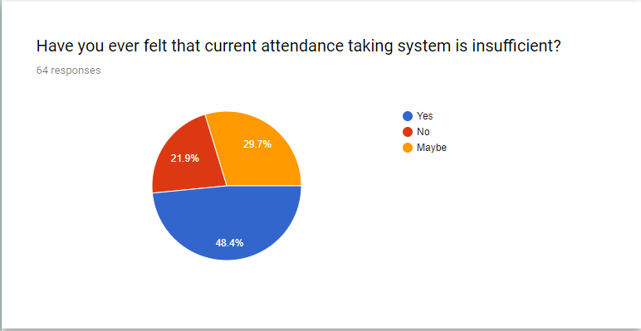

From this pie chart we can see that, 48.4 percent stakeholder voted that current attendance taking system is inefficient. 21.9 percent voted for no and rest are unsure about the judgement.

Appendix a2: Firebase

**FIREBASE** is a technology that allows you to make web applications with no server-side programming so that development turns out to be quicker and easier. It supports the web, iOS, OS X, and Android clients. Applications using Firebase can just utilize and control information, without thinking about how information would be put away, and synchronized crosswise over different examples of the application in real time. With Firebase, you don't need to stress over-provisioning servers or building REST APIs with just a little bit of configuration; you can allow Firebase to make a chance to take every necessary step: storing data, verifying users, and implementing access rules.

# Reference

[1] “How fingerprint scanners work - optical, capacitive, and other variants”. [Online]. Available: <https://www.androidauthority.com/how-fingerprint-scanners-work-670934/>.

[2] “Student Scheduling & Logistics Software Solutions”. [Online]. Available: https://www.schoolpass.com/product-tour/.

[4] Clavereau, M. (2011). Absence: time to tackle the root causes. Retrieved 15th October, 2013 from http://www.hrmagazine.co.uk Dale, M. R. (2005). A Process for Combining Structured Analysis and Object Oriented Design. Retrieved 10th February, 2013 from

[5] http://www.dtic.mil/ndia/systems/Rickman2.pdf. Dan, P. and Neil, P. (2005). UML 2.0 in a Nutshell. O'Reilly publication. ISBN: 0-596-00795-7. Dubin, C. (2011). "Biometrics: Hands Down, ID Management". Retrieved 30th March 2013 from

[6].http://proquest.umi.com/pqdweb?index=0&did=2277161341&SrchMode=1&sid=2&Fmt=6VInst=PROD&VTy pe=PQD&RQT=309&VName=PQD&TS=1304030671&clientId=13314. Hong, L., Wan, Y., and Jain, A. (1998). Fingerprint Image Enhancement algorithm and performance evaluation, Computer

[7] Journal of IEEE transactions pattern annulus machine intelligent, 20(8), pp. 777-789. Jianjiang, F. (2007). Combining minutiae descriptors for fingerprint matching, Pattern Recognition, pp. 342 – 352. Kadry, S. and Smaili, M. (2010). Wireless Attendance Management System Based on Iris Recognition. Scientific research essay. Retrieved 12th November, 2012 Kreimer, S. (2011). Matching the Right Patient to the right Record. Hospitals & Health Networks. Retrieved 12th November, 2012 from http://proquest. umi.

[8] http://www.smartcardalliance.org. Wayman, J. L., Jain, A. K., Maltoni, D., and Maio, D. (2005). Biometric Systems: Technology, Design and Performance Evaluation, New York: Springer Verlag. Yuihotakaishi (2011). Attendance Monitoring System Using Biometrics for Security Staff, studymode Inspiring.

[9] “Arduino Cookbook, 2nd Edition - O’Reilly Media”. [Online]. Available: <http://shop.oreilly.com/product/0636920022244.do>

[10] “Send Sensor Data to Firebase Real-Time Database - Hackster.io”. [Online]. Available: https://www.hackster.io/varuldcube100/send-sensor-data-to-firebase-real-time-database-4d6b83. [Accessed: 09-Oct.-2019].

# Index

Database, 4, 7

Firebase 4,12,13,32,33

Introduction, 4

Glossary, 4,5

Arduino, 12,13

Biometric 6,7,33

Requirements Discovery, 4

Sensor, 4,8,10,15,20,33,34

Sequence Diagram, 8, 12, 13

Sequence Diagram for Use Case 1, 12

Sequence Diagram for Use Case 2, 13

State diagram, 8, 9

System Architecture, 6

System Evolution, 14

System Model, 8

System Requirements, 7

System Requirements Specification, 7

Use case diagram, 8, 10

User Requirements, 5

Use-case Scenerio-1, 10

Use-case Scenerio-2, 11

References, 11