**Group No: 5**

**Group Members:**

A.H.M. Zobyer-201714013

Farzana Faruk Jhumu-201714023

Masrur Hasan Mahin-201714027

Md. Ariful Islam Tarek-201714030

Nafiz Imtiaz Khan-201714043

Sumaiya Nuha Mustafina-201714059

**Project Name: Automated Attendance System in MIST**

**Introduction:**

Biometrics is the technical term for body measurements and calculations. It refers to metrics related to human characteristics. Biometrics authentication (or realistic authentication) is used in computer science as a form of identification and access control. Biometrics provides added security. This can be incredibly beneficial when used in a work environment. Biometric terminals use advanced technology to scan fingerprints. With a biometric attendance system student’s attendance can be accurately logged.

Biometric attendance systems rely on multispectral imaging. For this, we use fingerprints sensors both inside and outside of a class room. They can accurately scan fingerprints. They look beyond the layers of grease, dirt, sweat, and moisture. Different wavelengths of light are used to enhance the quality of the data capture. The surface and subsurface of the fingerprint are stored by the system. There are two main components of the sensor. This includes the light source and an imaging system. The light illuminates the finger. The imaging system creates a digital imaging array. The fingerprint is then stored as a computer algorithm. One cannot retrieve the fingerprints from the system. This increases security.

Time theft and attendance abuse can be prevent by biometrics attendance System. Students may clock each other in or out. With biometric scanners, there is no way for a student to clock in or out another student. Also late coming tendency will be reduced.

**Goals:**

1. To ensure 100% secure attendance by biometrics technology.
2. To keep track of a student how much portion of a class he/she was physically present.
3. To reduce wastage of time during manual roll calling system.
4. To make it easy for both students and teachers to know about their attendance.
5. To reduce late coming tendency.

**Feature list:**

* the attendance using fingerprint
* keep track of number of student in the class
* keep track of which class is going on
* the sensor will entry the attendance between a certain time
* after each class update the attendance in database
* after completion of the course the eligibility to give exam will be shown
* fine will be calculated for a particular student
* average class attendance for a particular instructor will be shown
* application can be submitted through our system and teacher can validate/invalidate that assignment and according to that attendance will be counted

**Market Analysis:**

|  |  |  |  |  |  |
| --- | --- | --- | --- | --- | --- |
| Project Name | F1:  Giving attendance by scanning fingerprint | F2:  After each class attendance will be updated on database | F3:  Collegiate and Non-collegiate for a course will be generated for each student | F4: Sending SMS to the parent for following missed class | F5:  Both app and web application |
| SchoolPass | ✓ | ✓ |  | ✓ | ✓ |
| TeacherKit |  | ✓ |  | ✓ |  |
| MySchool |  | ✓ |  | ✓ | ✓ |
| Jolly Technologies | ✓ | ✓ |  | ✓ |  |
| Top Hat |  | ✓ |  |  |  |
| Our Project | ✓ | ✓ | ✓ | ✓ | ✓ |

**Project Plan :**

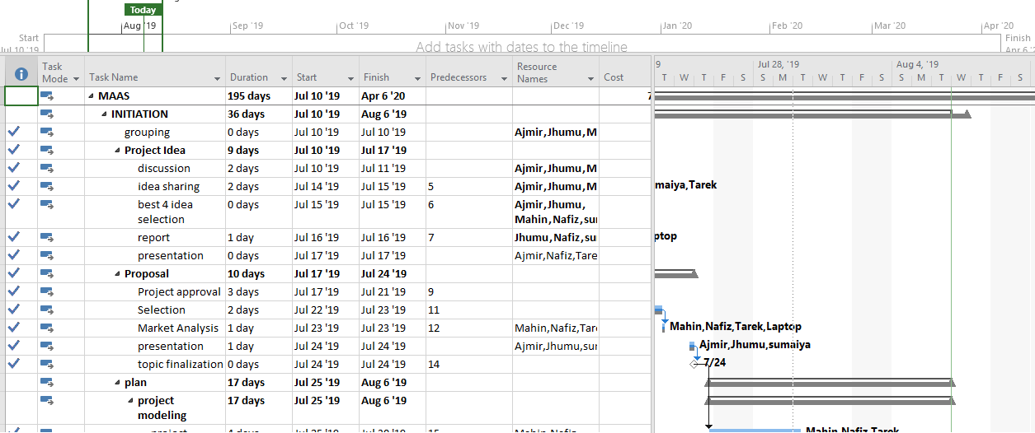

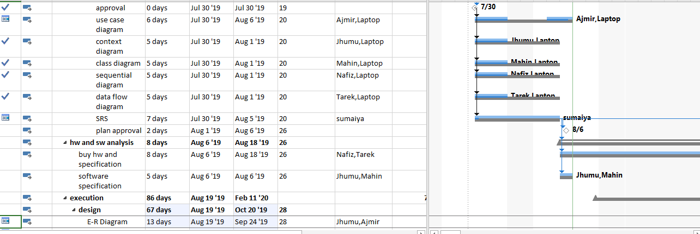

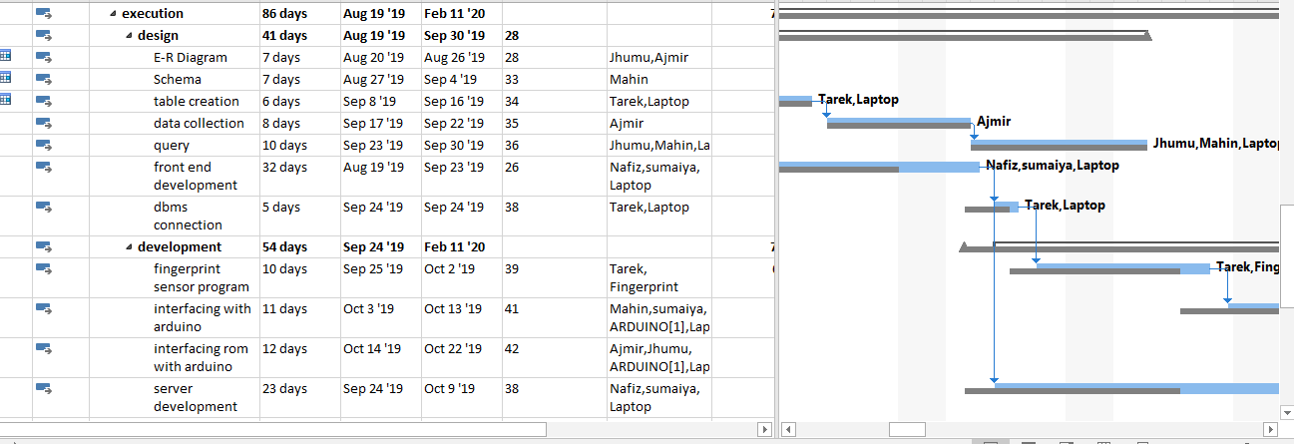

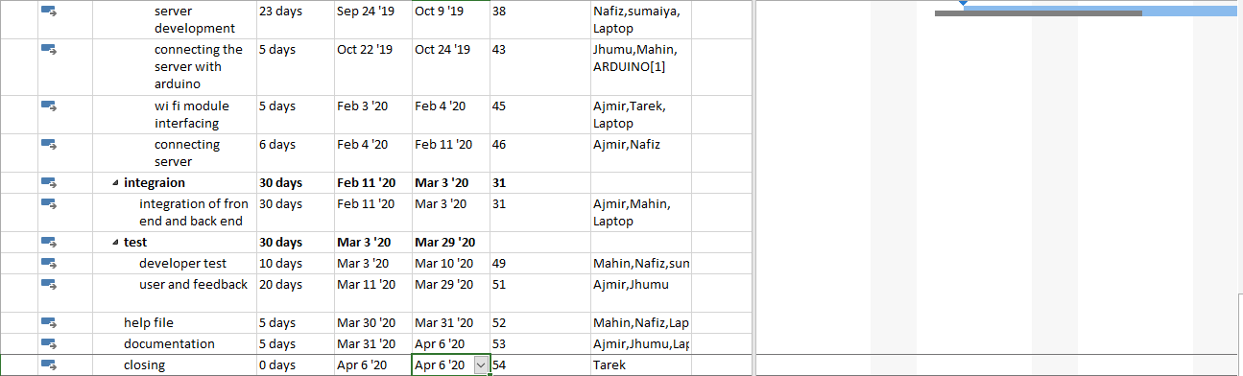

Milestone:

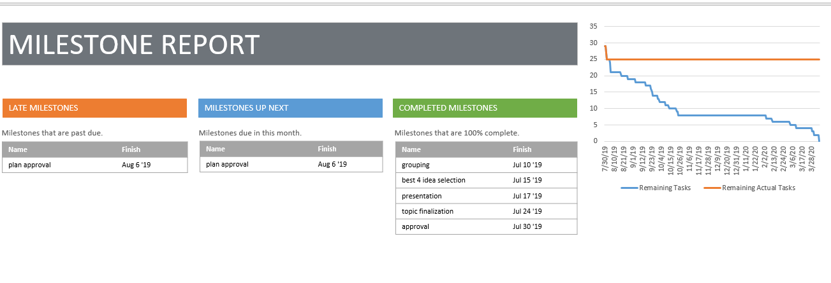

Critical Task:

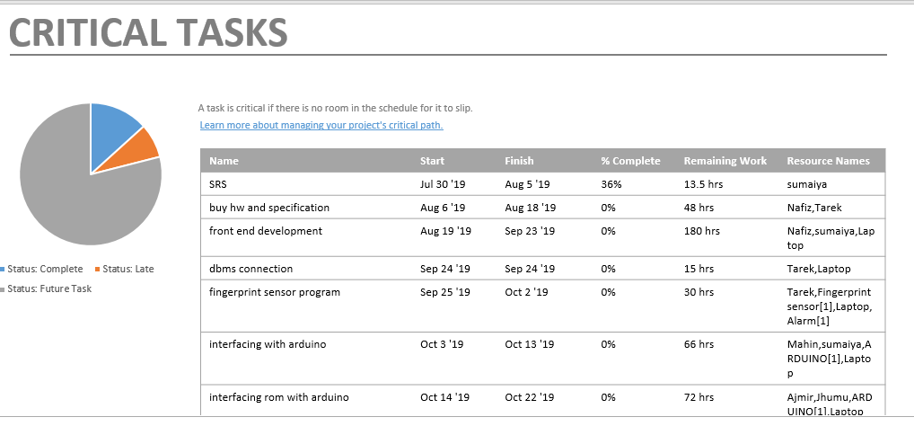

Cost Analysis:

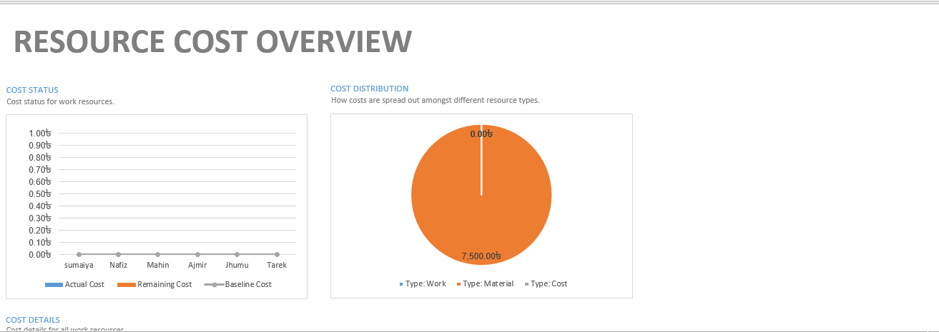

**Justification & motivation:**

* We have a limited time period for each class and taking attendance of all the students almost take 5 to 10 minutes . So the feature of taking the attendance using fingerprint will save us the 5 to 10 minutes each class. Also giving proxy is a common thing while giving attendance so we have been motivated to induce automated attendance system in MIST to solve these problems.
* Sometimes students give attendance and get out of the class without attending the whole class. So our project will have a feature of tracking physical presence of a student to ensure the complete presence of a student in a particular class hour.
* In MIST attendance is quite important. If a student fails to get a 90 percentage of attendance for at least one course then he or she has to provide her application forms and required documents (like prescription) signed by the head teachers and course coordinator and then has to submit the documents to respective course teachers, which is indeed a lengthy process and students have to face difficulties while approaching the faculty members at the busiest period of 13th and 14th week. So we are motivated to add such a feature where all the previously stated processes will be online based .