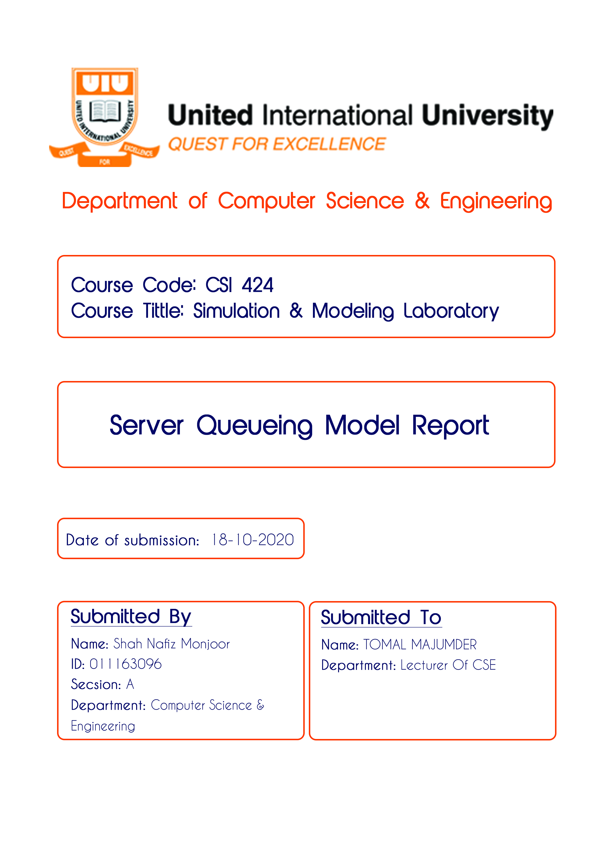

**Number of Delay for 10 customers**

|  |  |  |  |
| --- | --- | --- | --- |
| Performance Measure | FIFO | LIFO | SJF |
| Average Delay | 0.00228 | 0.0023 | 0.0023 |
| Expected Number of Customers in the queue | 0.0057 | 0.0057 | 0.0057 |
| Expected Utilization of the server-1 | 0.3715 | 0.3715 | 0.3715 |
| Expected Utilization of the server-2 | 0.2055 | 0.2056 | 0.2056 |

**Number of Delay for 50 customers**

|  |  |  |  |
| --- | --- | --- | --- |
| Performance Measure | FIFO | LIFO | SJF |
| Average Delay | 0.0139 | 0.0185 | 0.0139 |
| Expected Number of Customers in the queue | 0.0394 | 0.0525 | 0.0394 |
| Expected Utilization of the server-1 | 0.5349 | 0.5400 | 0.5349 |
| Expected Utilization of the server-2 | 0.2212 | 0.2160 | 0.2212 |



**Number of Delay for 100 customers**

|  |  |  |  |
| --- | --- | --- | --- |
| Performance Measure | FIFO | LIFO | SJF |
| Average Delay | 0.0436 | 0.0410 | 0.0354 |
| Expected Number of Customers in the queue | 0.1425 | 0.1337 | 0.1157 |
| Expected Utilization of the server-1 | 0.4618 | 0.4671 | 0.4598 |
| Expected Utilization of the server-2 | 0.3827 | 0.3775 | 0.3849 |

