Maman 23
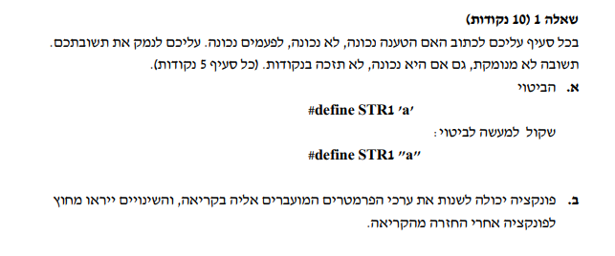
A: Not correct
#define STR1 ‘a’ - defines STR1 as a character literal (const char) while #define STR1 “a” defines it as a string literal (const char*).In the first case STR1 will be a single byte while in the second it will be a pointer to an array with two values (‘a’, ‘\0’).
B: Sometimes correct
If the function is called with pointers it can modify the values (not the pointers) however if values are passed directly the function receives copies that are held in the function’s stack scope and any modification will remain within that scope and be lost once the function returns.

