DOCUMENTATION
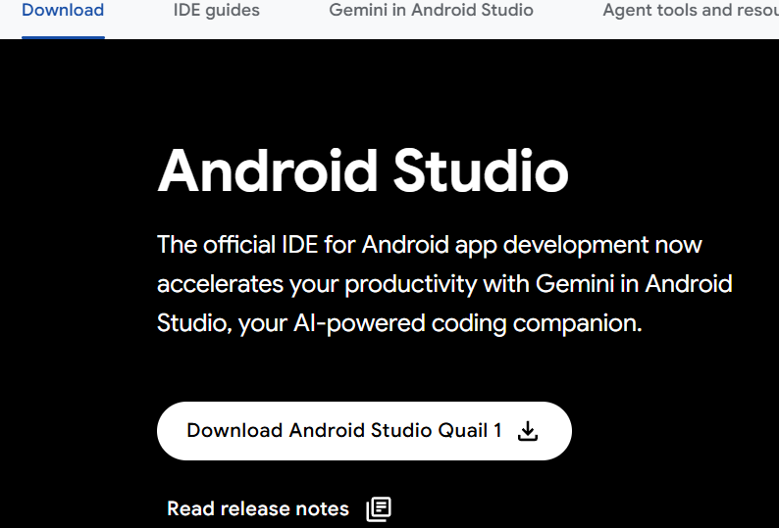Week ONE
Objectives
The main objectives of the project were:
- To familiarize with the Android Studio development environment.
- To design a simple and interactive user interface.
- To implement functionality for changing the application title.
- To allow users to modify the background color of the application.
- To enable adjustment of font size dynamically.
- To understand event-driven programming in Android development.
Activities Undertaken
1. Project Creation
A new Android Studio project was created and configured. The project structure was explored to understand the purpose of different folders and files, including layouts, resources, and Java/Kotlin source files.
2. User Interface Design
The graphical user interface was designed using XML layouts. Components added to the interface included:
- TextView for displaying the application title.
- EditText for entering a new title.
- Buttons for changing properties.
- Controls for selecting different background colors.
- Controls for increasing or decreasing font size.
3. Title Customization Feature
A feature was implemented to allow users to enter a custom title and update the displayed title dynamically when a button is clicked.
Functionality Implemented
- User enters new title text.
- Application validates input.
- TextView updates immediately with the new title.
4. Background Color Modification
Functionality was added to enable users to change the application's background color through button clicks or selection controls.
Features Implemented
- Multiple color options.
- Instant background color updates.
- Improved user interaction and visual feedback.
5. Font Size Adjustment
The application was enhanced to allow users to increase or decrease the font size of the title text.
Features Implemented
- Font size increase button.
- Font size decrease button.
- Real-time text resizing.
6. Testing and Debugging
The application was tested on the Android emulator and physical devices to ensure all customization features worked correctly. Any errors encountered during development were identified and resolved.
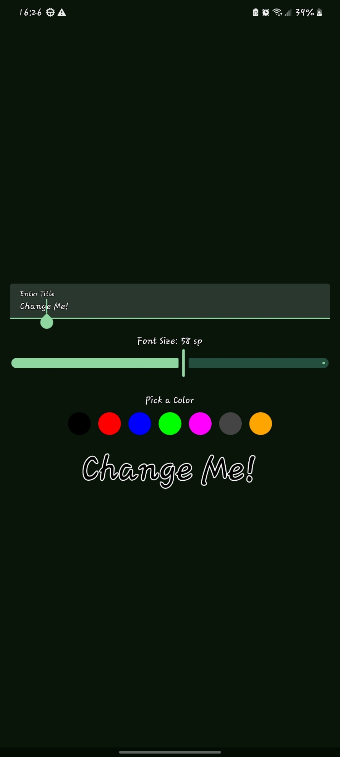
WEEK 2: DEVELOPMENT OF THE STUDENT REGISTRATION SYSTEM
Activities Undertaken
1. Login Page Development
A login interface was designed and implemented to provide secure access to the application. The login page includes username and password input fields as well as a login button. Basic validation was implemented to ensure that users cannot proceed without entering the required credentials.
Features Implemented
- Username input field
- Password input field
- Login button
- Input validation for empty fields
- User authentication workflow
2. Student Registration Module
A student registration form was developed to capture and manage student information. The form allows users to enter student details and save them within the application.
Student Information Captured
- Student ID
- Full Name
- Email Address
- Phone Number
- Course/Program
Features Implemented
- Data entry form
- Validation of required fields
- Save functionality
- Error handling for invalid inputs
3. Local Database Integration
To ensure that student records are retained even after the application is closed, local data storage functionality was implemented. SQLite/Room Database was selected for storing student information securely on the device.
Database Operations Implemented
- Create student records
- Read student records
- Update existing records
- Delete records
4. Navigation Design
Simple navigation was introduced to enhance usability and improve user experience. The navigation structure enables users to move efficiently between the main sections of the application.
Navigation Structure
- Login Screen
- Dashboard/Home Screen
- Student Registration Screen
- Student Records Screen
5. User Interface Enhancement
Material Design principles were applied to create a clean and user-friendly interface. Layouts, buttons, text fields, and notifications were designed to improve accessibility and overall user experience.
Improvements Made
- Consistent application theme
- Responsive layouts
- User-friendly forms
- Success and error notifications
WEEK 3: USER INTERFACE (UI) PROTOTYPE DEVELOPMENT
1. User Interface Planning
The system requirements were analyzed to determine the necessary screens and user interactions. Wireframes and layout designs were created before implementation.
2. Development of Five Application Screens
Five key screens were designed and implemented to represent the major functionalities of the system.
Screens Developed
- Login Screen
  - User authentication interface.
  - Username and password input fields.
  - Login button.
- Dashboard/Home Screen
  - Central navigation point.
  - Quick access to major system functions.
- Student Registration Screen
  - Form for entering student details.
  - Data validation controls.
- Student Records Screen
  - Displays saved student records.
  - Provides access to record management functions.
- Profile/Settings Screen
  - Allows management of user preferences and system settings.
3. Navigation Implementation
Navigation functionality was implemented to allow seamless movement between screens. Users can easily access different sections of the application without confusion.
Navigation Features
- Screen-to-screen transitions.
- Intuitive navigation controls.
- Consistent user experience throughout the application.
- Reduced complexity in accessing system functions.
4. Responsive Design Development
The interface was designed to adapt to different device screen sizes and orientations. Layouts were optimized to maintain usability and appearance across multiple Android devices.
Responsive Design Features
- Flexible layouts.
- Proper component alignment.
- Consistent display on various screen resolutions.
- Improved accessibility and readability.
5. Modern User Interface Design
Modern design principles were applied to create an attractive and professional-looking application.
UI Enhancements
- Clean layout structure.
- Consistent color scheme.
- Material Design components.
- Well-organized buttons and input fields.
- Improved visual hierarchy and readability.
6. Functional Forms Implementation
Interactive forms were developed to collect user input and support system operations.
Form Features
- Input validation.
- Error handling mechanisms.
- User-friendly data entry fields.
- Clear labels and instructions.
- Submission functionality.

