ASSIGNMENT-6.5
AI-ASSISTED CODING
NAME :SALENDRA NAGARAJU
HALL TICKET NO:2303A51361
BATCH :20
TASK:1
Use an AI tool to generate eligibility logic.
#prompt:
Generate Python code to check voting eligibility based on age and
Citizenship.
Code:
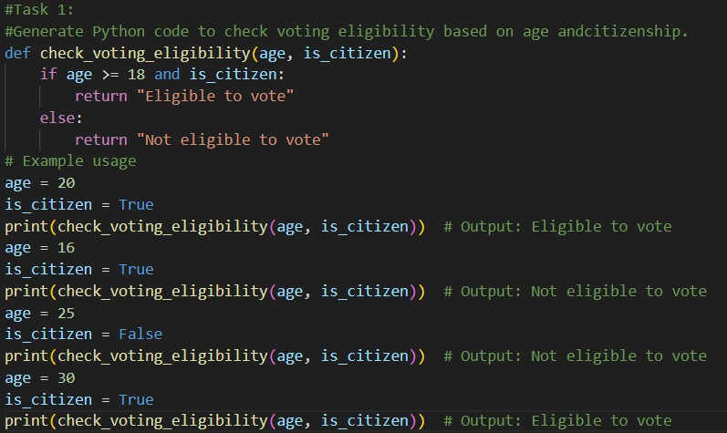
Output:
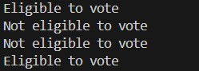
Observation:
The AI-generated voting eligibility program determines eligibility based solely on age and citizenship. While the logic correctly enforces the minimum age requirement and citizenship condition, it lacks input validation and does not handle invalid or unexpected user inputs. Additionally, the system does not account for exceptional cases or regional voting rules, limiting its reliability and suitability for real-world.
Task:2
Use an AI tool to process strings using loops.
Prompt:
Generate Python code to count vowels and consonants in a string using a loop.
Code:
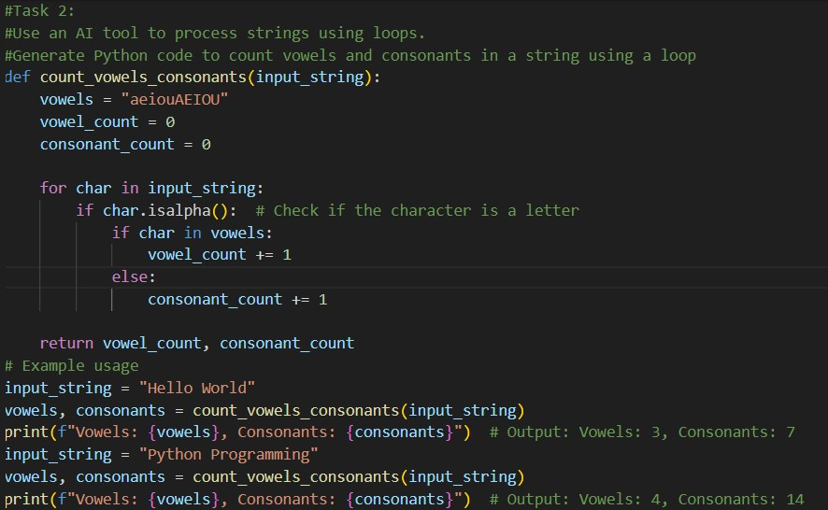
Output:
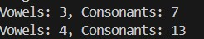
Observation:
The AI-generated program correctly counts the number of vowels and consonants in a given string using a loop. It converts the input to lowercase to ensure case-insensitive comparison and uses isalpha() to ignore non-alphabetic characters. However, the program does not handle special cases such as empty input or accented characters, which may limit its accuracy in broader real-world scenario.
Task 3:
Use an AI tool to generate a complete program using classes, loops, and conditionals.
Prompt:
Generate a Python program for a library management system using classes, loops, and conditional statements.
Code:
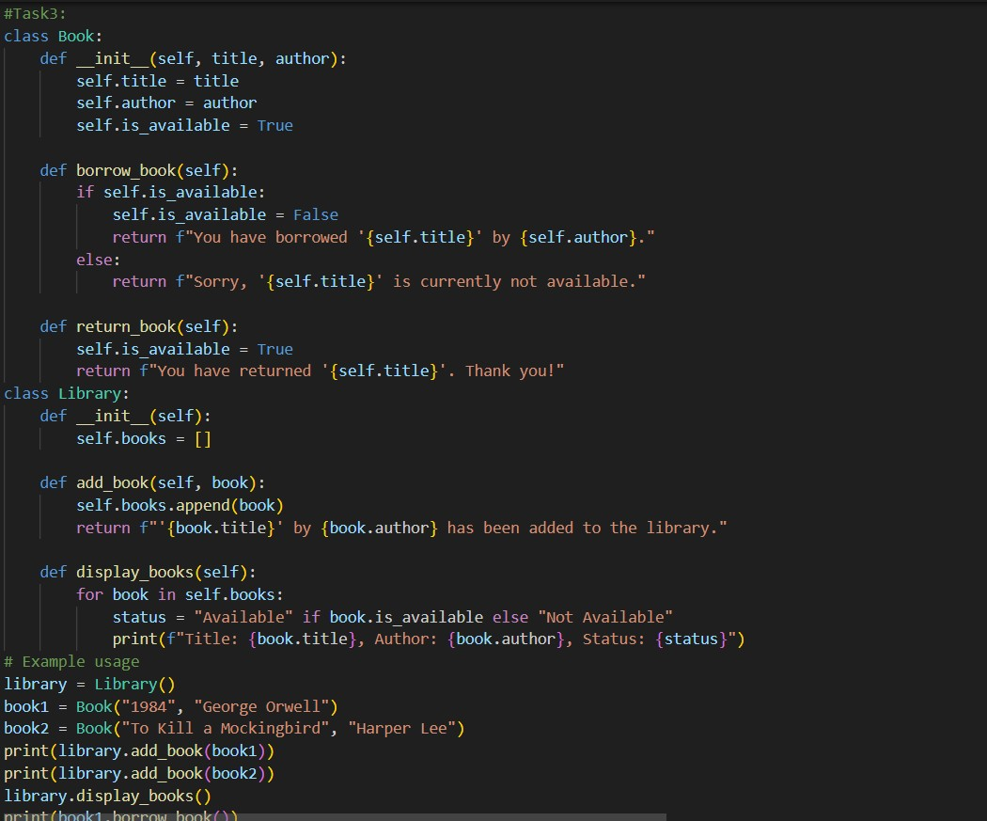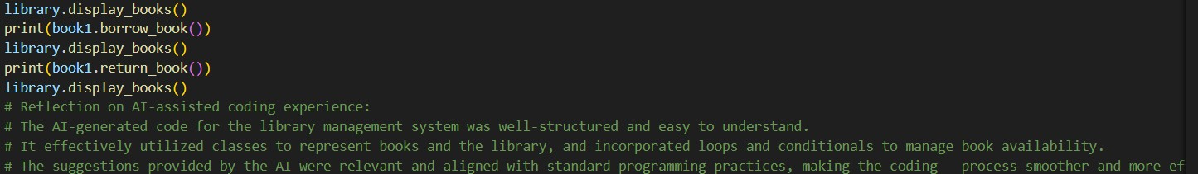
Output:
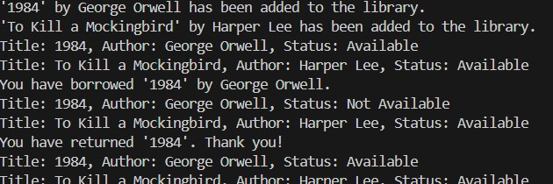
Observation:
The AI-generated library management system effectively demonstrates object-oriented programming by using separate Book and Library classes to manage books and their availability. It provides basic functionalities such as adding books, displaying available books, borrowing, and returning books through a menu-driven interface. However, the system lacks input validation, does not handle duplicate book titles, and does not persist data between runs, which limits its scalability and suitability for real-world library applications.
Task 4:
Use an AI tool to generate an attendance management class.
Prompt:
Generate a Python class to mark and display student attendance using loops.
Code:
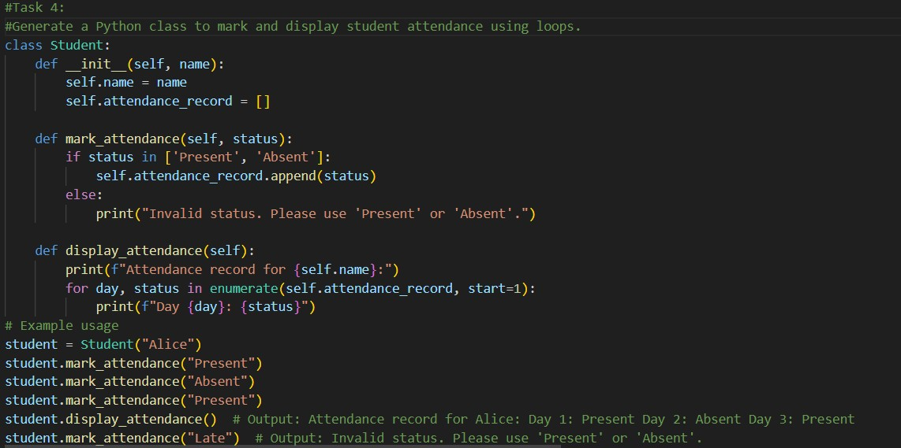
Output:
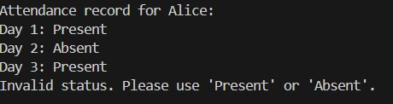
Observation:
The AI-generated student attendance system uses an object-oriented approach to record and track attendance for a student. It allows attendance to be marked day by day with basic input validation and accurately calculates the number of days present out of the total days. However, the system is limited to a single student, does not store attendance records persistently, and lacks support for attendance analysis such as percentages or multiple students, reducing its applicability in real-world academic environments.
Task:5
Use an AI tool to complete a navigation menu.
Prompt:
Generate a Python program using loops and conditionals to simulate an ATM menu.
Code:
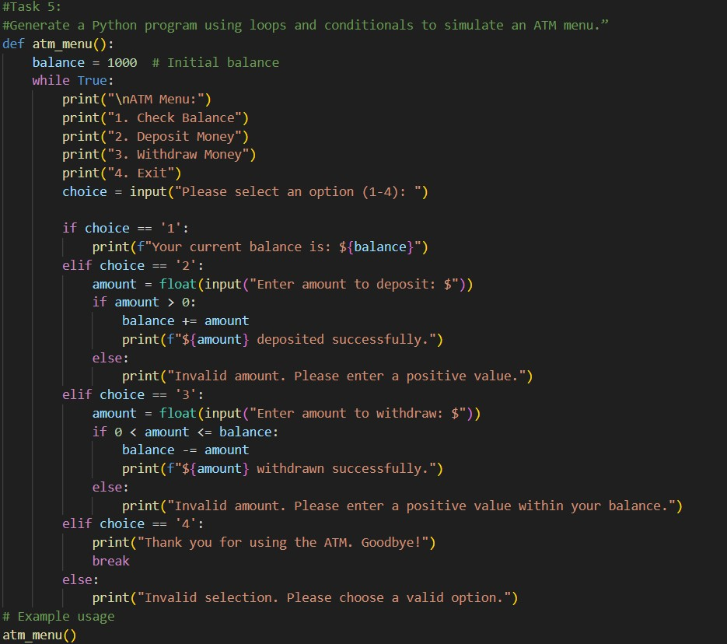
Output:
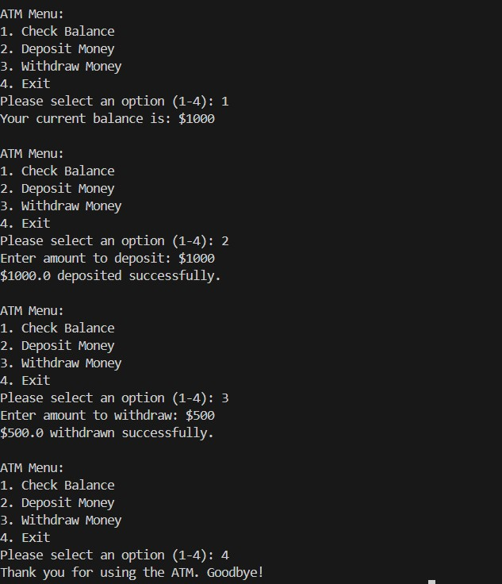
Observation:
The AI-generated ATM simulation program provides basic banking operations such as checking balance, depositing money, and withdrawing money through a menu-driven interface. It correctly updates the account balance and includes simple validation for deposit and withdrawal amounts. However, the system lacks user authentication, exception handling for invalid numeric inputs, transaction history, and data persistence, making it unsuitable for real-world banking applications.

