**COMPUTER NETWORKS**

**LAB – 1**

Name: Naga Tharun Makkena

Roll No: SE20UCSE105

Section: CSE-2

1. **Wireshark_Intro_v7.0 lab sheet**

--------------------------------------------------------------------------------------------------------------------------------------



Ans: TCP

HTTP

TLSv1.2

DNS

MDNS

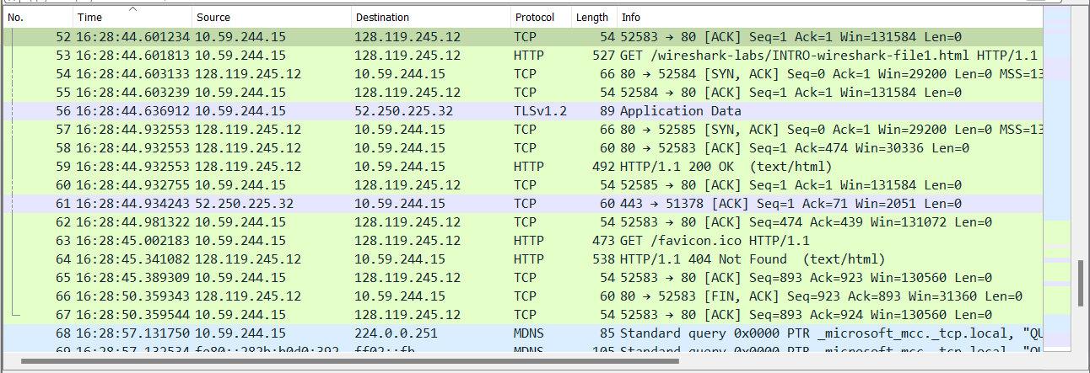

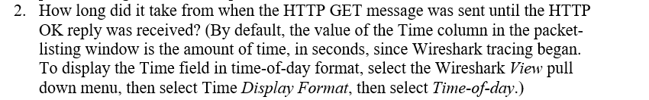

Ans: HTTP GET: 16:28:44.601813

HTTP OK: 16:28:44.932553

Time difference: 0.33074 seconds

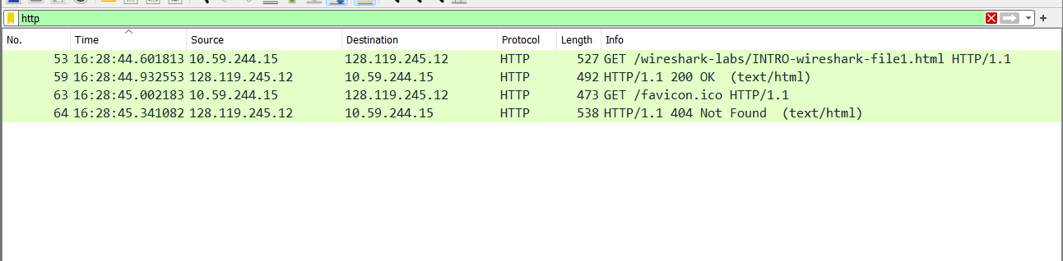



Ans: Internet address of the gaia.cs.umass.edu: 128.119.245.12

Internet address of my computer: 10.59.244.15

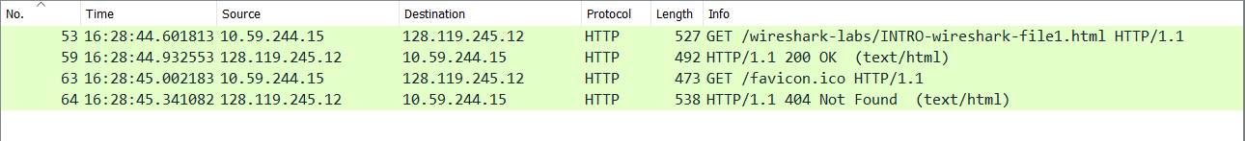

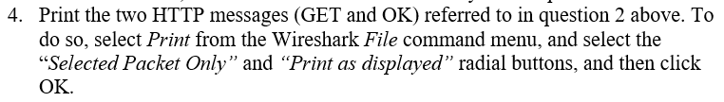

Ans:

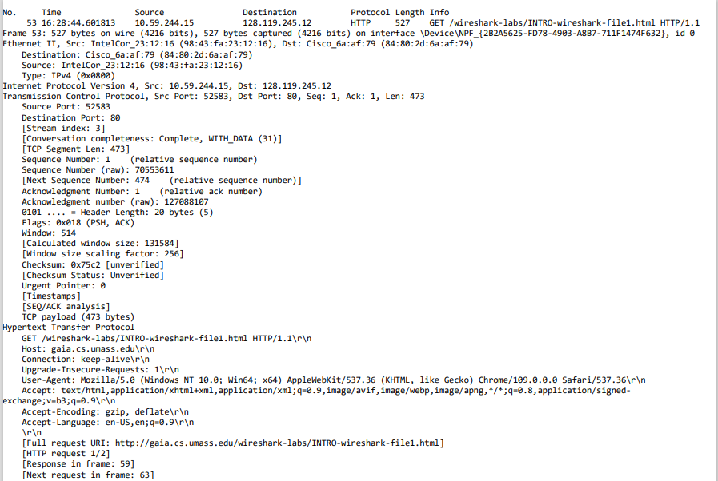

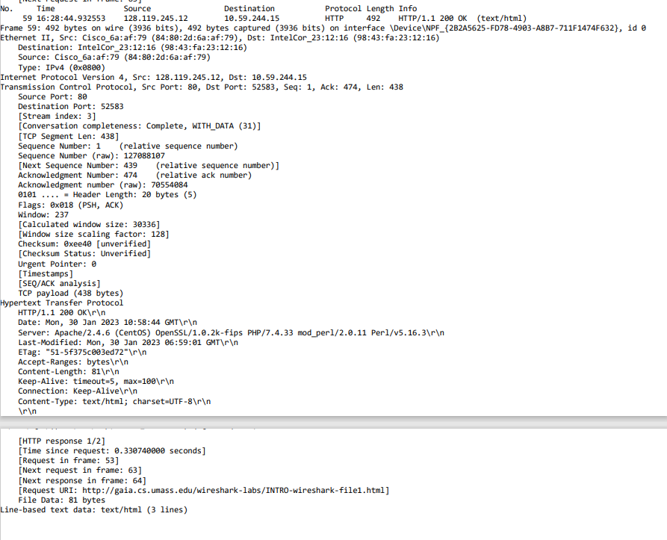

1. **Wireshark_ICMP_v7.0 lab sheet**

--------------------------------------------------------------------------------------------------------------------------------------

[**www.ust.hk**](http://www.ust.hk) **gave “Request timed out” multiple times. So used ping command on 1.1.1.1**

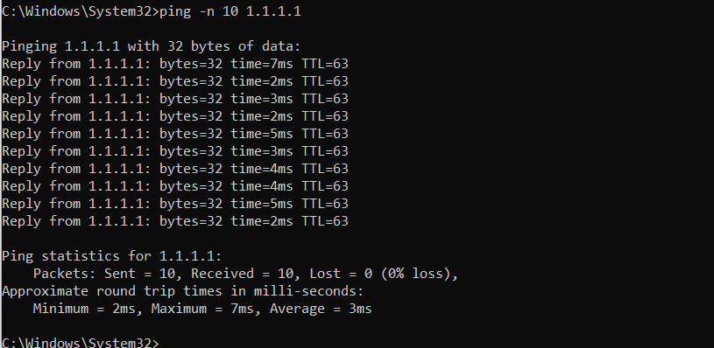



Ans: IP address of my host: 10.59.244.15

IP address of the destination host: 1.1.1.1

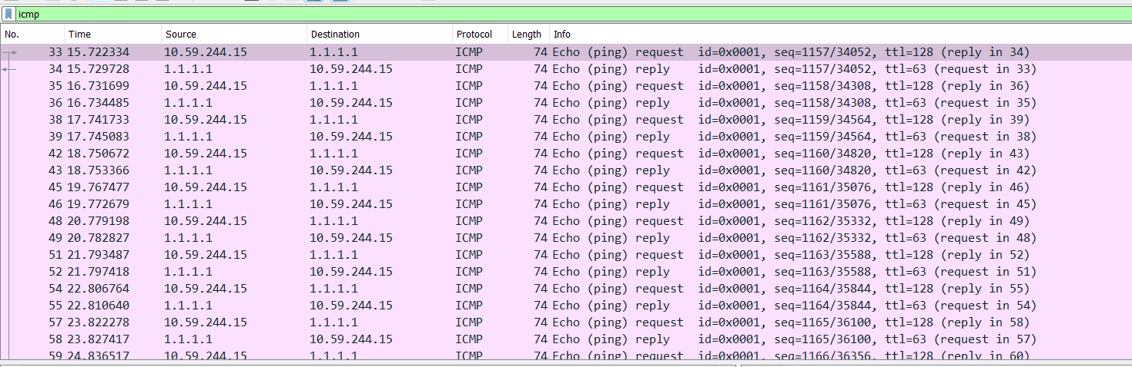



Ans: The ICMP packet is designed to communicate network-layer information between the hosts and the routers but not between the application layer processes. Because of this, the ICMP packet does not have source and destination port numbers. Each ICMP packet has “Type” and “Code” values. These values identify the specific message being received. Since the network software itself interprets all ICMP messages, no port numbers are required to direct the ICMP messages to an application layer process.

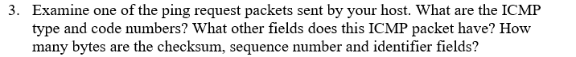

Ans: For a ping request packet:

ICMP Type: 8

ICMP Code: 0

The ICMP packet has Checksum, Identifier, Sequence Number, Data fields.

The checksum, sequence number, identifier fields are **two bytes**.

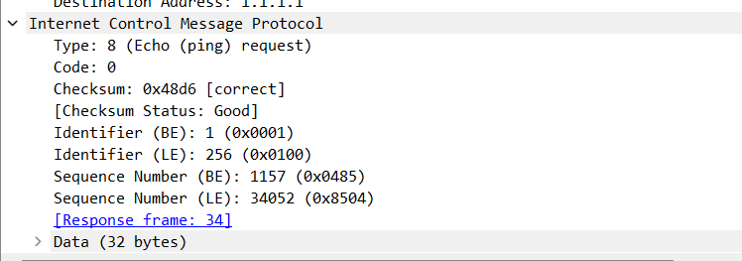

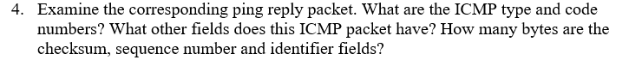

Ans: For a ping reply packet:

ICMP Type: 0

ICMP Code: 0

The ICMP packet has Checksum, Identifier, Sequence Number, Data fields.

The checksum, sequence number, identifier fields are **two bytes**.

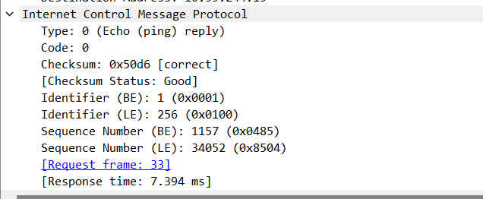

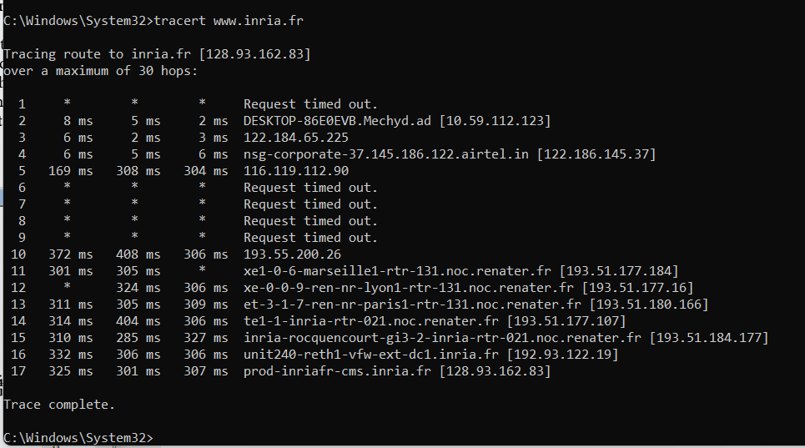



Ans: IP address of my host: 10.59.244.15

IP address of the target destination host: 128.93.62.83





Ans: **No**, if ICMP sent UDP packets instead, then IP protocol number will be **0x11**.



Ans: The ICMP echo packet has the same fields similar to ICMP ping query packets (data visible in question 3 of this lab).

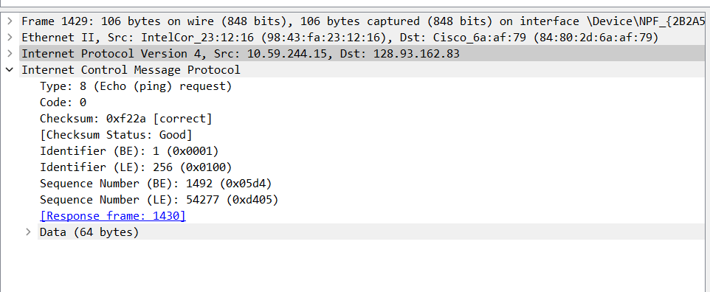



Ans: The fields include the **header of the failed IP pack**et and **first 64 bits of the failed IP packet.**



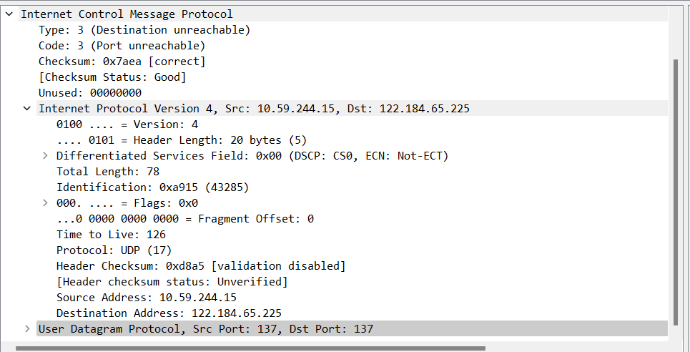



Ans: The last three ICMP packets received by the source host are marked in grey shade.

These packets are ICMP are of message **Type: 0** which are **echo reply packets**.



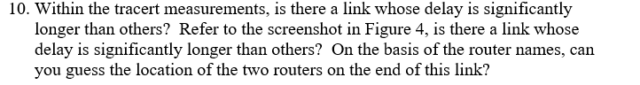

Ans: There is a significant delay from **step 4 to step 5** which is longer than others. This can be due to the hop between two countries.

