**Computer Networks Lab Assignment 9**

1. Implementation of UDP Server-Client model using C or C++.

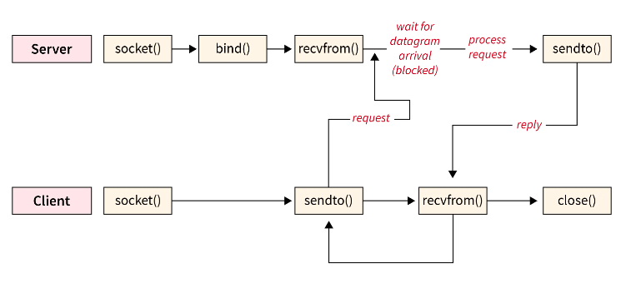

UDP Server-Client Model