High Performance Computing
Quiz
Report

Team No: 9
Team Members:
Anirudh Chimpidi – SE20UCSE019
Naga Tharun Makkena – SE20UCSE105
Sri Harsha Vandanapu - SE20UCSE184
Rohan Potta - SE20UCSE145
Dhanush Bommavaram - SE20UCSE039

Matrix Chain Multiplication
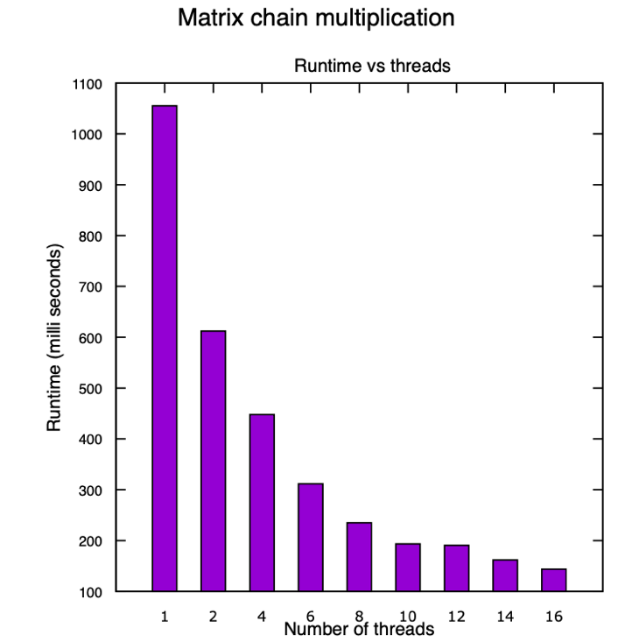

Here, min_number_multiplications is called multiple times with different number of threads, we can observe that as the number threads increases runtime decreases. The decrease is also exponential (approx.). This parallelization was made possible by using #pragma omp parallel for applied to the inner for loop in the code.

