High Performance Computing
Assignment-3
Report

Team No: 9
Team Members:
Anirudh Chimpidi – SE20UCSE019
Naga Tharun Makkena – SE20UCSE105
Sri Harsha Vandanapu - SE20UCSE184
Rohan Potta - SE20UCSE145
Dhanush Bommavaram - SE20UCSE039

Q1) Threshold
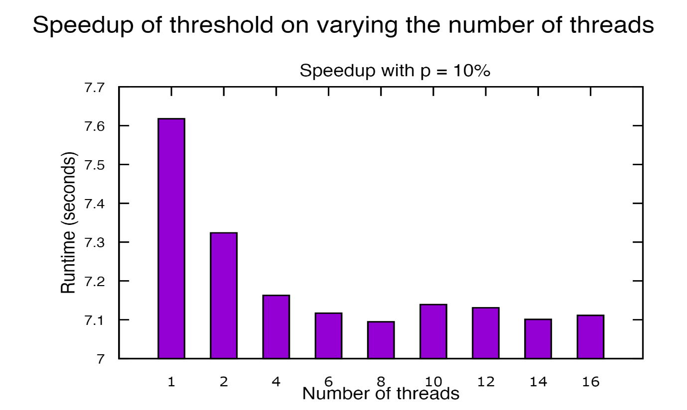
Here, we can observe that by keeping the size of the array of the rows and columns as 1024, 2048, 4096 and 8192 and keeping the threshold value as 10, we can notice the speed up when changing the threads from 1, 2, 4; however, once we make the number of threads close to 8, 10, 12, 14, 16 we don’t see much of a speed up as the graph remains almost constant.

Q2) Matrix Chain Multiplication
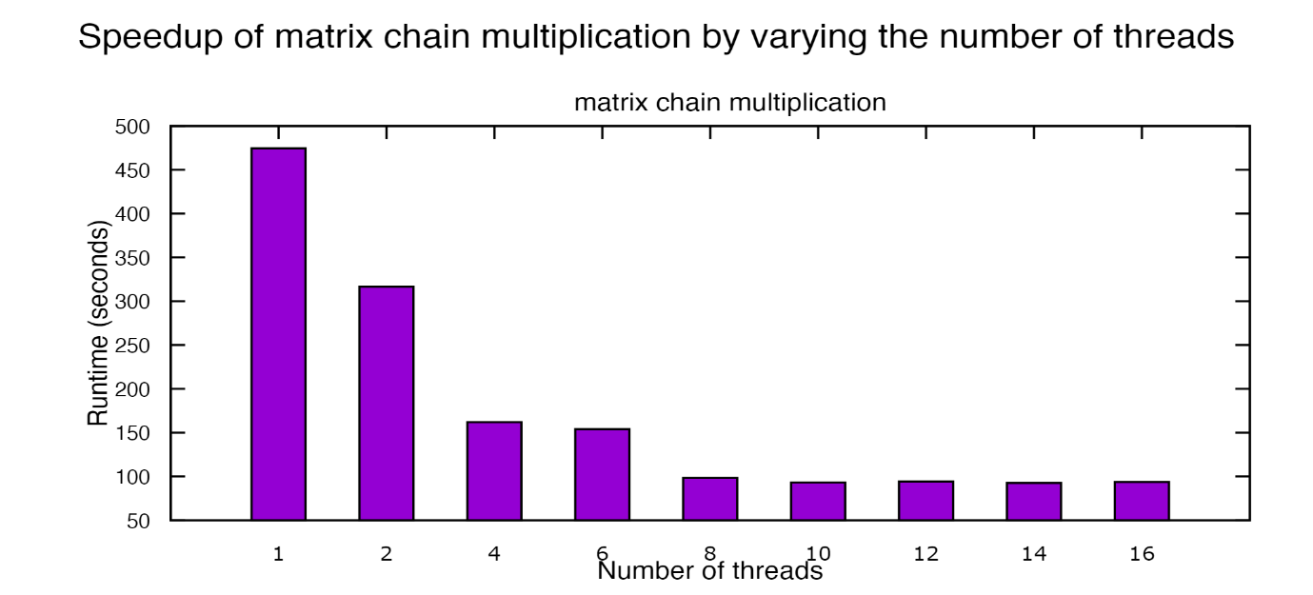
Here we took the number of matrices(n) as ten and the dimension as 1000.
The graph shown above shows that the speed-up is tremendous across threads 1 and 2. However, as we come towards threads 4, 6, 8, 10, 12, 14, 16 there is a marginal difference, and this was done as the main objective to achieve this speed up was to try and increase and maximize the number of cache hits possible.

Q3) Game of Life
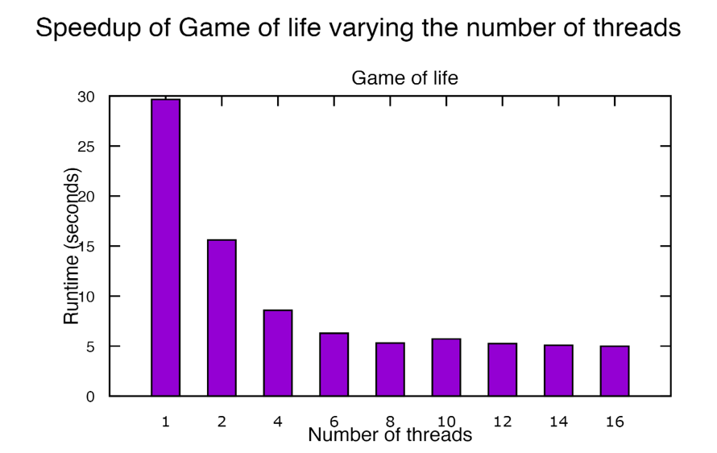
First, for the input, we created a file that would make a random seed file based on the user input of the rows and the columns.
Then using that seed file as the input, we then take in and apply the game of life rules onto the board and return the final answer.
From the graph, we can see that the speed-up is exponential (near threads 1, 2, 4, 6) and flatlines out towards 8, 10, 12, 14, 16 and this is because the space allocation takes time, and it becomes difficult to achieve more speed-up.

