Report on Different Synchronization Algorithms
For a same no of threads execution, similar operations we calculated the throughputs of different synchronization algorithms and below is the trend we observed. We can see coarse gain is bad in terms of throughput but it is easiest to implement. And optimistic is better as we are only locking the nodes that are required to modify, as it enables parallel, concurrent execution. Lazy list also performs good but there is a overhead of flag value.
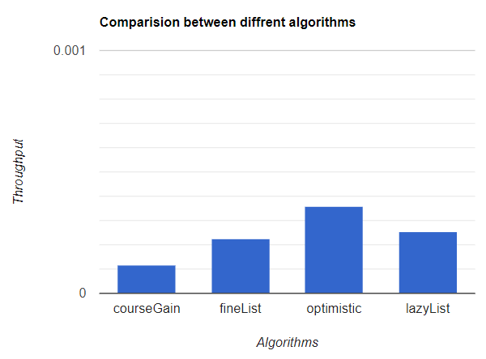
In coarse gain as we can see below there is no much difference in throughput for increase in no of threads as we are locking head when one thread is accessing it, there is no concurrency as a result it doesn’t yield better performance.
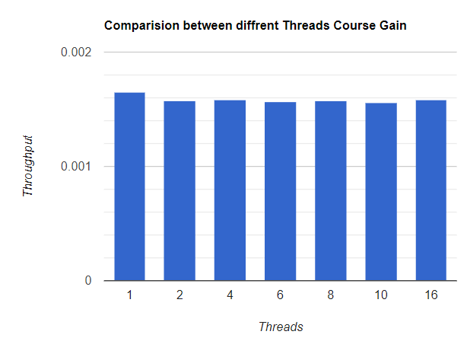

Whereas in optimistic synchronization we can see as the number of threads increasing, we can observe throughput increasing as one thread is not blocking another.
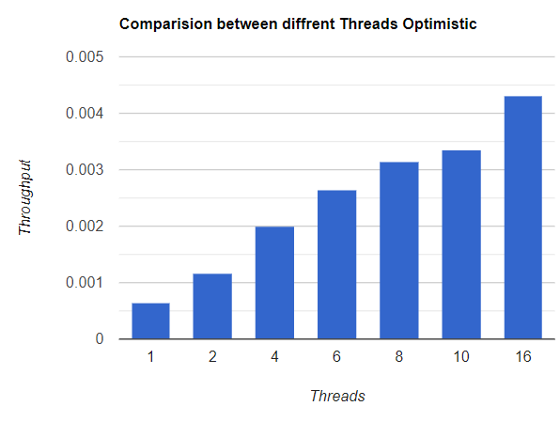
We can say overall implementation wise coarse gain is better, but to achieve parallel execution and use multi-threading effectively Optimistic is best, If we are okay to bear memory over head we can also use lazy list as It is also performing better than coarse gain, fine gain.

