**A Project Report**

**On**

**Healthcare Optimization Solution**

**Submitted In accordance with the requirement for the degree of**

**BACHELOR OF TECHNOLOGY**

**INFORMATION TECHNOLOGY**

**Under the Esteemed Guidance of**

**Mr. B.V V H CHANDRA SEKHAR** M.Tech., (Ph.D.).,

**ASSISTANT PROFESSOR**

**Submitted by**

**KAKUMANU NAGA VIJAY SHEKAR (218X1A1255)**

**SANAM VEERA VENKATA MANI SANKAR (218X1A1259)**

**CHALLA SIVA PRAKASH (218X1A1206)**

**SHAIK JOHN USSMAN (218X1A1233)**



**DEPARTMENT OF INFORMATION TECHNOLOGY**

**KALLAM HARANADHAREDDY INSTITUTE OF TECHNOLOGY  
(AUTONOMOUS)**

**Approved by (AICTE, New Delhi; Permanently Affiliated to JNTU KAKINADA)**

**Accredited by NAAC with an ‘A’ Grade**

**NH – 16, Chowdavaram, Guntur – 522019 (A.P)**

**ACADEMIC YEAR: 2024-2025**

**HOSPITAL OPTIMIZATION SOLUTION**

**Project Overview:**

Healthcare Optimization Solution is a comprehensive solution designed to enhance the patient experience and streamline administrative tasks within a healthcare facility. The app aims to provide admin and patients with easy access to information about doctor availability, bed availability, and use for appointment booking, improving overall patient care and track all the operational efficiency.

**Objectives:**

* Real Time Salesforce Project
* Data Modelling
* Creating an application
* User Interface Customization
* Object & Relationship in Salesforce
* Formula fields and Validation rules.
* Conditional formatting.
* Reports & Dashboards.
* Apex.
* Visualforce.

**Salesforce Key Features and Concepts Utilized:**

* **Creation of Object:**

Salesforce objects are database tables that permit you to store data that is specific to an organization. What are the types of Salesforce objects

Salesforce objects are of two types:

1. **Standard Objects**: Standard objects are the kind of objects that are provided by salesforce.com such as users, contracts, reports, dashboards, etc.
2. **Custom Objects**: Custom objects are those objects that are created by users. They supply information that is unique and essential to their organization. They are the heart of any application and provide a structure for sharing data.

* **Fields and Relationships:**

Fields represent the data stored in the columns of a relational database. It can hold any valuable information that you require for a specific object. Hence, the overall searching, deletion, and editing of the records become simpler and quicker.

Types of Fields

1. **Standard Fields:** Standard Fields are the predefined fields in Salesforce that perform a standard task. The main point is that you can’t simply delete a Standard Field until it is a non-required standard field.
2. **Custom Fields:** Custom Fields are highly flexible, and users can change them according to requirements. Moreover, each organiser or company can use them if necessary. Hence, the final decision depends on the user, and he can add/remove Custom Fields of any given form.

* **Apex and Visualforce Page:**

Apex is a strongly typed, object-oriented programming language that allows developers to execute flow and transaction control statements on the Lightning platform server in conjunction with calls to the Lightning Platform? API. Using syntax that looks like Java and acts like database stored procedures, Apex enables developers to add business logic to most system events, including button clicks, related record updates, and Visualforce pages. Apex code can be initiated by Web service requests and from triggers on objects.

* **Tabs:**

A tab is like a user interface that is used to build records for objects and to view the records in the objects.

**Types of Tabs:**

1. **Custom Tabs:** Custom object tabs are the user interface for custom applications that you build in salesforce.com. They look and behave like standard salesforce.com tabs such as accounts, contacts, and opportunities.
2. **Web Tabs:** Web tabs make it easier for your users to quickly access content and applications they frequently use without leaving the salesforce.com application.
3. **Visualforce Tabs:** Visualforce Tabs are custom tabs that display a Visualforce page. Visualforce tabs look and behave like standard salesforce.com tabs such as accounts, contacts, and opportunities.
4. **Lightning Component Tabs:** Lightning Component tabs allow you to add Lightning components to the navigation menu in Lightning Experience and the mobile app.
5. **Lightning Page Tabs:** Lightning Page Tabs let you add Lightning Pages to the mobile app navigation menu. Lightning Page tabs don't work like other custom tabs. Once created, they don't show up on the all tabs page when you click the Plus icon that appears to the right of your current tabs.

* **The Lightning App:**

An app is a collection of items that work together to serve a particular function. In Lightning Experience, Lightning apps gives users access to sets of objects, tabs, and other items all in one convenient bundle in the navigation bar. Lightning apps let you brand your apps with a custom color and logo. You can even include a utility bar and Lightning page tabs in your Lightning app. Members of your org can work more efficiently by easily switching between apps.

* **User Adoption:** As a new Administrator, you perform user management tasks like creating and editing users, resetting passwords, granting permissions, configuring data access, and much more.
* **Report:** Reports give you access to your Salesforce data. You can examine your Salesforce data in almost infinite combinations, display it in easy-to-understand formats, and share the resulting insights with others. Before building, reading, and sharing reports, review these reporting basics.
* **Dashboards:** Dashboards help you visually understand changing business conditions so you can make decisions based on the real-time data you’ve gathered with reports. Use dashboards to help users identify trends, sort out quantities, and measure the impact of their activities.

**Detailed Steps to Solution Design:**

1. **Creation Of Objects:**
2. **Patient Object:**

* From the setup page >> Click on Object Manager >> Click on Create >> Click on Custom Object.
* Enter the label name >> Patient

Plural label name>>Patients

* Enter Record Name Label and Format

Record Name >>Patient name

Data Type >> Text

* Click on allow reports.
* Allow Search >> Save.

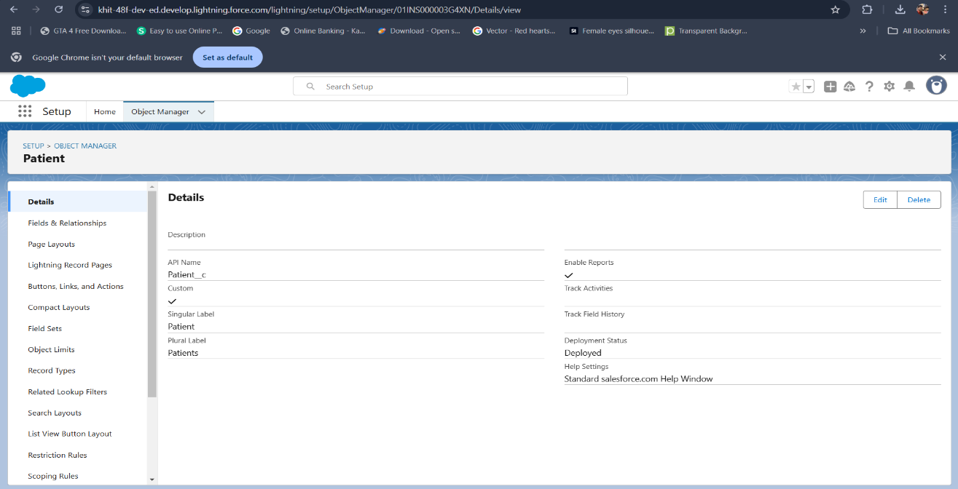

**Fig: Patient Object**

1. **Doctor Object**:

* The purpose of creating a doctor object is to store and manage information about Patients. From the setup page >> Click on Object Manager >> Click on Create >> Click on Custom Object.
* Enter the label name >>Doctor
* Plural label name >> Doctor
* Enter Record Name Label and Format

Record Name >> Doctor Name, Data type >> Text

* Click on Allow reports.
* Allow search >> Save.

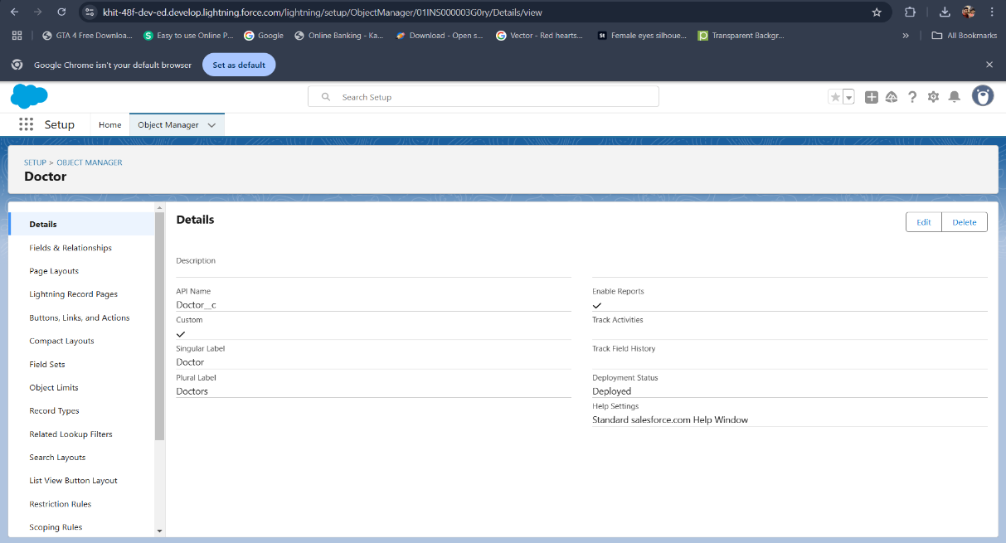

**Fig: Doctor Object**

1. **Appointment Object:**

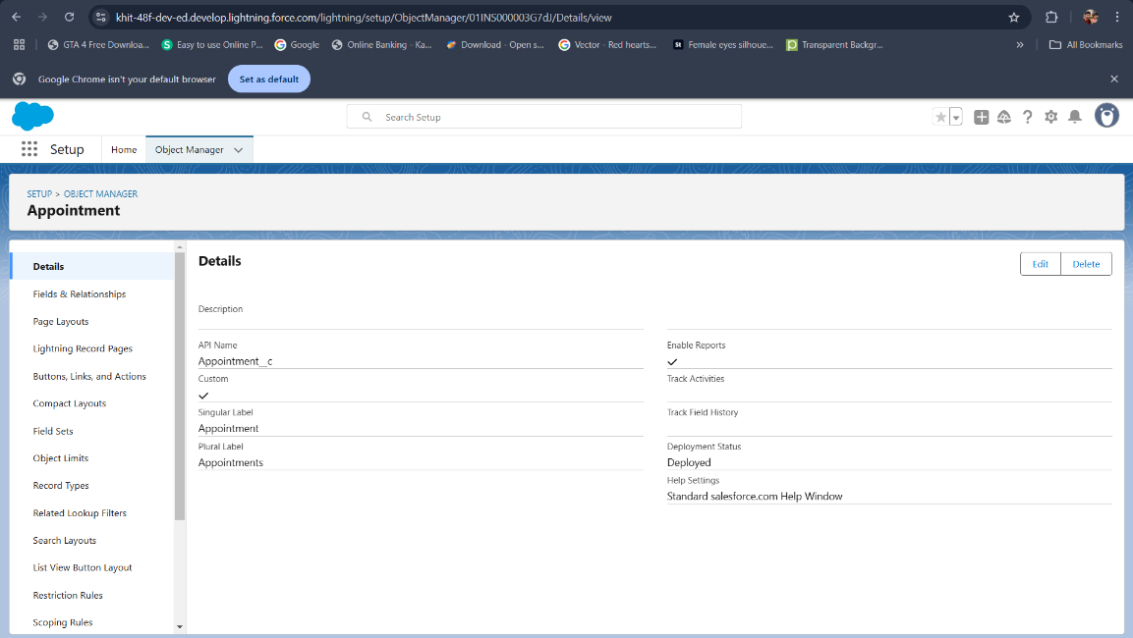

**Fig: Appointment Object**

1. **Bed Reservation Object:**

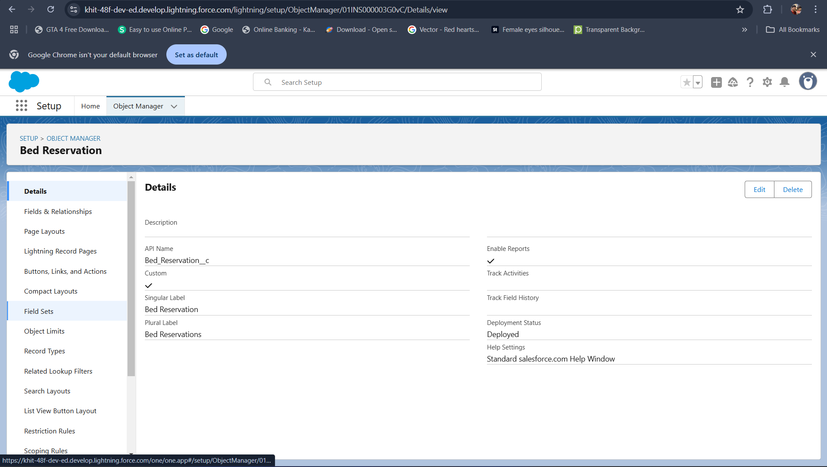

**Fig: Bed Reservation Object**

1. **Fields & Relationships:**
2. **Patient Fields & Relationship:**

|  |  |  |
| --- | --- | --- |
| **Object Name** | **Field Name** | **Data Type** |
| Patient | Address | Text Area |
| Patient | DOB | Date |
| Patient | Age | Formula |
| Patient | Blood Group | Picklist (A+,A-,B+,B-,AB+,AB-,O+,O-) |
| Patient | Email | Email |
| Patient | Mobile | Phone |
| Patient | Gender | Picklist ( Male, Female, Other) |
| Patient | Patient ID | Auto Number (Display format : p-{000}, Starting number : 1) |

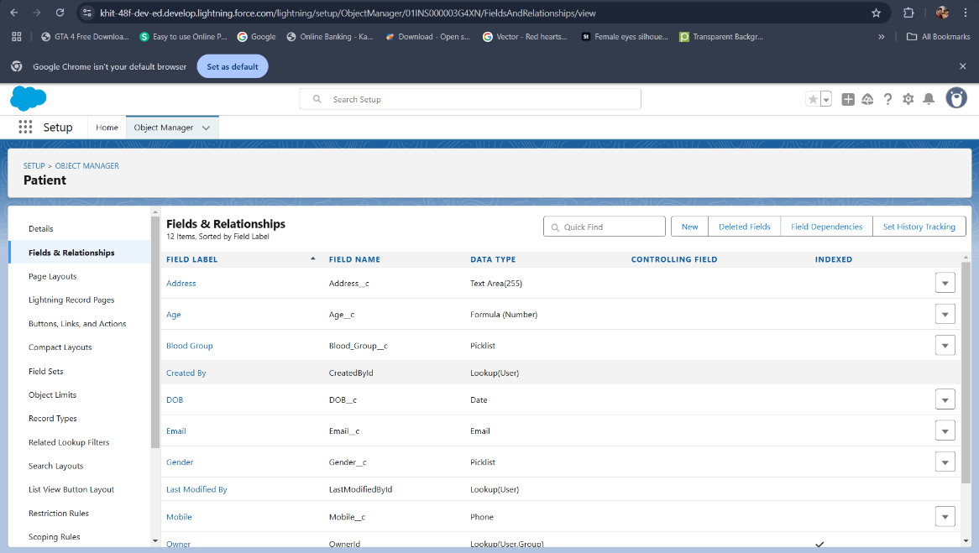

**Fig: Patient Fields & Relationships**

1. **Doctor Fields & Relationship:**

|  |  |  |
| --- | --- | --- |
| **Object Name** | **Field Name** | **Data Type** |
| Doctor | DOB | Date |
| Doctor | Age | Formula (FLOOR((TODAY()- DOB__c )/365) |
| Doctor | Blood Group | Picklist (A+,A-,B+,B-,AB+,AB-,O+,O-) |
| Doctor | Doctor ID | Auto Number |
| Doctor | Email | Email |
| Doctor | Gender | Picklist ( Male, Female, Other) |
| Doctor | Mobile | Phone |
| Doctor | Specialization | Picklist(Multi-Select) |

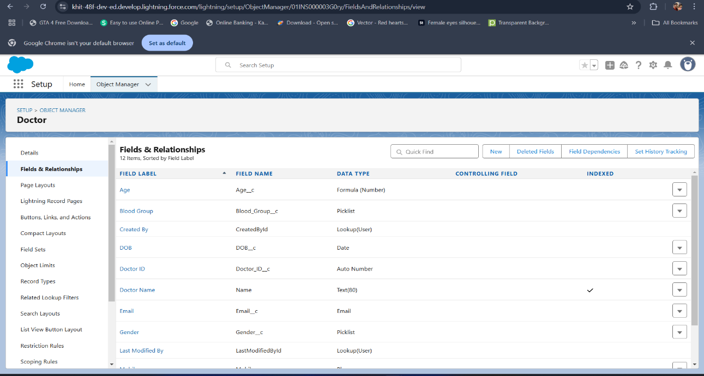

**Fig: Doctor Fields & Relationships**

1. **Appointment Fields & Relationship:**

|  |  |  |
| --- | --- | --- |
| **Object Name** | **Field Name** | **Data Type** |
| Appointment | Appointment Date | Date |
| Appointment | Doctor Name | Lookup (Doctor) |
| Appointment | Start Time | Time |
| Appointment | End Time | Time |

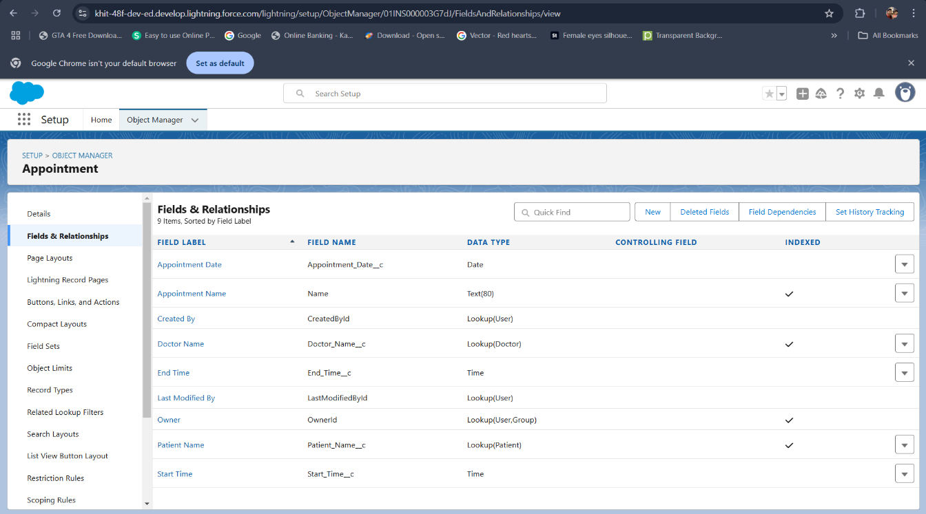

**Fig: Appointment Fields & Relationships**

1. **Bed Reservation Fields & Relationship:**

|  |  |  |
| --- | --- | --- |
| **Object Name** | **Field Name** | **Data Type** |
| Bed Reservation | Bed Type | Picklist (Regular, Healing, Paediatric, Maternity, Surgical) |
| Bed Reservation | Bed Number | Picklist (R1,R2,H1,H2,P1,P2,M1,M2,S1,S2) |
| Bed Reservation | Reservation Date | Date |
| Bed Reservation | Start Time | Time |
| Bed Reservation | End Time | Time |
| Bed Reservation | Patient | Lookup (Patient) |
| Bed Reservation | Booking Status | Picklist (Available, Booked) |

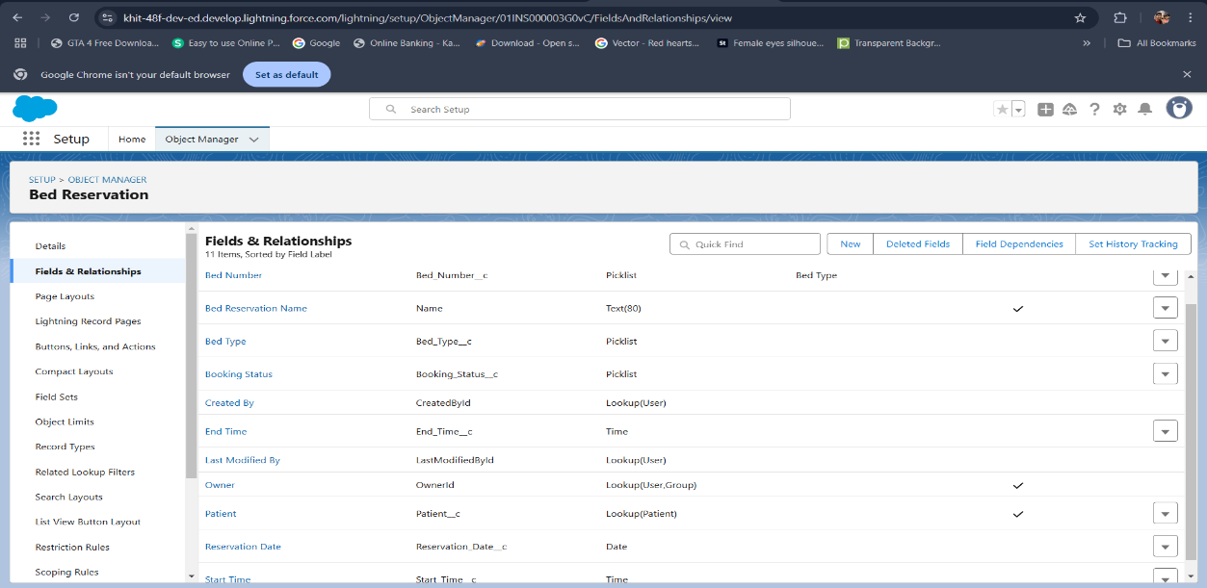

**Fig: Bed Reservation Fields & Relationships**

1. **Creation of Field Dependencies:**

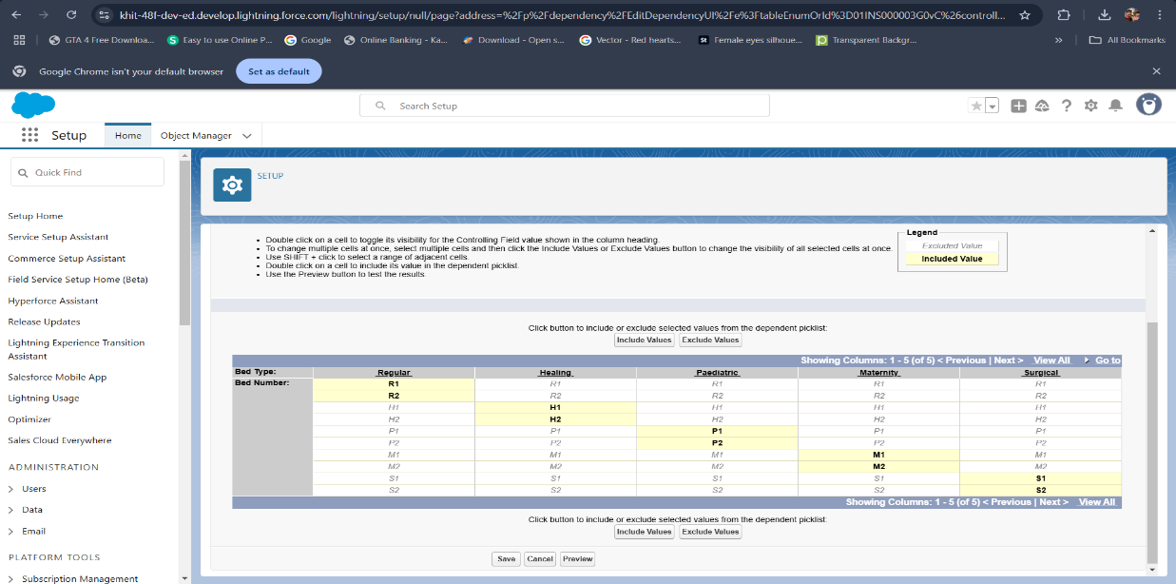

**Fig: Field Dependencies of Bed Reservation**

1. **Creation of Validation Rule:**

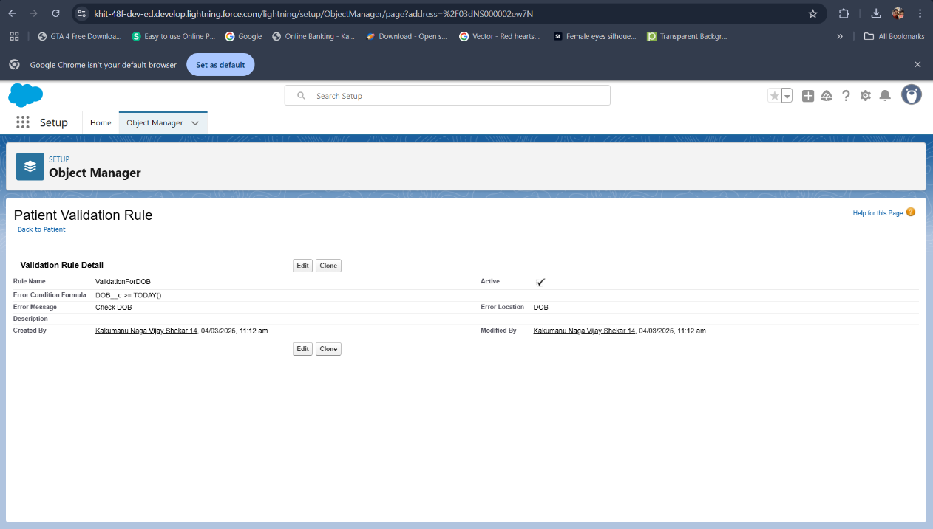

**Fig: Patient Validation Rule**

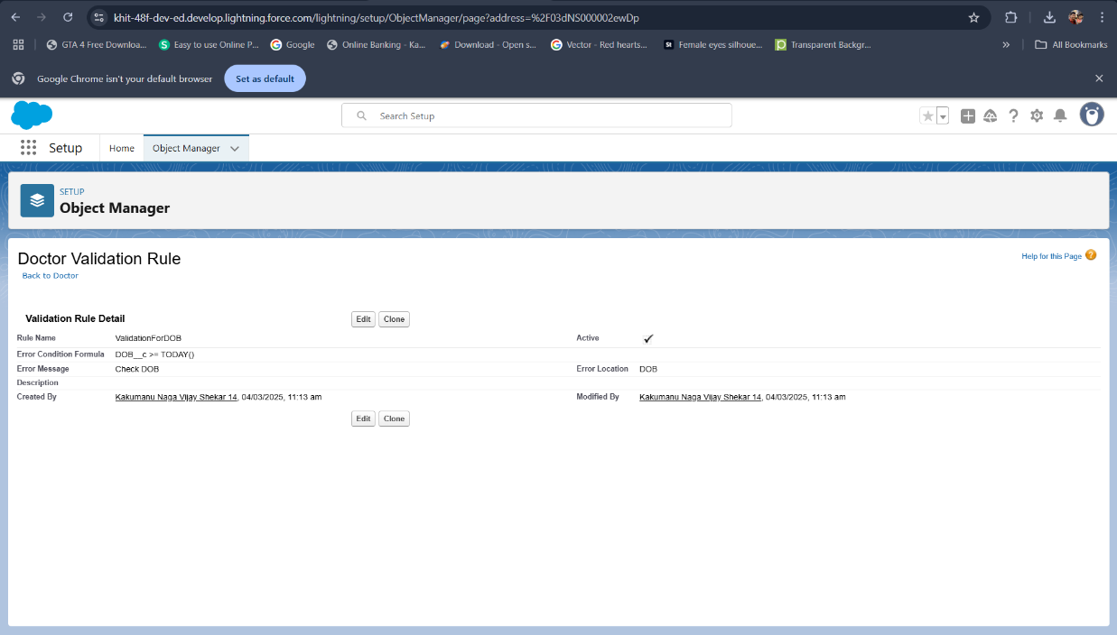

**Fig: Doctor Validation Rule**

1. **APEX and Visualforce Page:**
2. **Patient Object:**
3. Creating Apex Controller Class for Patient object
4. Creating Visualforce Page for patient object
5. **Doctor Object:**
6. Creating Apex Controller Class for Doctor object
7. Creating Visualforce Page for Doctor object
8. **Appointment Object:**
9. Creating Apex Controller Class for Appointment object
10. Creating Visualforce Page for Appointment object
11. **Reservation Object:**
12. Creating Apex Controller Class for Bed Reservation object
13. Creating Visualforce Page for Bed Reservation object
14. **Home Tab:**
15. Creating Apex Controller Class for Home Page Tab
16. Creating Visualforce Page for Home Tab

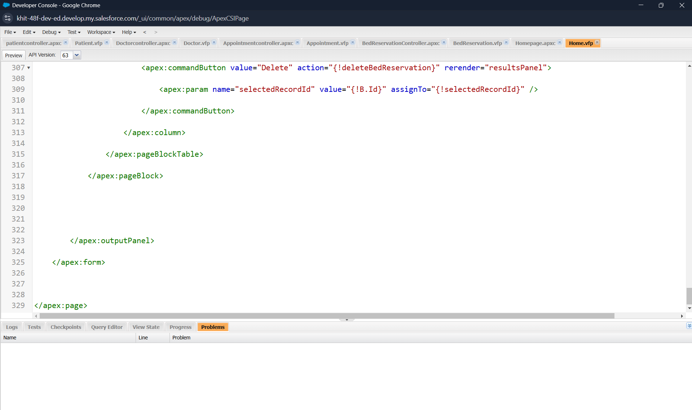

**Fig: Patient, Doctor, Appointment, Bed Reservation for Apex code and Visualforce Page**

1. **Creation Of Visualforce Tabs:**
2. **Creating a Visualforce Tab:**

* Go to setup page >> type Tabs in Quick Find bar >> click on tabs >> click New (Visualforce tabs)
* Select Visualforce Page as Patient>> Tab Label as Patient >>Tab Name (Auto Fill)>>Select any tab style >> Next (Add to profiles page) keep it as default >> Next (Add to Custom App) keep it as default >> Save.
* Create 4 more tabs with Doctor, Appointment, Home page and Bed Reservation.

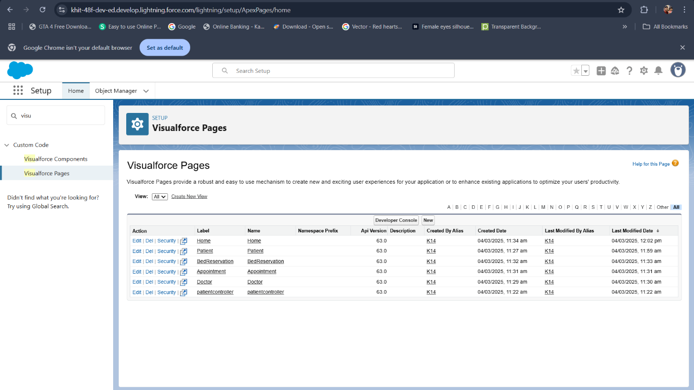

**Fig: Patient, Doctor, Appointment, Bed Reservation, Home Page For Visualforce Tabs**

1. **The Lightning App**
2. **Create a Lightning App:**

* Go to setup page >> search “app manager” in quick find >> select “app manager” >> click on new lightning App.
* App Name: Healthmate  
  Developer Name: This will auto populated  
  Description: Enriching patients care  
  Image: optional (if you want to give any image you can otherwise not mandatory) Primary colour hex value: keep this default.
* Then click Next >> (App option page) Set Navigation Style as Standard Navigation >> Next.
* keep it as default >> Next.
* To Add Navigation Items: Search for the item in the (Patient, Doctor, Bed Reservation, Appointment, Reports, Dashboard) from the search bar and move it using the arrow button >> Next >> Next.
* To Add User Profiles: Search profiles (System administrator) in the search bar >> click on the arrow button >> save & finish.

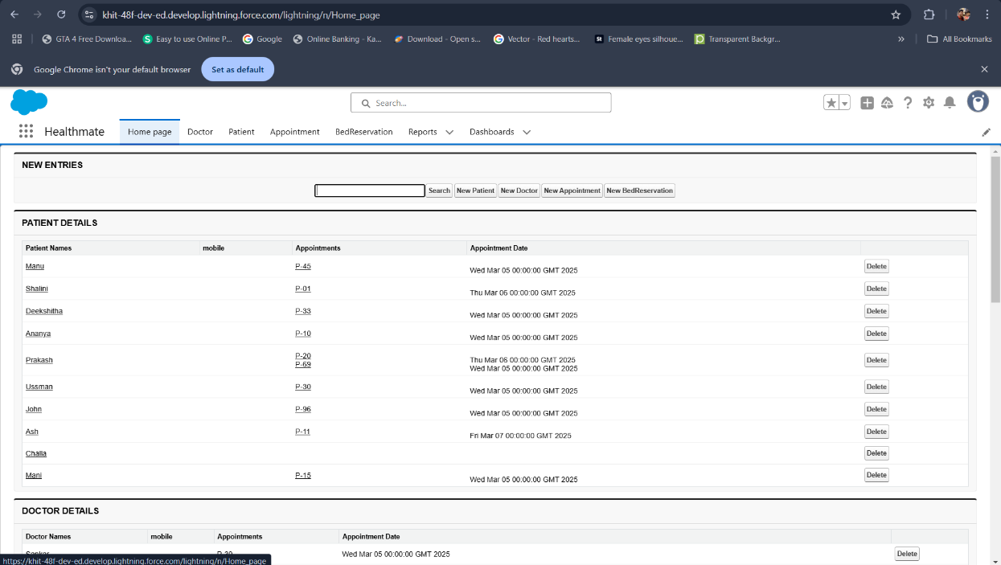

**Fig: Healthmate Lightning App**

1. **User Adoption**
2. **Create a Record (Patient):**

* Click on App Launcher on the left side of the screen.
* Search HealthMate & click on it.
* When you're in the HomePage click on the New Patient button which will open the Patient Page.
* Fill the Details and click on Save.

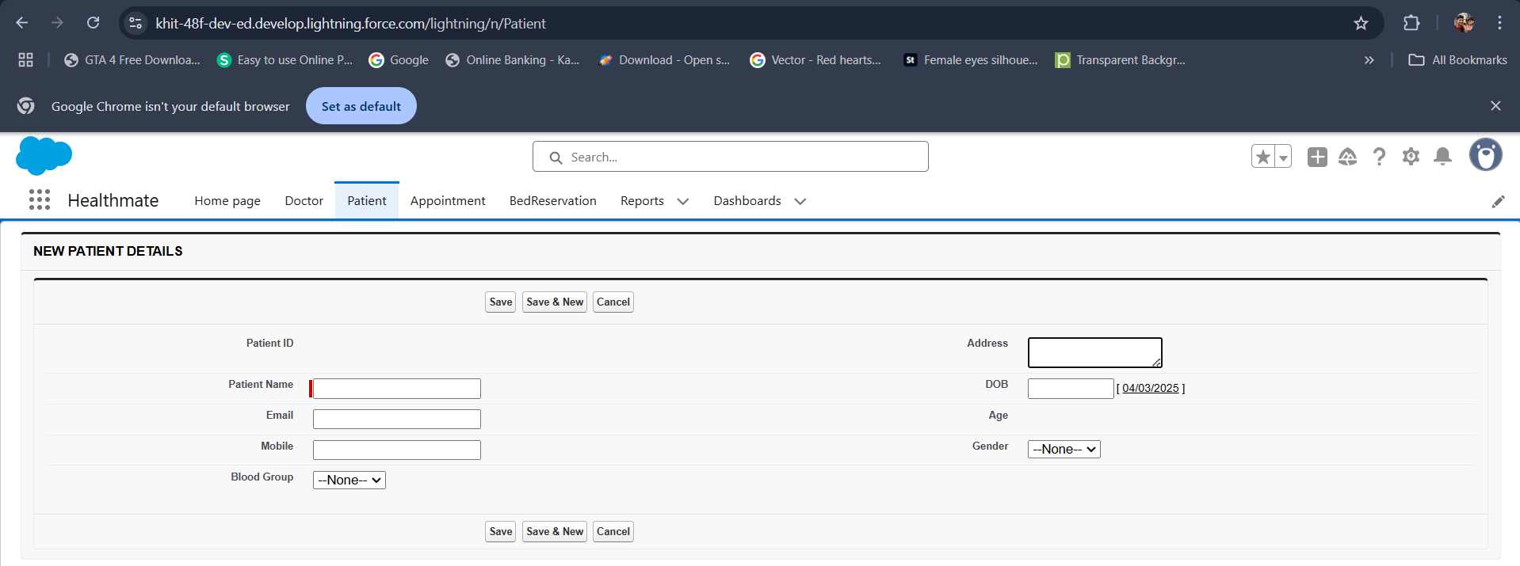

**Fig: Patient Record Cration**

1. **Create a Record (Doctor):**

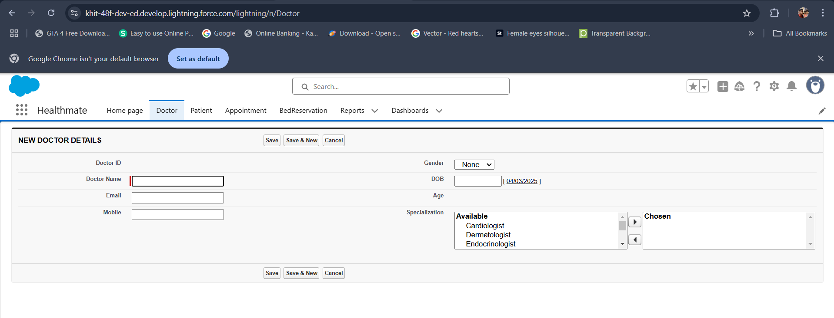

**Fig: Doctor Record Cration**

1. **Create a Record (Appointment):**

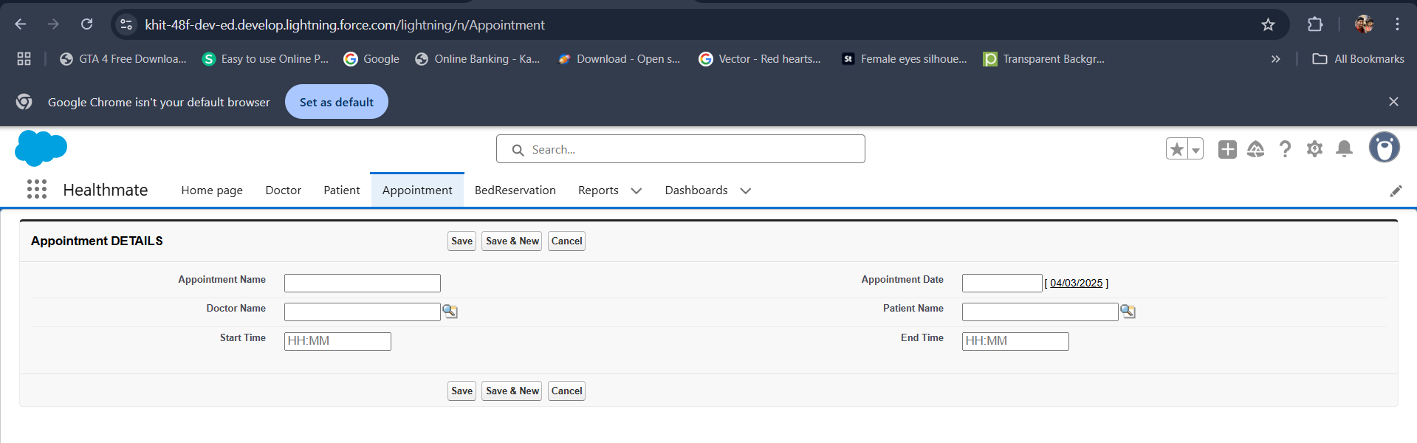

**Fig: Appointment Record Cration**

1. **Create a Record (Bed Reservation):**

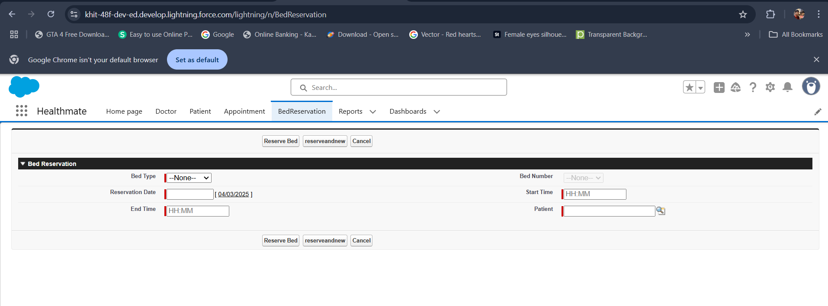

**Fig: Bed Reservation Record Cration**

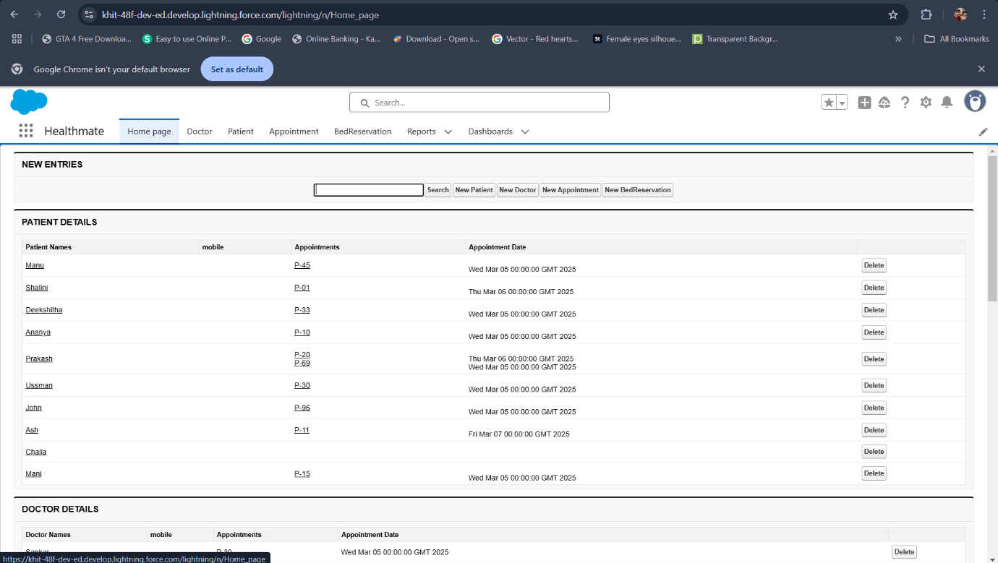

**Fig: Home Page**

1. **Report:**
2. **Create Report:**

* Go to the app >> click on the reports tab.
* Click New Report.
* Select report type from category or from report type panel or from search panel >> click on start report.
* Customise your report

From top on the left side click on report dropdown and select Joined Report and apply. Add fields from the left pane as shown below.

* Save or run it and give the report name and save it.

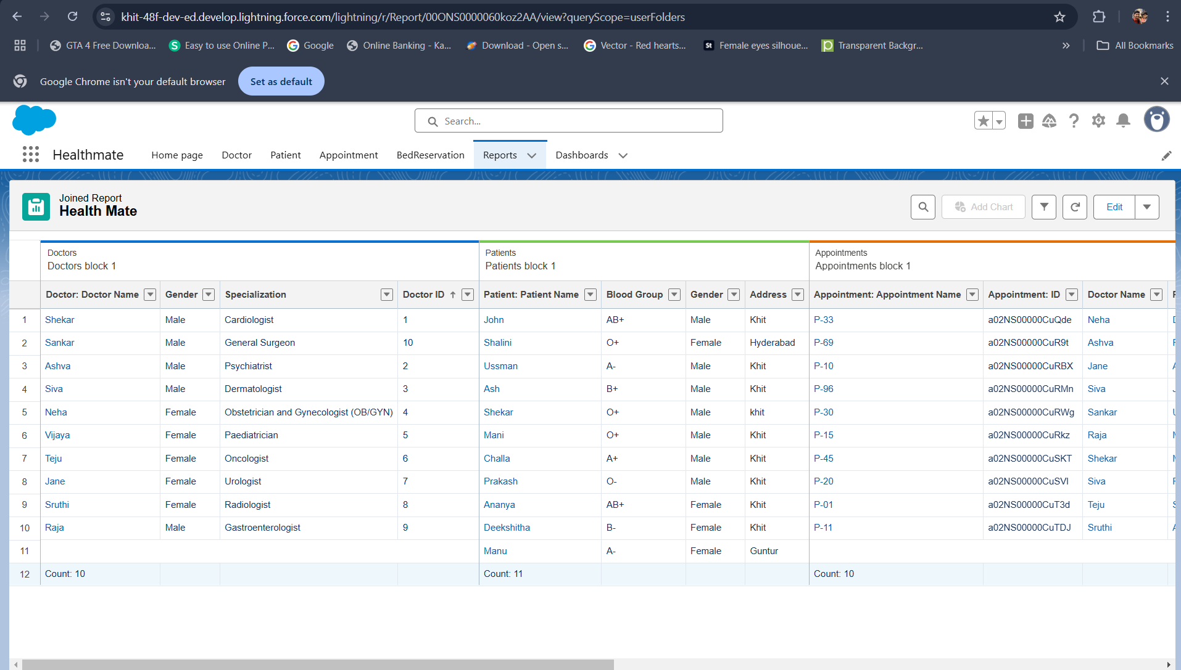

**Fig: Joined Report of Patient, Doctor, Appointment, Bed Reservation (Healthmate Report)**

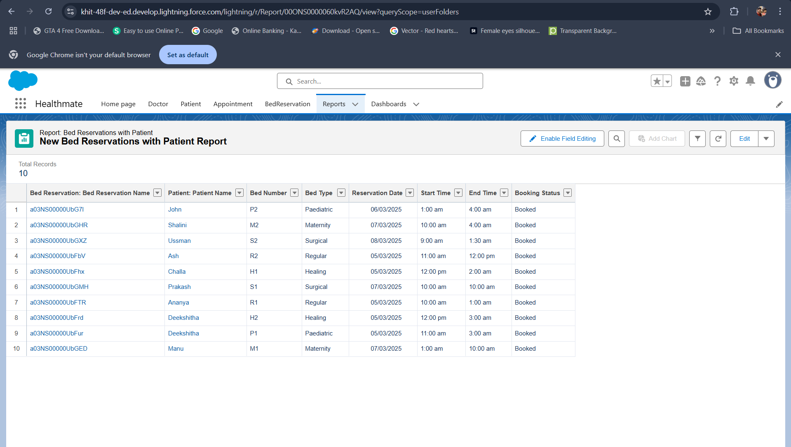

**Fig: Bed Reservations with Patient Report**

1. **Dashboard:**
2. **Create Dashboard:**

* Go to the app >> click on the Dashboards tabs.
* Give a Name and click on Create.
* Select a Report and click on select.
* Select Legend position as bottom and component theme as dark.
* Click Add then click on Save and then click on Done.

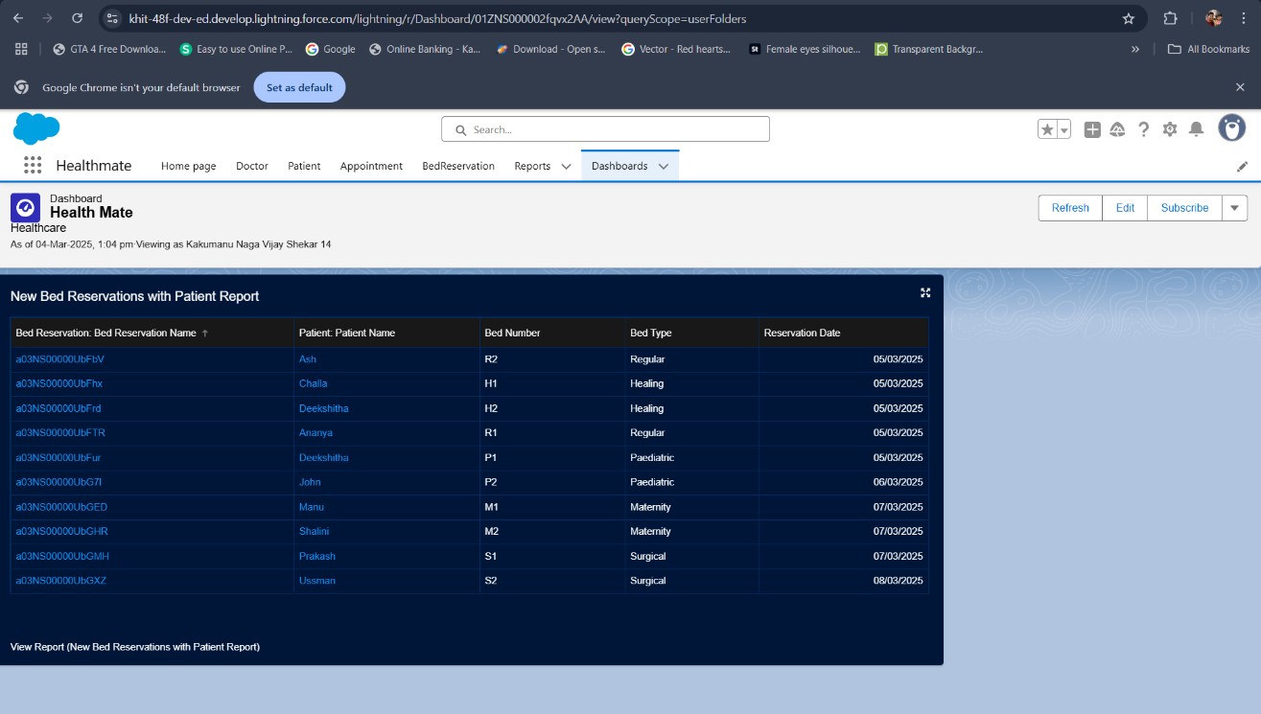

**Fig: Healthmate Dashboard**

**Testing & Validation:**

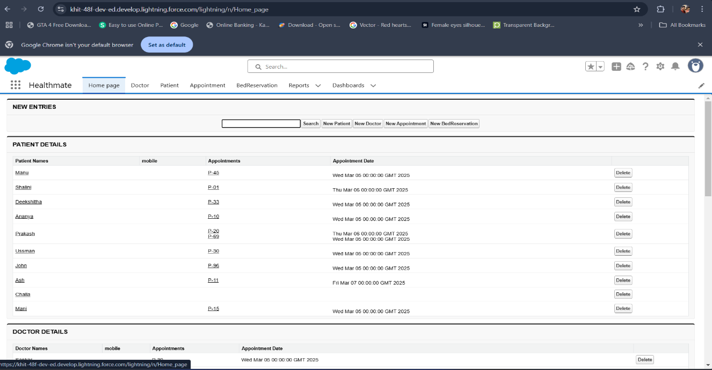

**Fig: Home: Patient Details**

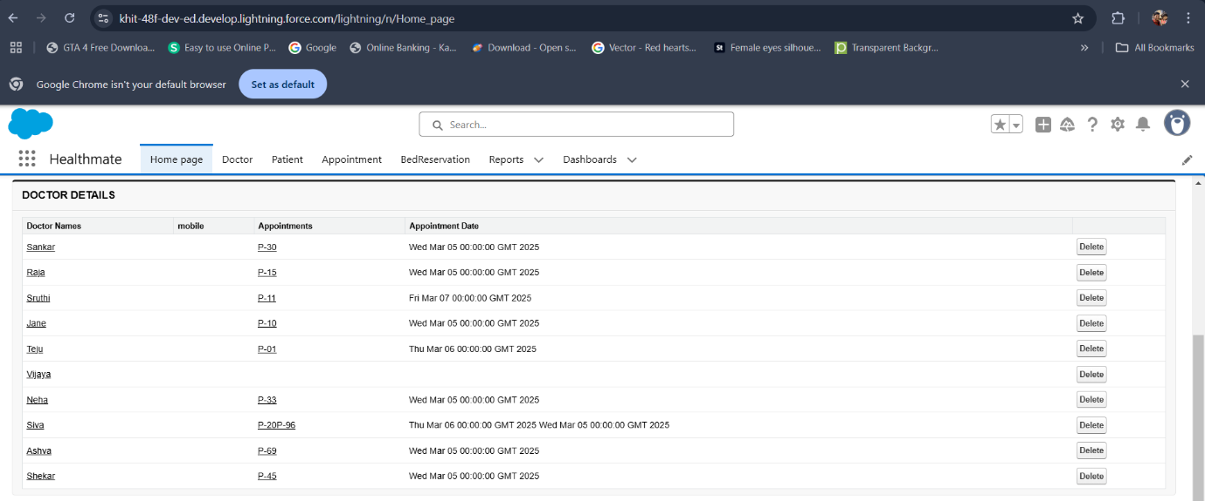

**Fig: Home: Doctor Details**

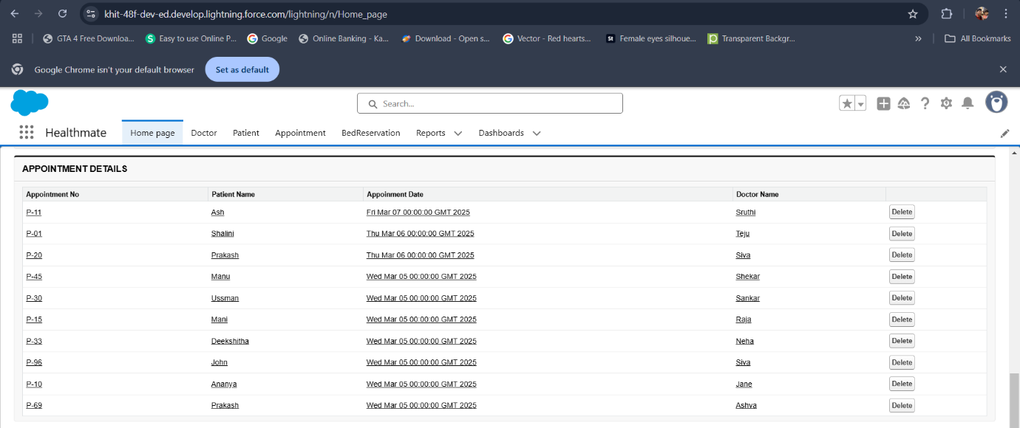

**Fig: Home: Appointment Details**

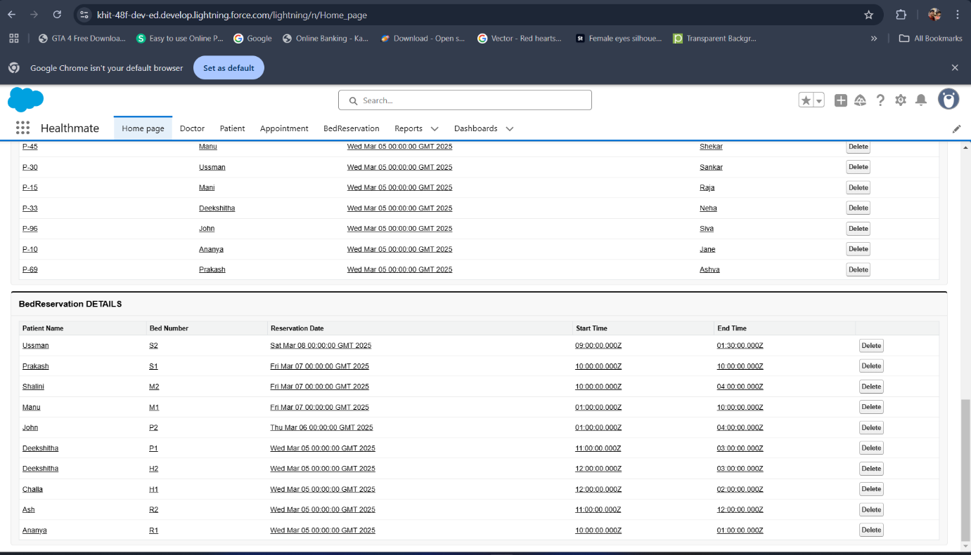

**Fig: Home: Bed Reservation Details**

**Key Scenarios Addressed by Salesforce in the Implementation Project:**

Salesforce has been instrumental in addressing various key scenarios in healthcare optimization projects. Here are some notable examples:

1. **Appointment Scheduling and Management**: Salesforce helps streamline patient appointment scheduling and management. Patients can book appointments through a portal, receive automated reminders, and check in via kiosks. This improves patient management and communication between healthcare providers and patients.
2. **Patient Medication Journey Management**: Salesforce Health Cloud integrates with various systems to manage patient medication journeys. This includes handling extensive patient records, ensuring data flow and integration, maintaining regulatory compliance, and addressing data quality issues.
3. **Physician Network Development**: Healthcare groups use Salesforce to capture more referrals from existing referring physicians and recruit new ones. This improves provider referrals and enhances patient care.

**Conclusion:**

Salesforce has emerged as a powerful platform for healthcare optimization, offering solutions that enhance patient management, streamline workflows, and improve overall operational efficiency. The integration of Salesforce Health Cloud, Einstein Analytics, AI-powered chatbots, IoT, and blockchain has enabled healthcare providers to deliver personalized care, optimize resource allocation, and ensure data security.

**Key Takeaways:**

* Real-time tracking improves efficiency
* Automated appointment scheduling enhances patient care.
* Reports and dashboards provide actionable insights.

Future research and developments should focus on cost-effective solutions, improved AI capabilities, and enhanced interoperability to maximize the benefits of Salesforce in healthcare optimization.