C# Training

Two Sum

Problem
Given an array of integers nums and an integer target, return indices of the two numbers such that they add up to target.
You may assume that each input would have exactly one solution, and you may not use the same element twice.
You can return the answer in any order.

Example 1:
Input: nums = [2,7,11,15], target = 9
Output: [0,1]
Explanation: Because nums[0] + nums[1] == 9, we return [0, 1].

Example 2:
Input: nums = [3,2,4], target = 6
Output: [1,2]
Example 3:

Input: nums = [3,3], target = 6
Output: [0,1]

Constraints:

2 <= nums.length <= 104
-109 <= nums[i] <= 109
-109 <= target <= 109
Only one valid answer exists.

Solution
public class Solution {
public int[] TwoSum(int[] nums, int target) {
int[] outpt = new int[2];
for(int i =0; i<nums.Length;i++){
for(int j =0; j<nums.Length;j++){
if((i!=j)&&((nums[i]+nums[j]) == target)){
outpt[0]=i;
outpt[1]=j;
return outpt;
}}
}
return outpt;
}
}

2. Add Two String

Problem

You are given two non-empty linked lists representing two non-negative integers. The digits are stored in reverse order, and each of their nodes contains a single digit. Add the two numbers and return the sum as a linked list.
You may assume the two numbers do not contain any leading zero, except the number 0 itself.

Example 1:
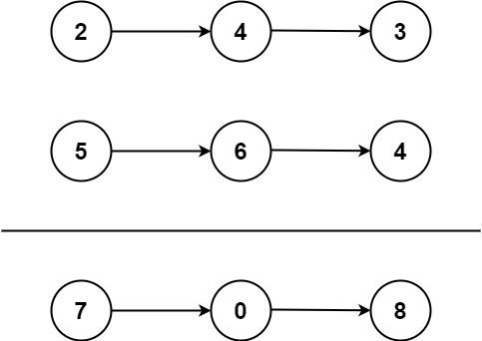
Input: l1 = [2,4,3], l2 = [5,6,4]
Output: [7,0,8]
Explanation: 342 + 465 = 807.
Example 2:
Input: l1 = [0], l2 = [0]
Output: [0]
Example 3:
Input: l1 = [9,9,9,9,9,9,9], l2 = [9,9,9,9]
Output: [8,9,9,9,0,0,0,1]

Constraints:
- The number of nodes in each linked list is in the range [1, 100].
- 0 <= Node.val <= 9
- It is guaranteed that the list represents a number that does not have leading zeros.

Solution

/**
* Definition for singly-linked list.
* public class ListNode {
* public int val;
* public ListNode next;
* public ListNode(int val=0, ListNode next=null) {
* this.val = val;
* this.next = next;
* }
* }
*/
public class Solution {
public ListNode AddTwoNumbers(ListNode l1, ListNode l2) {
ListNode result = new ListNode();
int carVal=0;
String revStr = "";
while(l1 != null || l2 != null){
carVal = (l1 == null ? 0 : l1.val) + (l2 == null ? 0 : l2.val) + carVal;
revStr = (carVal % 10).ToString()+revStr;
carVal = carVal / 10;
l1 = l1?.next;
l2 = l2?.next;
}
if(carVal>0){revStr = carVal.ToString()+revStr;}
for(int i = 0; i < revStr.Length;i++){
if(i==0){
result = new ListNode(revStr[i]-'0');
}
else{
ListNode node = result;
result = new ListNode(revStr[i]-'0',node);
}
}
return result;
}
}

3. Longest Substring Without Repeating Characters

Problem
Given a string s, find the length of the longest substring without repeating characters.

Example 1:
Input: s = "abcabcbb"
Output: 3
Explanation: The answer is "abc", with the length of 3.

Example 2:
Input: s = "bbbbb"
Output: 1
Explanation: The answer is "b", with the length of 1.

Example 3:
Input: s = "pwwkew"
Output: 3
Explanation: The answer is "wke", with the length of 3.
Notice that the answer must be a substring, "pwke" is a subsequence and not a substring.

Solution

