**Project Design Phase-II**

**Data Flow Diagram & User Stories**

| Date | 30 june 2025 |
| --- | --- |
| Team ID | LTVIP2025TMIID36226 |
| Project Name | Intlegent health care assistant using IBM granite |
| Maximum Marks | 4 Marks |

**Data Flow** 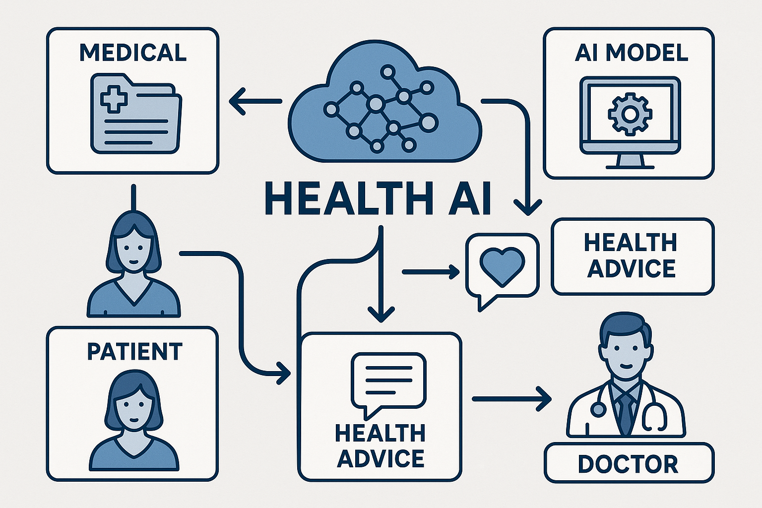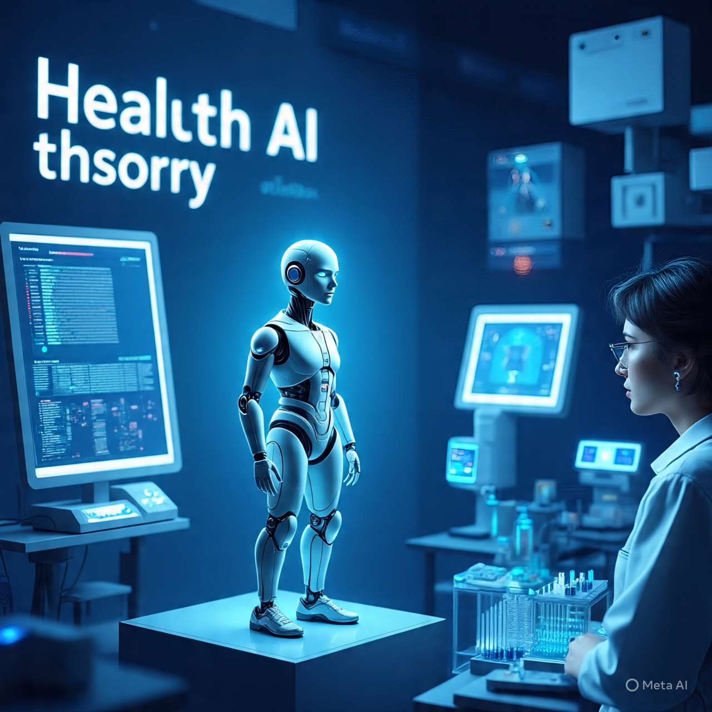Health AI (Healthcare Artificial Intelligence) refers to the application of artificial intelligence technologies, such as machine learning, natural language processing, and computer vision, to improve healthcare outcomes, streamline clinical workflows, and enhance patient care.

Health AI can be used in various areas, including:

1. *Medical diagnosis*: AI algorithms can analyze medical images, lab results, and patient data to help doctors diagnose diseases more accurately and quickly.

2. *Personalized medicine*: AI can help tailor treatment plans to individual patients based on their unique characteristics, medical histories, and genetic profiles.

3. *Predictive analytics*: AI can analyze large datasets to identify patterns and predict patient outcomes, allowing healthcare providers to take proactive measures to prevent complications.

4. *Clinical decision support*: AI-powered systems can provide healthcare professionals with real-time guidance and recommendations to inform their clinical decisions.

5. *Patient engagement*: AI-powered chatbots and virtual assistants can help patients manage their health, adhere to treatment plans, and communicate with healthcare providers.

The benefits of Health AI include:

1. *Improved accuracy*: AI can reduce errors in diagnosis and treatment.

2. *Enhanced patient care*: AI can help healthcare providers deliver more personalized and effective care.

3. *Increased efficiency*: AI can automate routine tasks, freeing up healthcare professionals to focus on more complex and high-value tasks.

4. *Better outcomes*: AI can help healthcare providers identify high-risk patients and intervene early to prevent complications.

However, Health AI also raises important questions about:

1. *Data quality and security*: AI algorithms require high-quality data to function effectively, and patient data must be protected from unauthorized access.

2. *Bias and fairness*: AI algorithms can perpetuate biases and disparities in healthcare if they are trained on biased data.

3. *Transparency and explainability*: AI decisions must be transparent and explainable to ensure trust and accountability.

Overall, Health AI has the potential to revolutionize healthcare by improving patient outcomes, enhancing the patient experience, and reducing costs..