**Objective**: Speed up the investigation of powertrain failures by having a user interface connected to all relevant data sources.

**User Groups**

* **Advanced diagnostics** (6) – Brent Berry - **Fixing**
* **Product group (10) –** Andrew Keller and Aaron Zhu – **Design changes**
* **Engine Inspection (?**) – Sam McLaughlin – **Failures**

Aisha explanation: Dean’s group and Sam look for internal customers. Brent look for external customers.

**Application Features**

* Search vin number and show the visual chassis
  + Engine hours
  + Mileage
  + Time Scale
* Extracting warranty claims
* Support link cases
* Fault Codes as they occur
* Software versions & Software updates
* Engine Revolutions
* At the end of graph show current state of truck with data mentioned in email as other data visible
* Engine Swings will have 2 engines
* Service Intervals – Show when service was recommended (different service types – severe, normal)
* Engine Service bulletins (engine, part recalls, etc..)
* Compare 2 chasis at a time – Fault codes, previous claims, business rules not known

**Workflow out of Application and trigger for Engineer to use application**

* Escalation process comes from dealers
* If dealer cant resolve issues
* Goes to OEM support center
* PACCAR group – Regional service group
* Finally it comes to Diagnostics groups which use this application

**Application Security Implementation** – Single sign-on (AD Directory)

**Tech Stack** – MS .NET, Local DB not preferred

**Hosting**: Need quote & architecture of both On-Prem & Cloud app only for services

**Application screens**

* Screen 1: Login
* Screen 2: Search box for - Engine Chasis / VIN /Engine serial No
* Screen 3: Screen with a vehicle data plotted on Miles, Engine Hrs (Y axis) & Day, Weeks, Year (X axis). Refer sample provided below
  + Ability to print this view or save as PDF
  + User should be able to toggle X & Y axis to view by Engine Hrs, Miles, Engine Revs, Day, Week, Year
  + Report - Export all the parameters to an excel
* Compare vehicle on a benchmark on the graph
  + Compare vehicles by vocation or entire population
  + Engine in use vs Time
  + Lower Band / Upper Band
  + Y- axis: Hours, Miles, Engine Revs
  + X-axis: Day, Weeks, Months, Years
  + No -upper & lower bounds in **phase 2**
* Search by Fault code filter & get a list of chassis then drill – **Phase 2**

**Chassis History High Level Requirements:**

Assemble data in a timeline starting from crank set date (Engine build date) and extending to current date, make the start point optional (day 0 @ chassis build, engine build, or in service date, etc.). The timeline can be displayed as a chart with the vertical axis optional in miles or engine hours and the horizontal axis in time (option of date, weeks in service or months in service), the chassis can be plotted along the chart with notes extending from each significant event. The events can be filtered on or off, but for general purposes would have a standard template.

Make each event keyword searchable and add a link from each event to information about the event.

**Rough Example:**

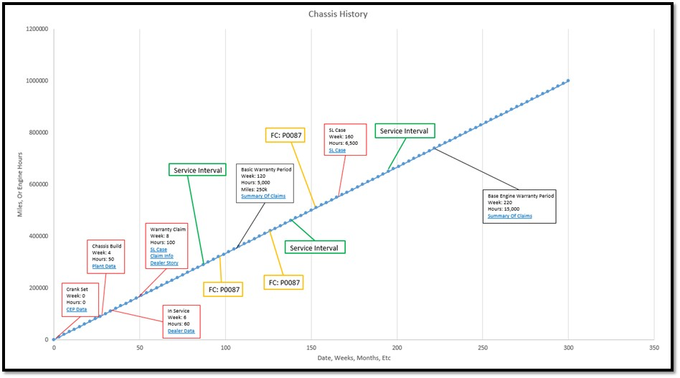

**Kinds of events to add to plot:**

* Warranty claims
* Support link cases
* Engine build date
* Chassis build date
* In service date
* Fault code occurrences
  + Create a drop down menu to be able to choose what faults you are interested in seeing, possibly with the option to save FC lists for a sub system that you are interested in.
* Required service intervals (Based on application) A,B,C type services oil changes, filter changes etc.
* Major component repairs, cylinder heads, engine swings, etc. (Maybe warranty claims is enough)
* Warranty periods for standard and major components (Extended warranty periods, if the chassis has extended warranty)
* Campaigns

**Other data to be easily visible:**

* ESN
* Chassis
* Engine Model
* Breakdown of engine configuration from E4 number (Example P/N E4R4E5D98058613500 =  EPA17 W/O REPTO 455HP, W/DEB etc…)
* HP Rating
* Transmission Configuration
* Application: Line haul, pickup and delivery, refuse, logger etc…
* Truck model
* Size of fleet? (How many trucks owned by customer)
* Average miles in fleet

**Additional data points:** Claim, Claim Type, Chassis ID, Miles, Repair Date, ATA9, ATA9 Desc, Total Pro Part, Total Pro Labor, Total Pro Amt, Cust Name, Fail Base BN, Dlr Story, Chassis Build Month, Engine Build Month, Engine Manufacture Date, Engine Model Name, Engine Displacement Liter Quantity, Engine Horsepower Number, Engine Model Year, Engine Serial Number, Actual Delivery Dt, Project Accepted Failure Mode, eWarp ID