RooMe

**Abstract:**

This project is the web based system which helps the students going abroad to find their roommates online, based on their compatibility features like region, room rent, food habits, location, etc…

RooMe also helps students and other bachelors staying abroad to find a perfect room with compatible roommates without hassle of manual search over colleges and community zones.

Roome uses 128 bit AES encryption technique to secure the user data from any intrusion.

**Introduction:**

Often people find it difficult to find an ideal roommate when they relocate to a new place. This problem mostly arises for bachelors or people moving without family. These people struggle a lot to get an ideal roommate and often compromise a lot with the situations and stay in an uncomfortable situation. This project provides a platform to find idle roommates based on individual set of priorities.

The users have register with the system and login, through which they will enter their priorities. Based on his priorities, the system will bounce back with the appropriate results which match the priorities given by the user.

The user details will be encrypted with a 128-bit AES on the server side for the security reasons.

**EXISTING SYSTEM**

Students going away from home for studies or job find it very tedious and time taking to find perfect roommates. They have to go through hassle of manual search over community places, work/study places to find roommates.

**PROPOSED SYSTEM**

This project helps students and other bachelors staying away from home to find a perfect room with compatible roommates, based on their location and priorities like room rent, food habits, gender, nationality, they get a refined results through app saving time and energy.

**Background and/or Related Work:**

There are not many apps which does a refined roomie search based on various priorities like RooMe. And definitely they weren't using AES 128 bit cryptosystem.

**Methodology:**

The android application is developed using Android Studio, using an sql database and PHP is used on the server side. The AES 128 bit encryption is performed on the server side using the PHP language.

The application screens are prepared from scratch, based on various priorities which acts as filters, the tables in sql are created.

The comparison or matching of data usually happens on the server side using the PHP script. The user data is encrypted on the server side before sending to the database. And also will be decrypted before sent to the client side.

**Experiments:**

When a new user is registered with the system, The user name and password is encrypted using a 128 bit AES encryption technique and then saved in the system. Similarly when a user logins with the system, the data is encrypted using a 128 bit AES encryption technique and then login call is performed.

Whenever the user navigates to a the dashboard, the data in the database is decrypted using a 128 bit AES encryption technique and sent to the client side, dashboard screen.

With the use of comparison variables, the PHP script performs matching operations and sends the results to client side.

**Discussion and/or Analysis:**

The user is given the results based on the latest entries into the database. More often than not the user gets best matched results based on at least one priority. If not he will be provided with results matching with only same city.

**Screen Shots:**

Registration Screen Login Screen

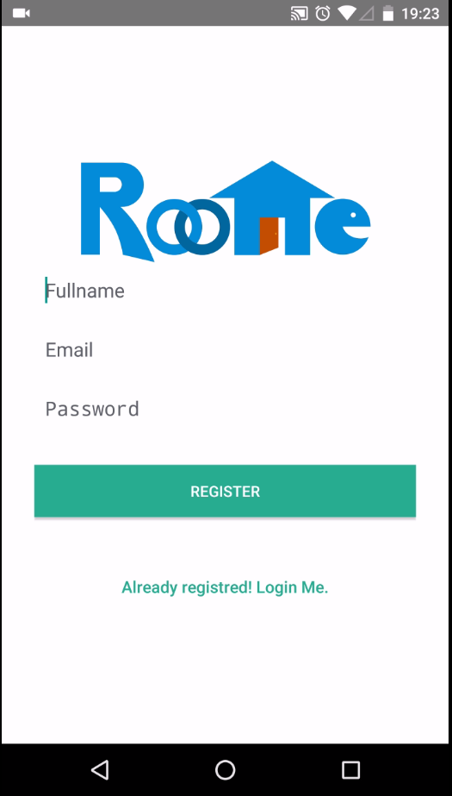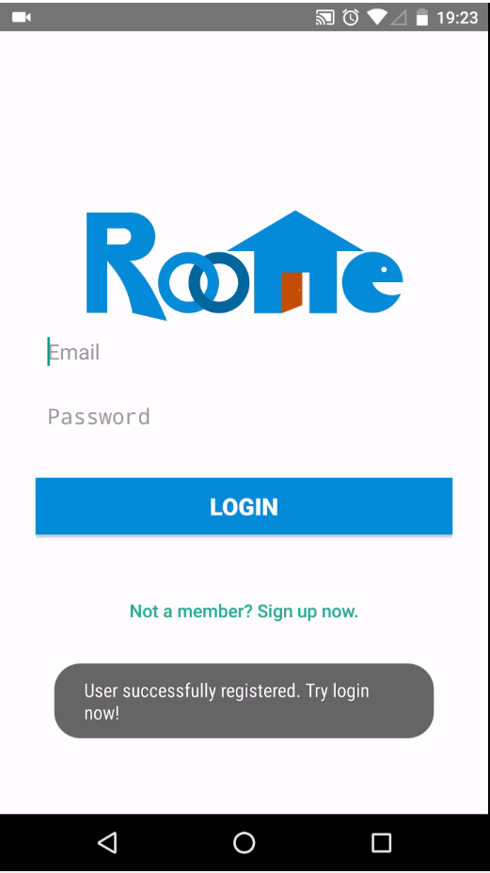

Post for Roommate Screen Dashboard Screen

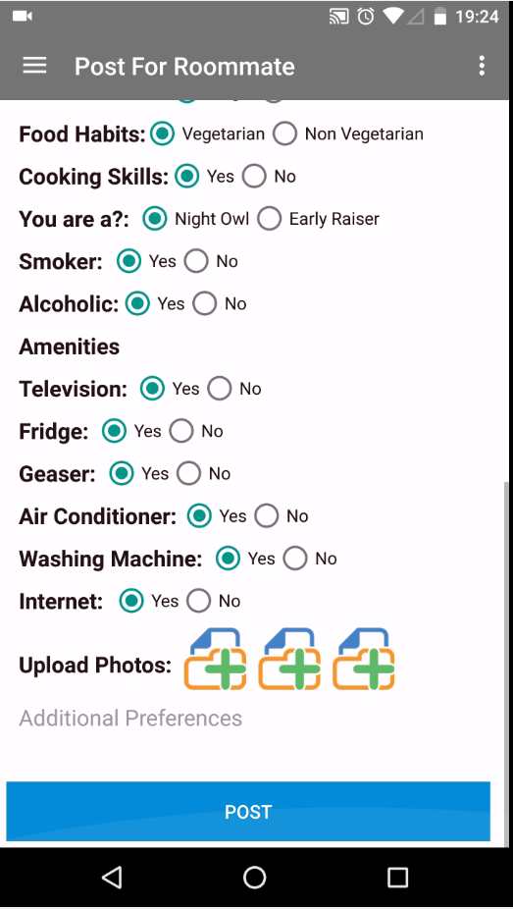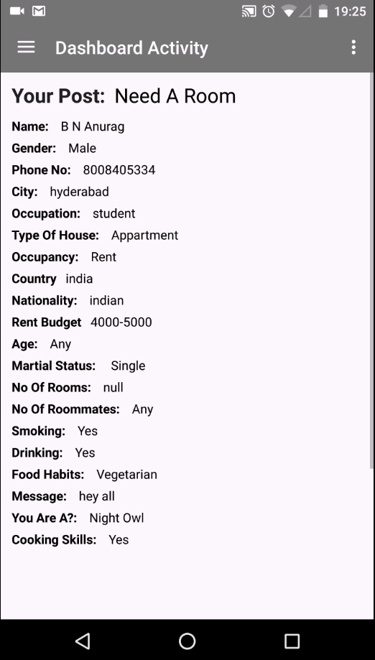

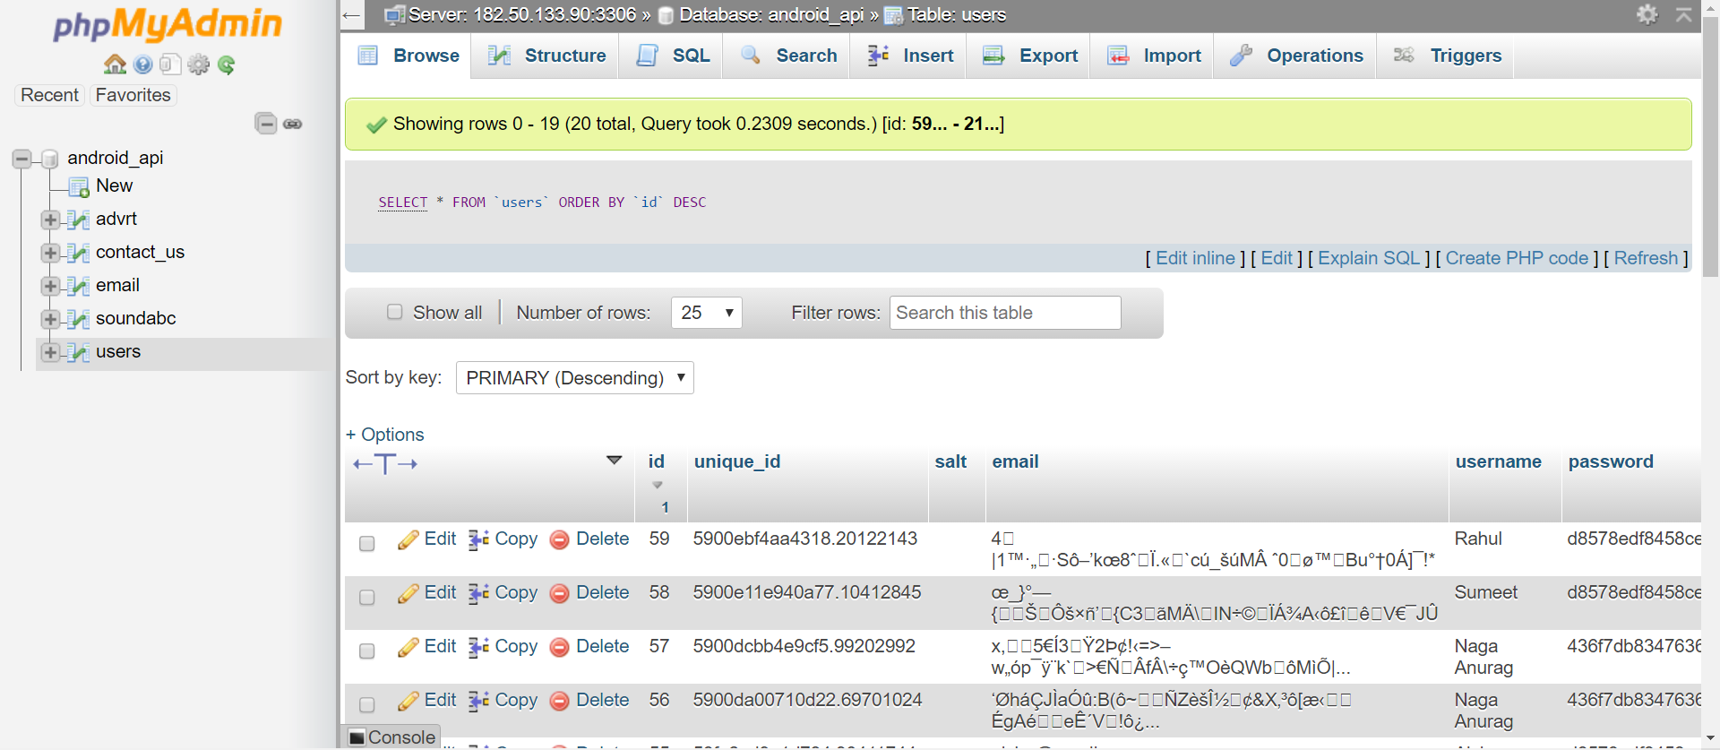

Database with Encrypted Data

**Conclusion:**

This Project is designed and developed to reduce the effort put forth by people going away from home to a new place in searching compatible roommates. People spend lots of time spending in community places to find roommates; of finding roommates before reaching a new place is almost impossible. It can be used to fill that void, by providing an online platform to users to find roommates online even before reaching the new place which saves a lot of time and energy.

**Future Scope:**

With the global applicability, this project can be implemented worldwide. With the transition of the world into digital generation, online platform like this have a scope of becoming a successful venture by enhancing its features like an owner posting ad for tenants, people who needs a roommate posting an ad for ‘need of a roommate’. With the increase of the usage of mobile applications, presence of such a facility on a mobile application level also benefits the users and with the user data is being encrypted with a 128 bit encryption system on the server side the security of the application increased exponentially.

**References / Bibliography:**

https://www.rivier.edu/journal/ROAJ-Fall-2010/J455-Selent-AES.pdf

https://paragonie.com/white-paper/2015-secure-php-data-encryption

https://paragonie.com/blog/2015/05/using-encryption-and-authentication-correctly