Document Guide



**Teams Site Search App Tool Document Guide**

**Overview**

This document will guide service desk on how to use the Teams Site Search App Tool based on the results of the recommendation. Below is the URL of the tool:

<https://mcportal.accenture.com/WebTools/TeamSites>

Sites/URL should be input on the following format:

<https://ts.accenture.com/sites/Name_of_the_ParentSite>

Note: If the parent site contains spaces in between names, the space should be replaced by %20

Example: https://ts.accenture.com/sites/MIC Manila Test Do Not Bill

For the search field, of the tool, the below URL should be input:

<https://ts.accenture.com/sites/MIC%20Manila%20Test%20Do%20Not%20Bill>

Below are the following outputs and recommendations based from the following scenarios:

SharePoint site is accessible:

Recommendation:

* If the SharePoint site is not accessible to customer, then it means that customer doesn’t have permission to access the site. Advise the customer to request access from the listed Site Admins.
* If SharePoint site percent usage is above 80%, customer may request site quota upgrade up to 400GB which is subject for approval, otherwise perform site cleanup. Assign SNOW incident <INCXXXX> ticket to MC team <MSGCOLLAB-O365-OPER> for the quota upgrade.

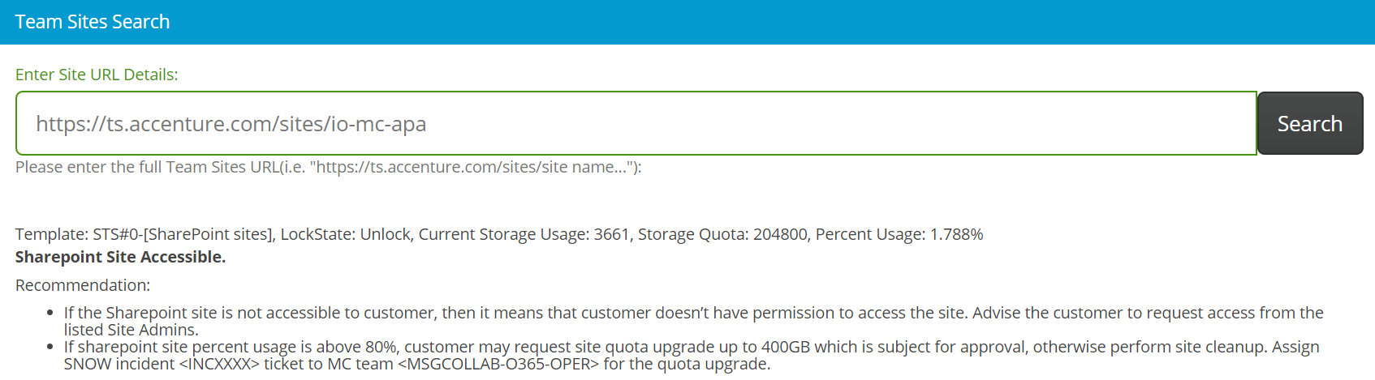

MS Teams site is accessible:

Recommendation:

* If the MS Teams site is not accessible to customer, then it means that customer doesn’t have permission to access the site. Advise the customer to request access from the listed Site Admins.
* If MS Team site percent usage is above 80%, advise the customer to perform site cleanup. There is no quota upgrade available.

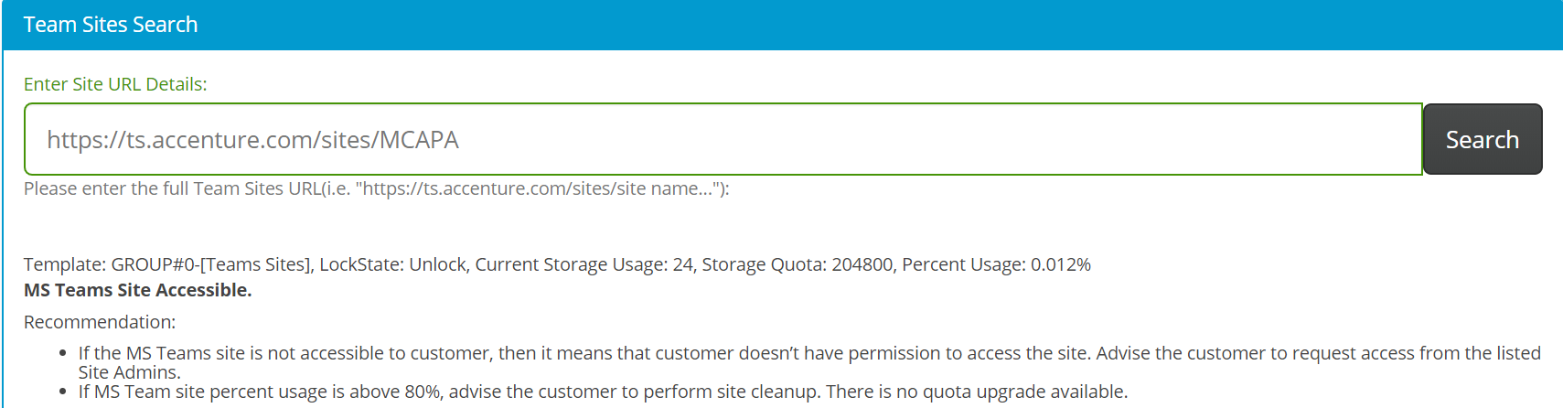

SharePoint site is does not exist:

Comment:

* Change recommendation to: “Check if URL is correct. If correct, then the site was deleted. If the customer wants to restore the site, assign SNOW incident <INCXXXX> ticket to MC team <MSGCOLLAB-O365-OPER>.
* Note: Site can only be restored within 90 days after deletion.”

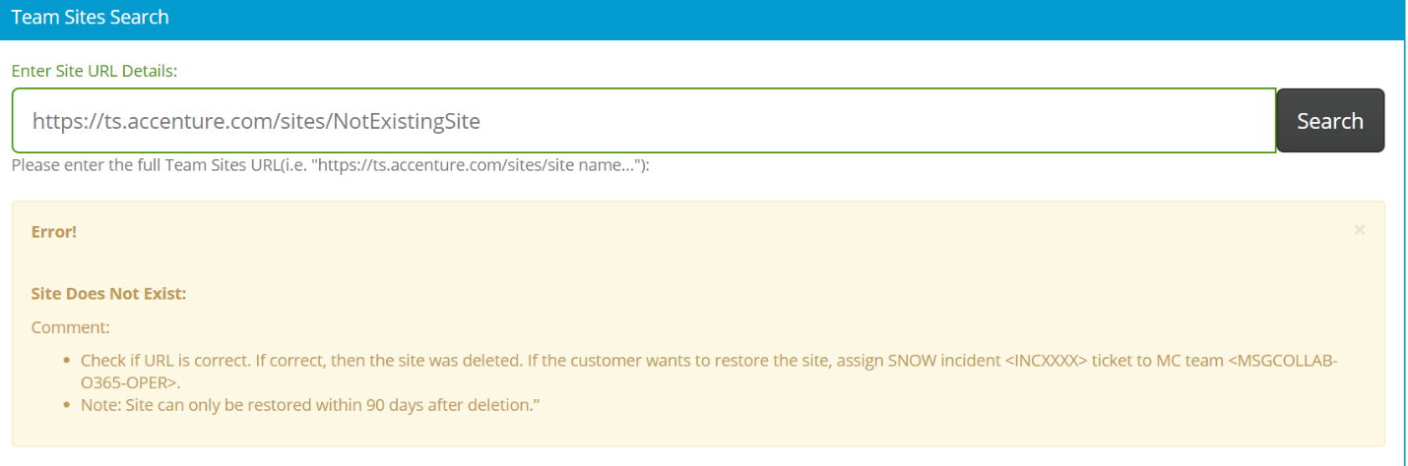

SharePoint site is blocked:

Recommendation:

* The SharePoint site is blocked. Advise the Site Owner to correct invalid entries from SNOW [SharePoint Service Catalog](https://support.accenture.com/support_portal?id=iframe_catalog_request&sys_id=0813b9900f6d1600e65a4b9ce1050eeb), otherwise log a SNOW incident ticket (INCXXX) to DSRM Team: APPSUP-APP-CIO-DSRM.

