1. PROJECT TITLE:
SSPO-DL Spark: Shuffled shepherd Student psychology optimization based deep learning with spark architecture for big data classification
2. HARDWARE REQUIREMENTS
OS-Windows 10
RAM-8GB
ROM-More than 100 GB
GPU-Yes
CPU-1.7 GHz

3. SOFTWARE REQUIREMENTS
Software name(Python): Version: 3.7.6
(Download link: https://www.python.org/downloads/release/python-376/ )
Click -> Windows x86-64 executable installer.
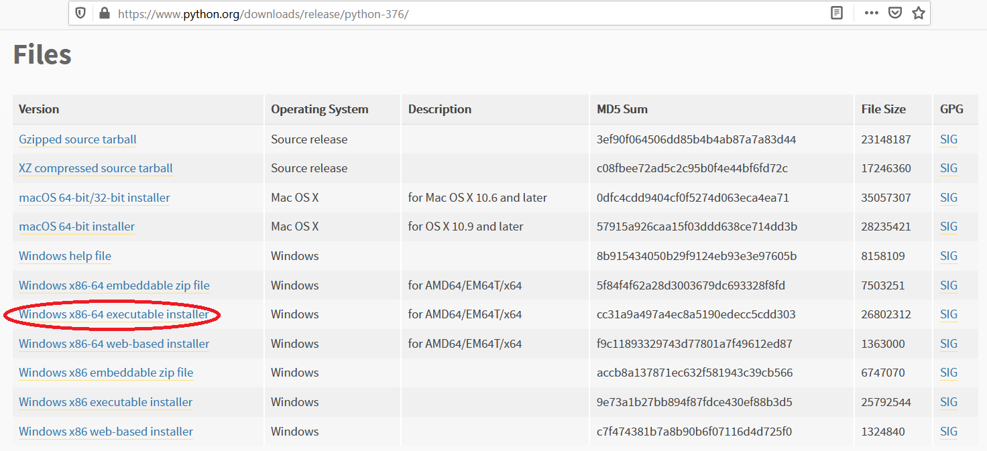

Software name: PyCharm: Version: 2020.3.3
(Download link: https://www.jetbrains.com/pycharm/download/other.html)
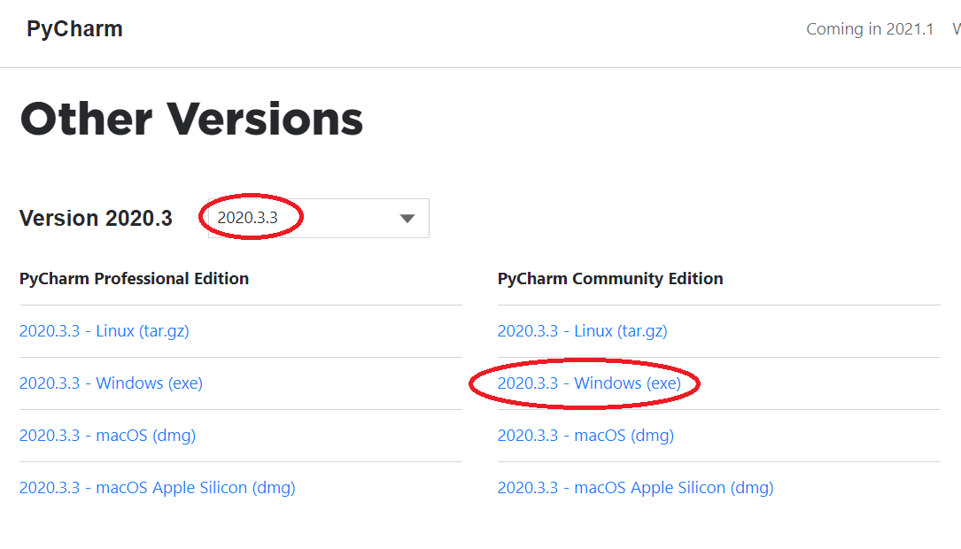
(For installation procedure, please refer the doc “steps to install python.doc”)

4. HOW TO RUN
Step 1: Loading the project in PYCHARM
- Open pycharm
- Go to File, select Open browse the project from your drive and select it. So that the project will get loaded into the Pycharm.
- For the first time, Pycharm will take some time to load the settings.
- Please wait if any process is loading on the bottom of the screen.
- Check the Project Interpreter (File -> Settings -> Project: 146203 -> Project Interpreter).
If this location “(C:\Users\---\AppData\Local\Programs\Python\Python37-64\python.exe) is not presented, then add this ‘python.exe’ from the installed location.
- In Pycharm Terminal(bottom left), type the comment “pip install -r requirements.txt”
Step 2: Run the program and getting the results
- From 'current project folder' window in pycharm, Open ‘146203 -> Main->GUI.py’ and click run button
- In GUI window, 1) Select the dataset (eg:Adult)
2) Enter Training data(%) (eg:80)
3) Click START, after some time the result will be displayed
4) To view the current result graph, click Run Graph
[Expected Execution time expected: 15 minutes]
- Step 3: Generate the graphs plotted in the paper
- From 'current project folder' window in pycharm, open ‘146203 -> Main->Result_graphs.py’, and click run button.

5. IMPORTANT PYTHON FILE AND DESCRIPTION:
Main-> GUI.py: User Interface, code starts here
Main-> Run.py: Main code
Main->Preprocessing.py: Box-Cox Transformation of data
Main-> Spark.py: Master & slave
Main-> DFCM.py: Deep Fuzzy clustering
Main-> Fusion.py: Feature fusion using Pearson Correlation-Deep Residual Network
Main-> Data_Augmentation.py: Data Augmentation
Proposed_SSPO_DQN-> SSPO.py: Optimization Update equationline 66
Proposed_SSPO_DQN-> DQN.py: Deep Q Network
Main-> Result_graphs.py: displays graphs in paper.

