**1. PROJECT TITLE:**

SSPO-DL Spark: Shuffled shepherd Student psychology optimization based deep learning with spark architecture for big data classification

**2. HARDWARE REQUIREMENTS**

OS-Windows 10

RAM-8GB

ROM-More than 100 GB

GPU-Yes

CPU-1.7 GHz

**3. SOFTWARE REQUIREMENTS**

Software name(**Python**): Version: 3.7.6

(Download link: <https://www.python.org/downloads/release/python-376/> )

Click -> Windows x86-64 executable installer.

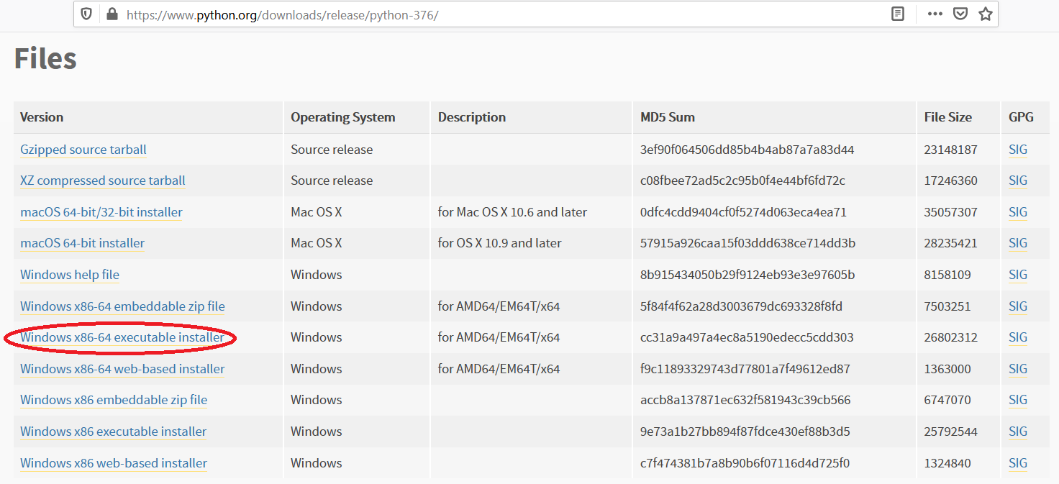

Software name: **PyCharm**: Version: 2020.3.3

(Download link: <https://www.jetbrains.com/pycharm/download/other.html>)

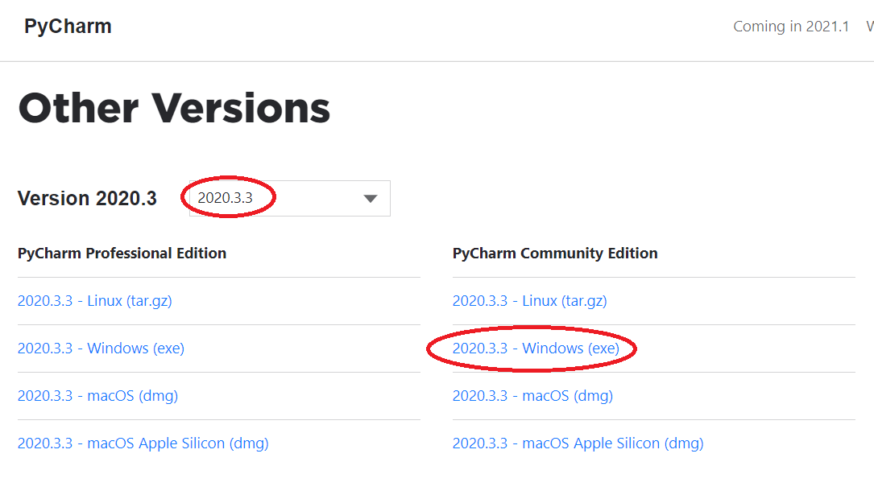

(For installation procedure, please refer the doc “steps to install python.doc”)

**4. HOW TO RUN**

**Step 1**: Loading the project in PYCHARM

* Open pycharm
* Go to File, select Open browse the project from your drive and select it. So that the project will get loaded into the Pycharm.
* For the first time, Pycharm will take some time to load the settings.
* Please wait if any process is loading on the bottom of the screen.
* Check the Project Interpreter (File -> Settings -> Project: 146203 -> Project Interpreter).

If this location “(C:\Users\---\AppData\Local\Programs\Python\Python37-64\python.exe) is not presented, then add this ‘python.exe’ from the installed location.

* In Pycharm Terminal(bottom left), type the comment “pip install -r requirements.txt”

**Step 2**: Run the program and getting the results

* From 'current project folder' window in pycharm, Open ‘**146203** **-> Main->GUI.py**’ and click run button
* In GUI window, 1) Select the dataset (eg:Adult)

2) Enter Training data(%) (eg:80)

3) Click START, after some time the result will be displayed

4) To view the current result graph, click Run Graph

[Expected Execution time expected: **15 minutes**]

* **Step 3**: Generate the graphs plotted in the paper
* From 'current project folder' window in pycharm, open ‘146203 -> Main->Result_graphs.py’, and click run button.

**5. IMPORTANT PYTHON FILE AND DESCRIPTION:**

**Main-> GUI.py**: User Interface, code starts here

**Main-> Run.py**: Main code

**Main->Preprocessing.py:** Box-Cox Transformation of data

**Main-> Spark.py:** Master & slave

**Main-> DFCM.py:** Deep Fuzzy clustering

**Main-> Fusion.py:** Feature fusion using Pearson Correlation-Deep Residual Network

**Main-> Data_Augmentation.py:** Data Augmentation

**Proposed_SSPO_DQN-> SSPO.py:** Optimization Update equation🡪line 66

**Proposed_SSPO_DQN-> DQN.py:** Deep Q Network

**Main-> Result_graphs.py**: displays graphs in paper.