Apache Maven, is an innovative software project management tool, provides new concept of a project object model (POM) file to manage project’s build, dependency and documentation.
The most powerful feature is able to download the project dependency libraries automatically.
Ant and Maven both are build tools provided by Apache. The main purpose of these technologies is to ease the build process of a project. There are many differences between ant and maven that are given below
Ant | Maven
Ant doesn’t have formal conventions, so we need to provide information of the project structure in build.xml file. | Maven has a convention to place source code, compiled code etc. So we don't need to provide information about the project structure in pom.xml file.
Ant is procedural you need to provide information about what to do and when to do through code. You need to provide order. | Maven is declarative, everything you define in the pom.xml file.
There is no life cycle in Ant. | There is life cycle in Maven.
It is a tool box. | It is a framework.
It is mainly a build tool. | It is mainly a project management tool.
The ant scripts are not reusable. | The maven plug-ins is reusable.
It is less preferred than Maven. | It is more preferred than Ant.

POM Structure:
<project xmlns="http://maven.apache.org/POM/4.0.0" xmlns:xsi="http://www.w3.org/2001/XMLSchema-instance"
xsi:schemaLocation="http://maven.apache.org/POM/4.0.0 http://maven.apache.org/xsd/maven-4.0.0.xsd">
<modelVersion>4.0.0</modelVersion>
<groupId>com.companyname.project-group</groupId>
<artifactId>project</artifactId>
<version>1.0</version>
<repositories>
. . . .
</repositories>
<dependencies>
. . . .
<dependencies>
<build>
<plugins>
. . .
</plugins>
</build>
</project>
- Maven Installation & Configuration
Maven Windows Installation:
1. Download Apache Maven
Go to Maven official website, download the Maven zip file, Unzip It.
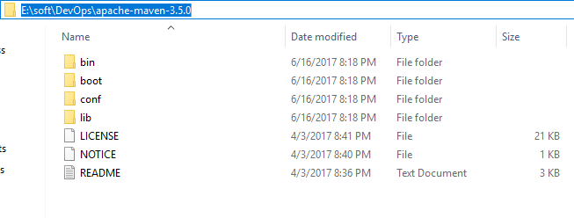
2. Configure the JAVA_HOME Windows environment variables by specifying Java Installation Location
Control Panel → User Accounts → User Accounts → Change my Environment Variables
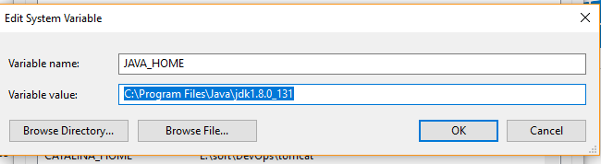
3.Add both M2_HOME and MAVEN_HOME as Windows environment variable & point it to Maven folder
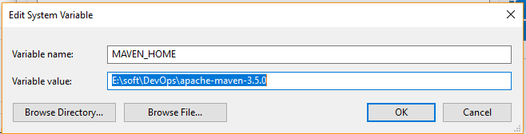
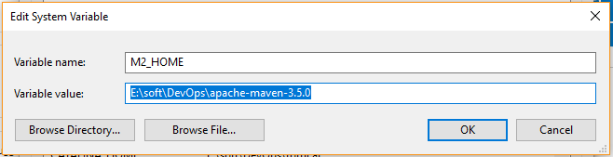
4.Update PATH variable, append Maven bin folder – %MAVEN_HOME%\bin, so that you can run the Maven’s command everywhere.
5. Verify Maven is installed properly or by mvn –version command
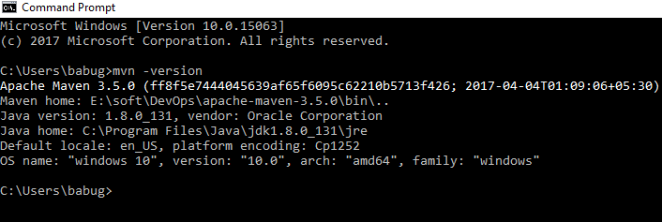
MAVEN INSTALL UBUNTU:
1. In a terminal, run apt-cache search maven, to get all the available Maven package.
2. Run command sudo apt-get install maven, to install the latest Apache Maven.
3. Run command mvn -version to verify your installation.
babu@ubuntu:~$ mvn --version
Apache Maven 3.3.9
Maven home: /usr/share/maven
Java version: 1.8.0_131, vendor: Oracle Corporation
Java home: /usr/lib/java/jdk1.8.0_131/jre
Default locale: en_US, platform encoding: UTF-8
OS name: "linux", version: "4.10.0-19-generic", arch: "amd64", family: "unix"
babu@ubuntu:~$
What is Build Lifecycle?
A Build Lifecycle is a well defined sequence of phases which define the order in which the goals are to be executed. Here phase represents a stage in life cycle.
As an example, a typical Maven Build Lifecycle is consists of following sequence of phases
Phase | Handles | Description
prepare-resources | resource copying | Resource copying can be customized in this  Phase.
Compile | compilation | Source code compilation is done in this phase.
Package | packaging | This phase creates the JAR / WAR package as  Mentioned in packaging in POM.xml.
Install | installation | This phase installs the package in local /  Remote maven repository.
There are always pre and post phases which can be used to register goals which must run prior to or after a particular phase.
When Maven starts building a project, it steps through a defined sequence of phases and executes goals which are registered with each phase. Maven has following three standard lifecycles:
- Clean
- Default or build
- Site
A goal represents a specific task which contributes to the building and managing of a project. It may be bound to zero or more build phases. A goal not bound to any build phase could be executed outside of the build lifecycle by direct invocation.
The order of execution depends on the order in which the goals and the build phases are invoked.
For example, consider the command below. The clean and package arguments are build phases
While the dependency: copy-dependencies are a goal.
Mvn clean dependency: copy-dependencies package
Here the clean phase will be executed first, and then the dependency: copy-dependencies goal will be executed, and finally package phase will be executed.
Clean Lifecycle
When we execute mvn post-clean command, Maven invokes the clean lifecycle consisting of the following phases.
- Pre-clean
- Clean
- Post-clean
Thus when mvn clean command executes, Maven deletes the build directory.
We can customize this behavior by mentioning goals in any of the above phases of clean life cycle.
In the following example, we’ll attach maven-ant run-plugin: run goal to the pre-clean, clean, and post-clean phases. This will allow us to echo text messages displaying the phases of the clean lifecycle.
We've created a pom.xml in C:\MVN\project folder.
<project xm lns="http://m aven.apache.org/POM/4.0.0"
xm lns:xsi="http://www.w3.org/2001/XMLSchem a-instance"
xsi:schem aLocation="http://m aven.apache.org/POM/4.0.0
http://m aven.apache.org/xsd/m aven-4.0.0.xsd">
<m odelVersion>4.0.0</m odelVersion>
<groupId>com .com panynam e.projectgroup</groupId>
<artifactId>project</artifactId>
<version>1.0</version>
<build>
<plugins>
<plugin>
<groupId>org.apache.m aven.plugins</groupId>
<artifactId>m aven-antrun-plugin</artifactId>
<version>1.1</version>
<executions>
<execution>
<id>id.pre-clean</id>
<phase>pre-clean</phase>
<goals>
<goal>run</goal>
</goals>
<configuration>
<tasks>
<echo>pre-clean phase</echo>
</tasks>
</configuration>
</execution>
<execution>
<id>id.clean</id>
<phase>clean</phase>
<goals>
<goal>run</goal>
</goals>
<configuration>
<tasks>
<echo>clean phase</echo>
</tasks>
</configuration>
</execution>
<execution>
<id>id.post-clean</id>
<phase>post-clean</phase>
<goals>
<goal>run</goal>
</goals>
<configuration>
<tasks>
<echo>post-clean phase</echo>
</tasks>
</configuration>
</execution>
</executions>
</plugin>
</plugins>
</build>
</project>
Now open command console, go to the folder containing pom.xml and execute the following mvn command.
C:\MVN\project>mvn post-clean
Maven will start processing and display all the phases of clean life cycle
[INFO] Scanning for projects...
[INFO]
[INFO] ------------------------------------------------------------------------
[INFO] Building project 1.0
[INFO] ------------------------------------------------------------------------
[INFO]
[INFO] --- Maven-ant run-plug-in: 1.1: run (id pre-clean) @ project ---
[INFO] Executing tasks
[echo] pre-clean phase
[INFO] Executed tasks
[INFO]
[INFO] --- Maven-clean-plug-in: 2.5: clean (default-clean) @ project ---
[INFO]
[INFO] --- Maven-ant run-plug-in: 1.1: run (id clean) @ project ---
[INFO] Executing tasks
[echo] clean phase
[INFO] Executed tasks
[INFO]
[INFO] --- Maven-ant run-plug-in: 1.1: run (id.post-clean) @ project ---
[INFO] Executing tasks
[echo] post-clean phase
[INFO] Executed tasks
[INFO] ------------------------------------------------------------------------
[INFO] BUILD SUCCESS
[INFO] ------------------------------------------------------------------------
[INFO] Total time: 2.078 s
[INFO] Finished at: 2015-09-26T08:03:06+05:30
[INFO] Final Memory: 7M/247M
[INFO] ------------------------------------------------------------------------
You can try tuning mvn clean command which will display pre-clean and clean, nothing will be executed for post-clean phase.
Default or Build Lifecycle
This is the primary life cycle of Maven and is used to build the application. It has following 23 phases.
Lifecycle Phase | Description
Validate  . | Validates whether project is correct and all necessary information  is available to complete the build process
initialize | Initializes build state, for example set properties
generate-sources | Generate any source code to be included in compilation phase.
process-sources | Process the source code, for example, filter any value.
generate-resources | Generate resources to be included in the package.
process-resources | Copy and process the resources into the destination directory,  Ready for packaging phase.
Compile | Compile the source code of the project.
process-classes | Post-process the generated files from compilation, for example to  do byte code enhancement/optimization on Java class
generate-test-sources | Generate any test source code to be included in compilation phase.
process-test-sources | Process the test source code, for example, filter any values.
test-compile | Compile the test source code into the test destination directory.
process-test-classes | Process the generated files from test code file compilation.
test | Run tests using a suitable unit testing framework Junit jsone.
prepare-package | Perform any operations necessary to prepare a package before the actual packaging.
package | Take the compiled code and package it in its distributable format, such as a JAR, WAR, or EAR file.
pre-integration-test | Perform actions required before integration tests are executed.  For example, setting up the required environment.
integration-test  . | Process and deploy the package if necessary into an environment  where integration tests can be run
post-integration-test | Perform actions required after integration tests have been executed. For example, cleaning up the environment.
verify | Run any check-ups to verify the package is valid and meets quality criteria’s.
install | Install the package into the local repository, which can be used as a dependency in other projects locally.
deploy | Copies the final package to the remote repository for sharing with other developers and projects.

There are few important concepts related to Maven Lifecycles which are wroth to mention:
When a phase is called via Maven command, for example mvn compile, only phases up to and including that phase will execute.
Different maven goals will be bound to different phases of Maven lifecycle depending upon the type of packaging JAR /WAR /EAR.
In the following example, we’ll attach maven-ant run-plug-in: run goal to few of the phases of Build lifecycle. This will allow us to echo text messages displaying the phases of the lifecycle.
We've updated pom.xml in C:\MVN\project folder.
<project xm lns="http://m aven.apache.org/POM/4.0.0"
xm lns:xsi="http://www.w3.org/2001/XMLSchem a-instance"
xsi:schem aLocation="http://m aven.apache.org/POM/4.0.0
http://m aven.apache.org/xsd/m aven-4.0.0.xsd">
<m odelVersion>4.0.0</m odelVersion>
<groupId>com .com panynam e.projectgroup</groupId>
<artifactId>project</artifactId>
<version>1.0</version>
<build>
<plugins>
<plugin>
<groupId>org.apache.m aven.plugins</groupId>
<artifactId>m aven-antrun-plugin</artifactId>
<version>1.1</version>
<executions>
<execution>
<id>id.validate</id>
<phase>validate</phase>
<goals>
<goal>run</goal>
</goals>
<configuration>
<tasks>
<echo>validate phase</echo>
</tasks>
</configuration>
</execution>
<execution>
<id>id.com pile</id>
<phase>com pile</phase>
<goals>
<goal>run</goal>
</goals>
<configuration>
<tasks>
<echo>com pile phase</echo>
</tasks>
</configuration>
</execution>
<execution>
<id>id.test</id>
<phase>test</phase>
<goals>
<goal>run</goal>
</goals>
<configuration>
<tasks>
<echo>test phase</echo>
</tasks>
</configuration>
</execution>
<execution>
<id>id.package</id>
<phase>package</phase>
<goals>
<goal>run</goal>
</goals>
<configuration>
<tasks>
<echo>package phase</echo>
</tasks>
</configuration>
</execution>
<execution>
<id>id.deploy</id>
<phase>deploy</phase>
<goals>
<goal>run</goal>
</goals>
<configuration>
<tasks>
<echo>deploy phase</echo>
</tasks>
</configuration>
</execution>
</executions>
</plugin>
</plugins>
</build>
</project>
Now open command console, go the folder containing pom.xml and execute the following mvn command.
C:\MVN\project>mvn com pile
Maven will start processing and display phases of build life cycle upto compile phase.
[INFO] Scanning for projects...
[INFO]
[INFO] ------------------------------------------------------------------------
[INFO] Building project 1.0
[INFO] ------------------------------------------------------------------------
[INFO]
[INFO] --- Maven-ant run-plug-in: 1.1: run (id validate) @ project ---
[INFO] Executing tasks
[echo] validate phase
[INFO] Executed tasks
[INFO] --- Maven-resources-plug-in: 2.6: resources (default-resources) @ project -
[WARNING] Using platform encoding (Cp1252 actually) to copy filtered resources, i.e. build is platform dependent
[INFO] skip non existing resource Directory C:\MVN\project\src\main\resources
[INFO]
[INFO] --- Maven-compiler-plug-in: 3.1: com pile (default-com pile) @ project ---
[INFO] No sources to com pile
[INFO]
[INFO] --- Maven-ant run-plug-in: 1.1: run (id com pile) @ project ---
[INFO] Executing tasks
[echo] com pile phase
[INFO] Executed tasks
[INFO] ------------------------------------------------------------------------
[INFO] BUILD SUCCESS
[INFO] ------------------------------------------------------------------------
[INFO] Total time: 3.704 s
[INFO] Finished at: 2015-09-26T08:22:05+05:30
[INFO] Final Memory: 10M/247M
[INFO] ------------------------------------------------------------------------
Site Lifecycle
Maven Site plug-in is generally used to create fresh documentation to create reports, deploy site etc.
Phases
Pre-site
Site
Post-site
Site-deploy
In the following example, we'll attach maven-ant run-plug-in: run goal to all the phases of Site lifecycle. This will allow us to echo text messages displaying the phases of the lifecycle.
We've updated pom.xml in C:\MVN\project folder.
<project xm lns="http://m aven.apache.org/POM/4.0.0"
xm lns:xsi="http://www.w3.org/2001/XMLSchem a-instance"
xsi:schem aLocation="http://m aven.apache.org/POM/4.0.0
http://m aven.apache.org/xsd/m aven-4.0.0.xsd">
<m odelVersion>4.0.0</m odelVersion>
<groupId>com .com panynam e.projectgroup</groupId>
<artifactId>project</artifactId>
<version>1.0</version>
<build>
<plugins>
<plugin>
<groupId>org.apache.m aven.plugins</groupId>
<artifactId>maven-antrun-plugin</artifactId>
<version>1.1</version>
<executions>
<execution>
<id>id.pre-site</id>
<phase>pre-site</phase>
<goals>
<goal>run</goal>
</goals>
<configuration>
<tasks>
<echo>pre-site phase</echo>
</tasks>
</configuration>
</execution>
<execution>
<id>id.site</id>
<phase>site</phase>
<goals>
<goal>run</goal>
</goals>
<configuration>
<tasks>
<echo>site phase</echo>
</tasks>
</configuration>
</execution>
<execution>
<id>id.post-site</id>
<phase>post-site</phase>
<goals>
<goal>run</goal>
</goals>
<configuration>
<tasks>
<echo>post-site phase</echo>
</tasks>
</configuration>
</execution>
<execution>
<id>id.site-deploy</id>
<phase>site-deploy</phase>
<goals>
<goal>run</goal>
</goals>
<configuration>
<tasks>
<echo>site-deploy phase</echo>
</tasks>
</configuration>
</execution>
</executions>
</plugin>
</plugins>
</build>
</project>
Now open command console, go the folder containing pom.xml and execute the following mvn command.
C:\MVN\project>mvn site
Maven will start processing and display phases of site life cycle upto site phase.
[INFO] Scanning for projects...
[INFO]
[INFO] ------------------------------------------------------------------------
[INFO] Building project 1.0
[INFO] ------------------------------------------------------------------------
[INFO]
[INFO] --- Maven-ant run-plug-in: 1.1: run (id pre-site) @ project ---
[INFO] Executing tasks
[echo] pre-site phase
[INFO] Executed tasks
[INFO]
[INFO] --- Maven-site-plug-in: 3.3: site (default-site) @ project ---
[WARNING] Report plug-in org. apache. Maven. Plug-ins: maven-project-info-reports-plug-in has an empty version.
[WARNING]
[WARNING] It is highly recommended to fix these problems because they threaten the stability of your build.
[WARNING]
[WARNING] For this reason, future Maven versions might no longer support building such malformed projects.
[INFO] configuring report plug-in org. apache .maven .plug-ins: maven-project-info-reports-plug-in: 2.8.1
[WARNING] No project URL defined - decoration links will not be relativized
[INFO] Rendering site with org .apache .maven .skins: maven-default-skin: jar: 1.0 skin.
[INFO] Generating "Dependency Convergence" report --- maven-project-info-reports-plug-in: 2.8.1
[INFO] Generating "Dependency Information" report --- maven-project-info-reports-plug-in: 2.8.1
[INFO] Generating "About" report --- maven-project-info-reports-plug-in: 2.8.1
[INFO] Generating "Plug-in Management" report --- maven-project-info-reports-plug-in: 2.8.1
[INFO] Generating "Project Plug-ins" report --- maven-project-info-reports- plug-in: 2.8.1
[INFO] Generating "Project Summary" report --- maven-project-info-reports- plug-in: 2.8.1
[INFO]
[INFO] --- Maven-ant run-plug-in: 1.1: run (id site) @ project ---
[INFO] Executing tasks
[echo] site phase
[INFO] Executed tasks
[INFO] ------------------------------------------------------------------------
[INFO] BUILD SUCCESS
[INFO] ------------------------------------------------------------------------
[INFO] Total time: 11.390 s
[INFO] Finished at: 2015-09-26T08:43:45+05:30
[INFO] Final Memory: 18M/247M
[INFO] ------------------------------------------------------------------------
Processing math: 100%
Maven Repository:
A maven repository is a directory of packaged JAR file with pom.xml file. Maven searches for dependencies in the repositories. There are 3 types of maven repository:
1. Local Repository
2. Central Repository
3. Remote Repository

Maven searches for the dependencies in the following order:
Local repository then Central repository then Remote repository.
If dependency is not found in these repositories, maven stops processing and throws an error.
- Local Repository:
The maven local repository is a local folder that is used to store all your project’s dependencies (plug-in jars and other files which are downloaded by Maven). In simple, when you build a Maven project, all dependency files will be stored in your Maven local repository. By default, Maven local repository is default to .m2
Folder → C:\Documents and Settings\{your-username}\.m2
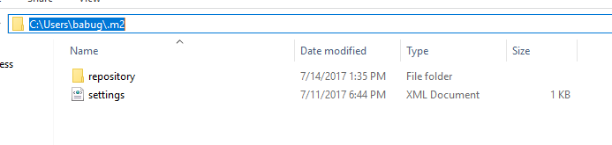
We can change the location of maven local repository by changing the settings.xml file. It is located in MAVEN_HOME/conf/settings.xml update local Repository to other repo folder & save
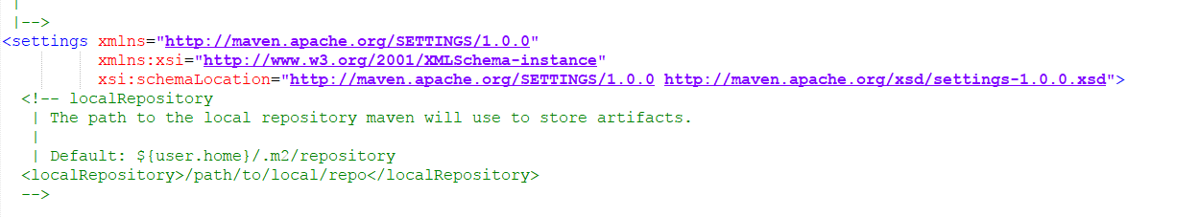
<Local Repository>E: /maven-repo</local Repository>
Now, your new Maven local repository is now changed to E: /maven-repo.
2. Central Repository:
When you build a Maven’s project, Maven will check your pom.xml file, to identify which dependency to download. First, Maven will get the dependency from your Local repository, if not found, then get it from the default Maven central repository – http://repo1.maven.org/maven2/ Maven central repository is located on the web. It has been created by the apache maven community itself. The path of central repository is: http://repo1.maven.org/maven2/
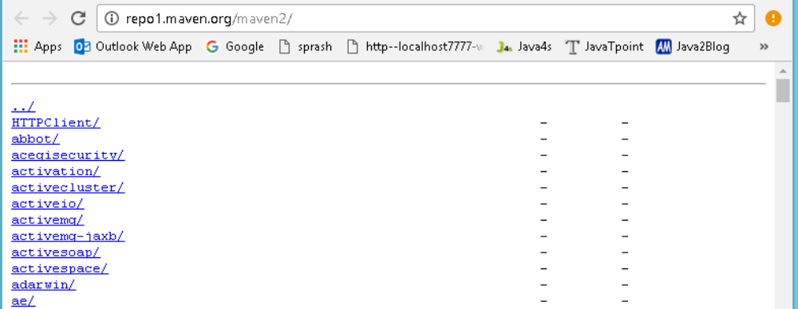
The central repository contains a lot of common libraries that can be viewed by this URL http://search.maven.org/#browse
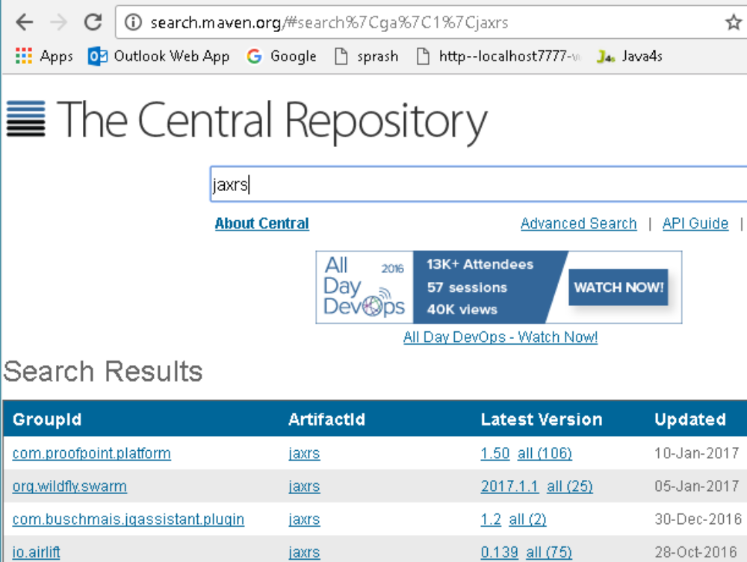

3. Remote Repository:
Maven remote repository is located on the web. Most of libraries can be missing from the central repository such as JBoss library etc, so we need to define remote repository in pom.xml file.
In Maven, when you’re declared library does not exist either in local repository nor Maven center repository, the process will stop and output error messages to your Maven console. For Example org.jboss.resteasy.jar will be only available in JBoss repository only.
To tell Maven to get the dependency from Java.net, you need to declared a remote repository in your pom.xml file like this
<project xmlns="http://maven.apache.org/POM/4.0.0”>
<modelVersion>4.0.0</modelVersion>
<groupId>JAXRS-HeaderParam-Example</groupId>
<artifactId>JAXRS-HeaderParam-Example</artifactId>
<version>0.0.1-SNAPSHOT</version>
<packaging>war</packaging>
<repositories>
<repository>
<id>JBoss repository</id>
<url>https://repository.jboss.org/nexus/content/groups/public-jboss/</url>
</repository>
</repositories>
<dependencies>
<dependency>
<groupId>org.jboss.resteasy</groupId>
<artifactId>resteasy-jaxrs</artifactId>
<version>2.2.1.GA</version>
</dependency>
</dependencies>
</project>
Maven pom.xml file:
POM is an acronym for Project Object Model. The pom.xml file contains information of project and configuration information for the maven to build the project such as dependencies, build directory, source directory, test source directory, plug-in, goals etc.
Maven reads the pom.xml file, and then executes the goal.
Elements of maven pom.xml file:
P.S: element details are provided in the comments
<project xmlns="http://maven.apache.org/POM/4.0.0" xmlns:xsi="http://www.w3.org/2001/XMLSchema-instance"
xsi:schemaLocation="http://maven.apache.org/POM/4.0.0 http://maven.apache.org/maven-v4_0_0.xsd">
<modelVersion>4.0.0</modelVersion> //2.It specifies the modelVersion
<groupId>JAXRS-HeaderParam-Example</groupId> // 3.It specifies the id for the project group.
<artifactId>JAXRS-HeaderParam-Example</artifactId> //4.generated .jar, .war file name
<version>0.0.1-SNAPSHOT</version> //5.pecifies the version of the artifact
<packaging>war</packaging> //6.packaging type such as jar, war etc
<repositories>
<repository>
<id>JBoss repository</id>
<url>https://repository.jboss.org/nexus/content/groups/public-jboss/</url>
</repository>
</repositories>
<dependencies>
<dependency>
<groupId>junit</groupId>
<artifactId>junit</artifactId>
<version>4.8.2</version>
<scope>test</scope>
</dependency>
<dependency>
<groupId>org.jboss.resteasy</groupId>
<artifactId>resteasy-jaxrs</artifactId>
<version>2.2.1.GA</version>
</dependency>
</dependencies>
<build>
<finalName>RESTfulExample</finalName>
<plugins>
<plugin>
<artifactId>maven-compiler-plugin</artifactId>
<configuration>
<source>1.6</source>
<target>1.6</target>
</configuration>
</plugin>
</plugins>
</build>
</project> //1. It is the root element of pom.xml file
Maven Example:
We have a maven template for creating project using Maven. That is,
mvn archetype:generate -DgroupId={project-packaging}
-DartifactId={project-name}
-DarchetypeArtifactId=maven-archetype-quickstart
-DinteractiveMode=false
This tells Maven to create a Java project from the Maven maven-archetype-quickstart template. If we ignore the archetypeArtifactId option, a huge list of the Maven templates will be listed.
Normally, we just use the following two templates
1. maven-archetype-webapp – Java Web Project (WAR)
2. maven-archetype-quickstart – Java Project (JAR)
3.maven-archetype-sample-j2ee – enterprises projects(ear)
Sample Maven Project Creation:
- Navigate to the folder you want to create the Java project. Type below command:
mvn archetype:generate -DgroupId=com.smlcodes
-DartifactId=MavenSample
-DarchetypeArtifactId=maven-archetype-quickstart
-DinteractiveMode=false
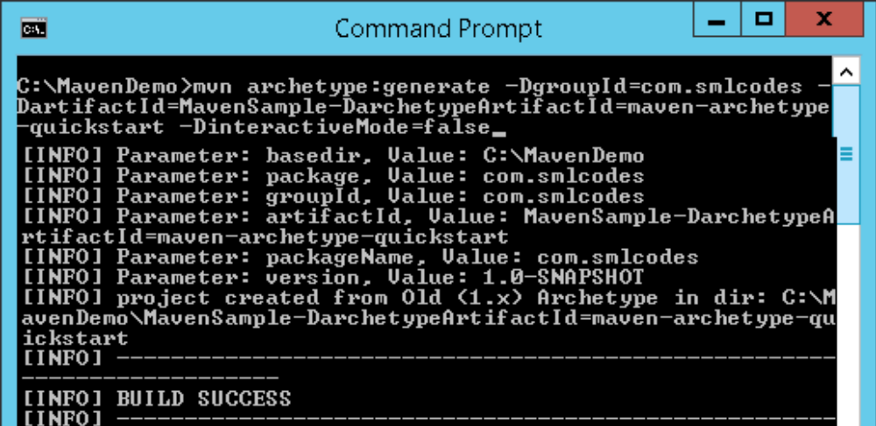
- If we check the Generated project folder it will contains following structure
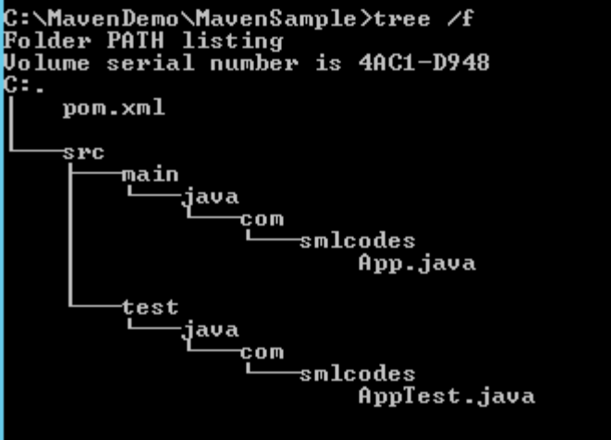
All source code files puts in folder /src/main/java/, all unit test code puts in /src/test/java/.
- The above created Project is Normal Project, Eclipse cannot recognize it to Importing, To make this as an Eclipse project, in terminal, navigate to “MavenSample” project, type this command
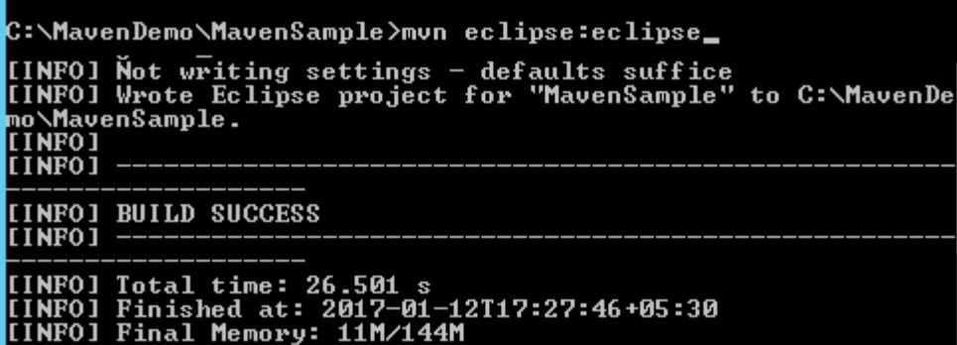
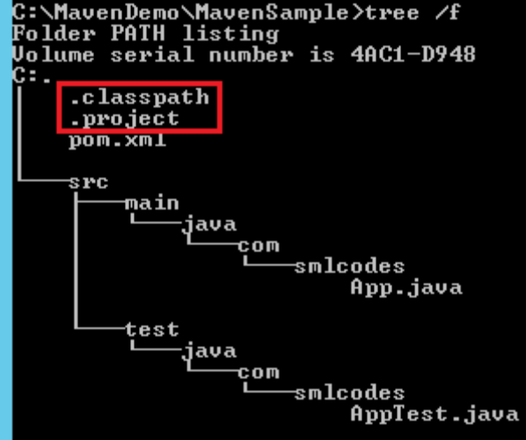
- The generated pom.xml will be in below formate
<project xmlns="http://maven.apache.org/POM/4.0.0" xmlns:xsi="http://www.w3.org/2001/XMLSchema-instance"
xsi:schemaLocation="http://maven.apache.org/POM/4.0.0 http://maven.apache.org/maven-v4_0_0.xsd">
<modelVersion>4.0.0</modelVersion>
<groupId>com.smlcodes</groupId>
<artifactId>MavenSample</artifactId>
<packaging>jar</packaging>
<version>1.0-SNAPSHOT</version>
<name>MavenSample</name>
<url>http://maven.apache.org</url>
<dependencies>
<dependency>
<groupId>junit</groupId>
<artifactId>junit</artifactId>
<version>3.8.1</version>
<scope>test</scope>
</dependency>
</dependencies>
</project>
- Update Java resources with appropriate logic
//App.java
package com.smlcodes;
public class App {
public static void main(String[] args) {
App ob = new App();
System.out.println("Your Random Number Is : " + ob.randomNumber());
}
public int randomNumber() {
int random = (int) (Math.random() * 1000) ;
return random;
}
}
//AppTest.java
package com.smlcodes;
import org.junit.Assert;
import org.junit.Test;
public class AppTest {
@Test
public void testRandomNumber() {
App ob = new App();
Assert.assertTrue(ob.randomNumber()>0);
}
}
6. In pom.xml packing method is <packaging>jar</packaging> , to do packing we have to use
mvn package command
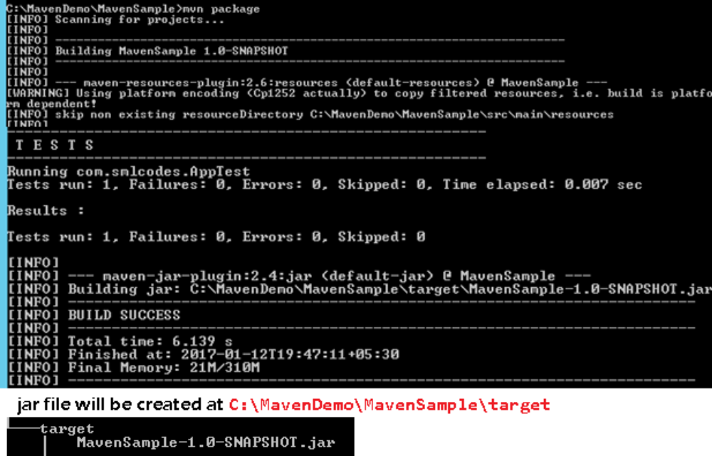
7. We can test the Jar file by using below command on project root directory
java -cp target/MavenSample-1.0-SNAPSHOT.jar com.smlcodes.App
Maven with Eclipse IDE:
Configure Maven in Eclipse:
- Go to Window →Preferences →Maven →Installations →Add →Maven location → Finish
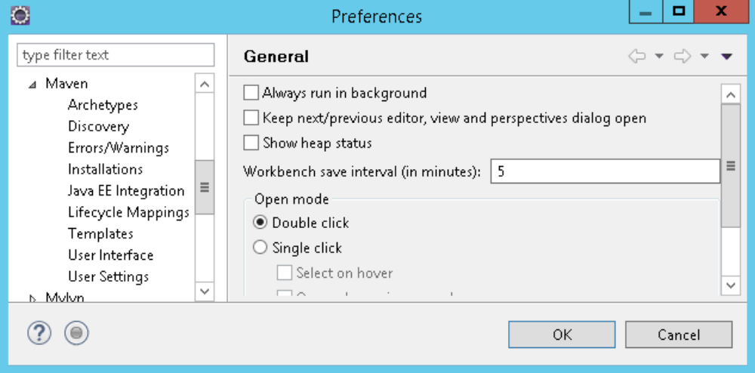
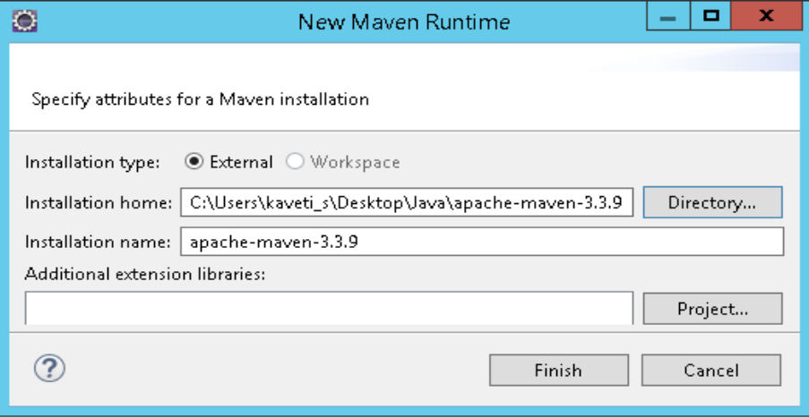
- Select the maven installation then click ok
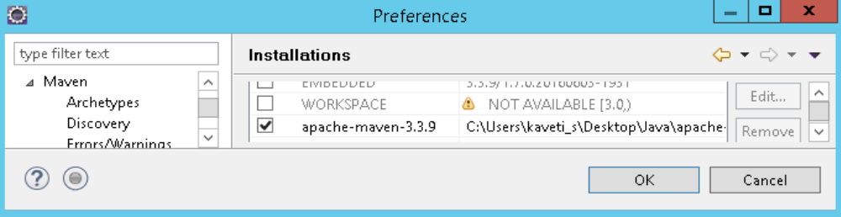
- Go to Maven User Settings locate settings.xml (apache-maven-3.5.0\conf\settings.xml )
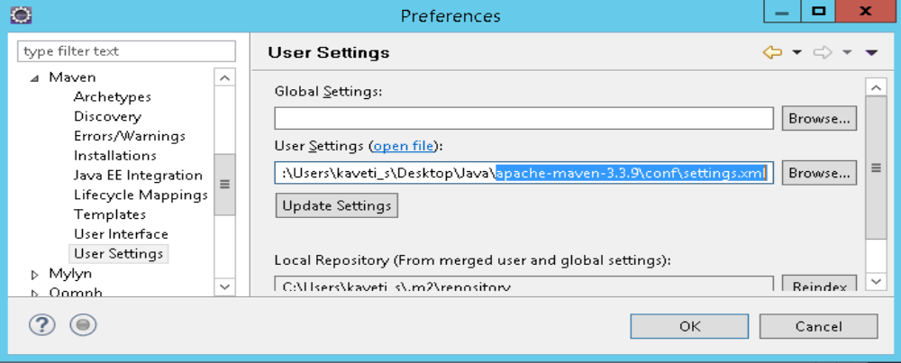
How to Convert Java Project into Maven Project in Eclipse:
Right Click on Project →Configure → Convert to Maven Project → provide details→Finish
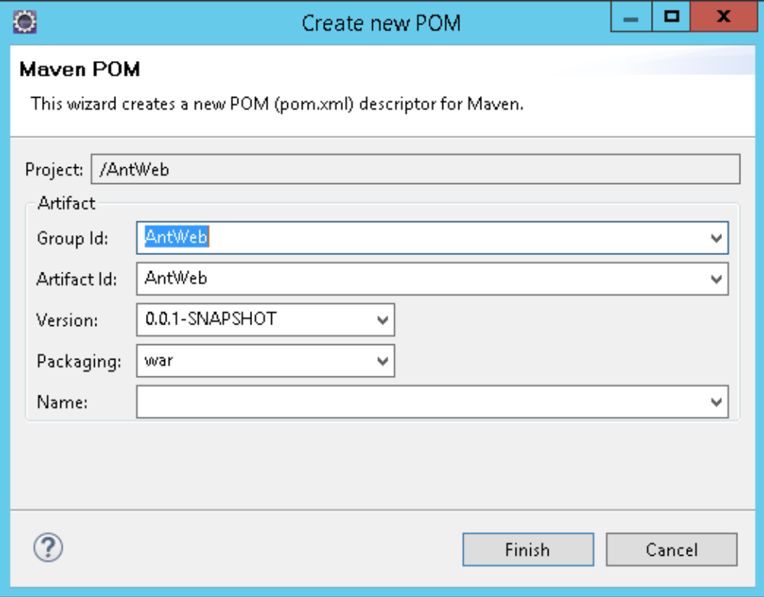
How to import Maven Project to Eclipse:
- Open Eclipse IDE, File → Import →Maven → Existing Maven Projects → Choose Root Directory → Finish
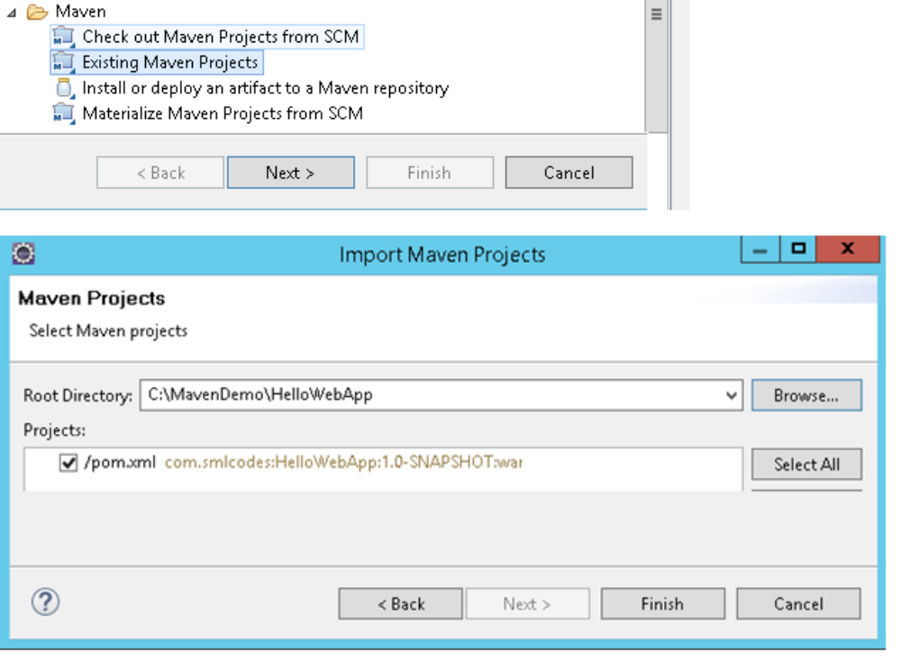
Create Web Application with Maven:
To create Java Webapplication using maven we have to maven-archetype-webapp template
//Syntax
> mvn archetype:generate -DgroupId={project-packaging}
-DartifactId={project-name}
-DarchetypeArtifactId=maven-archetype-webapp
-DinteractiveMode=false
1. Navigate to the folder you want to create the project & type this command
> mvn archetype:generate -DgroupId=com.smlcodes
-DartifactId=HelloWebApp
-DarchetypeArtifactId=maven-archetype-webapp
-DinteractiveMode=false
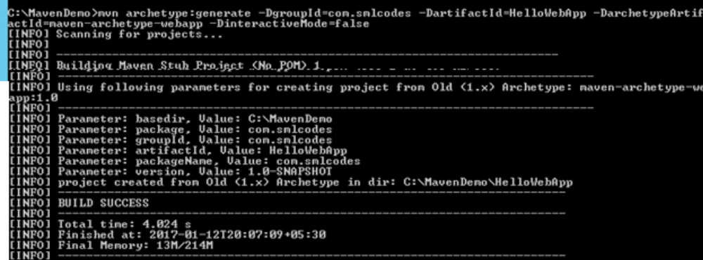
- If we check the Generated project folder it will contains following structure
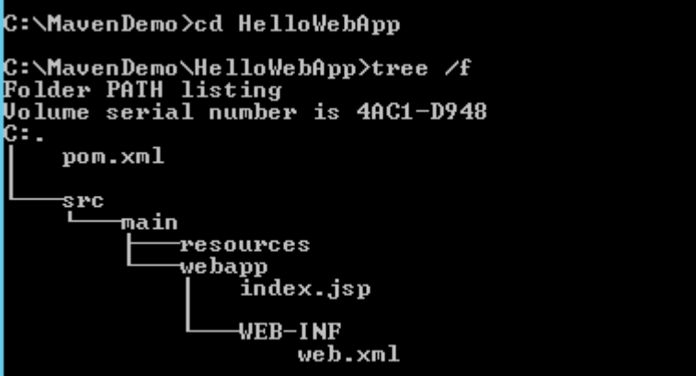
3. The above created Project is Normal Project, Eclipse cannot recognize it to Importing, to make this as an Eclipse project, in terminal, navigate to “MavenSample” project, and type this command
mvn eclipse:eclipse -Dwtpversion=2.0
Maven Commands & Operations:
So far we used some maven commands like
1. mvn archetype → For generating maven Project
2. mvn eclipse:eclipse → For Converting maven Project to eclipse maven project
3. mvn install:install-file → For adding jar to local maven repository
4. mvn package → For packing project to .jar / .war

Like that we have many maven commands, now we will see the most usefull commands in maven
Maven build lifecycle
Maven is based around the central concept of a build lifecycle. What this means is that the process for building and distributing a particular artifact (project) is clearly defined.
Here are three built-in build lifecycles: default, clean and site. The default lifecycle handles your project deployment, the clean lifecycle handles project cleaning, while the site lifecycle handles the creation of your project's site documentation.
For example, the default lifecycle comprises of the following phases (refer to the Lifecycle Reference)
- validate - validate the project is correct and all necessary information is available
- compile - compile the source code of the project
- test - test the compiled source code using a suitable unit testing framework. These tests should not require the code be packaged or deployed
- package - take the compiled code and package it in its distributable format, such as a JAR.
- verify - run any checks on results of integration tests to ensure quality criteria are met
- install - install the package into the local repository, for use as a dependency in other projects locally
- deploy - done in the build environment, copies the final package to the remote repository for sharing with other developers and projects.
mvn package :
When you run “mvn package” command, it will compile source code, run unit test and pack it depends on your “packaging” tag in pom.xml file.
Maven is run by phases, read this default Maven build lifecycle article for more detail. So, when the “package” phase is executed, all its above phases – “validate“, “compile” and “test“, including the current phase “package” will be executed orderly.
1. If “packaging”=jar, it will package your project into a “jar” file and put it into your target folder
2. If “packaging”=war, it will package your project into a “war” file and put it into your target folder
3.if“packaging”=ear, it will package your project into a “ear” file and put it into your target folder
<project>
<modelVersion>4.0.0</modelVersion>
<groupId>AntWeb</groupId>
<artifactId>AntWeb</artifactId>
<version>0.0.1-SNAPSHOT</version>
<packaging>war/jar</packaging>
</project>
C:\MavenDemo\MavenSample>mvn package
[INFO] ------------------------------------------------------------------------
[INFO] Building MavenSample 1.0-SNAPSHOT
-------------------------------------------------------
T E S T S
-------------------------------------------------------
Running com.smlcodes.AppTest
Tests run: 1, Failures: 0, Errors: 0, Skipped: 0, Time elapsed: 0.03 sec
mvn clean:
In Maven based project, many cached output existed in your “target” folder. When you want to build your project for deployment, you have to make sure clean all the cached output so that you are always get the latest for deployment.
To clean our project cached output, we will use command
C:\MavenDemo\MavenSample>mvn clean
[INFO] Scanning for projects...
[INFO] Building MavenSample 1.0-SNAPSHOT
[INFO] ------------------------------------------------------------------------
[INFO] --- maven-clean-plugin:2.5:clean (default-clean) @ MavenSample ---
[INFO] Deleting C:\MavenDemo\MavenSample\target
[INFO] ------------------------------------------------------------------------
[INFO] BUILD SUCCESS
[INFO] ------------------------------------------------------------------------
[INFO] Total time: 1.032 s
mvn test:
To run unit test via Maven we will use command.it will run the entire unit tests in your project
1. To run the entire unit test (Application1 and Application2),use below command
mvn test
2. To run single test (Application1), use below command
mvn -Dtest= Application1 test
3. To run single test (Application2), use below command
mvn -Dtest= Application2 test
mvn install
When we use “mvn install”, it will package your project and deploy to local repository automatically, so that other developers can use it.
When “install” phase is executed, all above phases “validate“, “compile“, “test“, “package“, “integration-test“, “verify” phase , including the current “install” phase will be executed orderly. Refer to this Maven lifecycle for detail
Before running mvn install the folder structure of the project is as below
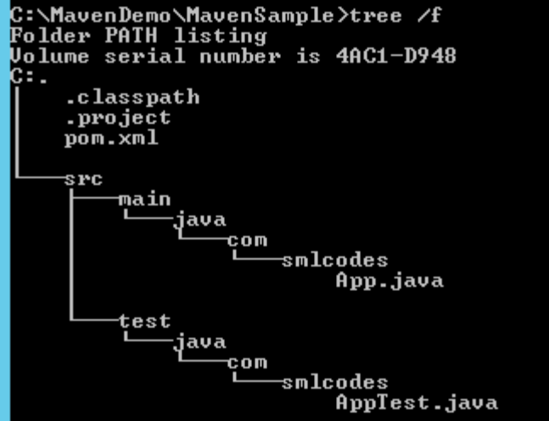
C:\MavenDemo\MavenSample>mvn install
[INFO] Scanning for projects...
[INFO] ------------------------------------------------------------------------
[INFO] Building MavenSample 1.0-SNAPSHOT
[INFO] ------------------------------------------------------------------------
[INFO] --- maven-resources-plugin:2.6:resources (default-resources) @ MavenSample ---
[INFO] Compiling 1 source file to C:\MavenDemo\MavenSample\target\classes
[INFO] skip non existing resourceDirectory C:\MavenDemo\MavenSample\src\test\resources
[INFO] Compiling 1 source file to C:\MavenDemo\MavenSample\target\test-classesmaven-surefire-plugin:2.12.4:test (default-test) @ MavenSample ---
[INFO] Surefire report directory: C:\MavenDemo\MavenSample\target\surefire-reports
-------------------------------------------------------
T E S T S
-------------------------------------------------------
Running com.smlcodes.AppTest
Tests run: 1, Failures: 0, Errors: 0, Skipped: 0, Time elapsed: 0.013 sec
[INFO]
[INFO] --- maven-jar-plugin:2.4:jar (default-jar) @ MavenSample ---
[INFO] Building jar: C:\MavenDemo\MavenSample\target\MavenSample-1.0-SNAPSHOT.jar
[INFO] ------------------------------------------------------------------------
[INFO] BUILD SUCCESS
After running mvn install , project structure is as below, & it creates MavenSample-1.0-SNAPSHOT.jar
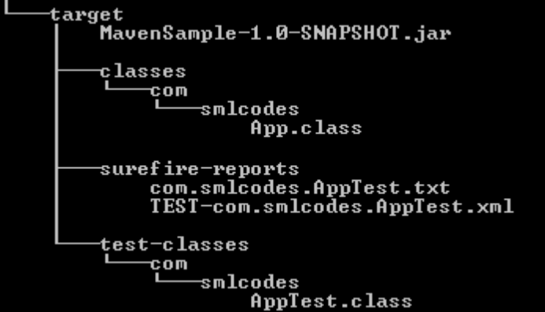
It’s always recommended to run “clean” and “install” together, so that you are always deploy the latest project to your local repository.
mvn clean install
mvn site :
“mvn site” is used to generate a documentation site for your project information
C:\MavenDemo\MavenSample>mvn site
[INFO] Scanning for projects...
[INFO]
[INFO] ------------------------------------------------------------------------
[INFO] Building MavenSample 1.0-SNAPSHOT
[INFO] ------------------------------------------------------------------------
[INFO]
[INFO] --- maven-site-plugin:3.3:site (default-site) @ MavenSample --- [INFO] Rendering site with org.apache.maven.skins:maven-default-skin:jar:1.0 skin.
[INFO] Generating "Dependencies" report --- maven-project-info-reports-plugin:2.9
[INFO] Generating "Dependency Convergence" report --- maven-project-info-reports-p
[INFO] Generating "Dependency Information" report --- maven-project-info-reports-p
[INFO] Generating "About" report --- maven-project-info-reports-plugin:2.9
[INFO] Generating "Plugin Management" report --- maven-project-info-reports-plugin
[INFO] Generating "Plugins" report --- maven-project-info-reports-plugin:2.9
[INFO] Generating "Summary" report --- maven-project-info-reports-plugin:2.9
[INFO] ------------------------------------------------------------------------
[INFO] BUILD SUCCESS
[INFO] ------------------------------------------------------------------------
[INFO] Total time: 55.925 s
[INFO] Finished at: 2017-01-13T11:51:09+05:30
[INFO] Final Memory: 20M/288M
[INFO] ------------------------------------------------------------------------
If we open the /site folder of our project, we can find the generated documenet files
Open
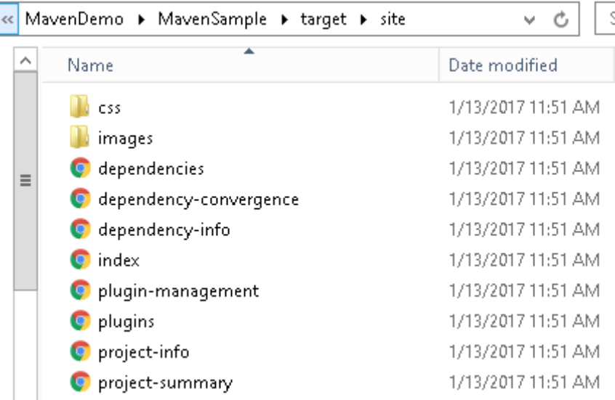
Open index.html, it will navigates to Home page of your project document
“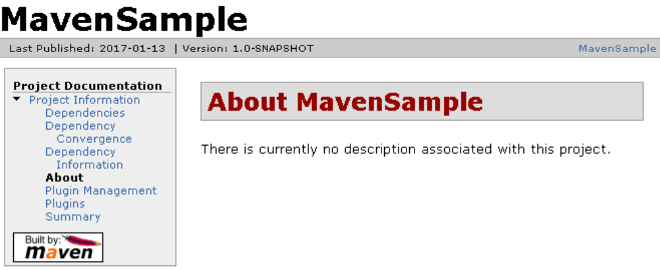
“mvn site:deploy” to deploy your generated documentation site to server automatically, via WebDAV mechanism.

Code Coverage plug-ins with maven:
1. Jacoco
2. Sonarqube
3. PMD
4. CheckStyle
5. JXR
6. Findbugs
7. Cobertura
1. Analyzing code coverage with the Maven Jacoco plug-in:

Jacoco is a free Java code coverage tool. This is essentially the successor to Emma, and it has been developed by the EclEmma team as an Eclipse project. Jacoco offers line and branch coverage.

<project xmlns="http://maven.apache.org/POM/4.0.0" xmlns:xsi="http://www.w3.org/2001/XMLSchema-instance"
xsi:schemaLocation="http://maven.apache.org/POM/4.0.0 http://maven.apache.org/maven-v4_0_0.xsd">
<modelVersion>4.0.0</modelVersion>
<groupId>com.kiran.hello</groupId>
<artifactId>samplpro</artifactId>
<packaging>jar</packaging>
<version>1.0-SNAPSHOT</version>
<name>samplpro</name>
<url>http://maven.apache.org</url>
<dependencies>
<dependency>
<groupId>junit</groupId>
<artifactId>junit</artifactId>
<version>3.8.1</version>
<scope>test</scope>
</dependency>
</dependencies>
<build>
<plugins>
<plugin>
<groupId>org.jacoco</groupId>
<artifactId>jacoco-maven-plugin</artifactId>
<version>0.7.2.201409121644</version>
<executions>
<execution>
<id>default-prepare-agent</id>
<goals>
<goal>prepare-agent</goal>
</goals>
</execution>
<execution>
<id>default-report</id>
<phase>prepare-package</phase>
<goals>
<goal>report</goal>
</goals>
</execution>
</executions>
</plugin>
</plugins>
</build>
</project>
--------------------------------------------------------------------------------------

HOW TO VIEW REPORT:
Open the index.html file generated in the target/site/Jacoco folder.
In the pom file, we instruct Maven to run the following two goals of the Maven Jacoco plug-in:
Prepare-agent: This is bound by default to the initialize phase of the Maven
Default lifecycle: The goal runs and prepares the agent that does the analysis.
Report: This agent gathers test coverage information when the tests are run and create the report as part of the prepare-package phase (which we have explicitly specified).

You could subject the project to code coverage and generate the same report without making any changes to the pom file. To do this, runs the following command: mvn Jacoco: prepare-agent test Jacoco: report

If we get a following error:
May get the following error:
[ERROR] No plug-in found for prefix 'Jacoco' in the current project and in the plug-in groups [org.apache.maven.plugins] available from the repositories [local (C:\software\maven), central

Workaround command:
mvn org.jacoco: jacoco-maven-plugin:prepare-agent test
org.jacoco: jacoco-maven-plugin: report
How about failing the build if the code coverage is below a threshold value? To do this, perform the following steps:
<execution>
<id>default-check</id>
<phase>prepare-package</phase>
<goals>
<goal>check</goal>
</goals>
<configuration>
<rules>
<rule>
<element>BUNDLE</element>
<limits>
<limit>
<counter>COMPLEXITY</counter>
<value>COVEREDRATIO</value>
<minimum>0.60</minimum>
</limit>
</limits>
</rule>
</rules>
</configuration>
</execution>

2. Analyzing code coverage with the Maven Cobertura plug-in:
Cobertura is another popular Java tool that calculates the percentage of code accessed by tests. It is based on coverage. There are many ways to use Cobertura, including standalone, through Ant script, and Maven.

Cmd: mvn cobertura: cobertura
Description:
Jacoco instruments the code online when the tests are running and hence, it needs to have the agent running. On the other hand, Cobertura instruments the byte code during compilation offline. The cobertura goal of the Cobertura Maven plug-in instruments the project, runs the tests, and generates the report.

There are separate goals to instrument and check results, if require

case:
<plugin>
<groupId>org.codehaus.mojo</groupId>
<artifactId>cobertura-maven-plugin</artifactId>

<version>2.6</version>
<configuration>
<check>
<branchRate>85</branchRate>
<lineRate>85</lineRate>
<haltOnFailure>true</haltOnFailure>
</check>
</configuration>
<executions>
<execution>
<goals>
<goal>check</goal>
</goals>
</execution>
</executions>
</plugin>

mvn cobertura:check

3. Analyzing code with the Maven SonarQube plug-in:

- SonarQube is a platform to manage code quality.
- It is a web-based application, where rules,
- Alerts, thresholds, and other metrics can be configured. It provides various ways to analyze code.
- The results of the analysis can then be viewed in a web application.
- SonarQube also
- Provides several paid plugins, such as SQALE, and for specific languages, such as Cobol and C++.

SonarQube :
1. http://www.sonarqube.org/downloads/.
2. Download the latest release.
3. Unzip the ZIP file to a folder of your choice.
4. Based on the platform, start the server by following the instructions.
5. Confirm that the server is running by visiting the web page at http://localhost:9000/ (assuming it's a default installation).

How to do it:
1. Before run the maven, first start the sonar server
2. Open maven project
3. mvn sonar: sonar
4. Visit the Sonar web page at http://localhost:9000 or refresh
5. Click on the project link:

More info:
- The sonar goal of the Maven SonarQube plug-in sets in motion a series of steps to do various analyses of the project.
- Based on the configuration, the Sonar plug-in performs Check style
- Analysis, Find Bugs analysis and PMD analysis, as well as detects code coverage, code duplication, design issues and code complexity.
- It sends the output to a database and generates reports that can be viewed from the web page by the user.

4. Analyzing code with the Maven PMD plug-in:[program mistake detector]
- PMD is a source code analyzer.
- It finds common programming flaws such as unused variables,
- Empty catch blocks, and unnecessary object creation.
- It also includes the Copy/Paste Detector (CPD) that finds duplicated code.
- steps to perform: go maven project where pom.xml is saved
mvn pmd:pmd pmd:cpd
- Check the contents of the target folder:
- open the pmd.xml
- Open the cpd.html file in the site folder.
5. Analyzing code with the Maven Check style plug-in:

- Check style is a tool that helps programmers follows coding standards.
- It automates the process of checking if defined coding standards are followed.
- It can support any coding standards by suitable configuration.
- Like other tools, it can be run standalone as well as integrated with Maven.
mvn checkstyle:checkstyle
Open the checkstyle-result.xml report in the target folder:

6. Analyzing code with the Maven Find Bugs plug-in:

- Find Bugs is another tool that uses static analysis to inspect Java byte code for bugs in a Java code.
- It is based on the concept of bug patterns.
- A bug pattern is a code snippet that is often an error.

steps:
1. mvn clean compile findbugs:findbugs
2. Open the generated XML file findbugsXml.xml in the target folder:
When the findbugs goal of the FindBugs plug in is run, it analyzes the byte code and reports errors to an output file in the XML format. Unlike Check style and the PMD plugins, it does not generate a default site report unless configured differently.
You can also launch the FindBugs GUI to view the report in a graphical format:
1. Run the following Maven command:
mvn compile findbugs:findbugs findbugs:gui
2. Observe the FindBugs screen:

7. Generating source references with the Maven JXR plug in:

Following warnings when running the PMD or Check style plug in:
[INFO] --- Maven-pmd-plug in: 3.2: pmd (default-cli) @ project-with violations
---
[WARNING] Unable to locate Source XRef to link to – DISABLED
[INFO] --- Maven-checkstyle-plug in: 2.13: checkstyle (default-cli) @
Project-with-violations ---
[INFO]
[INFO] There are 36 checkstyle errors.
[WARNING] Unable to locate Source XRef to link to – DISABLED
The plugins attempt to link the violation to the specific lines in the cross-reference of the source. As they are unable to find this cross-reference, they display the warning.

=====================================================================
To generate this cross-reference, we need to use the Maven JXR plug in.

mvn jxr:jxr

Browse the target/site folder.

Open the contents of the XRef folder in the browser:

Once the cross-reference exists, code quality tools, such as PMD and Check style, link to this
How to checkout code from GITHUB using MAVEN:
WINDOWS ENVIRONMENT:
How to checkout source code from git and to deploy that source code after convert it as war file in tomcat?
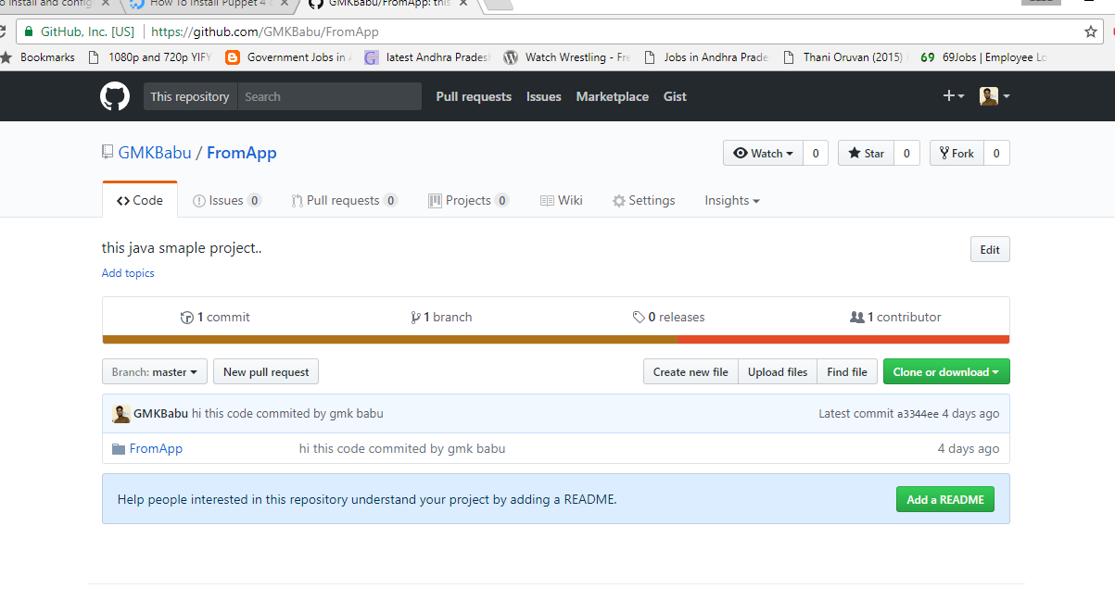
- Check the source code is at Git repository.
- Get the user credential.
- Get URL of repository.
- Create a maven repository(use web app to generate war file)
- Check the pom.xml file.
- Update the pom.xml with SCM configurations like
1)
<scm>
<developerConnection>scm:git:https://github.com/GMKBabu/FromApp.git</developerConnection>
</scm>
2)
<build>
<plugins>
<plugin>
<groupId>org.apache.maven.scm</groupId>
<artifactId>maven-scm-provider-gitexe</artifactId>
<version>1.9.5</version>
<configuration>
<goals>install</goals>
</configuration>
</plugin>
</plugins>
</build>

- Save the pom.xml.
- Use mvn scm commands to perform actions on the repository.
mvn scm:validate
mvn scm :checkout
mvn package
- Now we see the checkout folder in target.
POM.XML:
<project xmlns="http://maven.apache.org/POM/4.0.0" xmlns:xsi="http://www.w3.org/2001/XMLSchema-instance" xsi:schemaLocation="http://maven.apache.org/POM/4.0.0 http://maven.apache.org/xsd/maven-4.0.0.xsd">
<modelVersion>4.0.0</modelVersion>
<groupId>FromApp</groupId>
<artifactId>FromApp</artifactId>
<version>0.0.1-SNAPSHOT</version>
<packaging>war</packaging>
<scm>
<developerConnection>scm:git:https://github.com/GMKBabu/FromApp.git</developerConnection>
</scm>
<build>
<plugins>
<plugin>
<groupId>org.apache.maven.scm</groupId>
<artifactId>maven-scm-provider-gitexe</artifactId>
<version>1.9.5</version>
<configuration>
<goals>install</goals>
</configuration>
<plugin>
</plugins>
</build>
</project>
LINUX ENVIRONMENT
How to checkout source code from git and to deploy that source code after convert it as war file in tomcat?
- Open Ubuntu/Redhat in Linux.
- Then open terminal and check java is install or not by using java -version command.
- Also check maven by mvn --version.
- Open browser and download latest apache tomcat .
- Download the tar.gz file and unzip it by using tar -zxvf apache-tomcat-8.0.45.tar.gz command.
- open the conf folder in tomcat folder and edit tomcat-user.xml by using sudo gedit tomcat-users.xml
add these code at the bottom of the file
<role rolename="manager-gui"/>
<role rolename="manager-script"/>
<role roelename="admin-gui"/>
<user username="babu" password="babu" roles="manager-gui,manager-script,admin-gui"/>
- After this save and exit from the folder.
- Then copy the path of bin folder in tomcat folder and paste in terminal, now fire the sudo sh startup.sh
- And open http://localhost:8080.com and Check the manager app by providing user and password credential.
- Check the .m2 folder of maven in ubuntu.
- If it’s not found then try with command locate maven after that go to .m2 folder Or we can find in some machine by directly go to /home/ubuntu/.m2.
- And add a file with settings.xml name.
add below code in settings.xml file.
<?xml version="1.0" encoding="UTF-8"?>
<settings>
<servers>
<server>
<id>TomcatServer</id>
<username>babu</username>
<password>babu</password>
</server>
</servers>
</settings>

- After that save that file and exit from that location.
- Or try like this, just go to desktop in ubuntu and open a empty document and add the above code and save it as settings.xml
- And use the copy (cp) command to copy the file into .m2 folder.
- Fire cp ~/Desktop/settings.xml . command from .m2 folder location.
- Check the source code is at Git repository.
- Get the user credential.
- Get URL of repository.
- Go to pom.xml location and add following scm and tomcat plugins.

1)
<scm>
<developerConnection>scm:git:https://github.com/GMKBabu/FromApp.git</developerConnection>
</scm>
2)
<build>
<plugins>
<plugin>
<groupId>org.apache.maven.scm</groupId>
<artifactId>maven-scm-provider-gitexe</artifactId>
<version>1.9.5</version>
<configuration>
<goals>install</goals>
</configuration>
</plugin>
</plugins>
</build>

- Save the pom.xml.
- Use mvn scm commands to perform actions on the repository.
mvn scm:validate
mvn scm :checkout
POM.xml:
<project xmlns="http://maven.apache.org/POM/4.0.0" xmlns:xsi="http://www.w3.org/2001/XMLSchema-instance" xsi:schemaLocation="http://maven.apache.org/POM/4.0.0 http://maven.apache.org/xsd/maven-4.0.0.xsd">
<modelVersion>4.0.0</modelVersion>
<groupId>FromApp</groupId>
<artifactId>FromApp</artifactId>
<version>0.0.1-SNAPSHOT</version>
<packaging>war</packaging>
<scm>
<developerConnection>scm:git:https://github.com/GMKBabu/FromApp.git</developerConnection>
</scm>
<build>
<plugins>
<plugin>
<groupId>org.apache.maven.scm</groupId>
<artifactId>maven-scm-provider-gitexe</artifactId>
<version>1.9.5</version>
<configuration>
<goals>install</goals>
</configuration>
<plugin>
</plugins>
</build>
</project>
- Now we see the checkout folder in target.
- Now using tomcat plug-in and mentioning tomcat url, username, password as configuration we can deploy the war file in tomcat server

<plugin>
<groupId>org.apache.tomcat.maven</groupId>
<artifactId>tomcat7-maven-plugin</artifactId>
<version>2.2</version>
<configuration>
<url>http://localhost:8080/manager/text</url>
<server>TomcatServer</server>
<path>/FromApp</path>
</configuration>
</plugin>
- before fire the commands start the tomcat server using http://localhost:8080.com
- complete project pom.xml
<project xmlns="http://maven.apache.org/POM/4.0.0" xmlns:xsi="http://www.w3.org/2001/XMLSchema-instance" xsi:schemaLocation="http://maven.apache.org/POM/4.0.0 http://maven.apache.org/xsd/maven-4.0.0.xsd">
<modelVersion>4.0.0</modelVersion>
<groupId>FromApp</groupId>
<artifactId>FromApp</artifactId>
<version>0.0.1-SNAPSHOT</version>
<packaging>war</packaging>
<dependencies>
<dependency>
<groupId>junit</groupId>
<artifactId>junit</artifactId>
<version>3.8.1</version>
<scope>test</scope>
</dependency>
<dependency>
<groupId>javax.servlet</groupId>
<artifactId>javax.servlet-api</artifactId>
<version>3.1.0</version>
<scope>provided</scope>
</dependency>
</dependencies>
<build>
<sourceDirectory>src</sourceDirectory>
<plugins>
<plugin>
<artifactId>maven-compiler-plugin</artifactId>
<version>3.5.1</version>
<configuration>
<source>1.8</source>
<target>1.8</target>
</configuration>
</plugin>
<plugin>
<artifactId>maven-war-plugin</artifactId>
<version>2.6</version>
<configuration>
<warSourceDirectory>WebContent</warSourceDirectory>
<failOnMissingWebXml>false</failOnMissingWebXml>
</configuration>
</plugin>
<plugin>
<groupId>org.apache.tomcat.maven</groupId>
<artifactId>tomcat7-maven-plugin</artifactId>
<version>2.2</version>
<configuration>
<url>http://localhost:8080/manager/text</url>
<server>TomcatServer</server>
<path>/FromApp</path>
</configuration>
</plugin>

</plugins>
</build>
</project>
- now fire the following command
1.mvn clean package install tomcat7:deploy(for deploy purpose)
2.mvn clean package install tomcat7:undeploy(for undeploy purpose)
3.mvn clean package install tomcat7:redeploy(for redeploy purpose)

How to deploy WAR file in TOMCAT using MAVEN:
To depoloy .War file in tomcat we need tomcat user credencials. We can find those from apache-tomcat-8.0.37\conf\tomcat-users.xml
1. Add a user with roles manager-gui and manager-script.
tomcat-users.xml location is : apache-tomcat-8.0.37\conf\tomcat-users.xml
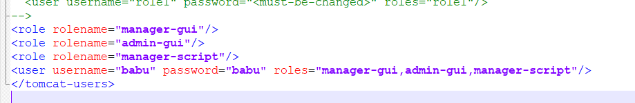
2. Add above Tomcat’s user in the Maven setting file, later Maven will use this user to login Tomcat server.
settings.xml location is : apache-maven-3.3.9\conf\settings.xml
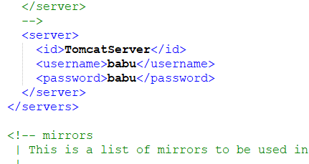
- Declares a Maven Tomcat plugin in POM.xml
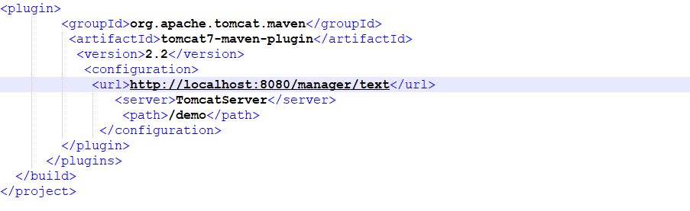
4. Deploy the Application .war file Tomcat
Use following mvn commands for deploying war in tomcat server
- For Deploying in Tomcat 7 Deploy
URL = http://localhost:8080/manager/text
Command = mvn tomcat7:deploy

- For Deploying in Tomcat 6 Deploy
URL = http://localhost:8080/manager/
Command = mvn tomcat6:deploy
C:\Workspace\HelloWeb>mvn tomcat7:deploy
[INFO] Scanning for projects...
[INFO]
[INFO] ------------------------------------------------------------------------
[INFO] Building HelloWeb 0.0.1-SNAPSHOT
[INFO] ------------------------------------------------------------------------
[INFO]
[INFO] >>> tomcat7-maven-plugin:2.2:deploy (default-cli) > package @ HelloWeb >>>
[INFO] Packaging webapp
[INFO] Assembling webapp [HelloWeb] in [C:\Workspace\HelloWeb\target\HelloWeb-0.0.1-SNAPSHOT]
[INFO] Processing war project
[INFO] Copying webapp resources [C:\Workspace\HelloWeb\WebContent]
[INFO] Webapp assembled in [93 msecs]
[INFO] Building war: C:\Workspace\HelloWeb\target\HelloWeb-0.0.1-SNAPSHOT.war
[INFO]
[INFO] <<< tomcat7-maven-plugin:2.2:deploy (default-cli) < package @ HelloWeb <<<
[INFO]
[INFO] --- tomcat7-maven-plugin:2.2:deploy (default-cli) @ HelloWeb ---
[INFO] Deploying war to http://localhost:8080/demo
Uploading: http://localhost:8080/manager/text/deploy?path=%2Fdemo
Uploaded: http://localhost:8080/manager/text/deploy?path=%2Fdemo (3 KB at 1385.3 KB/sec)
[INFO] tomcatManager status code:200, ReasonPhrase:OK
[INFO] OK - Deployed application at context path /demo
[INFO] ------------------------------------------------------------------------
[INFO] BUILD SUCCESS
[INFO] ------------------------------------------------------------------------
[INFO] Total time: 7.158 s
[INFO] Finished at: 2017-01-13T12:43:53+05:30
[INFO] Final Memory: 15M/191M
[INFO] ------------------------------------------------------------------------
