Steps to run configure the DOCKER CODE

Docker-compose down _ Use this command to close/break all the applications in Docker

Use the commands in yellow in the same sequence.

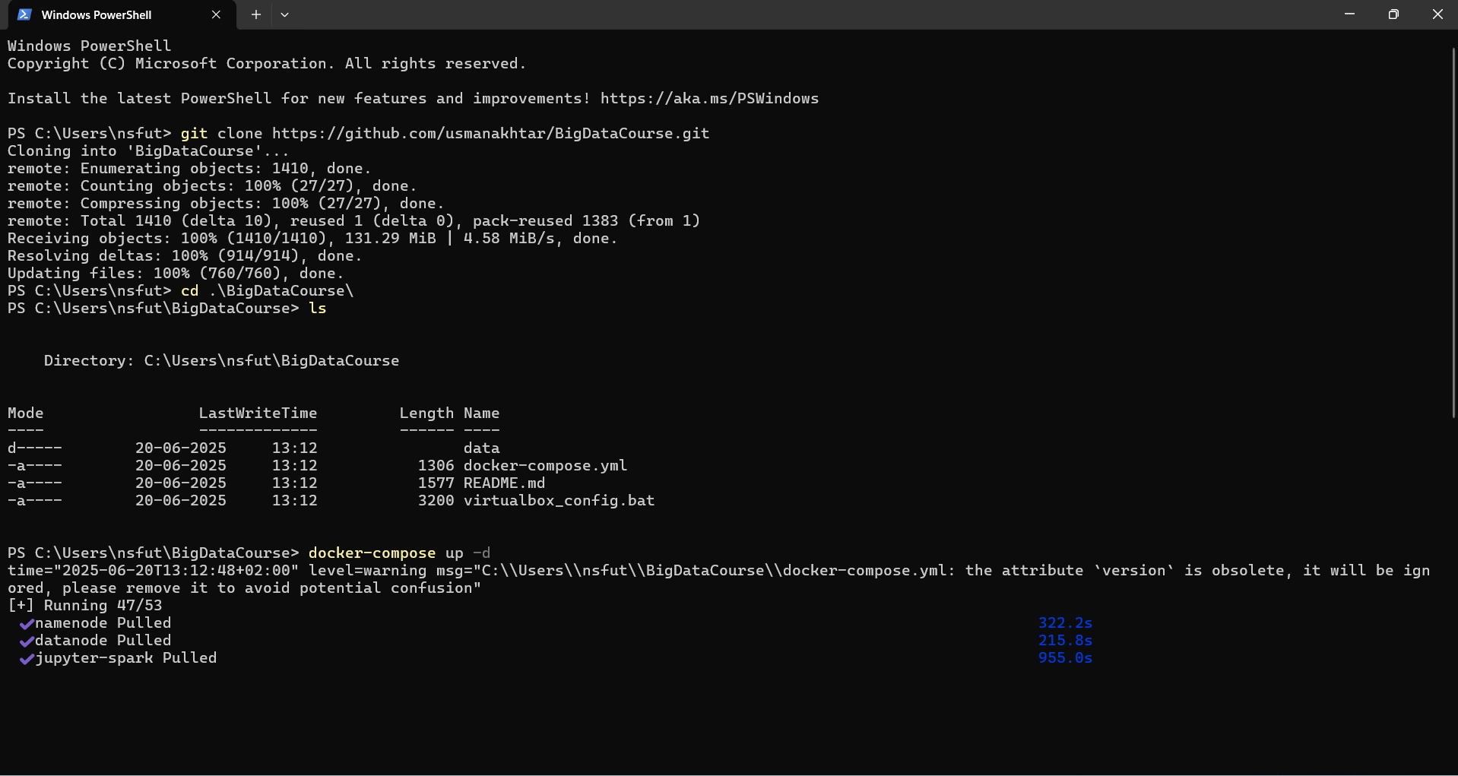

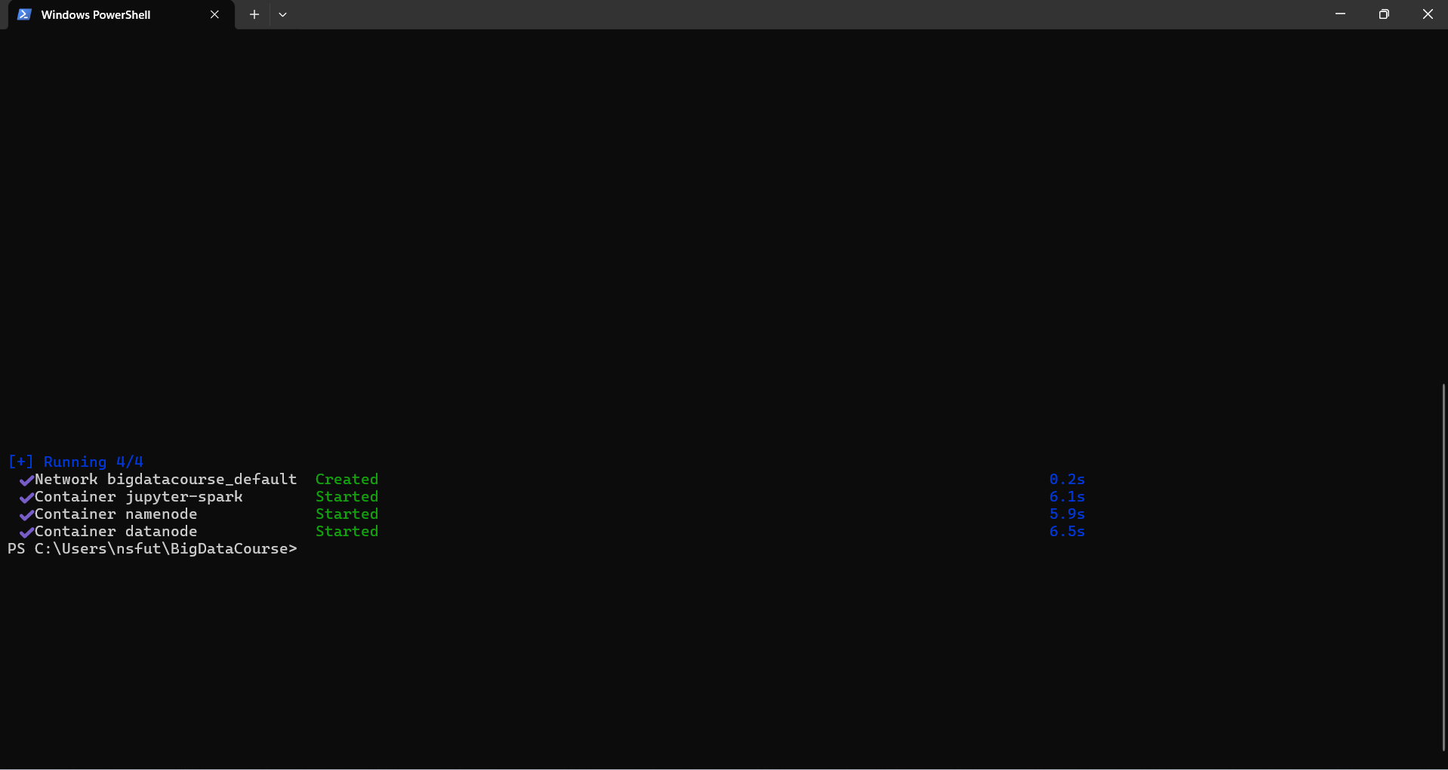

Issues: -

If you have any Issues, try resetting the code, restarting the laptop, or configuring Linux. Alternatively, check if Intel is configured correctly, as it may vary depending on the motherboard.

If any file is not configured in Docker Desktop properly, then use the below commands

**docker-compose down** Then click on Enter

Run Again **docker-compose up -d**

Clone the project

Power shell basic codes required to learn

Docker-compose _ Once installed it needs to add the containers.

cd. -

ls -

Status should be – engine running on the bottom left side.

In this class we will configure the environmental setup. Following are the steps involved in configutation:

1. You need to install the docker desktop:

For windows: https://docs.docker.com/desktop/setup/install/windows-install/Links to an external site.

For Mac: https://docs.docker.com/desktop/setup/install/mac-install/Links to an external site.

2. Download the Gitbash for Windows/Mac:

https://git-scm.com/downloadsLinks to an external site.

3. Clone the repository

https://github.com/usmanakhtar/BigDataCourse/Links to an external site.