RAILWAY RESERVATION SYSTEM

1. Introduction

1.1 Purpose
The Railway Reservation System allows passengers to search for trains, check seat availability, book and cancel tickets, make online payments, and manage their reservations securely.

1.2 Scope
The system provides:
- Passenger login and logout
- Train search by source, destination, and journey date
- Train details and seat availability
- Class selection and ticket booking
- Online payment and PNR generation
- Ticket cancellation and refund
- Multilingual support
- Waitlist monitoring
- Secure passenger information

1.3 Definitions, Acronyms, and Abbreviations
Term | Meaning
SRS | Software Requirements Specification
PNR | Passenger Name Record
UI | User Interface
API | Application Programming Interface
Passenger | User who books railway tickets
Waitlist | Status when a confirmed seat is unavailable

1.4 References
- IEEE Std. 830-1998 – Software Requirements Specification
- Railway Reservation System project requirements

1.5 Overview
The system allows passengers to search for trains, reserve tickets, make payments, and manage bookings including cancellation, refunds, and waitlist status.

2. Overall Description

2.1 Product Perspective
The Railway Reservation System is an online system connecting passengers with railway reservation services. It manages train, passenger, seat, booking, payment, and reservation information.

2.2 Product Functions
- User account management
- Train search and train information
- Seat availability and class selection
- Ticket booking and payment
- PNR generation
- Cancellation and refund
- Waitlist monitoring
- Multilingual support
- Security

2.3 User Characteristics
The primary user is the passenger, who can search for trains, check availability, book/cancel tickets, make payments, and monitor reservations.

2.4 Constraints
- Internet connection is required.
- Booking depends on seat availability.
- Payment depends on the payment service.
- Cancellation and refunds follow applicable rules.
- Passenger information must be protected.

2.5 Assumptions and Dependencies
Assumptions:
- Passengers provide valid information.
- Train and seat information is accurate.
- Passengers have a valid payment method.
Dependencies:
- Database for storing reservation information.
- Payment service for online payments.
- Updated train and seat availability information.

3. Specific Requirements

3.1 External Interface

3.1.1 User Interface
The system shall provide interfaces for login, train search, train details, seat availability, booking, payment, PNR, cancellation, refund, waitlist status, and language selection.

3.1.2 Software Interface
The system shall interact with a database and online payment service.

3.1.3 Hardware Interface
The system shall be accessible through computers, laptops, tablets, and smartphones.

3.1.4 Communication Interface
The system shall use an internet connection and secure communication for sensitive information.

3.2 Functional Requirements
- FR-01: The system shall allow passengers to securely log in and log out.
- FR-02: The system shall allow passengers to search trains by source, destination, and journey date.
- FR-03: The system shall display train details such as departure, arrival, duration, and available classes.
- FR-04: The system shall allow passengers to check seat availability and select a class.
- FR-05: The system shall allow passengers to book tickets and make online payments.
- FR-06: The system shall generate booking confirmation and PNR after successful booking.
- FR-07: The system shall allow passengers to cancel tickets and receive eligible refunds.
- FR-08: The system shall provide multilingual support.
- FR-09: The system shall allow passengers to monitor waitlisted bookings.
- FR-10: The system shall protect passenger and booking information from unauthorized access.

3.3 Non-Functional Requirements

Security
The system shall protect user accounts, booking information, and payment-related data.

Performance
The system should provide train search, seat availability, and booking results within a reasonable response time.

Usability
The system shall have a simple, clear, and user-friendly interface.

Reliability
The system shall maintain accurate seat and booking information and prevent duplicate bookings.

Availability
The system should be available whenever reservation services are provided.

Maintainability
The system should be modular and easy to modify or update.

3.4 Design Constraints
- The system shall use a database to store reservation information.
- The system shall maintain consistency between seat availability and bookings.
- Only authenticated users can access protected information.
- Online payment depends on the payment service.
- Cancellation and refund shall follow applicable rules.
- The system shall support multiple languages.

Functional and Non-Functional Requirements:

Req ID | Type | Description | Priority | Acceptance Criteria | Rationale (short) | Comments
FR-01 | Functional | The system shall allow passengers to securely log in and log out. | High | Valid login credentials allow access; logout ends the session. | Account access and security | Based on user account requirements.
FR-02 | Functional | The system shall allow passengers to search for trains using source, destination and journey date. | High | Matching trains are displayed for the entered journey details. | Find suitable trains | Based on searching requirement.
FR-03 | Functional | The system shall display train details and allow passengers to check seat availability. | High | Departure, arrival, duration, classes and seat availability are displayed. | Train and seat selection | Based on tracking and seat availability requirements.
FR-04 | Functional | The system shall allow passengers to select their preferred travel class. | High | Passenger can select an available class. | Preference and budget | Based on class-selection requirement.
FR-05 | Functional | The system shall allow passengers to book a ticket, make online payment, and receive booking confirmation with a PNR. | High | Successful payment results in a confirmed booking and generated PNR. | Complete reservation | Based on booking, PNR and payment requirements.
FR-06 | Functional | The system shall allow passengers to cancel tickets and receive an eligible refund. | High | Cancelled ticket is updated and eligible refund is processed. | Booking management | Based on cancellation and refund requirements.
NFR-01 | Non-Functional | The system shall protect passenger account, booking and payment-related information from unauthorized access. | High | Unauthorized users cannot access protected information. | Security | Derived from the stated secure-system requirement.
NFR-02 | Non-Functional | The system shall provide secure handling of passenger login and session information. | High | Protected account information is accessible only after authentication. | Account protection | Derived from secure login and secure-system requirements.
NFR-03 | Non-Functional | The system shall maintain accurate booking and seat-availability information during reservation operations. | High | Displayed booking and availability status remains consistent after a transaction. | Reservation accuracy | Derived from booking and seat-availability requirements.
NFR-04 | Non-Functional | The system shall support users who use their native language. | Medium | Supported interface content can be displayed in the selected language. | Accessibility | Based directly on the multilingual requirement.
NFR-05 | Non-Functional | The system shall securely handle online payment information during ticket booking. | High | Payment information is handled only through the supported payment process. | Payment security | Derived from payment integration and secure-system requirements.
NFR-06 | Non-Functional | The system shall maintain the correct status of bookings after booking or cancellation. | High | Booking status is correctly updated after each completed operation. | Data consistency | Derived from booking and cancellation requirements.

Use-case Flow diagram:

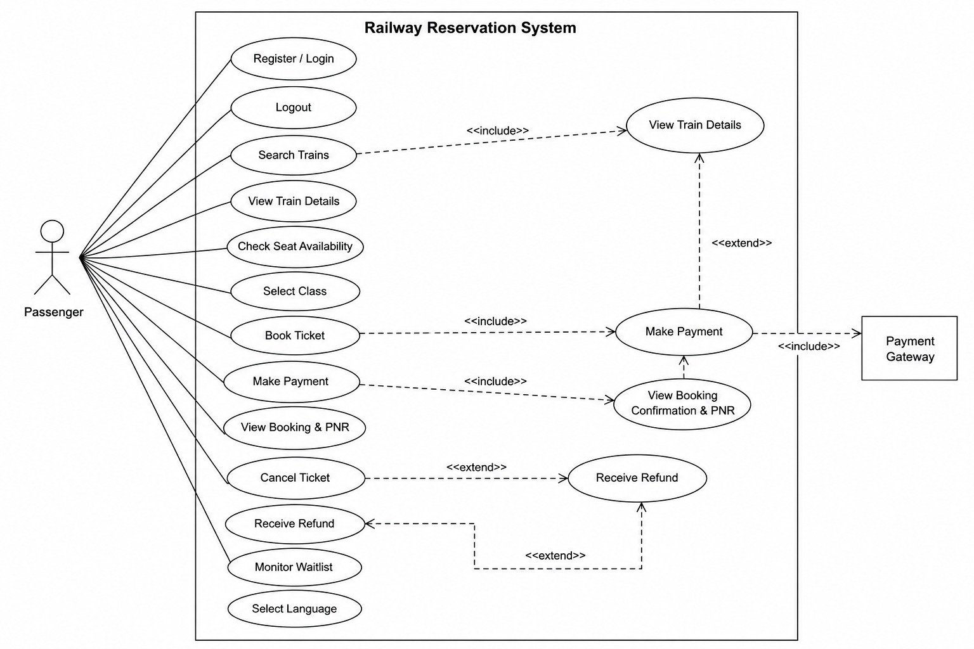

Use-case Flow:

UC-01 – Register / Login
1. Passenger opens the system.
2. Passenger enters valid login details.
3. System authenticates the passenger.
4. System grants access to the account.
5. If the details are invalid, the system displays an error and asks the passenger to try again.
UC-02 – Search and View Train Details
1. Passenger enters source, destination and journey date.
2. System searches for matching trains.
3. System displays available trains.
4. Passenger selects a train.
5. System displays departure time, arrival time, duration and available classes.
UC-03 – Check Seat Availability and Select Class
1. Passenger selects a train.
2. System displays current seat availability.
3. Passenger selects an available travel class.
4. System records the selected class for booking.
UC-04 – Book Ticket and Make Payment
1. Passenger selects the train and class.
2. Passenger chooses the booking option.
3. System prepares the reservation.
4. Passenger makes an online payment through the payment gateway.
5. System verifies successful payment.
6. System confirms the booking and generates a PNR.
UC-05 – View Booking Confirmation & PNR
1. Passenger opens the booking details.
2. System retrieves the reservation.
3. System displays booking confirmation and PNR.
4. Passenger uses the PNR to identify the reservation.
UC-06 – Cancel Ticket and Receive Refund
1. Passenger selects a booked ticket.
2. Passenger requests cancellation.
3. System updates the ticket status to cancelled.
4. System determines the eligible refund.
5. System processes the eligible refund.
6. System displays the updated cancellation/refund status.
UC-07 – Monitor Waitlist
1. Passenger opens waitlisted booking details.
2. System retrieves the current waitlist status.
3. System displays the current status to the passenger.
UC-08 – Select Language
1. Passenger opens language settings.
2. Passenger selects a supported language.
3. System changes the supported interface content to the selected language.
UC-09 – Logout
1. Passenger selects Logout.
2. System ends the current session.
3. System returns the passenger to the login/access screen.

Test Cases :
Test Case 1
Test Case ID | TC_01
Name of Module | User Login
Test case description | Verify that a registered passenger can log in with valid credentials and that invalid credentials are rejected.
Pre-conditions | Passenger is registered and the login page is available.
Test Steps | 1. Open the Railway Reservation System.  2. Enter username/email.  3. Enter password.  4. Click Login.  5. Repeat using an invalid password.
Test data | Valid: Username = passenger01, Password = Pass@123  Invalid: Username = passenger01, Password = Wrong@123
Expected Results | Valid credentials should log in the passenger successfully. Invalid credentials should be rejected and an appropriate login error should be displayed.
Actual Result | To be filled after execution.
Test Result | To be marked Pass/Fail after execution.

Test Case 2
Test Case ID | TC_02
Name of Module | Search Trains
Test case description | Verify that the system returns trains for valid journey details and handles invalid search details.
Pre-conditions | Passenger is logged in and the train search function is available.
Test Steps | 1. Enter source station.  2. Enter destination station.  3. Select journey date.  4. Click Search.  5. Repeat with an invalid/empty destination.
Test data | Valid: Source = Bengaluru, Destination = Chennai, Date = valid future date  Invalid: Destination = empty
Expected Results | For valid details, matching trains should be displayed. For missing/invalid details, the system should display a validation message and should not perform the search.
Actual Result | To be filled after execution.
Test Result | To be marked Pass/Fail after execution.

Test Case 3
Test Case ID | TC_03
Name of Module | Seat Availability
Test case description | Verify that the system displays the correct seat availability for a selected train and class.
Pre-conditions | Passenger has searched for trains and at least one train is available.
Test Steps | 1. Select a train.  2. Select a travel class.  3. Open seat availability.  4. Check the displayed availability.  5. Try selecting a class that is unavailable.
Test data | Valid: Train = available train, Class = AC 3 Tier  Invalid: Class/option = unavailable class
Expected Results | The system should display the current availability for the selected class. An unavailable class should not be selectable for booking.
Actual Result | To be filled after execution.
Test Result | To be marked Pass/Fail after execution.

Test Case 4
Test Case ID | TC_04
Name of Module | Ticket Booking
Test case description | Verify that a passenger can book an available train using valid passenger details and that invalid details are rejected.
Pre-conditions | Passenger is logged in and seats are available.
Test Steps | 1. Select an available train.  2. Select travel class.  3. Enter passenger details.  4. Submit the booking.  5. Repeat with missing passenger details.
Test data | Valid: Passenger name = Ravi Kumar, Age = 21, Class = AC 3 Tier  Invalid: Passenger name = empty, Age = -2
Expected Results | Valid passenger details should be accepted and the booking should proceed. Invalid or missing details should be rejected with validation messages.
Actual Result | To be filled after execution.
Test Result | To be marked Pass/Fail after execution.

Test Case 5
Test Case ID | TC_05
Name of Module | Online Payment
Test case description | Verify that payment is processed for a valid booking and invalid payment information is rejected.
Pre-conditions | Passenger has selected a valid train and booking is ready for payment.
Test Steps | 1. Open the payment page.  2. Select UPI as payment method.  3. Enter valid payment details.  4. Confirm payment.  5. Repeat using invalid payment details.
Test data | Valid: Amount = ₹850, Payment method = UPI, UPI ID = valid  Invalid: UPI ID = invalid_format
Expected Results | Valid payment should be processed successfully. Invalid payment details should be rejected and the booking should not be confirmed until payment succeeds.
Actual Result | To be filled after execution.
Test Result | To be marked Pass/Fail after execution.

Test Case 6
Test Case ID | TC_06
Name of Module | Booking Confirmation & PNR
Test case description | Verify that a successful booking generates and displays a valid PNR and booking confirmation.
Pre-conditions | Passenger has completed a successful ticket booking and payment.
Test Steps | 1. Complete a successful booking.  2. Open booking confirmation.  3. View the PNR.  4. Check the displayed booking details.
Test data | Valid: Successfully paid booking with generated PNR  Invalid: Enter a non-existing PNR when searching/viewing booking details
Expected Results | A successful booking should display confirmation and a generated PNR with correct booking details. A non-existing PNR should return an appropriate message.
Actual Result | To be filled after execution.
Test Result | To be marked Pass/Fail after execution.
Test Case 7
Test Case ID | TC_07
Name of Module | Ticket Cancellation & Refund
Test case description | Verify that an eligible confirmed ticket can be cancelled and the applicable refund is processed.
Pre-conditions | Passenger is logged in and has a confirmed ticket eligible for cancellation.
Test Steps | 1. Open booked tickets.  2. Select a confirmed ticket.  3. Choose Cancel Ticket.  4. Confirm cancellation.  5. Check the refund status.
Test data | Valid: PNR = confirmed booking, Ticket amount = ₹850  Invalid: PNR = non-existing/cancelled booking
Expected Results | A valid eligible ticket should be cancelled and the applicable refund status should be displayed. An invalid or already cancelled booking should not be cancelled again.
Actual Result | To be filled after execution.
Test Result | To be marked Pass/Fail after execution.

Test Case 8
Test Case ID | TC_08
Name of Module | Waitlist Monitoring
Test case description | Verify that the system displays the current status of a waitlisted booking.
Pre-conditions | Passenger is logged in and has a waitlisted booking.
Test Steps | 1. Open the waitlist section.  2. Select the waitlisted booking.  3. View the current waitlist status.  4. Try to access a non-existing booking.
Test data | Valid: Existing waitlisted booking  Invalid: PNR = non-existing PNR
Expected Results | The system should display the current waitlist status for the valid booking. For a non-existing PNR, an appropriate error or not-found message should be displayed.
Actual Result | To be filled after execution.
Test Result | To be marked Pass/Fail after execution.

Test Case 9
Test Case ID | TC_09
Name of Module | Language Selection
Test case description | Verify that the passenger can select a supported language and that an unsupported language is not accepted.
Pre-conditions | Passenger is logged in and language settings are available.
Test Steps | 1. Open language settings.  2. Select a supported language.  3. Check the interface text.  4. Try selecting an unsupported language option.
Test data | Valid: Language = supported language  Invalid: Language = unsupported language
Expected Results | The interface should change to the selected supported language. An unsupported language should not be applied and an appropriate message should be displayed if applicable.
Actual Result | To be filled after execution.
Test Result | To be marked Pass/Fail after execution.

.

