**CMPE-273 Lab – 3 : GoogleMap API Verify if Address Exists**

**Name: Naga Varun Bathina, 017434261**

* The first step is to define the protobuf message and service in a `.proto` file, `googlemap.proto`:

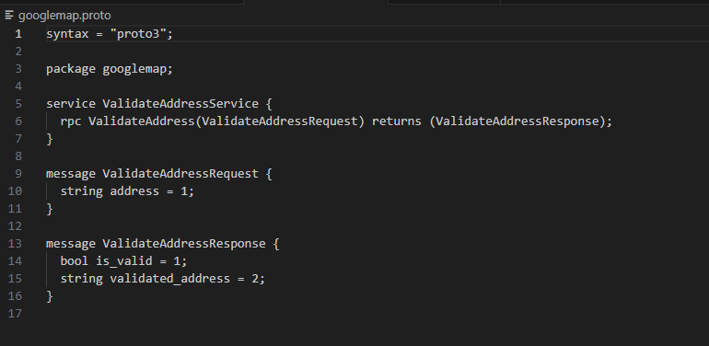

* I set up my code by generating the Python code for gRPC client and server using the `protoc` compiler and `grpcio-tools`:

pip install grpcio-tools, python -m grpc_tools.protoc -I. --python_out=. --grpc_python_out=. googlemap.proto commands.

This will generate `googlemap_pb2.py` and `googlemap_pb2_grpc.py` files.

* Create the server implementation in **`googlemap_validate_address_server.py`**
* We generate API in Google cloud console and use it here after enabling geocoding API in GCP
* Create the Client implementation in **`googlemap_validate_address_client.py`**
* To run the server and client, execute them in separate terminal windows:

Command1: python googlemap_validate_address_server.py

In another terminal:

Command2: python googlemap_validate_address_client.py

* This will start the gRPC server and make a request to validate the address using the client.
* **Server: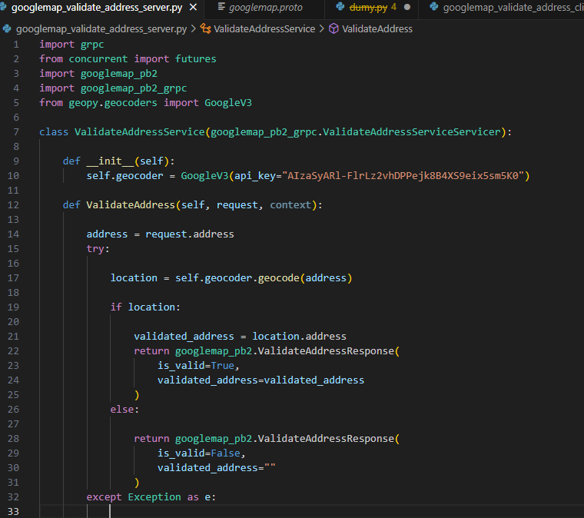Client:**

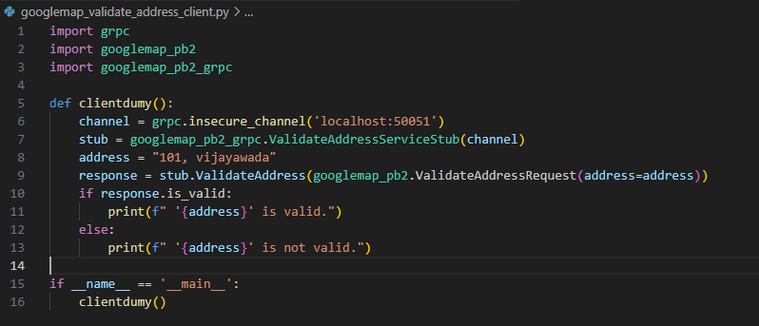

**Outputs for validating Addresses with help of GoogleMap API:**

1. **1326, The Alameda, San Jose, CA:**

**Valid**

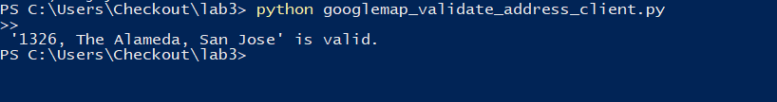

1. **101, Vijayawada**



1. **Jhuhui**

