**Navtech .Net Coding Assessment**

**Project Structure Explanation:**

1. NavTech.AppGateway -> WebApi Project(Startup project) which contains controllers, Program and startup.cs
2. Business Process -> Contains Business Process Interfaces and Services
3. Data Access -> Contains Data Access Layer interfaces and services
4. Model -> All model classes used in application are declared here

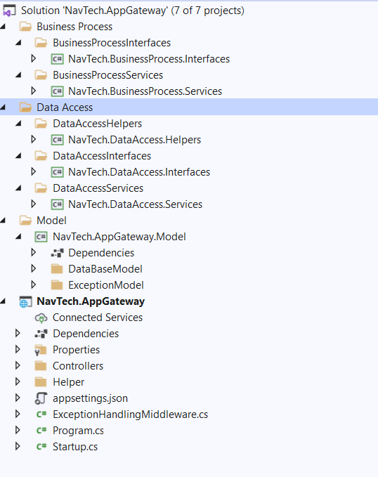

**Implementation Approach**

1. Read Configuration
2. Created Mock server api’s using postman to get the Product details from two sources – default Fields and custom fields

<https://65448a11-0f01-42f3-ac03-1ff1b0deabc9.mock.pstmn.io/api/defaultFields/Product>

<https://65448a11-0f01-42f3-ac03-1ff1b0deabc9.mock.pstmn.io/api/customFields/Product>

1. Created ReadConfiguration api in the controller. Get API to get the records according to the data required from both the sources.

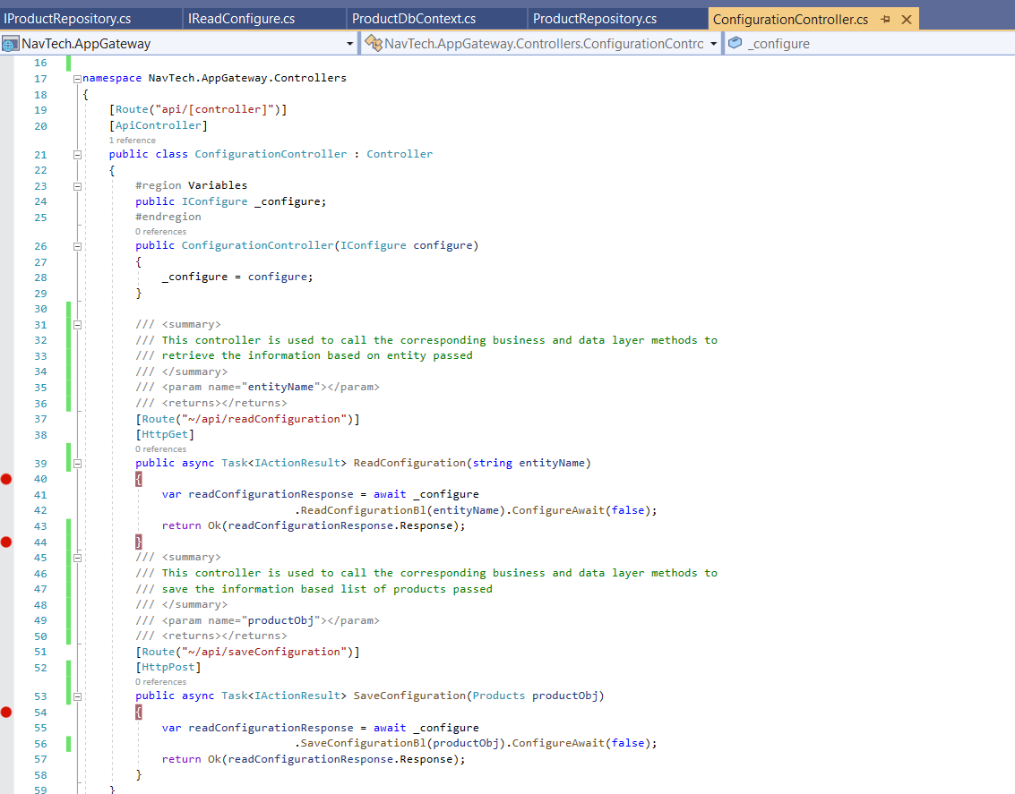

1. Controller calls the business layer which contains the logic to call data layer of both the sources. Merges both the data into a list. Iterating through the list to call the data layer to get the records from database.

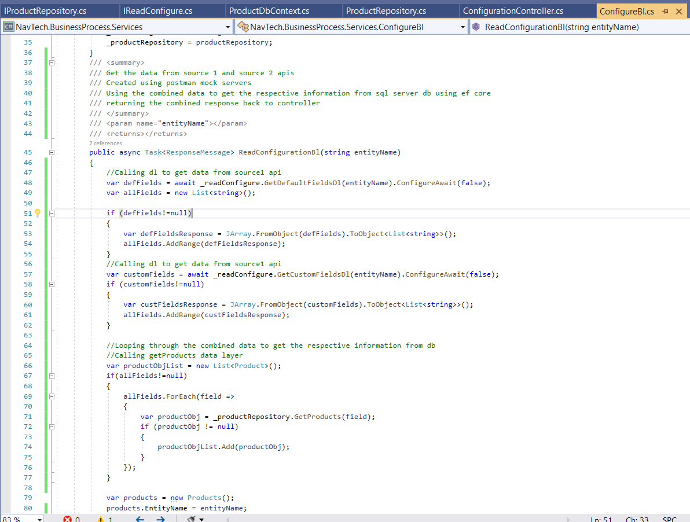

1. Used EntityFramework core to fetch the records present in sql server db.

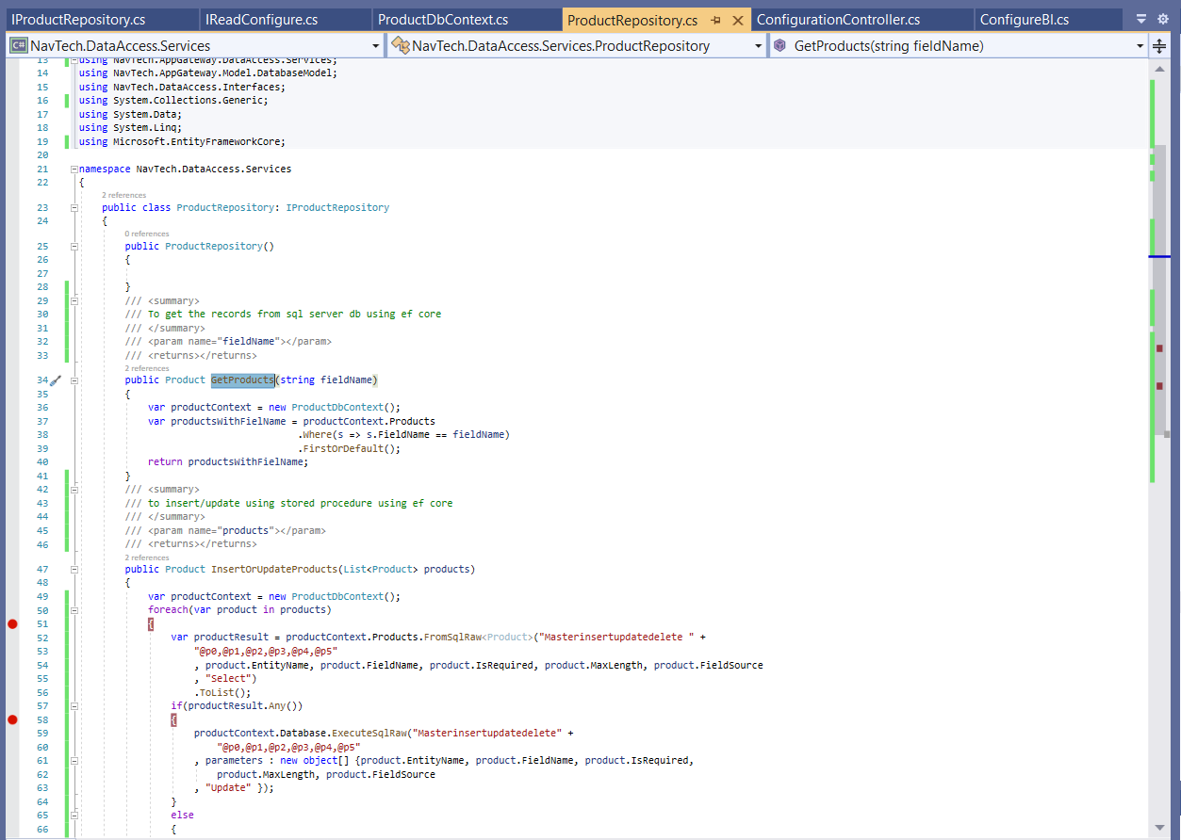

1. Save/Update Configuration
2. Created save configuration api - Post method to accept list of Product entities and insert/update the configuration in sql server db.

Business and data layer methods for the same purpose.

Used Data – base driven approach and created classes using scaffolding.

Created stored procedure to check insert/update based on product list sent in request.

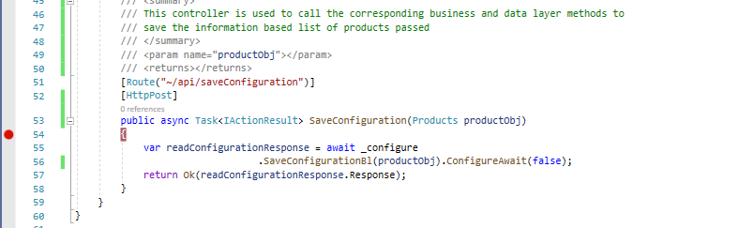

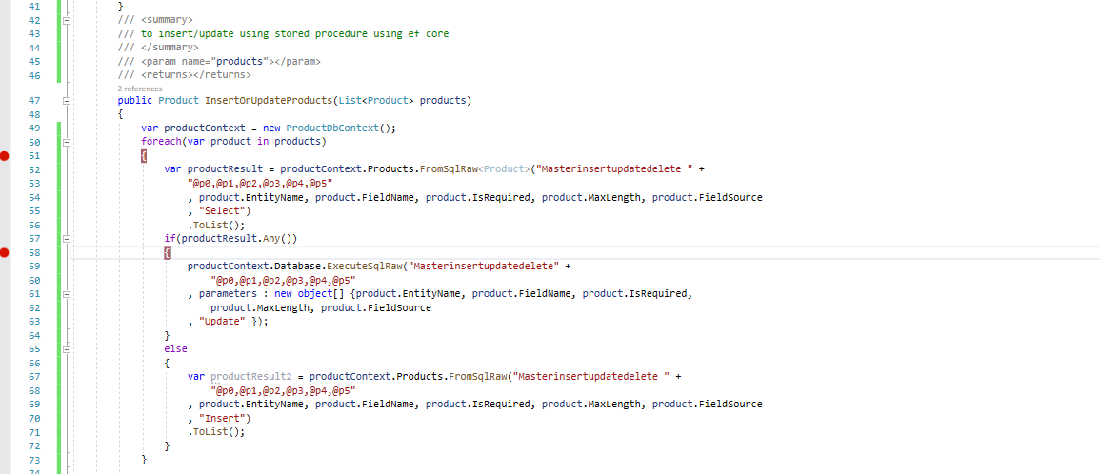

**Problems Faced –**

1. Currently looped through each entity , checked if it exists and then performed insert/update operation using stored procedure.

<https://github.com/NagaVisaradha95/NavTechAssignment/tree/main/StoredProcedureScripts>

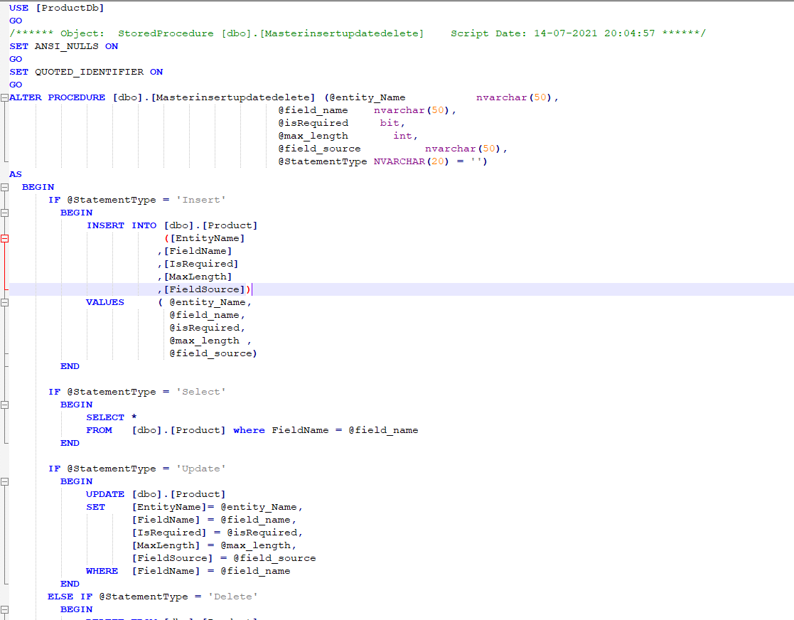

But tried to do bulk insert/update using stored procedure by creating user defined data types. Couldn’t pass the information from c# to stored procedure using EF.

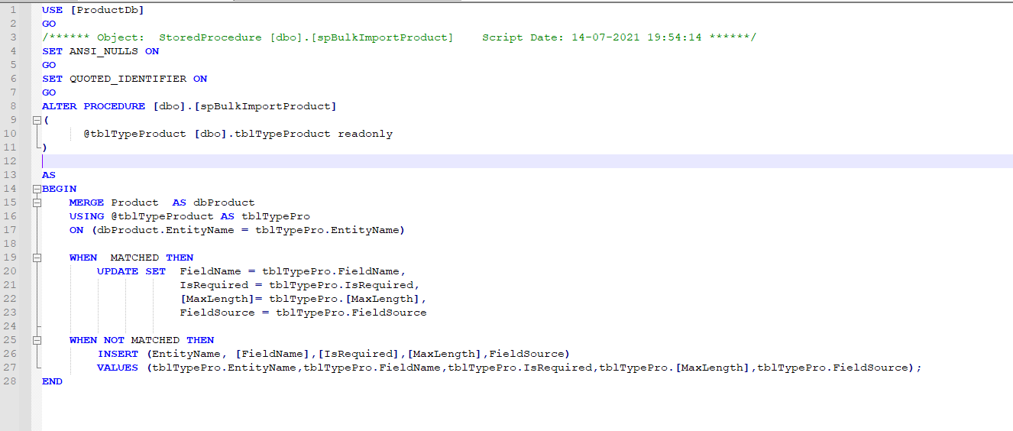

1. Couldn’t integrate unit testing project due to time constraints. Getting build errors. So, excluded from the repository.
2. Added Custom Exception Handling middleware, but still yet to handle different types of exceptions.

If I could get another day, I can try to complete these problems as well.

Thanks for the assignment.