Query Raiser App

Introduction:

The Query raiser app helps in growth of an institution which enhance the conversation between Query raiser and the Respective Groups .

The Query Raiser is an application works on Dot Net MVC platform and MS SQL Database. The Program starts with login.cshtml which held in _login.cshtml layout. The login.cshtml action method(login) place in Account Controller

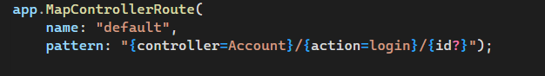

_login layout has two view

*login

&

*register

Overview of website:

The signin page of the website looks as follows:

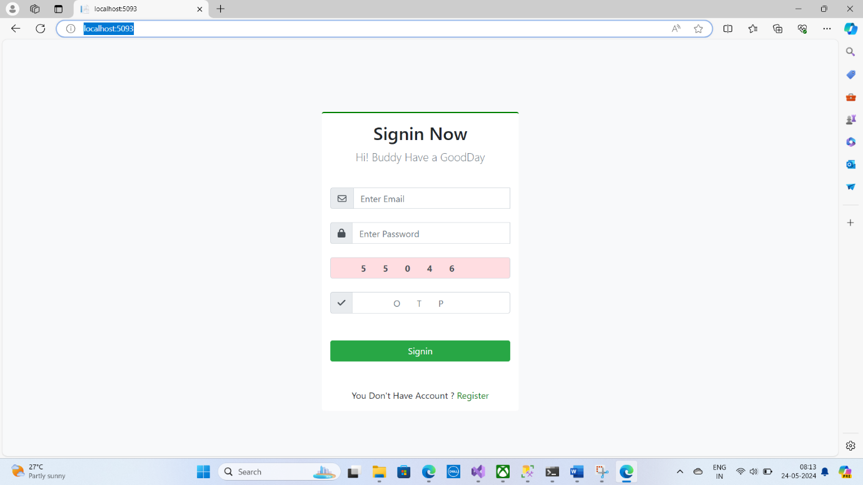

When we click on the register link the registration page opens and the new users can be added with the help of it which ask the username, email,usertype,and set password for registration.

Once the registration was completed the page was redirect to the login page.

Login.cshtml view connected two script file loginscript.js,valid.js

Once the value was entered and signin was clicked,will be validated by Jquery Ajax before pass on to the url (Account/hellofun) hellofun action method

Once the value reach the action method it verifies the user trustability after the finish the process the action method return to the data ajax success

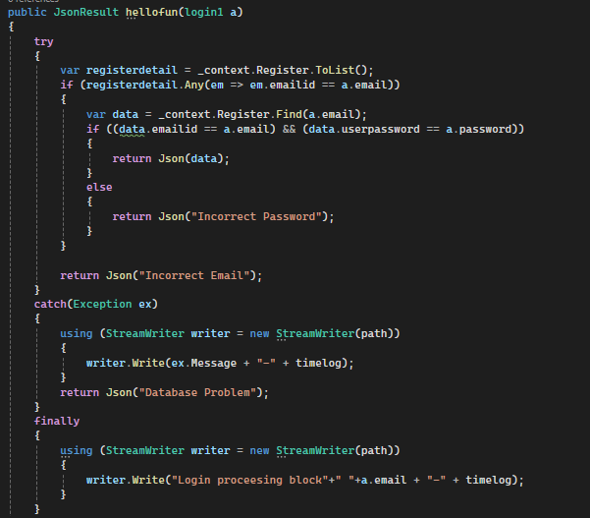

Loginscript.js jquery ajax success

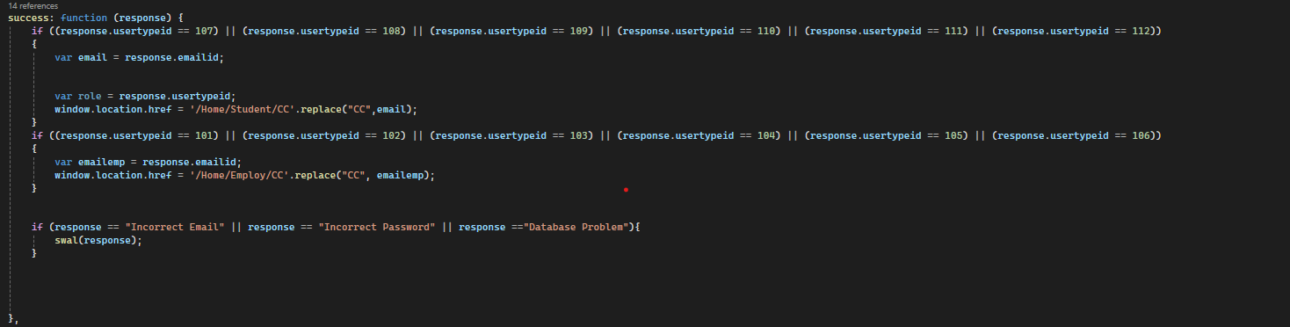

Once the verification was completed the page was redirect to the respective user type either the company view or school view

Home controller have two action method (Stuent,Employ) it also have respective view

*One is Student.cshtml is _layout Layout page

*Another one is Employ.cshtml is _employ Layout page

Student.cshtml 🡪report_student_query.js,querychecker.js,resentviewscript.js

Employ.cshtml🡪 report_emp_query.js,querychecker.js,resentviewscript.js

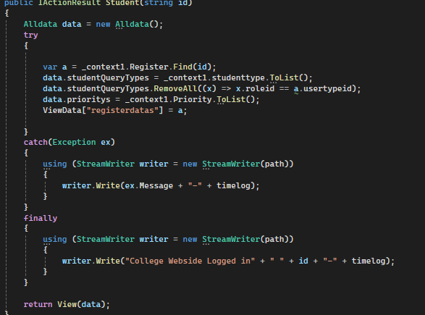

Query cannot be raise to the same usertype of the Queryraiser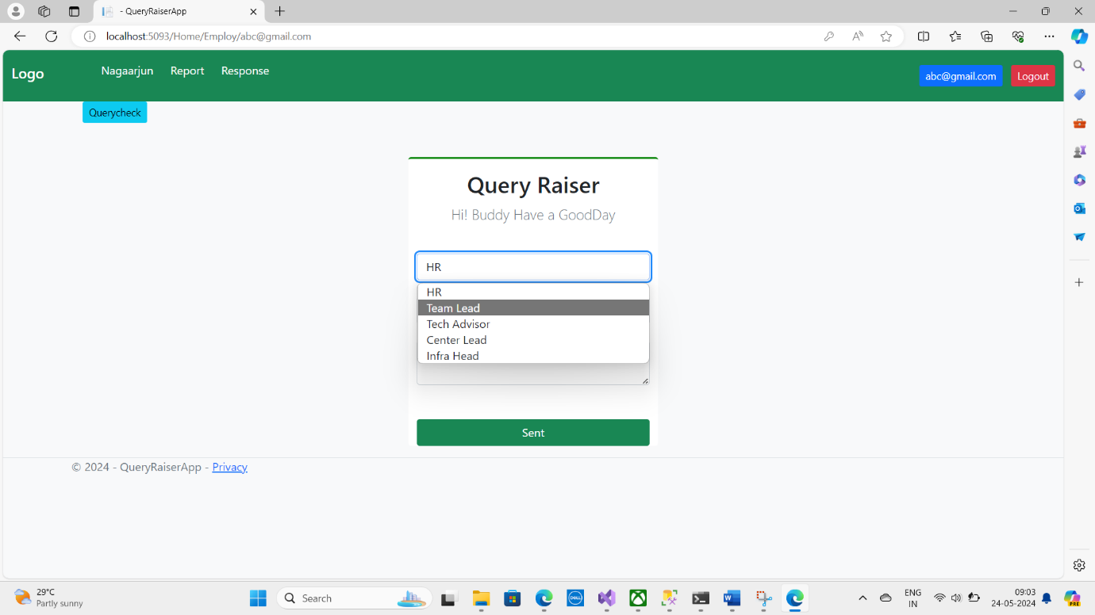

Every time send button was clicked the values pass on to the reportsave with the help of Jquery Ajax.

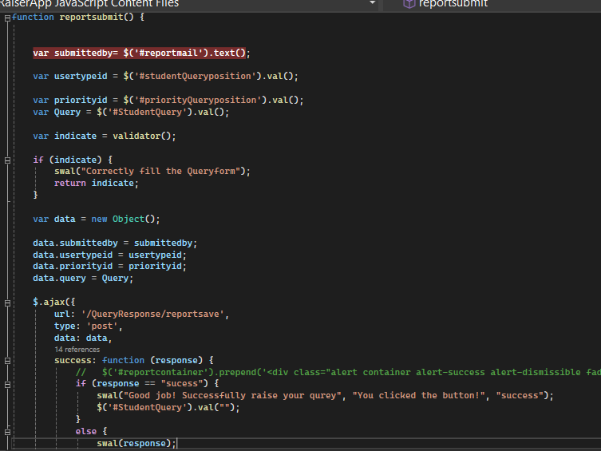

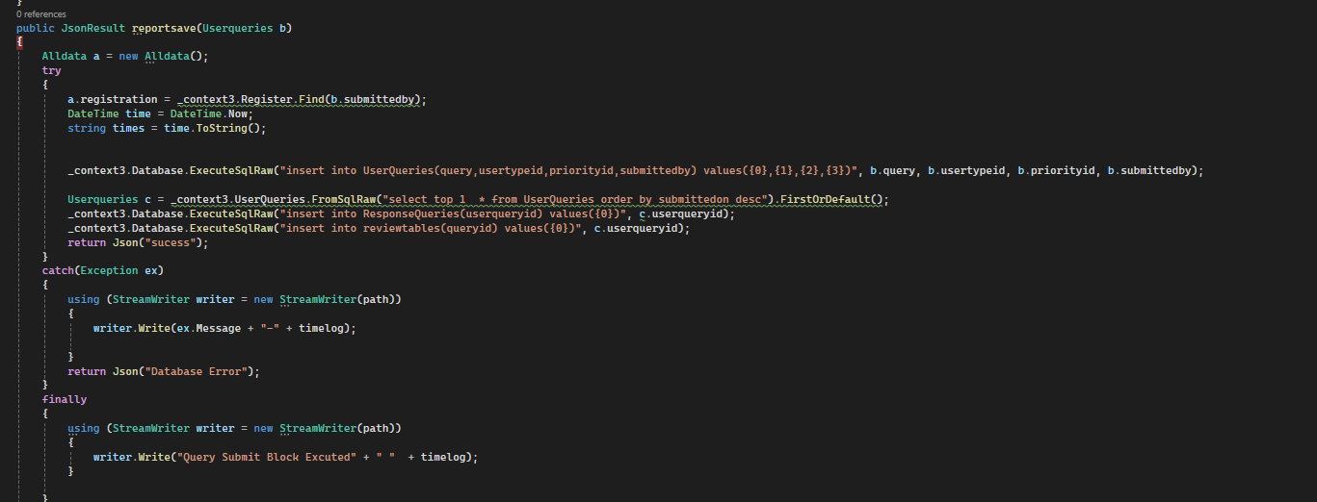

Userqueries was insert ,it also insert same queryid to the ResponseQueries,reviewtables

It is also same process to Company modules

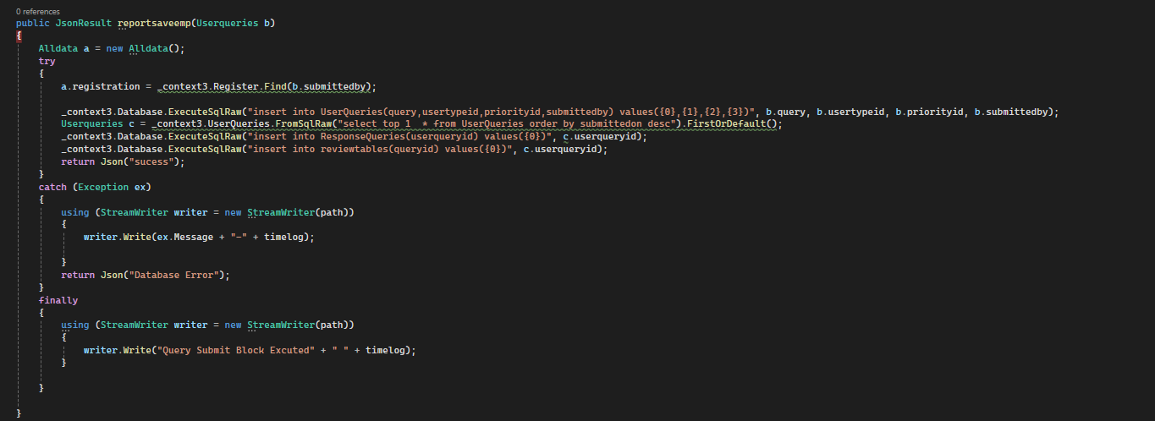

REPORT CONTROLLER

Report controller have two action method report,Employ_report have also view

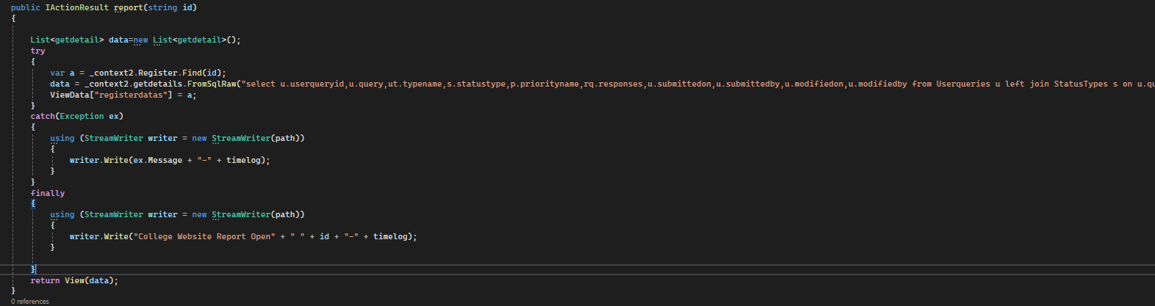

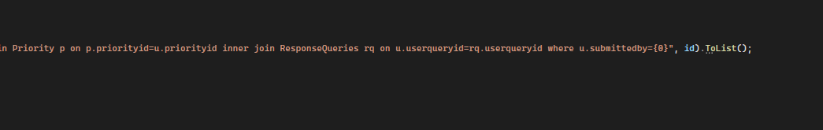

Report action method where condition submitedby

Report view only reflect the query which was raised by the query user

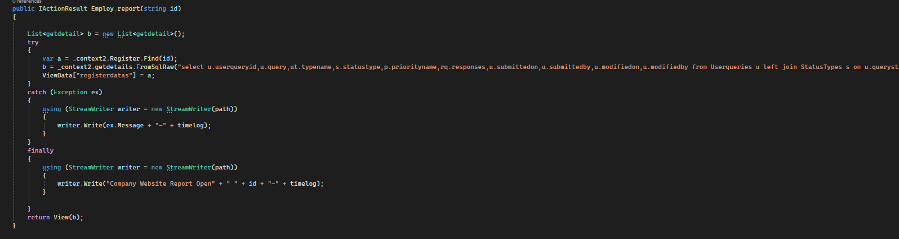

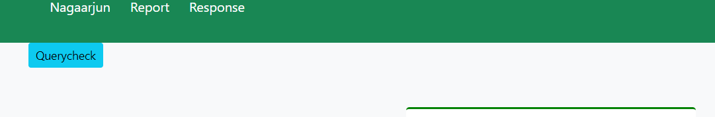

Response button was clicked

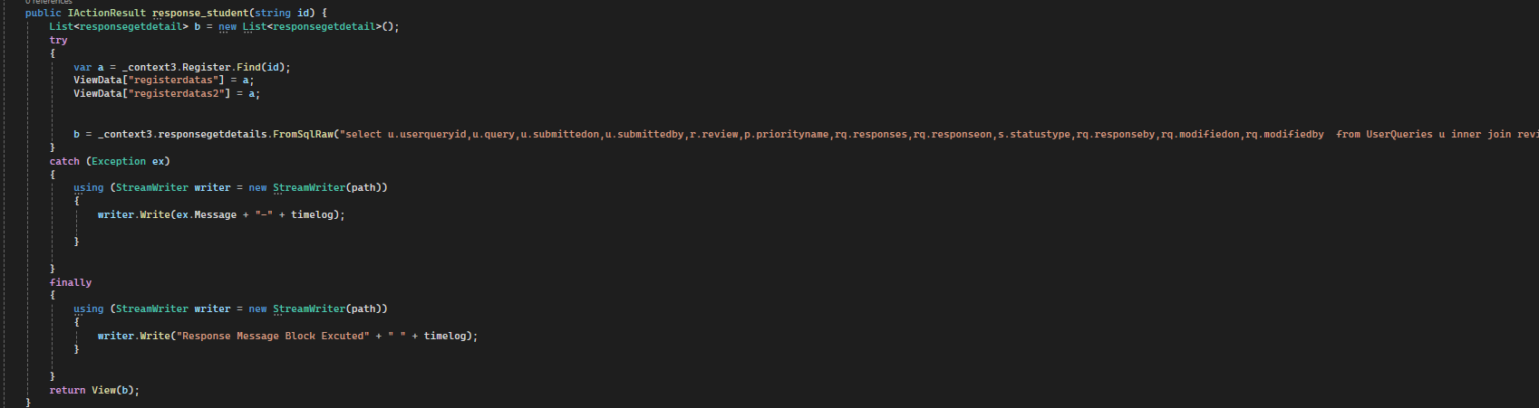

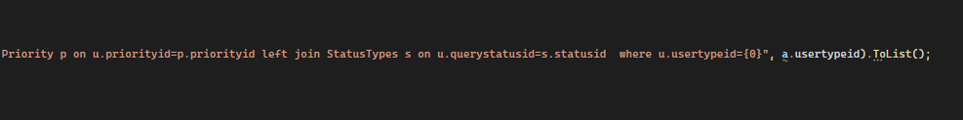

Response will be reflected on the only Respective receiver

Message Mechanism

*Once the Query was Generated by the Query Raiser the message passes on to the receiver on Response Tab(Respective User Type).

*when the receiver replay to the query raiser the message show him with respective date time and status

*replay from the receiver reflect on the report tab on the query raiser show him with respective date time and status with the receiver emailed as well

*Query raised by the query raiser can be seen by the persons under same cretiria of same user type id in response tab

*the process goes on as mention above

*every message either by the query raiser and the receiver will not be replaced by the new message instead all the messages shows on the report and response tab of query raiser and receiver respectively

*the process ends when the receiver changes to the status to closed

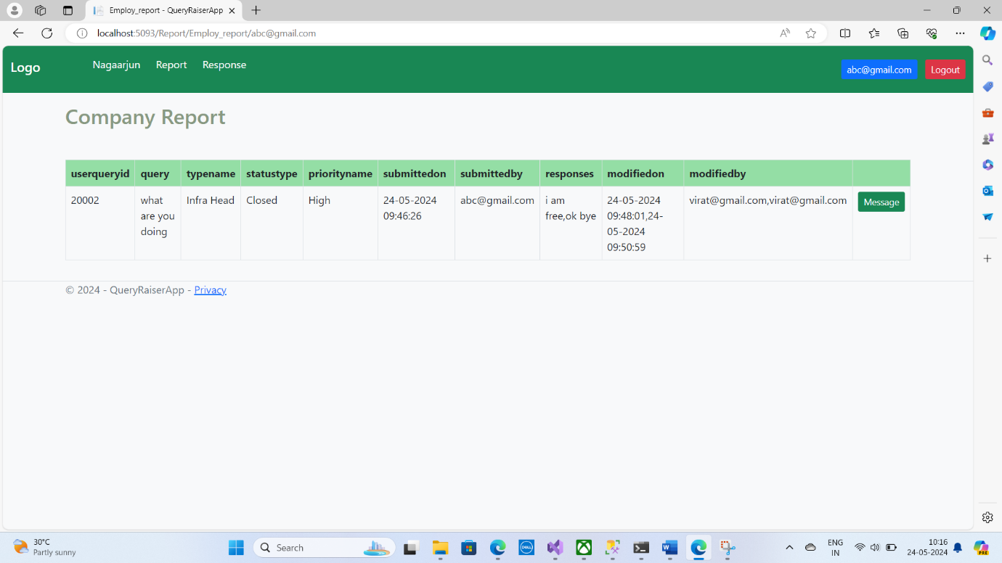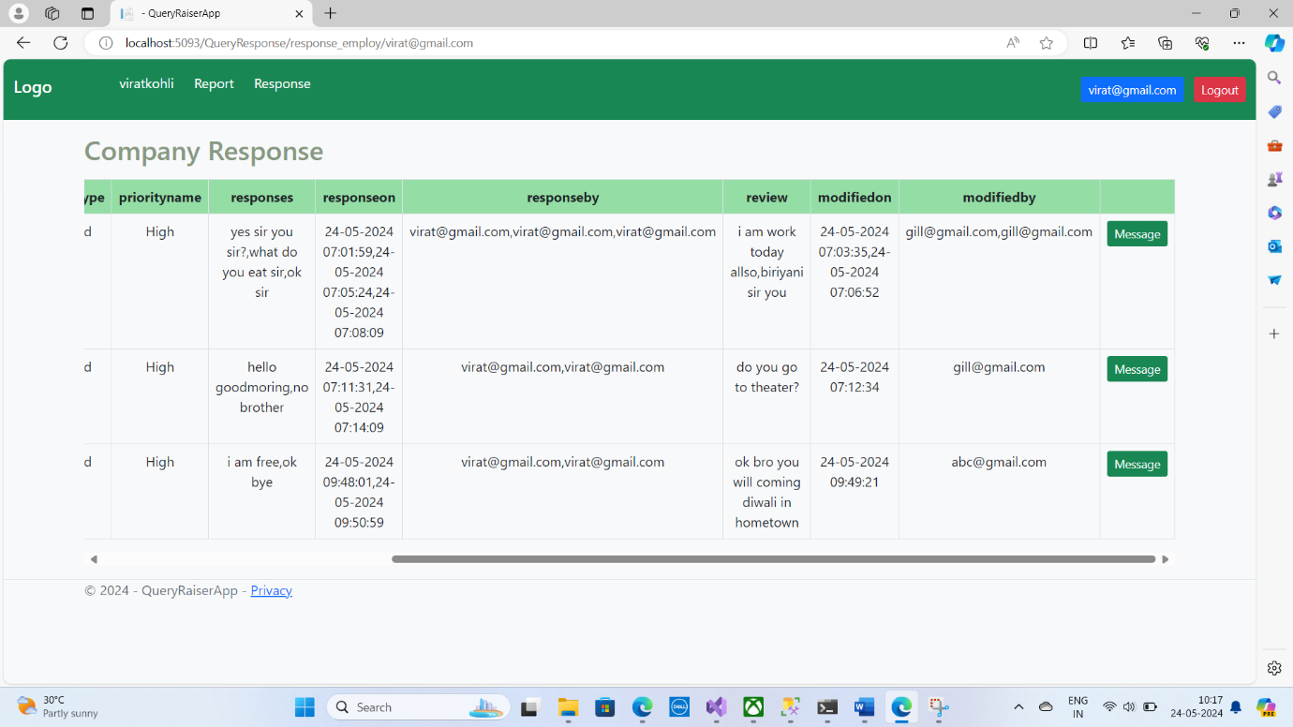

Conversation box

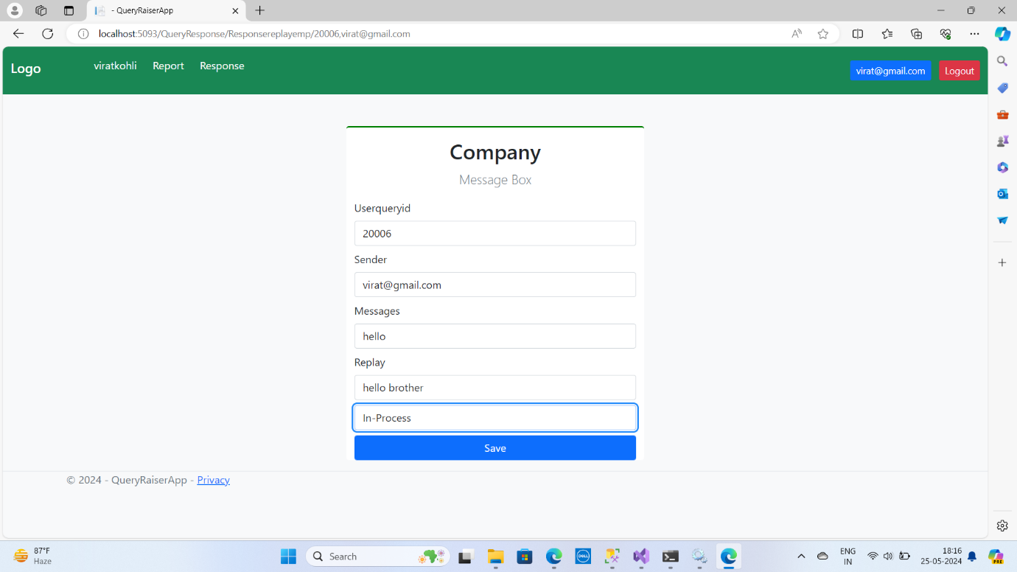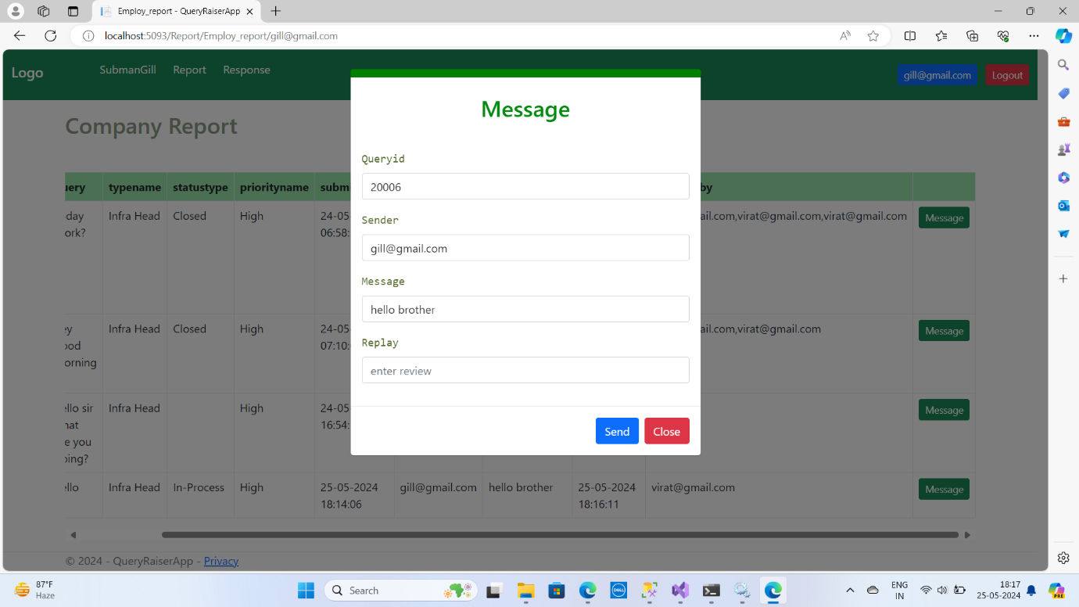



The status was closed can not continue the conversation 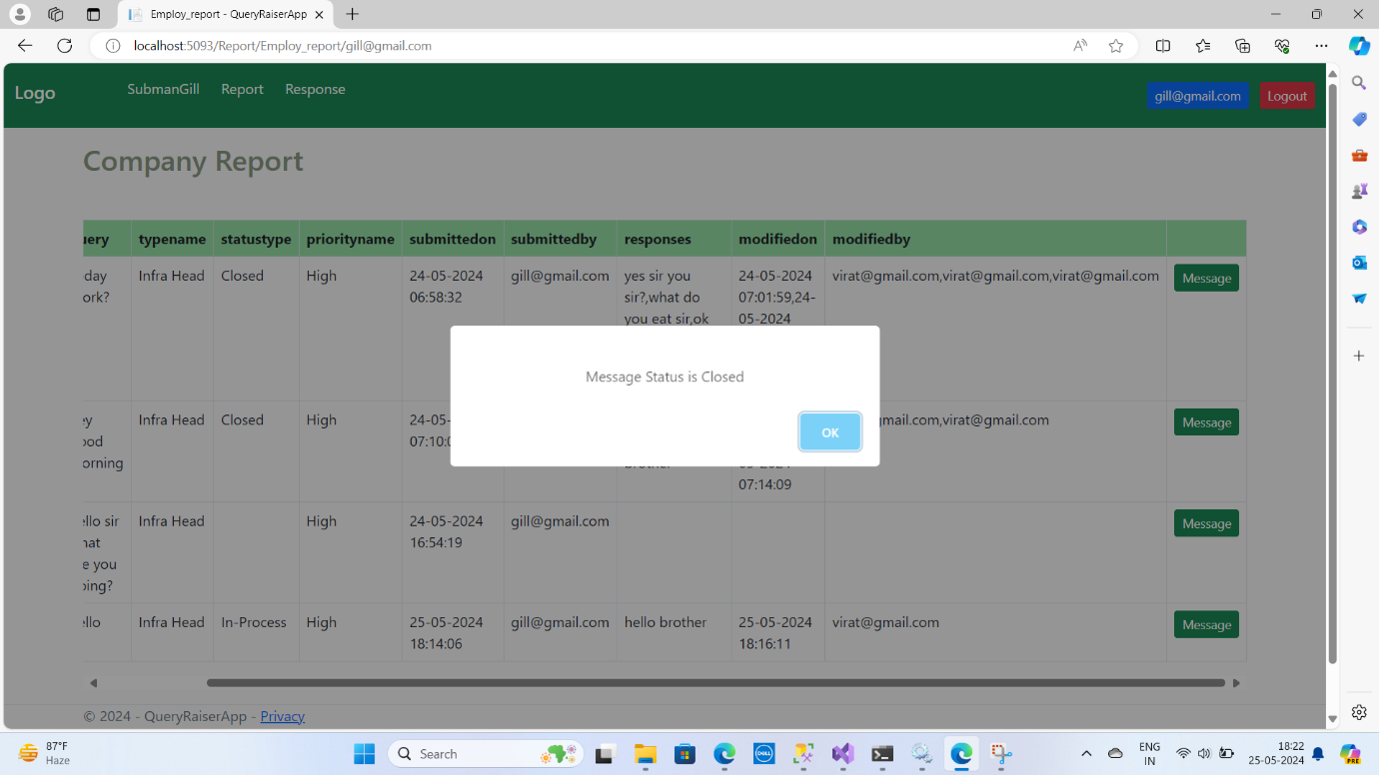

Conclusion:

Hence the query raiser app is user friendly easy accessible and trust worthy